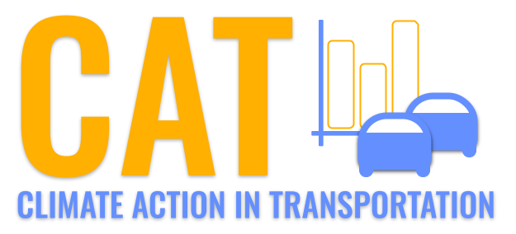 

**PM10 Emissions in Oceana County, 2035**  
Made with CAT VISUALIZER by Gao Labs @ Cornell University.

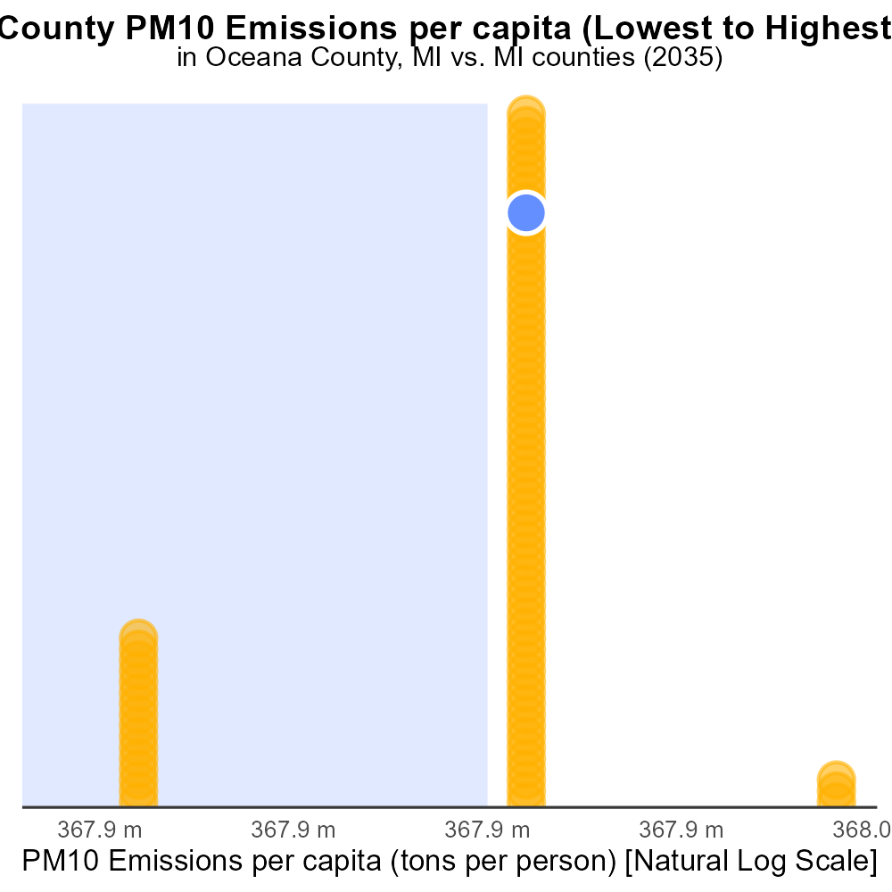

## Keywords

Primary Exhaust PM10; on-road transportation; Oceana County; MI; 2035; total emissions

## Highlights

* Assessing primary exhaust PM10 emissions from on-road transportation in Oceana County.
* Projected total emissions data for 2035 to inform environmental policy decisions.
* Identifying trends and patterns to address air quality concerns in the region.
* Evaluating the impact of on-road transportation on PM10 levels in Oceana County.
* Insights to guide strategies for mitigating air pollution and protecting public health.

# Introduction

In this report, we delve into the assessment of primary exhaust PM10 emissions from on-road transportation in Oceana County, Michigan, with a specific focus on the year 2035. The data on total emissions serves as a crucial basis for policymakers and environmentalists to make informed decisions regarding air quality regulations and mitigation strategies. By analyzing the trends and patterns of PM10 levels in the region, we aim to address growing concerns about air pollution and its potential impact on public health.

The evaluation of the impact of on-road transportation on PM10 emissions in Oceana County will provide valuable insights into the sources and distribution of pollutants, enabling the development of targeted interventions to reduce emissions and improve air quality standards.

# Time Driven Overall by Area

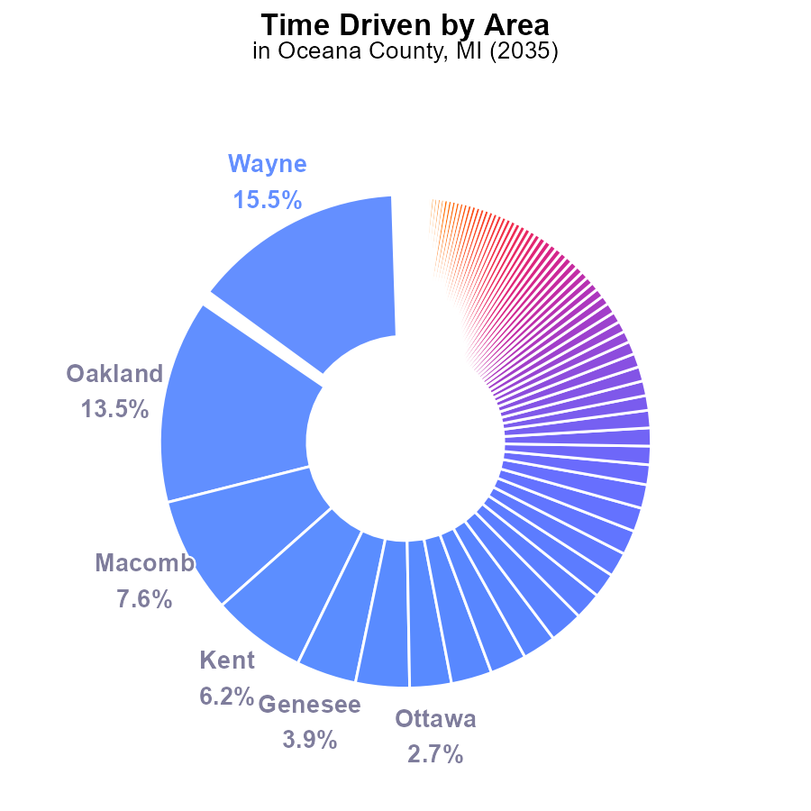

## Findings

* Top contributors to PM10 emissions in Oceana County, MI in 2035 are Wayne (15.5%), Oakland (13.5%), and Macomb (7.6%) counties.
* Cumulatively, the top three counties account for 36.6% of the total PM10 emissions, indicating a concentration of emissions in a few areas.
* The remaining counties contribute smaller percentages to emissions, with many under 1% indicating a fairly distributed emission pattern across the region.

## Recommendations

To reduce emissions, focus on targeted interventions in Wayne, Oakland, and Macomb counties with stricter emission controls. Implement region-wide policies to minimize emissions from all counties, even those with lower contributions, to achieve a comprehensive reduction in PM10 levels.

# Emissions Rate (per mile) by Vehicle Type

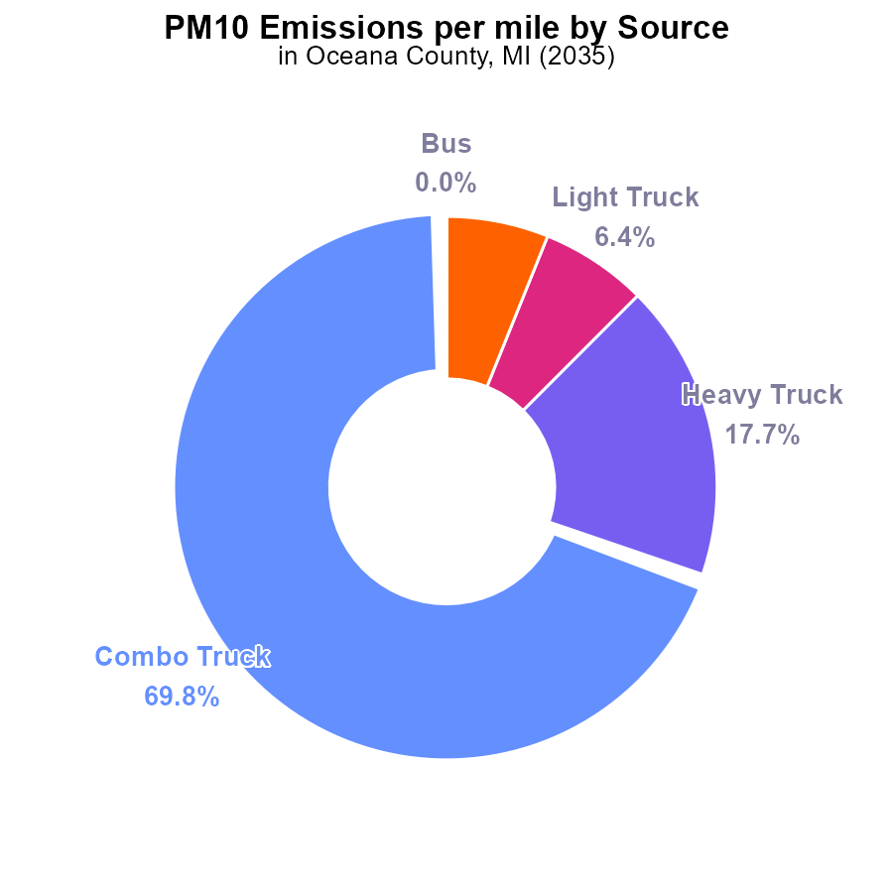

## Findings

* Combo trucks contribute to 69.8% of PM10 emissions per mile in Oceana County
* Heavy trucks contribute to 17.7% of PM10 emissions per mile in Oceana County
* Light trucks contribute to 6.4% of PM10 emissions per mile in Oceana County

## Recommendations

To lower PM10 emissions in Oceana County, measures should focus on reducing emissions from combo trucks, heavy trucks, and light trucks. Encouraging the use of cleaner fuel technologies and optimizing transportation routes can help decrease emissions.

# Vehicle Starts over Time for Passenger Vehicle Starts

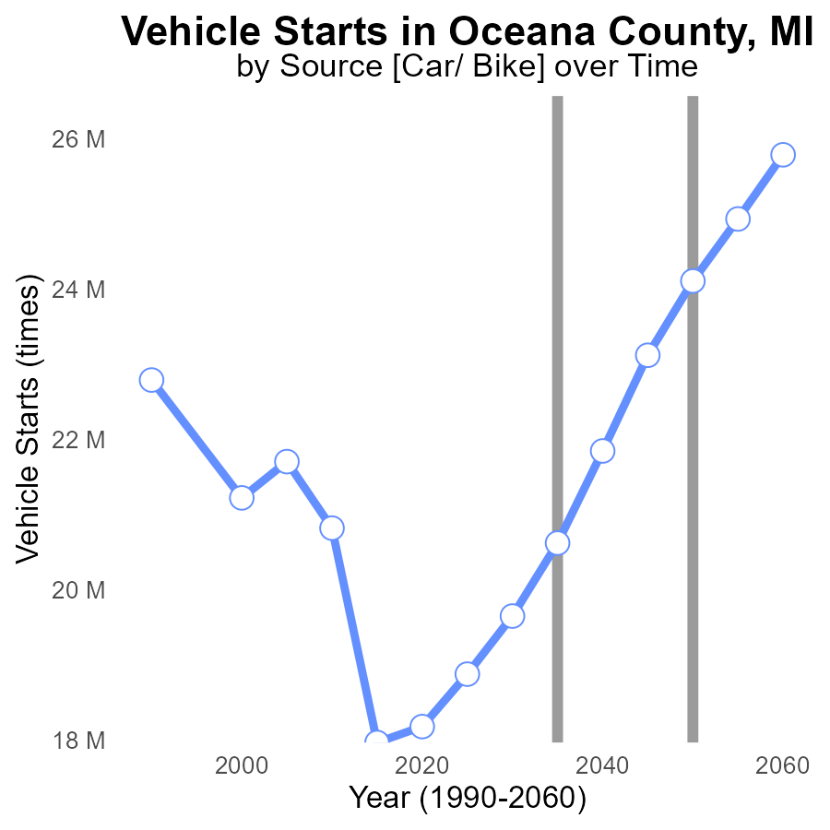

## Findings

* Emissions from vehicle starts in Oceana County, MI for PM10 increased over time.
* By 2050, emissions are projected to decrease to the benchmark level.
* The highest difference from the benchmark was in 2015.

## Recommendations

To reduce emissions, promote vehicle technologies with lower emissions, incentivize carpooling and public transport use, and invest in infrastructure to support electric vehicles.

# Emissions over Time for Passenger Vehicles

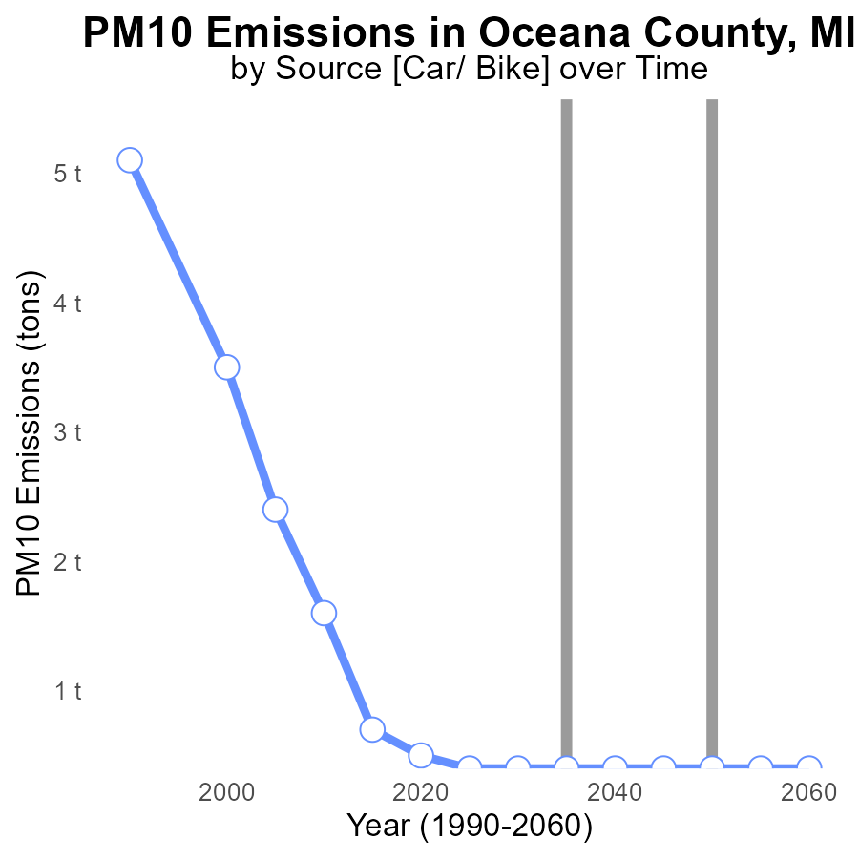

## Findings

* PM10 emissions in Oceana County decreased from 700.0 tons in 2015 to 500.0 tons in 2020.
* Emissions remained constant at 400.0 tons from 2025 to 2055.
* Overall, the county achieved a 28.6% reduction in PM10 emissions from 2015 to 2020.

## Recommendations

To maintain the achieved reduction, focus on implementing stricter emission control measures for industrial activities. Regular monitoring and enforcement of emission standards are essential for sustaining the emissions decline.

# Emissions Rate (per mile) in My Region

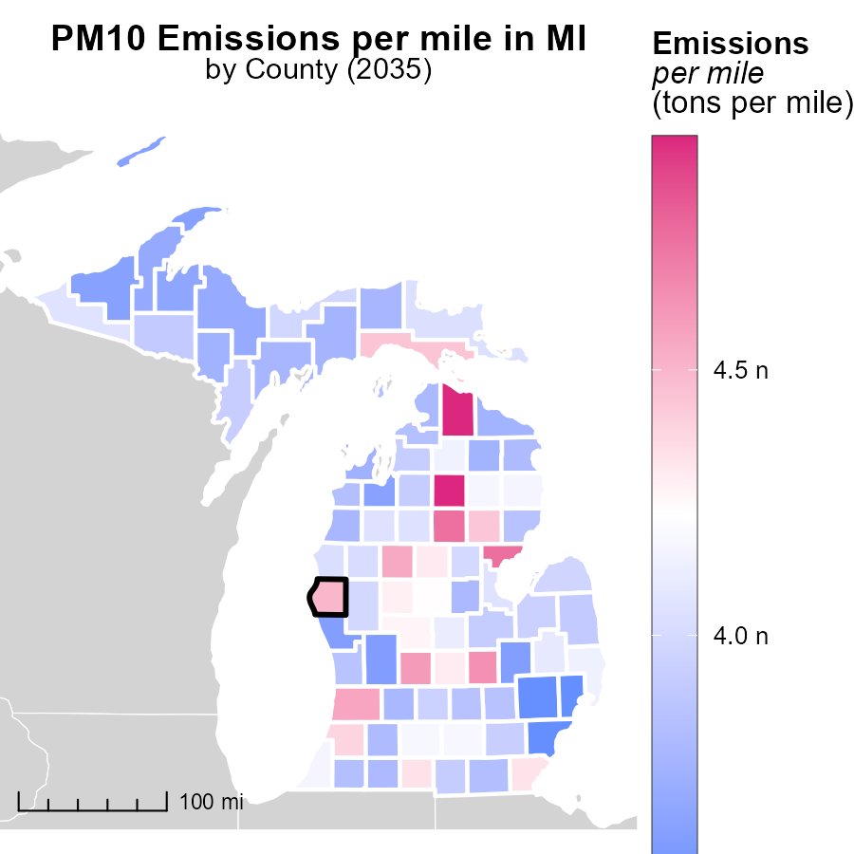

## Findings

* Crawford County, MI has the highest emissions per mile at 4.9 tons.
* Washtenaw County, MI has a median level of emissions per mile at 3.9 tons.
* Macomb County, MI has the lowest emissions per mile at 3.5 tons.

## Recommendations

To lower emissions, focus on initiatives like promoting public transportation, carpooling, and improving vehicle fuel efficiency standards in counties with higher emissions like Crawford County. Encourage the use of electric vehicles and invest in infrastructure to support them in all counties.

# Emissions Rate (per capita) in My Region

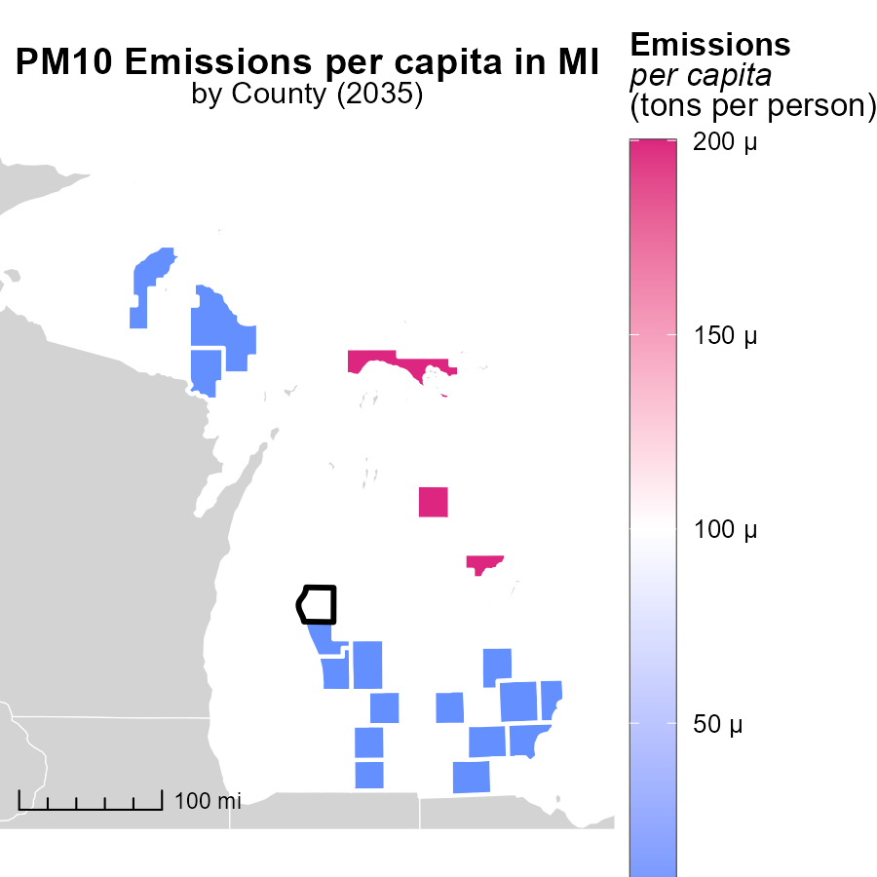

## Findings

* The highest emissions per capita were in Arenac County, MI, with 153.2 tons per person.
* Manistee County, MI had median emissions of 61.1 tons per person.
* Wayne County, MI had the lowest emissions per capita at 34.9 tons per person.

## Recommendations

To lower emissions, focus on high-impact areas like Arenac County by implementing targeted reduction strategies. Encourage sustainable practices in Manistee County to maintain the median level. Support Wayne County in sustaining its low emission levels through continued efforts.

# Time Driven by Fuel Type over Time

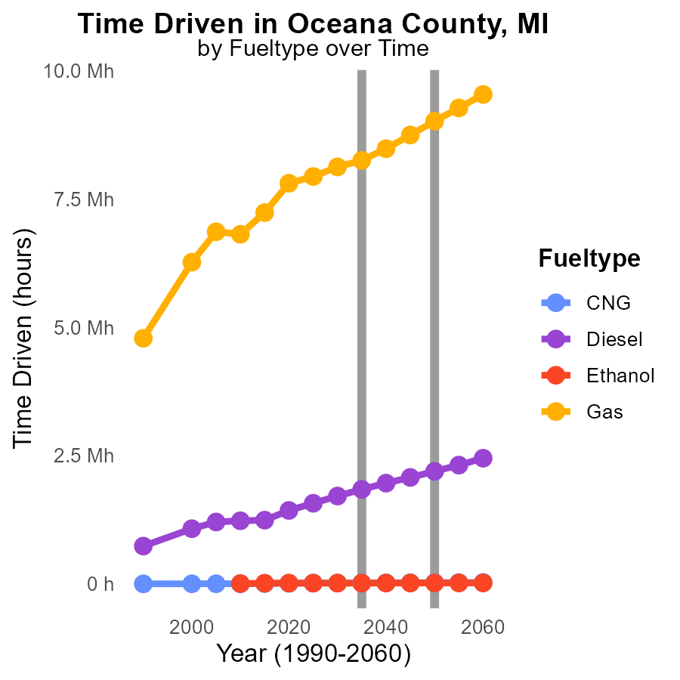

## Findings

* Diesel emissions are the highest and steadily increase over the years, reaching 2.1 million units by 2045.
* Gas emissions have the largest total volume in 2025, at 7.9 million units, dropping to 8.7 million units by 2045.
* CNG and Ethanol have significantly lower emissions compared to Diesel and Gas, with relatively minor changes over time.

## Recommendations

To lower emissions, considering the significant values of Diesel and Gas, transitioning to cleaner fuel alternatives like CNG and investing in infrastructure for Ethanol would be effective. Additionally, introducing policies to promote the adoption of electric vehicles can greatly reduce emissions.

# Vehicles by Road Type over Time

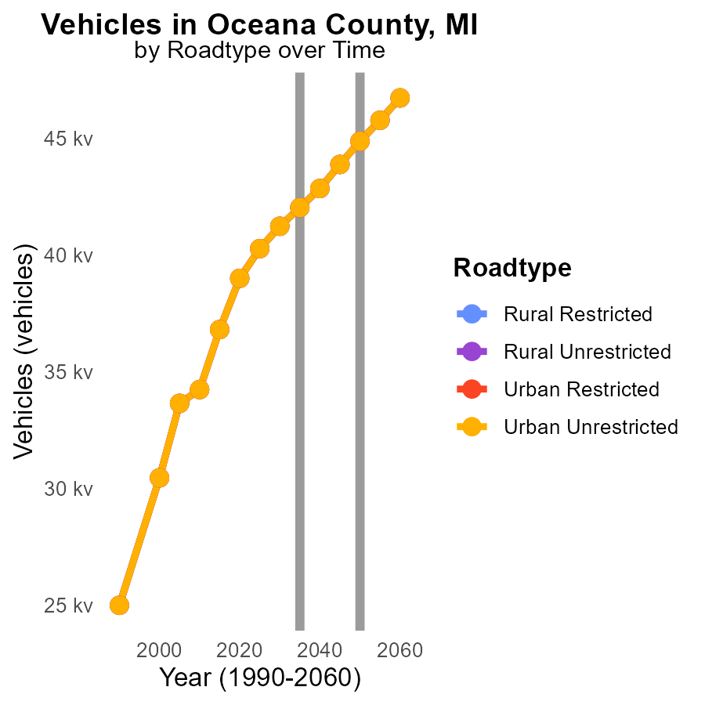

## Findings

* PM10 emissions from vehicles in Oceana County, MI are projected to increase from 40.3k in 2025 to 43.9k in 2045.
* There is a decreasing trend in emissions as the years progress, with the highest reduction percentage occurring between 2025 and 2035.
* Differences with the 2050 target show a steady decline across all road types and areas, implying overall progress in emission reduction efforts.

## Recommendations

To further decrease PM10 emissions, focus on implementing stricter vehicle emission standards. Invest in public transportation to reduce the reliance on individual vehicles and promote carpooling and the use of electric vehicles. Additionally, continue monitoring and enforcing emission control measures to ensure continued progress towards meeting emission reduction targets.

# Areas Ranked by Idling

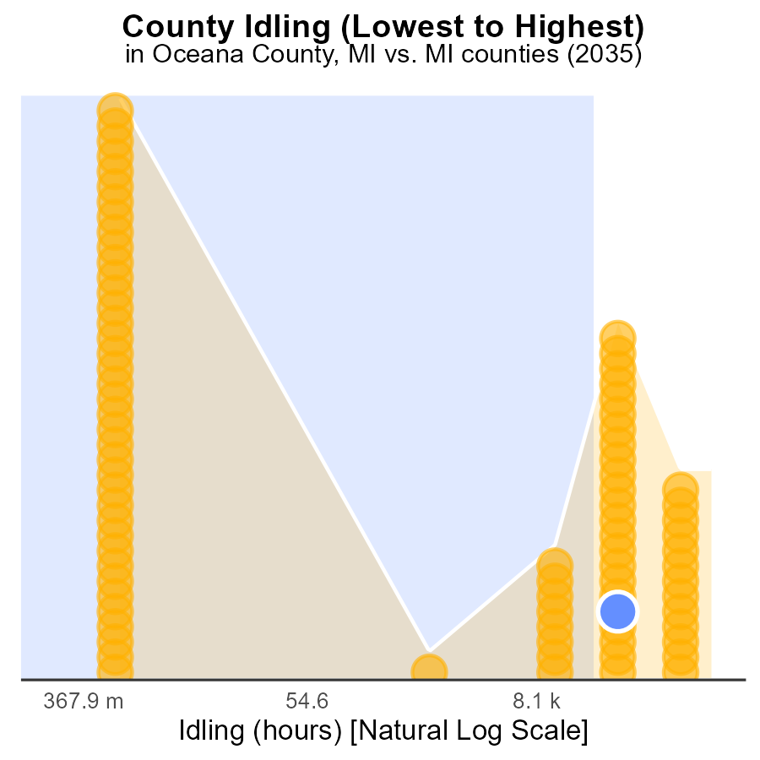

## Findings

* Wayne county has the highest idling emissions with 1.0 million hours, ranking 83rd nationwide.
* Alcona county stands out as the lowest emitter with 0.0 idle hours, ranking 1st.
* Oceana, Muskegon, and Arenac counties have similar idling emissions around 76-78.3k hours, ranking between 51-53.

## Recommendations

To lower idling emissions, encourage the adoption of anti-idling technologies in Wayne county vehicles. In Alcona, maintain the current idling reduction practices. Oceana, Muskegon, and Arenac can collaborate on regional idling reduction initiatives to decrease emissions further.

# Areas Ranked by Emissions Rate (per capita)

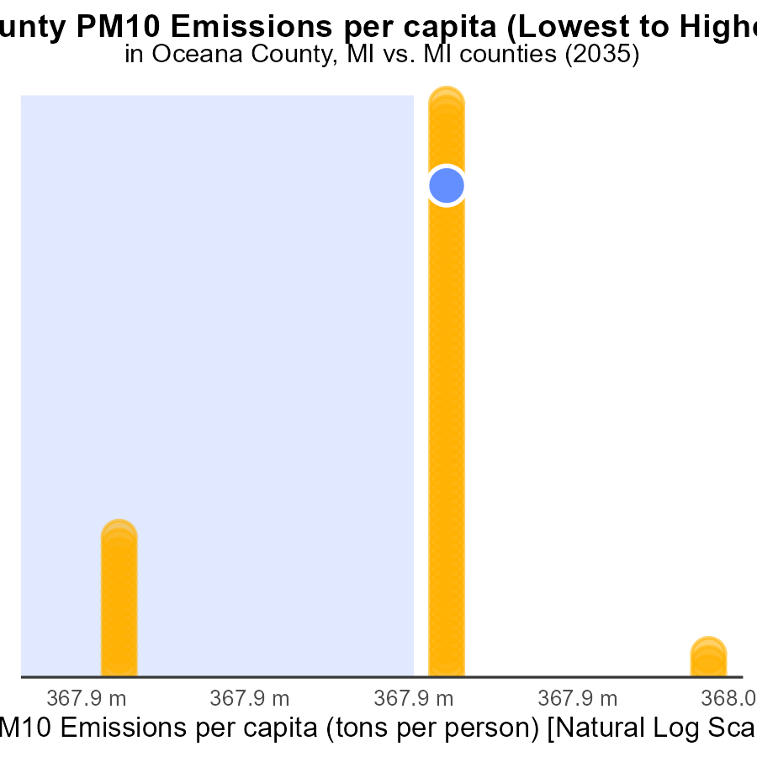

## Findings

* The county with the highest PM10 emissions per capita is Mackinac, with 157.7 tons per person.
* The county with the lowest PM10 emissions per capita is Macomb, with 31.5 tons per person.
* Overall, the counties have high PM10 emissions per capita, with most falling above the 85th percentile.

## Recommendations

To lower PM10 emissions, focus on implementing stricter regulations on industries with high emissions, promoting clean energy use, and improving public transportation to reduce individual vehicle emissions.

# Conclusion

The data from the report on Primary Exhaust PM10 - Total emissions from on-road transportation in Oceana County, MI in 2035 highlights several key insights. The top contributors to PM10 emissions are Wayne, Oakland, and Macomb counties, indicating a concentration of emissions in specific areas. Combo trucks are the primary emitters, emphasizing the need for targeted interventions in the transportation sector.

To address the rising emissions and achieve sustainable reductions, the county should focus on implementing stricter emission controls, promoting cleaner fuel technologies, and encouraging the use of electric vehicles. By targeting high-emission counties and industries, investing in public transport, and enforcing regulations, Oceana County can work towards a significant decrease in PM10 levels. Continuous monitoring and enforcement of emission standards are crucial for maintaining the achieved reductions and ensuring a healthier environment for the residents of Oceana County.

# About This Report

Data based on MOVES estimates collected by the Climate Action in Transportation program at Cornell University. Demographic data sourced from the US Census's American Community Survey 5-year estimates. This report was generated with the help of AI.

# References

* U.S. Census Bureau. (2023). American Community Survey 5-year estimates: Detailed tables. Retrieved from https://data.census.gov
* U.S. Environmental Protection Agency. (2024). Motor Vehicle Emission Simulator (MOVES 4.0) [Software]. Retrieved from https://www.epa.gov/moves