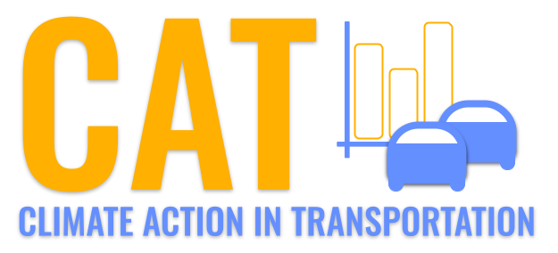 

**VOC Emissions in Chippewa County, 2040**  
Made with CAT VISUALIZER by Gao Labs @ Cornell University.

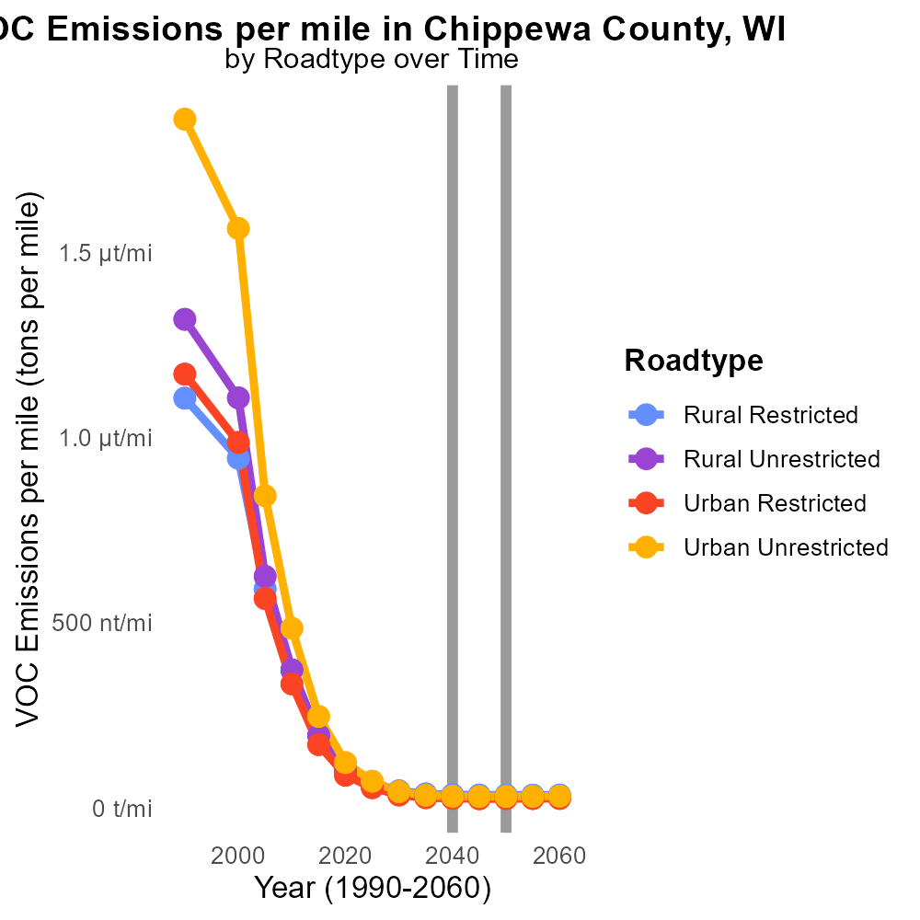

## Keywords

Volatile Organic Compounds; on-road transportation; Chippewa County; emissions; 2040; environmental impact

## Highlights

* Study on VOC emissions from transportation in Chippewa County, WI.
* Projection of emissions in 2040 to assess future environmental impact.
* Focus on on-road transportation and its contribution to VOC levels.
* Exploring potential mitigation strategies for reducing VOC emissions.
* Insights to inform policy decisions for sustainable transportation.

# Introduction

The following report delves into the examination of Volatile Organic Compounds (VOC) emissions stemming from on-road transportation in Chippewa County, Wisconsin, with a specific focus on the projected scenario for the year 2040. As the county continues to experience growth and development, the environmental impact of transportation activities becomes increasingly significant.

By analyzing current emission levels and predicting future trends, this study aims to provide critical insights into the contribution of on-road transportation to VOC concentrations in the region. Additionally, the report will explore potential strategies and solutions that could effectively mitigate these emissions, offering valuable information to policymakers and stakeholders in their efforts to promote sustainable practices in the transportation sector.

# Hotelling (Engines Off) Overall by Area

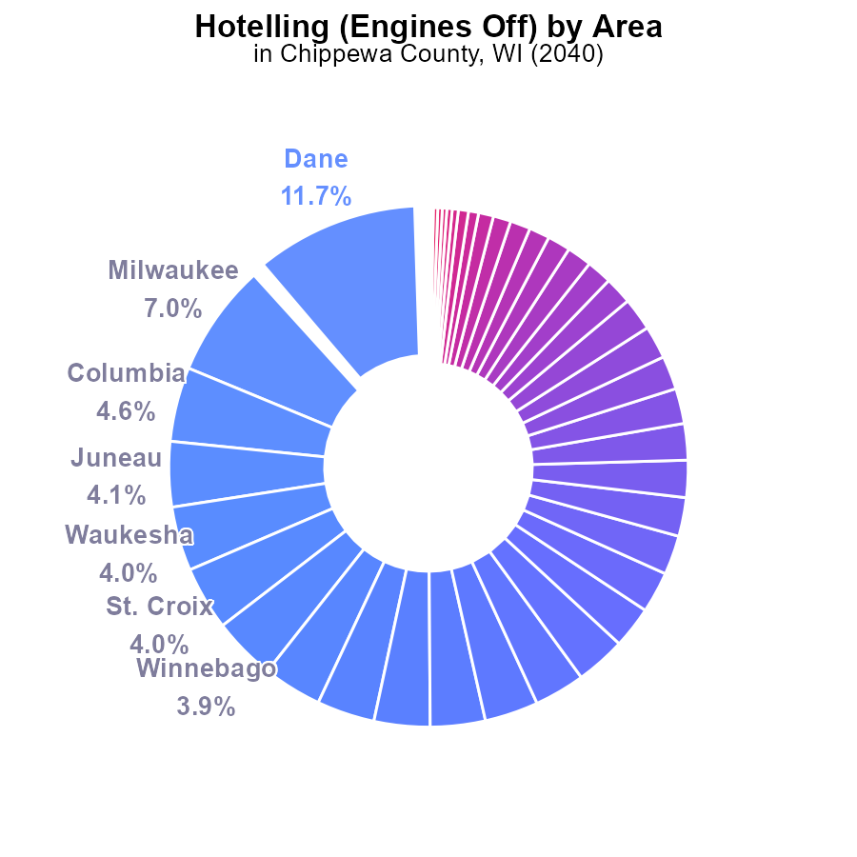

## Findings

* Top 5 counties emit 30.3% of VOCs, with Dane at 11.7%.
* Remaining 71 counties emit only 29.7% altogether.
* 43 counties emit less than 1%.

## Recommendations

Policymakers should focus on reducing emissions in Dane, Milwaukee, Columbia, Juneau, and Waukesha. Encourage other counties to adopt cleaner practices.

# Emissions Rate (per capita) by Fuel Type

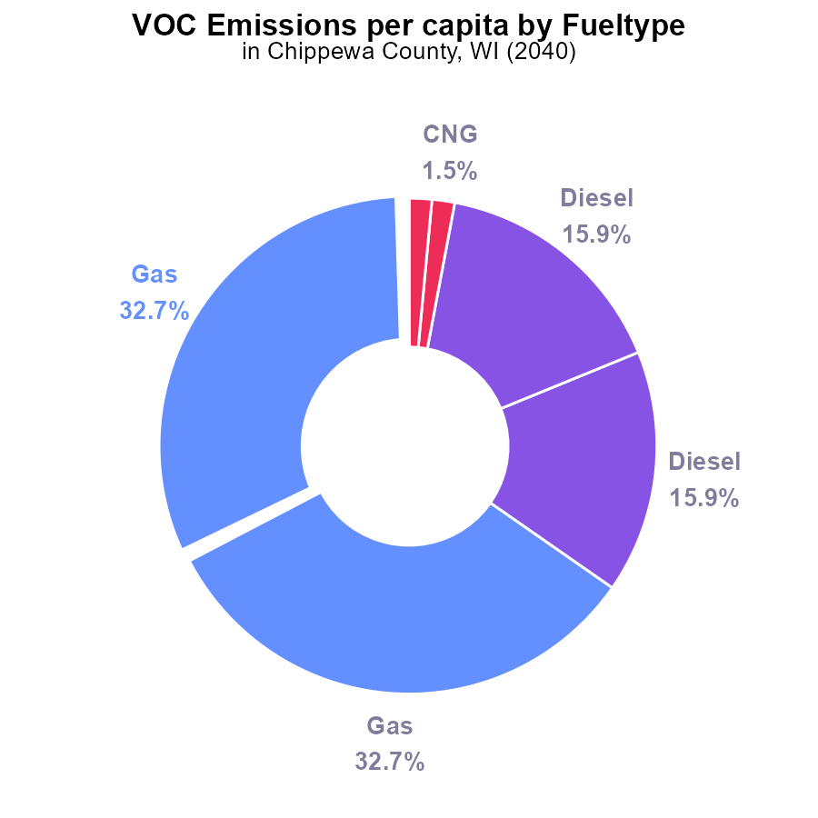

## Findings

* Gasoline contributes the highest amount of VOC emissions per capita with 65.4%.
* Diesel follows as the second-highest contributor with 31.8% of VOC emissions per capita.
* CNG and Ethanol have minimal to zero impact on VOC emissions per capita in Chippewa County.

## Recommendations

To reduce VOC emissions, focus on decreasing gasoline and diesel usage through promoting electric vehicles, enhancing public transportation, and incentivizing car-sharing programs.

# Emissions Rate (per capita) Overall over Time

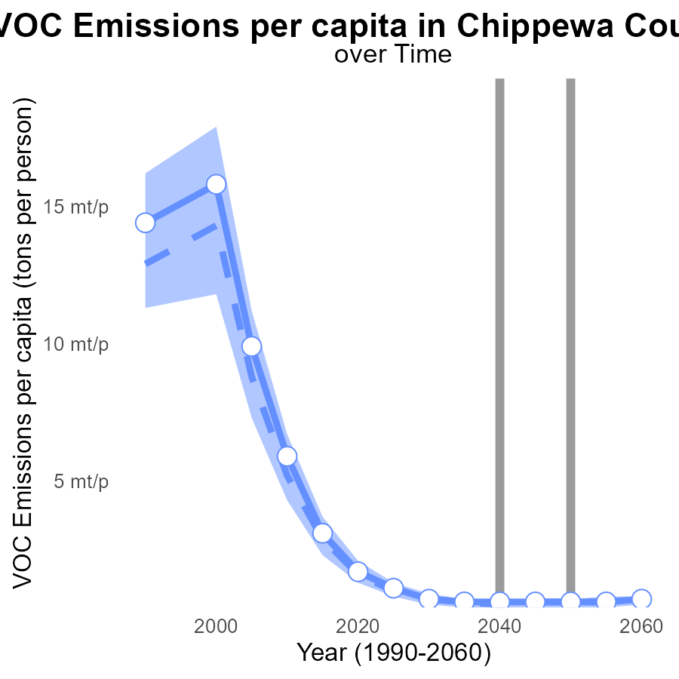

## Findings

* Emissions per capita for VOC in Chippewa County are significantly higher than the median area, increasing from 1.7 tons per person in 2020 to 666.9 μ in 2060.
* The benchmark difference varies over the years, reaching a minimum of -0.0001 in 2060.
* Despite a decreasing trend from 2020 to 2060, Chippewa County's VOC emissions per capita remain above the upper 75% benchmark, showing a need for targeted reduction strategies.

## Recommendations

To lower VOC emissions in Chippewa County, immediate steps should focus on implementing stricter regulations for industries, promoting cleaner production technologies, and incentivizing the adoption of sustainable practices by residents and businesses. Continuous monitoring and assessment of emission sources are vital to track progress effectively and adjust strategies as needed.

# Emissions Rate (per vehicle) over Time for Passenger Vehicles

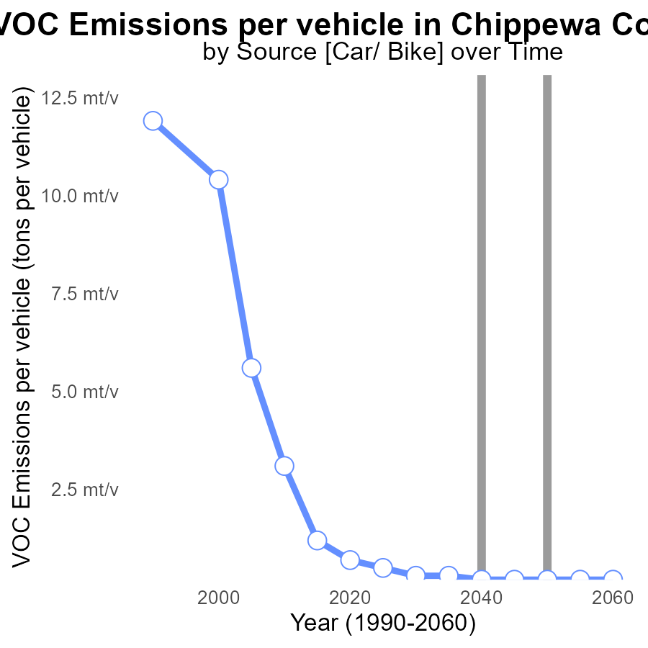

## Findings

* Emissions per vehicle decreased steadily from 685.4 µ tons in 2020 to 242.6 µ tons in 2060.
* The benchmark difference remained stable at around 0e+00 tons per vehicle from 2040 to 2060.
* There was a significant reduction of 442.8 µ tons per vehicle in VOC emissions from 2020 to 2060.

## Recommendations

To further reduce emissions, policies should focus on promoting the adoption of electric vehicles to decrease VOC emissions. In addition, implementing stricter vehicle emission standards can help maintain the achieved reductions.

# Vehicles Mapped by Area

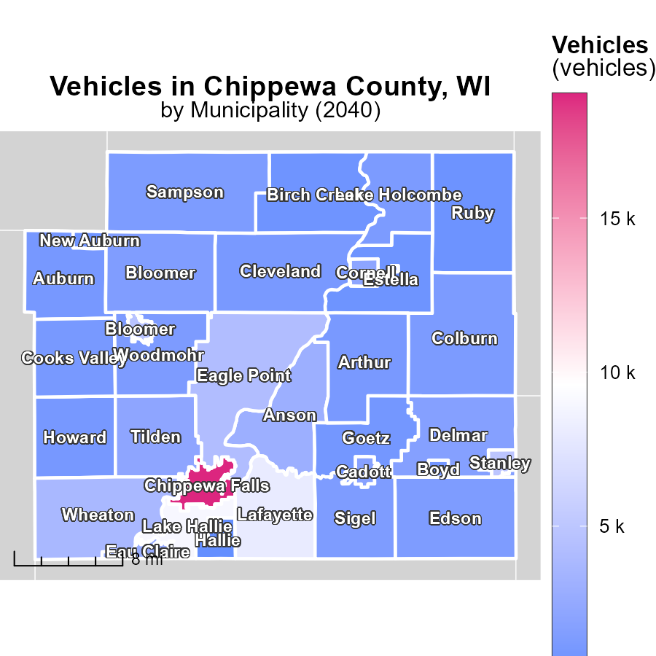

## Findings

* Chippewa Falls, WI emitted 19.0 k tons of vehicle emissions in 2040.
* Edson, WI's vehicle emissions totaled 1.3 k tons, the median value in 2040.
* Hallie, WI had the lowest vehicle emissions at 172.9 tons in 2040.

## Recommendations

To reduce vehicle emissions, focus on implementing sustainable transportation policies in Chippewa Falls, WI, incentivize eco-friendly vehicles in Edson, WI, and support public transport initiatives in Hallie, WI.

# Emissions Rate (per mile) Mapped by Area

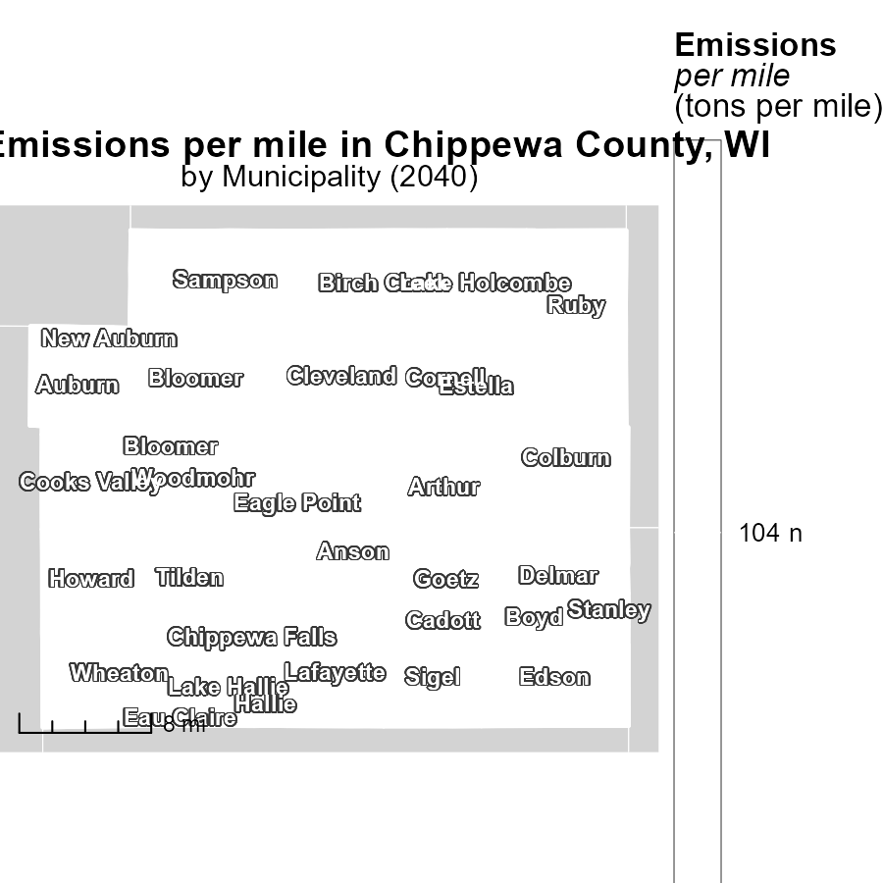

## Findings

* Anson, WI has the highest emissions per mile at 104.1 tons per mile.
* Eau Claire, WI has a median emissions rate of 104.1 tons per mile.
* Woodmohr, WI has the lowest emissions per mile at 104.1 tons per mile.

## Recommendations

To lower emissions, focus on improving fuel efficiency and promoting the use of electric vehicles in Anson, Eau Claire, and Woodmohr, WI. Implement stricter emissions standards for vehicles.

# Emissions Rate (per mile) by Road Type over Time

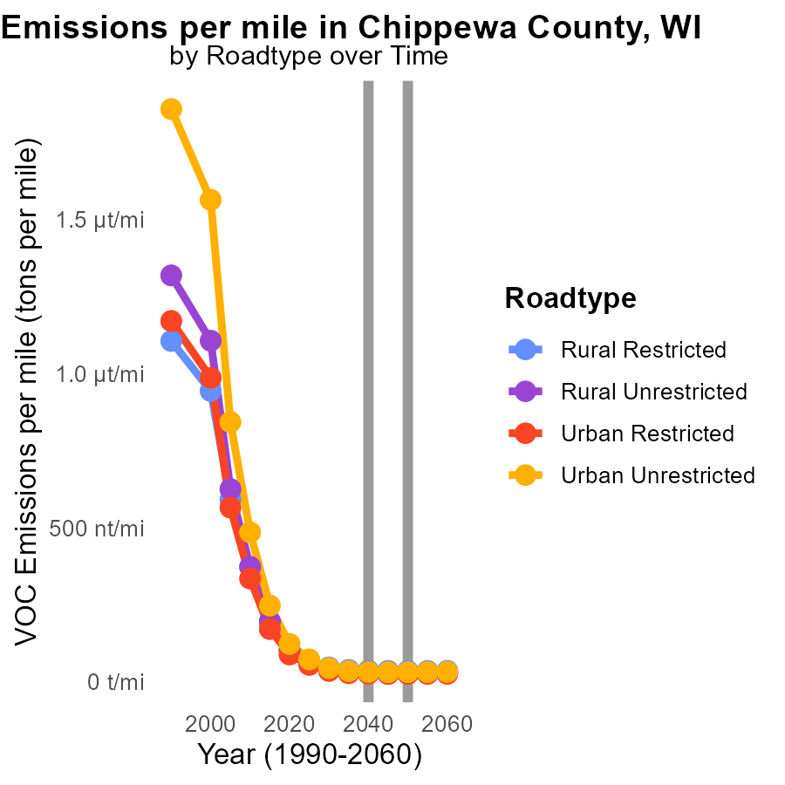

## Findings

* Emissions in Chippewa County are decreasing across different road types by 2030-2050.
* The highest emissions per mile are in Rural Restricted areas, with a decrease to 35.2 tons per mile by 2050.
* Urban Unrestricted areas show a decrease from 44.3 tons per mile in 2030 to 31.4 tons per mile by 2050.

## Recommendations

To further reduce emissions in Chippewa County, focus on implementing stricter emissions standards for vehicles, promoting public transportation, and encouraging carpooling to lower the emissions levels indicated in the data.

# Vehicles by Fuel Type over Time

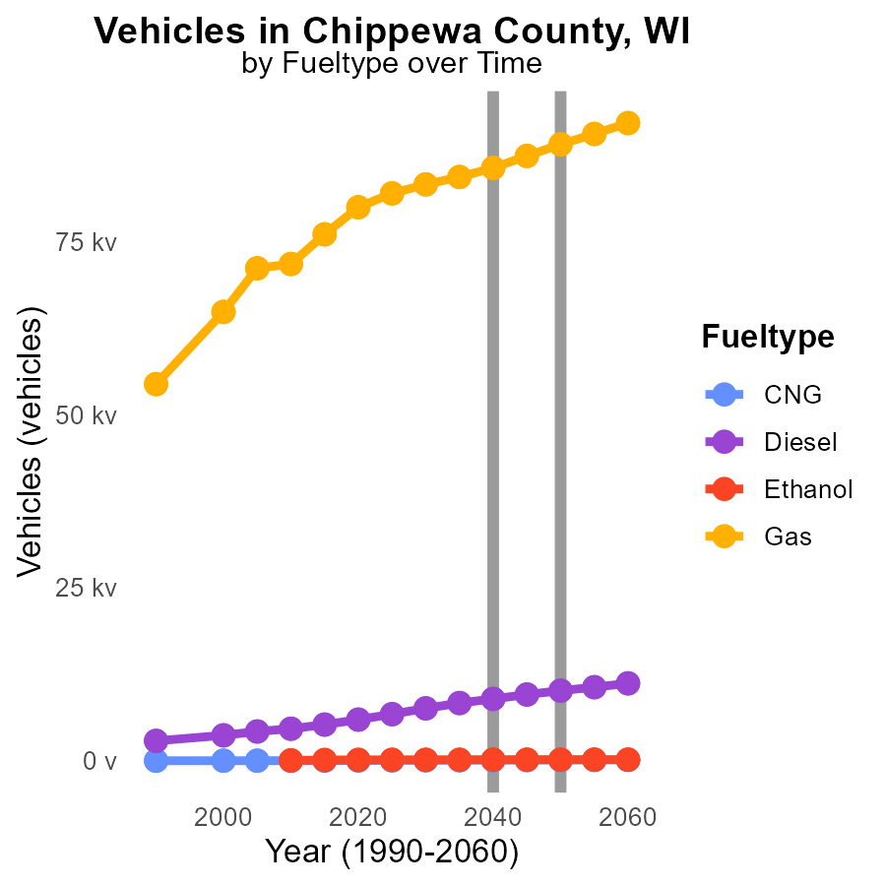

## Findings

* By 2050, CNG vehicles are projected to increase by 59.6%, while diesel is projected to decrease by 2555 vehicles.
* Ethanol usage is forecasted to have a minor increase of 13.1% by 2050.
* Gas vehicles are expected to rise by 5784.5 vehicles by 2030 and then decrease to 0 by 2050.

## Recommendations

To lower emissions, focus on incentivizing the switch to CNG vehicles to capitalize on the significant decrease in diesel usage. Implement policies promoting sustainable fuel sources like ethanol. Eventually phase out gas vehicles.

# Areas Ranked by Emissions

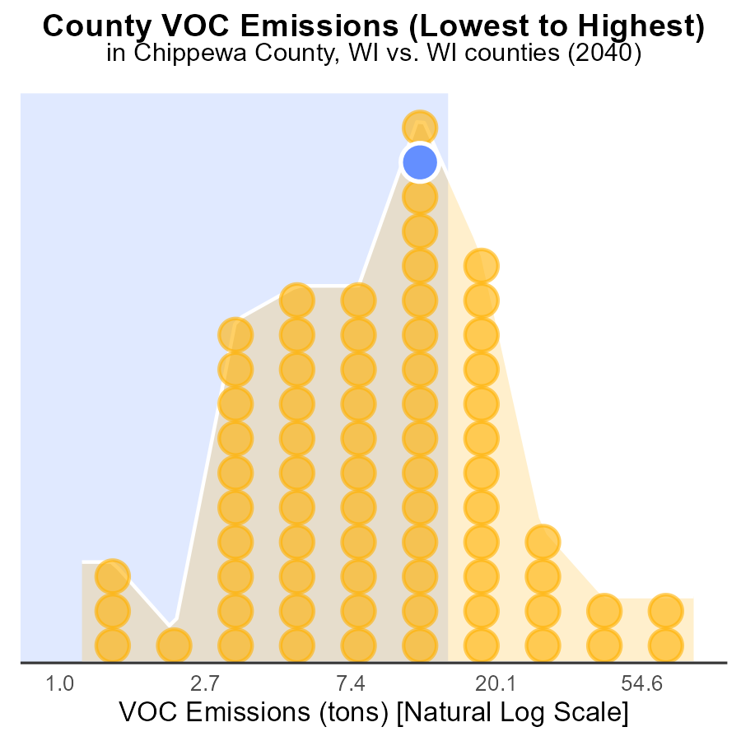

## Findings

* Dane County has the highest VOC emissions with 210.0 tons in 2040.
* Menominee County has the lowest VOC emissions with 2.1 tons in 2040, ranking 1st.
* Chippewa, Monroe, and Sauk counties have similar VOC emissions ranging from 35.1 to 37.5 tons.

## Recommendations

To lower VOC emissions, focus on Dane County as it has the highest emissions. Implement stricter emission control measures in industrial areas. Provide incentives for transitioning to cleaner technologies.

# Areas Ranked by Emissions Rate (per vehicle)

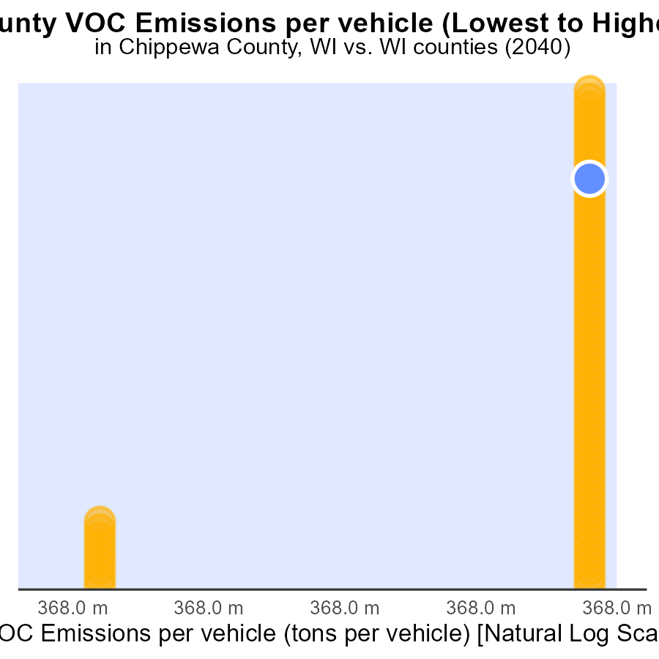

## Findings

* Milwaukee has the lowest VOC emissions per vehicle at 270.5 tons per vehicle.
* Juneau County ranks highest in VOC emissions per vehicle at 445.5 tons per vehicle.
* Chippewa, Fond du Lac, and Rock counties have similar VOC emissions per vehicle ranging from 393.2 to 395.5 tons per vehicle.

## Recommendations

To lower VOC emissions per vehicle, focus on improving vehicle efficiency, promoting electric vehicles, and implementing stricter emission standards in Chippewa, Fond du Lac, Rock, and Juneau counties. Provide incentives for cleaner transportation options.

# Conclusion

In conclusion, the data on Volatile Organic Compounds (VOC) emissions from on-road transportation in Chippewa County, WI in 2040 provides valuable insights into the current situation and future prospects. The analysis indicates that a significant portion of VOC emissions is concentrated in the top five counties, with Dane County being the largest contributor. Policymakers are advised to focus on reducing emissions in these counties and promoting cleaner practices in others to achieve a tangible decrease in overall emissions.

Moreover, the data highlights the importance of addressing gasoline and diesel usage, which are the primary sources of VOC emissions per capita. Strategies to reduce emissions should prioritize the promotion of electric vehicles, enhanced public transportation, and incentives for car-sharing programs. Additionally, continuous monitoring, stricter regulations for industries, and the adoption of sustainable practices are essential for achieving targeted reduction goals. By implementing these measures, Chippewa County can work towards significantly decreasing VOC emissions and improving air quality for its residents.

# About This Report

Data based on MOVES estimates collected by the Climate Action in Transportation program at Cornell University. Demographic data sourced from the US Census's American Community Survey 5-year estimates. This report was generated with the help of AI.

# References

* U.S. Census Bureau. (2023). American Community Survey 5-year estimates: Detailed tables. Retrieved from https://data.census.gov
* U.S. Environmental Protection Agency. (2024). Motor Vehicle Emission Simulator (MOVES 4.0) [Software]. Retrieved from https://www.epa.gov/moves