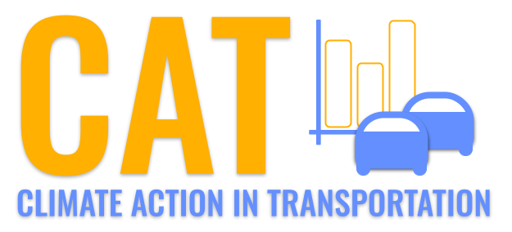 

**SO2 Emissions in Dubois County, 2030**  
Made with CAT VISUALIZER by Gao Labs @ Cornell University.

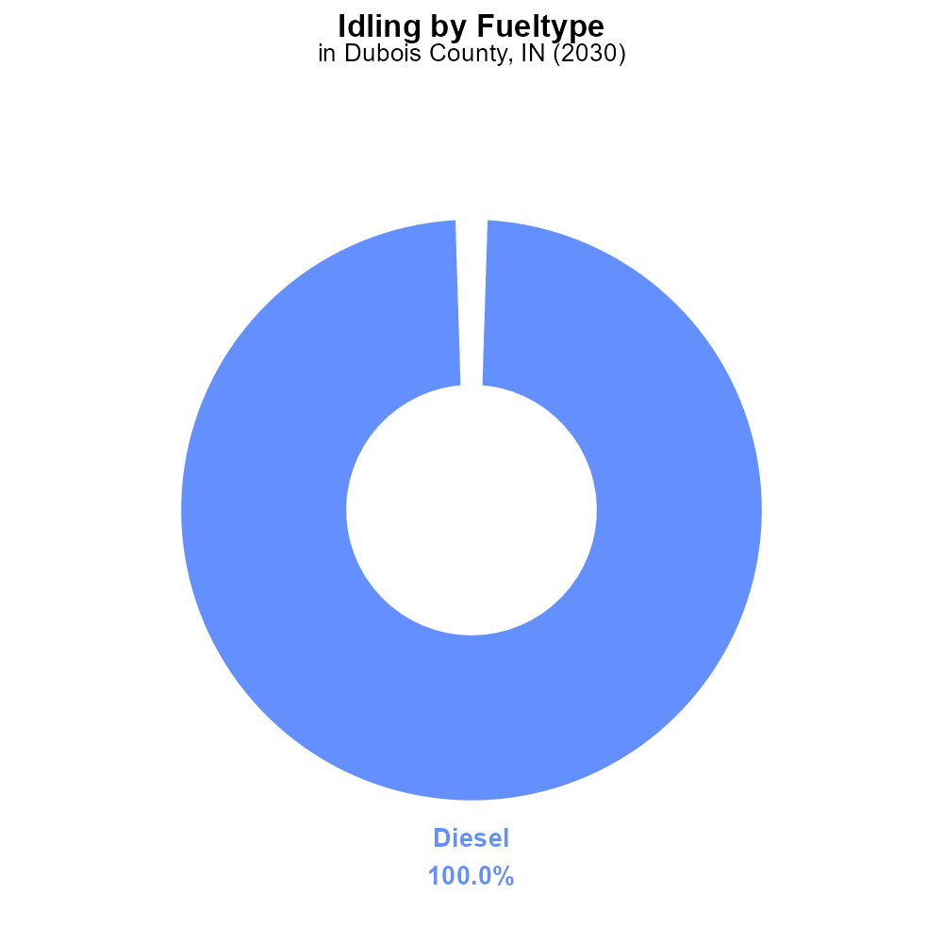

## Keywords

Sulfur Dioxides emissions; on-road transportation; Dubois County; IN; 2030

## Highlights

* SO2 emissions from transportation in Dubois County in 2030.
* Impacts of on-road transportation on air quality and health.
* Potential measures to reduce SO2 emissions in the future.

# Introduction

Sulfur Dioxide (SO2) emissions from on-road transportation have become a growing concern in Dubois County, Indiana. As the county's population grows and economic activities increase, so does the number of vehicles on the road, contributing to the release of harmful pollutants. It is projected that by the year 2030, the levels of SO2 emissions from transportation sources will have significant implications for air quality and public health in the region.

This report aims to analyze the current state of SO2 emissions from on-road transportation in Dubois County, assess the potential impacts on air quality and health, and propose strategies and policies to mitigate these emissions in the future. By understanding the sources and impacts of SO2 emissions from on-road transportation, stakeholders can work towards creating a cleaner and healthier environment for the residents of Dubois County.

# Idling by Fuel Type

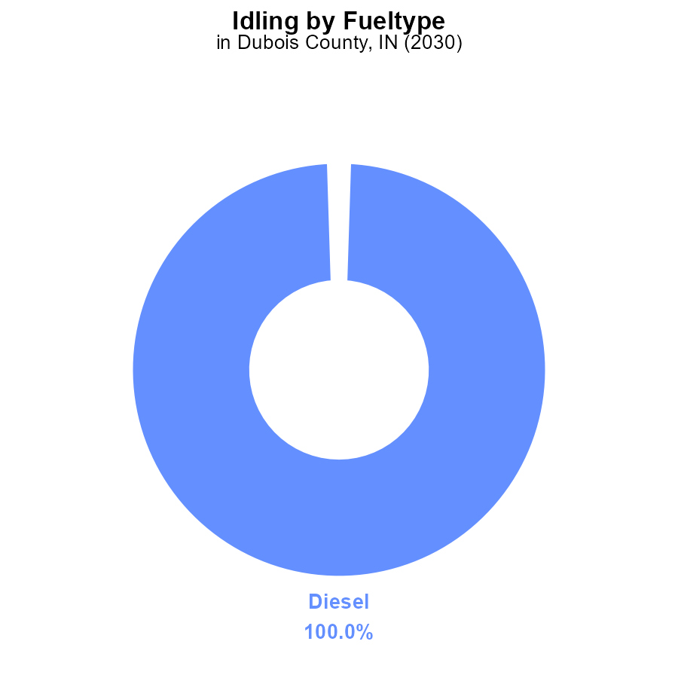

## Findings

* Diesel idling emissions in Dubois County, IN in 2030 were 13.7 kilograms of SO2 per hour, accounting for 100% of SO2 emissions from idling.

## Recommendations

To lower SO2 emissions from idling in Dubois County, IN, policymakers should focus on reducing idling time for diesel vehicles through implementing anti-idling campaigns and regulations in place.

# Idling by Regulatory Class

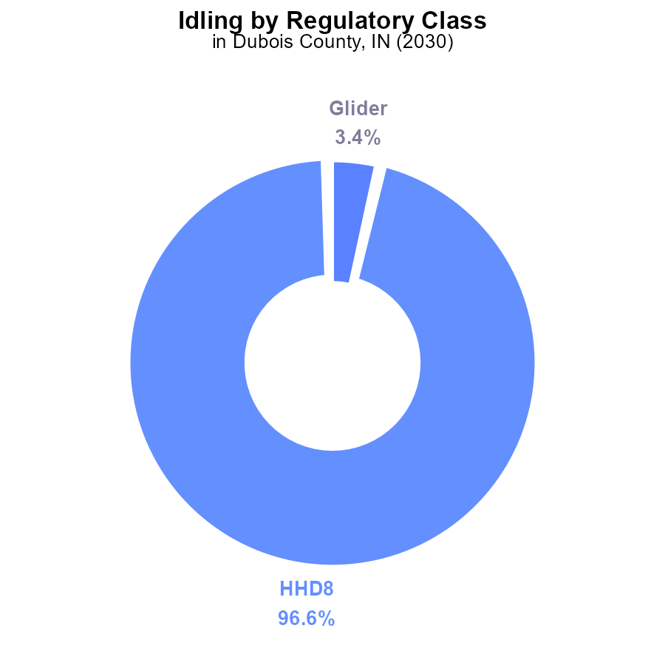

## Findings

* HHD8 emissions contribute to 96.6% of SO2 emissions from idling in Dubois County in 2030.
* Glider emissions only account for 3.4% of SO2 emissions from idling.
* Other vehicle types like MHD67, LDT, LDV, LHD34, LHD45, MC, and Urban Bus do not contribute to SO2 emissions from idling.

## Recommendations

To lower SO2 emissions, focus on reducing idling time for HHD8 vehicles. Consider implementing idling reduction policies or promoting technology that decreases idling in this vehicle category.

# Time Driven over Time for Buses

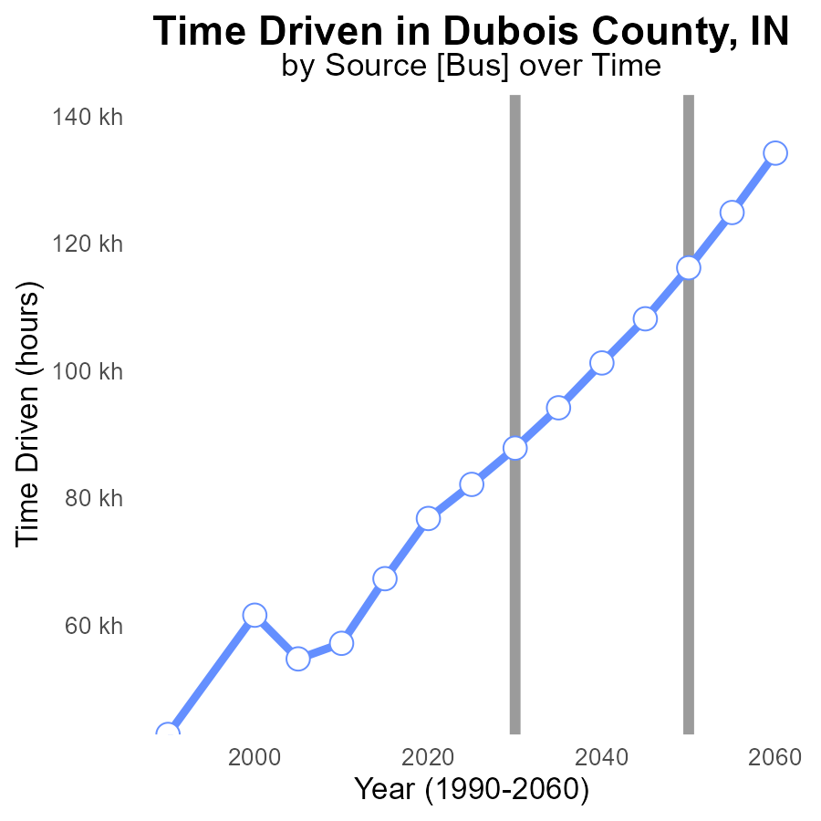

# Emissions Rate (per capita) Overall over Time

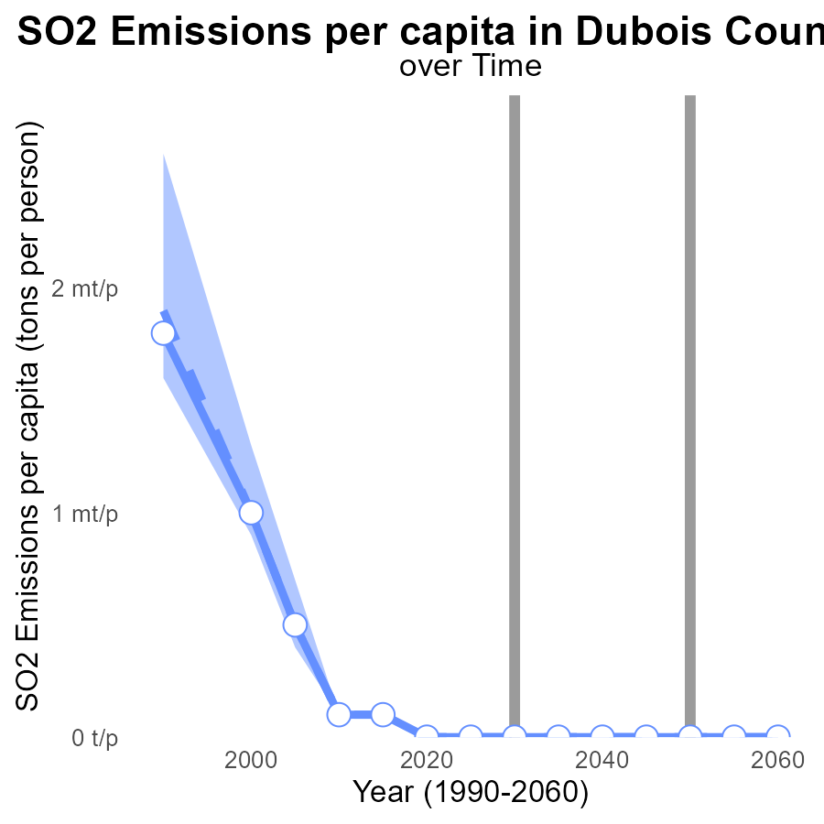

## Findings

* SO2 emissions per capita in Dubois County were significantly higher than the median area, but have steadily decreased over the years.
* In 2050, emissions per capita are projected to be below the median area for the first time.
* There is a notable benchmark difference highlighting the progress made in reducing SO2 emissions.

## Recommendations

To further lower SO2 emissions in Dubois County, continue investing in cleaner technologies and transitioning to renewable energy sources. Implement stricter regulations on industries contributing to SO2 emissions.

# Idling in My Region

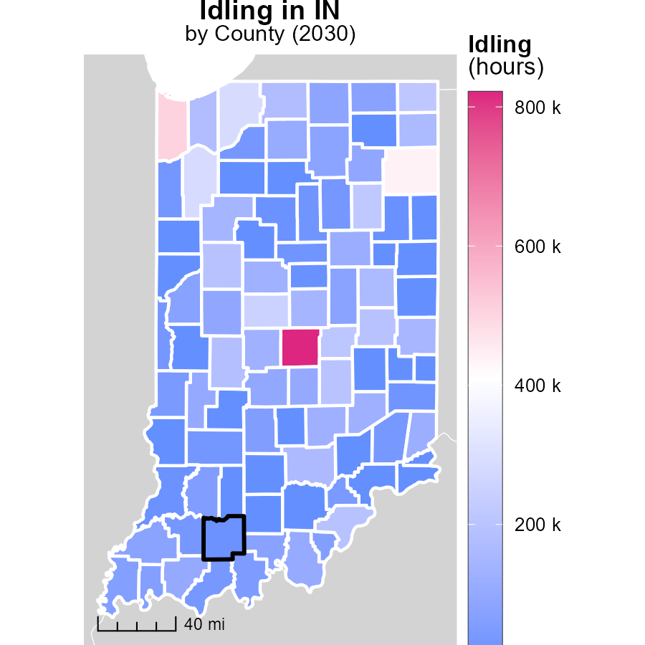

## Findings

* Marion County, IN has the highest idling hours at 821.1k, accounting for 92.9% of the total idling hours.
* Floyd County, IN has a median idling hours of 60.0k, representing 6.8% of the total idling hours.
* Washington County, IN has the lowest idling hours at 0.0, making up 0.0% of the total idling hours.

## Recommendations

To lower emissions, Marion County should implement idling reduction campaigns for vehicles, Floyd County can set idling limits, and Washington County can promote alternatives to idling like shut-off programs.

# Vehicle Miles Traveled in My Region

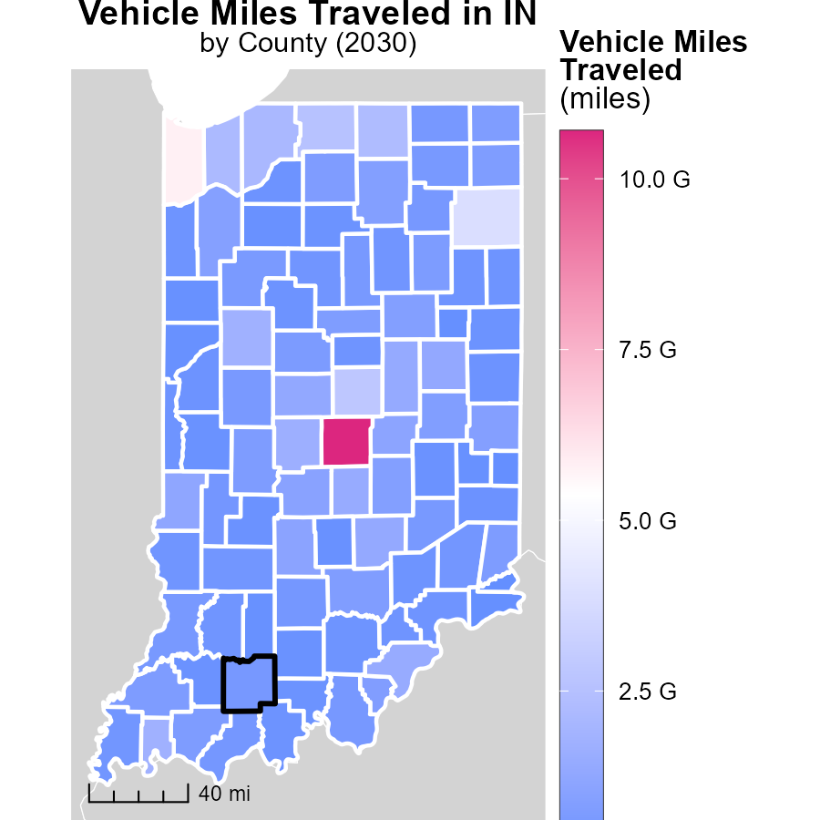

## Findings

* Marion County, IN has the highest vehicle miles traveled (10.7 billion miles).
* Whitley County, IN has a median of 528.7 million miles traveled.
* Ohio County, IN has the lowest vehicle miles traveled at 58.2 million miles.

## Recommendations

To lower emissions, incentivize public transportation in Marion County, invest in infrastructure for walking and biking in Whitley County, and promote carpooling in Ohio County.

# Vehicle Starts by Fuel Type over Time

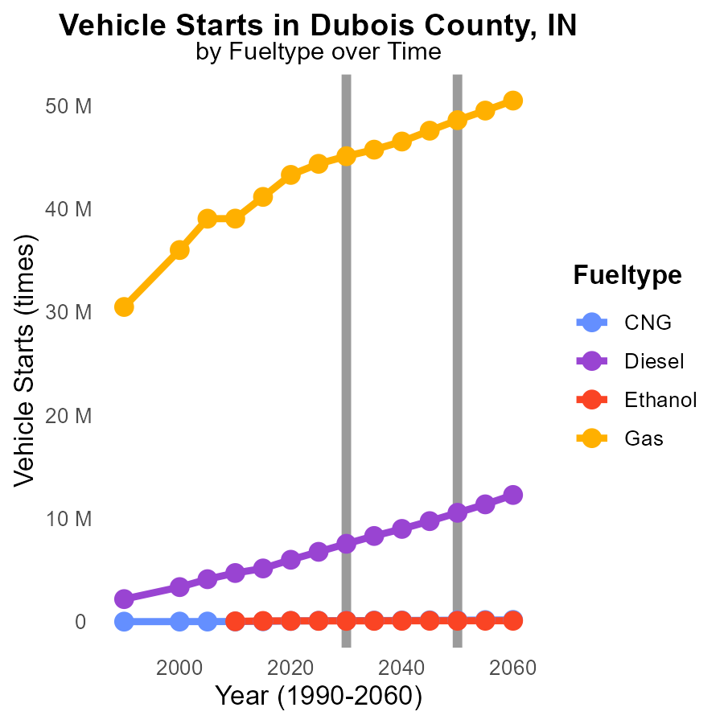

## Findings

* Diesel fuel type shows the highest emissions throughout 2020-2040.
* CNG emissions decrease by 67.99% from 2020 to 2040.
* Gasoline (Gas) emissions decrease by 60.99% from 2020 to 2040.

## Recommendations

To lower emissions, policymakers should prioritize transitioning vehicles from diesel to CNG or Gas. Encouraging the use of CNG vehicles can lead to a significant reduction in emissions by 2040. Additionally, promoting the adoption of electric vehicles can further decrease emissions in the long term.

# Emissions by Vehicle Type over Time

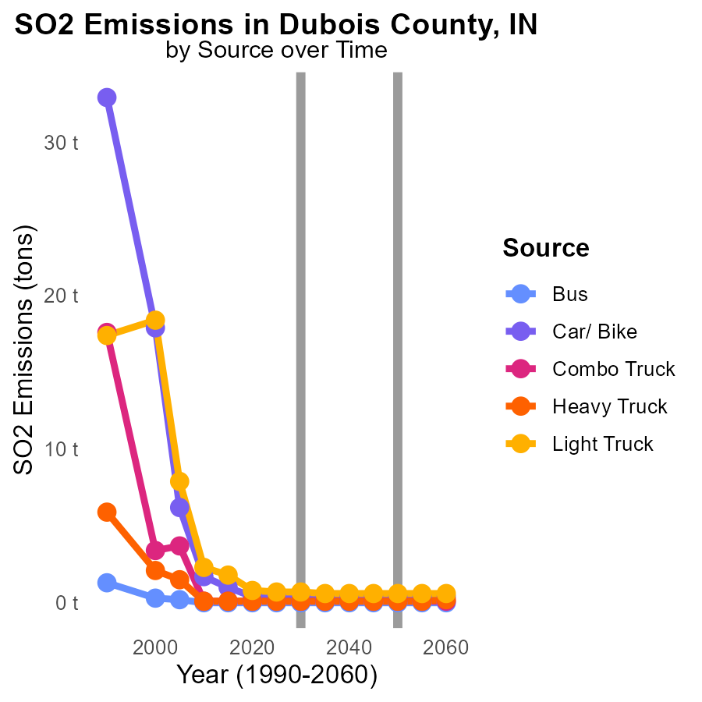

## Findings

* Car/ Bike emissions remain constant at 400.0 tons from 2020 to 2040.
* Light Truck emissions decrease from 800.0 tons in 2020 to 600.0 tons in 2040.
* Combo, Heavy, and Light Trucks exhibit constant emissions from 2020 to 2040.

## Recommendations

To reduce emissions, focus on promoting alternatives to car and bike transportation, and implement vehicle emission standards for light trucks.

# Areas Ranked by Emissions

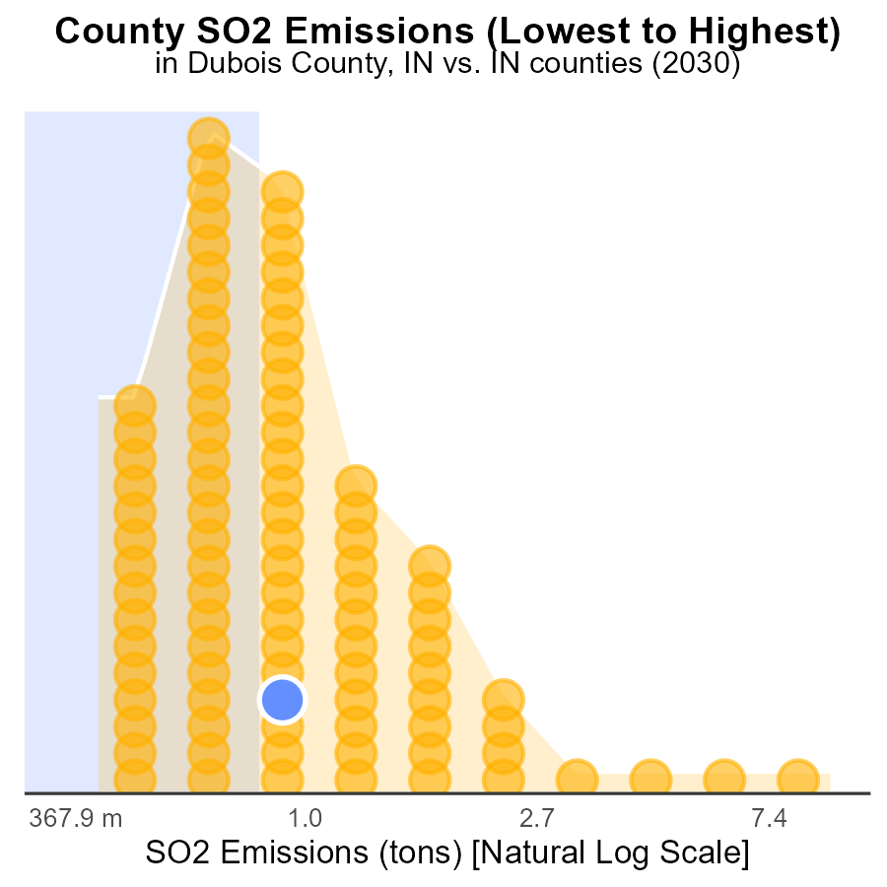

## Findings

* Marion county has the highest SO2 emissions in 2030 at 25.2 tons.
* Ohio county ranks 1st in emissions, contributing 100.0 tons of SO2.
* Most counties have low SO2 emissions, with 48.9% percentile being common.

## Recommendations

To lower emissions, focus on reducing industrial activities in Marion and Ohio counties, invest in cleaner technologies, and promote energy efficiency in highly emitting sectors.

# Areas Ranked by Emissions Rate (per capita)

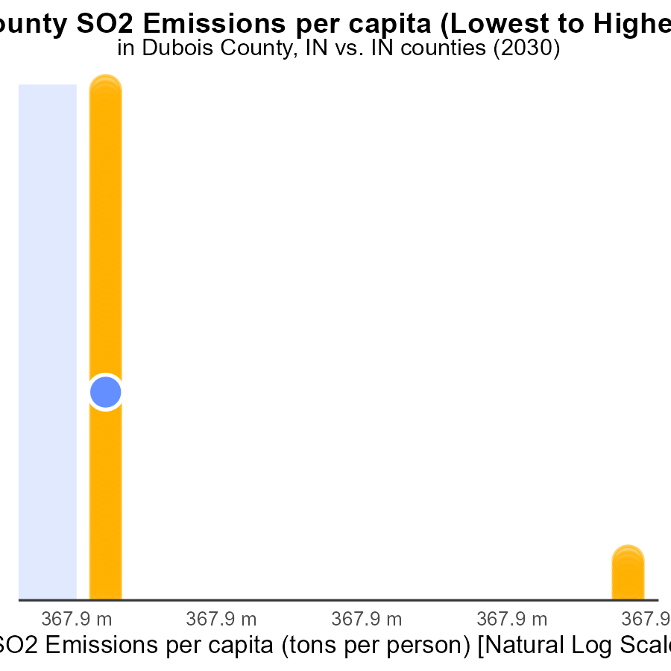

## Findings

* Jasper County has the highest SO2 emissions per capita at 68.8 tons per person.
* Blackford County has the lowest SO2 emissions per capita at 16.8 tons per person.
* Overall, there is a wide range of SO2 emissions per capita among the counties, with a difference of 51.9 tons per person between the highest and lowest.

## Recommendations

To reduce SO2 emissions, targeted efforts need to be made in Jasper County to significantly lower their emissions. Blackford County should share best practices with other counties to help them achieve lower emission levels. Implementing stricter regulations and incentivizing cleaner technologies across all counties would further decrease emissions and create a more equitable distribution.

# About This Report

Data based on MOVES estimates collected by the Climate Action in Transportation program at Cornell University. Demographic data sourced from the US Census's American Community Survey 5-year estimates. This report was generated with the help of AI.

# References

* U.S. Census Bureau. (2023). American Community Survey 5-year estimates: Detailed tables. Retrieved from https://data.census.gov
* U.S. Environmental Protection Agency. (2024). Motor Vehicle Emission Simulator (MOVES 4.0) [Software]. Retrieved from https://www.epa.gov/moves