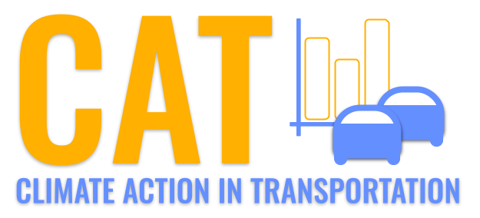 

**NOx Emissions in Bristol city, Virginia County, 2045**  
Made with CAT VISUALIZER by Gao Labs @ Cornell University.

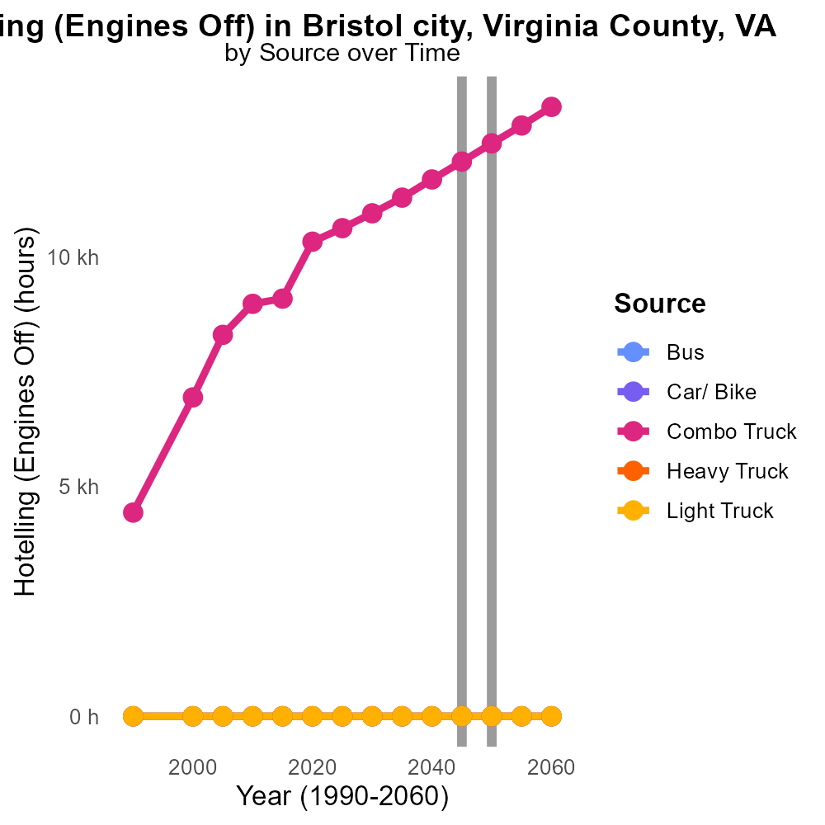

## Keywords

NOx emissions; on-road transportation; Bristol city; Virginia County; 2045; impact

## Highlights

* NOx emissions from on-road transportation in Bristol city, VA in 2045 are a significant concern.
* Understanding the sources and effects of NOx emissions is crucial for sustainable urban planning.
* Measuring the levels of NOx can help assess the air quality and public health impacts.
* Strategies to reduce NOx emissions from on-road transportation are imperative for a cleaner environment.
* The findings of this report will provide valuable insights for policymakers and stakeholders.

# Introduction

Oxides of Nitrogen (NOx) emissions from on-road transportation in Bristol city, Virginia County, VA in 2045 have become a focal point of environmental concern. As urban areas continue to grapple with air pollution, the impact of NOx emissions on public health and the environment cannot be overstated. The city of Bristol, situated in Virginia County, faces unique challenges in managing and mitigating these emissions due to its transportation infrastructure and population density.

This report aims to delve into the sources, levels, and implications of NOx emissions in Bristol city in 2045, offering a comprehensive analysis of the current scenario and projecting future trends. By examining the data on NOx emissions from on-road transportation, the report seeks to provide actionable insights for policymakers, urban planners, and stakeholders to formulate effective strategies for reducing emissions and fostering a cleaner, healthier urban environment.

# Vehicles by Vehicle Type

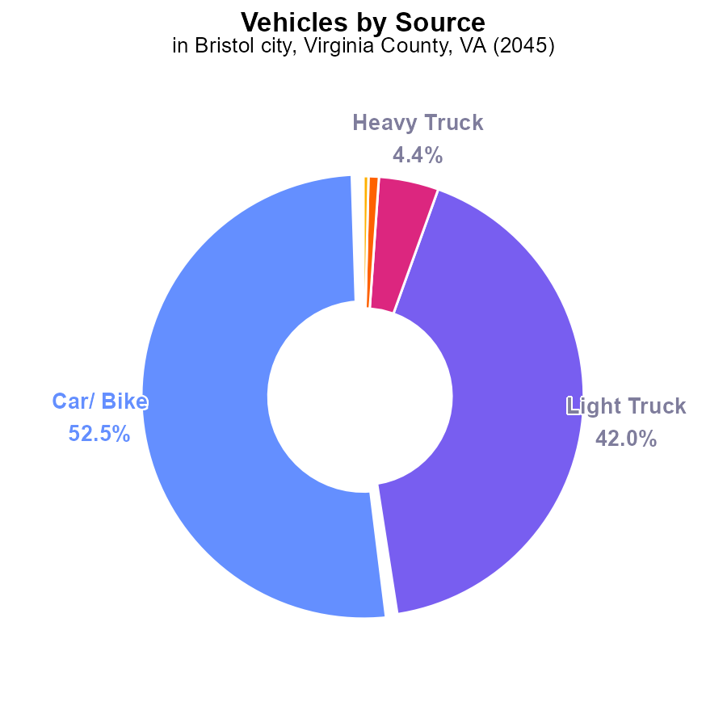

## Findings

* Vehicles in Bristol city, VA contribute the most to NOx emissions at 99.7%
* Light trucks make up the majority of vehicle emissions at 42.0%
* Buses have a smaller but still notable contribution to NOx emissions at 0.4%

## Recommendations

To lower NOx emissions in Bristol city, VA, focus on reducing vehicle emissions, particularly from light trucks. Introducing stricter emission standards for these vehicles can help significantly decrease NOx levels.

# Hotelling (Diesel Aux) by Regulatory Class

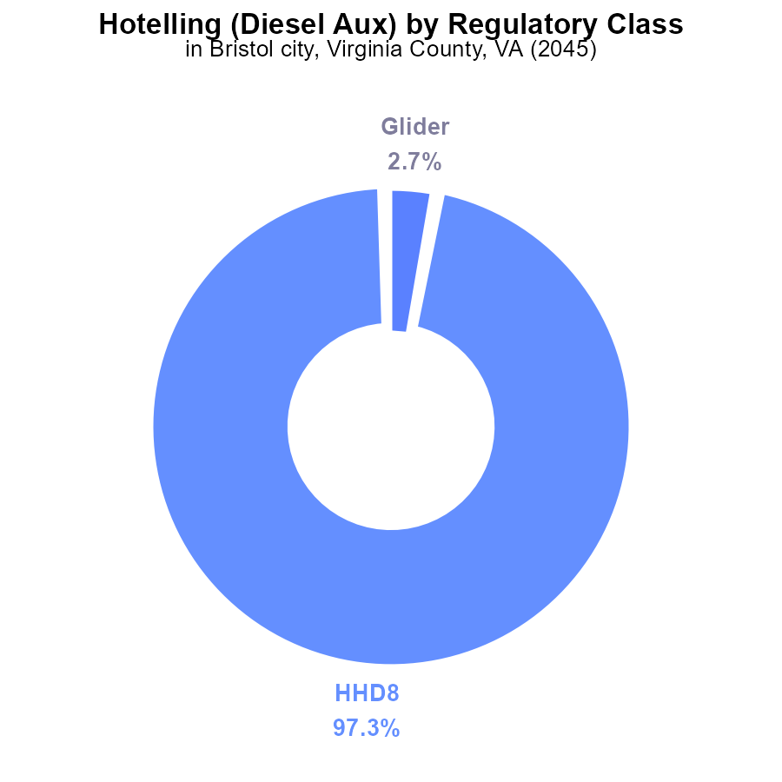

## Findings

* The Hotelling (Diesel Aux) equipment emitted 97.3% of NOx in Bristol, VA in 2045.
* Glider contributed 2.7% of the total NOx emissions in the area.
* Other vehicle types did not contribute to NOx emissions in 2045 in Bristol, VA.

## Recommendations

To reduce NOx emissions in Bristol, VA, focus on reducing emissions from Hotelling (Diesel Aux) equipment, which is the primary contributor. Consider stricter emission standards or transitioning to cleaner fuel alternatives. Additionally, continue monitoring and regulating NOx emissions from Glider vehicles to maintain overall air quality.

# Emissions over Time for Passenger Vehicles

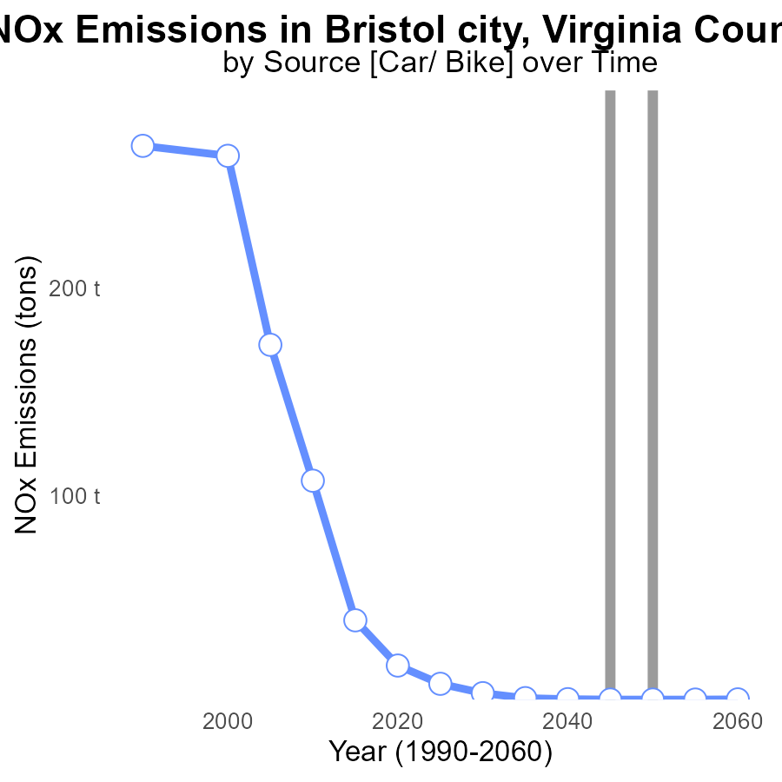

## Findings

* NOx emissions in Bristol city, VA have decreased steadily from 9.4 tons in 2025 to 1.9 tons in 2060.
* By 2045, emissions reached a benchmark of 1.8 tons, staying at the same level until 2060.
* The area has consistently met emission reduction benchmarks, with a total reduction of 7.6 tons from 2025 to 2060.

## Recommendations

To further lower NOx emissions, continue investing in clean energy sources, promote public transportation, and enforce stricter emission standards for industries and vehicles in Bristol city, VA.

# Hotelling (Engines Off) Overall over Time

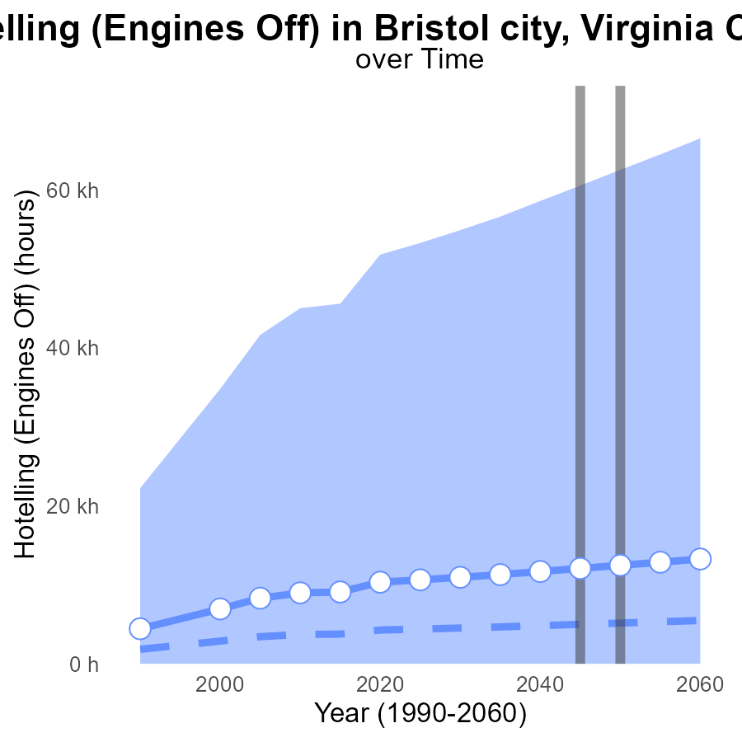

## Findings

* NOx emissions in Bristol city, VA are projected to increase steadily over the next 35 years.
* The median NOx emissions level is significantly lower than the emissions in Bristol city in all projected years.
* Benchmark differences show a consistent increase, indicating that Bristol city's emissions are above the benchmark levels.

## Recommendations

To lower NOx emissions, policies should focus on implementing stricter regulations on emissions from engines, particularly when idling in hotelling zones. Additionally, promoting the use of cleaner fuel sources or electric vehicles can significantly decrease emissions levels over time.

# Population Mapped by Area

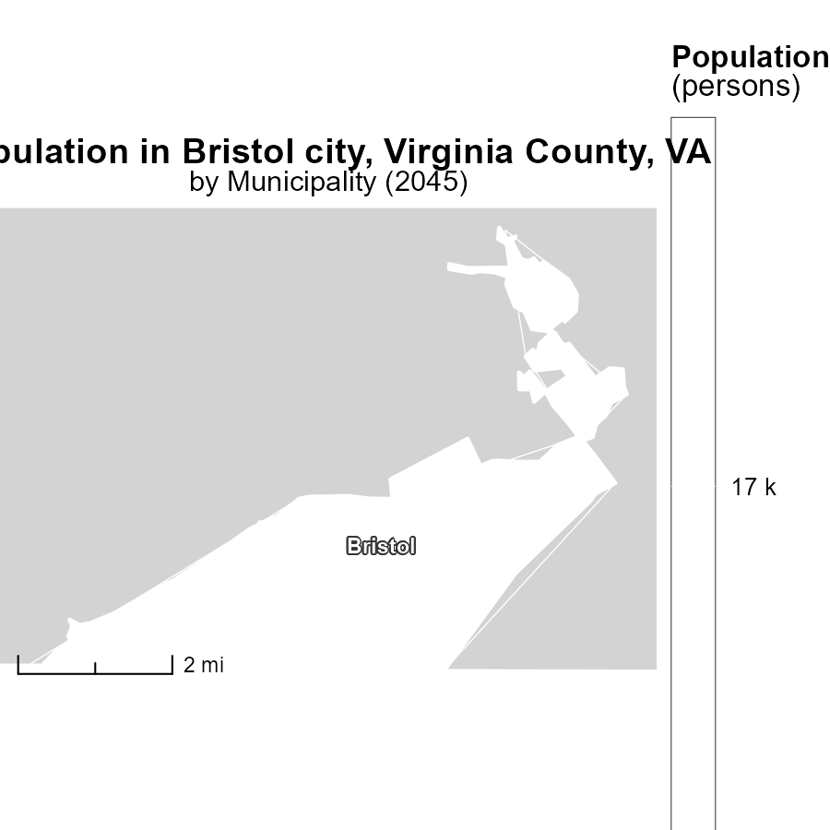

## Findings

* Bristol, VA has a population of 17.1k in 2045.

## Recommendations

To decrease emissions, focus on optimizing transportation methods, increasing green energy sources, and implementing stricter emission regulations in Bristol, VA.

# Emissions Rate (per mile) Mapped by Area

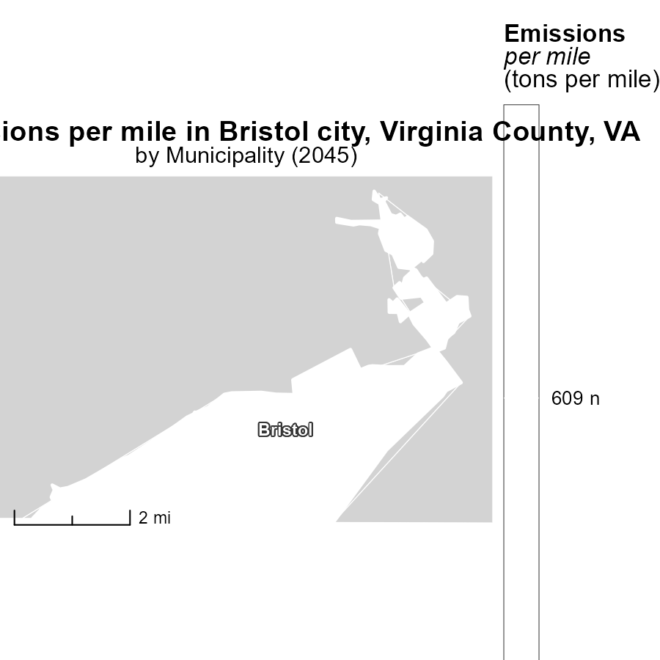

## Findings

* Bristol, VA has a median emission rate of 609.3 tons per mile in 2045.

## Recommendations

To lower emissions in Bristol, VA, measures such as promoting public transportation, incentivizing electric vehicles, and implementing stricter emission standards for vehicles should be considered.

# Emissions Rate (per vehicle) by Road Type over Time

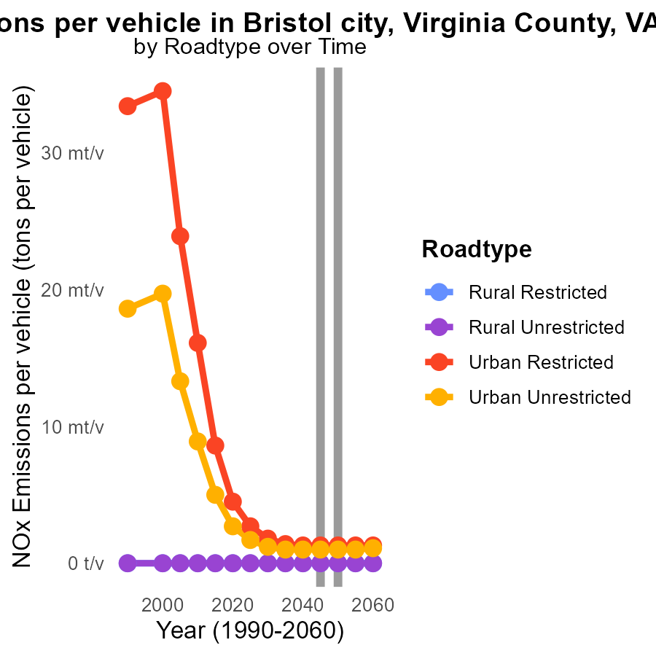

## Findings

* NOx emissions for Rural areas are consistently 0.0 tons per vehicle from 2035 to 2055.
* Urban Restricted areas show a slight decrease in NOx emissions per vehicle, from 1.4 to 1.3 tons, between 2035 and 2040.
* Urban Unrestricted areas have NOx emissions per vehicle ranging from 964.6 µ to 1.0 m tons, with no significant change from 2040 to 2055.

## Recommendations

To further reduce NOx emissions, focus on improving vehicle technology and promoting the use of electric vehicles, especially in urban areas. Implement strict emission standards for vehicles.

# Hotelling (Engines Off) by Vehicle Type over Time

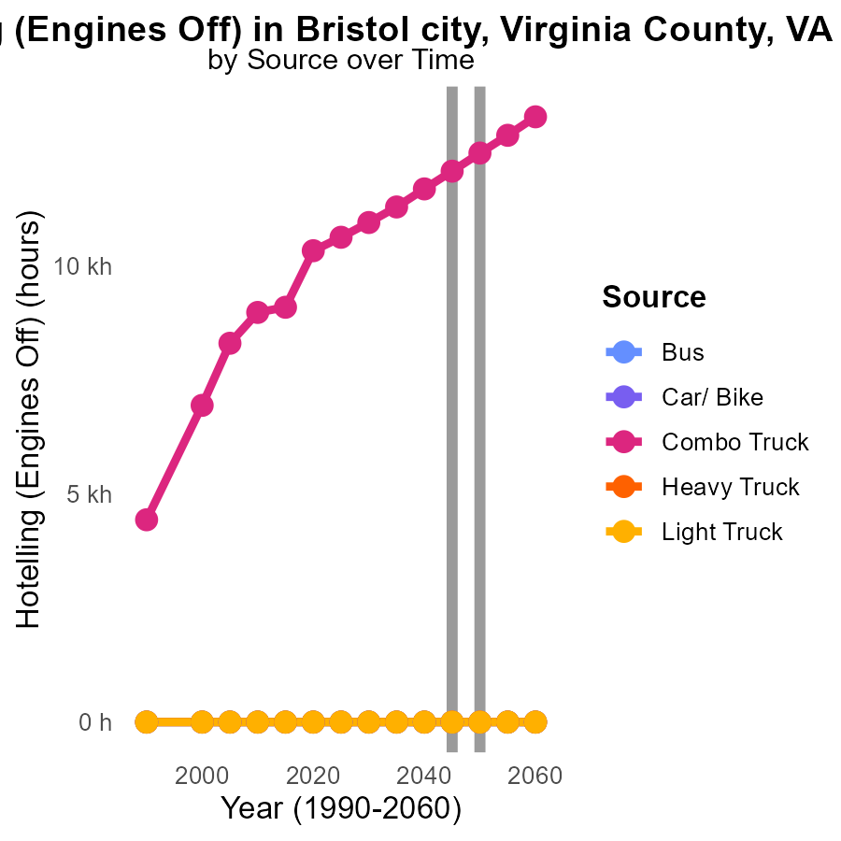

## Findings

* Combo trucks show a decrease in NOx emissions from 11.3 k in 2035 to 12.9 k in 2055.
* Bus, Car/Bike, Heavy Truck, and Light Truck emissions remain consistently at 0.0 throughout 2035-2055.
* By 2050, Combo Truck emissions are reduced to the 0.0 level achieved by other vehicle types.

## Recommendations

To further decrease emissions, focus on strategies that led to the reduction in Combo Truck emissions observed from 2035-2055. Implement technologies such as electric and hybrid vehicles across all vehicle types to achieve zero emissions. Invest in infrastructure to support alternative fuel types.

# Areas Ranked by Emissions Rate (per capita)

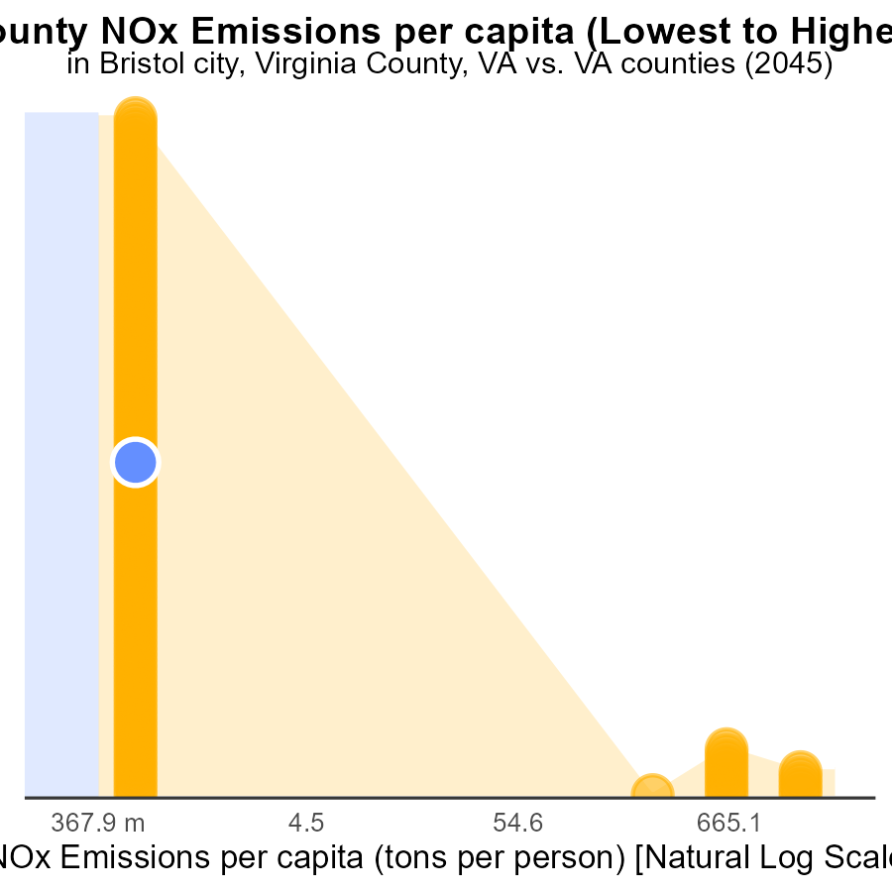

## Findings

* Manassas Park city, Virginia has the highest NOx emissions per capita at 376.1 tons per person.
* Augusta county has the lowest NOx emissions per capita at 6.2 tons per person.
* The majority of counties (44% to 45%) have NOx emissions per capita ranging from 3.0 to 3.1 tons per person.

## Recommendations

To decrease NOx emissions, policies should focus on high-emission areas like Manassas Park city, Virginia, encouraging cleaner technologies. Additionally, support should be given to counties with lower emissions to maintain their low levels.

# Areas Ranked by Time Driven

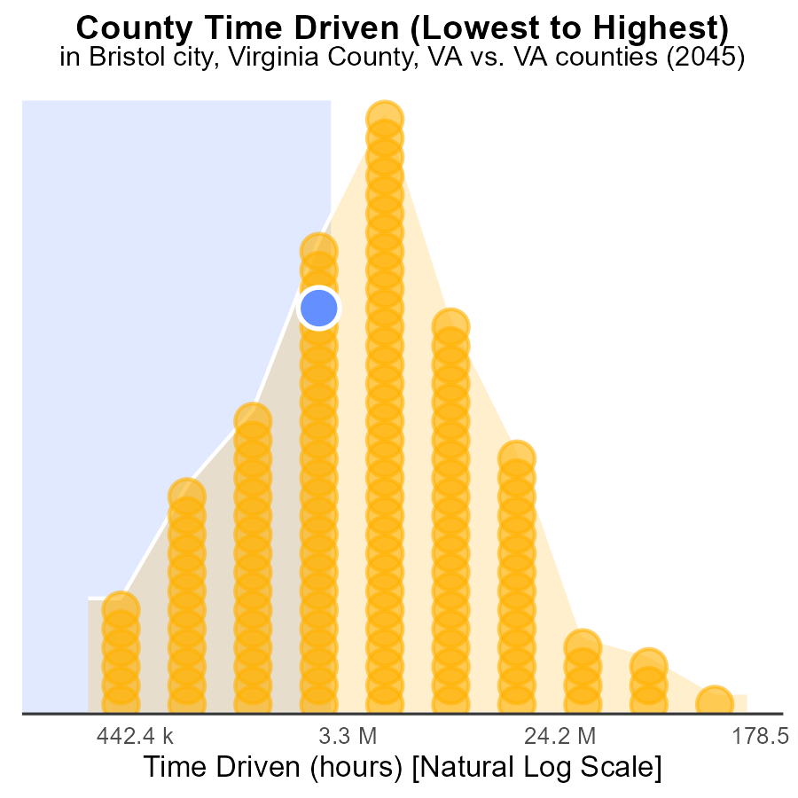

## Findings

* Fairfax county has the highest NOx emissions with 382.3 million source hours.
* Highland county has the lowest NOx emissions with 770.2 thousand source hours.
* Fairfax county accounts for 100.0% of the total emissions percentile among the listed counties.

## Recommendations

To lower NOx emissions, Fairfax county should focus on reducing source hours through stricter emission controls and promoting cleaner technologies. Highland county should maintain its low emissions level by implementing sustainable practices.

# Conclusion

In conclusion, NOx emissions from on-road transportation in Bristol city, Virginia County, VA in 2045 have shown a steady decrease over the years, reaching 1.8 tons by 2045 from 9.4 tons in 2025. The primary contributors to NOx emissions are light trucks and Hotelling (Diesel Aux) equipment. To further reduce NOx levels, a focus on stricter emission standards for these vehicles is crucial, alongside a transition to cleaner fuel alternatives. The data also reveals that Bristol city has consistently met emission reduction benchmarks, showcasing progress in mitigating NOx emissions.

Looking ahead, as NOx emissions are projected to increase steadily in the next 35 years, policies and actions targeting emissions from engines, particularly in hotelling zones, can help curb this trend. Additionally, promoting the use of electric vehicles and cleaner fuel sources, alongside investing in green energy and public transportation, will be key in achieving long-term emission reduction goals. By initiating these strategies, Bristol city can work towards a sustainable and healthier environment for its residents.

# About This Report

Data based on MOVES estimates collected by the Climate Action in Transportation program at Cornell University. Demographic data sourced from the US Census's American Community Survey 5-year estimates. This report was generated with the help of AI.

# References

* U.S. Census Bureau. (2023). American Community Survey 5-year estimates: Detailed tables. Retrieved from https://data.census.gov
* U.S. Environmental Protection Agency. (2024). Motor Vehicle Emission Simulator (MOVES 4.0) [Software]. Retrieved from https://www.epa.gov/moves