 

**CO Emissions in Esmeralda County, 2060**  
Made with CAT VISUALIZER by Gao Labs @ Cornell University.

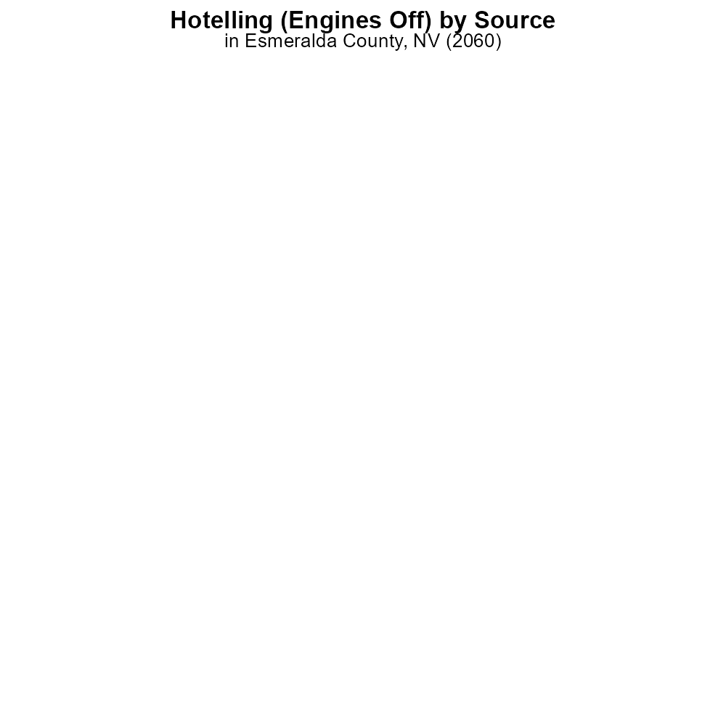

## Keywords

Carbon Monoxide emissions; on-road transportation; Esmeralda County; NV; 2060; environmental impact

## Highlights

* Study on CO emissions from Esmeralda County transportation.
* Analysis of impact on air quality and public health.
* Comparison with previous data to evaluate trends.
* Recommendations for reducing CO emissions in the future.
* Importance of addressing environmental concerns in transportation planning.

# Introduction

In 2060, Esmeralda County, NV, is facing growing concerns over Carbon Monoxide (CO) emissions resulting from on-road transportation. This report aims to thoroughly investigate the sources, levels, and impacts of CO emissions in the region to provide valuable insights for policymakers and stakeholders.

The study will delve into the specific sources of CO emissions from on-road transportation, analyze the effects on air quality and public health, and compare the current data with previous years to identify trends and potential areas for improvement. Additionally, recommendations will be outlined for strategies to mitigate CO emissions and enhance environmental sustainability in transportation planning for Esmeralda County moving forward.

# Vehicle Starts by Fuel Type

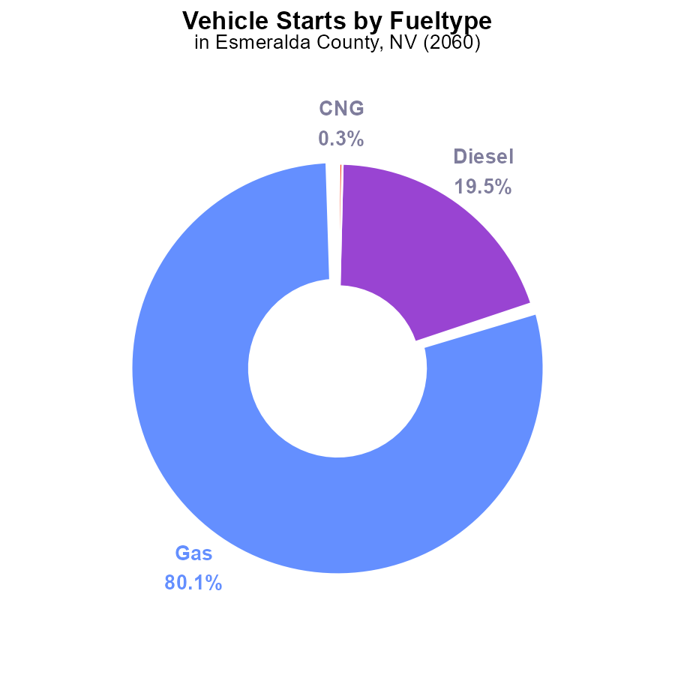

## Findings

* Gasoline vehicles account for 80.1% of carbon monoxide (CO) emissions from vehicle starts in Esmeralda County, NV in 2060.
* Diesel vehicles contribute 19.5% of CO emissions from vehicle starts in the county.
* Alternative fuels like CNG and ethanol make up only 0.4% of CO emissions combined.

## Recommendations

To decrease CO emissions in Esmeralda County, policies should focus on reducing gasoline and diesel vehicle usage, promoting the adoption of alternative fuels like CNG and ethanol, and incentivizing the use of electric vehicles.

# Hotelling (Engines Off) by Vehicle Type

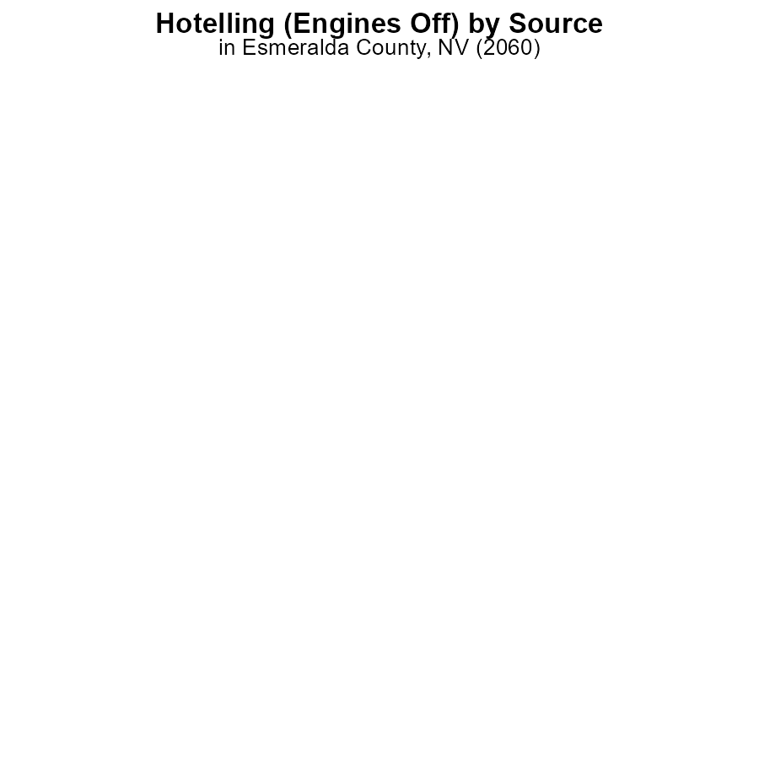

## Findings

* No CO emissions from buses, cars/bikes, combo trucks, heavy trucks, or light trucks in Esmeralda County, NV in 2060.

## Recommendations

Since there are no emissions reported for any vehicle type in the county, there is no immediate action needed to lower emission levels in this area. Continuous monitoring is recommended to track any future changes in emissions.

# Emissions Rate (per mile) Overall over Time

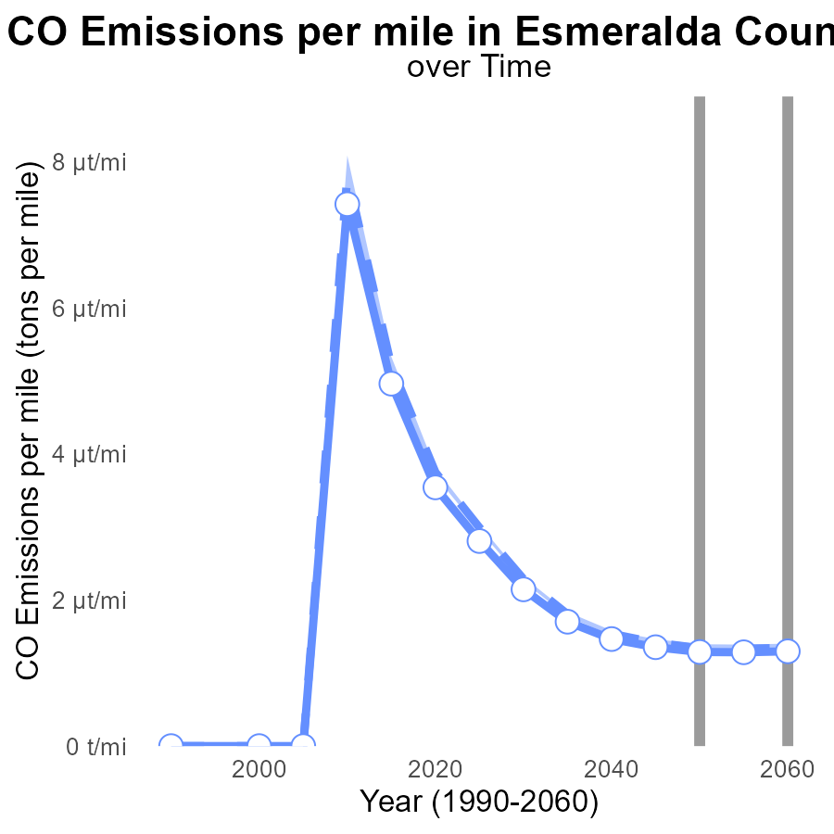

## Findings

* Emissions per mile in Esmeralda County, NV have been consistently below the median area from 2040 to 2060.
* There has been a gradual decrease in emissions per mile over the years, with a 13.3% reduction from 2040 to 2060.
* Esmeralda County's emissions per mile align with the lower 25th percentile of areas, indicating relatively low emissions compared to other regions.

## Recommendations

To further decrease emissions in Esmeralda County, focus on maintaining and even surpassing the current emission reduction trend. Invest in sustainable transportation infrastructure and promote the adoption of electric vehicles to continue lowering emissions levels.

# Population over Time for Passenger Vehicles

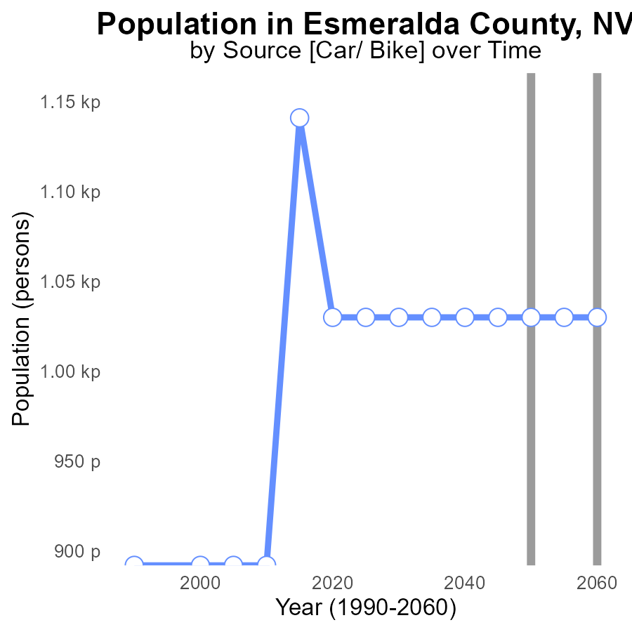

## Findings

* Esmeralda County, NV has a consistent CO emissions level of 1.0k persons over the years 2040 to 2060.
* There has been no change in CO emissions compared to the benchmark for this area.
* The population's impact on CO emissions remains stable with no increase or decrease.

## Recommendations

To maintain the stable CO emission levels in Esmeralda County, NV, continue monitoring population growth and its impact. Implement awareness campaigns on sustainable practices to ensure emissions remain unchanged.

# Time Driven in My Region

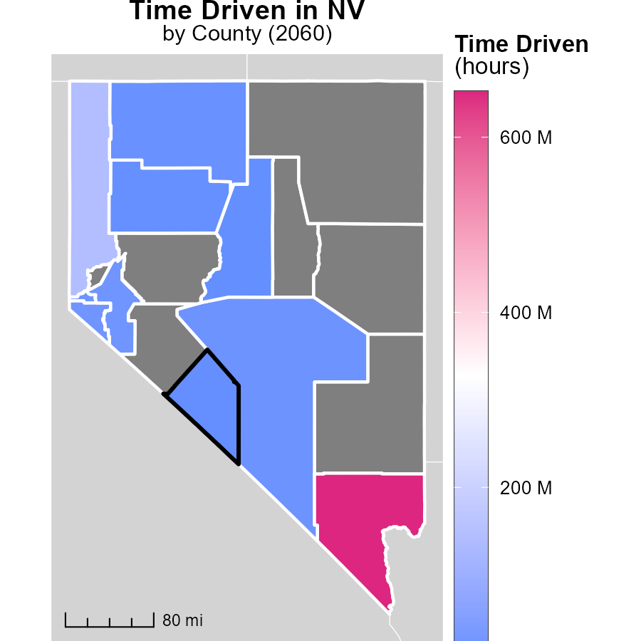

## Findings

* Clark County, NV emitted 652.1 million units, the highest among the counties.
* Nye County, NV emitted 17.0 million units, which is in the middle range.
* Lander County, NV emitted 3.4 million units, the lowest amount among the counties.

## Recommendations

To lower emissions in Clark County, focus on industries contributing most to emissions. Nye County should implement moderate emission reduction strategies. Lander County should prioritize emission reduction programs to maintain its low emissions.

# Vehicles Mapped by Area

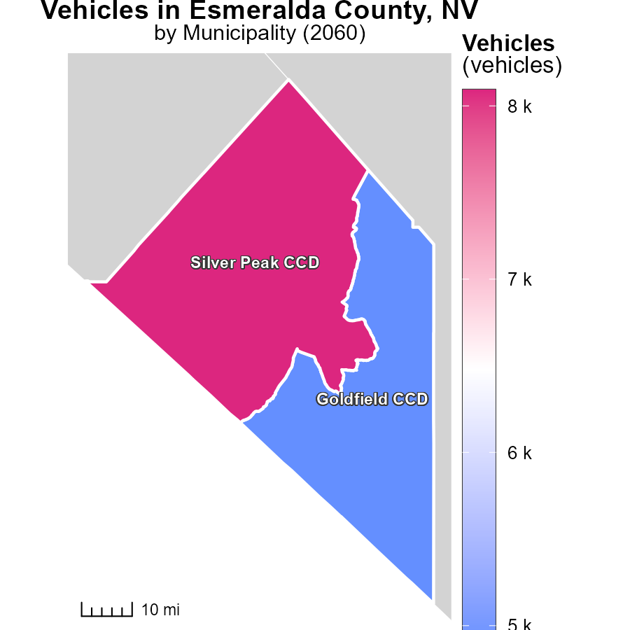

## Findings

* Silver Peak CCD, NV generates 8.1 thousand tons of emissions, the highest amount.
* Goldfield CCD, NV produces 4.9 thousand tons of emissions, at the median level.

## Recommendations

Implement stricter emissions standards for vehicles in Silver Peak CCD, NV to reduce the high emission levels. Goldfield CCD, NV can focus on promoting alternative transportation methods to lower emissions.

# Emissions by Road Type over Time

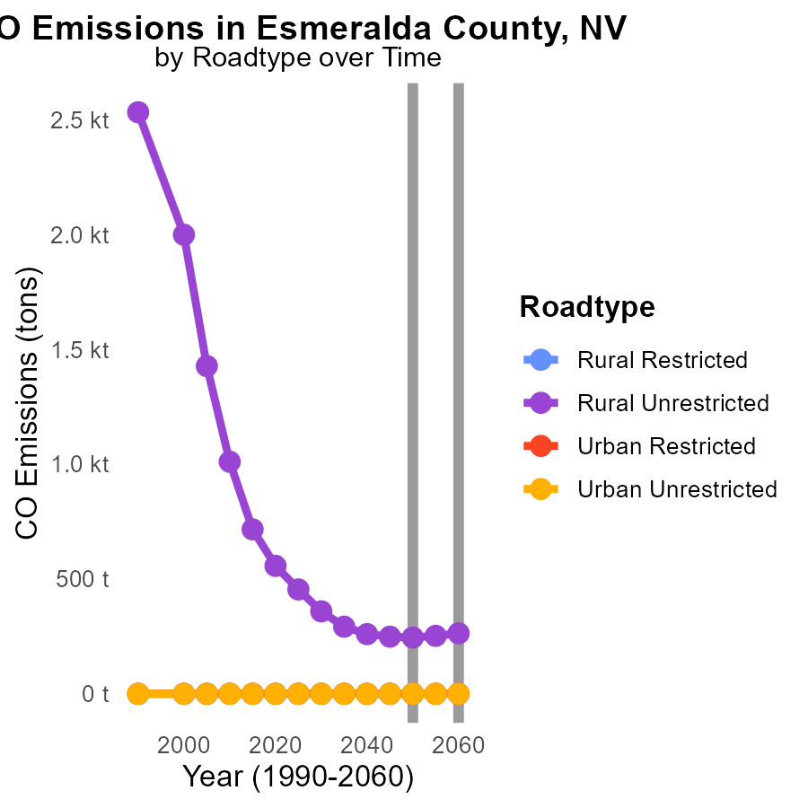

## Findings

* Rural Unrestricted emissions increased by 7.3 tons (3%) from 2050 to 2055.
* Rural Unrestricted emissions increased by 26.5 tons (10.8%) from 2050 to 2060.
* Other road types and Urban areas remained consistent with zero emissions over the years.

## Recommendations

To reduce emissions in Esmeralda County, focus on implementing stricter regulations on rural unrestricted road types as they showed an increasing trend. Invest in cleaner transportation options for rural areas.

# Time Driven by Fuel Type over Time

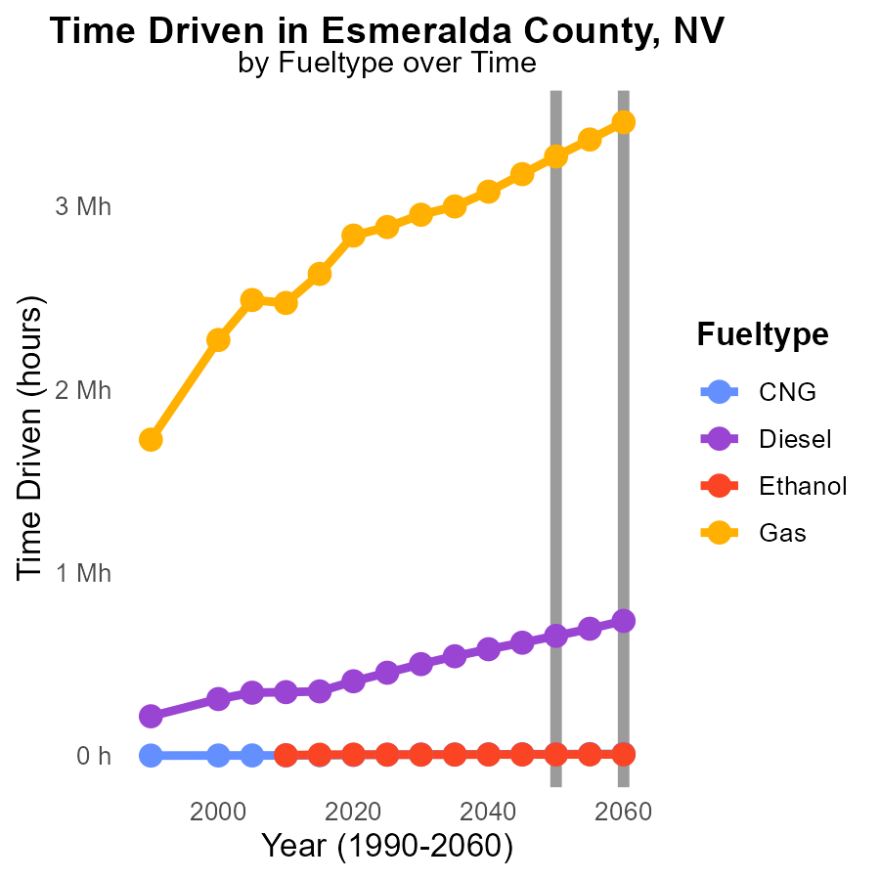

# Areas Ranked by Emissions

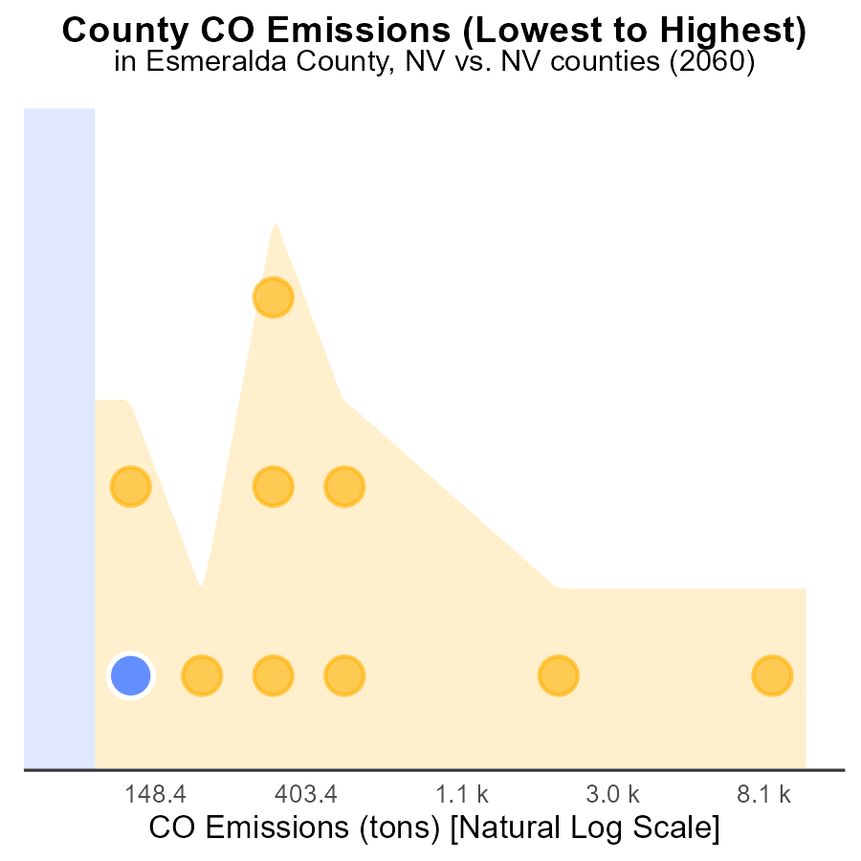

## Findings

* The county with the highest CO emissions is Esmeralda, emitting 263.3 tons.
* Lander ranks second with 281.9 tons and contributes 20.0% of total emissions.
* Clark County emits significantly more, with 29,500 tons, constituting the highest emission level at 100.0%.

## Recommendations

Efforts must focus on reducing emissions in Esmeralda and Lander counties through stricter regulations and promoting cleaner technologies. Additionally, initiatives should be implemented in Clark County to reduce its disproportionately high emissions.

# Areas Ranked by Vehicle Starts

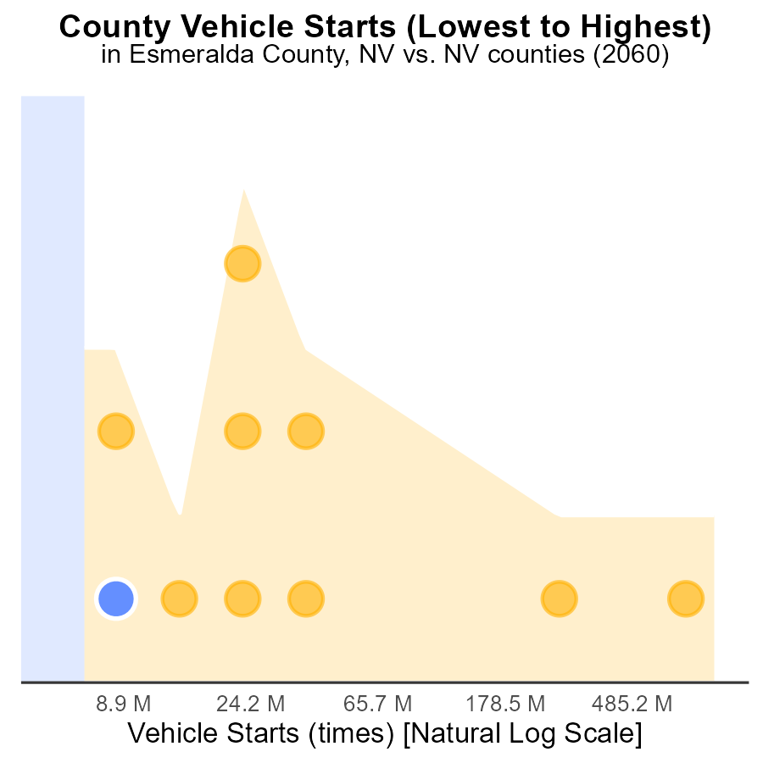

## Findings

* Clark county has the highest vehicle starts emissions, representing 100.0% of the total
* Lander county ranks 2nd in vehicle starts emissions with 20.0% of the total
* Esmeralda county ranks 1st in vehicle starts emissions, contributing 10.0% each

## Recommendations

To reduce emissions, focus on Clark county by promoting electric vehicles and public transportation. Implement carpooling initiatives in Lander and Esmeralda to lower their emission levels significantly.

# About This Report

Data based on MOVES estimates collected by the Climate Action in Transportation program at Cornell University. Demographic data sourced from the US Census's American Community Survey 5-year estimates. This report was generated with the help of AI.

# References

* U.S. Census Bureau. (2023). American Community Survey 5-year estimates: Detailed tables. Retrieved from https://data.census.gov
* U.S. Environmental Protection Agency. (2024). Motor Vehicle Emission Simulator (MOVES 4.0) [Software]. Retrieved from https://www.epa.gov/moves