 

**PM10 Emissions in Hartford County, 2030**  
Made with CAT VISUALIZER by Gao Labs @ Cornell University.

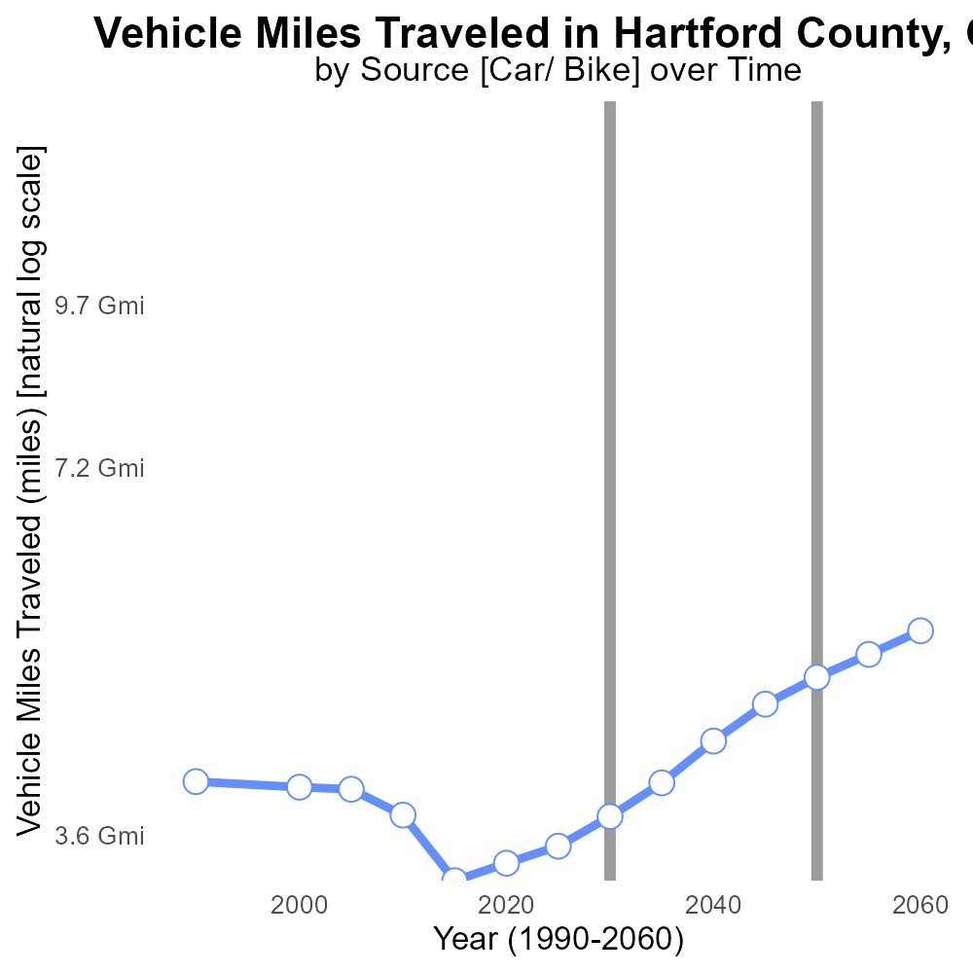

## Keywords

exhaust emissions; PM10; on-road transportation; Hartford County; 2030; total emissions

## Highlights

* Study on exhaust PM10 emissions from transportation in Hartford County, CT in 2030.
* Focus on primary exhaust emissions from on-road vehicles.
* Analysis of total PM10 emissions impact on air quality.
* Importance of understanding transportation emissions for mitigation strategies.
* Implications for public health and environmental policy.

# Introduction

The following report presents a detailed analysis of Primary Exhaust PM10 - Total emissions from on-road transportation in Hartford County, CT in 2030. As the world continues to grapple with environmental challenges, understanding exhaust emissions from transportation becomes crucial for developing effective mitigation strategies.

This study specifically focuses on the impact of primary exhaust PM10 emissions from on-road vehicles in Hartford County. By evaluating the total emissions and their contribution to air quality, the report aims to provide insights into the potential consequences for public health and environmental policy in the region.

# Emissions Rate (per capita) Overall by Area

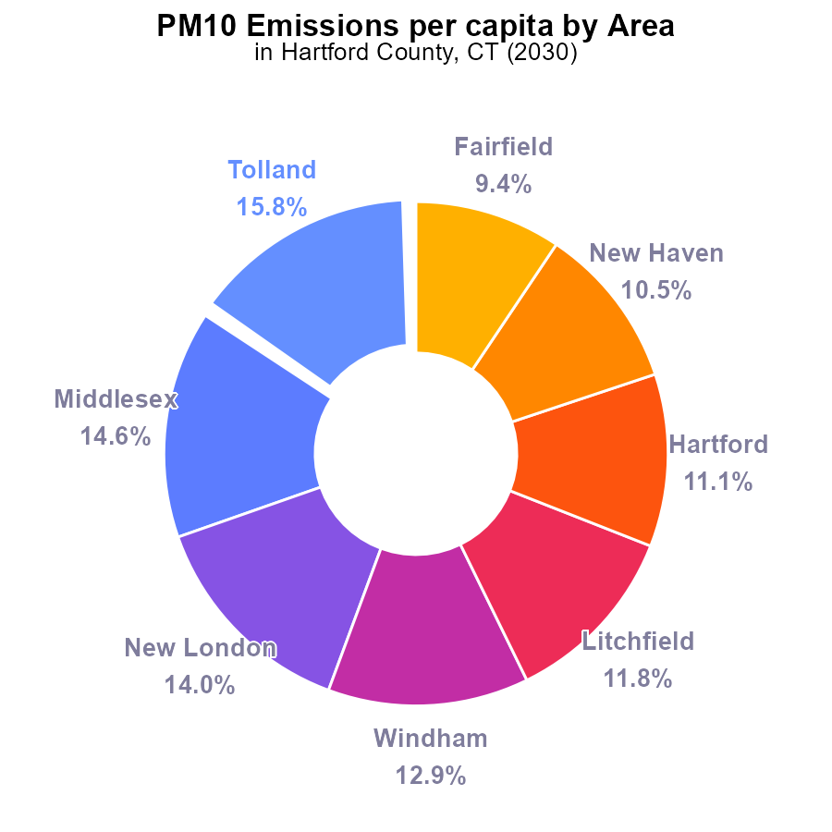

## Findings

* Tolland has the highest PM10 emissions per capita with 64.9 tons per person, followed by Middlesex and New London.
* Fairfield has the lowest PM10 emissions per capita with 38.8 tons per person, followed by New Haven and Hartford.
* Tolland, Middlesex, and New London together contribute to 44.4% of the total PM10 emissions in Hartford County.

## Recommendations

To lower the PM10 emissions, focus on reducing emissions in Tolland, Middlesex, and New London by implementing stricter regulations on industrial activities and promoting cleaner technologies.

# Vehicle Miles Traveled by Regulatory Class

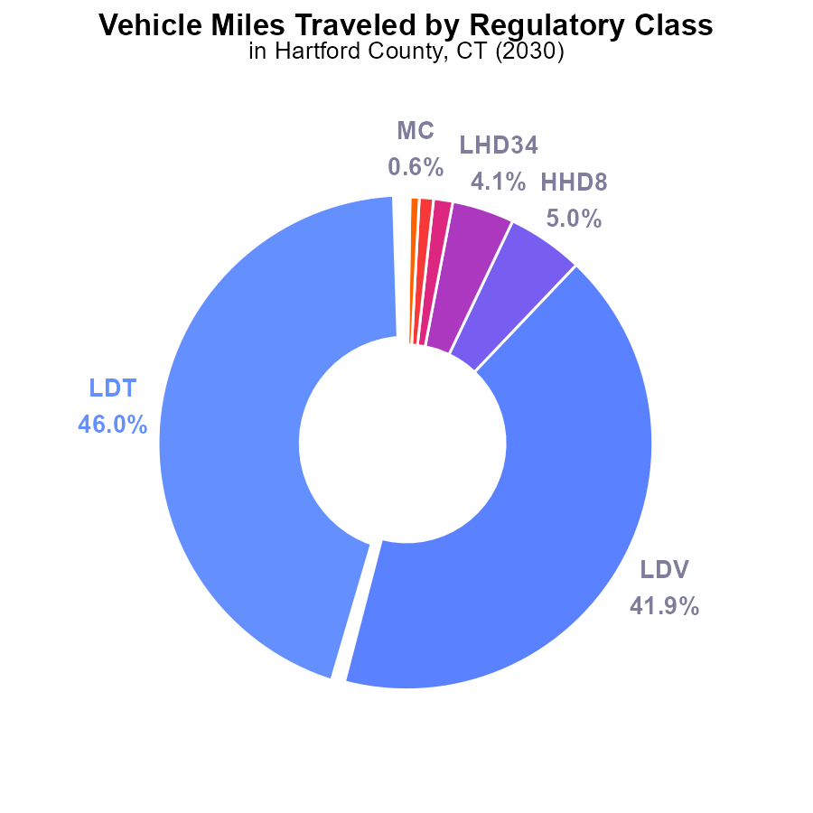

## Findings

* The top two contributors to PM10 emissions from vehicle miles traveled are LDT (46.0%) and LDV (41.9%).
* HHD8 and LHD34 are also significant contributors, accounting for 5.0% and 4.1% of the emissions, respectively.
* Collectively, MHD67, LHD45, MC, Glider, and Urban Bus contribute only 3.0% to PM10 emissions from vehicle miles traveled.

## Recommendations

To lower PM10 emissions from vehicle miles traveled in Hartford County, CT, a targeted approach is needed. It is recommended to focus on reducing emissions from LDT and LDV, the primary contributors, by promoting public transportation, carpooling initiatives, and the adoption of electric vehicles. Additionally, stricter regulations on heavy-duty vehicles like HHD8 and LHD34 can help further reduce emissions from these sources.

# Vehicle Miles Traveled over Time for Passenger Vehicles

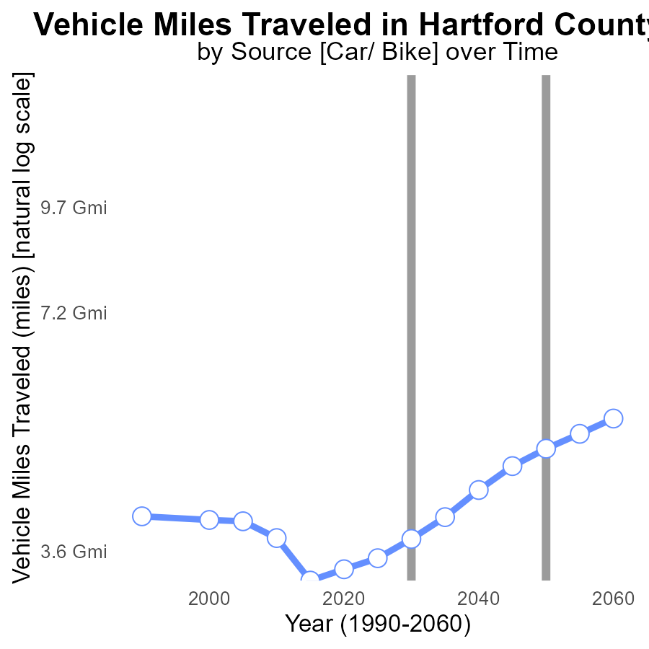

## Findings

* PM10 emissions in Hartford County decreased from 3.7 G in 2010 to 4.8 G in 2050.
* Vehicle miles traveled increased from 1.1 billion miles above benchmark in 2010 to no difference in 2050.
* The trend shows a decrease in emissions per mile traveled despite the increasing total vehicle miles.

## Recommendations

To further reduce PM10 emissions in Hartford County, policies should focus on promoting sustainable transportation options like public transit and electric vehicles. Additionally, implementing stricter emission standards for vehicles can help offset the increase in total vehicle miles traveled.

# Idling over Time for Buses

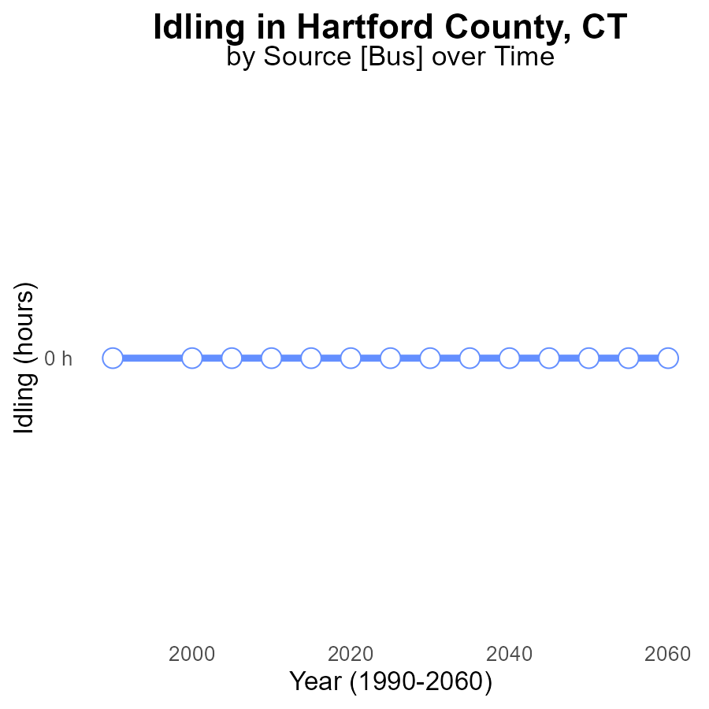

## Findings

* Between 2010 and 2050, the PM10 emissions from idling in Hartford County, CT, remained consistently at 0.0 hours.
* There was no observed change in PM10 emissions from idling compared to the benchmark set in 2010.
* The idling activities in Hartford County have not contributed to any increase in PM10 emissions over the years.

## Recommendations

To maintain the current low level of PM10 emissions from idling activities, continuous monitoring and enforcement of anti-idling regulations should be prioritized. Additionally, promoting the use of electric vehicles and implementing incentives for idling reduction can further help in keeping the emissions at minimal levels.

# Vehicle Starts Mapped by Area

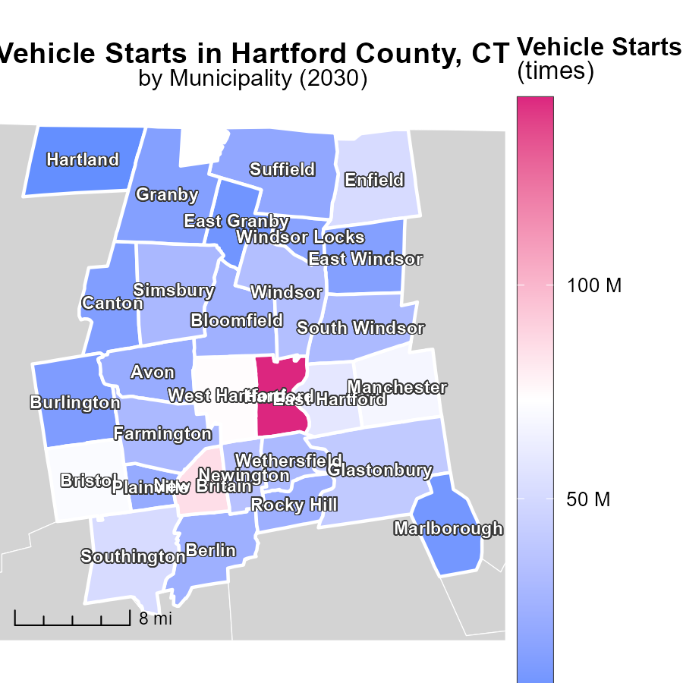

## Findings

* Hartford, CT has the highest vehicle starts with 143.9 million times.
* Simsbury, CT has a median of 29.4 million vehicle starts.
* Hartland, CT has the lowest vehicle starts with 2.2 million times.

## Recommendations

To lower emissions, focus on reducing vehicle starts by implementing carpooling incentives, improving public transportation, and promoting alternative transportation methods in high-start areas such as Hartford, CT.

# Time Driven in My Region

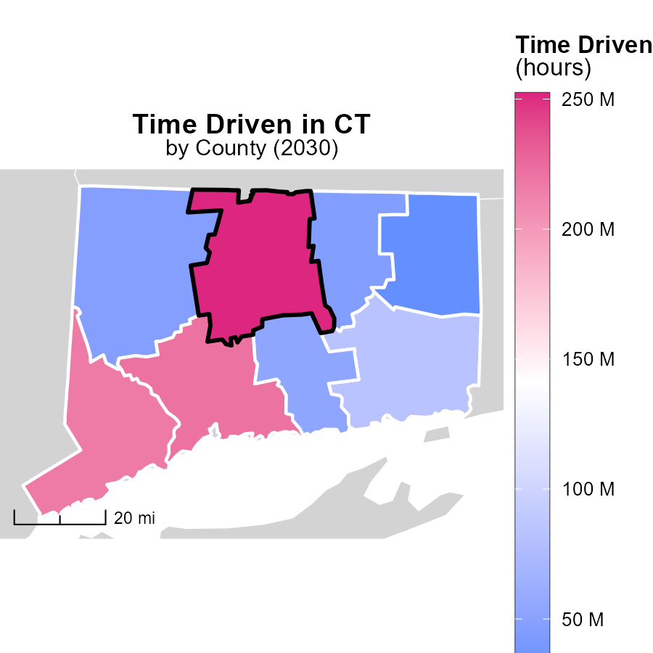

## Findings

* Hartford County, CT has the highest emissions with 252.2 million hours.
* New London County, CT has a median emissions level of 83.2 million hours.
* Windham County, CT shows the lowest emissions at 29.7 million hours.

## Recommendations

To lower emissions, focus on reducing hours of operation in high-emission areas like Hartford County. Encourage telecommuting and public transportation to decrease travel time.

# Emissions Rate (per capita) by Road Type over Time

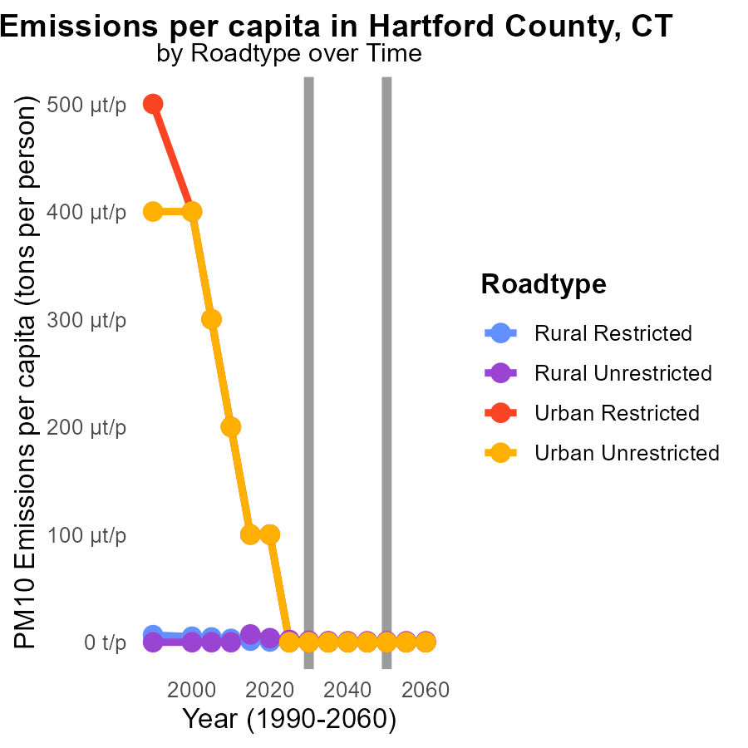

## Findings

* Emissions of PM10 per capita in Rural Restricted areas are projected to decrease by 83.3% from 2020 to 2040.
* Emissions of PM10 per capita in Urban Restricted areas are estimated to decrease by 76.4% during the same period.
* In 2040, Urban Unrestricted areas are anticipated to have the highest PM10 emissions per capita among all road types.

## Recommendations

To lower emissions, focus on implementing stricter emission standards for vehicles in Urban Unrestricted areas. Encourage the adoption of electric vehicles to reduce pollution levels significantly.

# Emissions Rate (per mile) by Fuel Type over Time

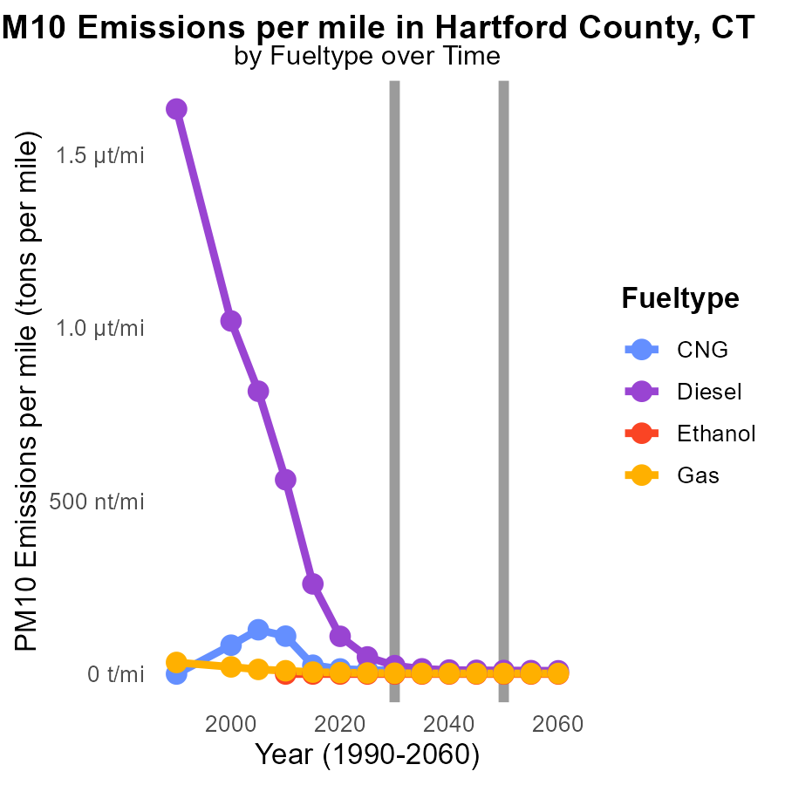

## Findings

* PM10 emissions per mile for Diesel are projected to decrease significantly from 108.9 tons in 2020 to 11.4 tons in 2040.
* CNG emissions per mile are expected to decrease steadily from 14.6 tons in 2020 to 8.3 tons in 2040.
* Gasoline emissions exhibit a downward trend, from 3.9 tons per mile in 2020 to 1.6 tons in 2040.

## Recommendations

To further reduce emissions, increasing the adoption of CNG vehicles can be beneficial due to their lower emissions compared to Diesel. Encouraging the use of alternative fuels like ethanol can help achieve significant reductions in emissions by transitioning away from traditional gasoline-powered vehicles.

# Areas Ranked by Emissions

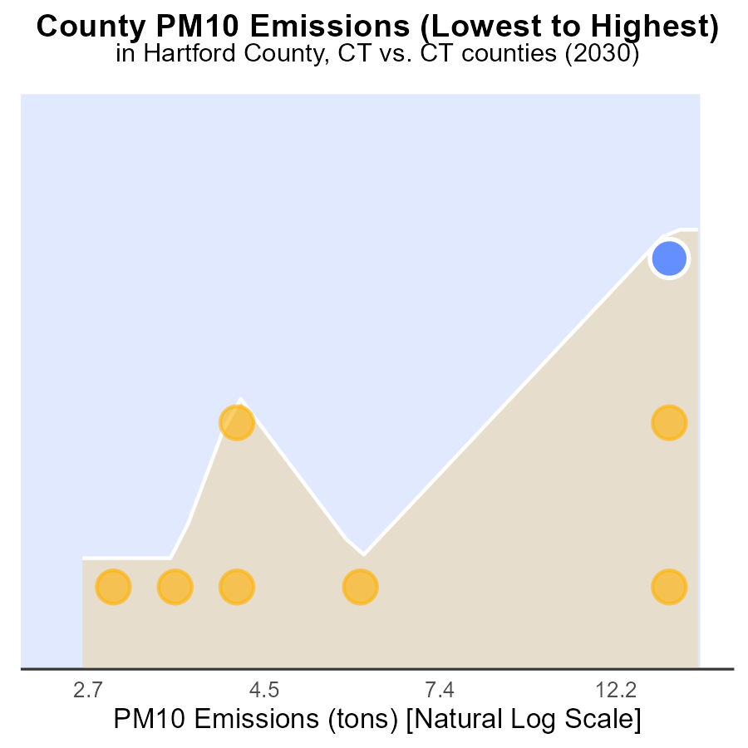

## Findings

* Hartford is the top county in PM10 emissions with 40.7 tons, ranking 8th nationally.
* Windham has the lowest emissions at 6.2 tons, ranking 1st with only 12.5% of the total emissions.
* The combined emissions of Hartford and New Haven counties constitute 66.4% of the total emissions in the data set.

## Recommendations

To reduce PM10 emissions, initiatives should focus on counties like Hartford and New Haven with high emission rates. Implementing stricter emission controls in industrial sectors can help lower overall emissions.

# Areas Ranked by Vehicles

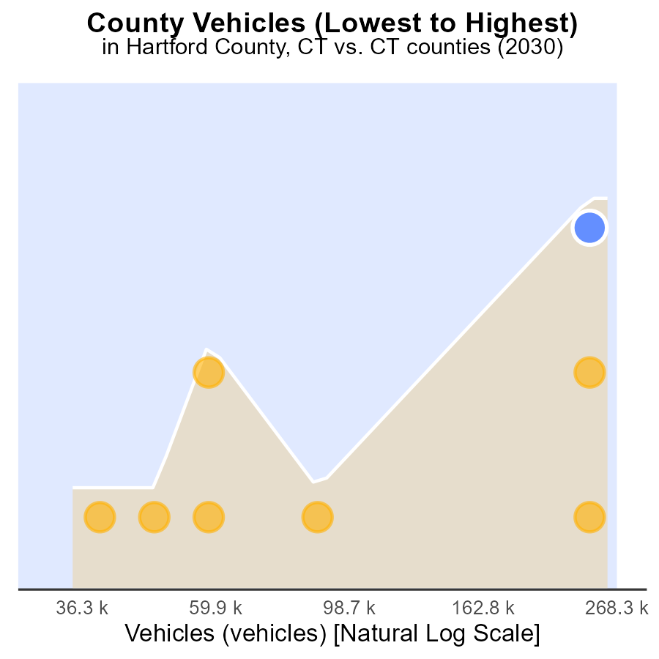

## Findings

* Hartford County has the highest PM10 emissions from vehicles with 729.4k tons.
* Windham County has the lowest emissions with 95.3k tons, ranking 1st in percentile.
* Overall, New Haven and Hartford counties contribute significantly to PM10 emissions, ranking 7th and 8th, respectively.

## Recommendations

To lower PM10 emissions from vehicles, Hartford County should implement stricter vehicle emission standards. New Haven can invest in public transportation to reduce vehicle emissions.

# About This Report

Data based on MOVES estimates collected by the Climate Action in Transportation program at Cornell University. Demographic data sourced from the US Census's American Community Survey 5-year estimates. This report was generated with the help of AI.

# References

* U.S. Census Bureau. (2023). American Community Survey 5-year estimates: Detailed tables. Retrieved from https://data.census.gov
* U.S. Environmental Protection Agency. (2024). Motor Vehicle Emission Simulator (MOVES 4.0) [Software]. Retrieved from https://www.epa.gov/moves