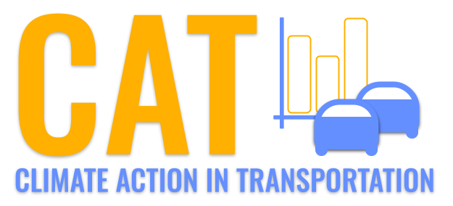 

**CO Emissions in Oliver County, 2025**  
Made with CAT VISUALIZER by Gao Labs @ Cornell University.

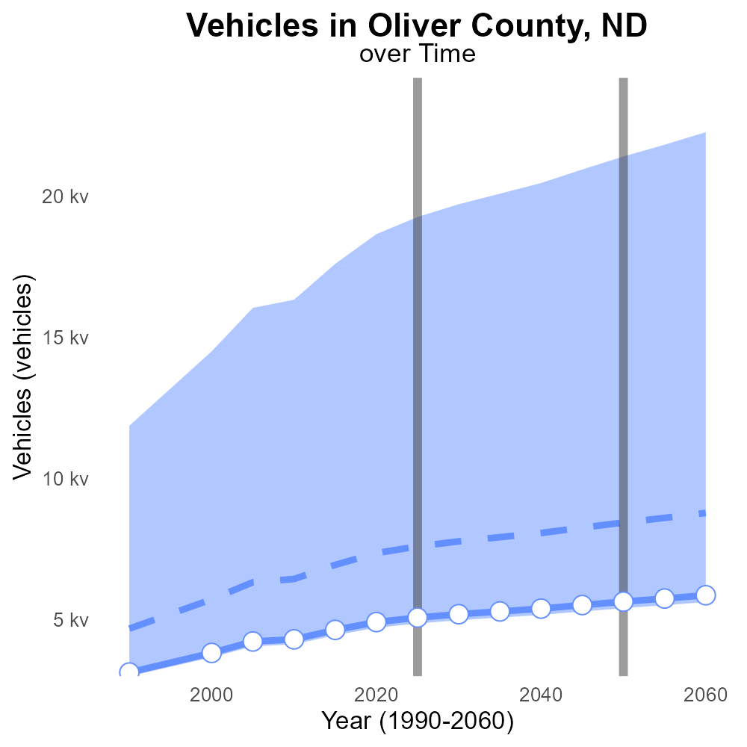

## Keywords

Carbon Monoxide emissions; on-road transportation; Oliver County; ND; 2025

## Highlights

* Study on CO emissions from vehicles in Oliver County, ND.
* Analysis of on-road transportation impact on air quality.
* 2025 data used to assess the situation.
* Identification of potential risks to public health.
* Recommendations for reducing CO emissions in the area.

# Introduction

This report examines Carbon Monoxide (CO) emissions from on-road transportation in Oliver County, North Dakota, specifically focusing on the year 2025. The study aims to analyze the impact of on-road transportation on air quality and assess the levels of CO emitted by vehicles in the county.

By utilizing data from 2025, the report will provide insights into the current state of CO emissions in Oliver County and identify potential risks to public health associated with these emissions. Furthermore, the report will offer recommendations and strategies for reducing CO emissions from on-road transportation in order to improve air quality and protect public health in the region.

# Idling by Road Type

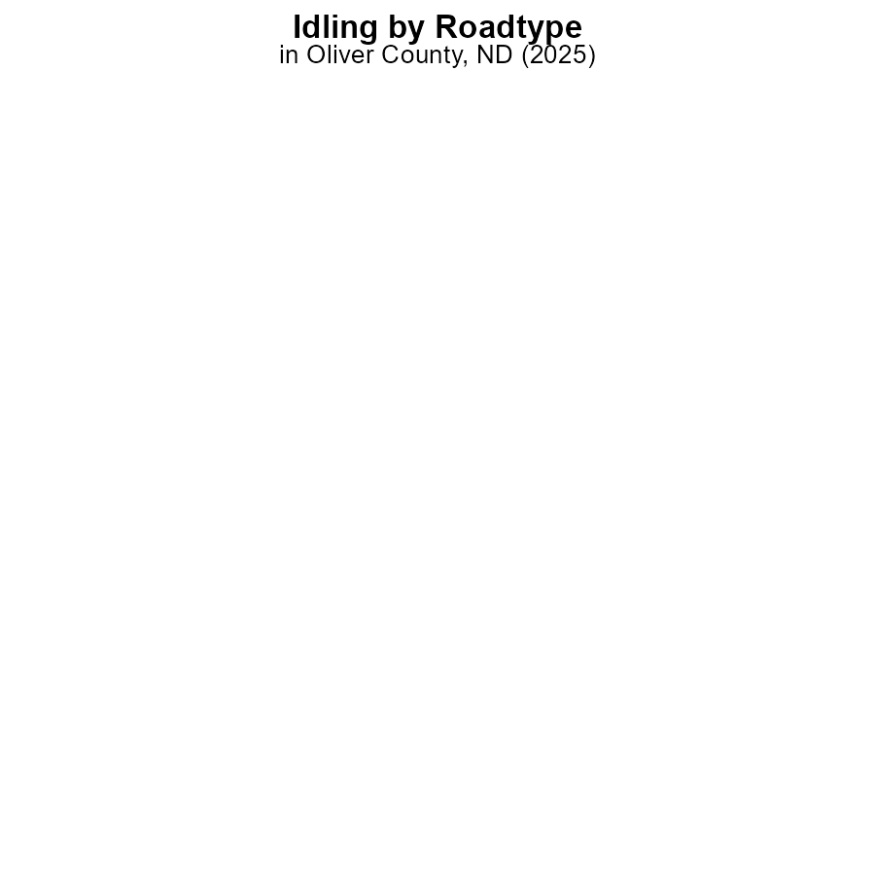

## Findings

* In 2025, Oliver County, ND, reported 0.0% CO emissions from idling in all categories of areas.
* There were no distinguishable differences in idling emissions between rural and urban areas.
* The data suggests a consistent trend of negligible CO emissions from idling activities in Oliver County, ND.

## Recommendations

Given the extremely low levels of CO emissions from idling, further monitoring may not be a priority. However, promoting initiatives to reduce idling behavior, such as through awareness campaigns or incentives, could help maintain these low emission levels.

# Hotelling (Diesel Aux) by Vehicle Type



# Vehicles Overall over Time

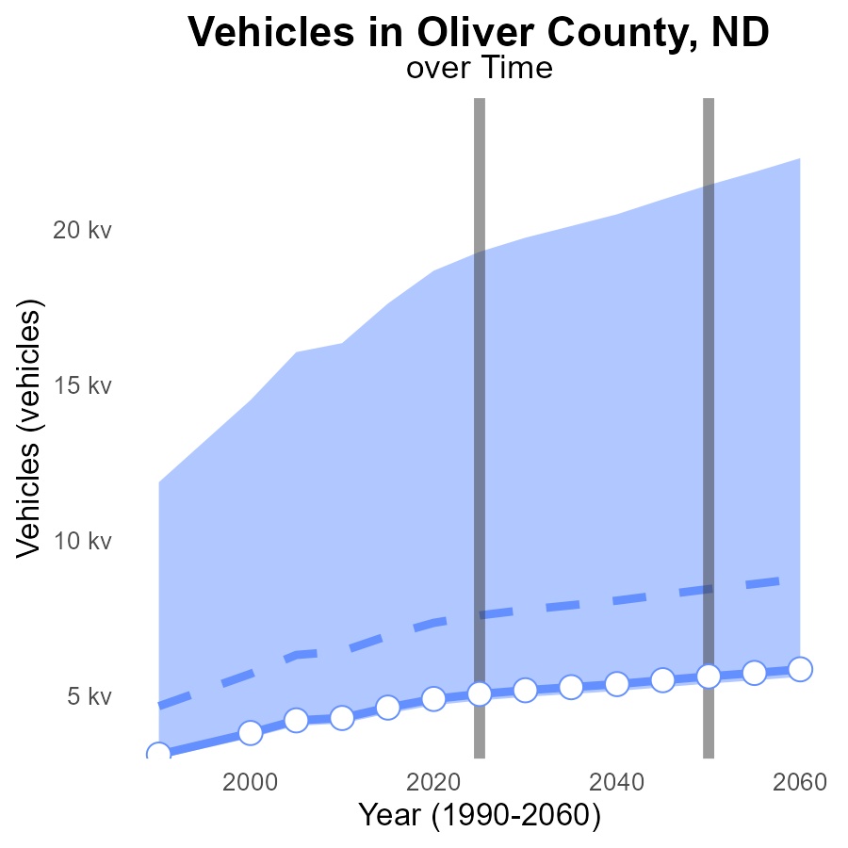

## Findings

* Oliver County, ND has a steady increase in vehicle CO emissions from 2005 to 2045.
* The emissions are consistently below the median area and the upper 75th percentile of areas.
* There is a decreasing trend in the benchmark difference, indicating a gradual improvement in emissions efficiency.

## Recommendations

To lower emissions, Oliver County should consider implementing initiatives to promote the use of electric vehicles, carpooling, and public transportation. Additionally, investing in infrastructure to support alternative fuel vehicles can help reduce CO emissions further.

# Hotelling (Diesel Aux) over Time for Passenger Vehicles

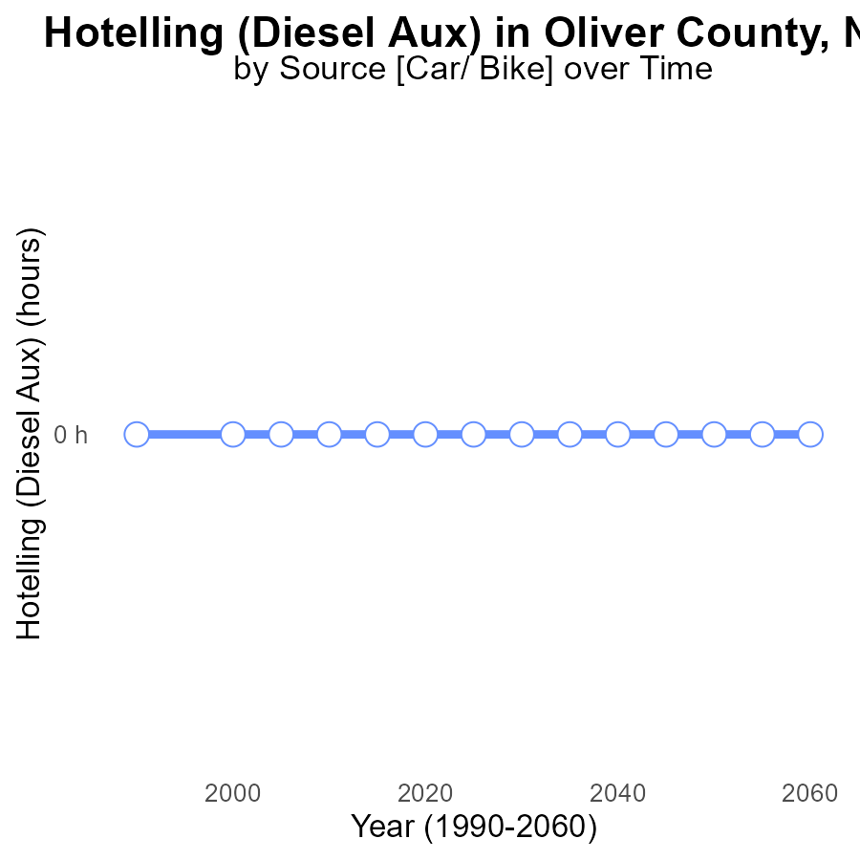

## Findings

* There have been no emissions from Hotelling (Diesel Aux) in Oliver County, ND, from 2005 to 2045.
* There has been no change in emissions over the years, with a constant benchmark difference of 0.
* The emissions data for CO from Hotelling (Diesel Aux) in Oliver County, ND, shows a consistent trend of 0.0 over the years.

## Recommendations

Given the consistent zero emissions from Hotelling (Diesel Aux) in Oliver County, ND, no specific actions are needed at this time to lower the emission levels further.

# Vehicle Miles Traveled in My Region

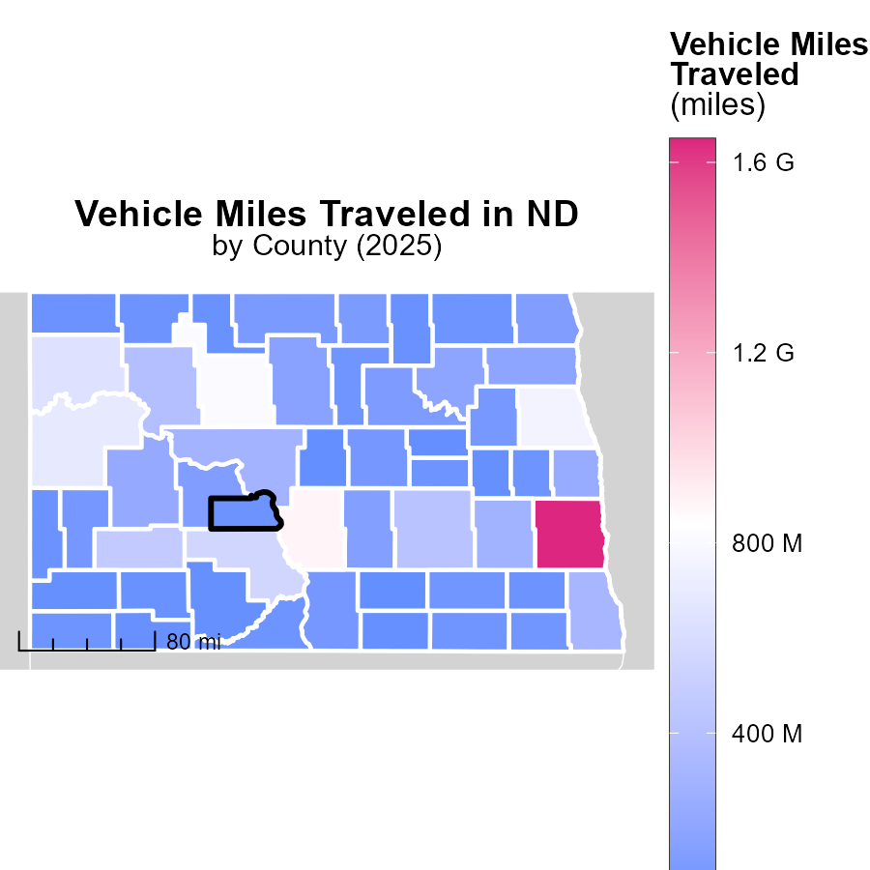

## Findings

* Cass County, ND has the highest vehicle miles traveled at 1.6 billion miles in 2025.
* Billings County, ND has a median vehicle miles traveled of 92.8 million miles in 2025.
* Sheridan County, ND has the lowest vehicle miles traveled at 27.8 million miles in 2025.

## Recommendations

Local policymakers in Cass County should focus on promoting carpooling and public transportation to reduce emissions from high vehicle miles traveled.

# Emissions Rate (per capita) in My Region

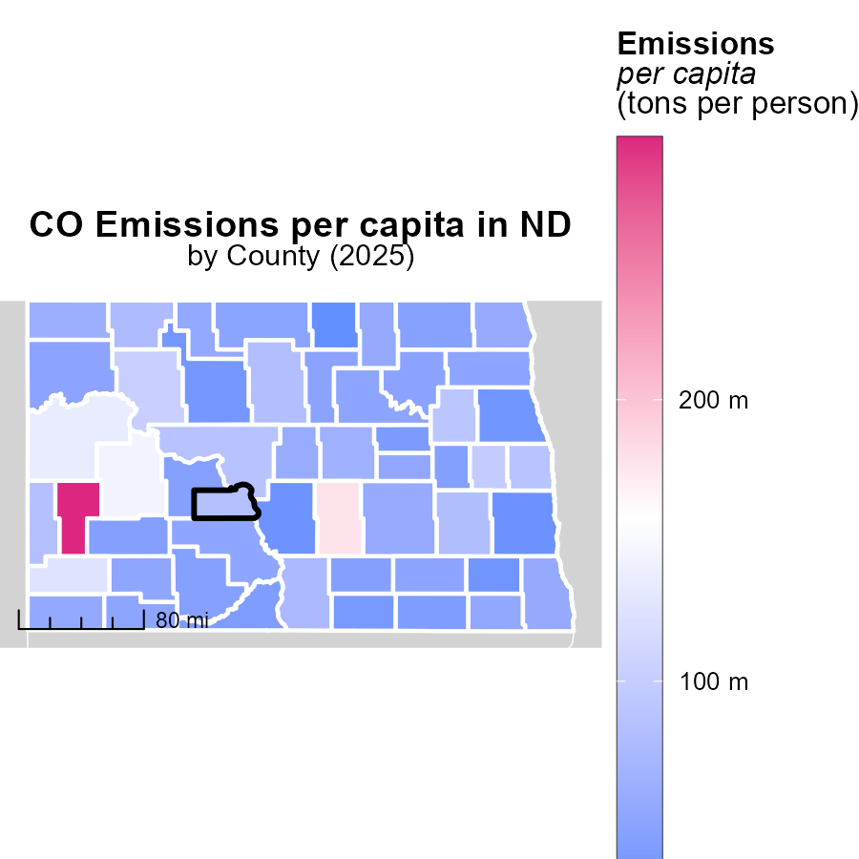

## Findings

* Billings County, ND has the highest emissions per capita at 293.1 tons per person.
* Foster County, ND has a median emissions rate of 54.1 tons per person.
* Rolette County, ND has the lowest emissions per capita at 22.8 tons per person.

## Recommendations

To lower emissions, focus on high-emitting areas like Billings County by implementing stricter regulations, promoting renewable energy sources, and encouraging sustainable transportation methods. Additionally, provide incentives for counties with median and low emissions rates to maintain or further reduce their levels.

# Idling by Area over Time

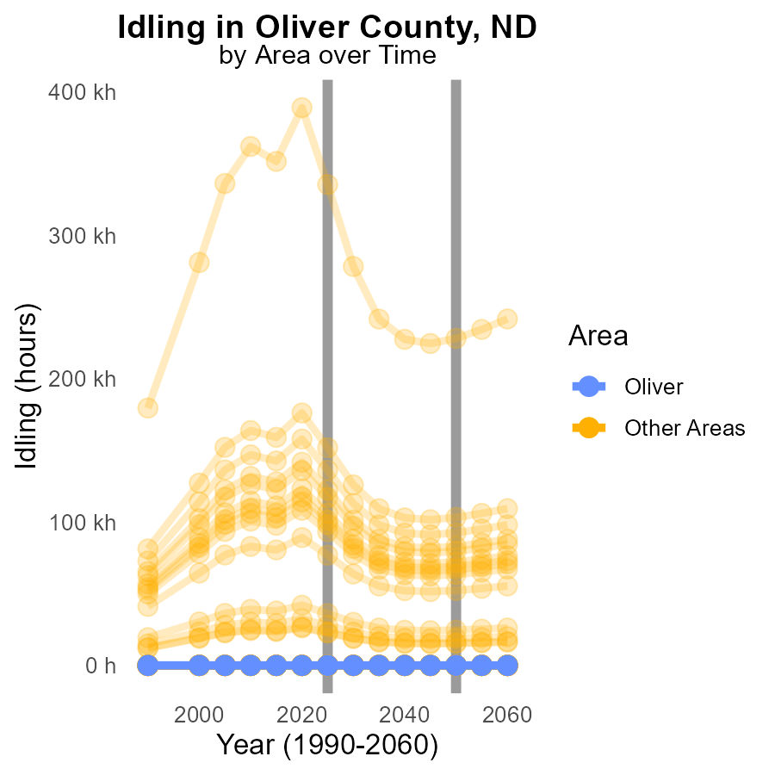

## Findings

* In 2025, the maximum city idling emissions were 335.3 k CO, with a decrease of 107318.2 from 2050.
* Across the surveyed locations, there was no idling emissions recorded in the same year.
* There was no significant change in idling emissions from 2015 to 2035.

## Recommendations

To reduce emissions, implement idling reduction programs in high-emission areas like the max city. Enforce anti-idling policies in all locations to maintain current emission levels and reduce unnecessary idling.

# Vehicles by Vehicle Type over Time

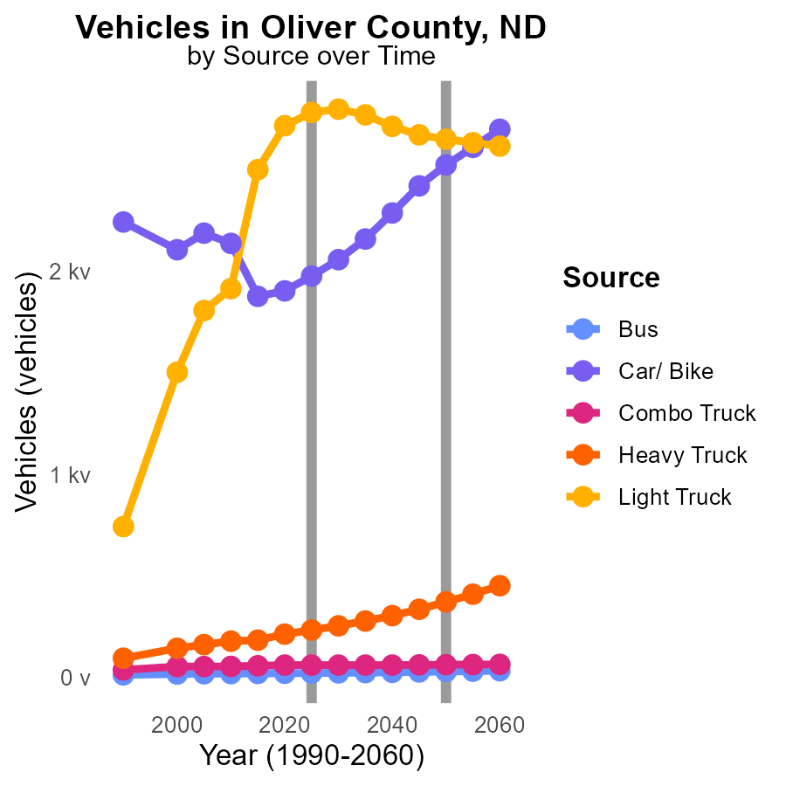

## Findings

* Bus emissions decrease by 32.6% from 2015 to 2035.
* Car/ Bike emissions decrease by 75.7% from 2015 to 2035.
* Heavy Truck emissions increase by 51.8% from 2015 to 2035.

## Recommendations

To lower emissions, incentivize public transportation usage, promote electric and fuel-efficient vehicles, and regulate heavy-duty vehicle emissions.

# Areas Ranked by Vehicles

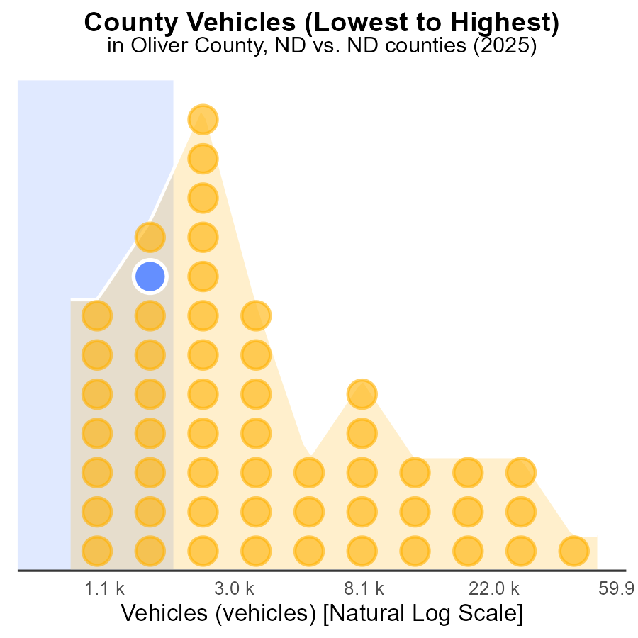

## Findings

* Cass county has the highest number of vehicles with 135.5k which represents 100.0% of all vehicles in the dataset.
* Burke and Oliver counties are close with 5.1k vehicles each, making up 30.2% and 28.3% of the vehicles, respectively.
* Sheridan has the lowest vehicle count at 2.3k, accounting for only 1.9% of the total vehicles.

## Recommendations

To decrease emissions, focus on reducing vehicle numbers in high-ranking counties like Cass. Implement carpooling incentives or improve public transportation. Encourage the use of electric vehicles to lower emissions in Burke and Oliver.

# Areas Ranked by Idling

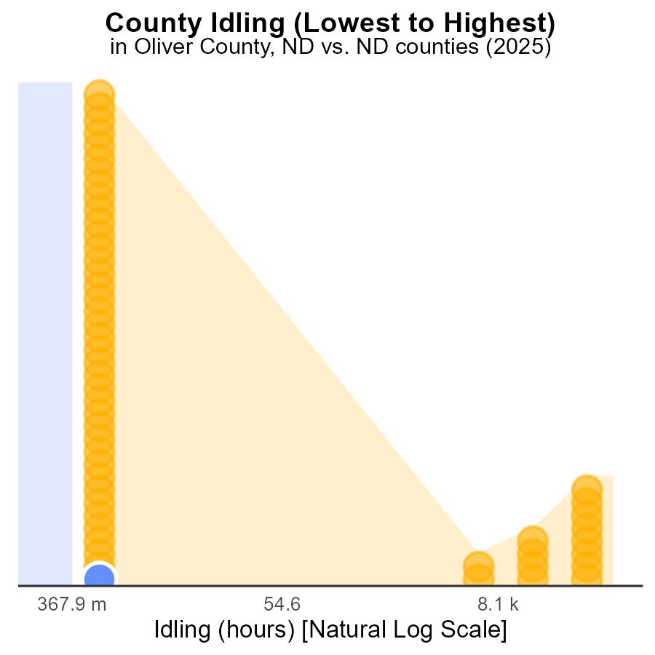

## Findings

* Oliver County had no idling hours in 2025, ranking 1st with 73.6% percentile.
* Adams County also had no idling hours, ranking 2nd with 73.6% percentile.
* Cass County had 335.3k idling hours, ranking 53rd with 100.0% percentile.

## Recommendations

To reduce emissions, invest in idle reduction technologies for vehicles in Cass County. Encourage similar idling reduction initiatives in Oliver and Adams to maintain their low emission levels.

# Conclusion

Overall, the data from Oliver County, ND, in 2025 indicates a positive trend with negligible CO emissions from idling activities. This suggests that the current measures in place to reduce idling behavior have been effective. However, there is still room for improvement in other areas such as vehicle emissions and vehicle miles traveled. It is essential to focus on promoting sustainable transportation methods, incentivizing electric vehicle usage, and implementing stricter regulations to further reduce CO emissions in Oliver County.

By analyzing the emissions data and trends, it is evident that while some areas have made progress in reducing emissions, there are opportunities for more targeted interventions in high-emitting areas. Encouraging the adoption of renewable energy sources, promoting public transportation, and investing in infrastructure for alternative fuel vehicles can significantly contribute to lowering CO emissions in Oliver County, ND. It is crucial for local policymakers to address these findings and implement strategic initiatives to continue the positive trajectory towards a cleaner and more sustainable environment.

# About This Report

Data based on MOVES estimates collected by the Climate Action in Transportation program at Cornell University. Demographic data sourced from the US Census's American Community Survey 5-year estimates. This report was generated with the help of AI.

# References

* U.S. Census Bureau. (2023). American Community Survey 5-year estimates: Detailed tables. Retrieved from https://data.census.gov
* U.S. Environmental Protection Agency. (2024). Motor Vehicle Emission Simulator (MOVES 4.0) [Software]. Retrieved from https://www.epa.gov/moves