 

**PM10 Emissions in Weber County, 2055**  
Made with CAT VISUALIZER by Gao Labs @ Cornell University.

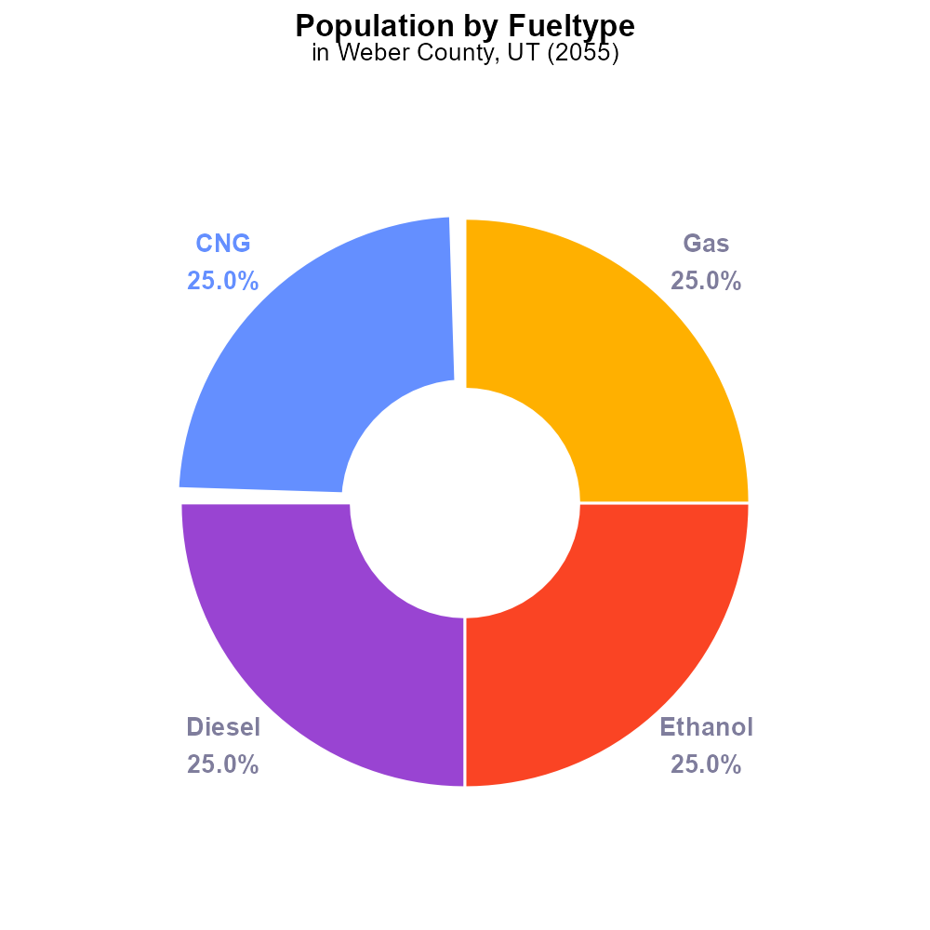

## Keywords

Primary Exhaust PM10; Total emissions; on-road transportation; Weber County; UT; 2055

## Highlights

* Study on PM10 emissions from on-road transportation in Weber County, UT in 2055.
* Evaluating primary exhaust sources and total emissions of PM10 in the area.
* Impact of on-road transportation on air quality and public health in Weber County.
* Analyzing trends and projections of PM10 emissions from vehicles in the region.
* Policy implications and recommendations for reducing PM10 emissions in Weber County.

# Introduction

In this report, we present a comprehensive analysis of Primary Exhaust PM10 emissions from on-road transportation in Weber County, UT,specifically focusing on the year 2055. The study aims to assess both the sources and total emissions of PM10 from various vehicles operatingwithin the county, shedding light on the impact of on-road transportation on air quality and public health in the region.

Through detailed data collection and analysis, we delve into the trends and projections of PM10 emissions, providing valuable insights for policymakers and stakeholders. The findings of this report will inform strategies and recommendations for mitigating PM10 emissions from on-road transportation in Weber County, ultimately contributing to a healthier and more sustainable environment for residents.

# Vehicles Overall by Area

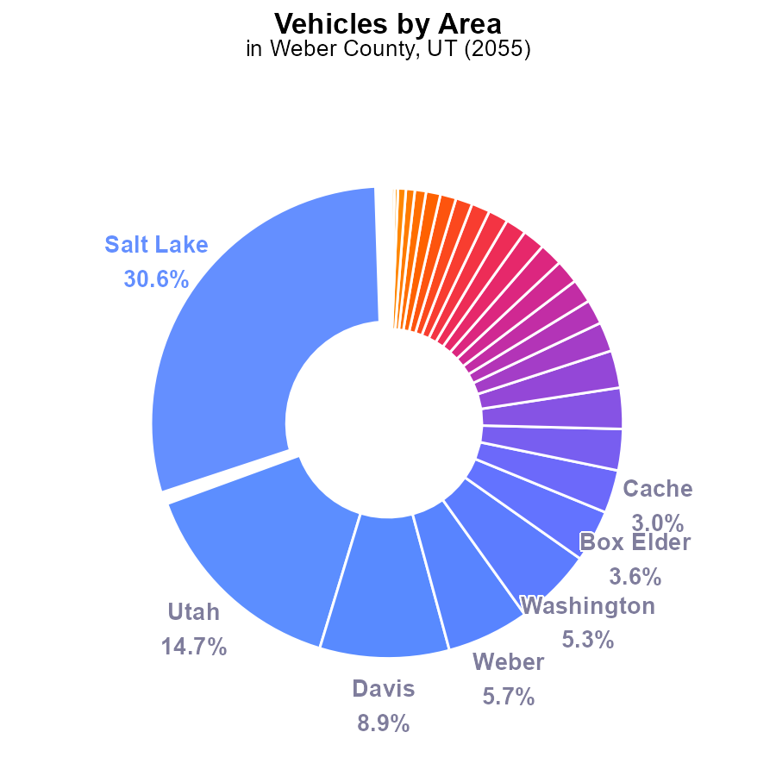

## Findings

* Salt Lake County has the highest PM10 emissions from vehicles at 30.6% (950.4k).
* The top five counties, including Salt Lake, account for 65.2% of PM10 emissions from vehicles.
* Many counties contribute only a small percentage of PM10 emissions, with Daggett and Piute at 0.1% each.

## Recommendations

To lower PM10 emissions, focus on counties like Salt Lake, Utah, Davis, Weber, and Washington that make up the majority of emissions. Implementing stricter vehicle emission standards and promoting the use of electric vehicles in these counties could significantly reduce overall emissions.

# Population by Fuel Type

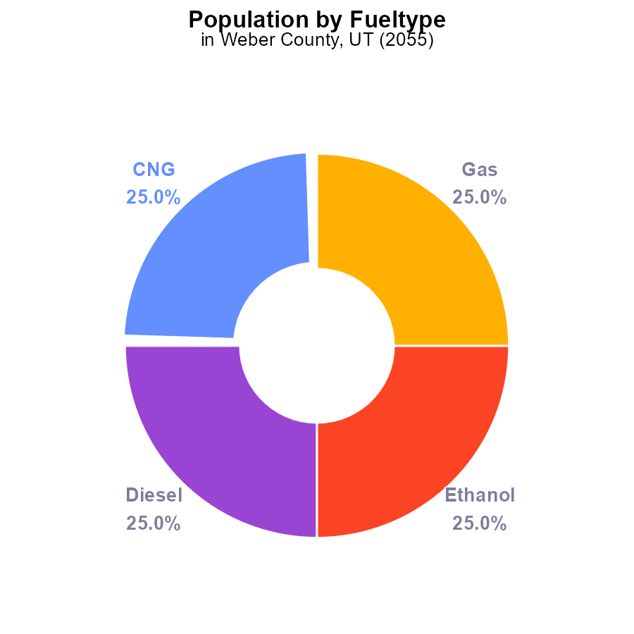

# Vehicles over Time for Buses

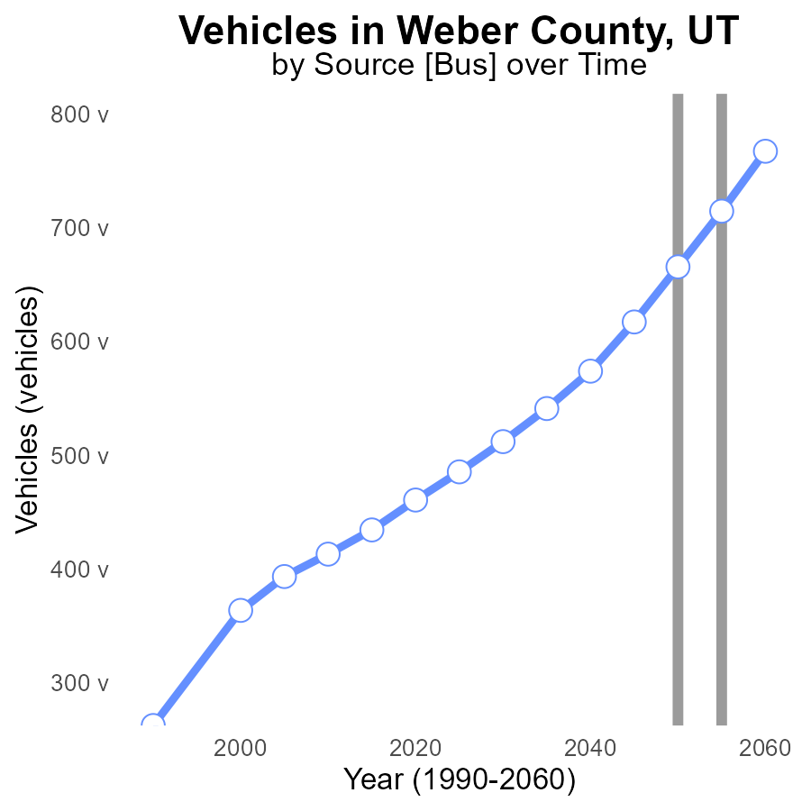

## Findings

* PM10 emissions from vehicles in Weber County are projected to decrease by 18.5% from 2035 to 2060.
* In 2050, PM10 emissions are expected to reach the benchmark, showing a positive trend.
* The most significant reduction is forecasted between 2050 and 2060, with a decrease of 13.3% in PM10 emissions.

## Recommendations

To further reduce PM10 emissions from vehicles in Weber County, policymakers should focus on promoting the adoption of electric vehicles, improving public transportation infrastructure, and implementing stricter vehicle emission standards. Additionally, incentives for carpooling and telecommuting could help reduce the overall number of vehicles on the road, contributing to a significant decrease in emissions over time.

# Hotelling (Diesel Aux) Overall over Time

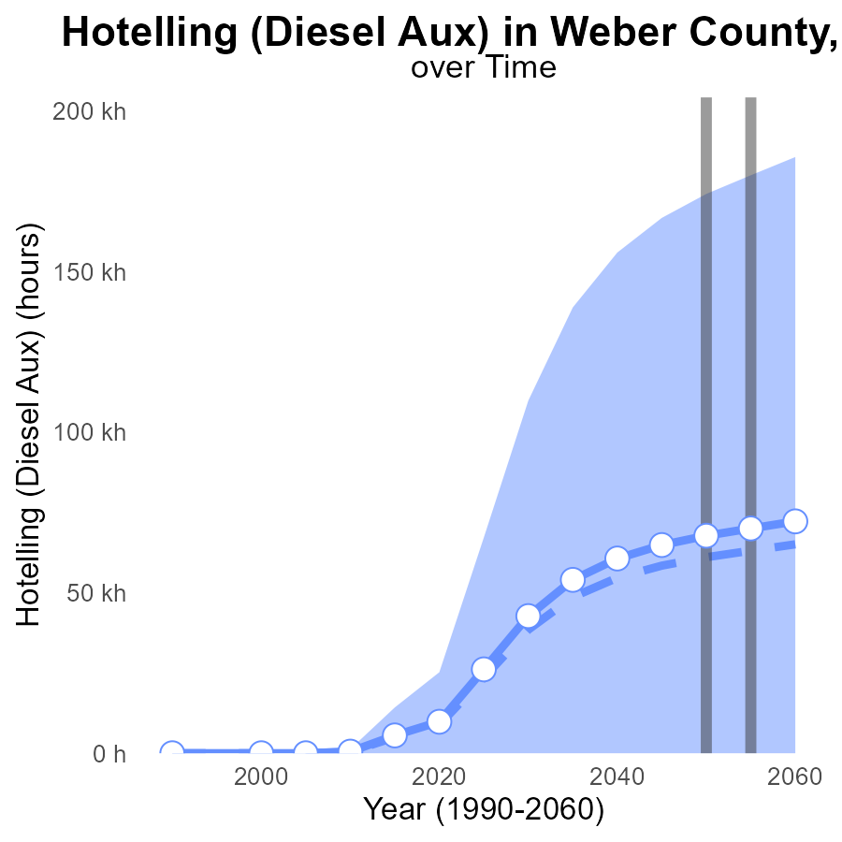

## Findings

* PM10 emissions in Weber County, UT are projected to increase steadily over the next few decades.
* The emissions for the year 2060 are estimated to be 72.2 k, marking a 7.1 k increase from the median area level.
* By 2050, emissions are expected to surpass the upper 75th percentile of areas, signaling potentially high pollution levels.

## Recommendations

To lower PM10 emissions, Weber County should implement stricter regulations on diesel auxiliary usage. Additionally, investing in cleaner energy sources and promoting public transport could help mitigate the increasing emission levels projected.

# Vehicles in My Region

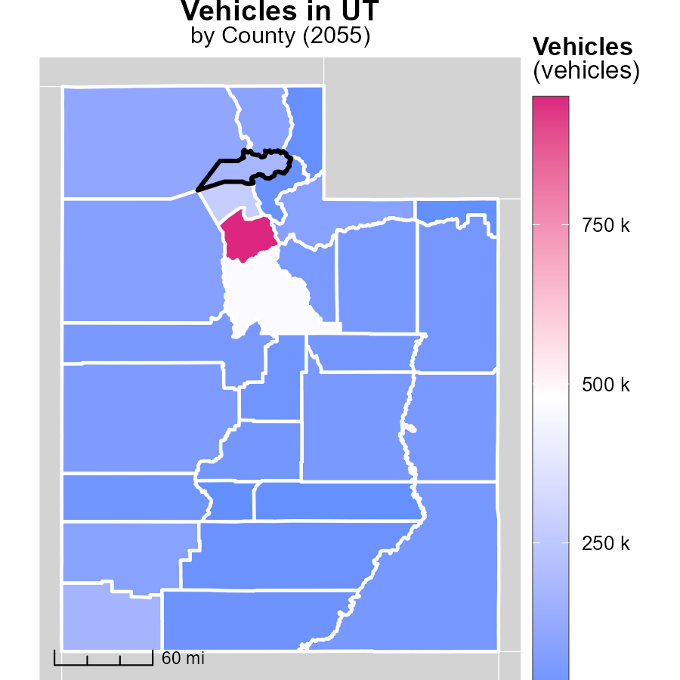

## Findings

* Salt Lake County, UT emits 950.4 thousand metric tons, the highest among the three counties.
* Piute County, UT emits the least with 3.7 thousand metric tons.
* Grand County, UT falls in between with 49.5 thousand metric tons.

## Recommendations

To lower emissions, focus on reducing vehicle usage, promoting public transportation, and incentivizing carpooling in Salt Lake County. Implement stricter emission standards for vehicles in Grand County. Encourage the adoption of electric vehicles in Piute County.

# Idling in My Region

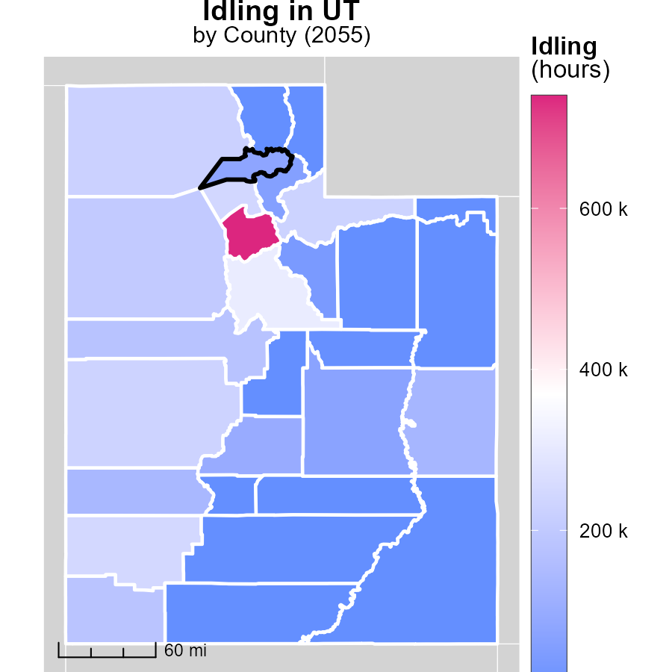

## Findings

* Salt Lake County, UT has the highest idling hours with 739.5k
* Emery County, UT has a median idling hours of 71.0k
* Wayne County, UT recorded the lowest idling hours at 0.0

## Recommendations

To reduce idling emissions, Salt Lake County should implement idling reduction initiatives, Emery County to set idling reduction goals, and Wayne County to promote anti-idling policies and awareness campaigns.

# Hotelling (Engines Off) by Vehicle Type over Time

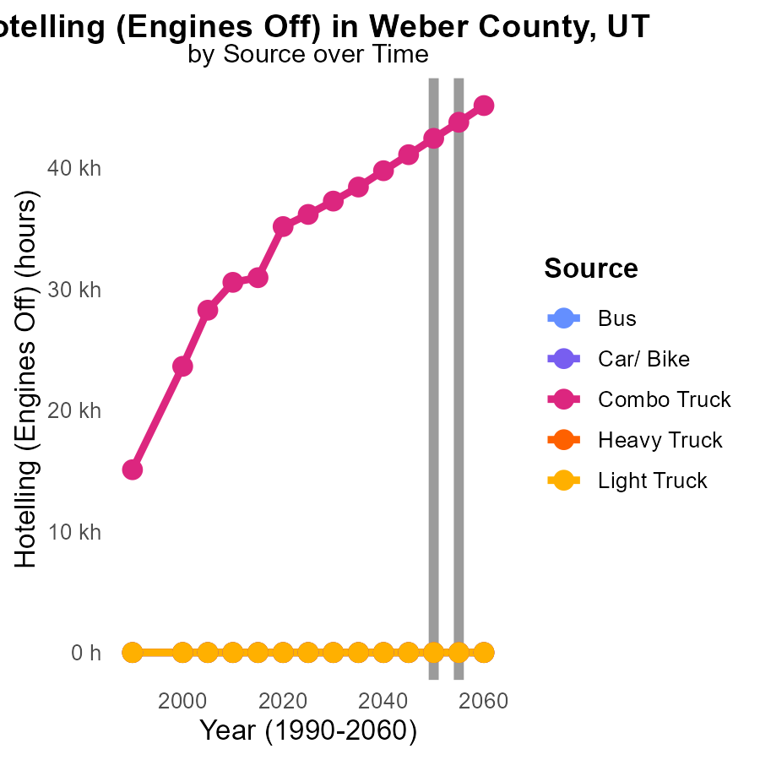

## Findings

* Combo trucks are the primary source of PM10 emissions in Weber County, UT.
* PM10 emissions from Combo trucks are projected to decrease by 6.3% from 2045 to 2060.
* Other vehicle types, such as buses, cars/bikes, heavy trucks, and light trucks, contribute negligible PM10 emissions in the specified year range.

## Recommendations

To lower PM10 emissions in Weber County, UT, focus on reducing emissions from Combo trucks. Implement stricter emission standards for Combo trucks and incentivize the adoption of cleaner fuel technologies.

# Emissions Rate (per vehicle) by Area over Time

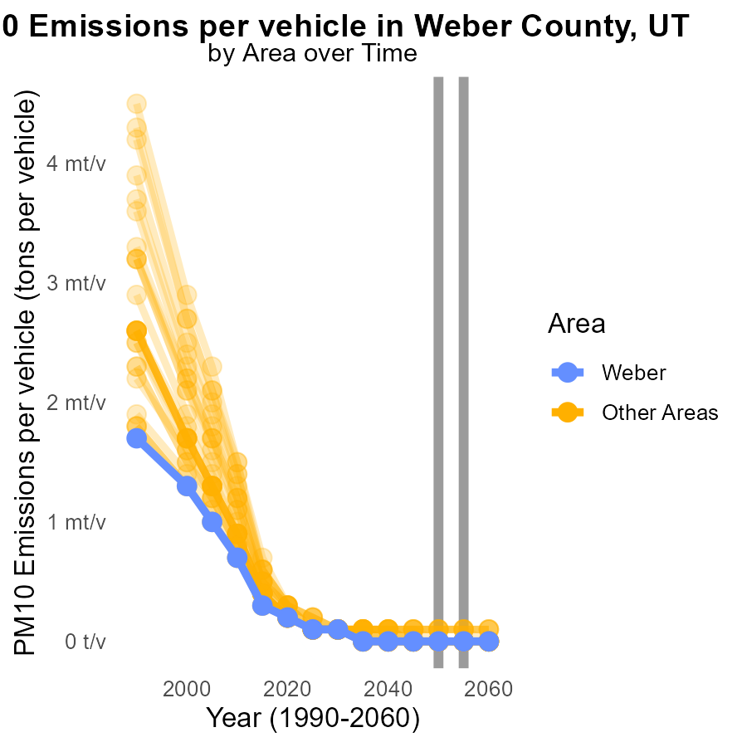

## Findings

* Max county has emissions ranging from 50.6 to 58.8 tons per vehicle.
* Min county has emissions ranging from 26.9 to 47.6 tons per vehicle.
* The difference with 2050 emissions is 0 across all locations in 2055.

## Recommendations

To lower emissions, consider implementing vehicle emission standards in both max and min counties. Encouraging the use of electric or hybrid vehicles can also help reduce emissions further.

# Areas Ranked by Hotelling (Diesel Aux)

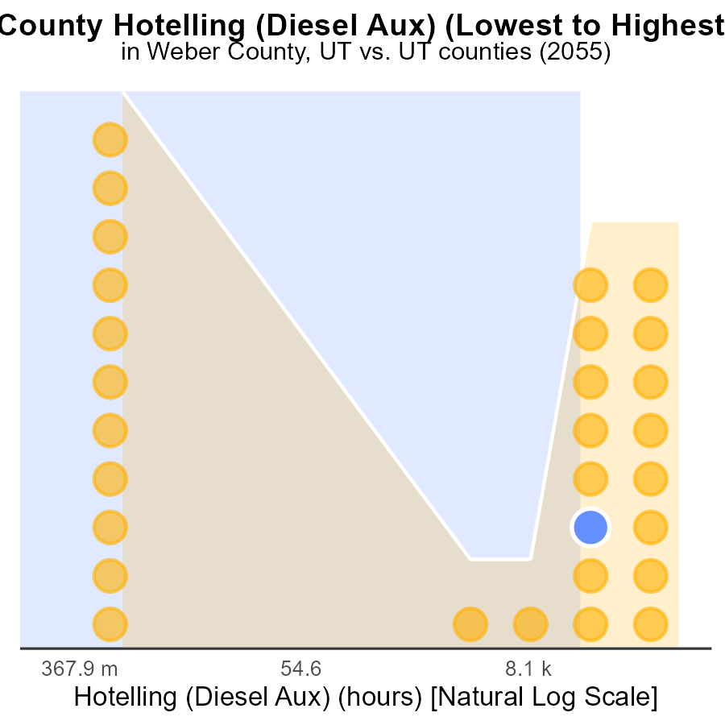

## Findings

* Salt Lake county has the highest PM10 emissions at 657.2 k hours, ranking 29th nationally.
* Sevier county ranks 17th nationally with 88.4 k hours of PM10 emissions, reaching 58.6% of the total percentile.
* Cache county, with 0.0 k hours of PM10 emissions, is the best performer nationally in this category.

## Recommendations

To reduce PM10 emissions, focus on Salt Lake county by promoting cleaner auxiliary power sources in Hotelling operations. Encourage Sevier and Weber counties to implement emission control measures. Implement Cache county's best practices across other counties.

# Areas Ranked by Hotelling (Engines Off)

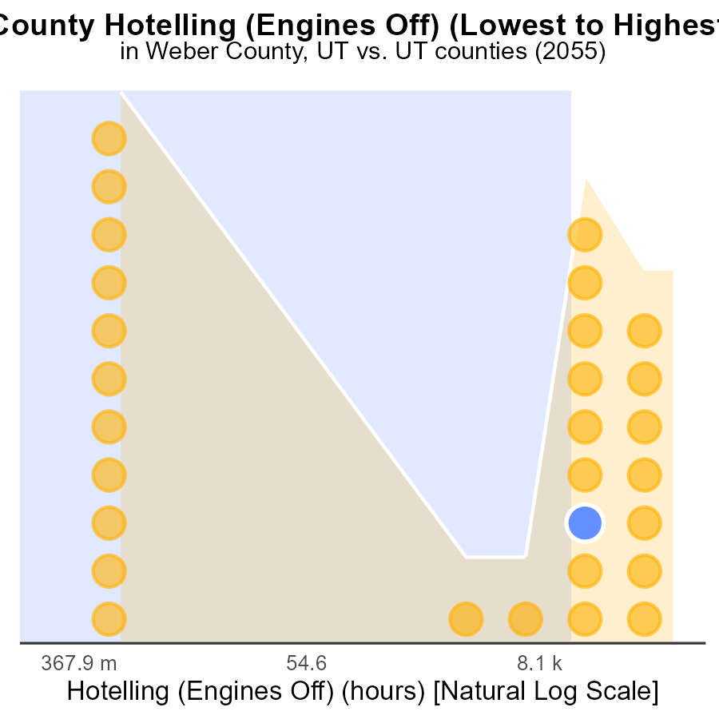

## Findings

* Salt Lake county has the highest PM10 emissions with 410.7k hours.
* Cache county has the lowest PM10 emissions at 0.0 hours.
* Sevier county ranks 17th with 55.2k hours and has the highest percentile of 58.6%.

## Recommendations

To reduce emissions, focus on Salt Lake county by promoting engine-off practices and investing in cleaner technologies. Encourage Cache county to maintain 0 emissions through strictly enforcing regulations. Implement policies in Sevier county to decrease emissions and improve air quality standards.

# Conclusion

In conclusion, the data on Primary Exhaust PM10 - Total emissions from on-road transportation in Weber County, UT for the year 2055 paints a clear picture of the current situation and provides valuable insights for future actions. While the county is projected to experience a decrease in PM10 emissions from vehicles over the next few decades, the overall trend shows a steady increase in emissions, with levels expected to surpass the upper 75th percentile by 2050. To combat this rise and ensure a healthier environment for residents, it is imperative that policymakers prioritize initiatives aimed at reducing emissions and promoting sustainable transportation practices.

Efforts should focus on implementing stricter vehicle emission standards, incentivizing the adoption of electric vehicles, improving public transportation infrastructure, and encouraging carpooling and telecommuting. Additionally, specific attention should be directed towards Combo trucks, which are identified as the primary source of PM10 emissions in Weber County. By enforcing stricter regulations and promoting cleaner fuel technologies for these vehicles, significant progress can be made in lowering emissions and mitigating the potential impact on air quality and public health. Collaborative efforts across different counties, learning from best practices, and tailoring solutions to specific emission contributors will be key in achieving long-term emission reduction goals.

# About This Report

Data based on MOVES estimates collected by the Climate Action in Transportation program at Cornell University. Demographic data sourced from the US Census's American Community Survey 5-year estimates. This report was generated with the help of AI.

# References

* U.S. Census Bureau. (2023). American Community Survey 5-year estimates: Detailed tables. Retrieved from https://data.census.gov
* U.S. Environmental Protection Agency. (2024). Motor Vehicle Emission Simulator (MOVES 4.0) [Software]. Retrieved from https://www.epa.gov/moves