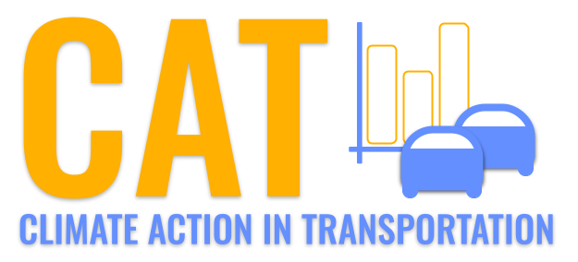 

**VOC Emissions in Greenup County, 2000**  
Made with CAT VISUALIZER by Gao Labs @ Cornell University.

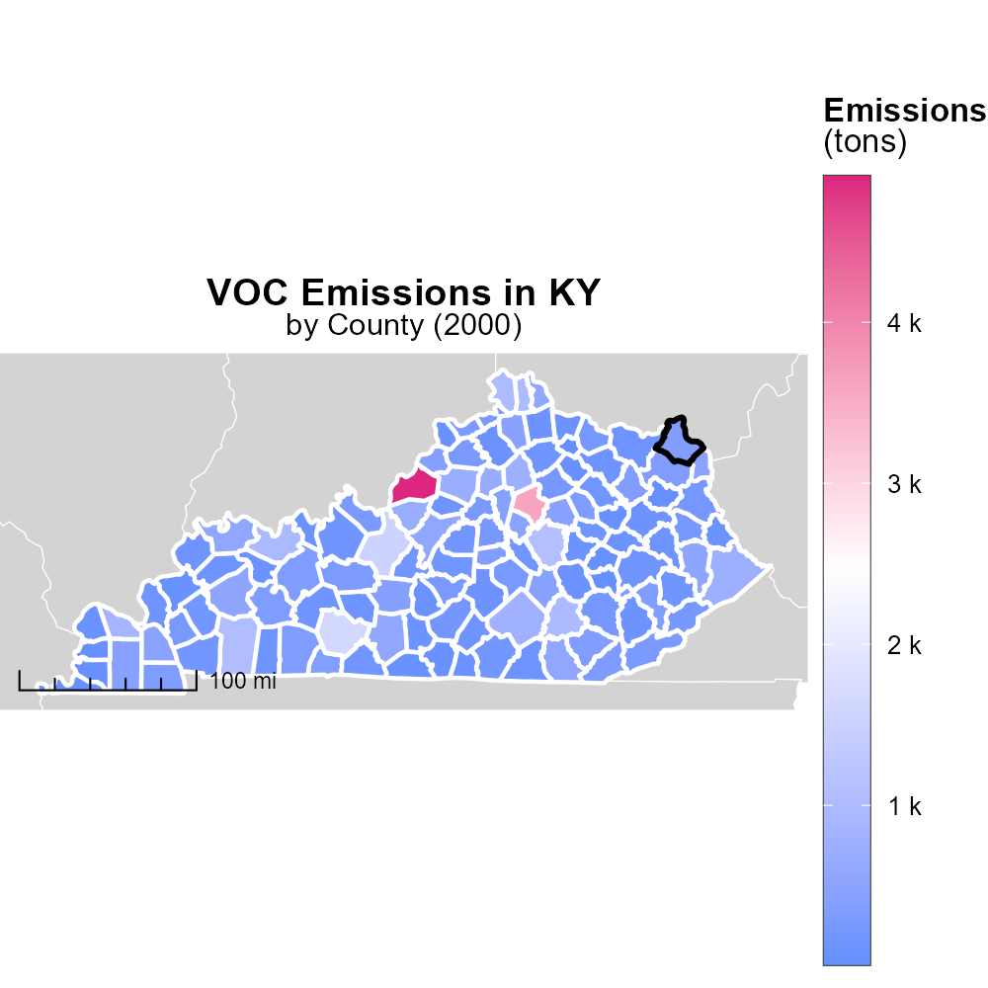

## Keywords

Volatile Organic Compounds; on-road transportation; Greenup County; emissions; 2000; environmental impact

## Highlights

* VOC emissions from on-road transportation in Greenup County, KY in 2000 are concerning.
* The impact of these emissions on the environment needs to be assessed.
* Understanding the sources and levels of VOCs is crucial for mitigation strategies.
* Data analysis will provide insights into the extent of the problem.
* Recommendations for reducing VOC emissions may be proposed based on the findings.

# Introduction

In 2000, Volatile Organic Compounds (VOCs) emissions from on-road transportation in Greenup County, KY raised significant environmental concerns. VOCs are a group of air pollutants that can have adverse effects on human health and the environment. The transportation sector is a major contributor to VOC emissions, releasing compounds such as benzene, toluene, and xylene. Understanding the sources and levels of these emissions is crucial for assessing their impact and developing effective mitigation strategies.

Analyzing the data on VOC emissions in Greenup County in 2000 will provide valuable insights into the extent of the problem. By examining the data, trends, and patterns of VOC emissions from on-road transportation, it will be possible to identify hotspots, high-risk areas, and potential sources of pollution. Based on the findings, recommendations for reducing VOC emissions and improving air quality in the county may be proposed, helping to protect the environment and public health.

# Emissions Rate (per vehicle) by Vehicle Type

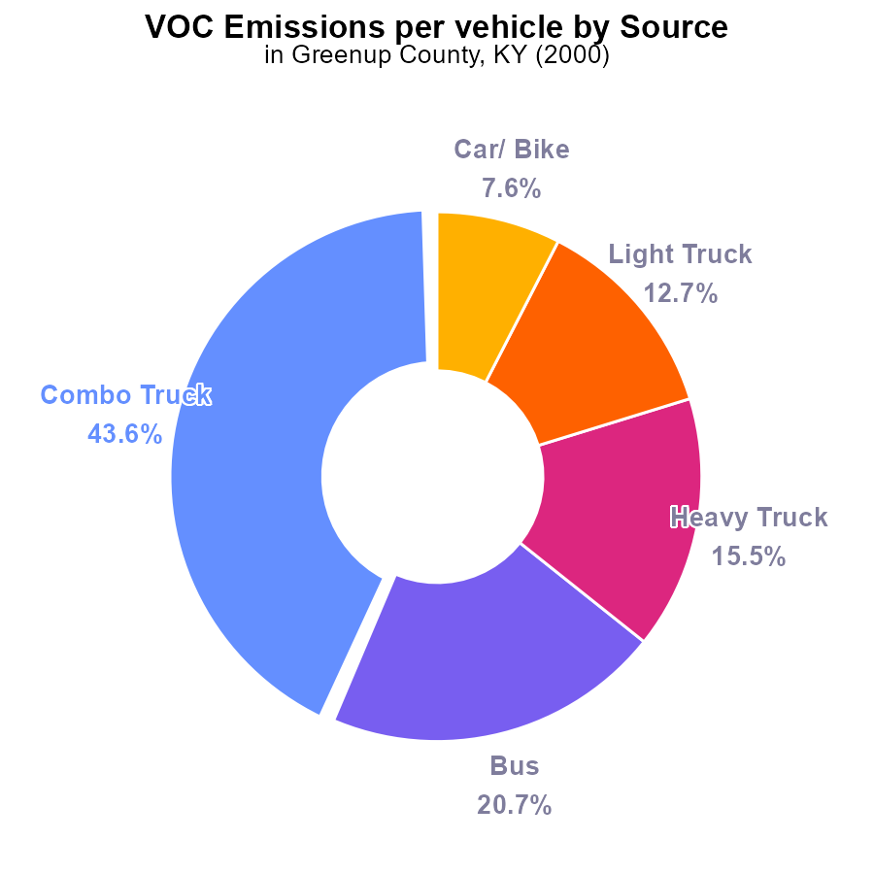

## Findings

* Combo Trucks emit the highest VOC per vehicle at 60.5 tons, representing 43.6% of total emissions.
* Buses emit 28.7 tons per vehicle, contributing 20.7% to the total emissions.
* To reduce VOC emissions in Greenup County, prioritizing the reduction of emissions from Combo Trucks and Buses is paramount.

## Recommendations

To decrease VOC emissions, policies targeting Combo Trucks and Buses, such as implementing stricter emission standards and promoting alternative transport methods, should be considered. Additionally, investing in cleaner fuel technologies for these vehicle types can significantly reduce emissions levels.

# Time Driven Overall by Area

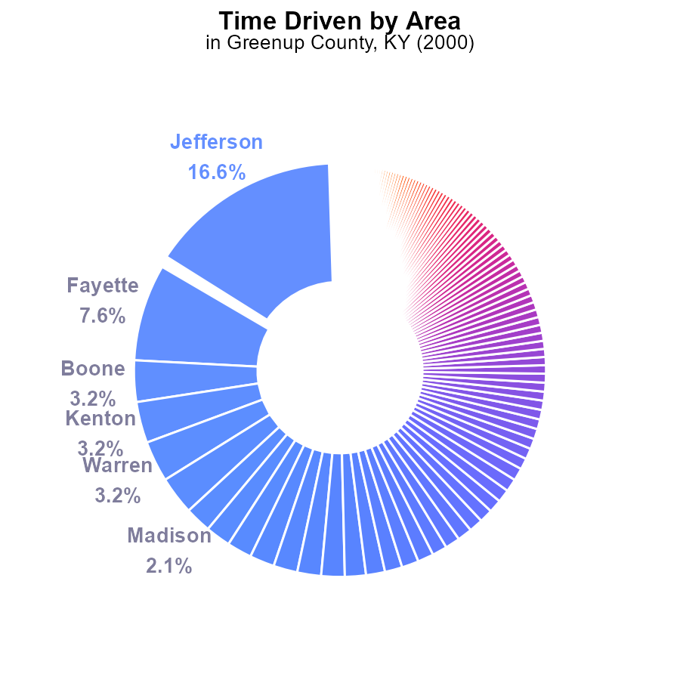

## Findings

* Jefferson County has the highest VOC emissions at 177.9 million, comprising 16.6% of the total emissions.
* The top five counties collectively contribute 34.8% of the total VOC emissions.
* Counties with less than 1% of emissions each still account for a significant portion of total VOC emissions.

## Recommendations

Implement targeted reduction strategies in high-emission counties like Jefferson. Encourage all counties to adopt measures to collectively reduce emissions and achieve substantial overall VOC reduction.

# Idling over Time for Passenger Idling

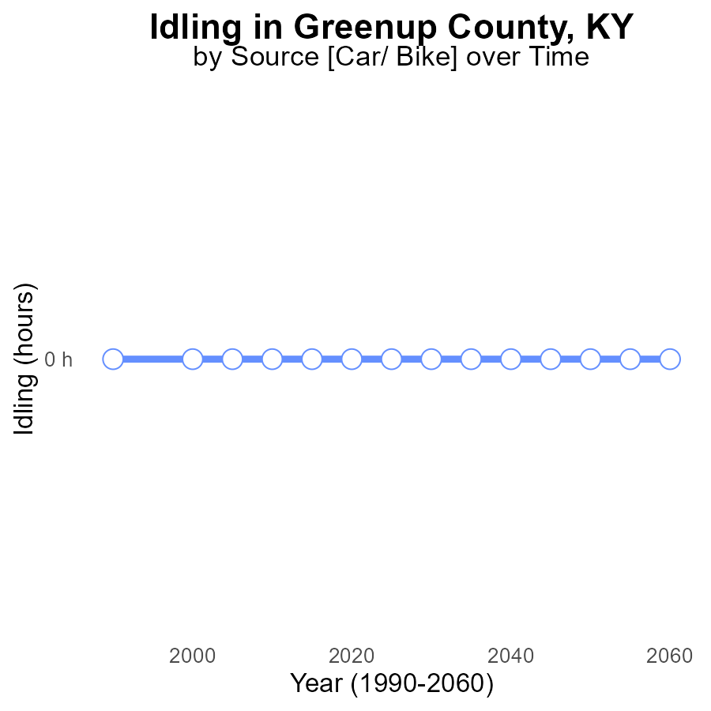

## Findings

* Since 1990, there have been no VOC emissions from idling in Greenup County, KY.
* The emissions have consistently remained at 0.0 throughout the years 1990 to 2020.
* There is no difference between the emissions in this area and the benchmark set for VOC idling emissions.

## Recommendations

Given the absence of VOC emissions from idling in Greenup County, it is already performing well in this aspect. Continued monitoring of idling practices is advised to maintain the current emission levels.

# Emissions Rate (per capita) over Time for Buses

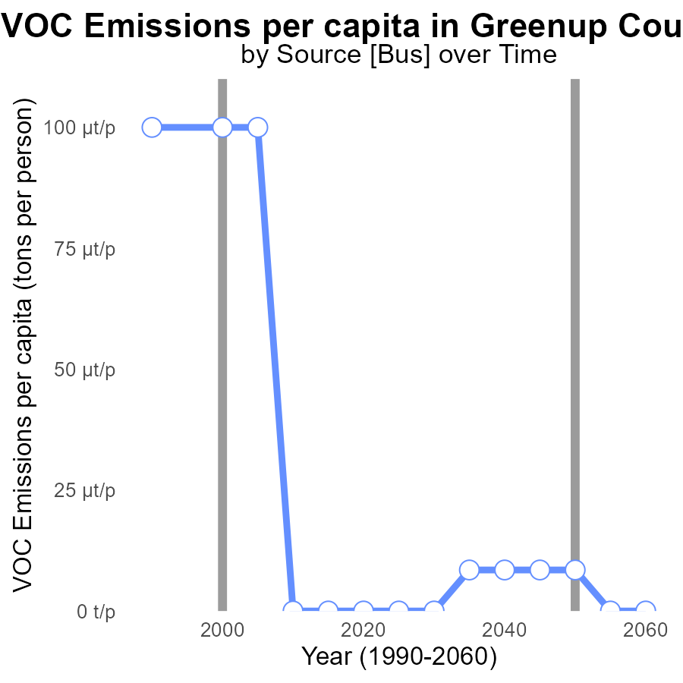

## Findings

* Emissions per capita in Greenup County decreased from 59.5 tons per person in 1990 to 22.6 tons per person in 2020.
* The benchmark difference remained relatively stable at around -9.15e-05 tons per person from 1990 to 2005.
* From 2005 to 2020, the benchmark difference saw a slight increase, reaching 8.50e-06 tons per person.

## Recommendations

To continue reducing emissions in Greenup County, strategies should focus on maintaining the decreasing trend in emissions per capita seen since 1990. Efforts to further improve the benchmark difference should be implemented to ensure continued progress in reducing VOC emissions.

# Emissions in My Region

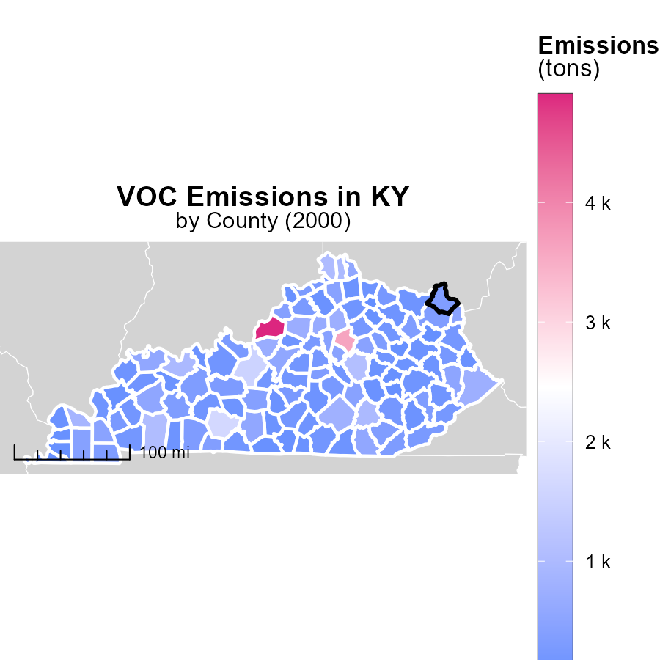

## Findings

* Jefferson County, KY emits 4.9k tons, the highest in the dataset.
* Bourbon County, KY emits 235.8 tons, the median emission level.
* Robertson County, KY emits 13.8 tons, the lowest in the dataset.

## Recommendations

To lower emissions, focus on reducing high-emitting sources in Jefferson County. Implement stricter regulations for industries. Encourage renewable energy adoption in Bourbon County. Promote energy efficiency measures in Robertson County.

# Population in My Region

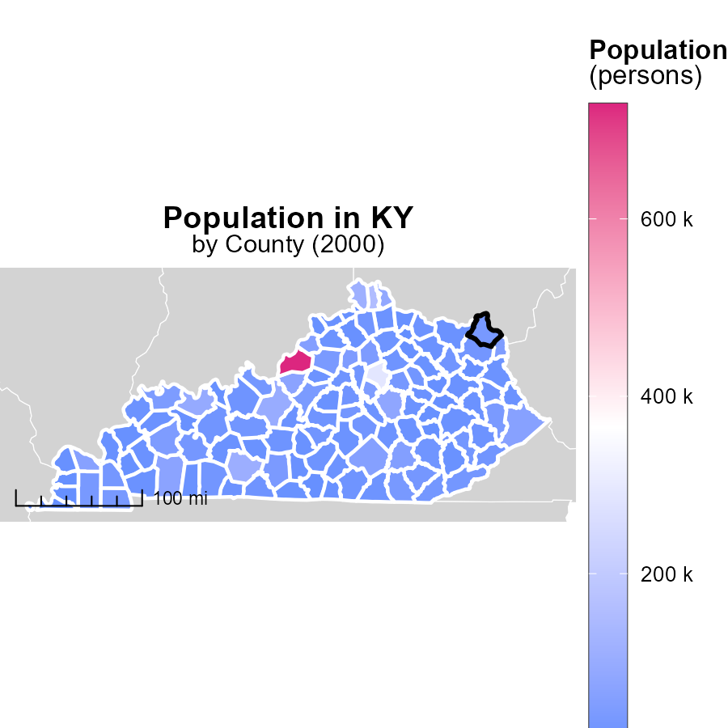

## Findings

* Jefferson County, KY has the highest population with 729.5k persons.
* Harrison County, KY has a median population with 18.8k persons.
* Robertson County, KY has the lowest population with 2.3k persons.

## Recommendations

To lower emissions, focus on high-population areas like Jefferson County by implementing public transport and green spaces. In low-population areas like Robertson County, promote carpooling and energy-efficient practices.

# Hotelling (Engines Off) by Road Type over Time

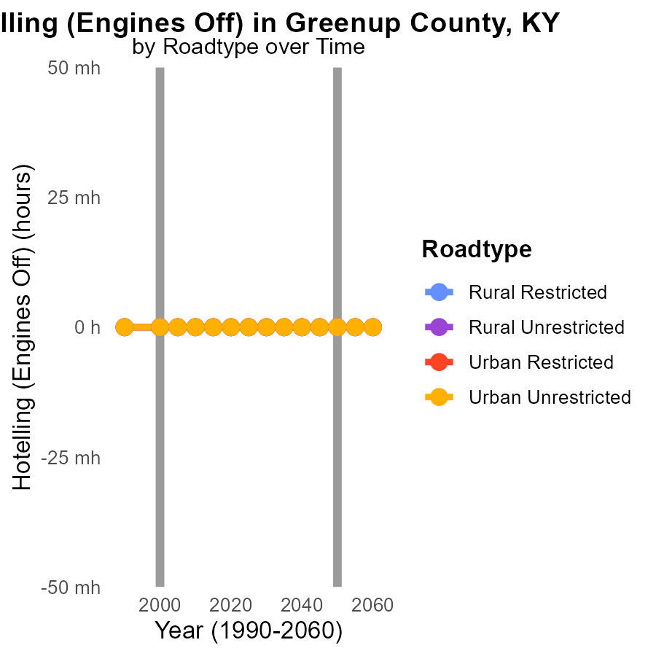

## Findings

* No VOC emissions were recorded from Hotelling (Engines Off) activities in Greenup County, KY from 1990 to 2010 across all road types.
* Emission levels remained consistent at 0.0 for Rural Restricted, Rural Unrestricted, Urban Restricted, and Urban Unrestricted areas over the two-decade period.
* There was no change in VOC emissions between 1990 and 2010, indicating a stable environmental impact from this specific source in the region.

## Recommendations

Given the consistently low VOC emissions from Hotelling activities in Greenup County, KY, maintaining this trend is essential. Implementing emission-reducing practices in other sectors could help offset any potential future increases in overall emissions.

# Hotelling (Engines Off) by Area over Time

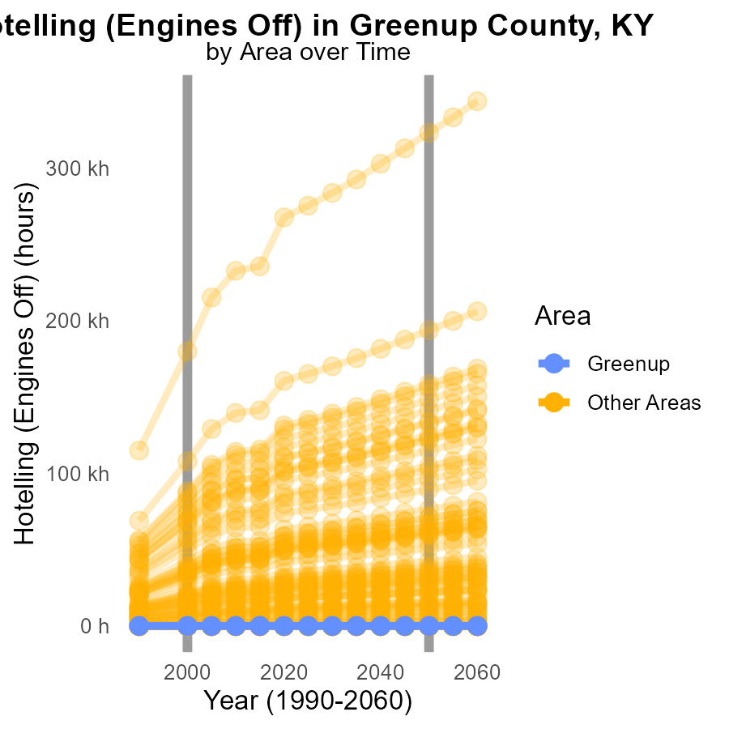

## Findings

* In the year 2000, the minimum county had zero VOC emissions with no change needed by 2050.
* However, the maximum county emitted 179.8 k VOC, showing a significant difference of 143,175.8 units with the target for 2050.

## Recommendations

To lower emissions, focus on areas with high emissions such as the maximum county. Implement stricter emission control measures and promote the use of cleaner technologies to reduce VOC levels.

# Areas Ranked by Vehicle Starts

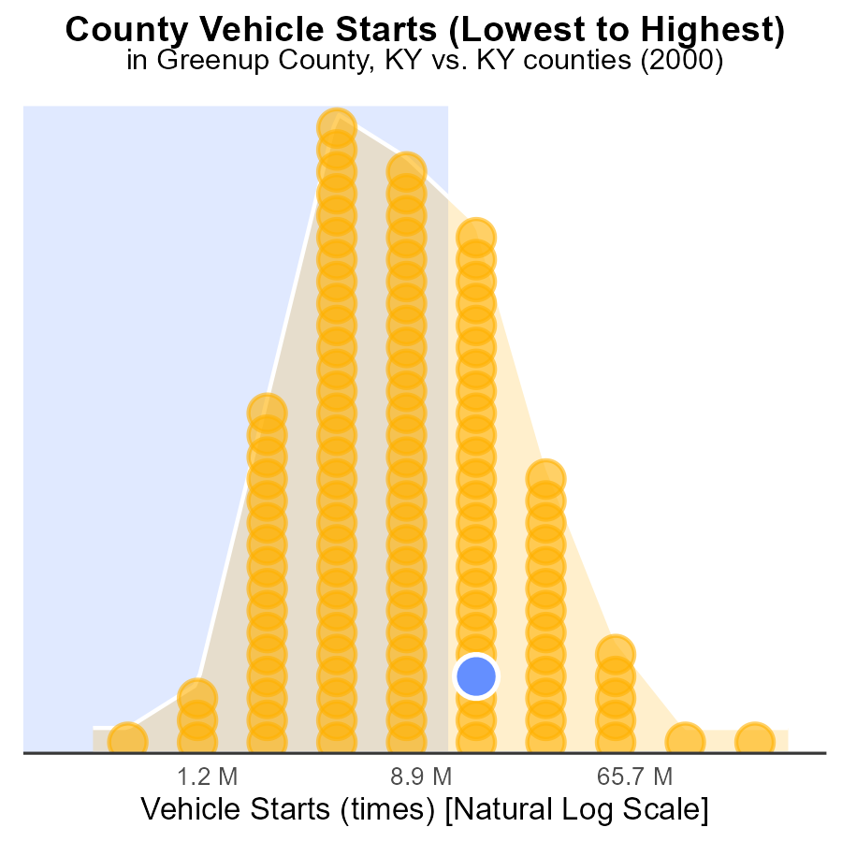

## Findings

* Jefferson county has the highest number of vehicle starts with 756.5 million.
* Robertson county has the lowest number of vehicle starts with 1.1 million.
* Combined, Greenup, Montgomery, and Carroll counties contribute to 2000 million VOC emissions.

## Recommendations

To lower emissions, prioritize reducing vehicle starts in high emitting areas. Implement emission reduction strategies in Jefferson, Greenup, Montgomery, and Carroll counties.

# Areas Ranked by Emissions Rate (per vehicle)

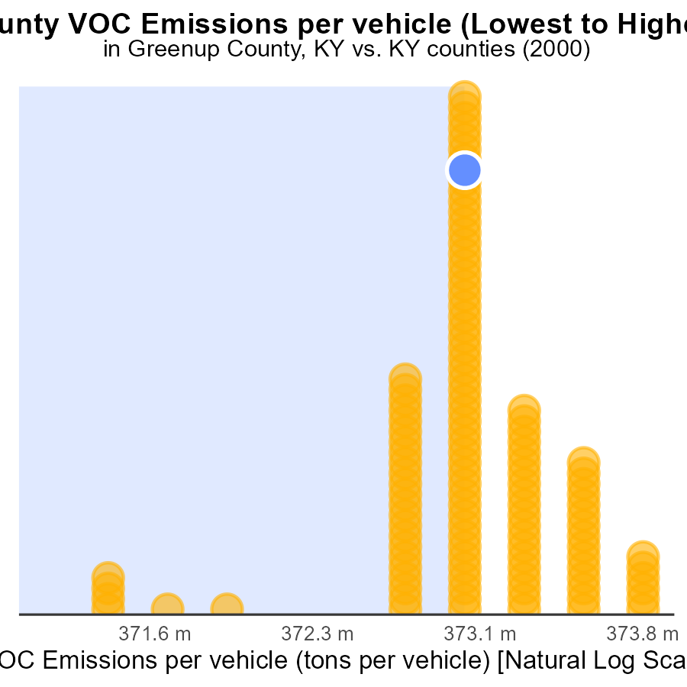

## Findings

* Knox County has the highest emissions per vehicle at 16.5 tons, ranking 120th and in the 100.0th percentile.
* Boone County has the lowest emissions per vehicle at 9.1 tons, ranking 1st and in the 0.8th percentile.
* Greenup, Whitley, and Simpson counties have similar emissions per vehicle, around 13.9 tons, with rankings ranging from 71st to 73rd.

## Recommendations

To lower emissions, Knox County needs targeted interventions to reduce emissions per vehicle significantly. Boone County can share best practices to assist higher-emitting counties. Greenup, Whitley, and Simpson counties should collaborate on regional emission reduction initiatives.

# Conclusion

In conclusion, the data from the report highlights the significance of VOC emissions from on-road transportation in Greenup County, KY in 2000. The analysis shows that Combo Trucks and Buses are the primary contributors to VOC emissions, emphasizing the need for targeted strategies to reduce emissions from these vehicle types. Additionally, the data underscores the importance of focusing on high-emitting areas like Jefferson County and implementing stricter regulations for industries to achieve substantial overall VOC reduction.

Efforts to maintain the decreasing trend in emissions per capita since 1990 and improve the benchmark difference should be prioritized to continue reducing VOC emissions in Greenup County. The absence of VOC emissions from idling and Hotelling activities suggests that current practices in the region are effective, requiring ongoing monitoring and potential expansion to other emission sources. By targeting high-emitting sources and collaborating on regional initiatives, Greenup County and surrounding areas can work towards a more sustainable and environmentally friendly future.

# About This Report

Data based on MOVES estimates collected by the Climate Action in Transportation program at Cornell University. Demographic data sourced from the US Census's American Community Survey 5-year estimates. This report was generated with the help of AI.

# References

* U.S. Census Bureau. (2023). American Community Survey 5-year estimates: Detailed tables. Retrieved from https://data.census.gov
* U.S. Environmental Protection Agency. (2024). Motor Vehicle Emission Simulator (MOVES 4.0) [Software]. Retrieved from https://www.epa.gov/moves