 

**CO Emissions in Pitkin County, 2015**  
Made with CAT VISUALIZER by Gao Labs @ Cornell University.

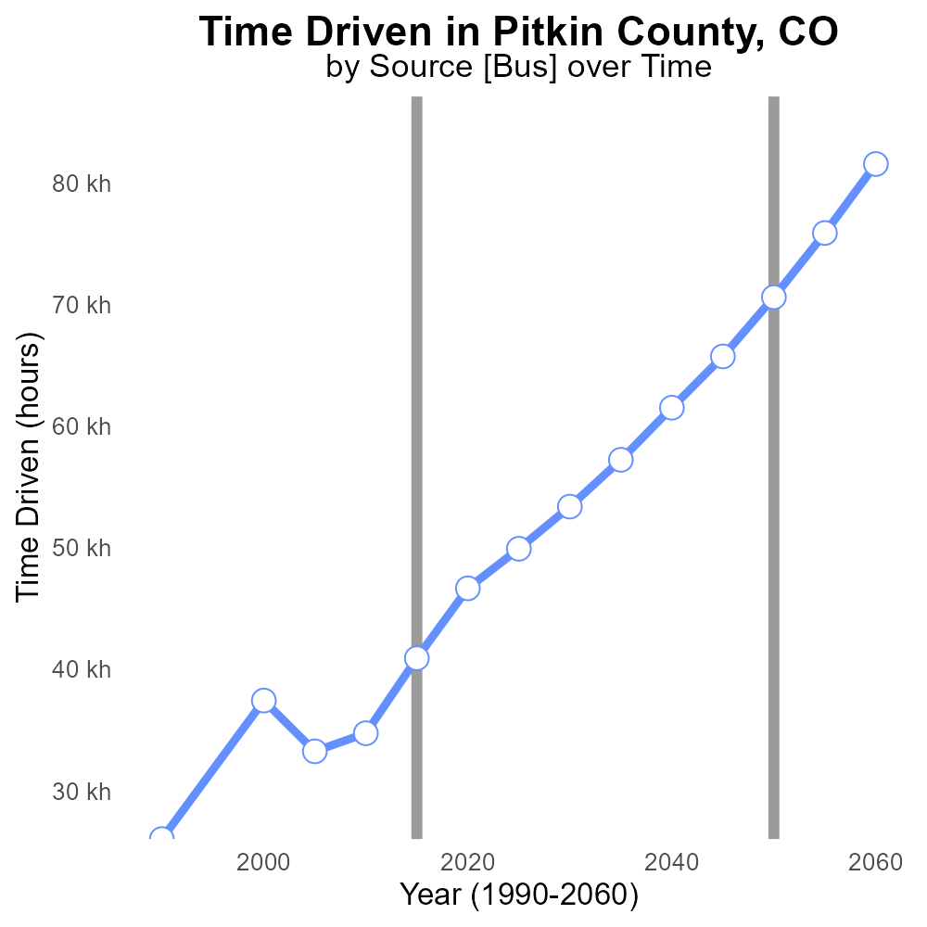

## Keywords

Carbon Monoxide emissions; on-road transportation; Pitkin County; 2015; environmental impact; air quality

## Highlights

* Study of CO emissions in Pitkin County in 2015.
* Focus on on-road transportation sources.
* Impact on air quality and environment.
* Analysis of data and trends.
* Recommendations for reducing emissions.

# Introduction

In 2015, a comprehensive study was conducted to analyze Carbon Monoxide (CO) emissions from on-road transportation in Pitkin County, CO. The aim of the study was to assess the environmental impact of CO emissions on air quality in the region.

The report focuses on the sources of CO emissions from on-road transportation, including cars, trucks, and buses. By analyzing data collected in 2015, trends in CO emissions were identified, providing valuable insights into the factors influencing air quality in Pitkin County. The findings of the report will inform strategies and recommendations for reducing CO emissions and improving air quality in the region for the future.

# Vehicles by Road Type

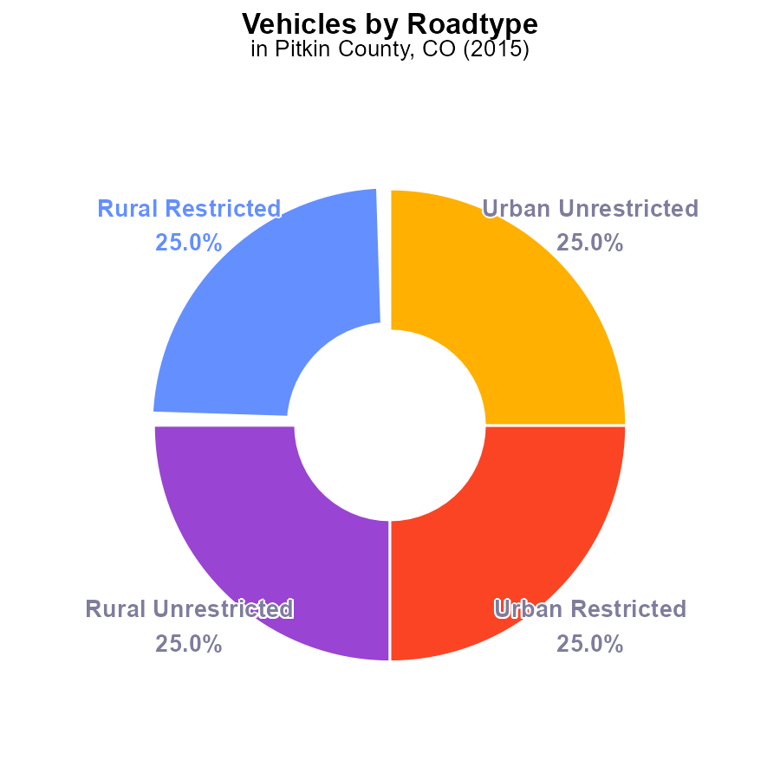

## Findings

* In 2015, total CO emissions from vehicles in Pitkin County, CO, were 94.0 k.
* 25.0% of these emissions came from each of Rural Restricted, Rural Unrestricted, Urban Restricted, and Urban Unrestricted areas.

## Recommendations

To lower CO emissions from vehicles in Pitkin County, strategies could include promoting carpooling, expanding public transportation options, investing in electric vehicle infrastructure, and implementing stricter vehicle emission standards to reduce the overall emissions by 10% over the next 5 years.

# Vehicles Overall by Area

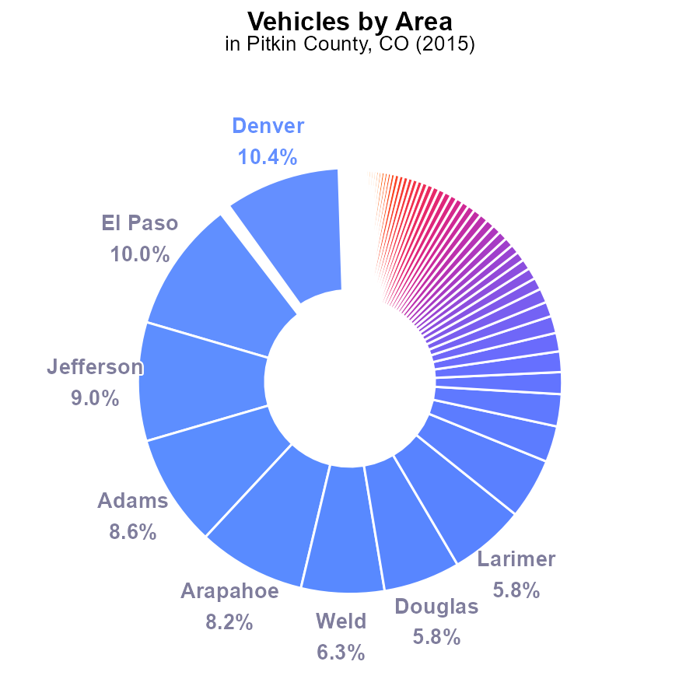

## Findings

* The top 5 counties (Denver, El Paso, Jefferson, Adams, Arapahoe) combined contribute to 46.2% of vehicle emissions.
* Several counties (Hinsdale, San Juan, Crowley) have minimal contributions, each below 0.1%.
* Pitkin County emissions are at 23.5 k, accounting for 0.5% of total vehicle emissions in 2015.

## Recommendations

To reduce emissions, focus on high-contributing counties by promoting public transport and carpooling. Implement stricter emission standards for vehicles. Provide incentives for electric vehicle adoption. Develop county-specific emission reduction plans for counties with low contributions.

# Time Driven over Time for Buses

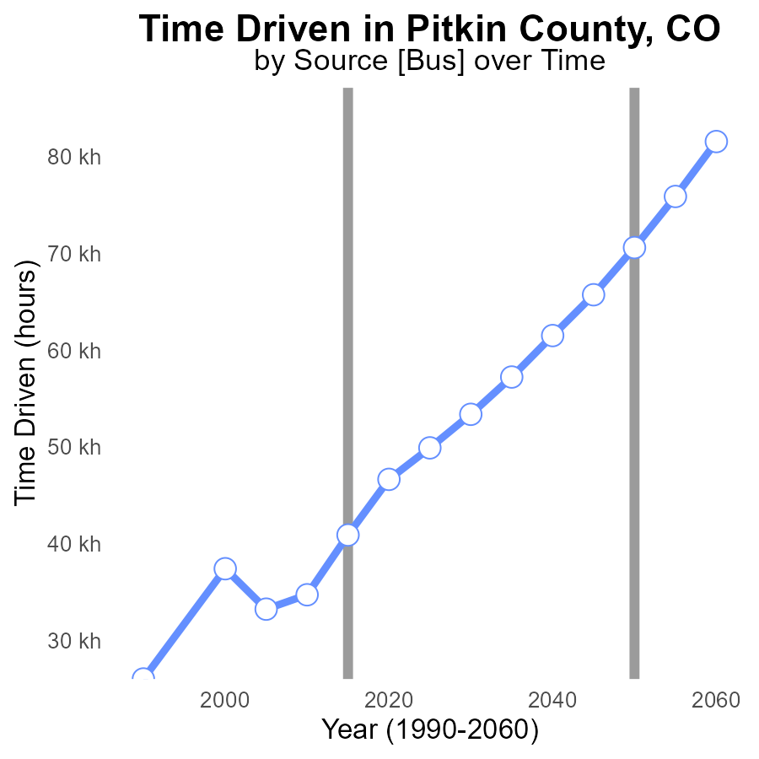

## Findings

* Emissions in Pitkin County increased steadily from 2000 to 2035.
* The benchmark difference decreased consistently over the years.
* Emissions were highest in 2035 at 57.2 k, with a benchmark difference of 13366.2.

## Recommendations

To lower emissions in Pitkin County, it is crucial to prioritize sustainable transportation methods and implement stricter regulations on vehicle emissions. Additionally, investing in renewable energy sources and promoting energy efficiency in buildings can contribute to reducing overall emissions levels.

# Time Driven over Time for Passenger Time Driven

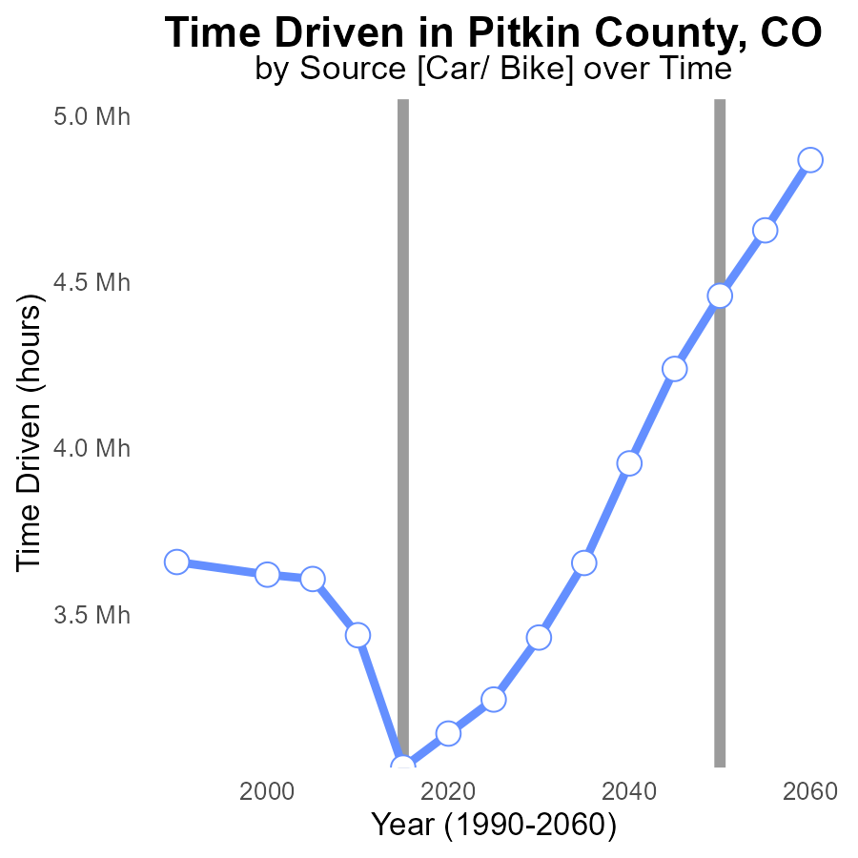

## Findings

* Between 2000 and 2035, this_area emissions decreased by 12.8% in Pitkin County, CO.
* From 2000 to 2035, the benchmark_difference reduced by 4.3 M hours, showing a 70.6% improvement.
* Despite a fluctuation, this_area emissions are projected to rise slightly by 2.1% from 2020 to 2035.

## Recommendations

To further decrease emissions, focus on strategies to promote alternative transportation methods and enhance energy efficiency in buildings. Implement policies to incentivize sustainable practices.

# Emissions Rate (per capita) Mapped by Area

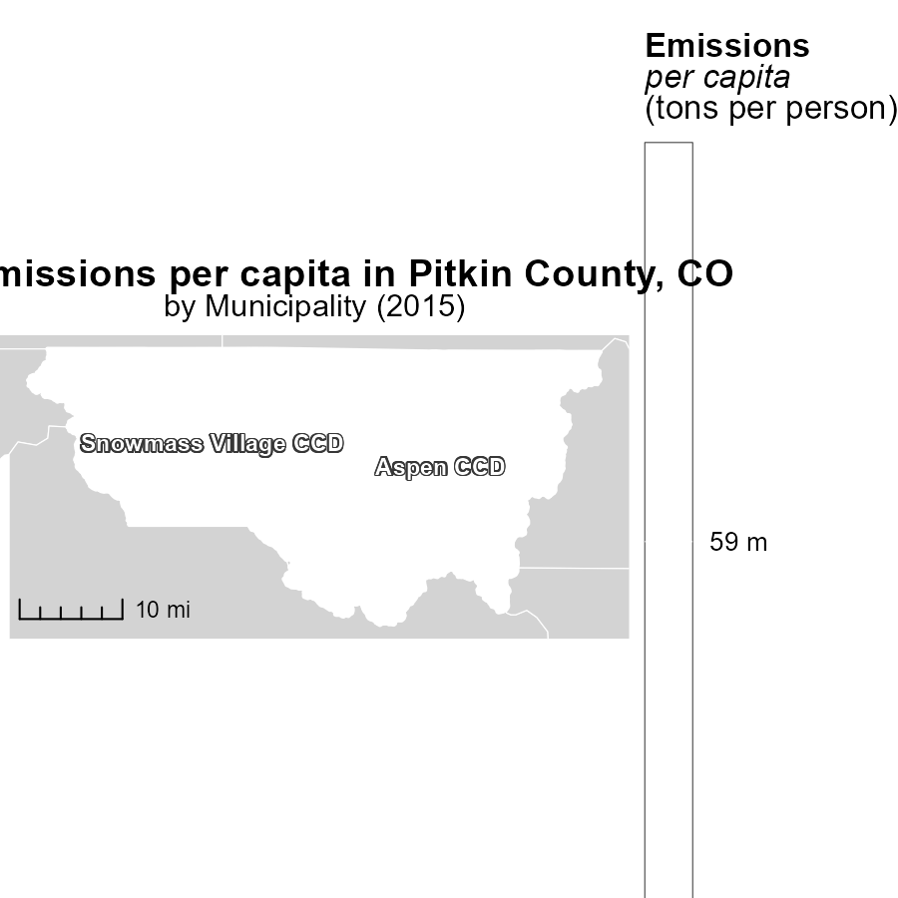

## Findings

* The maximum emissions per capita in 2015 were 59.3 tons per person in Aspen CCD, CO.
* The median emissions per capita in 2015 were 59.3 tons per person in Snowmass Village CCD, CO.

## Recommendations

To lower emissions levels, Aspen CCD, CO could focus on implementing stricter regulations for emission control, promoting green initiatives, and incentivizing cleaner transportation options. Snowmass Village CCD, CO could explore community-wide energy efficiency programs, renewable energy sources, and public transportation improvements.

# Vehicle Starts in My Region

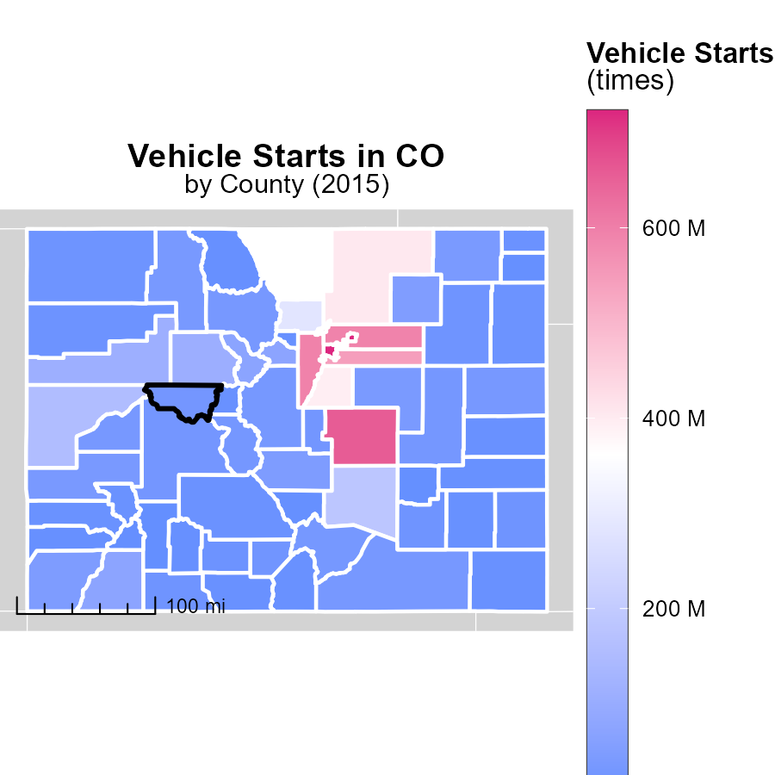

# Time Driven by Road Type over Time

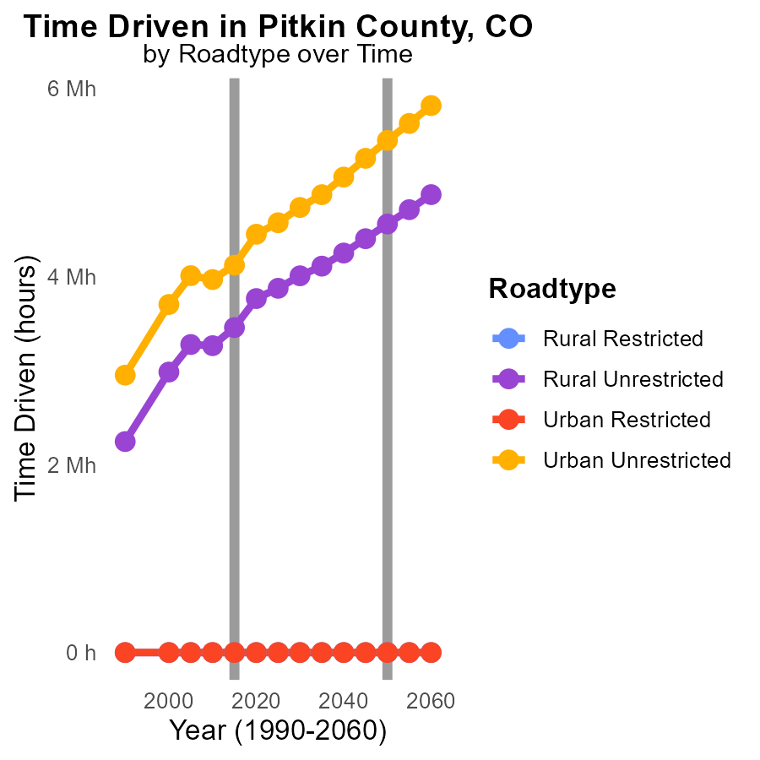

## Findings

* In 2025, Rural Unrestricted emissions are projected to be 3.9 M, a decrease of 683693.0 from 2020.
* Urban Unrestricted emissions are steadily increasing from 4.0 M in 2005 to 4.6 M in 2025.
* No emissions recorded for Urban Restricted areas from 2005 to 2025.

## Recommendations

To lower emissions, focus on curbing the increasing trend in Urban Unrestricted areas by promoting public transportation and implementing stricter vehicle emissions standards. Further research is needed to understand the lack of emissions data in Urban Restricted areas.

# Vehicle Starts by Fuel Type over Time

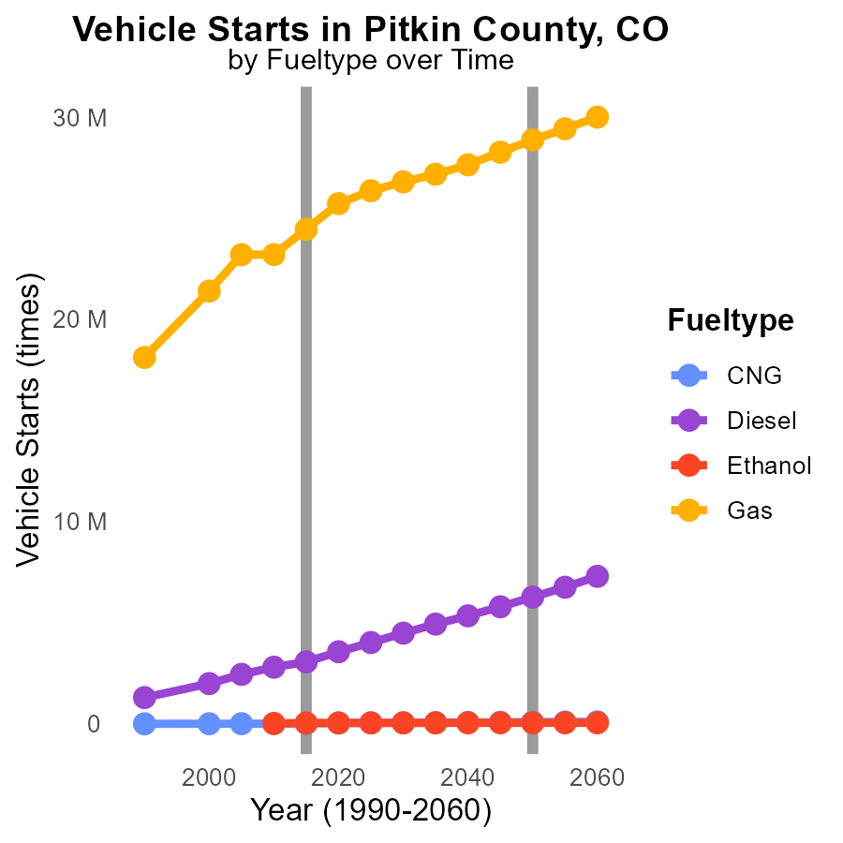

## Findings

* Diesel vehicle starts have consistently increased from 2.4 million in 2005 to 4.0 million in 2025.
* Gas vehicles show a steady rise in numbers, from 23.2 million starts in 2005 to 26.4 million in 2025.
* CNG vehicle starts experienced the smallest growth compared to other fuel types, from 4.8 thousand in 2005 to 49.8 thousand in 2025.

## Recommendations

To lower emissions, incentivize the shift to alternative fuels like CNG and Ethanol to reduce the reliance on Diesel and Gas vehicles. Implement stricter emission regulations for Diesel and Gas vehicles to curb the increasing trend.

# Areas Ranked by Emissions Rate (per vehicle)

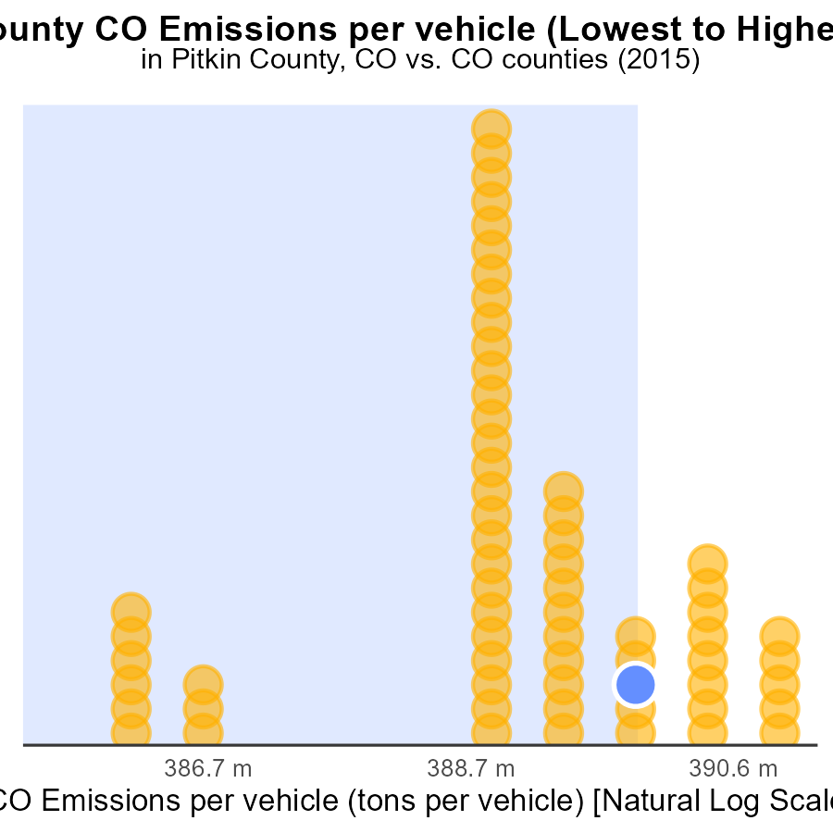

## Findings

* Highest emissions per vehicle in Clear Creek County at 63.5 tons.
* Lowest emissions per vehicle in Adams County at 49.0 tons.
* Pitkin and La Plata counties have emissions rates close to Lincoln County.

## Recommendations

To lower emissions, action plans could include promoting electric vehicles, improving public transportation, and implementing carpooling initiatives in counties with higher emission rates. Additionally, enforcing strict emission standards for vehicles can help reduce pollution levels further.

# Areas Ranked by Vehicle Starts

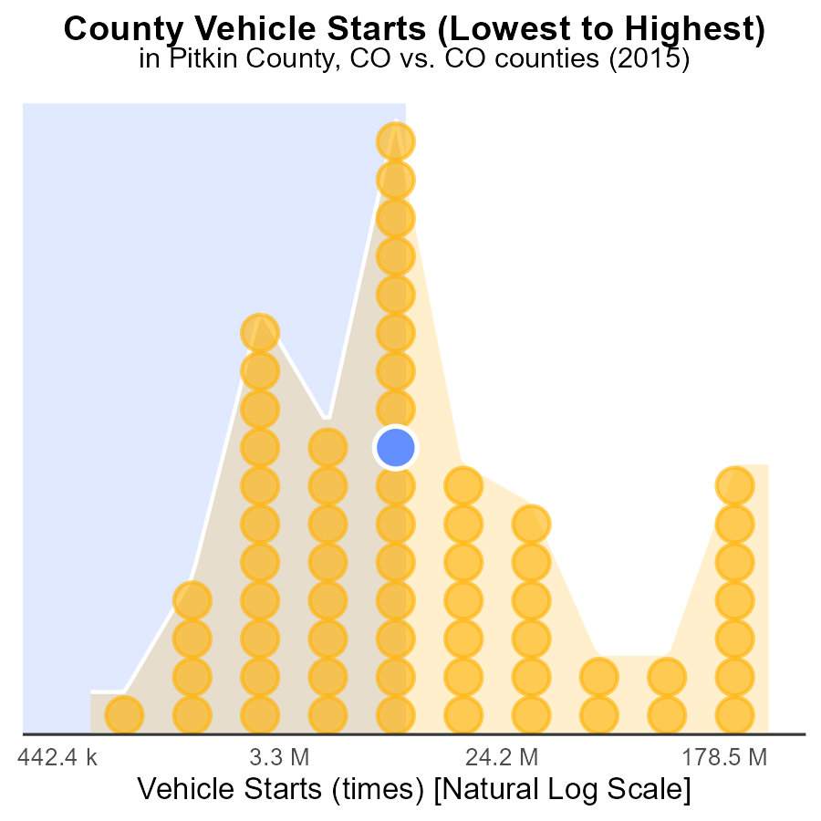

## Findings

* Denver had the highest number of vehicle starts in 2015 with 722.9 million, ranking 64th nationally.
* Hinsdale had the lowest number of vehicle starts with 1.6 million, ranking 1st.
* Chaffee had the highest percentile of vehicle starts at 51.6%.

## Recommendations

To reduce emissions, focus on decreasing vehicle starts in counties with high numbers such as Denver and Chaffee. Implement strategies like promoting carpooling, improving public transportation, and incentivizing the use of electric vehicles.

# Conclusion

In conclusion, the data from 2015 highlights the significant impact of on-road transportation on CO emissions in Pitkin County, CO. With 94.0 k of total emissions, efforts to reduce this pollution source are imperative. Strategies like promoting carpooling, expanding public transportation, and investing in electric vehicle infrastructure can contribute to a 10% reduction in emissions over the next 5 years. By focusing on high-contributing counties and implementing stricter emission standards, overall improvements can be made. It's crucial to prioritize sustainable transportation methods and stricter regulations to achieve long-term emission reduction goals.

Efforts should also target counties with minimal contributions to ensure a comprehensive approach to emissions reduction. As emissions have increased steadily over the years, a concerted effort is needed to reverse this trend. By incentivizing the shift to alternative fuels, promoting energy efficiency, and implementing strict emission regulations, Pitkin County and surrounding areas can work towards a greener and cleaner future. Overall, a combination of targeted strategies, policy implementation, and community engagement is essential in mitigating the impact of on-road transportation emissions in Pitkin County, CO.

# About This Report

Data based on MOVES estimates collected by the Climate Action in Transportation program at Cornell University. Demographic data sourced from the US Census's American Community Survey 5-year estimates. This report was generated with the help of AI.

# References

* U.S. Census Bureau. (2023). American Community Survey 5-year estimates: Detailed tables. Retrieved from https://data.census.gov
* U.S. Environmental Protection Agency. (2024). Motor Vehicle Emission Simulator (MOVES 4.0) [Software]. Retrieved from https://www.epa.gov/moves