 

**PM10 Emissions in Lancaster County, 2050**  
Made with CAT VISUALIZER by Gao Labs @ Cornell University.

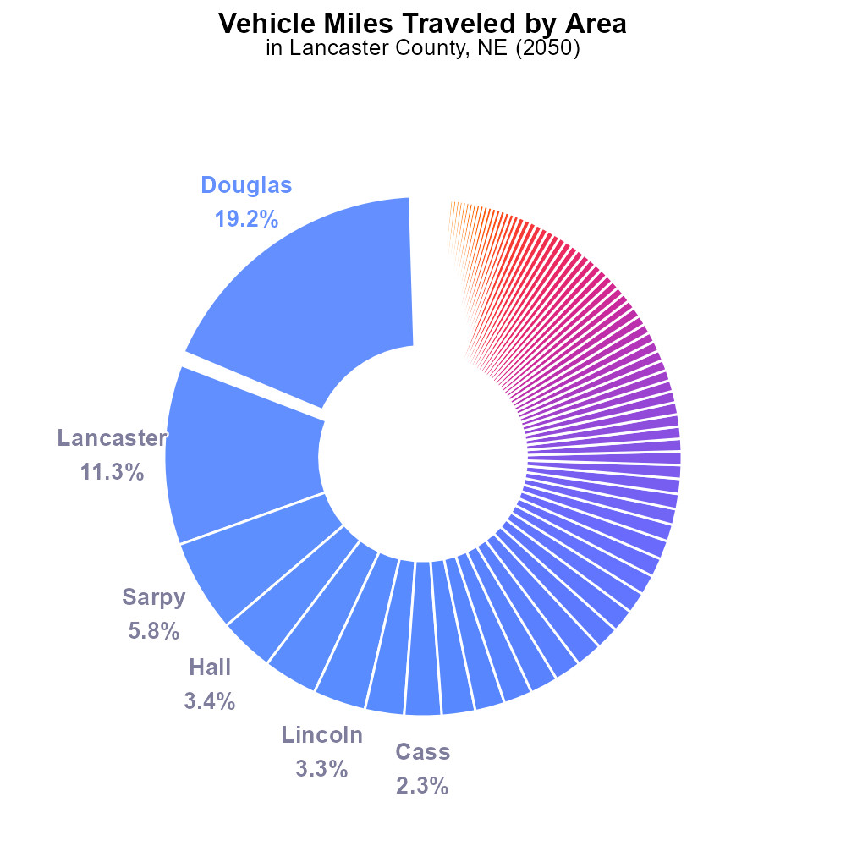

## Keywords

exhaust emissions; PM10; on-road transportation; Lancaster County; 2050; total emissions

## Highlights

* Study evaluates primary exhaust PM10 emissions from on-road transportation in Lancaster County, NE in 2050.
* Analysis focuses on the total emissions impact and potential implications for air quality and public health.
* Insight into future trends and policies to mitigate on-road transportation emissions is provided.
* Data-driven approach adopted to accurately assess the primary exhaust PM10 emissions in the region.
* Findings aim to inform decision-makers on sustainable transportation strategies for a cleaner environment.

# Introduction

This report presents a comprehensive analysis of primary exhaust PM10 emissions from on-road transportation in Lancaster County, NE, focusing on the year 2050. The study aims to scrutinize the total emissions generated by various vehicles on the county's roads and assess the potential impact on air quality and public health. By delving into on-road transportation emissions, this report provides valuable insights into future trends, challenges, and opportunities for policymakers and stakeholders to address the pressing issue of pollution.

Through a data-driven approach, the report offers a detailed examination of the primary exhaust PM10 emissions, offering a nuanced understanding of the sources and quantities involved. The findings of this analysis are intended to serve as a foundation for informed decision-making and the formulation of sustainable transportation strategies that prioritize environmental health and quality of life for residents of Lancaster County.

# Vehicle Miles Traveled Overall by Area

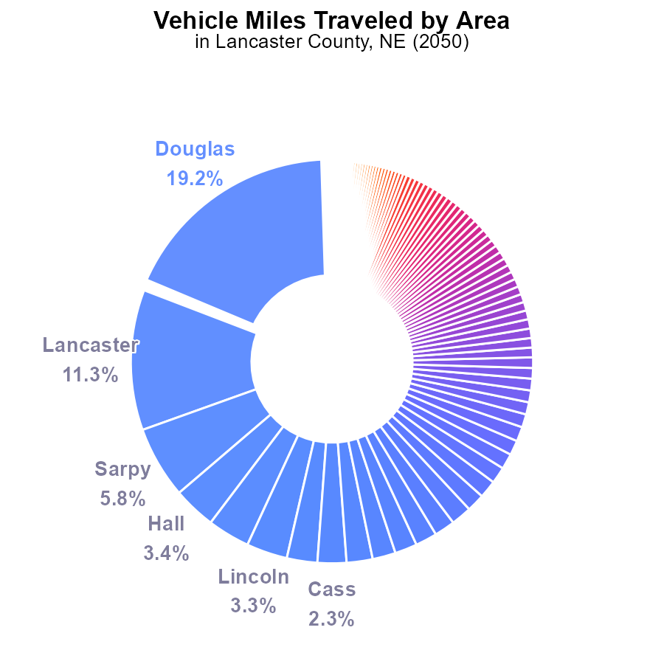

## Findings

* The top 3 counties, Douglas, Lancaster, and Sarpy, together contribute to 36.3% of PM10 emissions.
* Nearly half of all counties (49 out of 93) produce less than 0.2% of PM10 emissions individually.
* A significant number of counties (23 out of 93) emit less than 0.1% of PM10, with Arthur County being the lowest contributor at 0.0%.

## Recommendations

To lower PM10 emissions, prioritize reduction efforts in high-contributing counties like Douglas, Lancaster, and Sarpy. Implement stricter vehicle emission standards and promote the use of electric vehicles in these areas. For counties with minimal contributions, encourage sustainable transport options and vehicle maintenance to further reduce emissions.

# Vehicle Starts by Road Type

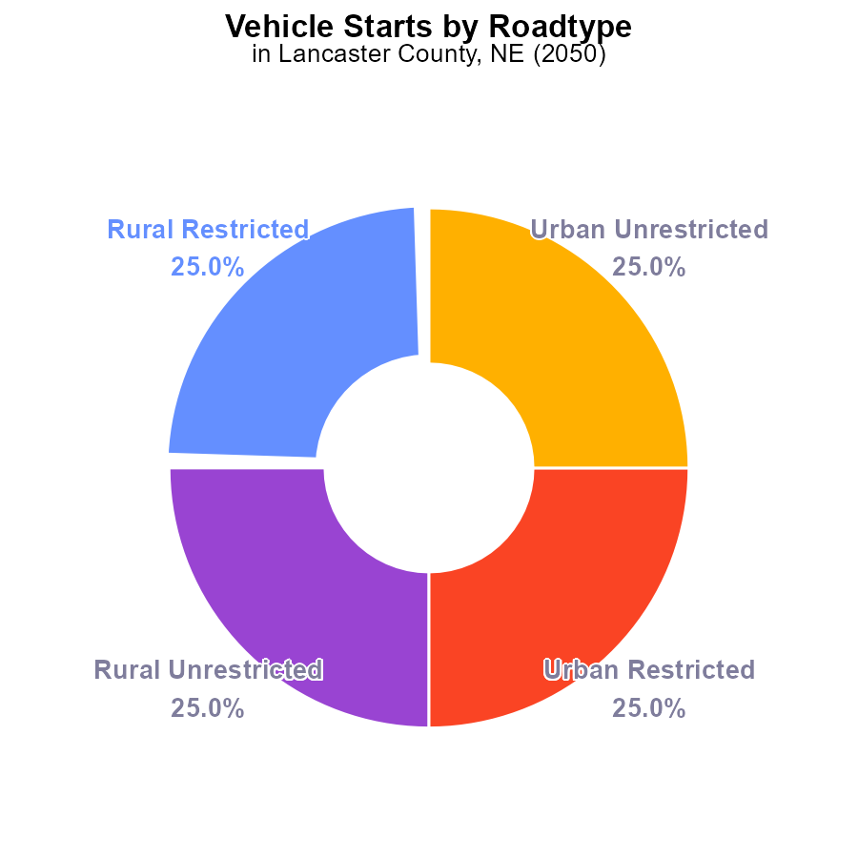

## Findings

* PM10 emissions in Lancaster County, NE from vehicle starts in 2050 are approximately 1,510 M times.
* Rural and urban areas contribute equally to PM10 emissions, each at 50%.
* There is a significant amount of PM10 emissions attributed to vehicle starts in Lancaster County.

## Recommendations

To lower the PM10 emissions from vehicle starts in Lancaster County, a comprehensive approach is needed. Implementing stricter vehicle emission standards, promoting the use of electric vehicles, and investing in public transportation infrastructure can help significantly reduce emissions.

# Population Overall over Time

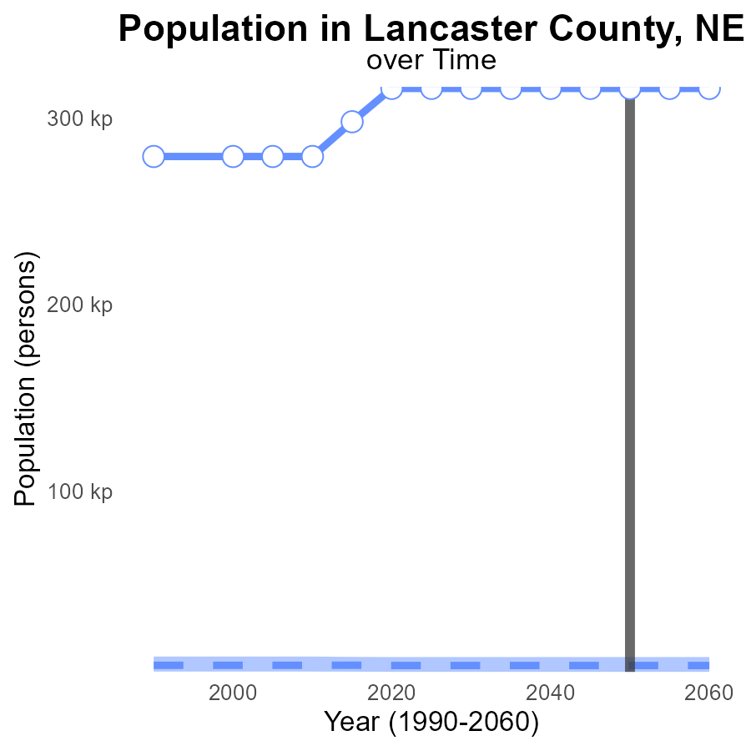

## Findings

* Lancaster County PM10 emissions in 2030-2060 remain at 316.0k, significantly higher than the median of 6193 persons.
* The upper 75% of areas have emissions around 10725 persons, contrasting with the lower 25% at 2788 persons.
* Benchmark difference indicates a vast disparity, highlighting the urgent need for emission reduction strategies.

## Recommendations

To lower PM10 emissions, policymakers should implement stricter regulations on industries and vehicle emissions, invest in clean energy sources, promote public transportation, and enhance green spaces to absorb pollutants.

# Time Driven over Time for Buses

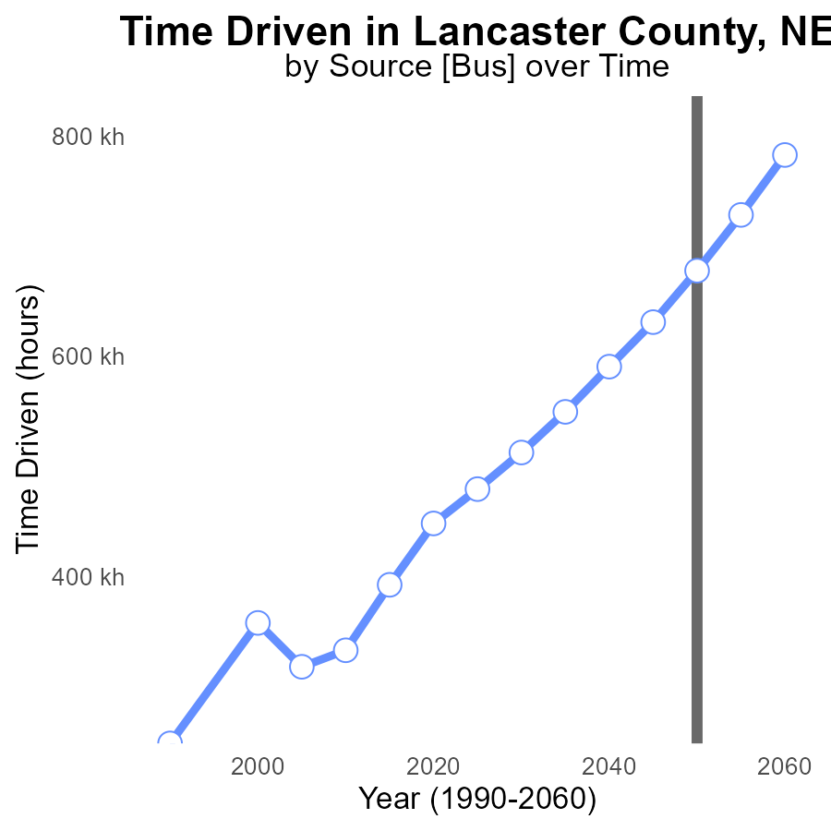

## Findings

* PM10 emissions in Lancaster County are projected to decrease over the next 30 years.
* By 2050, emissions are expected to be reduced by 677.6 k from a 2030 baseline of 512.4 k.
* The largest reduction is forecasted between 2045 and 2050, with a decrease of 163.3 k in PM10 emissions.

## Recommendations

To continue the declining trend in PM10 emissions, policymakers should focus on transitioning to cleaner energy sources, incentivizing electric transportation, and implementing stricter emissions regulations on industries.

# Population Mapped by Area

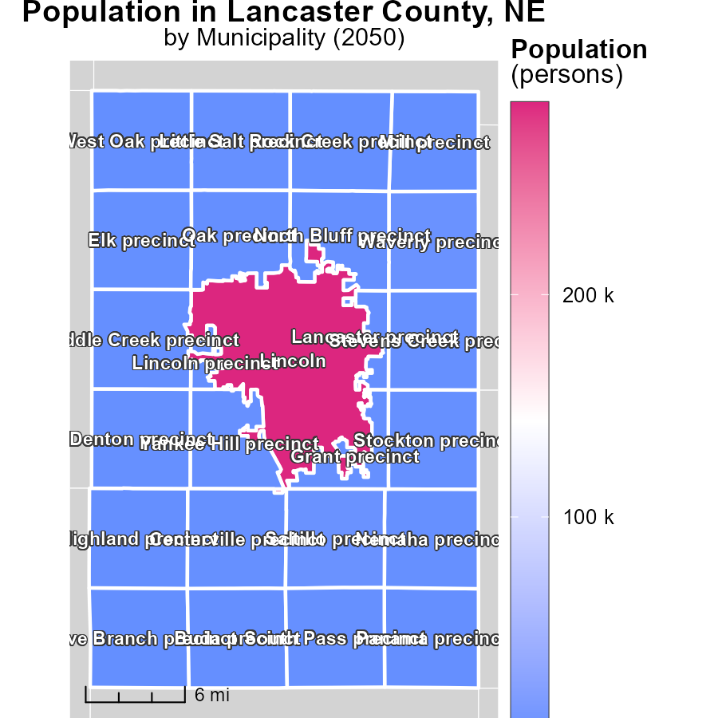

## Findings

* Population in Lincoln, NE is 286.4k, in Elk precinct, NE it is 1k, and in Mill precinct, NE it is 230.
* Population distribution varies greatly among the three locations.
* Lincoln, NE has the highest population, followed by Mill precinct, NE, and Elk precinct, NE.

## Recommendations

To lower emissions, focus on highly populated areas like Lincoln, NE, by promoting public transportation and enforcing energy-efficient regulations. In low-populated areas like Elk precinct, NE, encourage carpooling and renewable energy use.

# Hotelling (Diesel Aux) in My Region

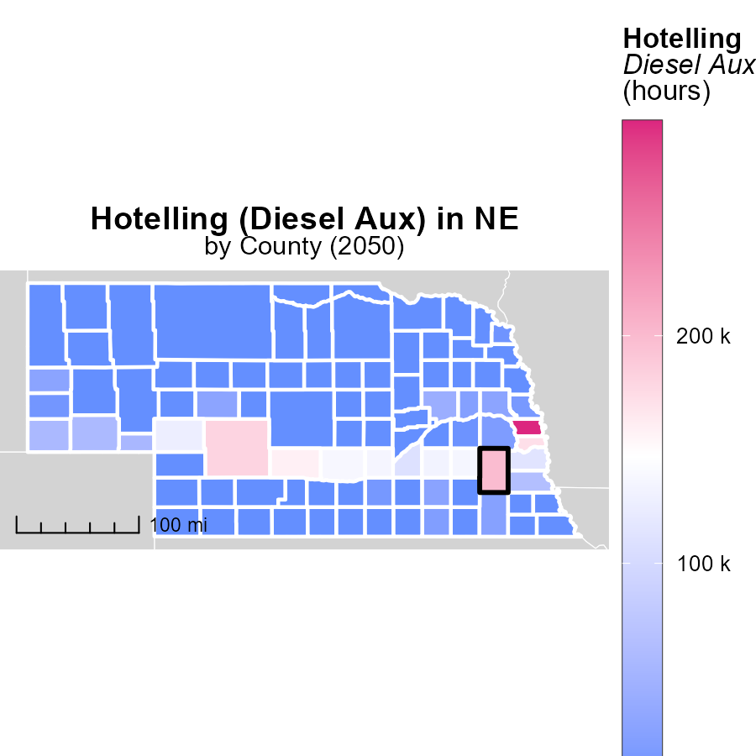

## Findings

* Douglas County, NE has the highest emissions at 294.3 k hours.
* Dundy County, NE and Wheeler County, NE have no emissions recorded.
* Emissions vary significantly between counties, indicating potential for targeted reduction strategies.

## Recommendations

Implement emission reduction initiatives in Douglas County, NE to lower emissions. Encourage other counties to adopt similar measures for overall reduction.

# Emissions by Area over Time

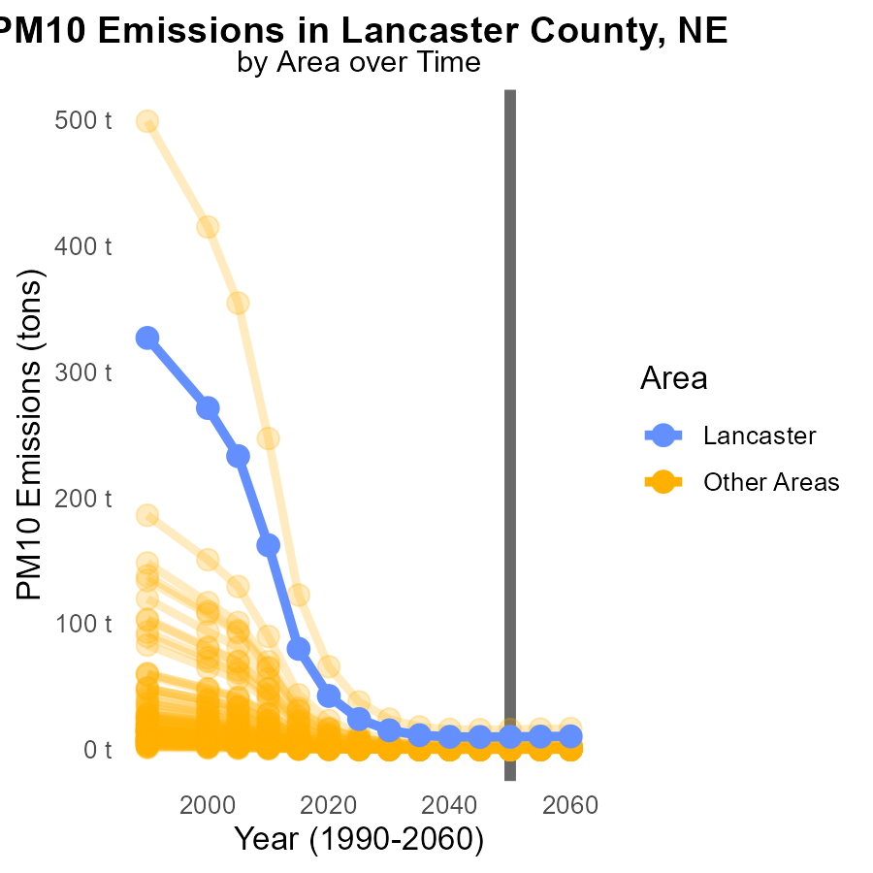

## Findings

* In 2040, the minimum county emissions of PM10 were 0 tons
* In 2040, the maximum county emissions of PM10 were 15.9 tons
* In 2040, the target county emissions of PM10 were 10.1 tons

## Recommendations

To lower PM10 emissions by 2040-2060: Implement stricter emission standards, invest in cleaner technologies, and promote sustainable transportation to reduce overall pollution levels.

# Idling by Road Type over Time

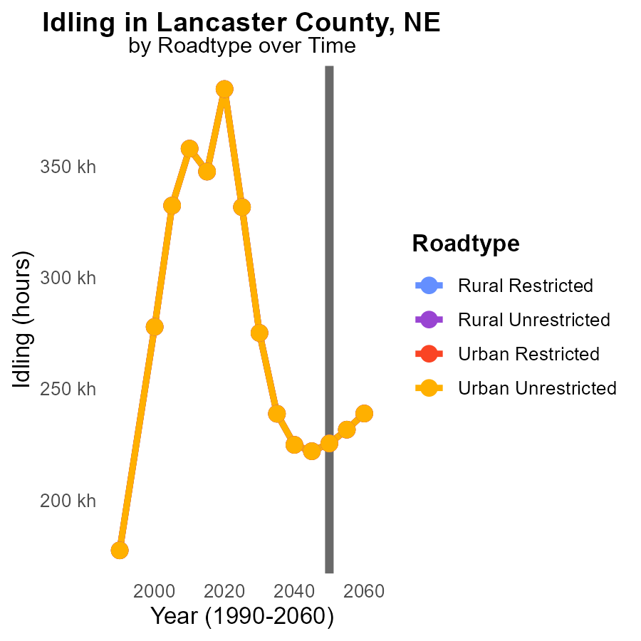

## Findings

* PM10 emissions are constant from 2040 to 2060 across all road types in Lancaster County, NE.
* The highest emissions occur in the Urban Unrestricted area with 238.9k in 2060.
* There is a decreasing trend in emissions from 2050 to 2060.

## Recommendations

To lower PM10 emissions, focus on urban unrestricted areas by promoting advanced vehicle technologies and implementing stricter idling regulations. Monitor and enforce emission control measures regularly.

# Areas Ranked by Population

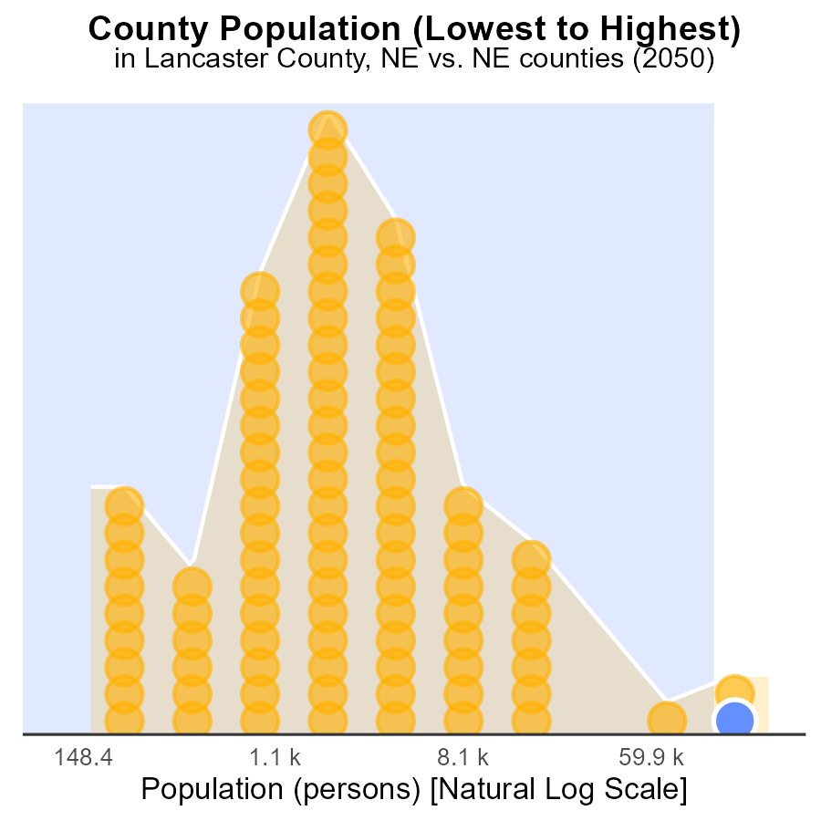

## Findings

* Lancaster county has the highest population with 316,000 people, ranking 184th in PM10 emissions at 98.9%.
* McPherson county has a population of 420,000 people, ranking 2nd in PM10 emissions at 1.1%.
* Douglas county has a population of 565,700 people, ranking 186th in PM10 emissions at 100%.

## Recommendations

To lower PM10 emissions, focus on Lancaster and Douglas counties with 316,000 and 565,700 people respectively. Implement stricter emission control measures in industries and promote the use of cleaner fuels in residential areas.

# Areas Ranked by Vehicles

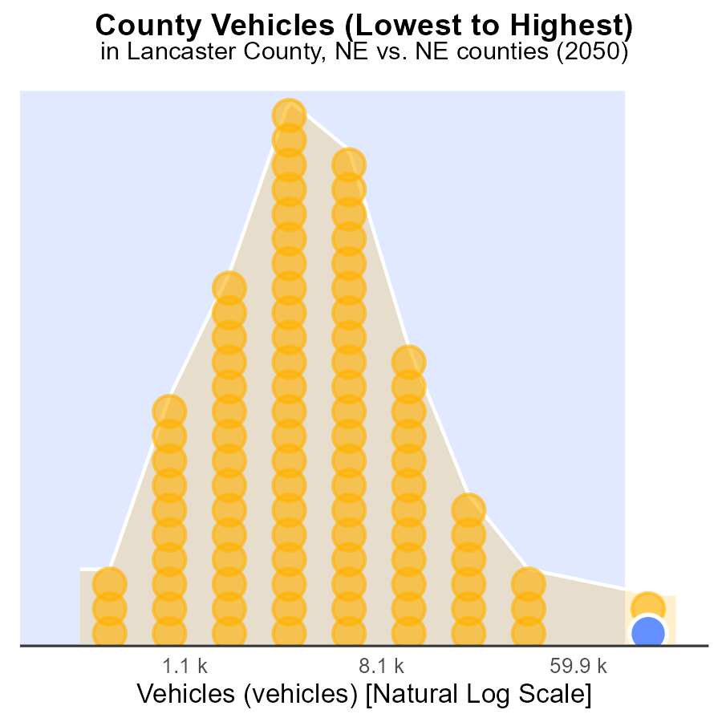

## Findings

* Douglas has the highest number of vehicles emissions
* Arthur has the lowest vehicles emissions in 2050
* Lancaster ranks highest in vehicles emissions percentile

## Recommendations

To reduce vehicle emissions, promote public transportation, carpooling, and incentivize electric vehicle adoption in counties with high vehicle emission levels like Douglas and Lancaster.

# Conclusion

In conclusion, the data reflects a concerning scenario regarding PM10 emissions from on-road transportation in Lancaster County, NE in 2050. Although the overall PM10 emissions are projected to decrease over the next 30 years, there are disparities among counties with high contributors like Douglas, Lancaster, and Sarpy. Efforts should be prioritized in these areas by implementing stricter vehicle emission standards and promoting the adoption of electric vehicles to significantly reduce emissions.

Additionally, the population distribution and emission levels highlight the importance of tailored strategies for different regions. Highly populated areas like Lincoln, NE require a focus on public transportation promotion and energy-efficient regulations, while low-populated areas like Elk precinct, NE can benefit from carpooling incentives and renewable energy use. By targeting specific counties like Douglas for emission reduction initiatives and encouraging sustainable transport options, Lancaster County can work towards a cleaner and healthier environment for its residents.

# About This Report

Data based on MOVES estimates collected by the Climate Action in Transportation program at Cornell University. Demographic data sourced from the US Census's American Community Survey 5-year estimates. This report was generated with the help of AI.

# References

* U.S. Census Bureau. (2023). American Community Survey 5-year estimates: Detailed tables. Retrieved from https://data.census.gov
* U.S. Environmental Protection Agency. (2024). Motor Vehicle Emission Simulator (MOVES 4.0) [Software]. Retrieved from https://www.epa.gov/moves