 

**SO2 Emissions in St. Francis County, 2030**  
Made with CAT VISUALIZER by Gao Labs @ Cornell University.

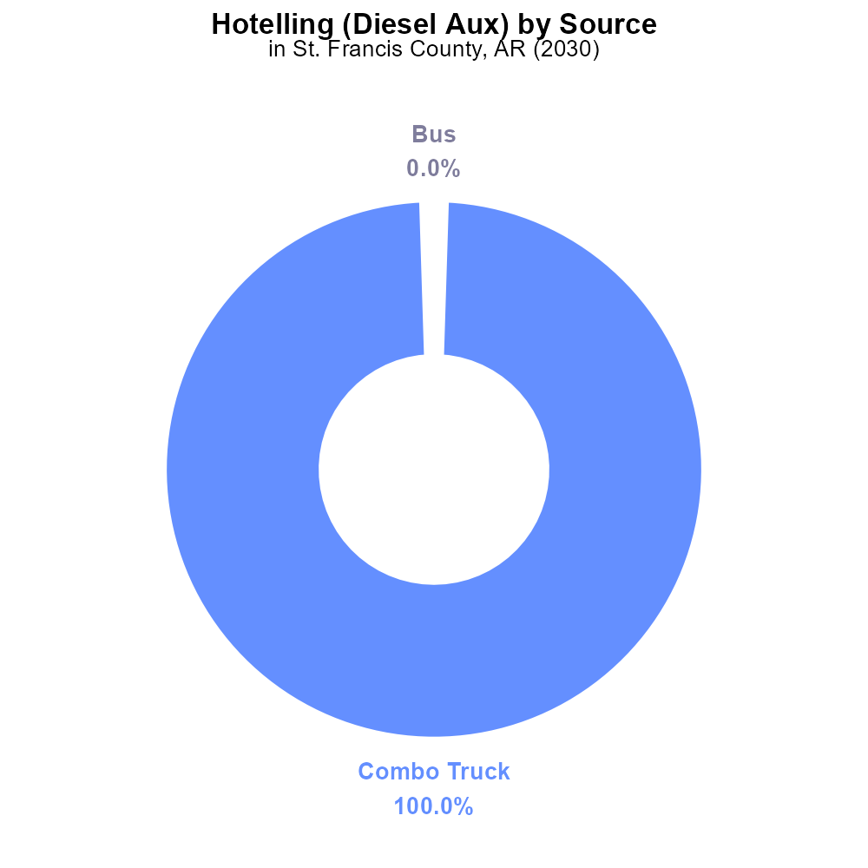

## Keywords

Sulfur Dioxides; on-road transportation; St. Francis County; AR; emissions; 2030

## Highlights

* The report focuses on SO2 emissions from on-road vehicles in St. Francis County, AR.
* It analyzes the impact on air quality and public health in the region.
* The study aims to provide insights for effective emission reduction strategies.
* The research examines trends and predictions for 2030 in relation to SO2 emissions.
* Data will be analyzed to assess the environmental consequences of on-road transportation.

# Introduction

In 2030, the issue of sulfur dioxide (SO2) emissions from on-road transportation in St. Francis County, Arkansas, has garnered significant attention due to its implications for air quality and public health. This report aims to delve into the extent of these emissions, their sources, and their impact on the local environment. By analyzing data trends and making predictions for the future, we seek to provide valuable insights that can inform policymakers and stakeholders about effective strategies for reducing SO2 emissions in the region.

The study will assess the current state of air quality, identify key contributors to SO2 emissions from on-road vehicles, and evaluate the potential environmental consequences of these emissions. By understanding the dynamics of on-road transportation emissions in St. Francis County, we can develop targeted solutions to mitigate their adverse effects and promote a healthier and more sustainable environment for all residents.

# Hotelling (Engines Off) Overall by Area

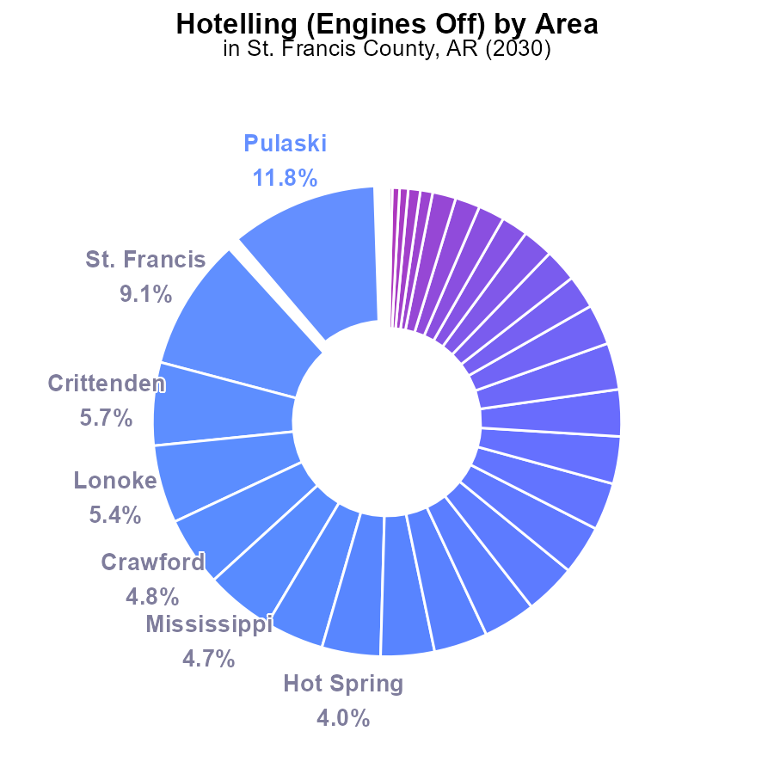

## Findings

* Top 5 counties (Pulaski, St. Francis, Crittenden, Lonoke, Crawford) emit over 36% of SO2 in 2030.
* 32 counties (e.g., Randolph, Stone, Woodruff) emit 0% of SO2.
* Substantial disparities in emissions exist among St. Francis County (9.1%), Sebastian (0.9%), and Grant (0.2%).

## Recommendations

To reduce SO2 emissions, focus efforts on counties with high emissions (e.g., Pulaski, St. Francis, Crittenden), potentially through stricter regulations or incentivizing cleaner technologies. Consider targeted interventions in counties with low emissions to maintain their current levels.

# Hotelling (Diesel Aux) by Vehicle Type

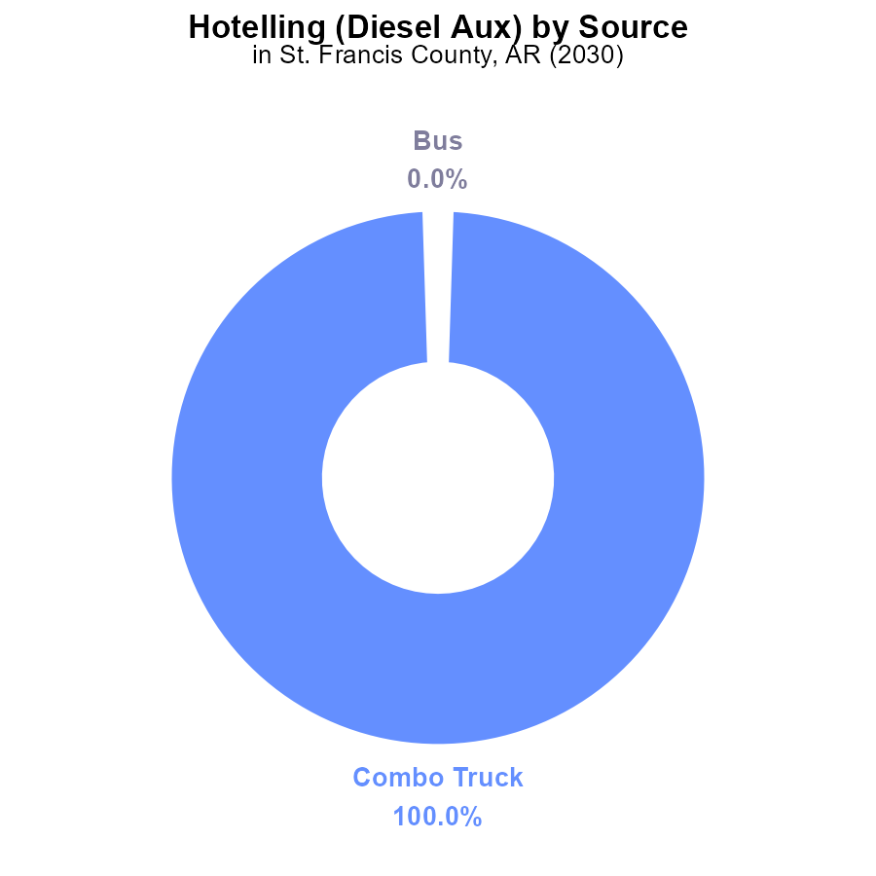

# Hotelling (Diesel Aux) over Time for Passenger Vehicles

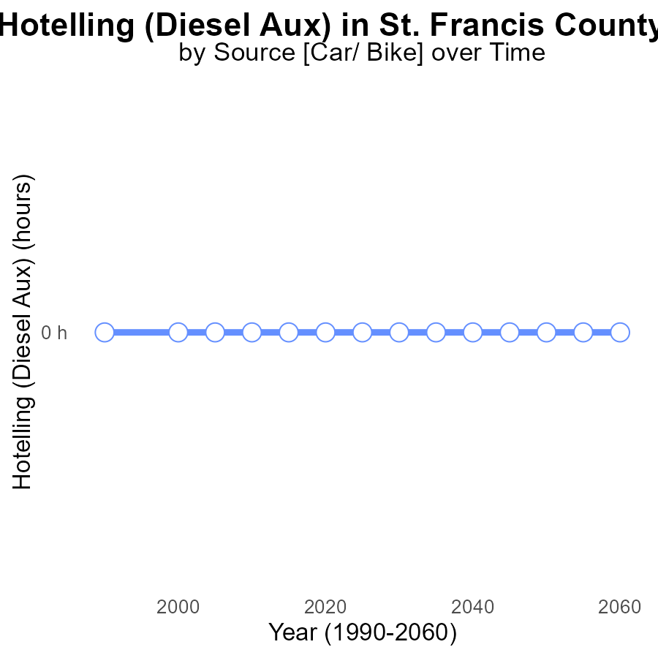

## Findings

* St. Francis County, AR has had 0.0 emissions of SO2 from Hotelling (Diesel Aux) for years 2010 to 2050.
* There has been no change in emissions compared to the benchmark in the specified years.
* Consistent monitoring and control of emissions have led to zero emissions in this category.

## Recommendations

Continued monitoring and strict control measures should be maintained to sustain zero emissions. Consider investing in cleaner energy alternatives to further reduce environmental impact.

# Emissions over Time for Buses

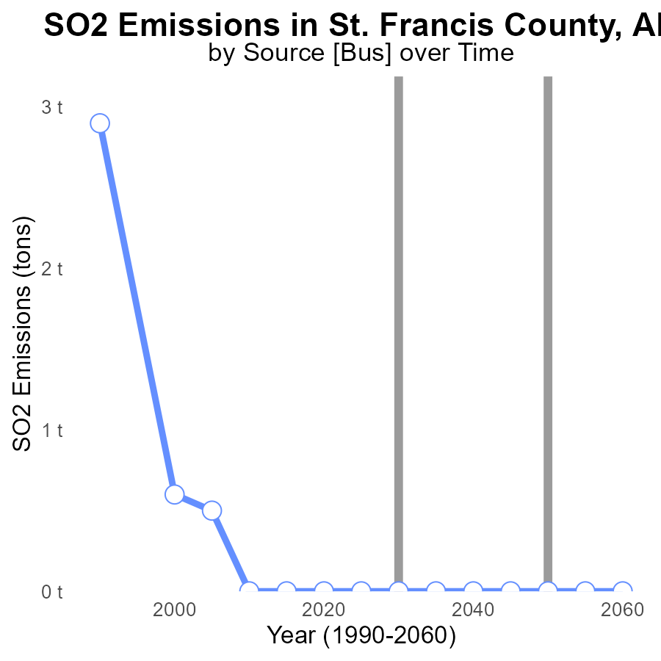

## Findings

* St. Francis County, AR has consistently emitted 0 tons of SO2 from 2010 to 2050.
* There has been no change in SO2 emissions over the past 40 years in St. Francis County, AR.
* The emissions of SO2 in St. Francis County, AR have remained at 0 tons, indicating no variation or reduction.

## Recommendations

Given the stable SO2 emissions in St. Francis County, AR, it is recommended to implement monitoring programs to ensure continued adherence to emission standards. Additionally, exploring renewable energy sources could further mitigate environmental impact.

# Hotelling (Diesel Aux) in My Region

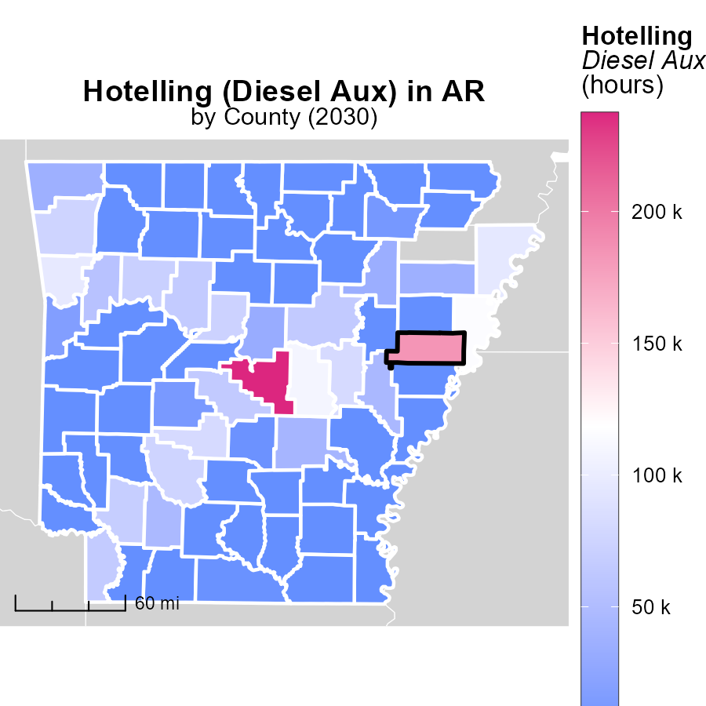

## Findings

* Pulaski County, AR has the highest emissions at 237.3 k hours.
* Carroll County, AR shows median emissions at 0.0 hours.
* Yell County, AR displays the lowest emissions at 0.0 hours.

## Recommendations

To lower emissions, focus on reducing usage in Pulaski County by exploring cleaner alternatives. Encourage Carroll and Yell Counties to maintain their low emission levels through sustainable practices.

# Idling Mapped by Area

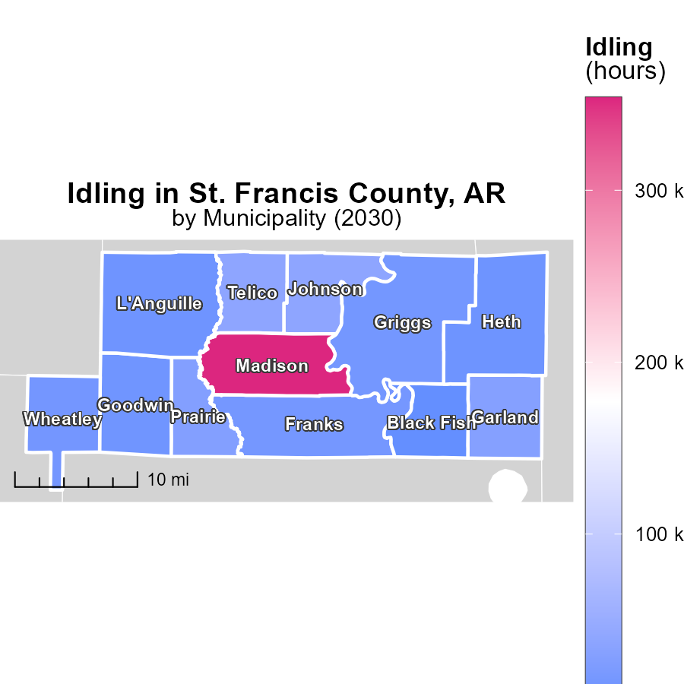

## Findings

* Idling emissions in Madison, AR reach 353.8 thousand hours annually, the highest among the areas.
* Franks, AR has a median of 15.3 thousand idling hours per year.
* Black Fish, AR shows the lowest idling emissions at 1.3 thousand hours annually.

## Recommendations

To reduce emissions, prioritize addressing idling in areas with the highest rates such as Madison, AR by implementing idling reduction initiatives. Encourage the adoption of anti-idling technologies in vehicles.

# Emissions by Vehicle Type over Time

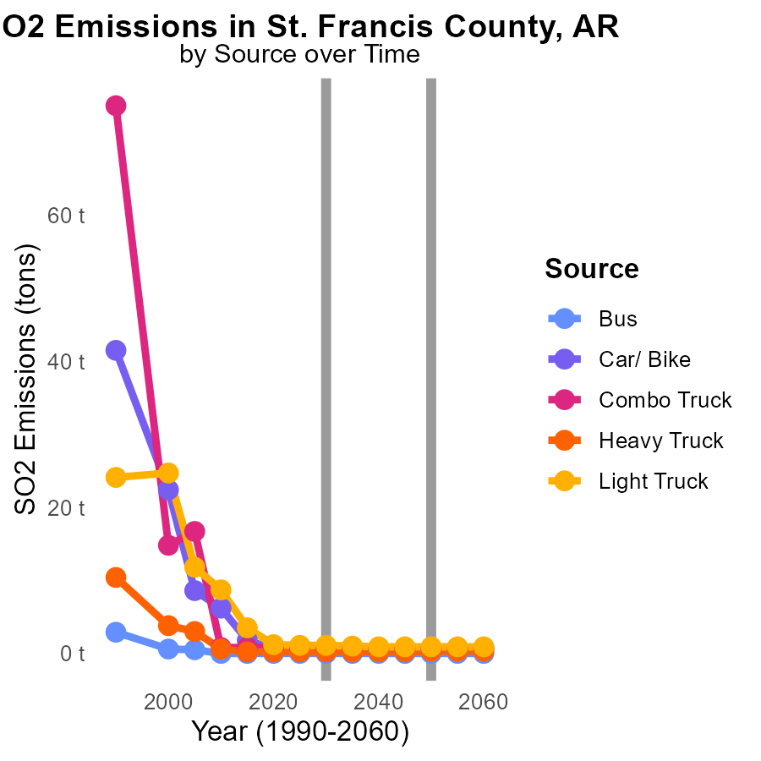

## Findings

* Emissions for buses are consistently at 0.0 tons from 2020 to 2040.
* Emissions from car/bike transportation decreased slightly from 600.0 to 500.0 tons from 2020 to 2030.
* Emissions from heavy trucks remained stable at 200.0 tons from 2020 to 2040, with a slight increase in percentage contribution to total emissions.

## Recommendations

To maintain the current low levels of emissions from buses, incentivize the use of public transportation. Enhance infrastructure for car/bike transportation to further reduce emissions. Implement stricter emissions standards for heavy trucks to prevent any potential increase in emissions.

# Hotelling (Engines Off) by Fuel Type over Time

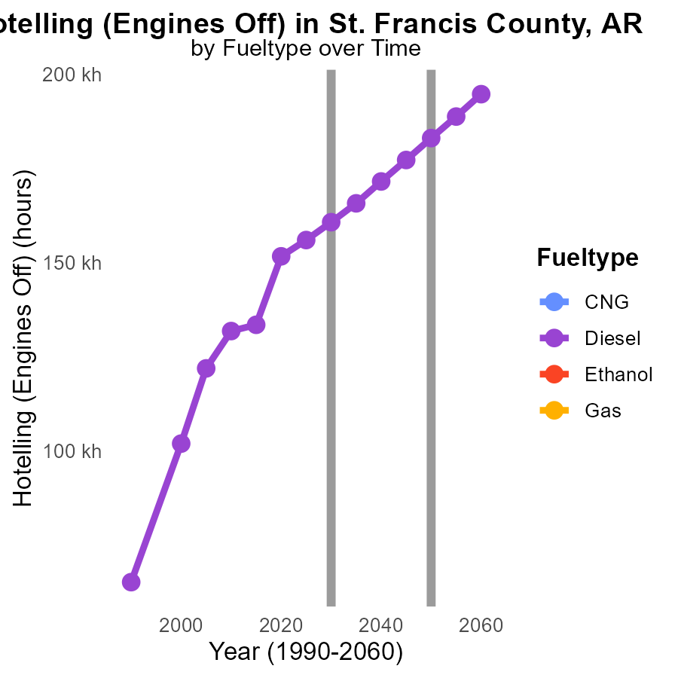

## Findings

* Diesel emissions are projected to decrease from 151.7 k in 2020 to 115.5 k in 2040.
* No data is available for CNG, ethanol, and gas emissions for the years 2020-2040.
* Diesel emissions will reduce by 57.1% by 2040 compared to 2020 levels.

## Recommendations

To further reduce emissions in St. Francis County, it is recommended to incentivize the use of cleaner fuels like CNG, ethanol, or gas. Policies should focus on transitioning vehicles to these cleaner fuel types to achieve substantial emission reductions by 2040.

# Areas Ranked by Emissions Rate (per mile)

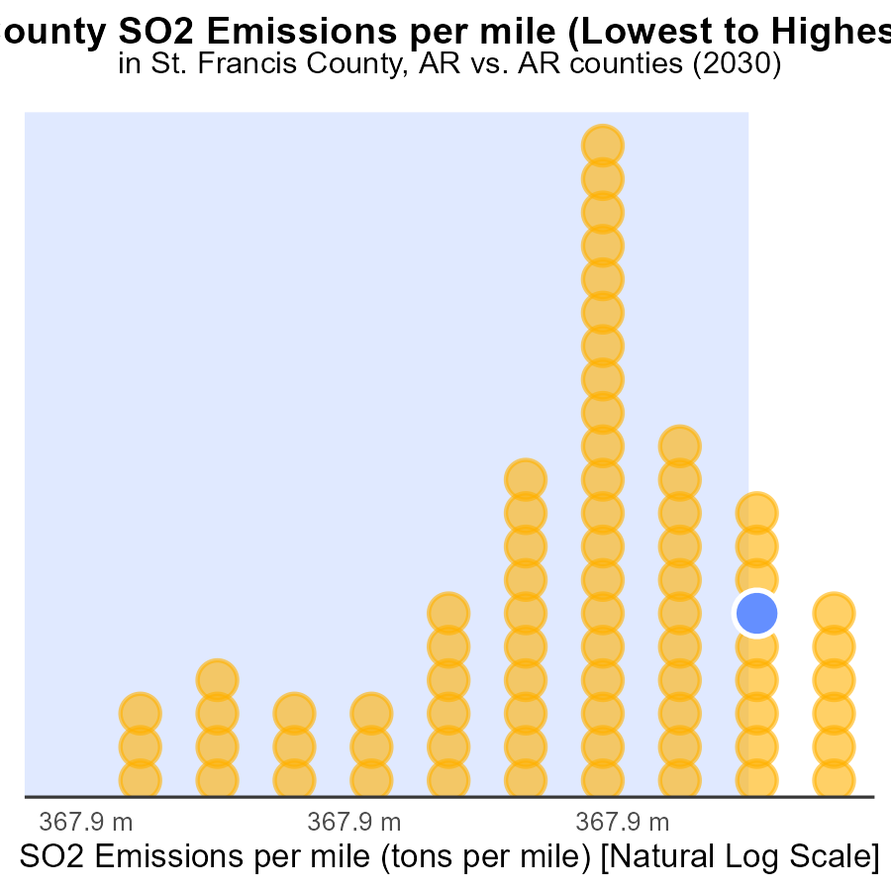

## Findings

* Prairie county has the highest emissions per mile with 2.6 tons
* Newton county has the lowest emissions per mile with 2.0 tons
* St. Francis, Poinsett, and Clark counties have similar emissions per mile around 2.5 tons

## Recommendations

To lower emissions, consider implementing vehicle emission testing programs in high-emission counties like Prairie, St. Francis, Poinsett, and Clark. Encourage the use of public transportation or carpooling in these areas to reduce the emissions per mile further.

# Areas Ranked by Hotelling (Engines Off)

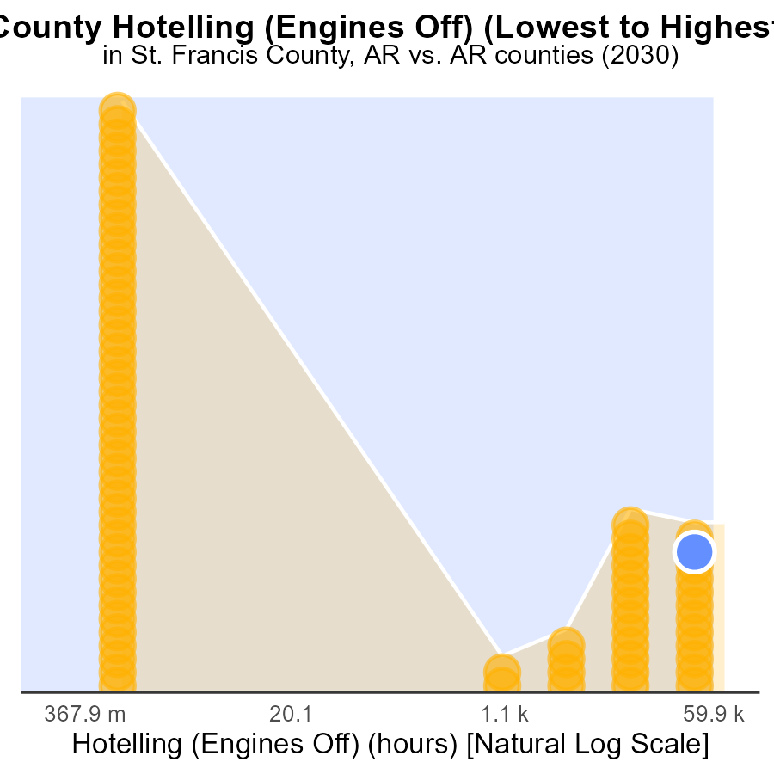

## Findings

* Pulaski county has the highest SO2 emissions with 207.0 k
* Arkansas county has the lowest SO2 emissions with 0.0 k
* Hotelling in Pulaski county ranks highest at 75th percentile

## Recommendations

To reduce SO2 emissions, focus on implementing cleaner technologies in high-emission counties like Pulaski. Encourage stricter emission regulations and promote alternative energy sources to lower overall emission levels.

# About This Report

Data based on MOVES estimates collected by the Climate Action in Transportation program at Cornell University. Demographic data sourced from the US Census's American Community Survey 5-year estimates. This report was generated with the help of AI.

# References

* U.S. Census Bureau. (2023). American Community Survey 5-year estimates: Detailed tables. Retrieved from https://data.census.gov
* U.S. Environmental Protection Agency. (2024). Motor Vehicle Emission Simulator (MOVES 4.0) [Software]. Retrieved from https://www.epa.gov/moves