 

**PM10 Emissions in Madera County, 2045**  
Made with CAT VISUALIZER by Gao Labs @ Cornell University.

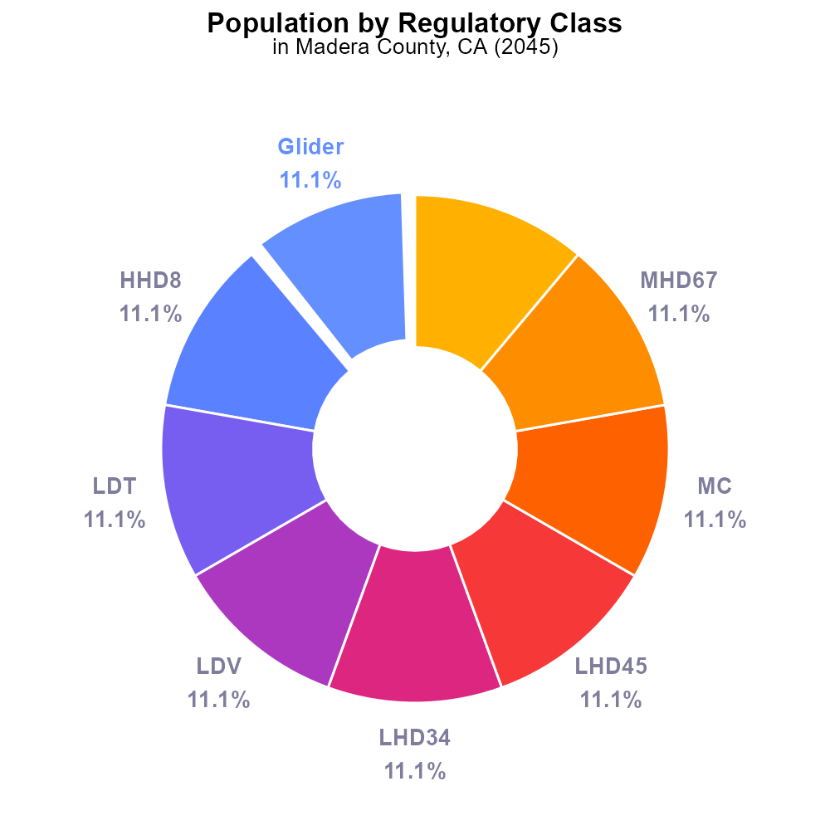

## Keywords

Primary Exhaust PM10; on-road transportation; Madera County; emissions; 2045; Total

## Highlights

* Analysis of PM10 emissions from on-road vehicles in Madera County, CA.
* Investigation into the impact of transportation on air quality in the region.
* Examination of total emissions for 2045 and potential implications for public health.
* Focus on primary exhaust sources and their contribution to PM10 levels.
* Insights on measures to reduce emissions and improve air quality in Madera County.

# Introduction

The report investigates the total emissions of Primary Exhaust PM10 from on-road transportation in Madera County, California, projecting data for the year 2045. As the population grows and the demand for transportation increases, understanding the impact of vehicle emissions on air quality becomes crucial. By focusing on primary exhaust sources, the report aims to quantify the contributions of on-road vehicles to the concentration of PM10 in the region.

Additionally, the report will explore potential measures and strategies to mitigate these emissions and improve air quality, considering the implications for public health and the environment in Madera County. It will provide insights for policymakers and stakeholders to make informed decisions for sustainable development and a healthier community.

# Population by Regulatory Class

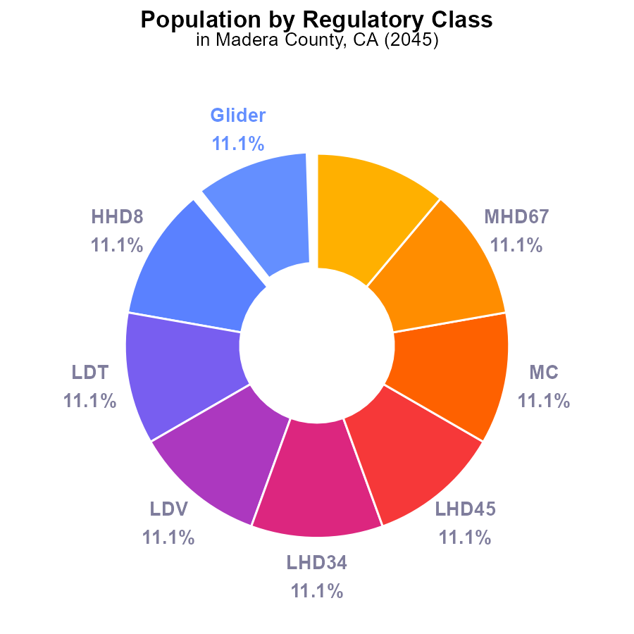

## Findings

* PM10 emissions in Madera County, CA in 2045 were 155.9 k.
* Urban buses were responsible for 11.1% of PM10 emissions, same as other vehicle types.
* PM10 emissions were evenly distributed among different vehicle types in Madera County.

## Recommendations

To lower PM10 emissions, consider implementing stricter regulations on all vehicle types, including urban buses. Encourage the use of cleaner fuels and technologies to reduce overall emissions levels.

# Vehicle Starts by Road Type

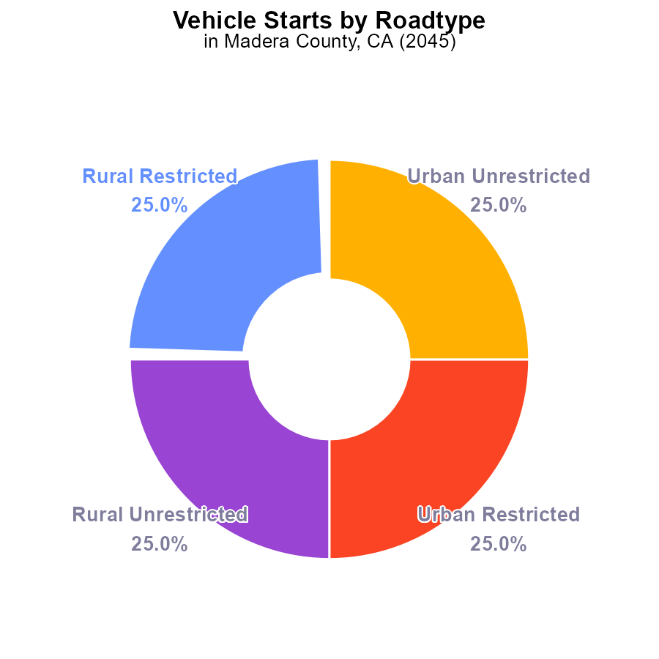

## Findings

* The total PM10 emissions in Madera County, CA in 2045 from vehicle starts are approximately 1026.4 million times.
* Each type (Rural Restricted, Rural Unrestricted, Urban Restricted, Urban Unrestricted) contributes equally to 25% of the total emissions.
* There is no variation in emission levels among the different categories of vehicle starts in Madera County.

## Recommendations

To lower PM10 emissions from vehicle starts, Madera County should focus on implementing county-wide vehicle emission standards and promoting the use of electric vehicles to reduce pollution levels across all categories.

# Vehicle Miles Traveled over Time for Passenger Vehicles

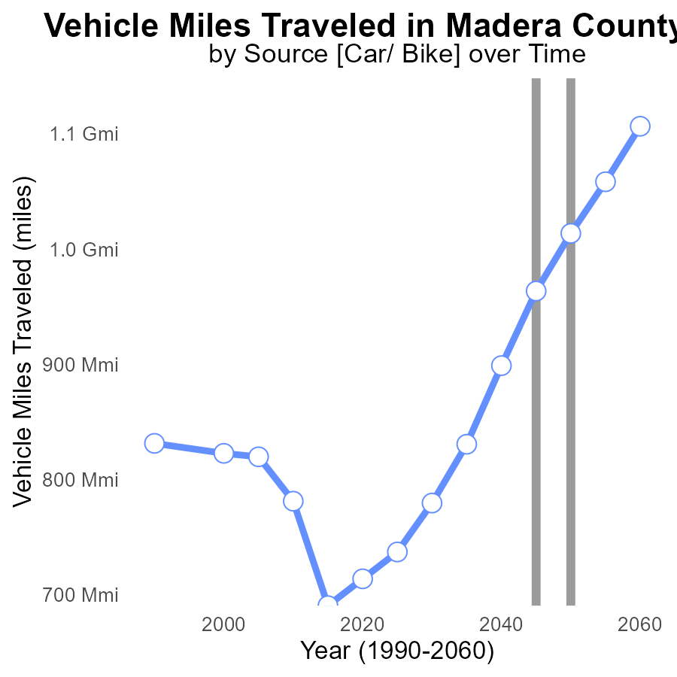

## Findings

* Vehicle miles traveled in Madera County are projected to increase steadily over the next four decades.
* There has been a significant decrease in vehicle miles traveled between 2050 and 2060, indicating a potential shift in transportation trends.
* Although the benchmark difference shows a decrease after 2050, emissions may still remain high if not addressed.

## Recommendations

To lower emissions in Madera County, consider investing in sustainable transportation infrastructure, promoting public transport, implementing carpooling programs, and encouraging the use of electric vehicles.

# Population Overall over Time

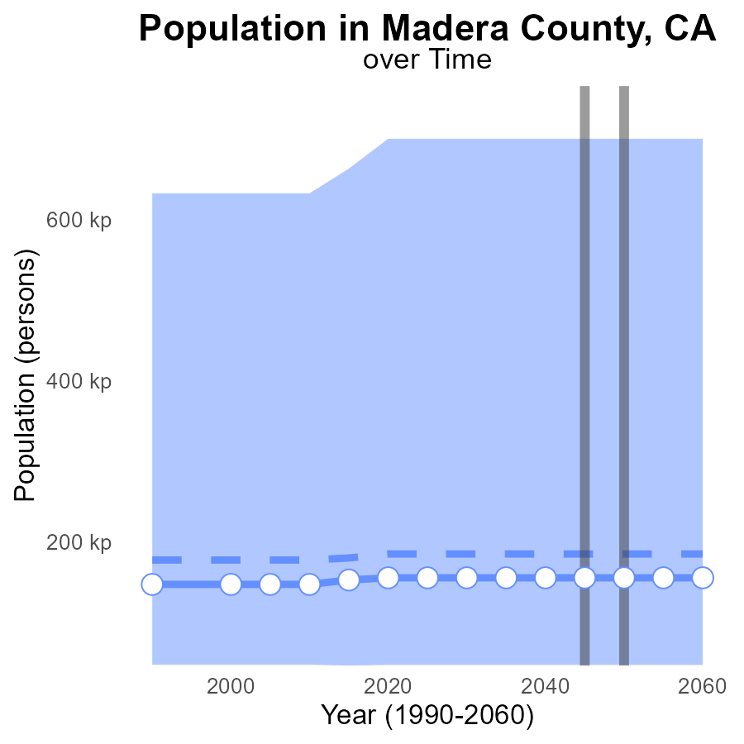

## Findings

* PM10 emissions in Madera County, CA are projected to remain stable at 155.9k persons across 2025-2060.
* This level is consistently 29.5k persons lower than the median area but falls within the upper 75th percentile of areas.
* The benchmark difference is constant at zero throughout the forecast period.

## Recommendations

To reduce PM10 emissions in Madera County, policies should focus on further lowering emissions to meet the median area levels while considering best practices from areas within the upper 75th percentile of emissions. Continuous monitoring and enforcement of air quality regulations are also essential to maintain the zero benchmark difference.

# Emissions Mapped by Area

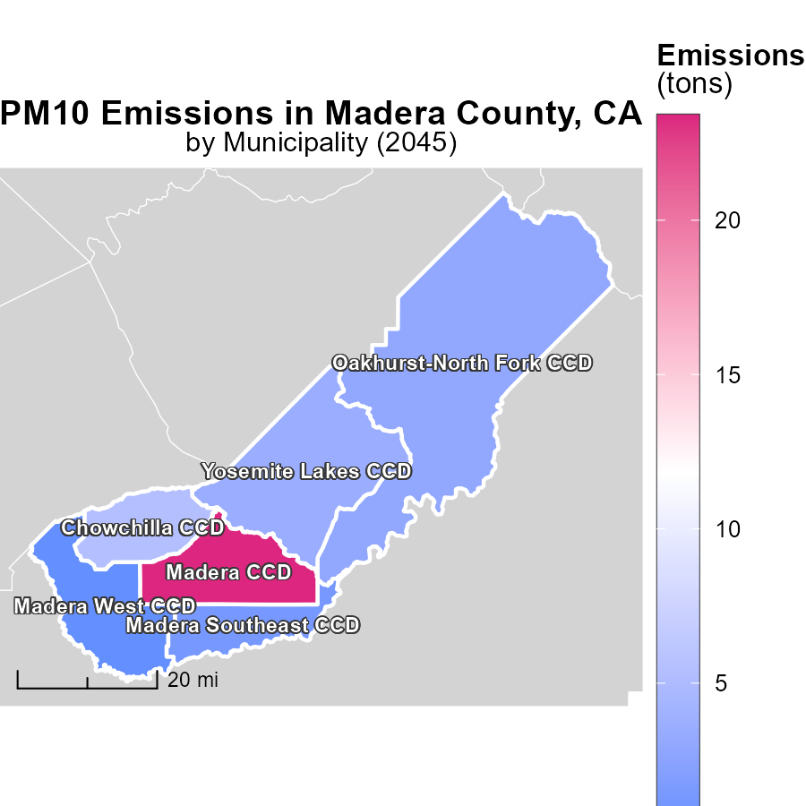

# Population in My Region

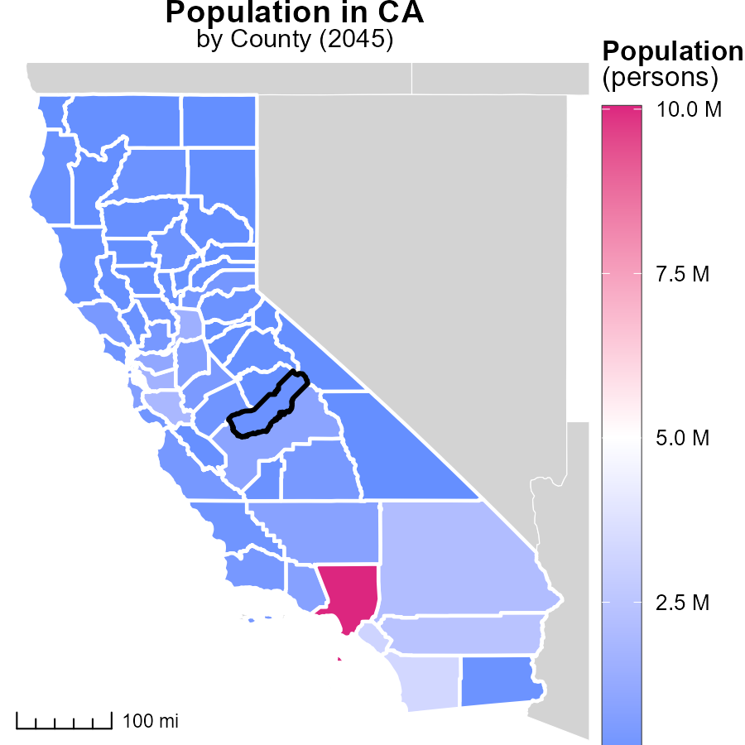

## Findings

* Los Angeles County, CA has the highest population with 10.0 million persons.
* Imperial County, CA has a median population of 180.6 thousand persons.
* Alpine County, CA has the lowest population with 1.2 thousand persons.

## Recommendations

To lower emissions, focus on high-density areas like Los Angeles County by promoting public transport and carpooling. Implement renewable energy projects in Imperial and Alpine Counties with community involvement.

# Population by Regulatory Class over Time

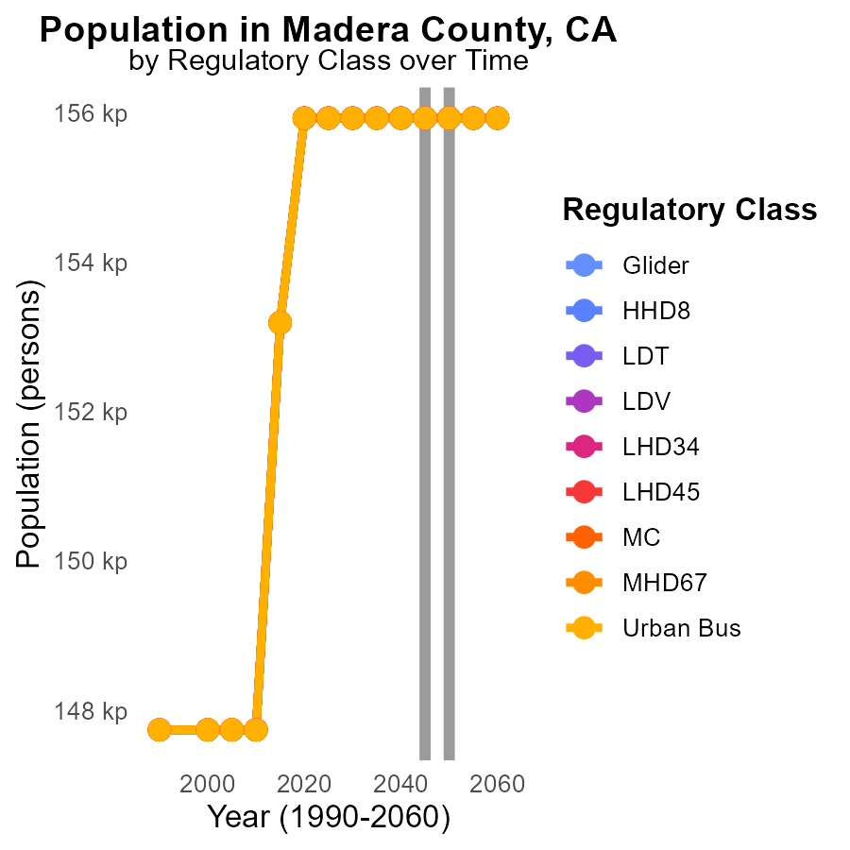

## Findings

* Stable PM10 emissions of 155.9 k persons from 2035 to 2055 across different vehicle types in Madera County
* No change in emissions from Glider, HHD8, LDT, LDV, LHD34, MC, MHD67, and Urban Bus categories from 2035 to 2055
* The data suggests consistent emission levels in Madera County, indicating the need for sustainable policies to maintain these levels

## Recommendations

Given the stable emissions trend, policymakers can focus on promoting sustainable transportation practices, such as incentivizing electric vehicles, improving public transportation infrastructure, and implementing stricter emission standards for vehicles in Madera County.

# Vehicle Miles Traveled by Road Type over Time

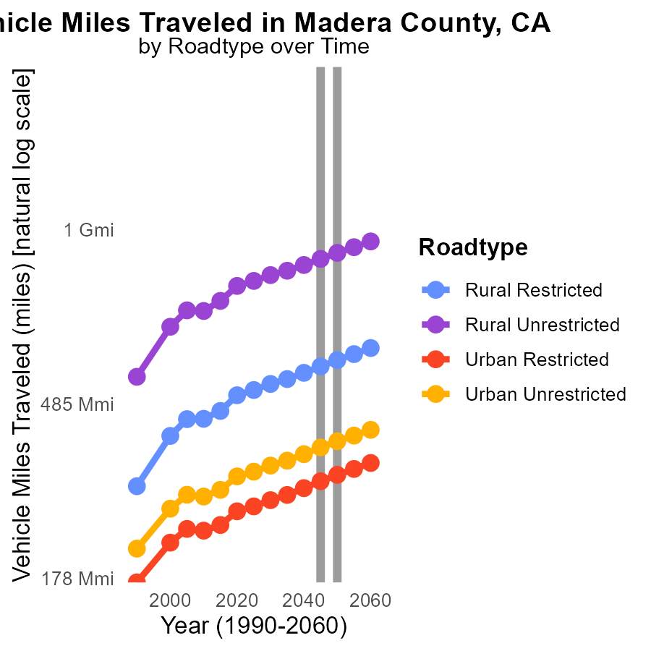

## Findings

* Between 2035 and 2055, Rural Unrestricted Vehicle Miles Traveled increases by 20.5%.
* Across all categories, Vehicle Miles Traveled see an average growth of 18.7% from 2035 to 2055.
* Urban Restricted Vehicle Miles Traveled show a 3.4% increase from 2035 to 2055.

## Recommendations

To lower emissions, policies promoting carpooling, public transportation, and telecommuting should be encouraged, especially in rural areas with unrestricted travel. Implementing tolls to reduce vehicle usage can also aid in decreasing emissions.

# Areas Ranked by Population

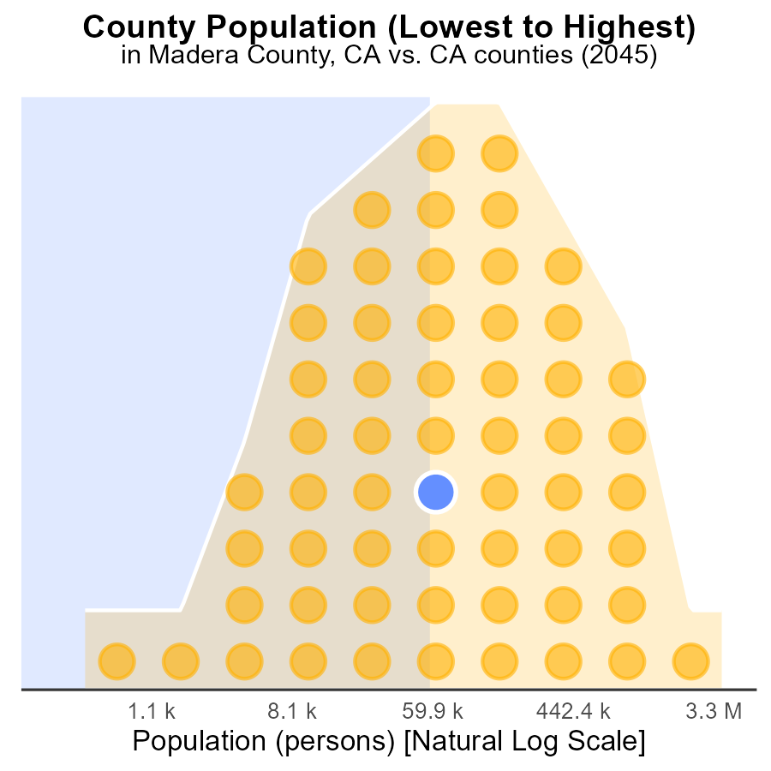

## Findings

* Los Angeles has the highest PM10 emissions with 10.0 million persons exposed.
* Madera County ranks 54th in emissions with 155.9 thousand persons affected.
* Alpine County has the lowest emissions, affecting only 1.2 thousand persons.

## Recommendations

To lower emissions, target reduction strategies in Los Angeles due to its high impact, while also addressing sources in Madera and Alpine counties to prevent escalation.

# Areas Ranked by Hotelling (Engines Off)

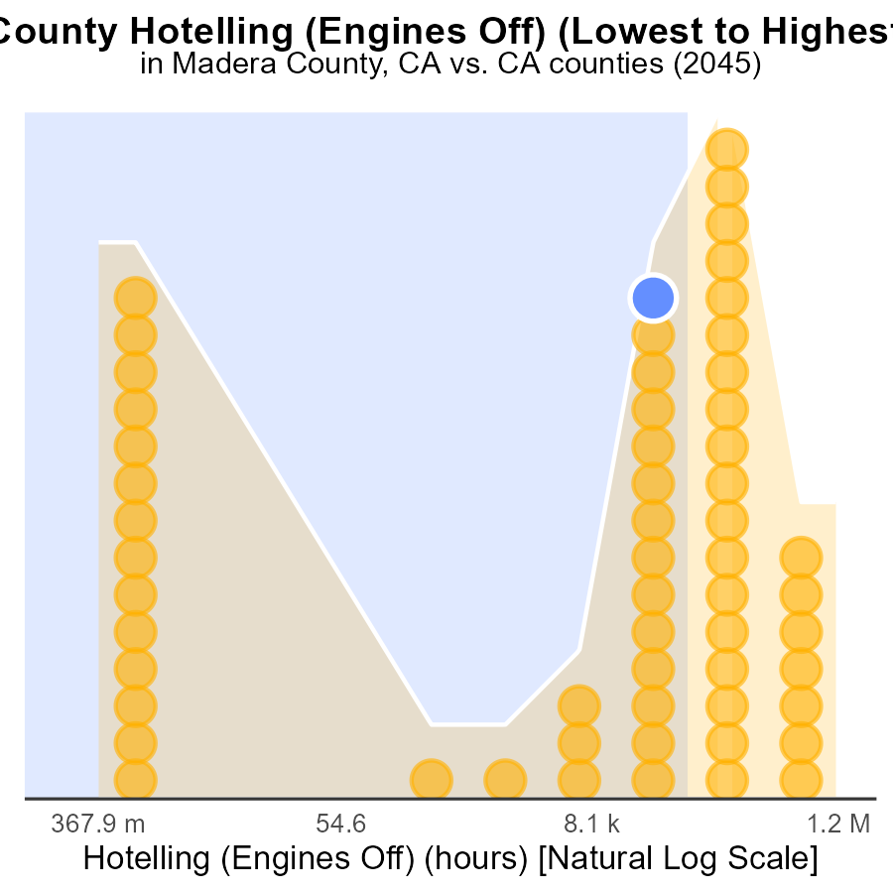

## Findings

* Los Angeles has the highest PM10 emissions with 3.3 million hours.
* Alpine ranked first with zero PM10 emissions.
* Imperial County had the highest PM10 emissions per hour at 163.5 thousand.

## Recommendations

To reduce emissions, promote the use of electric vehicles in highly polluted areas. Implement stricter regulations and incentives to encourage the adoption of cleaner technologies.

# Conclusion

In conclusion, the data on Primary Exhaust PM10 emissions from on-road transportation in Madera County, CA in 2045 paints a detailed picture of the current situation. With total emissions standing at 155.9 k, evenly distributed among different vehicle types with urban buses accounting for 11.1%, it is evident that a comprehensive approach is necessary to address the issue.

To lower PM10 emissions in the county, implementing stricter regulations on all vehicle types, including urban buses, and promoting cleaner fuels and technologies are crucial steps. The steady increase in vehicle miles traveled projected for the coming decades highlights the importance of sustainable transportation infrastructure and the promotion of electric vehicles. While the emissions have remained stable over the years, focusing on policies that aim to further reduce pollution levels and meet benchmark differences could help Madera County move towards a cleaner and healthier environment. By monitoring and enforcing air quality regulations, while learning from higher-emission areas like Los Angeles and implementing best practices, Madera County can aim for a more sustainable future.

# About This Report

Data based on MOVES estimates collected by the Climate Action in Transportation program at Cornell University. Demographic data sourced from the US Census's American Community Survey 5-year estimates. This report was generated with the help of AI.

# References

* U.S. Census Bureau. (2023). American Community Survey 5-year estimates: Detailed tables. Retrieved from https://data.census.gov
* U.S. Environmental Protection Agency. (2024). Motor Vehicle Emission Simulator (MOVES 4.0) [Software]. Retrieved from https://www.epa.gov/moves