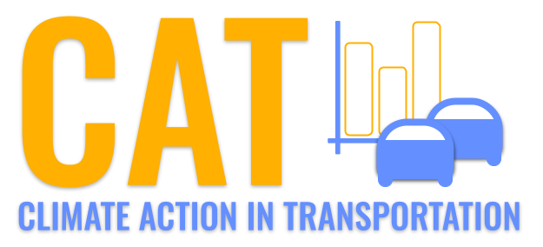 

**Carbon Emissions in Freeborn County, 2015**  
Made with CAT VISUALIZER by Gao Labs @ Cornell University.

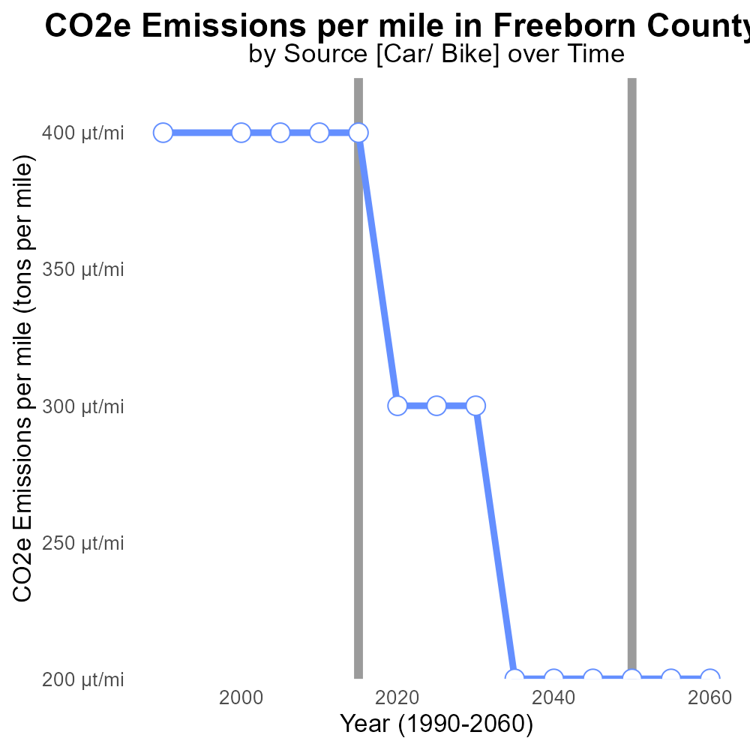

## Keywords

CO2 Equivalent emissions; on-road transportation; Freeborn County; MN; 2015

## Highlights

* Analysis of CO2 emissions from on-road vehicles in Freeborn County, MN.
* Assessment of environmental impact of transportation in the region.
* Comparison of 2015 emissions data with previous years.
* Implications for air quality and climate change in Freeborn County.
* Recommendations for reducing CO2 emissions from on-road transportation.

# Introduction

The following report provides an in-depth analysis of CO2 Equivalent emissions from on-road transportation in Freeborn County, MN, specifically focusing on the year 2015. The data presented offers insights into the environmental impact of transportation activities in this region.

By examining the emissions produced by various vehicles on the roads of Freeborn County, this report aims to highlight the scale of carbon footprint associated with transportation. Furthermore, this analysis will assess the implications of these emissions on local air quality and contribute to the ongoing discussion on mitigating climate change effects at a community level.

# Emissions Rate (per capita) by Fuel Type

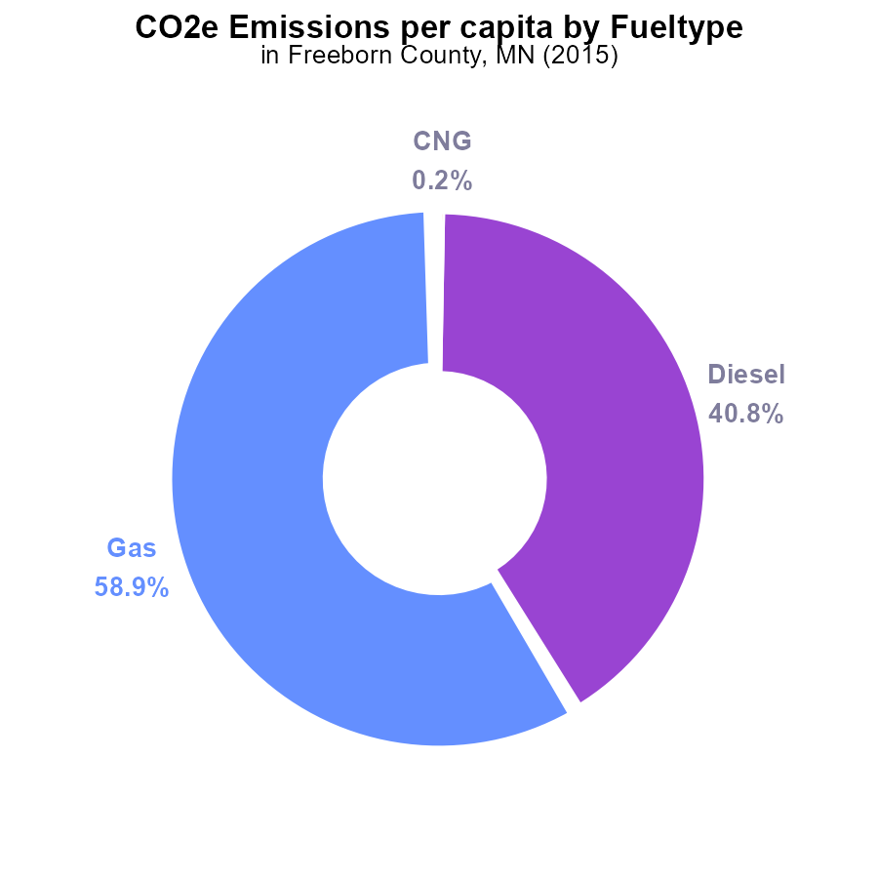

## Findings

* In 2015, the largest contributor to CO2e emissions per capita in Freeborn County, MN was Gasoline, accounting for 58.9%.
* Diesel emissions constituted a significant portion as well, contributing 40.8% per capita.
* In comparison, the emissions from Compressed Natural Gas (CNG) and Ethanol were much lower, each contributing only 0.2% and 0.1% per capita, respectively.

## Recommendations

To lower emissions in Freeborn County, actions should focus on reducing gasoline and diesel usage as they are the primary sources of CO2e emissions. Encouraging the adoption of cleaner fuel alternatives, improving public transportation, and promoting carpooling can help decrease emissions significantly.

# Hotelling (Diesel Aux) by Regulatory Class

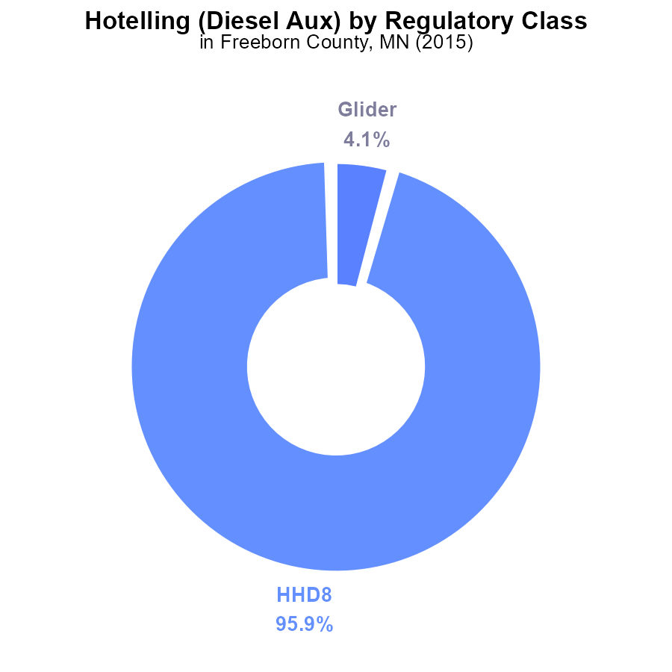

## Findings

* The Hotelling (Diesel Aux) equipment type emitted 95.9% of the total CO2e in Freeborn County, MN in 2015.
* Glider emissions accounted for 4.1% of the total CO2e, while all other equipment types had negligible contributions.
* Specific vehicle types such as LDT, LDV, LHD34, LHD45, and MC did not contribute to CO2e emissions in 2015 in the county.

## Recommendations

To lower CO2e emissions in Freeborn County, MN, focus on reducing emissions from Hotelling (Diesel Aux) equipment by implementing cleaner technologies and improving operational efficiency. Efforts should prioritize the reduction of emissions from the highest contributing sources identified in the data.

# Emissions Rate (per vehicle) over Time for Buses

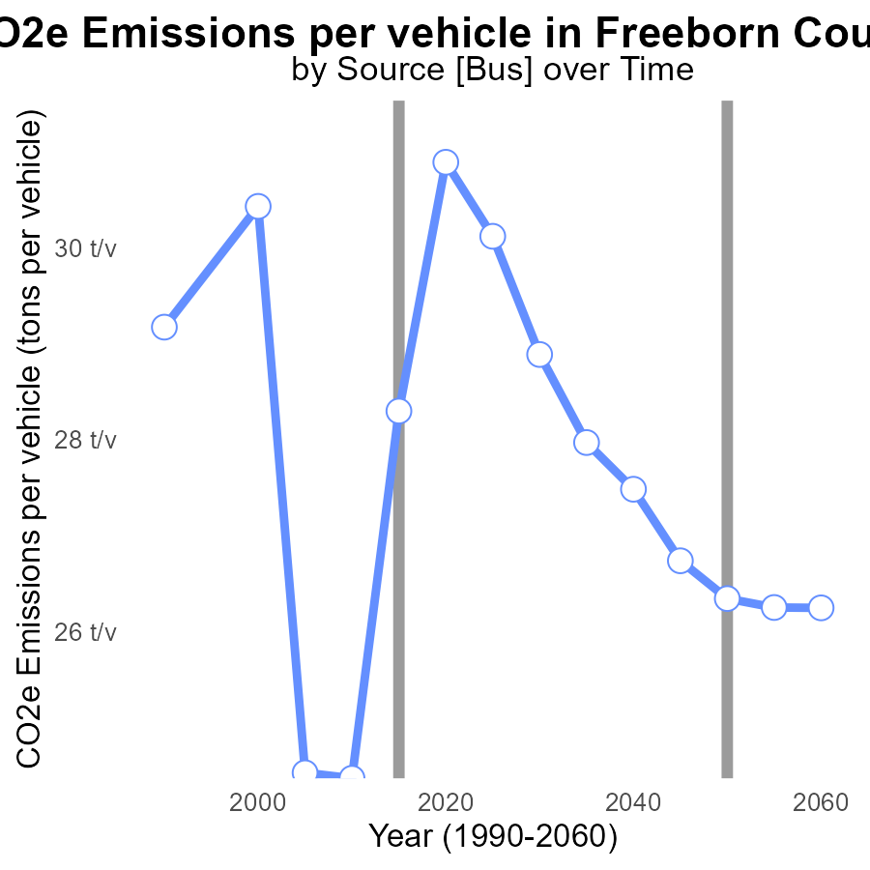

## Findings

* Emissions per vehicle varied from 24.5 to 30.9 tons from 2000 to 2020.
* There was a reduction of 4.5436 tons per vehicle in emissions from 2000 to 2020.
* Overall, emissions per vehicle decreased steadily over the years, with a total reduction of 6.8668 tons per vehicle from 2000 to 2035.

## Recommendations

To further reduce emissions, policies should focus on promoting electric vehicles and enhancing public transportation. Implementing stricter emissions standards for vehicles can also aid in decreasing emissions levels.

# Emissions Rate (per mile) over Time for Passenger Vehicles

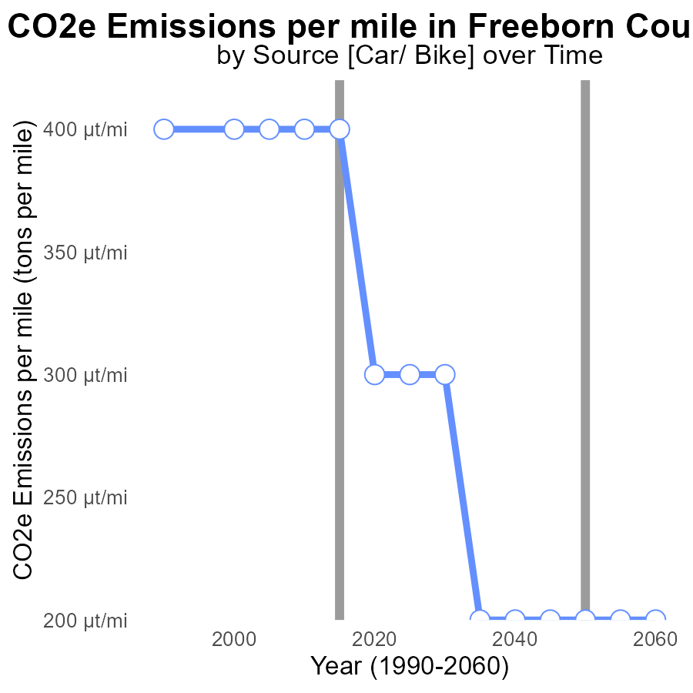

## Findings

* Emissions in Freeborn County, MN have decreased steadily from 386.8 µ in 2000 to 239.0 µ in 2035.
* The benchmark difference has remained relatively stable around -2e-04 tons per mile from 2000 to 2015 before showing a slight improvement.
* There has been around a 38% reduction in emissions per mile from 2000 to 2035, indicating a positive trend in environmental impact.

## Recommendations

To further lower emission levels, policymakers should invest in promoting the adoption of electric vehicles, enhancing public transportation infrastructure, and incentivizing carpooling initiatives to continue the decreasing trend observed in emissions per mile.

# Emissions Mapped by Area

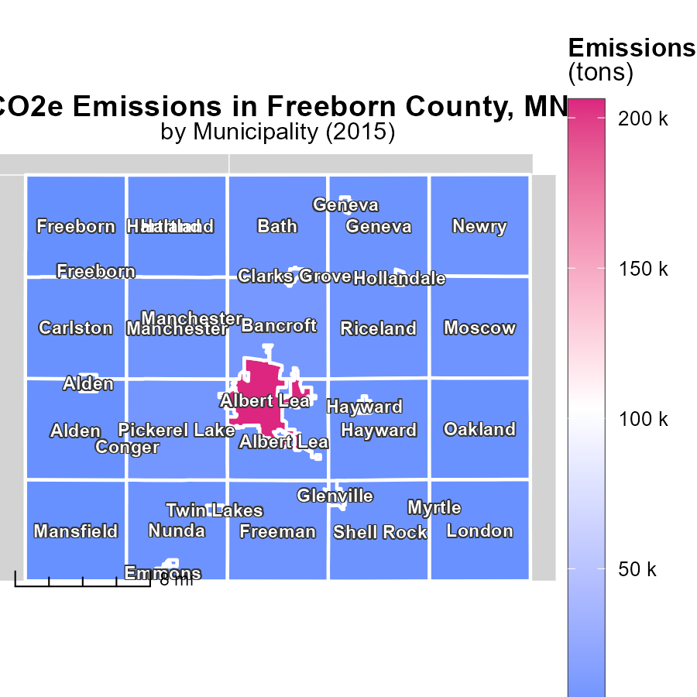

## Findings

* Albert Lea, MN emitted the highest amount of 206,000 tons in 2015
* Nunda, MN had a median emission of 4,500 tons in 2015
* Manchester, MN had the lowest emission of 648.1 tons in 2015

## Recommendations

To lower emissions, focus on reducing Albert Lea, MN's output significantly, optimizing Nunda, MN's emissions further, and maintaining Manchester, MN's low levels.

# Vehicles in My Region

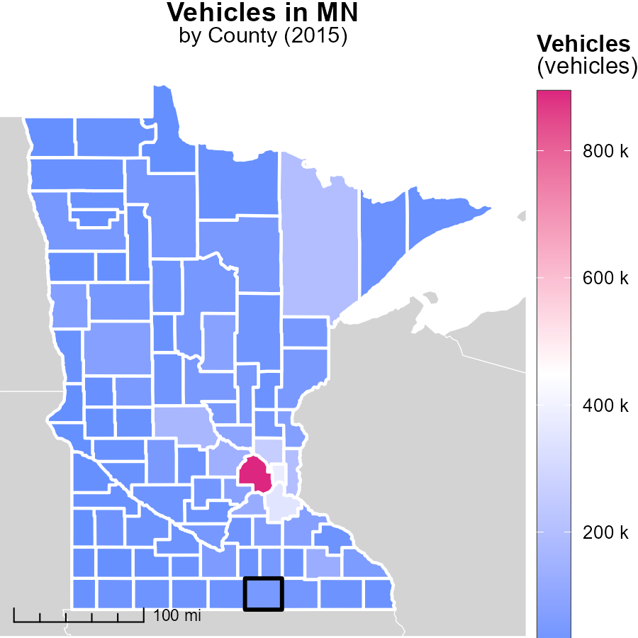

## Findings

* Hennepin County, MN had the highest vehicle emissions in 2015 at 893.6 thousand units.
* Martin County, MN had a median level of vehicle emissions with 26.9 thousand units.
* Traverse County, MN had the lowest vehicle emissions in 2015 with 4.3 thousand units.

## Recommendations

To lower vehicle emissions, focus on Hennepin County by promoting public transportation, carpooling, and bike-friendly initiatives. Encourage electric vehicle adoption in Martin County. Implement eco-friendly transportation options in Traverse County to further reduce emissions.

# Hotelling (Engines Off) by Vehicle Type over Time

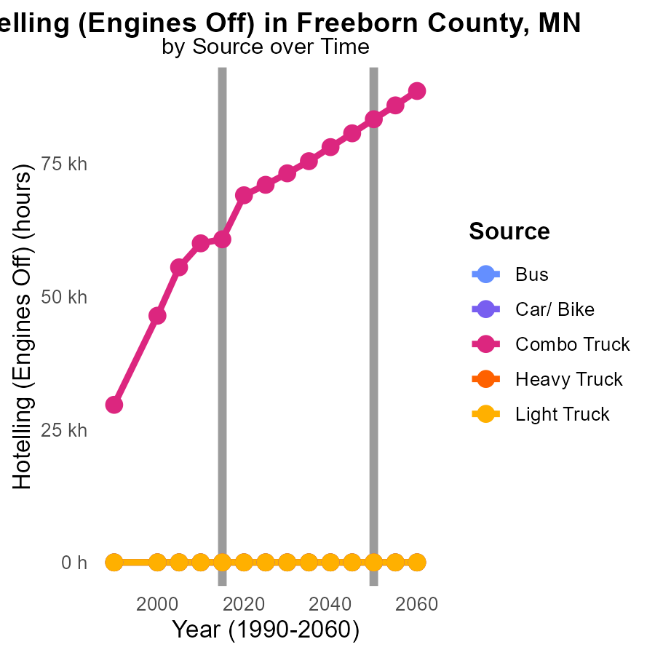

## Findings

* Combo Truck emissions increased from 55.5 k in 2005 to 71.0 k in 2025.
* Bus, Car/Bike, Heavy Truck, and Light Truck emissions remained consistently at 0.0 throughout 2005-2025.
* Combo Truck emissions saw the highest increase between 2020 and 2025, with a rise of 12330.9 in CO2e.

## Recommendations

To reduce emissions, focus on improving fuel efficiency in Combo Trucks, which showed a significant increase. Implement hybrid technologies or alternative fuels to mitigate rising emissions.

# Vehicle Starts by Vehicle Type over Time

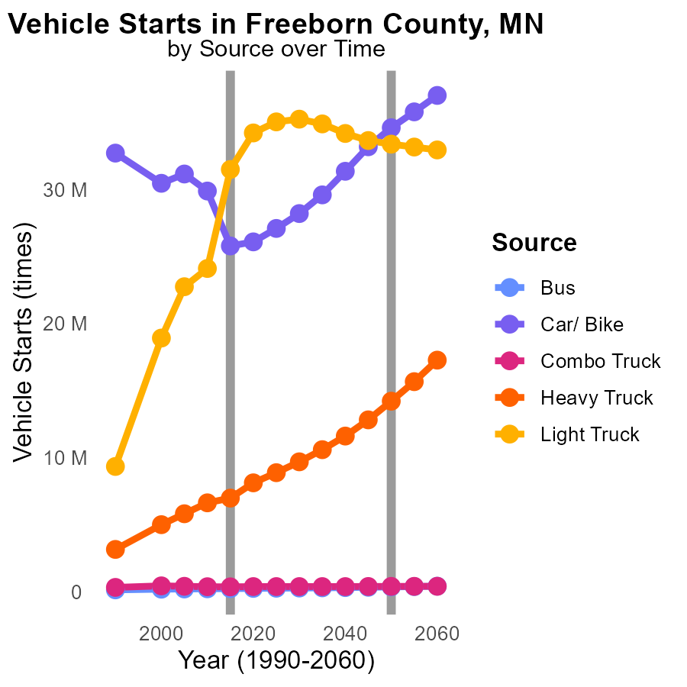

## Findings

* CO2e emissions from cars/bikes decreased by 12.7% from 2005 to 2025.
* Heavy trucks showed a 34.1% increase in CO2e emissions from 2005 to 2025.
* Light trucks had a 7.0% increase in CO2e emissions from 2010 to 2015.

## Recommendations

To reduce emissions, focus on promoting carpooling and public transportation to decrease CO2e from cars/bikes further. Implement stricter emission standards for heavy trucks, emphasizing the adoption of cleaner technologies. Encourage the use of electric vehicles for light trucks to reverse the recent emissions trend.

# Areas Ranked by Vehicle Starts

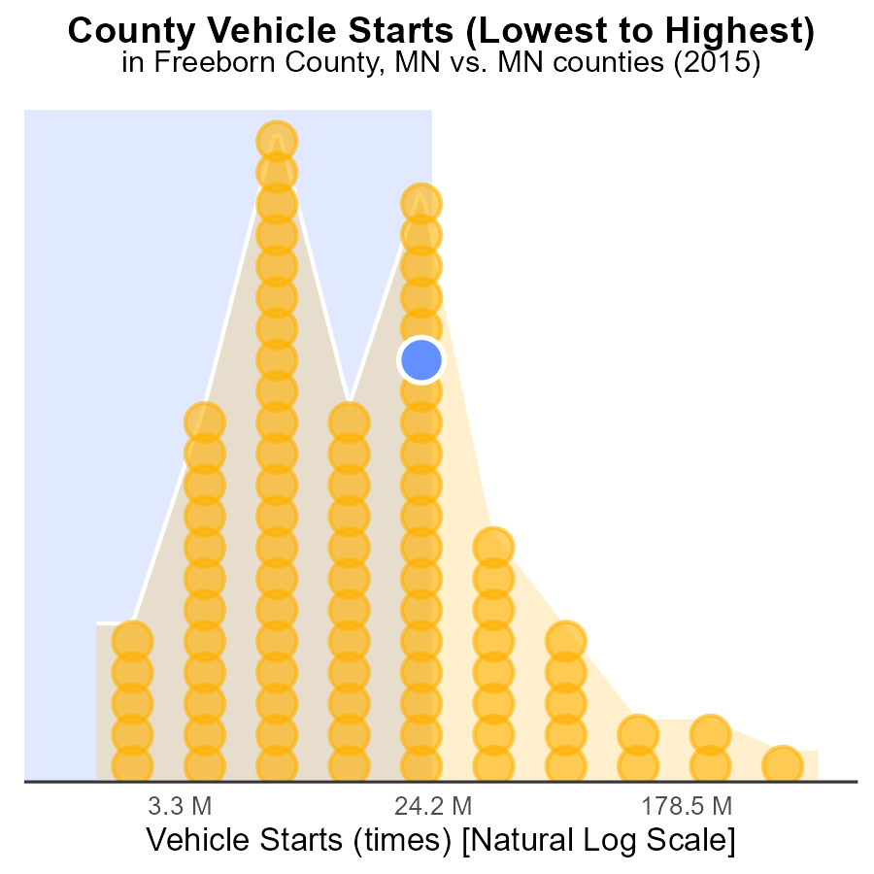

## Findings

* Hennepin county had the highest CO2e emissions with 1.4 G.
* Traverse county had the lowest CO2e emissions, accounting for only 1.1% of total vehicle starts.
* Steele county ranked 65th but had a high percentile of 74.7% in emissions among all counties.

## Recommendations

To lower emissions, focus on reducing vehicle starts in high-emitting counties like Hennepin and Steele. Encourage carpooling, public transportation, and active transportation methods.

# Areas Ranked by Emissions Rate (per vehicle)

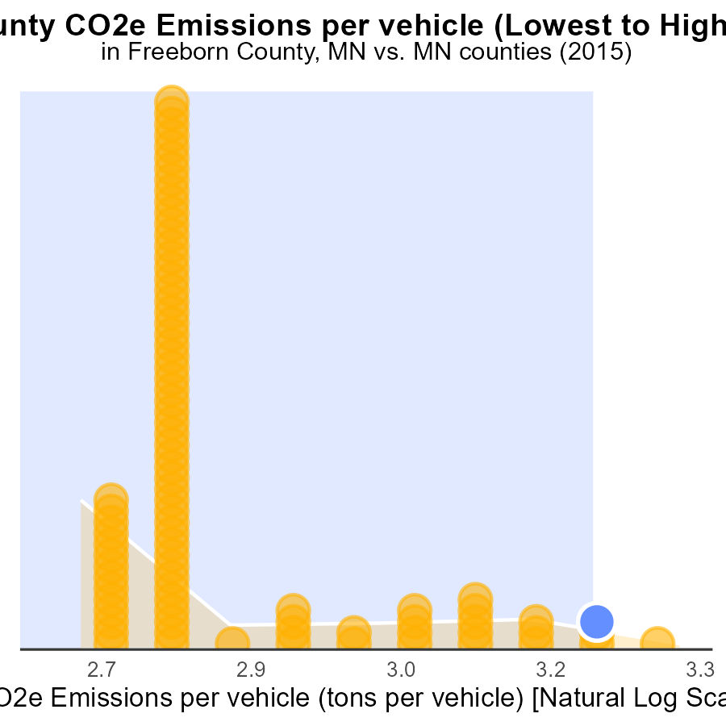

## Findings

* Hennepin county has the lowest emissions per vehicle at 6.3 tons.
* Pine county has the highest emissions per vehicle at 8.0 tons.
* Freeborn and Faribault counties have similar emissions per vehicle, both around 7.7 tons.

## Recommendations

To lower emissions, focus on Pine county that has the highest emissions per vehicle. Encourage the adoption of electric vehicles and improve public transportation infrastructure. Additionally, promote carpooling and the use of bicycles to reduce the number of vehicles on the road.

# Conclusion

In conclusion, the data from the report on CO2 Equivalent emissions from on-road transportation in Freeborn County, MN in 2015 highlights the significant contribution of gasoline and diesel emissions to the total CO2e output. To effectively lower emissions in the county, initiatives should target the reduction of gasoline and diesel usage through promoting cleaner fuel alternatives and improving transportation efficiency, such as public transport and carpooling. Additionally, focusing on reducing emissions from the highest contributing sources, like the Hotelling (Diesel Aux) equipment type, by implementing cleaner technologies can lead to substantial emission reductions.

Emissions per vehicle showed a promising decreasing trend over the years, emphasizing the importance of policies promoting electric vehicles and stricter emissions standards. Moreover, the overall reduction in emissions per mile and efforts to incentivize eco-friendly transportation options are steps in the right direction towards mitigating the environmental impact of on-road transportation in Freeborn County, MN. By strategically targeting key areas for emission reduction and advocating for sustainable transportation practices, the county can work towards a greener and more sustainable future.

# About This Report

Data based on MOVES estimates collected by the Climate Action in Transportation program at Cornell University. Demographic data sourced from the US Census's American Community Survey 5-year estimates. This report was generated with the help of AI.

# References

* U.S. Census Bureau. (2023). American Community Survey 5-year estimates: Detailed tables. Retrieved from https://data.census.gov
* U.S. Environmental Protection Agency. (2024). Motor Vehicle Emission Simulator (MOVES 4.0) [Software]. Retrieved from https://www.epa.gov/moves