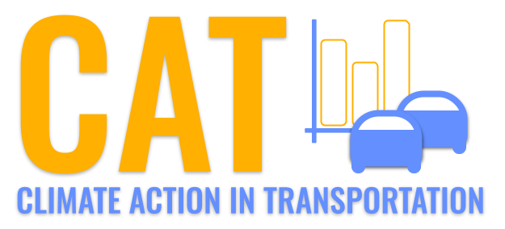 

**CO Emissions in Franklin County, 2025**  
Made with CAT VISUALIZER by Gao Labs @ Cornell University.

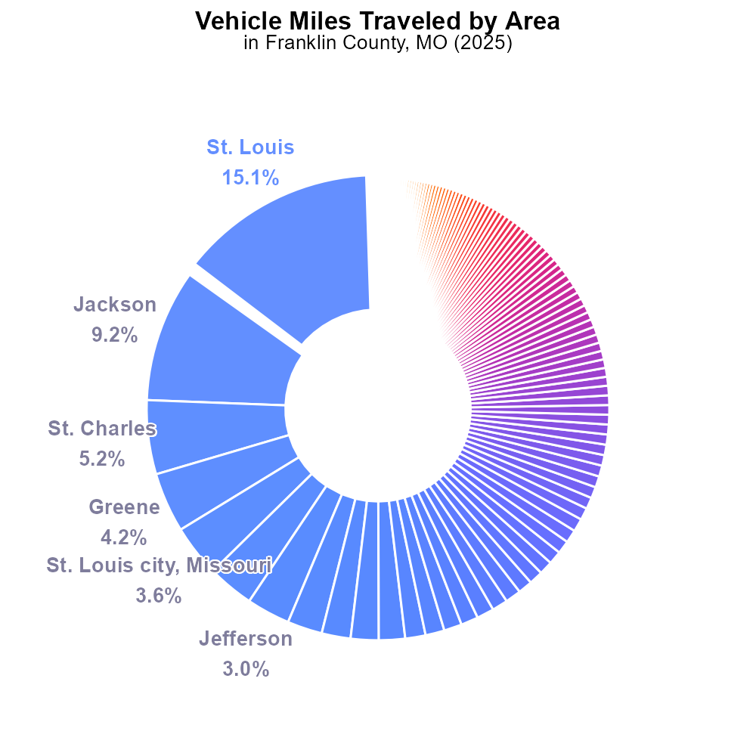

## Keywords

Carbon Monoxide emissions; on-road transportation; Franklin County; MO; 2025

## Highlights

* CO emissions impact in Franklin County transportation.
* Analyzing on-road CO emissions in 2025.
* Environmental concerns in Franklin County, MO.
* Measuring CO emission levels in transportation.
* Strategies for reducing CO emissions.

# Introduction

This report focuses on the Carbon Monoxide (CO) emissions originating from on-road transportation in Franklin County, Missouri, specifically in the year 2025. CO is a significant air pollutant that poses health risks and contributes to environmental degradation.

Franklin County's reliance on transportation networks highlights the importance of understanding and controlling CO emissions. By investigating the levels of CO emitted by vehicles on the county's roads, this report aims to shed light on the environmental impact and potential health effects associated with high concentrations of CO in the air. Strategies for reducing these emissions will also be explored, emphasizing the need for sustainable transportation practices in Franklin County to mitigate the adverse effects of CO on public health and the environment.

# Vehicle Starts by Vehicle Type

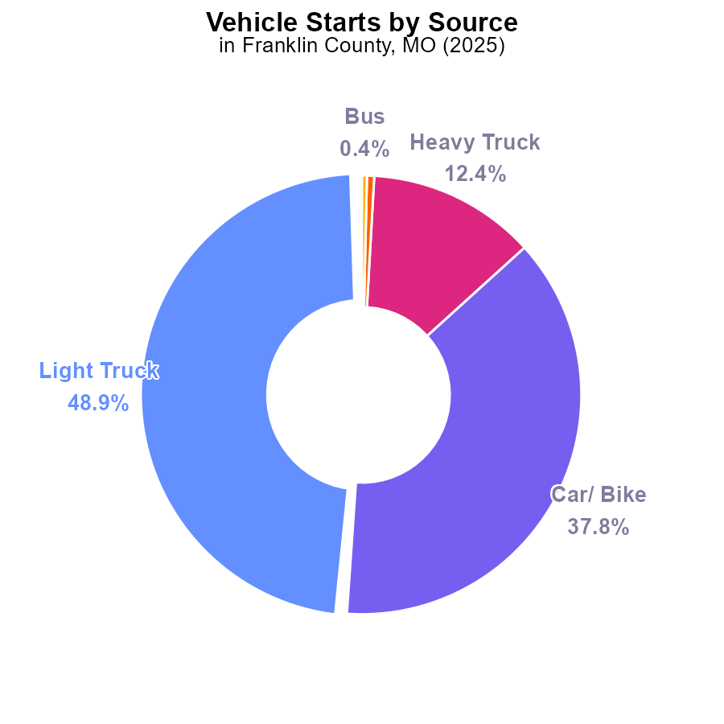

## Findings

* Light trucks contribute to 48.9% and cars/bikes to 37.8% of CO emissions from vehicle starts.
* Heavy trucks and combo trucks collectively account for 13% of vehicle start CO emissions.
* Buses contribute only 0.4% of CO emissions from vehicle starts in Franklin County, MO in 2025.

## Recommendations

To reduce CO emissions from vehicle starts, policymakers should focus on improving the emission controls of light trucks and cars/bikes, which are responsible for the majority of emissions. Implementing stricter emission standards for heavy trucks and combo trucks can significantly reduce their collective 13% contribution. Additionally, promoting the use of cleaner fuel and technologies in the public transportation sector, particularly buses, can help lower the emission levels further.

# Vehicle Miles Traveled Overall by Area

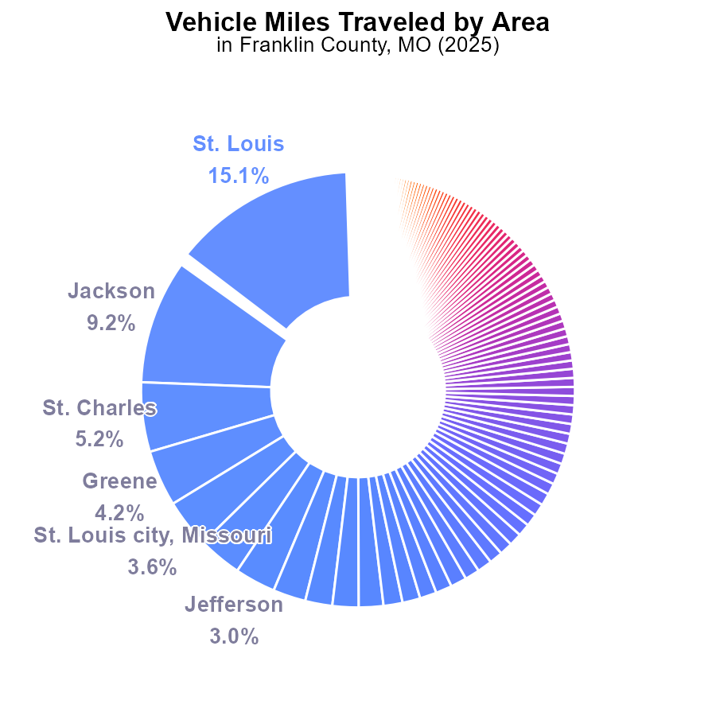

## Findings

* Top 5 counties contribute to over 38% of CO emissions in Franklin County, MO.
* 51 counties have CO emissions below 1%, indicating a more distributed emission profile.
* Significant variations exist with the highest county emitting 11.5 G and the lowest 23.6 M.

## Recommendations

To lower emissions, focus on high emitters. Implement carpooling incentives, public transport improvements, and promote electric vehicle adoption in top emitting counties. Encourage telecommuting to reduce VMT.

# Emissions Rate (per vehicle) over Time for Buses

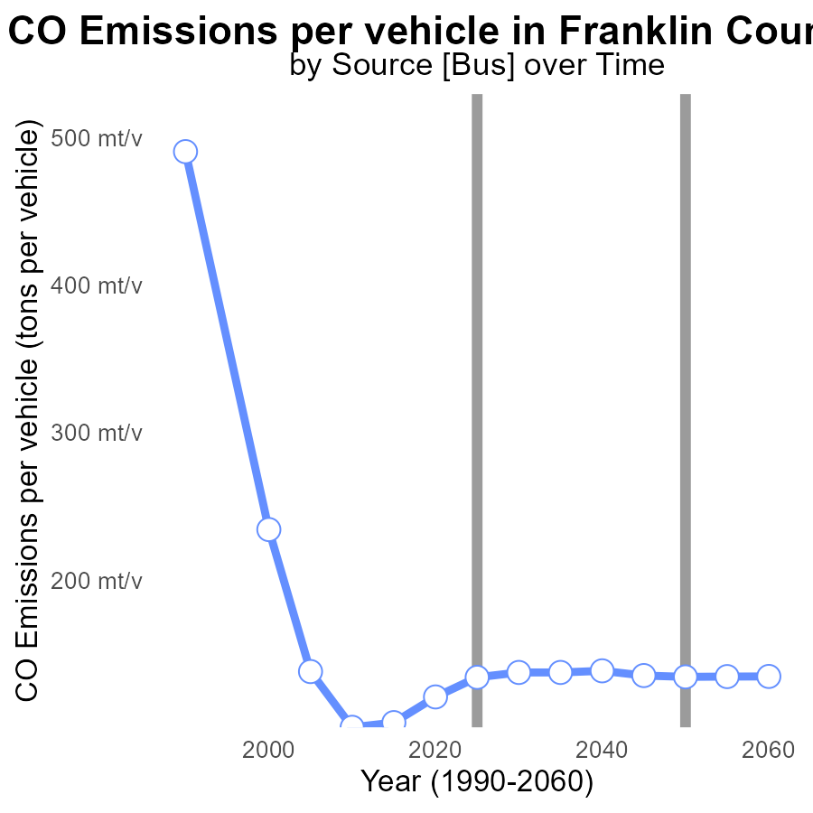

## Findings

* Emissions per vehicle decreased by 0.0036 tons from 2005 to 2010.
* Emissions increased from 2010 to 2020 but stabilised until 2040 with a minor drop.
* Overall trend shows a slight decrease in emissions per vehicle over the long term.

## Recommendations

To further reduce emissions, focus on the factors that led to the increase from 2010 to 2020. Implement stricter vehicle emission standards and promote the adoption of electric vehicles.

# Population Overall over Time

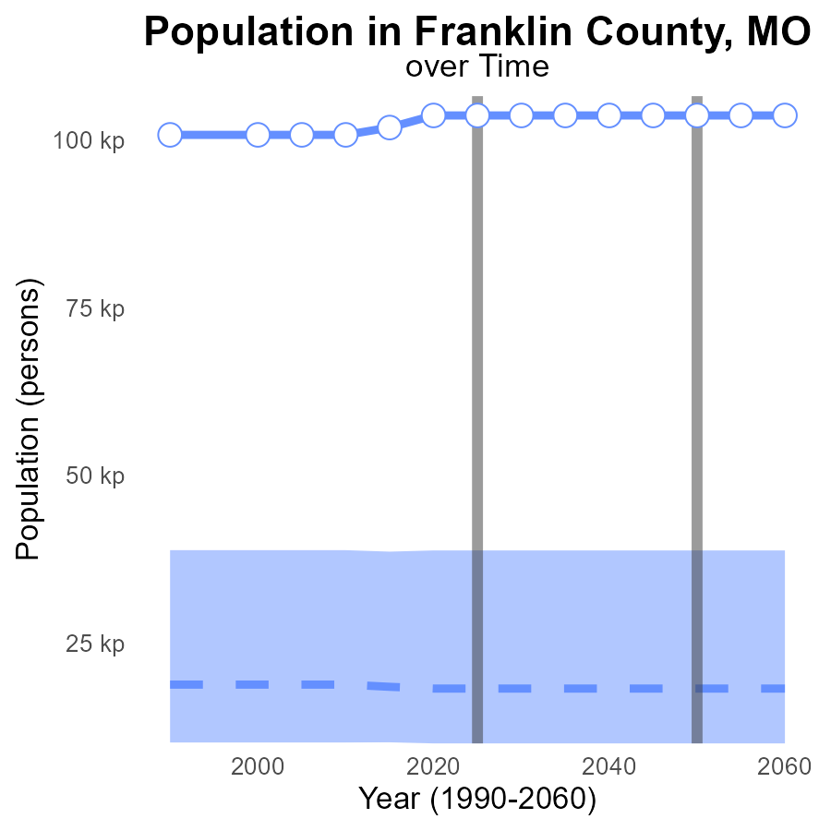

## Findings

* Population in Franklin County, MO has been consistently increasing by around 85.4k residents every five years since 2020
* Emissions data for CO in Franklin County, MO is not provided, making it challenging to analyze the environmental impact
* Benchmark difference for this area is set at 0 for the years 2020 to 2045

## Recommendations

To better assess emissions data in Franklin County, MO, it is crucial to include CO emission levels. Monitoring and reporting these emissions annually can provide a clearer understanding of the area's environmental impact. Establishing emission reduction targets linked to the benchmark difference can guide policymakers in developing effective strategies to lower emissions.

# Vehicle Starts in My Region

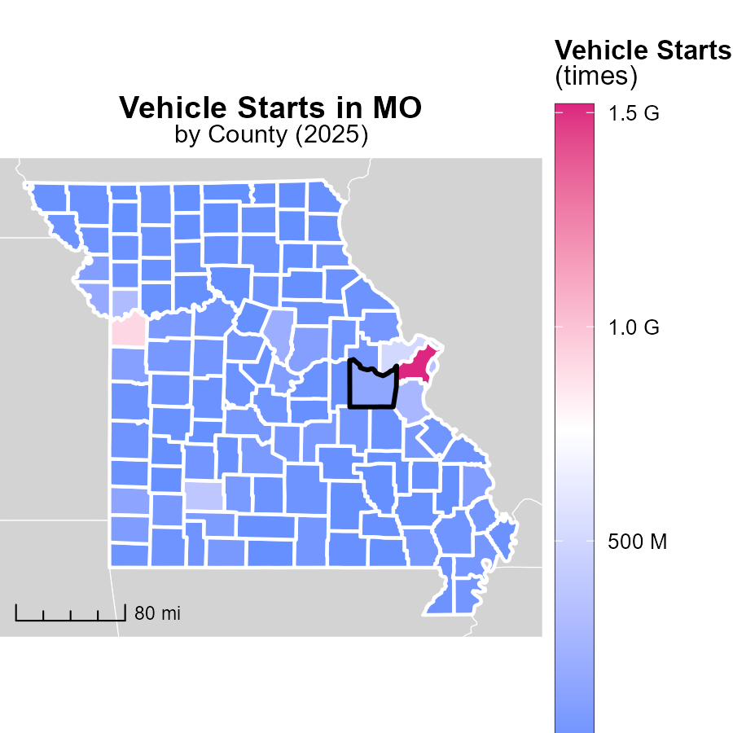

## Findings

* St. Louis County, MO has the highest vehicle starts with 1.5 billion.
* Macon County, MO has a median of 32.4 million vehicle starts.
* Worth County, MO has the lowest vehicle starts with 2.1 million.

## Recommendations

To lower emissions, focus on reducing vehicle starts in areas like St. Louis County by promoting carpooling, public transportation, and working from home. Encourage the use of electric vehicles to decrease emissions further.

# Emissions Rate (per capita) in My Region

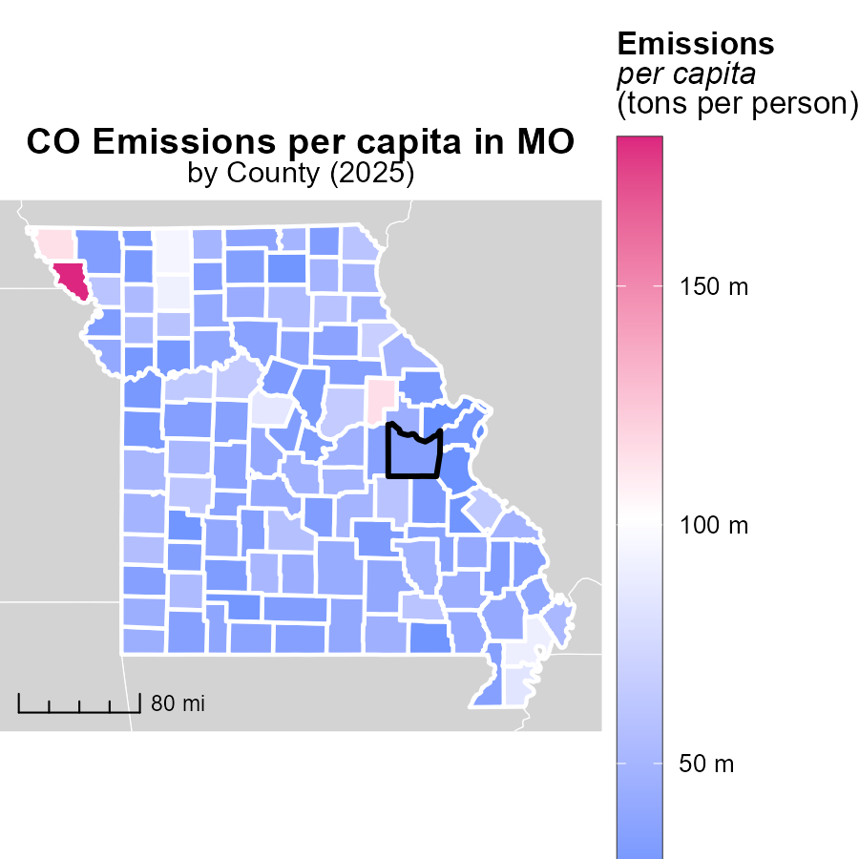

## Findings

* The highest emissions per capita were found in Holt County, MO, with 181.1 tons per person.
* Polk County, MO, had a median emissions rate of 41.0 tons per person.
* St. Louis city, Missouri County, MO, had the lowest emissions per capita at 21.7 tons per person.

## Recommendations

To lower emissions, Holt County, MO, should implement stricter regulations on industries contributing to high emissions. Polk County, MO, can focus on promoting sustainable transportation methods. St. Louis city, Missouri County, MO, should invest in renewable energy sources.

# Emissions by Road Type over Time

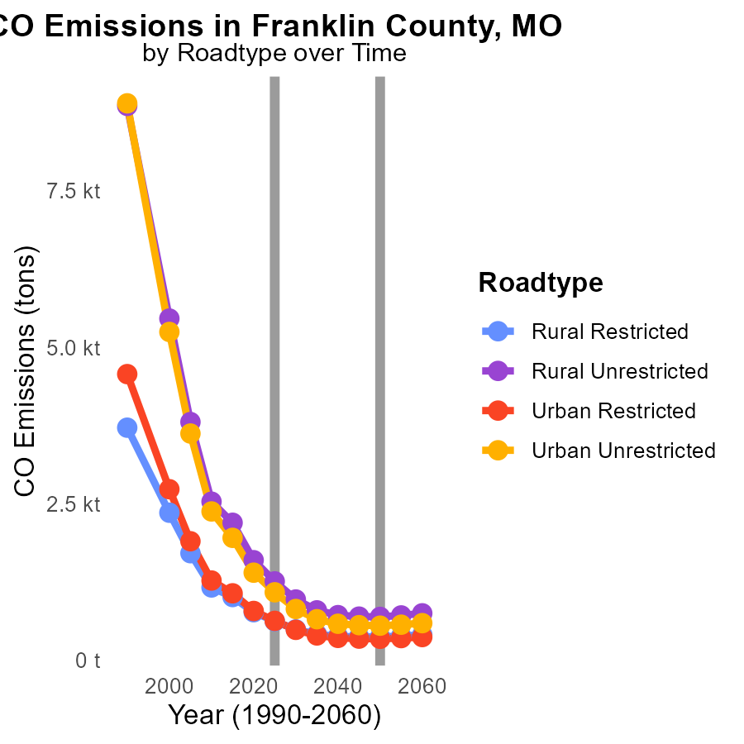

## Findings

* Emissions decrease across all road types from 2015 to 2035 in Franklin County, MO.
* Urban areas show higher emissions compared to rural areas for all road types.
* The most significant emission reduction occurs in Urban Unrestricted areas.

## Recommendations

To further reduce emissions, focus on improving public transportation in urban areas, promoting carpooling, implementing stricter emissions standards for vehicles, and investing in renewable energy sources for transportation.

# Emissions Rate (per mile) by Vehicle Type over Time

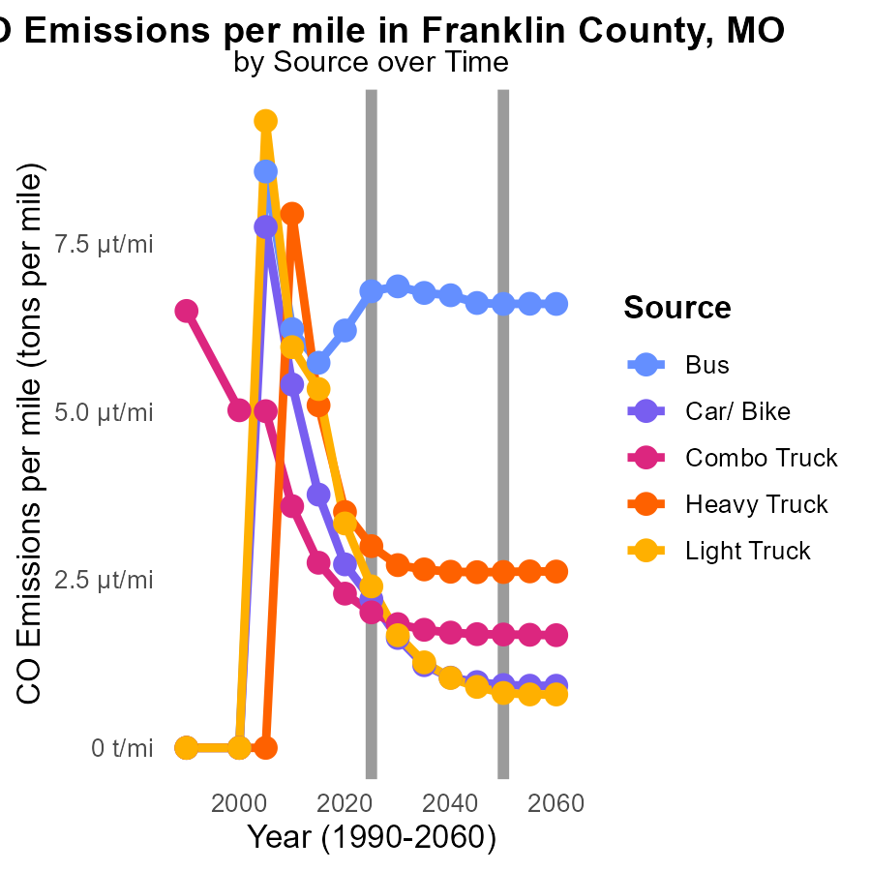

## Findings

* Emissions per mile decreased for all vehicle types from 2015 to 2035.
* Heavy trucks had the highest emissions in 2015 (5.1 tons per mile) but showed the most significant reduction (2.5 tons per mile) by 2035.
* Cars/Bikes had the lowest emissions in 2015 (3.8 tons per mile) and continued to decrease, reaching 1.2 tons per mile by 2035.

## Recommendations

To further reduce emissions, policymakers should continue promoting the use of electric vehicles, implementing stricter emissions standards for heavy trucks, incentivizing the use of public transportation, and investing in infrastructure to support biking and walking.

# Areas Ranked by Emissions Rate (per vehicle)

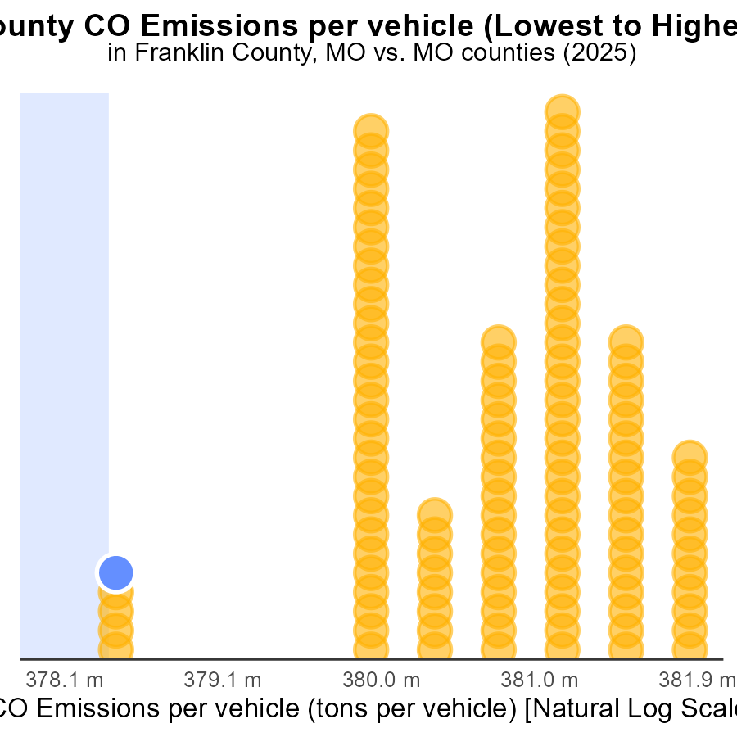

## Findings

* Holt county has the highest emissions per vehicle in 2025.
* St. Charles county ranks 1st with the lowest emissions per vehicle.
* Worth county has the highest percentage of emissions per vehicle at 5.2%.

## Recommendations

To lower emissions per vehicle, consider implementing stricter vehicle emission standards, promoting the use of electric vehicles, and improving public transportation infrastructure.

# Areas Ranked by Vehicle Starts

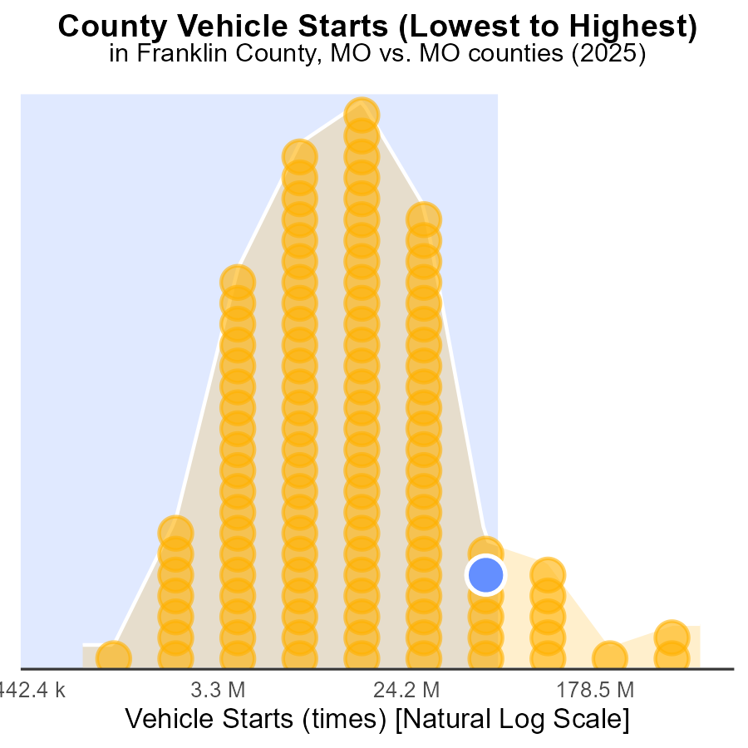

## Findings

* St. Louis county has the highest amount of vehicle starts in 2025.
* Worth county has the lowest percentage of vehicle starts in 2025.
* The top three counties with the highest percentile of vehicle starts are Platte, Franklin, and Jasper.

## Recommendations

To lower CO emissions, implement vehicle start-stop technology in high-start counties like St. Louis and Platte. Encourage the use of eco-friendly vehicles in all counties to reduce emissions.

# About This Report

Data based on MOVES estimates collected by the Climate Action in Transportation program at Cornell University. Demographic data sourced from the US Census's American Community Survey 5-year estimates. This report was generated with the help of AI.

# References

* U.S. Census Bureau. (2023). American Community Survey 5-year estimates: Detailed tables. Retrieved from https://data.census.gov
* U.S. Environmental Protection Agency. (2024). Motor Vehicle Emission Simulator (MOVES 4.0) [Software]. Retrieved from https://www.epa.gov/moves