 

**PM10 Emissions in Santa Fe County, 2005**  
Made with CAT VISUALIZER by Gao Labs @ Cornell University.

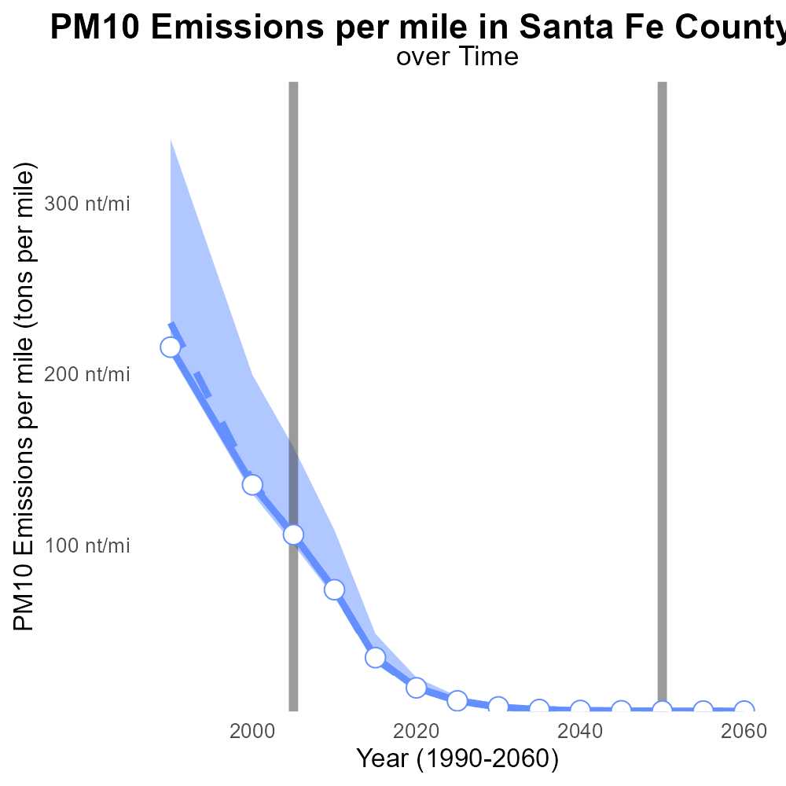

## Keywords

Primary Exhaust; PM10; Total emissions; on-road transportation; Santa Fe County; 2005

## Highlights

* An analysis of 2005 Primary Exhaust PM10 emissions in Santa Fe County.
* Focus on total emissions from on-road transportation in the area.
* Evaluation of the environmental impact of on-road transportation in 2005.
* Assessment of PM10 levels and their contribution to air pollution.
* Insights into primary sources of PM10 emissions in Santa Fe County.

# Introduction

The following report presents a comprehensive analysis of Primary Exhaust PM10 emissions in Santa Fe County, NM in the year 2005. Specifically, the study delves into the total emissions generated by on-road transportation within the county during this period. With a focus on the environmental implications of on-road transportation, the report aims to evaluate the impact of these emissions on air quality and public health.

Additionally, the research endeavors to provide insights into the levels of PM10 particulate matter present in the county's air in 2005 and their contribution to overall air pollution. By identifying and examining the primary sources of PM10 emissions in Santa Fe County during this period, the report seeks to offer valuable data for informing future environmental policies and practices.

# Idling Overall by Area

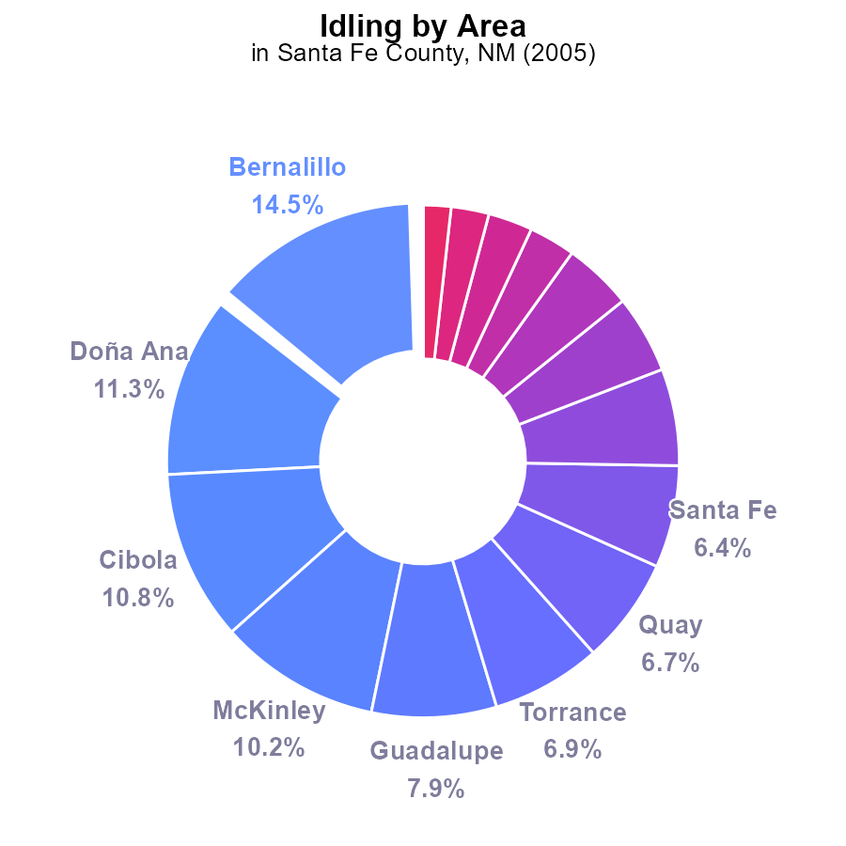

## Findings

* Top emitters: Bernalillo 14.5%, Doña Ana 11.3%, Cibola 10.8%
* Santa Fe County emitted 6.4%, much lower than top emitters
* Several areas had negligible emissions: Catron, Chaves, Curry, De Baca, Eddy, Harding, Lea, Los Alamos

## Recommendations

To lower PM10 emissions, focus on high emitters like Bernalillo, Doña Ana, and Cibola. Implement idling reduction measures in these areas. Monitor and enforce idling policies rigorously. Consider public awareness campaigns.

# Emissions Rate (per mile) Overall by Area

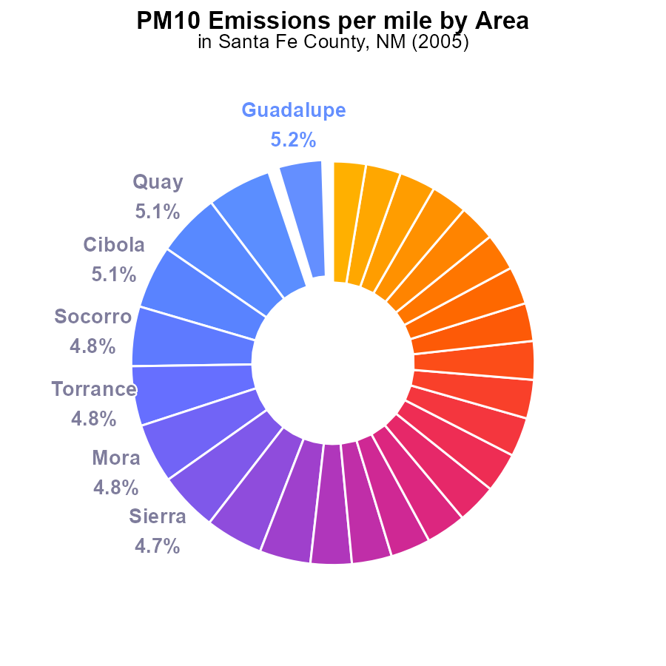

## Findings

* Top 5 counties with the highest PM10 emissions per mile are Guadalupe, Hidalgo, Quay, Cibola, and Socorro.
* The bottom 5 counties with the lowest PM10 emissions per mile are San Juan, Los Alamos, Curry, Bernalillo, and Eddy.
* Doña Ana, Santa Fe, and Valencia have notably lower emissions compared to other counties, at 3.3%, 3.2%, and 3.2% respectively.

## Recommendations

To lower emissions, focus on high PM10 counties like Guadalupe, Hidalgo, Quay, and Cibola through stricter regulations and monitoring. Encourage cleaner transportation modes in these areas.

# Emissions Rate (per capita) Overall over Time

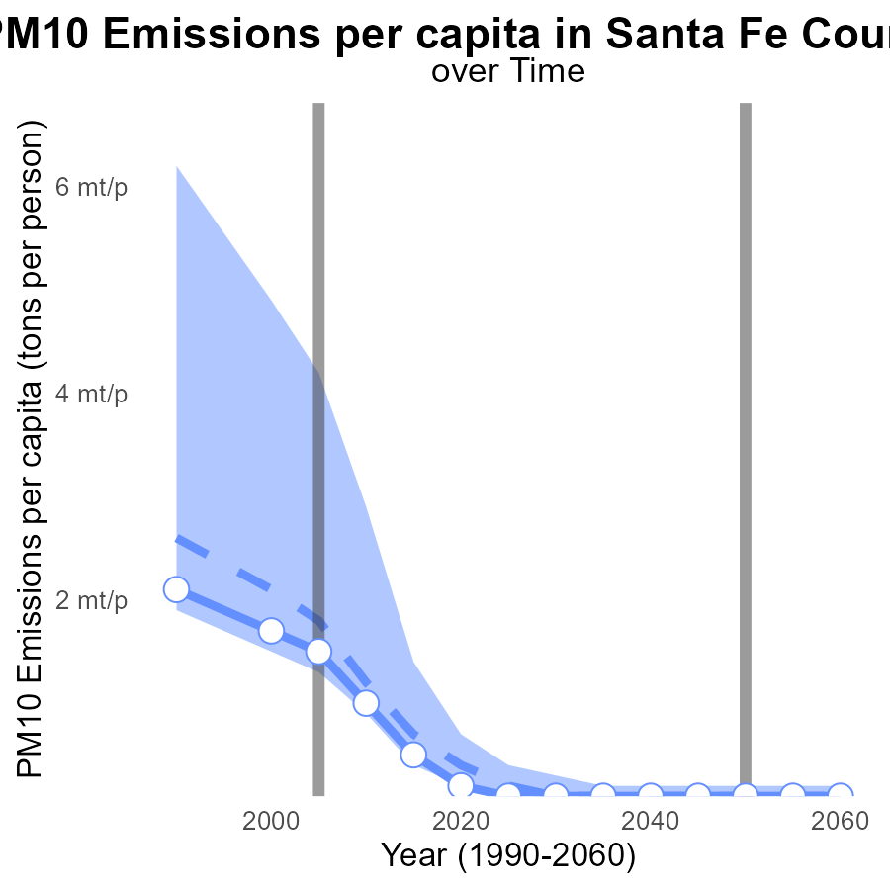

## Findings

* Emissions of PM10 per capita in Santa Fe County have decreased significantly from 1990 to 2025.
* The emissions were below the median area and lower 25th percentile benchmark throughout the years.
* There has been a consistent downward trend in emissions per capita, indicating successful emission reduction efforts.

## Recommendations

To further reduce PM10 emissions per capita, Santa Fe County should continue implementing and enforcing strict air quality regulations. Additionally, investing in cleaner technologies and promoting public transportation can help sustain the declining trend in emissions.

# Emissions Rate (per mile) Overall over Time

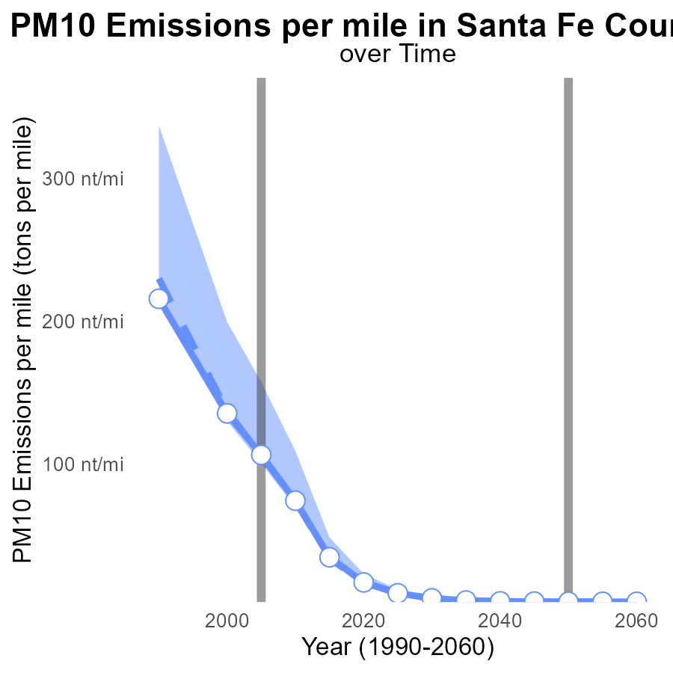

## Findings

* PM10 emissions per mile in Santa Fe County decreased by 93.2% from 1990 to 2025.
* In 2005, emissions were 556.9% above the median area.
* By 2015 and onwards, emissions were at or below the benchmark level of 0 tons per mile.

## Recommendations

To further reduce emissions, focus on sustaining the significant decline observed since 1990. Invest in clean transportation initiatives to maintain levels below the benchmark for improved air quality.

# Emissions Rate (per vehicle) in My Region

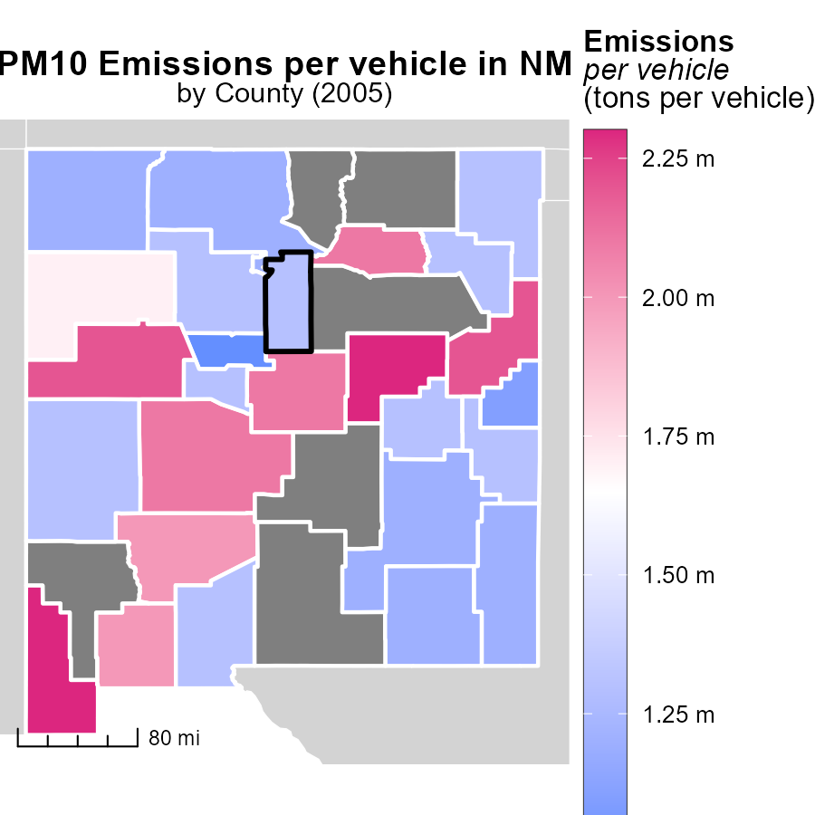

## Findings

* In 2005, Guadalupe County, NM had the highest emissions per vehicle at 2.3 tons per vehicle.
* The median emissions per vehicle in 2005 for Harding County, NM were 1.3 tons per vehicle.
* Bernalillo County, NM had the lowest emissions per vehicle in 2005 at 1.0 tons per vehicle.

## Recommendations

To lower emissions in Guadalupe County, NM, policies should target reducing emissions from vehicles specifically, considering their higher levels. For Harding County, maintaining emissions at the median level is crucial. Bernalillo County can serve as a benchmark for other regions in terms of emissions reduction.

# Hotelling (Diesel Aux) in My Region

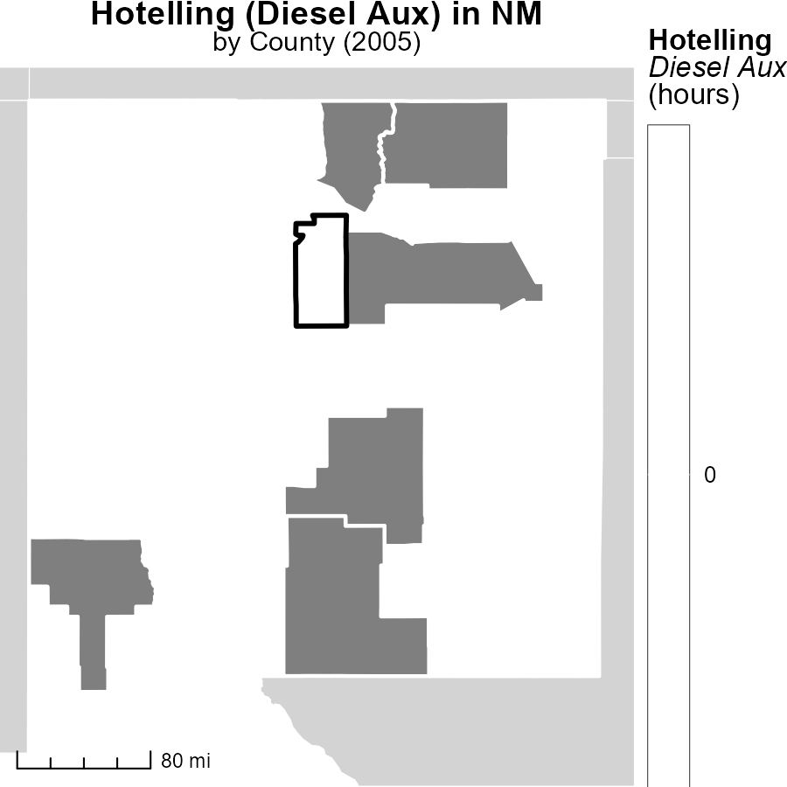

## Findings

* In 2005, Bernalillo County, NM had the highest emissions from Hotelling (Diesel Aux) at 0.0 hours.
* Luna County, NM had median emissions at 0.0 hours for Hotelling (Diesel Aux) in 2005.
* Valencia County, NM had the lowest emissions at 0.0 hours from Hotelling (Diesel Aux) in 2005.

## Recommendations

To lower emissions, implementing stricter regulations on Hotelling (Diesel Aux) activities in Luna County and Valencia County is crucial. Continuous monitoring and enforcing emission standards in Bernalillo County is necessary to reduce emissions.

# Emissions by Road Type over Time

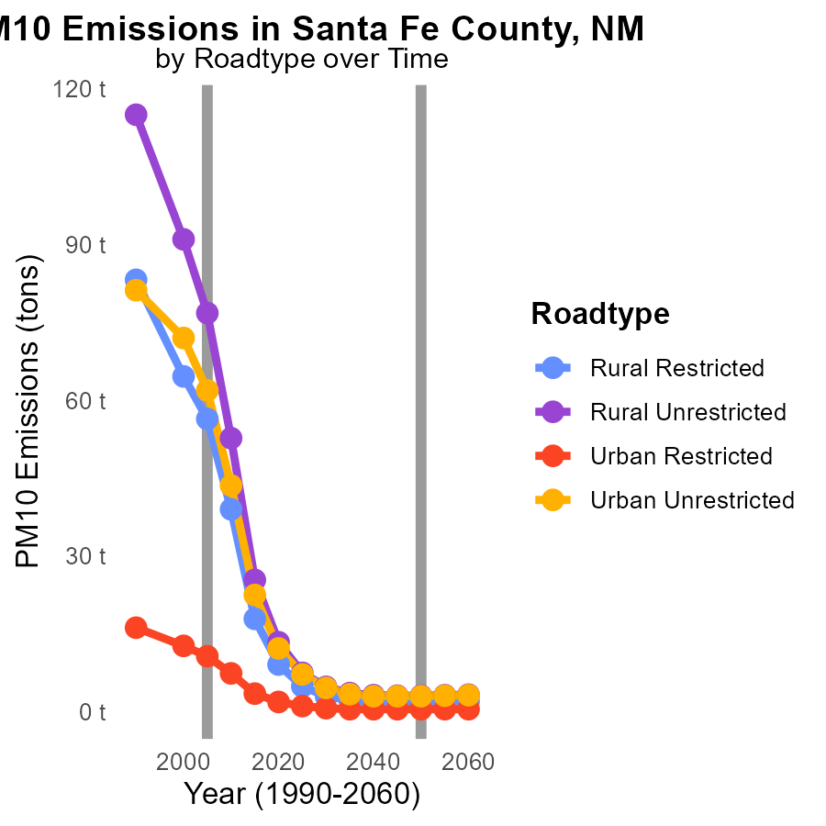

## Findings

* From 2000 to 2015, PM10 emissions in Santa Fe County decreased significantly for all road types.
* Rural Unrestricted had the highest total emissions in all years, with a 69.6% reduction from 2000 to 2015.
* Urban Unrestricted showed a 68% decrease in emissions from 2000 to 2015.

## Recommendations

To further lower PM10 emissions, policymakers should focus on implementing stricter emission standards for vehicles in Santa Fe County, especially targeting unrestricted rural and urban roads. Additionally, promoting the use of public transportation and carpooling can help reduce emissions significantly.

# Vehicle Miles Traveled by Vehicle Type over Time

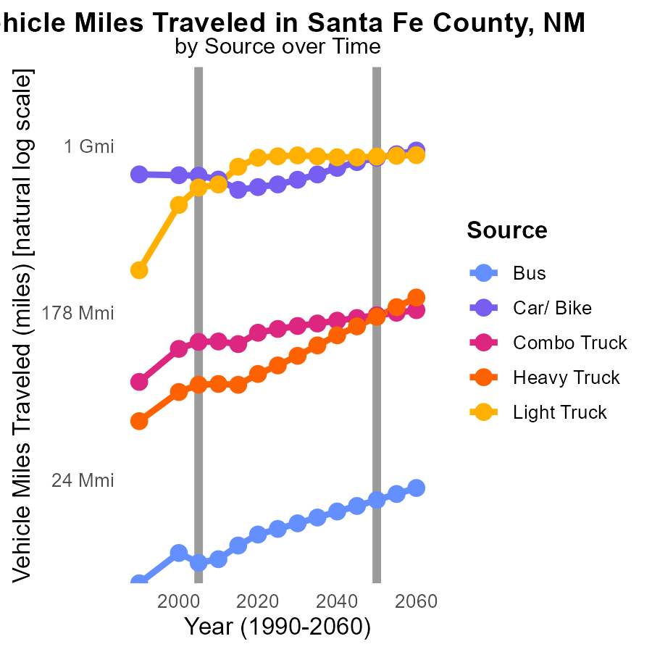

## Findings

* Vehicle miles traveled increased for buses, cars/bikes, and light trucks from 2000 to 2015.
* The highest increase in vehicle miles traveled was observed for light trucks, with a 104% rise from 2000 to 2015.
* Despite some fluctuations, heavy trucks maintained a relatively stable level of vehicle miles traveled over the years.

## Recommendations

To lower emissions in Santa Fe County, NM, authorities should consider promoting public transport and carpooling to reduce the increasing trend of vehicle miles traveled. Incentivizing the use of electric vehicles can also help curb emissions from the transportation sector.

# Areas Ranked by Vehicles

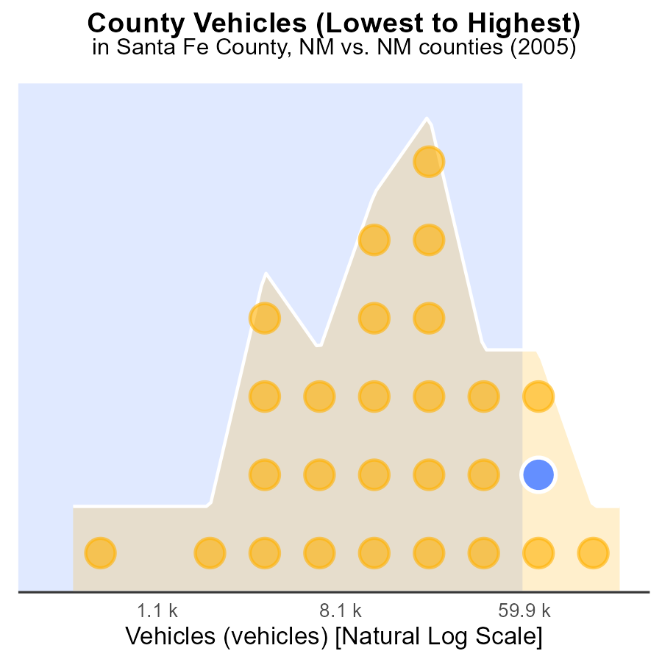

## Findings

* Bernalillo county had the highest number of vehicles emissions in 2005, ranking 27th.
* Doña Ana county had the highest percentile of vehicles emissions, reaching 96.3% in 2005.
* Harding county had the lowest percentile of vehicles emissions in 2005, accounting for only 3.7%.

## Recommendations

To lower vehicle emissions, Bernalillo county should invest in public transportation and promote carpooling to reduce the number of vehicles on the road. Doña Ana county can focus on implementing stringent vehicle emission testing and enforcement measures. Harding county should consider incentivizing the use of electric vehicles and adopting stricter vehicle emission standards.

# Areas Ranked by Emissions

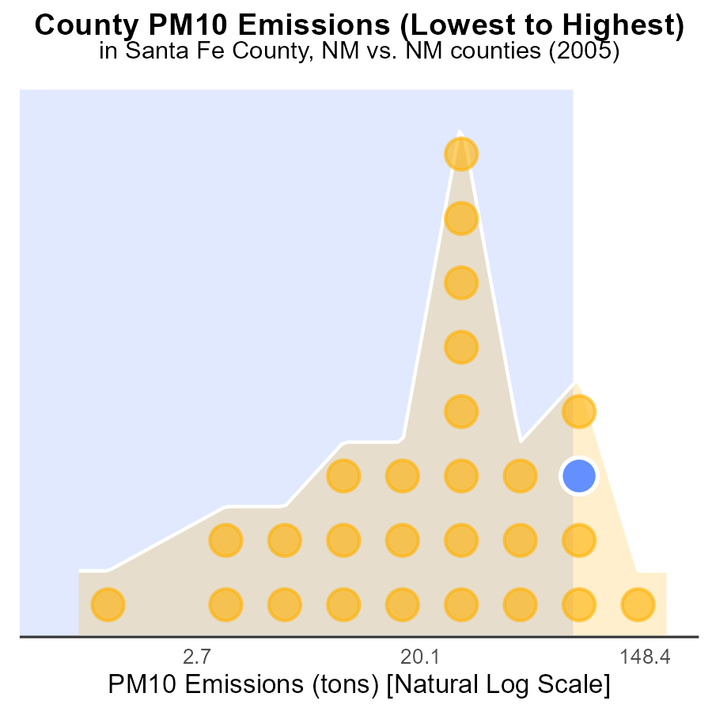

## Findings

* Bernalillo county has the highest PM10 emissions in 2005 at 479.5 tons.
* Doña Ana county has the highest percentile of emissions at 96.3%.
* Harding county has the lowest PM10 emissions in 2005 at 1.5 tons.

## Recommendations

To lower the PM10 emissions, Bernalillo county should focus on implementing stricter emissions regulations, while Doña Ana county could benefit from increased monitoring and enforcement. Harding county should continue efforts to maintain their low emission levels.

# Conclusion

In 2005, Santa Fe County, NM emitted 6.4% of Primary Exhaust PM10 from on-road transportation, significantly lower than top emitters like Bernalillo, Doña Ana, and Cibola. To further reduce emissions, the focus should be on implementing idling reduction measures in high emitter areas and enforcing strict air quality regulations. Investing in cleaner technologies and promoting public transportation can help sustain the declining trend in emissions per capita and per mile observed from 1990 to 2025. Additionally, targeting the highest emitters like Guadalupe, Hidalgo, Quay, and Cibola for stricter regulations and initiatives can lead to improved air quality.

Continuous monitoring and enforcement of emission standards, along with incentivizing the use of electric vehicles and promoting carpooling, are essential steps to lower PM10 emissions in Santa Fe County. By learning from counties like Bernalillo, Doña Ana, and Harding, where emissions vary significantly, Santa Fe County can tailor its strategies to combat on-road transportation-related emissions effectively. The consistent downward trend in emissions underscores the success of past efforts and sets a positive trajectory for sustainable emission reduction measures in the future.

# About This Report

Data based on MOVES estimates collected by the Climate Action in Transportation program at Cornell University. Demographic data sourced from the US Census's American Community Survey 5-year estimates. This report was generated with the help of AI.

# References

* U.S. Census Bureau. (2023). American Community Survey 5-year estimates: Detailed tables. Retrieved from https://data.census.gov
* U.S. Environmental Protection Agency. (2024). Motor Vehicle Emission Simulator (MOVES 4.0) [Software]. Retrieved from https://www.epa.gov/moves