 

**VOC Emissions in Clear Creek County, 2025**  
Made with CAT VISUALIZER by Gao Labs @ Cornell University.

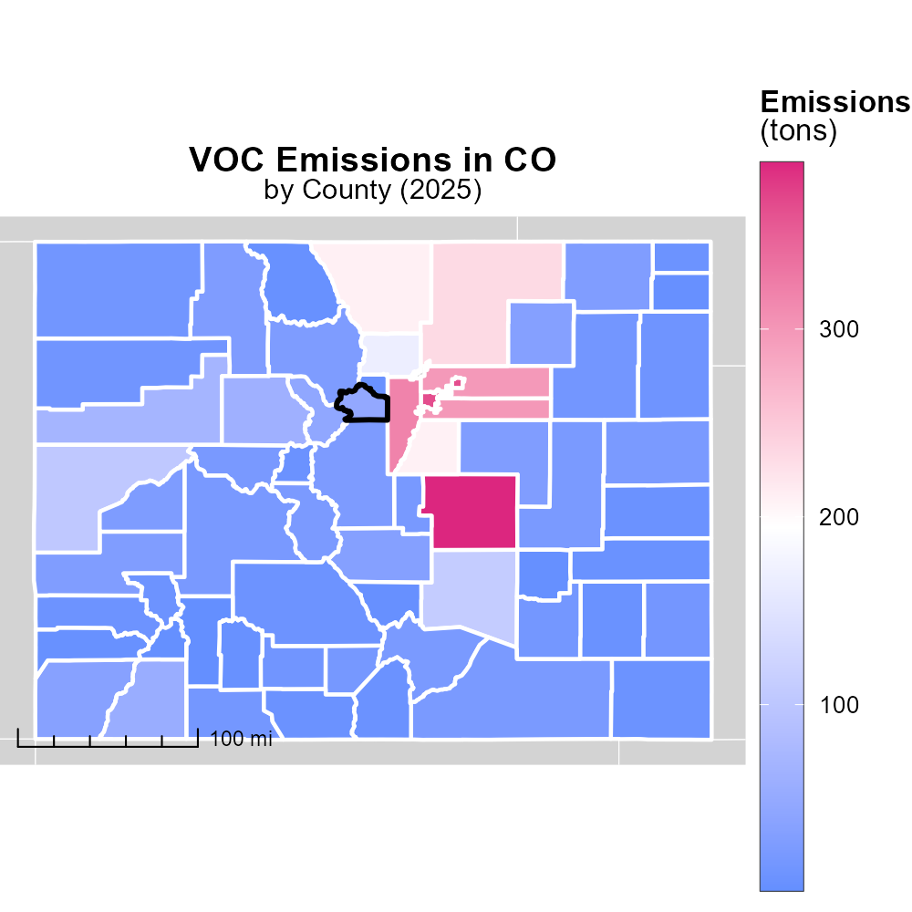

## Keywords

Volatile Organic Compounds; on-road transportation; Clear Creek County; emissions; CO 2025; environment

## Highlights

* Study on VOC emissions in Clear Creek County
* Assessing impact of on-road transportation
* Focus on environmental implications
* 2025 data to analyze trends
* Recommendations for mitigation

# Introduction

Clear Creek County, located in Colorado, is facing increasing concerns regarding the emissions of Volatile Organic Compounds (VOCs) from on-road transportation. As we approach the year 2025, it is crucial to assess the current status of VOC emissions and their impact on the environment in this region. This report aims to delve into the specific sources of VOCs from on-road transportation in Clear Creek County and analyze the trends observed in VOC emissions over the years.

Furthermore, this report will provide recommendations for mitigation strategies to reduce the emissions of VOCs from on-road transportation, aiming to preserve the environmental quality of Clear Creek County.

# Hotelling (Engines Off) by Fuel Type

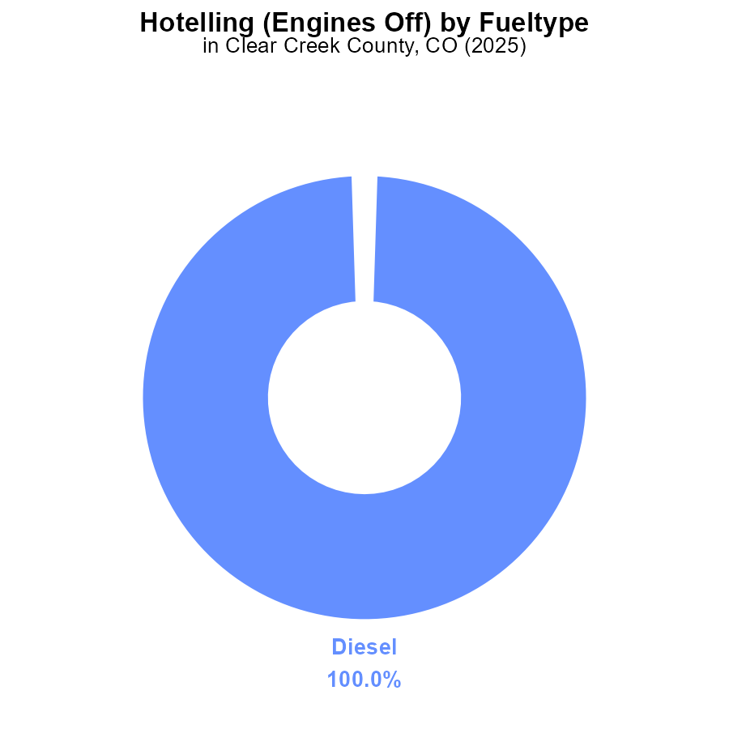

## Findings

* Diesel engines account for 100.0% of VOC emissions in Clear Creek County in 2025.
* There are no emissions from CNG, ethanol, or gas engines in the Hotelling (Engines Off) activity.
* VOC emissions are solely attributed to diesel engines being in use.

## Recommendations

Encouraging the use of cleaner fuels or electric vehicles can help in reducing VOC emissions in Clear Creek County. Implementing stricter regulations or incentives for the phasing out of diesel engines could also significantly decrease emissions.

# Emissions Rate (per vehicle) Overall by Area

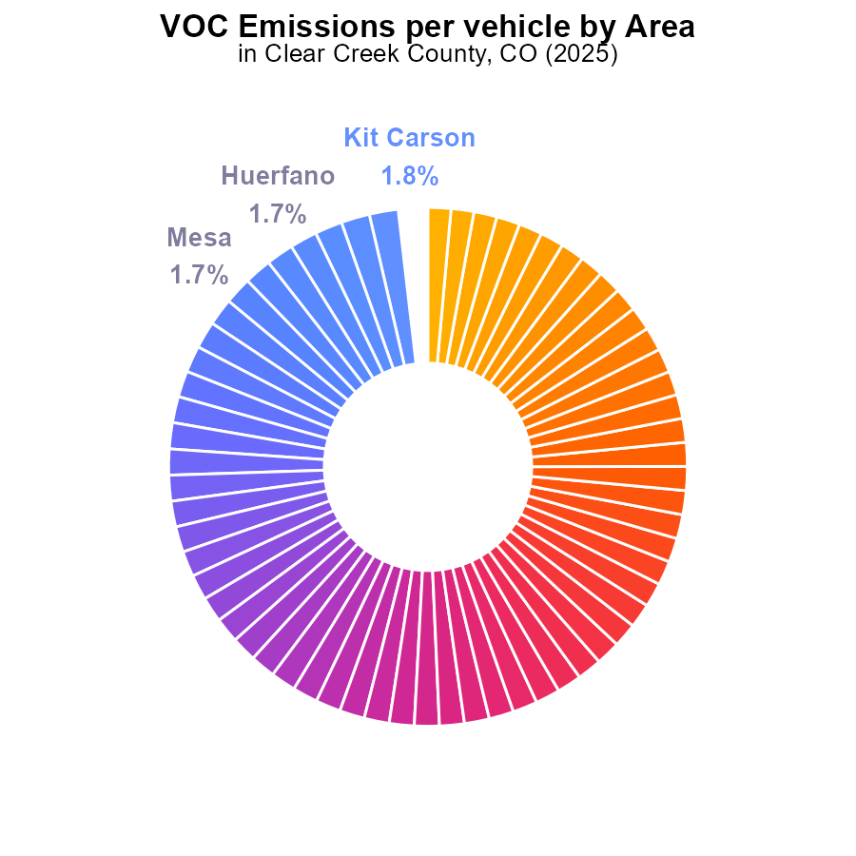

# Population over Time for Passenger Vehicles

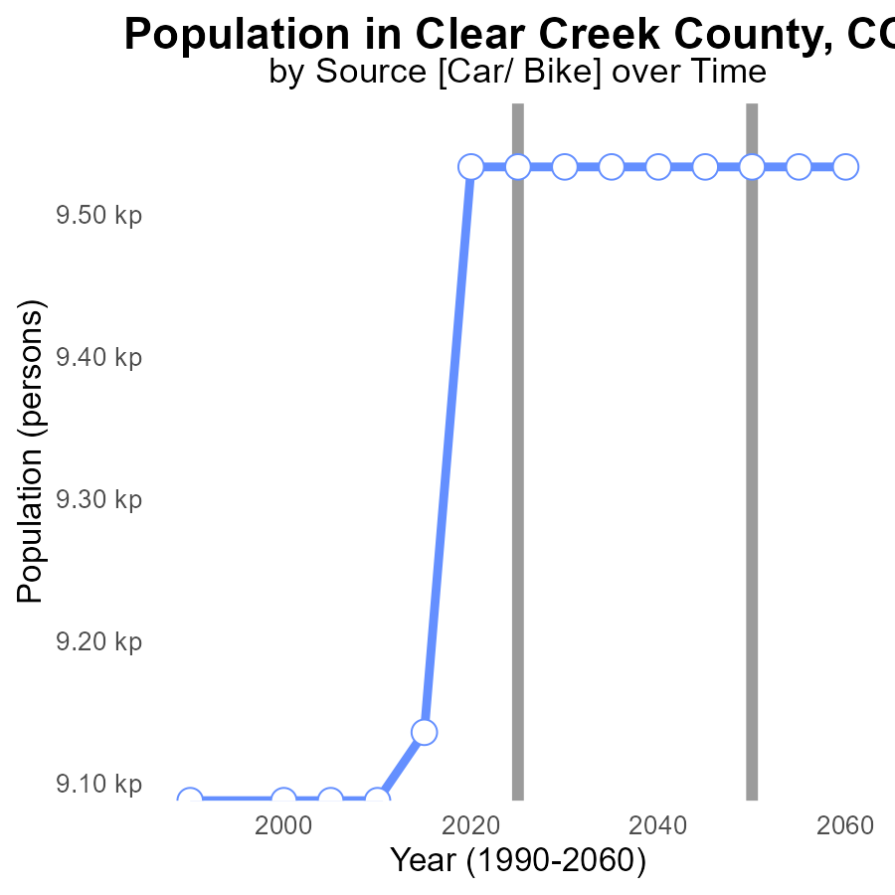

## Findings

* VOC emissions in Clear Creek County, CO, remained fairly stable from 2005 to 2015.
* There was a significant reduction in VOC emissions by 10% from 2015 to 2020.
* From 2020 to 2045, VOC emissions stayed constant at a benchmark of 0, showing a sustained decrease.

## Recommendations

To ensure further reduction in VOC emissions, focus on the strategies implemented between 2015 and 2020 that led to a 10% decrease. Continuing these efforts is crucial to maintain the current emission level at 0 for Clear Creek County by 2045.

# Vehicle Miles Traveled over Time for Passenger Vehicles

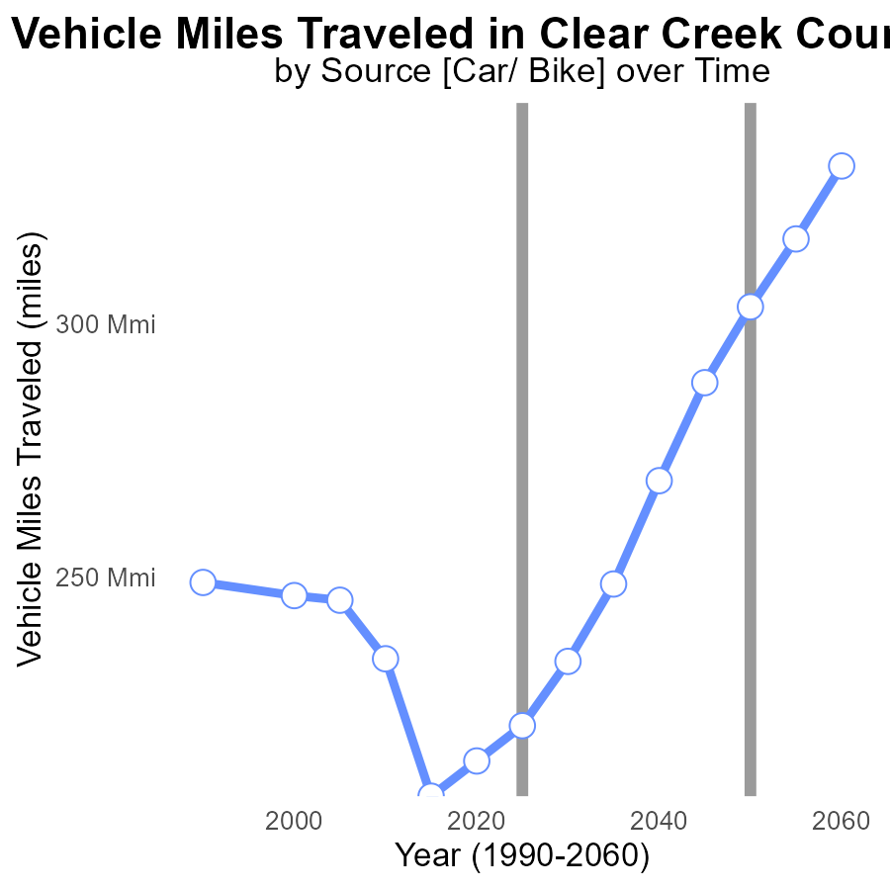

## Findings

* Vehicle miles traveled in Clear Creek County decreased by 13.4% from 2005 to 2045.
* The benchmark difference for vehicle miles traveled increased initially, peaking in 2015, then decreased afterwards.
* In 2045, the difference between the actual vehicle miles traveled and the benchmark was the lowest in the recorded years.

## Recommendations

To lower emissions, policymakers should focus on promoting alternative transportation methods like public transit, carpooling, and biking. Implementing policies to reduce single-occupancy vehicle usage can significantly impact emissions levels in Clear Creek County.

# Vehicle Miles Traveled Mapped by Area

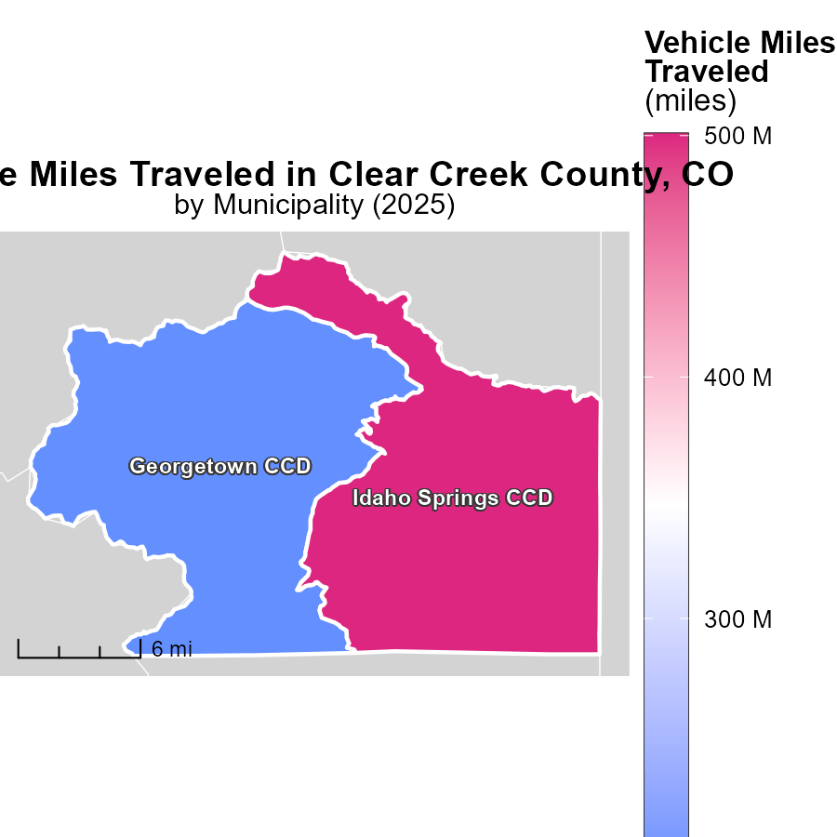

## Findings

* Idaho Springs CCD, CO had a maximum of 500.6 million vehicle miles traveled in 2025.
* Georgetown CCD, CO had a median of 193.5 million vehicle miles traveled in 2025.

## Recommendations

To lower emissions from vehicle miles traveled, focus on promoting public transportation, carpooling, and creating infrastructure for walking and biking in these areas with high mileage numbers.

# Emissions in My Region

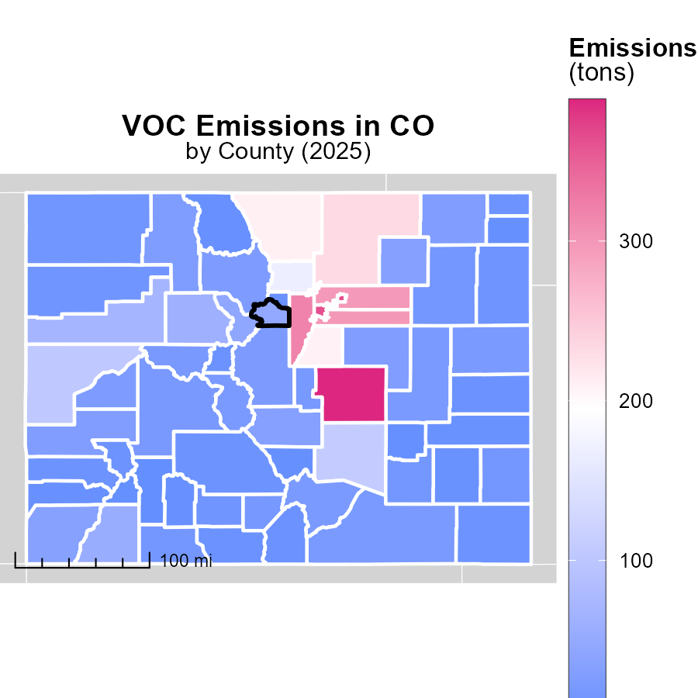

## Findings

* El Paso County, CO has the highest emissions at 388.5 tons.
* Lincoln County, CO has median emissions of 21.1 tons.
* Hinsdale County, CO has the lowest emissions at 1.2 tons.

## Recommendations

To lower emissions, focus on reducing emissions in El Paso County by promoting green technology. Encourage Lincoln County to maintain its emissions level. Support Hinsdale County's low-emission initiatives.

# Hotelling (Engines Off) by Fuel Type over Time

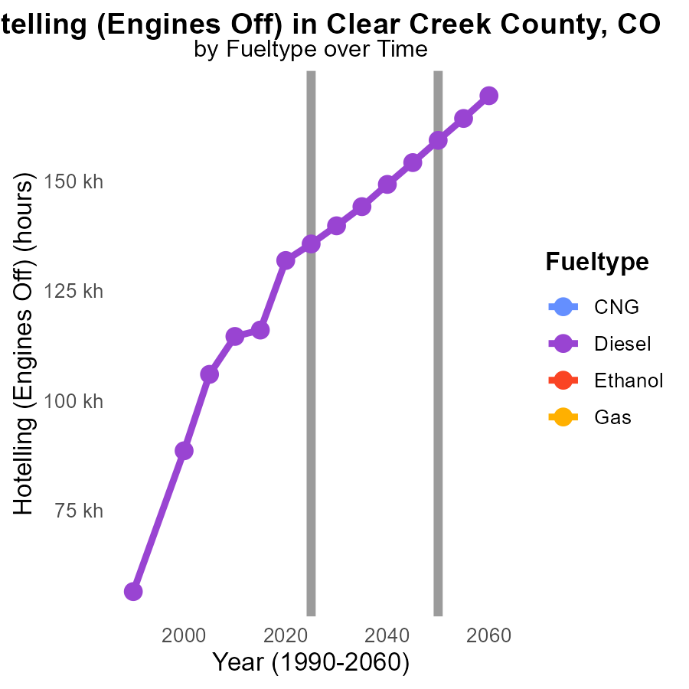

## Findings

* Diesel emissions in Clear Creek County, CO are expected to decrease by 31.4% from 2015 to 2035.
* No data is available for CNG, Ethanol, and Gas emissions from 2015 to 2035 in Clear Creek County, CO.

## Recommendations

To further reduce diesel emissions, implement strict emission standards for diesel vehicles. For CNG, Ethanol, and Gas, conduct thorough studies to quantify emissions and develop strategies to minimize them.

# Hotelling (Engines Off) by Regulatory Class over Time

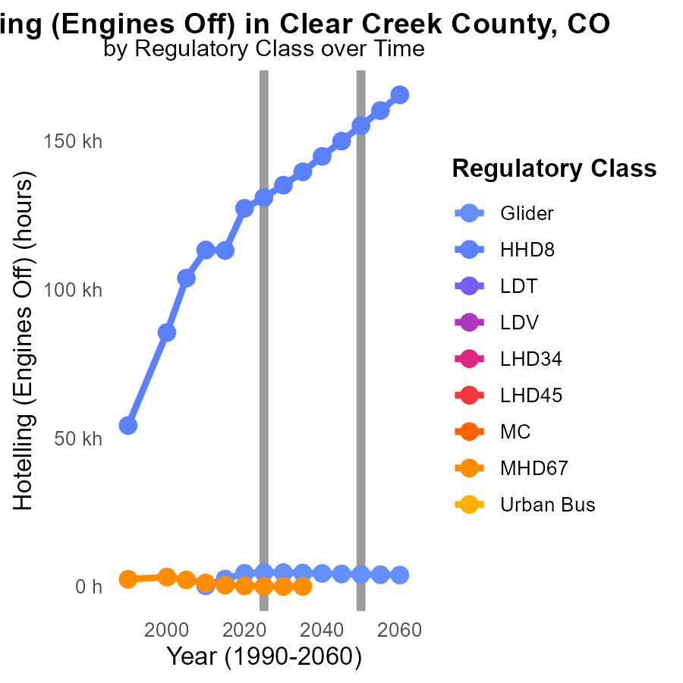

## Findings

* VOC emissions from Glider vehicles are decreasing annually, with a 96.9% reduction by 2035 compared to 2015.
* HHD8 emissions show a decreasing trend, with a significant 65.2% reduction projected by 2035 compared to 2015.
* Emissions from MHD67 vehicles vary greatly, with a considerable decrease in emissions from 2015 to 2025, and then a complete cessation by 2035.

## Recommendations

To further reduce emissions, strategies such as promoting the use of Glider vehicles, implementing stricter regulations on HHD8 vehicles, and transitioning completely from MHD67 vehicles to cleaner alternatives should be considered.

# Areas Ranked by Hotelling (Diesel Aux)

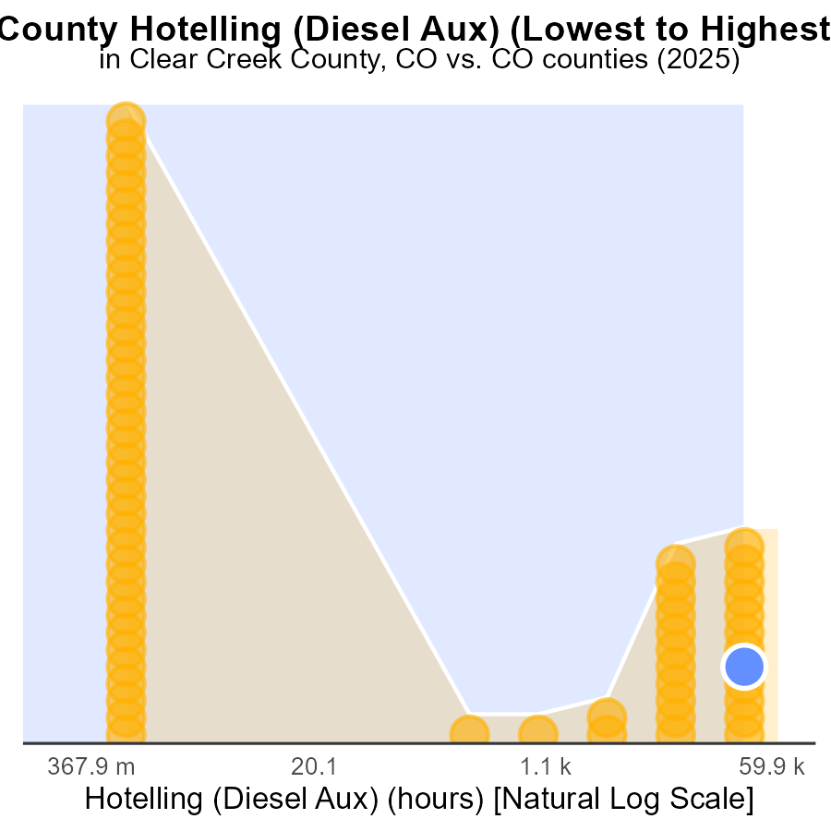

## Findings

* Weld county has the highest VOC emissions with 182.7 k hours, reaching the 100.0 percentile.
* Alamosa county has the lowest VOC emissions with 0.0 hours, ranking 1st at 57.8% percentile.
* Arapahoe county's VOC emissions stand at 103.8 k hours, ranking 58th at 90.6% percentile.

## Recommendations

To decrease overall VOC emissions, initiatives in Weld county are vital. Implementing stricter emission standards and promoting the use of cleaner fuel options can significantly reduce VOC levels. Alamosa county can serve as a model for other regions, showcasing that a shift towards cleaner energy sources yields positive results. Arapahoe county should focus on reducing emissions further to reach a similar level as Alamosa.

# Areas Ranked by Emissions

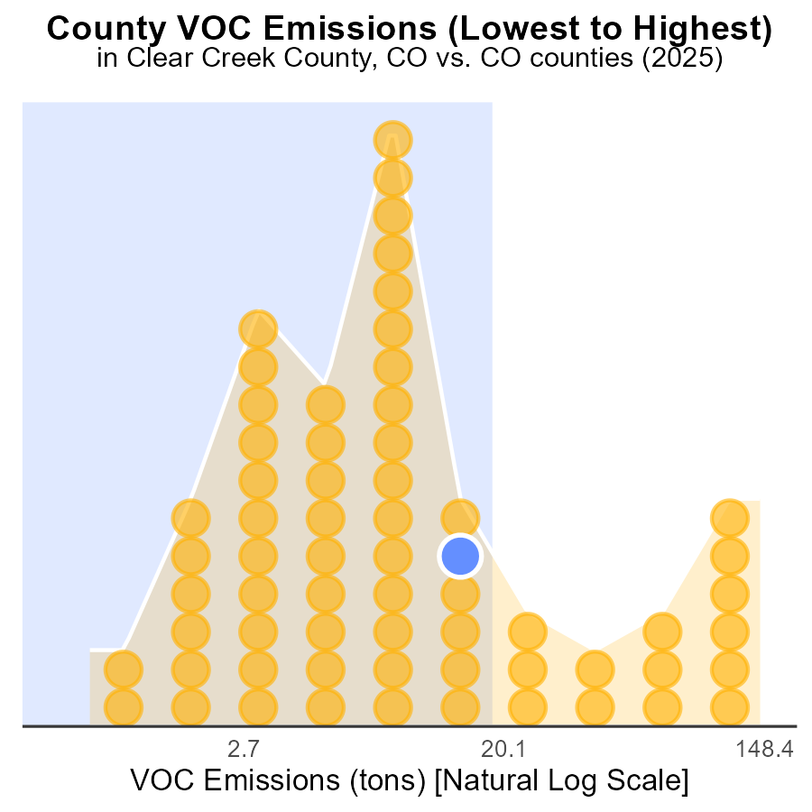

## Findings

* El Paso county has the highest VOC emissions in 2025 with 388.5 tons.
* Broomfield and Clear Creek counties rank 50th and 49th respectively for VOC emissions.
* Hinsdale county has the lowest VOC emissions, ranking 1st in 2025 with only 1.2 tons.

## Recommendations

To lower VOC emissions, targeted strategies should focus on El Paso county due to its significantly high emissions. Implementing stricter regulations and incentives for industries could help reduce emissions. Clear Creek and Broomfield counties also need attention to decrease their emissions. Hinsdale county should be acknowledged for its low emissions, and efforts should be made to maintain and improve this status.

# Conclusion

In conclusion, the analysis of Volatile Organic Compounds (VOC) emissions from on-road transportation in Clear Creek County, CO, in 2025 reveals that diesel engines are the exclusive source of VOC emissions. While there has been a significant reduction in VOC emissions by 10% from 2015 to 2020, efforts must be continued to maintain this decrease and target a sustained emission level of 0 by 2045. Vehicle miles traveled have decreased steadily, emphasizing the importance of promoting alternative transportation methods such as public transit, carpooling, and biking to further reduce emissions.

To achieve a significant reduction in VOC emissions, focusing on implementing stricter regulations on diesel vehicles, promoting cleaner fuel options, and transitioning to electric vehicles will be essential. Furthermore, tailoring interventions to high mileage areas like Idaho Springs CCD and Georgetown CCD can help in decreasing emissions. By leveraging the successful strategies implemented between 2015 and 2020, Clear Creek County can aim for a greener and more sustainable transportation future.

# About This Report

Data based on MOVES estimates collected by the Climate Action in Transportation program at Cornell University. Demographic data sourced from the US Census's American Community Survey 5-year estimates. This report was generated with the help of AI.

# References

* U.S. Census Bureau. (2023). American Community Survey 5-year estimates: Detailed tables. Retrieved from https://data.census.gov
* U.S. Environmental Protection Agency. (2024). Motor Vehicle Emission Simulator (MOVES 4.0) [Software]. Retrieved from https://www.epa.gov/moves