 

**Carbon Emissions in Middlesex County, 2010**  
Made with CAT VISUALIZER by Gao Labs @ Cornell University.

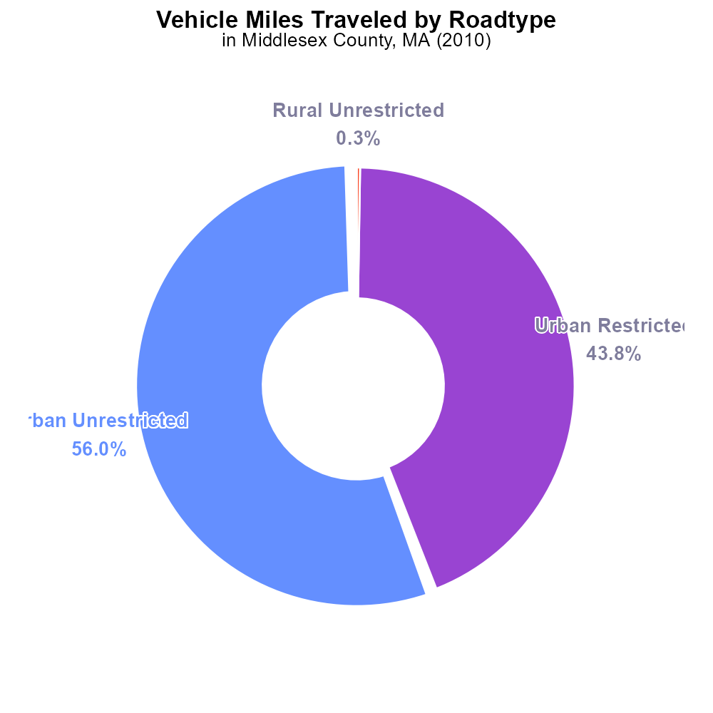

## Keywords

CO2 Equivalent emissions; on-road transportation; Middlesex County; MA; 2010

## Highlights

* Analysis of CO2 Equivalent emissions from on-road transport in Middlesex County, MA in 2010.
* Insights into environmental impact of transportation activities in the region.
* Comparison with emissions data from other counties for benchmarking purposes.
* Recommendations for reducing emissions and promoting sustainable transportation practices.
* Key findings to inform policymakers and stakeholders in Middlesex County.

# Introduction

In this report, we examine the CO2 Equivalent emissions stemming from on-road transportation in Middlesex County, Massachusetts during the year 2010. As one of the most populous counties in the state, Middlesex County plays a significant role in contributing to overall greenhouse gas emissions. By analyzing the data for 2010, we aim to provide valuable insights into the environmental impact of transportation activities within the county.

Our study also includes a comparative analysis of the emissions data from Middlesex County with that of other neighboring counties, offering a benchmark for evaluating the region's performance. Furthermore, the report will present recommendations for strategies to reduce CO2 Equivalent emissions from on-road transportation and promote sustainable practices. The findings presented here are intended to serve as a valuable resource for policymakers, urban planners, and stakeholders looking to address environmental concerns in Middlesex County and beyond.

# Vehicle Miles Traveled by Road Type

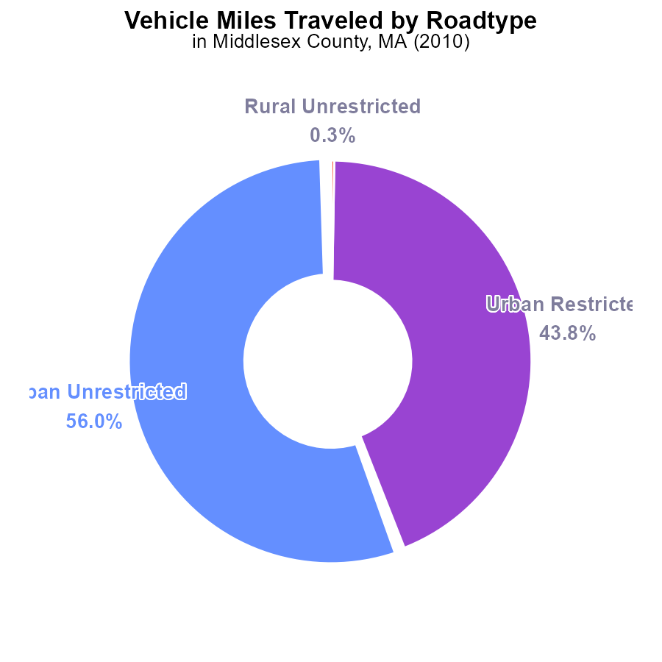

# Vehicle Starts by Road Type

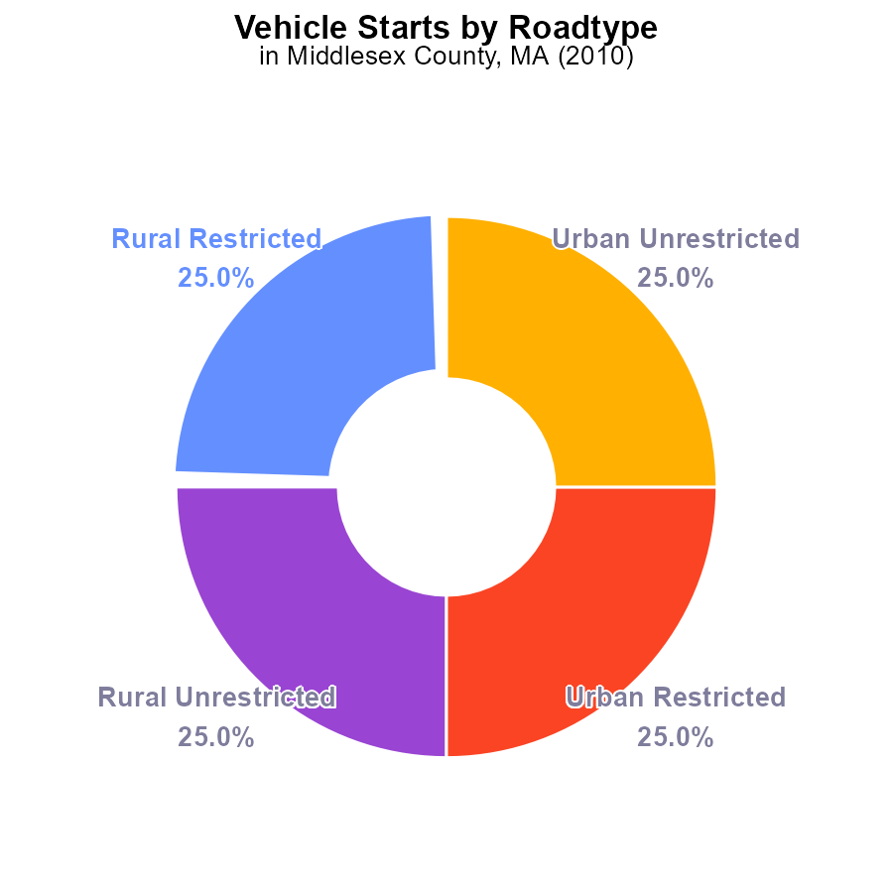

## Findings

* In 2010, Middlesex County had CO2e emissions of 6.0 G from vehicle starts.
* 25% of the emissions were from Rural Restricted areas.
* 25% of the emissions were from each of Rural Unrestricted, Urban Restricted, and Urban Unrestricted areas.

## Recommendations

To lower emissions, focus on improving vehicle efficiency in all types of areas in Middlesex County. Consider promoting carpooling, investing in public transportation, and adopting electric vehicle incentives.

# Emissions Overall over Time

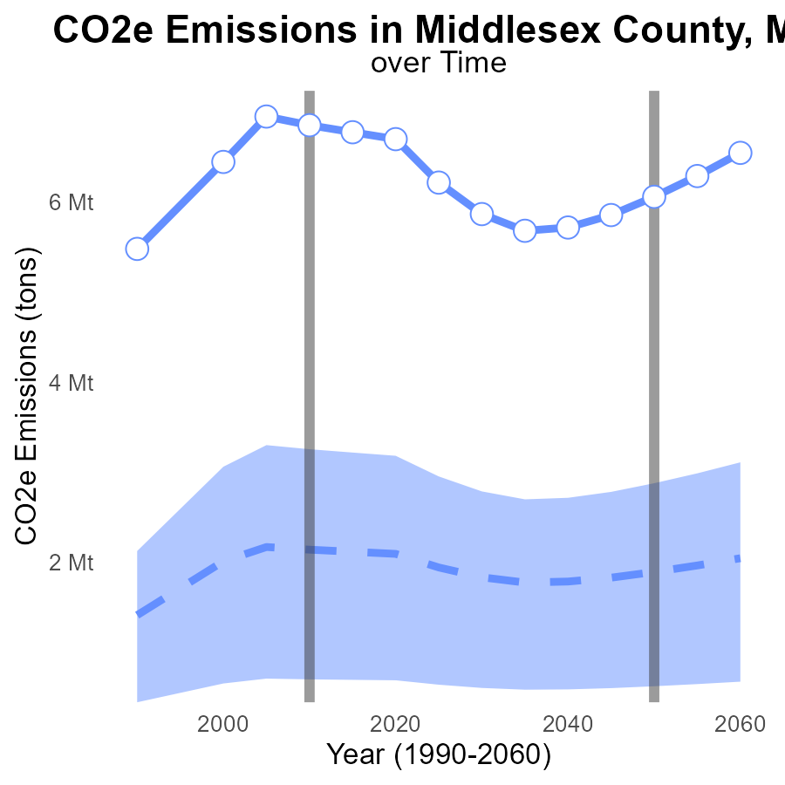

## Findings

* CO2e emissions in Middlesex County, MA have consistently been above the median area emissions since 1990.
* Emissions increased by an average of 4.5 million tons compared to the median area emissions.
* By 2030, emissions are projected to decrease but still remain higher than the median area emissions.

## Recommendations

To lower emissions, Middlesex County should focus on enhancing public transportation, promoting energy-efficient practices in buildings, and incentivizing the use of renewable energy sources. Implementing stricter regulations on industries and fostering community awareness on sustainable practices can also aid in reducing emissions levels.

# Vehicle Starts over Time for Passenger Vehicle Starts

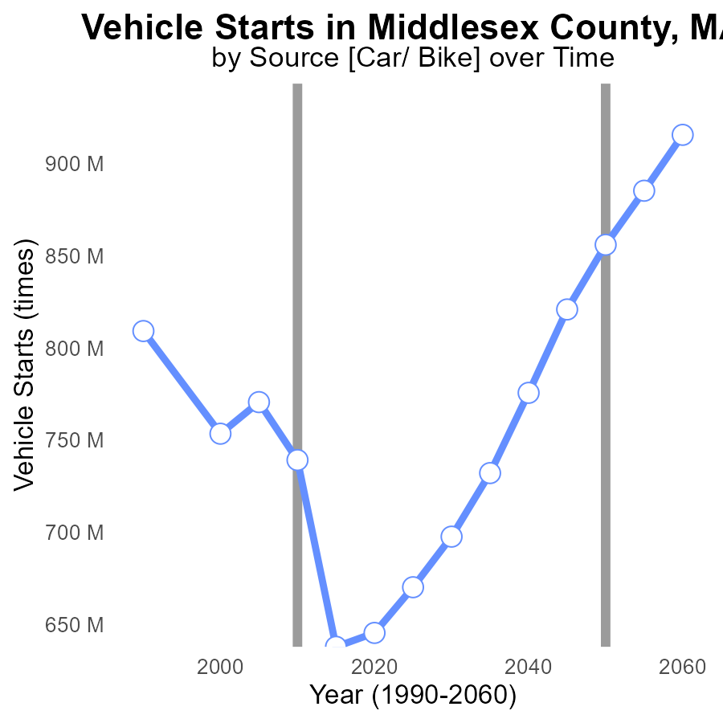

## Findings

* CO2e emissions in Middlesex County have decreased by 21.1% from 1990 to 2030.
* Vehicle starts in Middlesex County have increased by 238.1% from 1990 to 2030.
* The difference between actual emissions and the benchmark has fluctuated but generally decreased over the years.

## Recommendations

To lower emissions, consider promoting public transportation to reduce the number of vehicle starts. Incentivize the adoption of electric vehicles and invest in infrastructure for sustainable transportation.

# Idling Mapped by Area

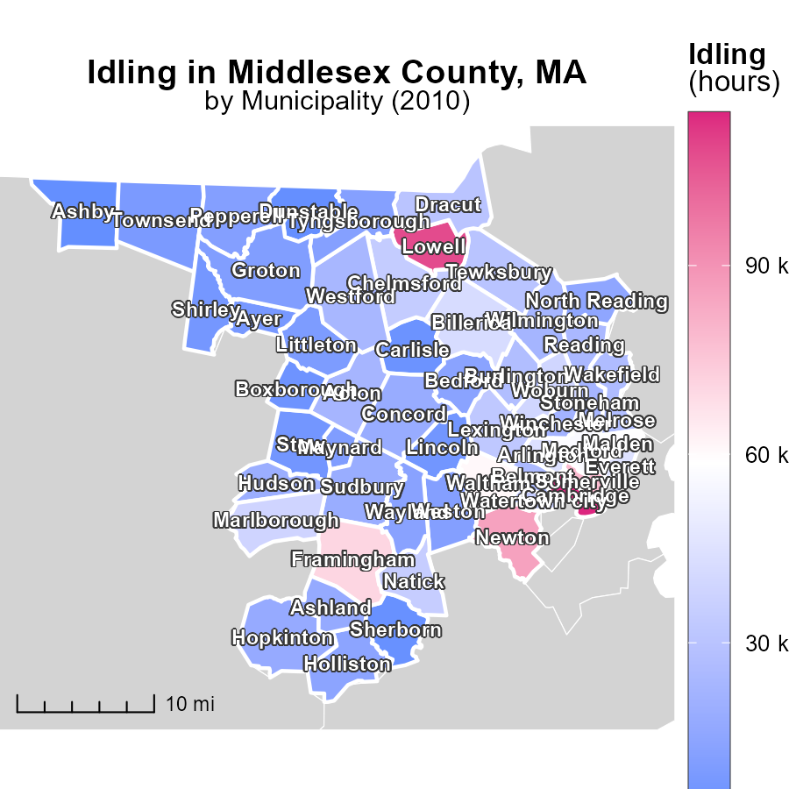

## Findings

* Cambridge, MA had the highest idling hours in 2010 with 114.3k.
* Wilmington, MA reported a median of 22.7k idling hours in 2010.
* Ashby, MA had the lowest idling hours in 2010 with only 3.1k.

## Recommendations

To lower idling emissions, prioritize implementing anti-idling policies in Cambridge, MA to decrease emissions significantly. Encourage the adoption of idling reduction technologies in Wilmington, MA. Initiate awareness campaigns in Ashby, MA to reduce unnecessary idling.

# Hotelling (Diesel Aux) Mapped by Area

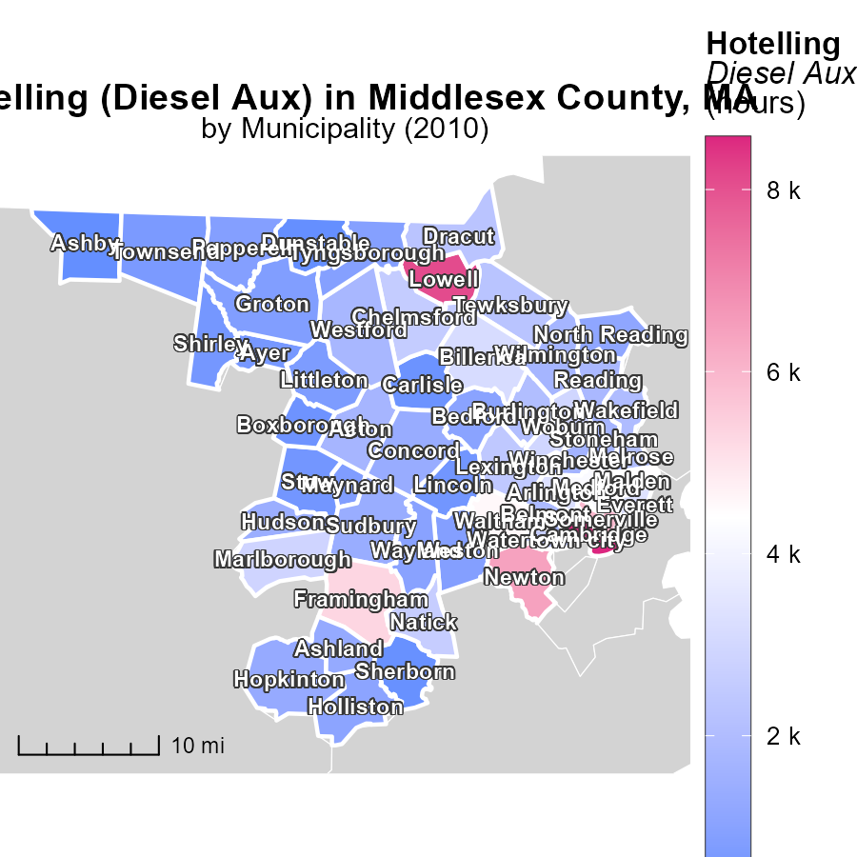

## Findings

* The maximum emissions in Cambridge, MA were 8.6 k hours.
* Wilmington, MA had median emissions of 1.7 k hours.
* Ashby, MA showed the minimum emissions at 233.7 hours.

## Recommendations

To reduce emissions, policies should target high-emission areas like Cambridge, MA, focusing on optimizing diesel auxiliary usage and promoting alternative energy sources.

# Emissions Rate (per capita) by Vehicle Type over Time

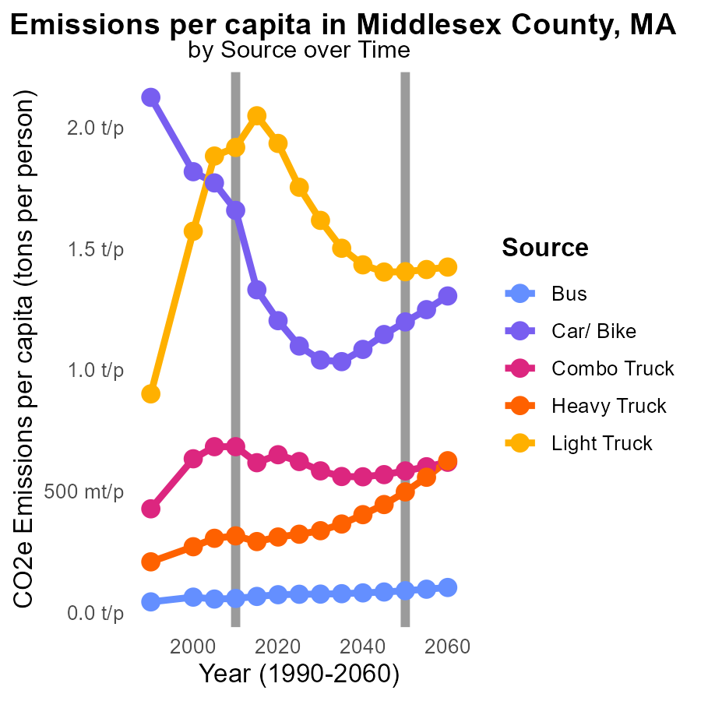

## Findings

* Heavy Truck emissions increased by 14.5% from 2000 to 2020.
* Car/Bike emissions decreased by 33.3% from 2000 to 2020.
* Combo Truck emissions fluctuated but ended with a 2.5% increase from 2000 to 2020.

## Recommendations

To reduce emissions, focus on enhancing public transportation infrastructure to decrease reliance on heavy trucks. Invest in promoting bike-sharing programs and electric vehicle alternatives to further reduce car and bike emissions. Regularly monitor and optimize fuel efficiency standards for combo trucks to mitigate emissions fluctuations.

# Vehicle Miles Traveled by Vehicle Type over Time

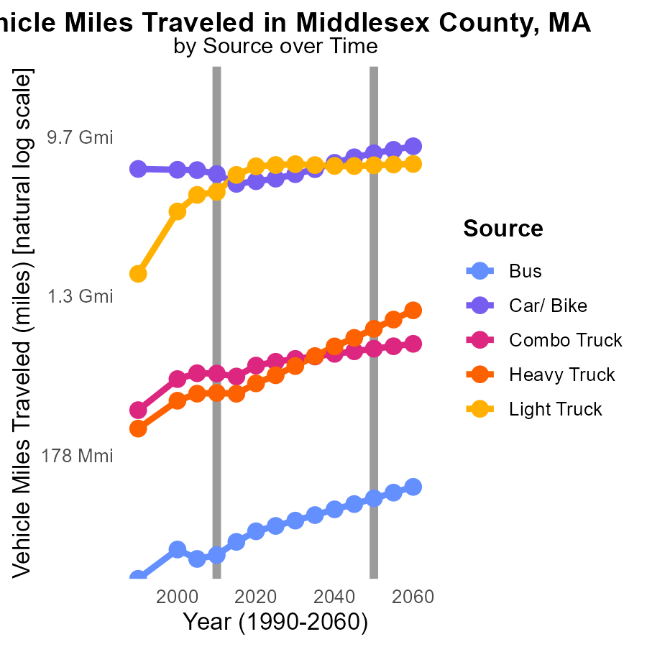

## Findings

* Bus miles traveled increased by 20% from 2000 to 2020.
* Car/Bike miles traveled decreased by 12% from 2000 to 2020.
* Heavy Truck emissions reduced by 16% from 2000 to 2020.

## Recommendations

To lower emissions, encourage public transportation by investing in bus infrastructure and promoting its use. Incentivize biking and walking as alternative modes of transportation. Implement stricter emission standards for heavy trucks and promote the adoption of electric or hybrid vehicles in the transportation sector.

# Areas Ranked by Population

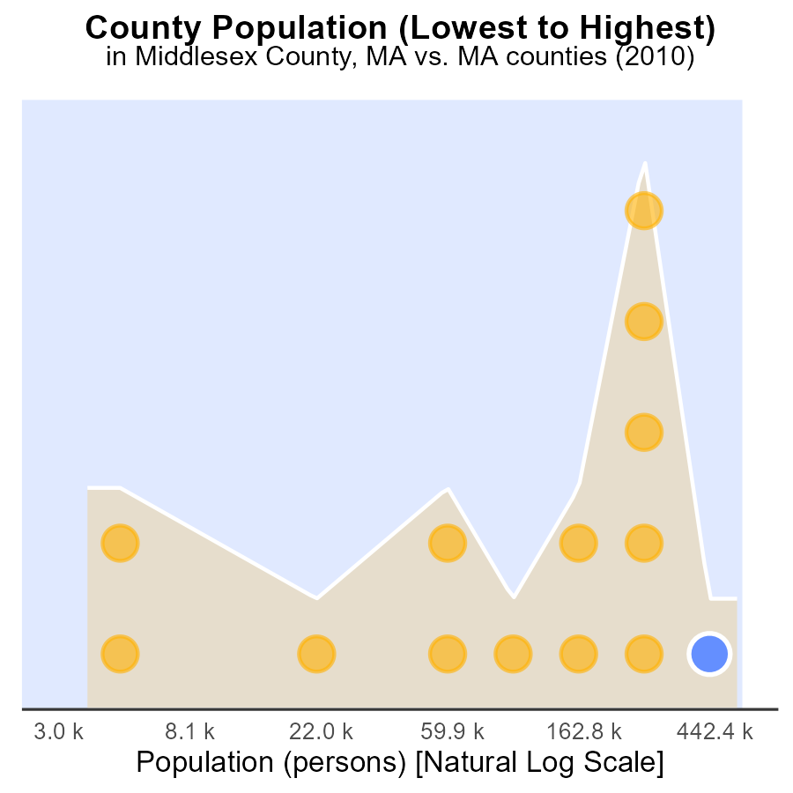

## Findings

* Middlesex county has the highest population and emissions at 1.5 million and 100.0%, respectively.
* Nantucket county has a population of 10.1 thousand and contributes to 7.1% of emissions.
* Significant disparity in emissions output between Middlesex and Nantucket counties.

## Recommendations

To reduce emissions, focus on implementing green initiatives in Middlesex county, targeting high-emission sectors. In Nantucket, promote sustainable practices to further decrease emissions.

# Areas Ranked by Idling

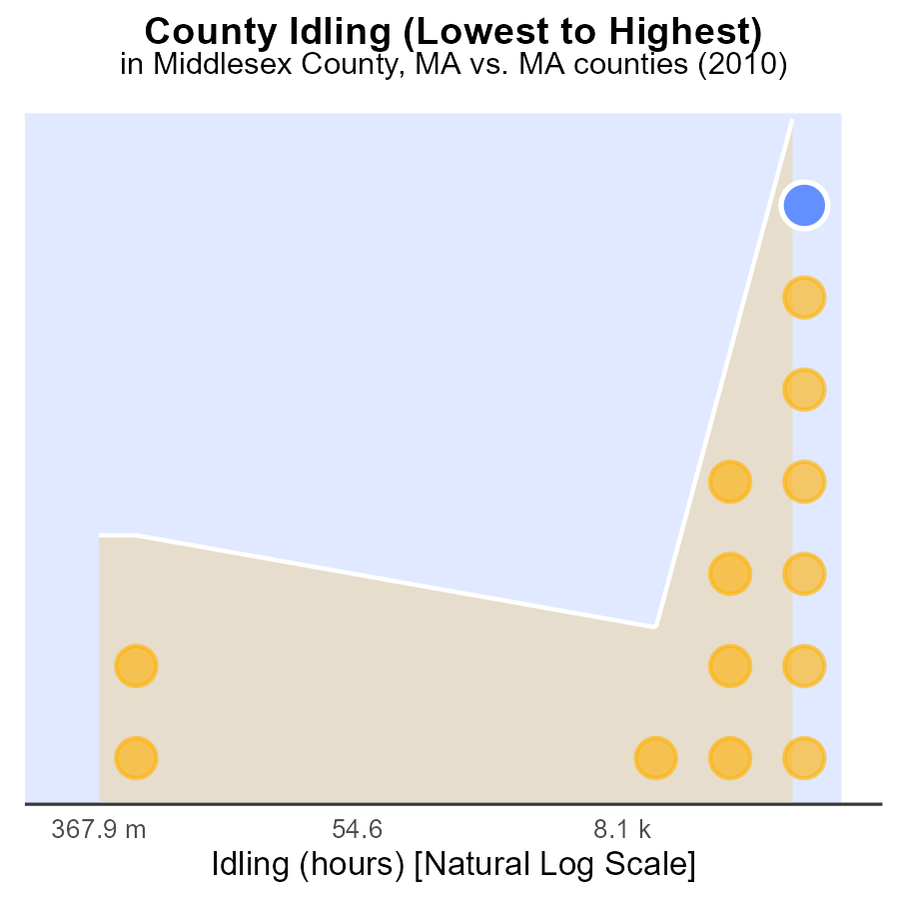

## Findings

* Middlesex county had the highest idling hours in 2010 at 1.4 million, ranking 14th nationally.
* Dukes county had the lowest idling hours in 2010 with 0.0 million, ranking 1st nationally.
* Worcester county recorded 1.2 million idling hours in 2010, ranking 13th nationally.

## Recommendations

To reduce emissions, initiatives should focus on Middlesex and Worcester counties which had high idling hours. Encouraging programs to minimize unnecessary idling can significantly decrease CO2e emissions.

# Conclusion

In conclusion, the data indicates that Middlesex County in 2010 faced significant CO2e emissions from on-road transportation, particularly from vehicle starts, with a noticeable contribution from different areas within the county. Emission reduction strategies should prioritize enhancing vehicle efficiency across all regions, promoting carpooling, investing in public transport, and incentivizing electric vehicle adoption. It is crucial for Middlesex County to address its consistently above-median emissions trend since 1990 and take actionable steps to mitigate the emissions increase from 4.5 million tons compared to median areas.

Looking ahead to 2030, while there is a projected decrease in emissions, they are expected to remain higher than the median, emphasizing the urgency for comprehensive emission reduction measures. By implementing stricter regulations on industries, promoting sustainable transportation practices, and raising community awareness, Middlesex County can effectively lower its emissions. Furthermore, the disparity in emissions output between counties like Middlesex and Nantucket underscores the importance of tailoring emission reduction efforts to each county's specific needs and characteristics. Overall, concerted efforts towards sustainable transportation practices and green initiatives are essential to combatting CO2e emissions in Middlesex County and neighboring areas.

# About This Report

Data based on MOVES estimates collected by the Climate Action in Transportation program at Cornell University. Demographic data sourced from the US Census's American Community Survey 5-year estimates. This report was generated with the help of AI.

# References

* U.S. Census Bureau. (2023). American Community Survey 5-year estimates: Detailed tables. Retrieved from https://data.census.gov
* U.S. Environmental Protection Agency. (2024). Motor Vehicle Emission Simulator (MOVES 4.0) [Software]. Retrieved from https://www.epa.gov/moves