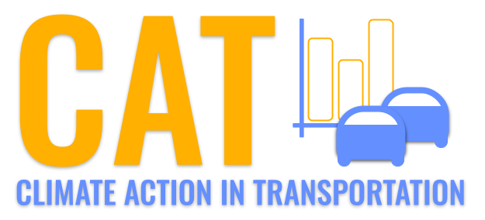 

**SO2 Emissions in Ottawa County, 2005**  
Made with CAT VISUALIZER by Gao Labs @ Cornell University.

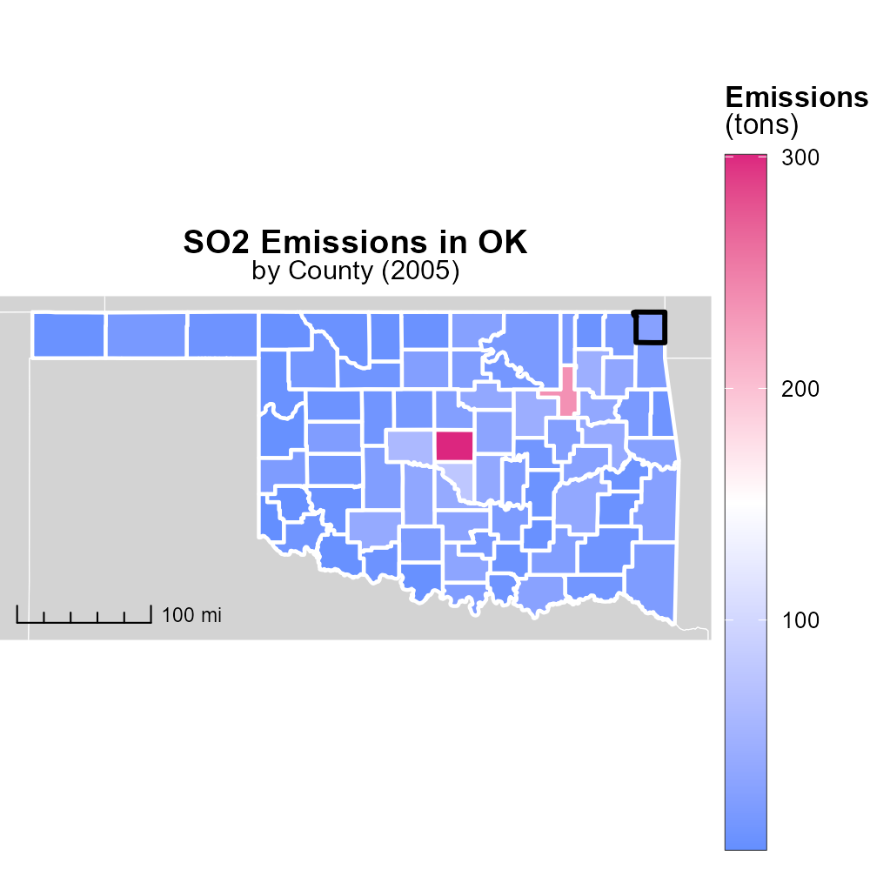

## Keywords

Sulfur Dioxide emissions; on-road transportation; Ottawa County; 2005; environmental impact; air quality

## Highlights

* SO2 emissions from on-road vehicles impact Ottawa County's air quality.
* Understanding these emissions is crucial for environmental management.
* The report analyzes on-road transportation's contribution to SO2 levels in 2005.
* Insights gained will help in devising strategies to reduce air pollution.
* Data from this study can inform policy decisions for better air quality.

# Introduction

In 2005, Sulfur Dioxide (SO2) emissions from on-road transportation in Ottawa County, Oklahoma, became a concern due to their significant impact on the region's air quality. This report aims to delve into the specifics of these emissions, analyzing the levels and trends of SO2 released by vehicles throughout the county during that year. Recognizing the importance of understanding the environmental footprint of transportation activities, this study investigates how on-road vehicles in Ottawa County contributed to the overall SO2 pollution, shedding light on potential sources and hotspots of emissions.

The findings from this analysis will be crucial for environmental management strategies, guiding policymakers and stakeholders in implementing measures to mitigate the negative effects of air pollution. By identifying patterns in SO2 emissions from on-road transportation in 2005, this report seeks to provide valuable insights that can inform future decisions towards enhancing air quality and promoting sustainable development in Ottawa County.

# Idling by Regulatory Class

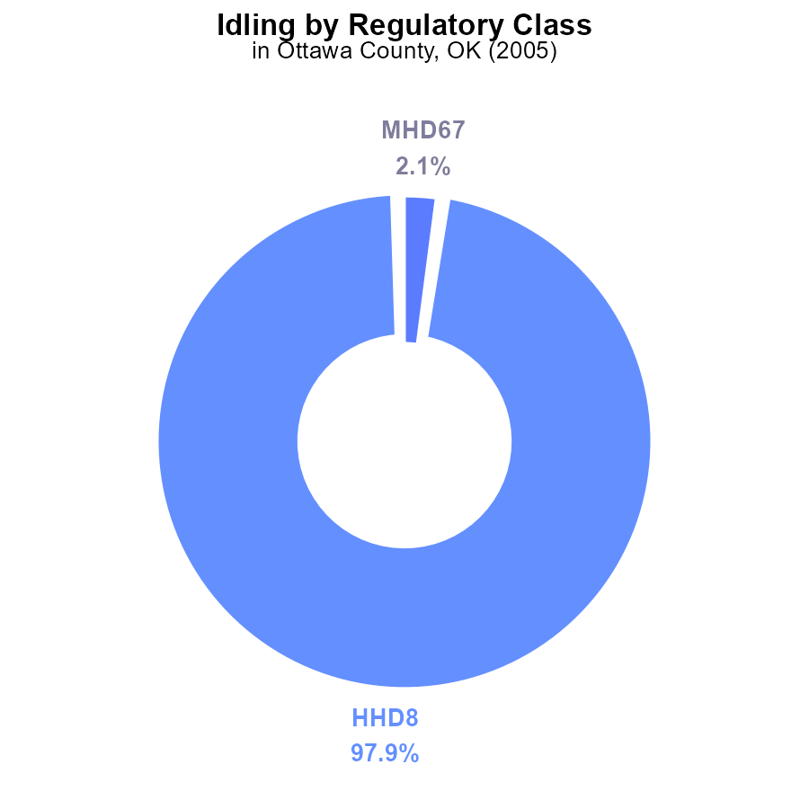

## Findings

* Over 97% of SO2 emissions in Ottawa County, OK in 2005 were from HHD8 vehicles idling.
* Less than 3% of SO2 emissions were from MHD67 vehicles idling in the same year and location.
* No significant emissions were recorded from other vehicle types such as LDT, LDV, LHD34, LHD45, MC, or Urban Bus.

## Recommendations

To decrease SO2 emissions in Ottawa County, OK, focus on implementing idling reduction strategies for HHD8 vehicles, considering their significant contribution. Additionally, further monitoring of MHD67 vehicles to prevent an increase in emissions should be considered, while maintaining oversight of other vehicle types for any potential emission sources.

# Vehicle Starts by Road Type

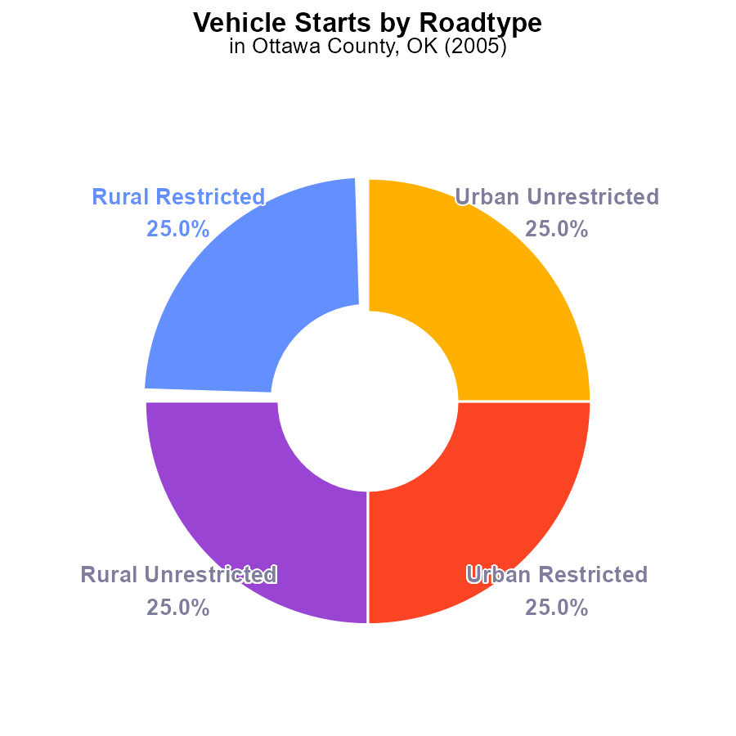

## Findings

* SO2 emissions in Ottawa County, OK in 2005 were 64.1M times from vehicle starts.
* 25.0% of the SO2 emissions were from Rural Restricted areas.
* 25.0% of the SO2 emissions were from Urban Unrestricted areas.

## Recommendations

To lower SO2 emissions, focus on reducing vehicle starts in Rural Restricted and Urban Unrestricted areas, possibly through promoting public transportation and carpooling initiatives.

# Vehicle Starts over Time for Buses

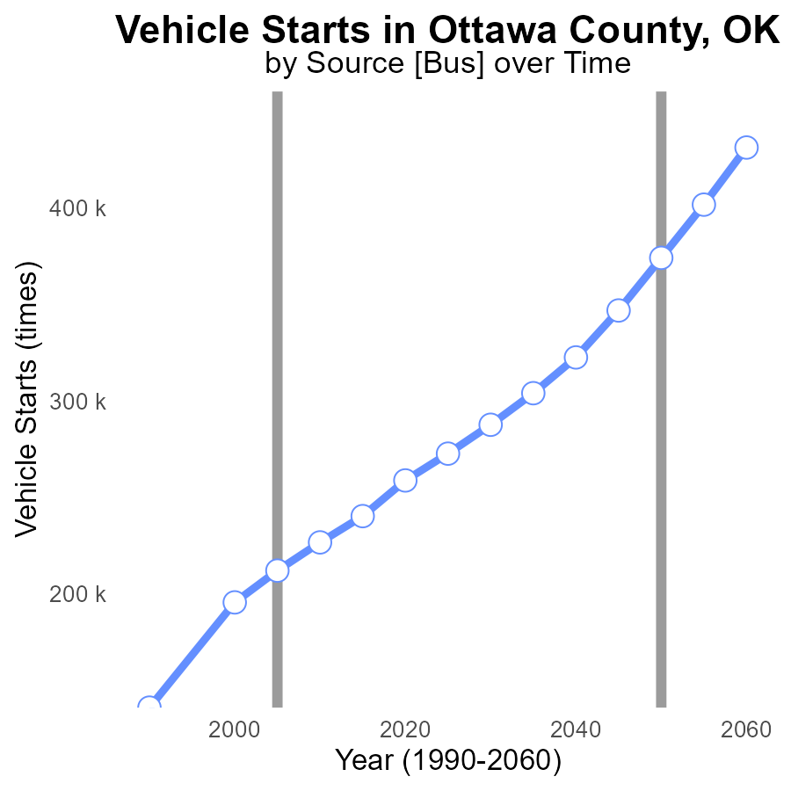

## Findings

* Emissions of SO2 in Ottawa County, OK have consistently increased from 1990 to 2025.
* Vehicle starts have also shown a steady increase over the same period.
* The difference between the actual emissions and the benchmark has been decreasing over time.

## Recommendations

To lower the emission levels in Ottawa County, OK, there is a need to implement stricter emission standards for vehicles. Encouraging the use of electric or hybrid vehicles can significantly reduce SO2 emissions, given the correlation between vehicle starts and emissions.

# Emissions Overall over Time

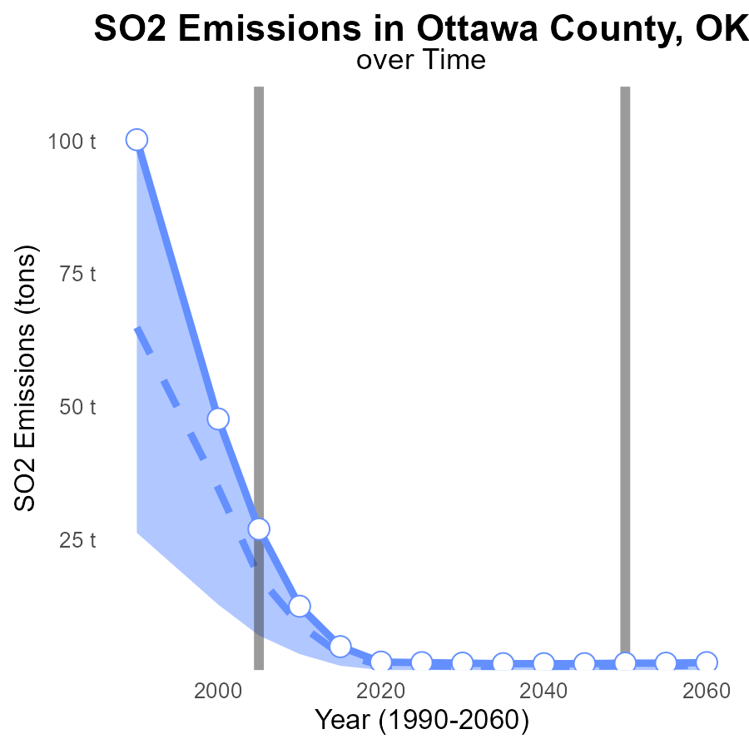

## Findings

* SO2 emissions in Ottawa County decreased from 100.2 tons in 1990 to 2.0 tons in 2020.
* The emissions were consistently above the upper 75th percentile of all areas until 2015.
* A significant decrease in SO2 emissions occurred between 2015 and 2020 from 4.9 to 2.0 tons.

## Recommendations

To further reduce SO2 emissions in Ottawa County, focus should be on implementing stricter emission regulations for industries and promoting the use of cleaner energy sources. Continuous monitoring and regular inspections of facilities are also necessary to ensure compliance with the set standards.

# Population in My Region

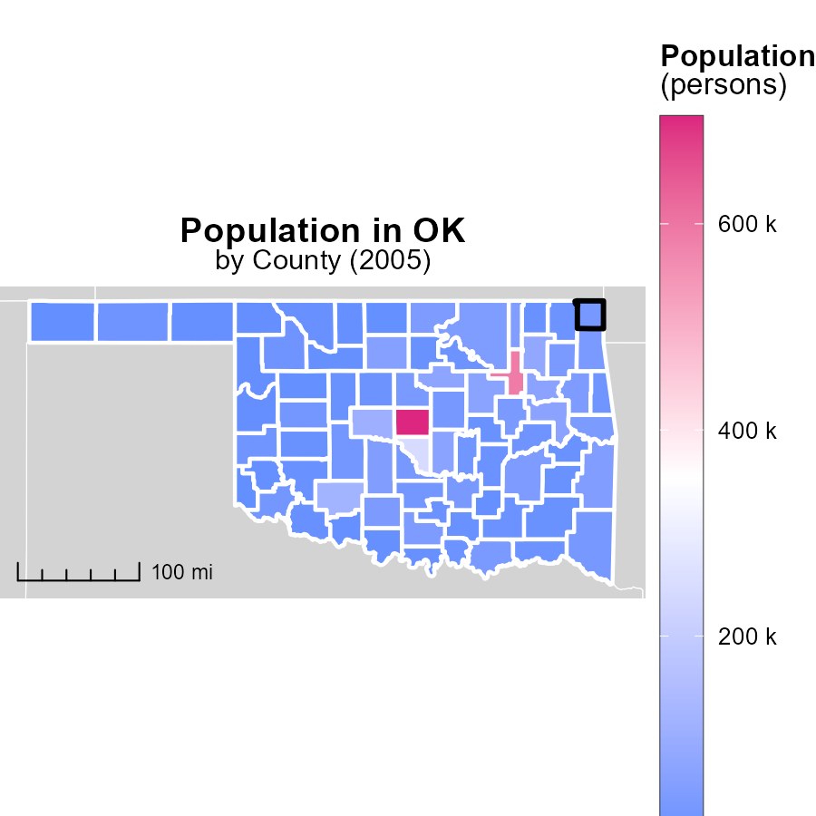

## Findings

* Oklahoma County has the highest population with 704.0k persons
* Beckham County has a median population of 21.8k persons
* Cimarron County has the lowest population with 2.5k persons

## Recommendations

To lower emissions, focus on densely populated areas like Oklahoma County by implementing public transportation systems. Encourage sustainable practices in medium-sized counties like Beckham. In sparsely populated areas like Cimarron, promote energy-efficient solutions for individual households.

# Emissions in My Region

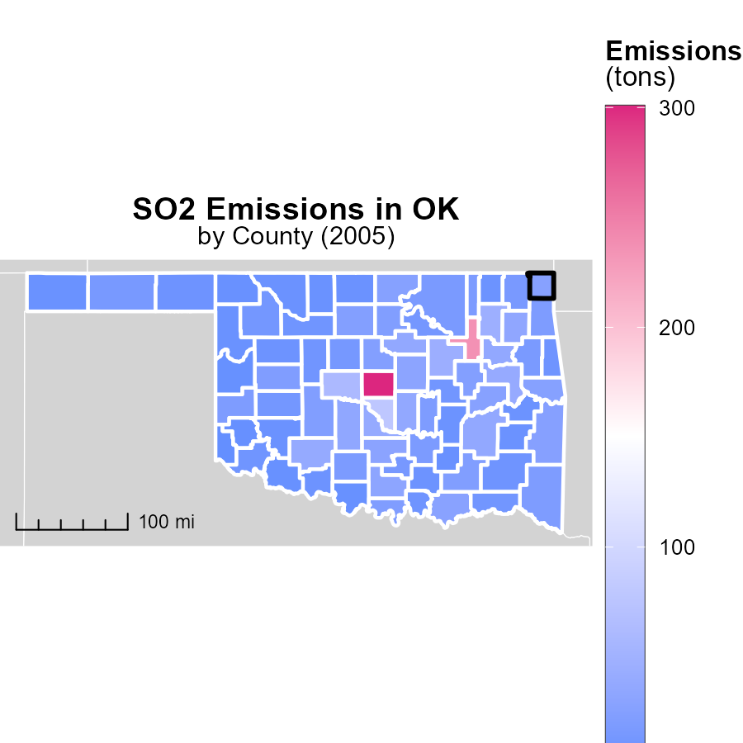

## Findings

* In 2005, Oklahoma County had the highest emissions at 300.6 tons.
* Pontotoc County had median emissions of 18.0 tons in 2005.
* Harmon County, OK, had the lowest emissions in 2005, amounting to 1.1 tons.

## Recommendations

To lower emissions, focus on reducing pollution sources in high emitting areas like Oklahoma County. Implement stricter emissions regulations and promote cleaner technologies in industrial sectors.

# Time Driven by Vehicle Type over Time

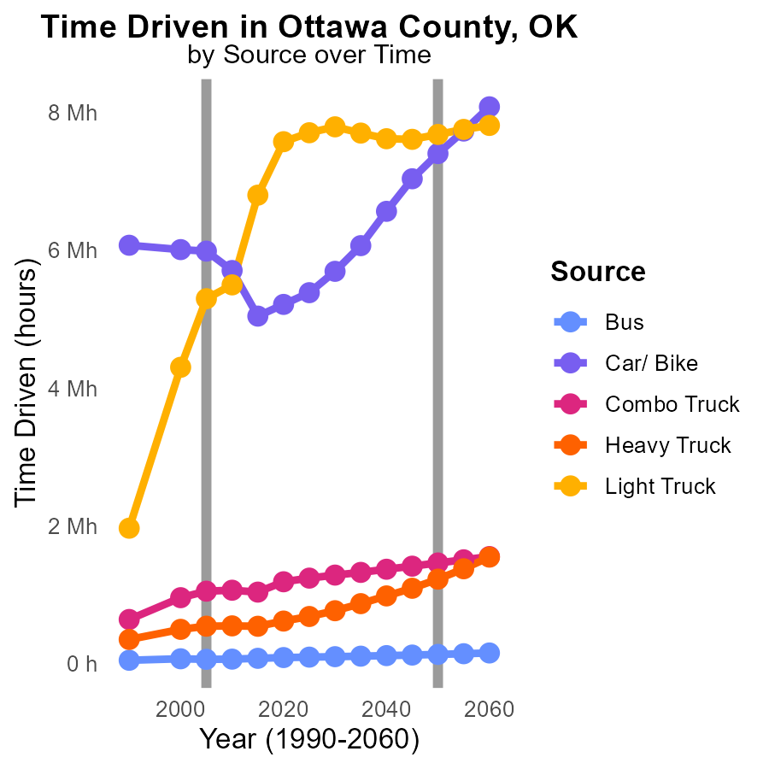

## Findings

* Bus emissions decreased by 12.6% from 2000 to 2015.
* Car/Bike emissions decreased by 16.7% from 2000 to 2015.
* Light Truck emissions increased by 58.8% from 2000 to 2015.

## Recommendations

To lower emissions, consider promoting public transportation, encouraging carpooling, and implementing stricter vehicle emission standards to reduce the environmental impact of transportation in Ottawa County, OK.

# Time Driven by Area over Time

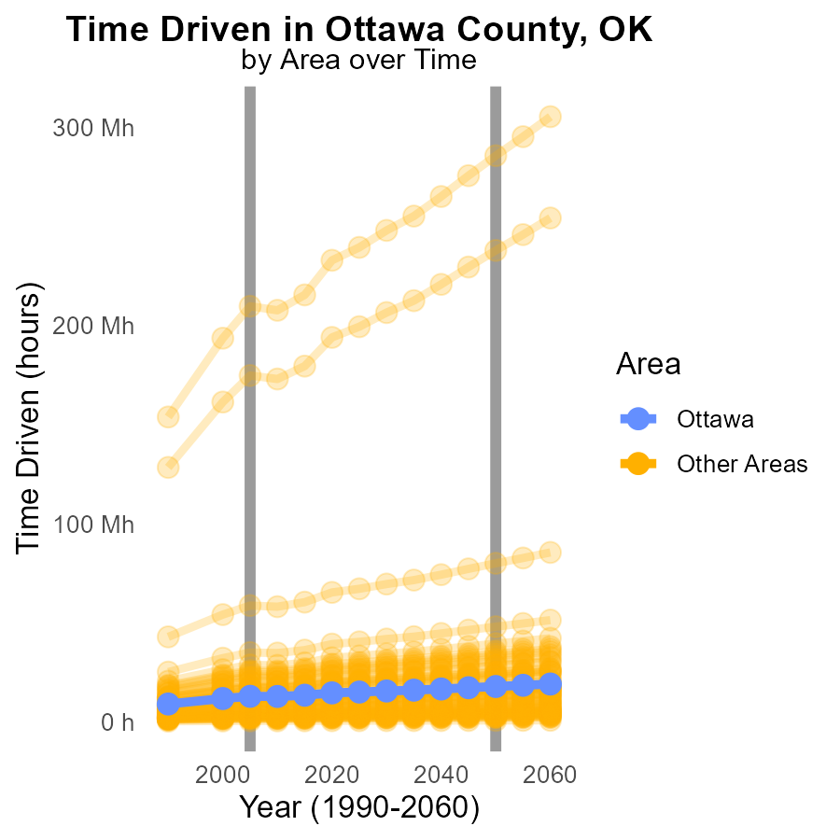

## Findings

* In 2005, the minimum SO2 emissions in a county were 560,000 kg, a difference of 219,092 kg from the expected 2050 level.
* The maximum SO2 emissions in a county in 2005 were 209.7 million kg, exceeding the 2050 target by 75,913,012 kg.
* SO2 emissions in a specified 'target county' in 2005 were 12.9 million kg, surpassing the 2050 goal by 4,960,308 kg.

## Recommendations

To lower SO2 emissions, policies must be enacted to reduce industrial processes contributing to high emissions, especially in counties exceeding targets. Incentivize cleaner technologies and sustainable practices to align with 2050 emission goals.

# Areas Ranked by Emissions Rate (per capita)

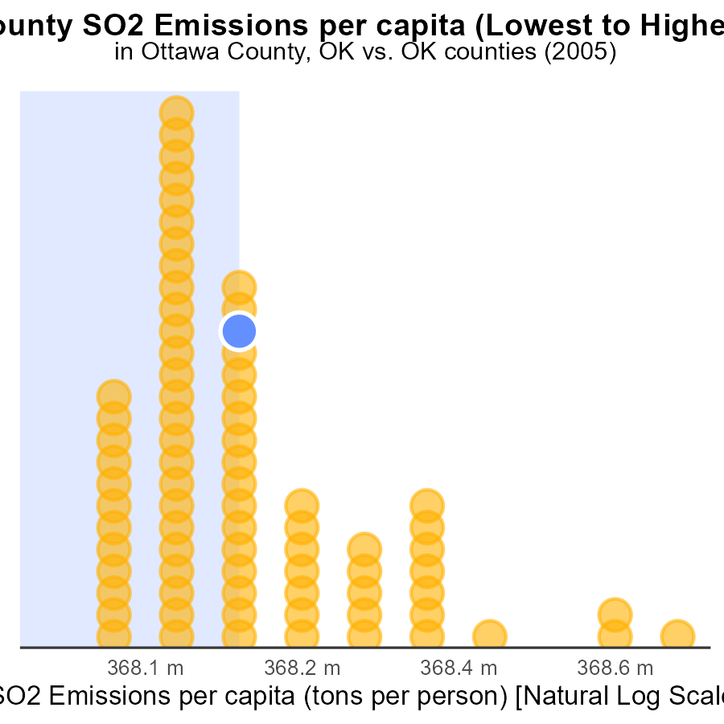

## Findings

* Highest SO2 emissions per capita in Love County (2.3 tons per person)
* Lowest SO2 emissions per capita in Cleveland County (318.4 tons per person)
* Ottawa, Custer, and Mayes Counties rank high in SO2 emissions per capita

## Recommendations

To lower SO2 emissions per capita, targeted strategies should be implemented in high-ranking counties like Ottawa, Custer, and Mayes. This could include promoting renewable energy sources, enforcing emission regulations, and encouraging energy efficiency.

# Areas Ranked by Hotelling (Engines Off)

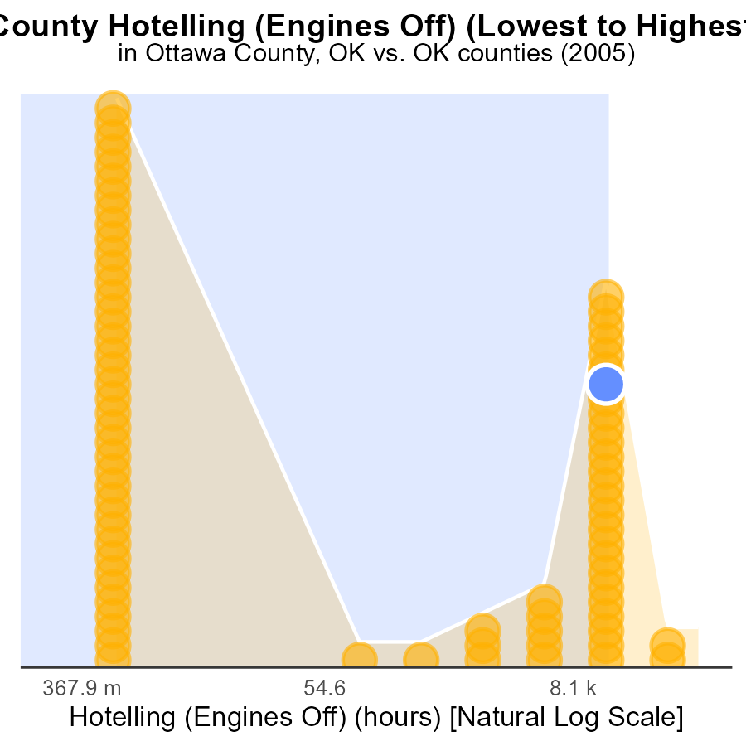

## Findings

* Highest SO2 emissions in Oklahoma county with 283.2k hours.
* Adair county had the lowest SO2 emissions with 0.0 hours.
* Sequoyah, Ottawa, and McClain counties had similar SO2 emission levels around 45.5k to 58.1k hours.

## Recommendations

Consider implementing emission control technologies in high emitting areas like Oklahoma county to reduce SO2 emissions. Encourage the continued low emissions practices in Adair county.

# Conclusion

In conclusion, the data from Ottawa County, OK in 2005 highlights a significant contribution of SO2 emissions from HHD8 vehicles idling, while other vehicle types such as MHD67, LDT, LDV, LHD34, LHD45, MC, and Urban Bus showed minimal emissions. To effectively reduce SO2 emissions, targeted strategies should focus on implementing idling reduction measures for HHD8 vehicles and monitoring MHD67 vehicles to prevent an increase in emissions. Additionally, efforts to decrease vehicle starts in Rural Restricted and Urban Unrestricted areas could be beneficial in lowering overall emissions. Stricter emission standards for vehicles, promoting public transportation, and incentivizing the use of electric or hybrid vehicles are crucial steps in mitigating SO2 emissions in Ottawa County. Collaboration with other counties, especially densely populated areas like Oklahoma County, medium-sized counties like Beckham, and sparsely populated areas like Cimarron, is essential to collectively reduce emissions and work towards achieving emission reduction goals.

The analysis of SO2 emissions across different counties in Oklahoma also indicates the need for tailored approaches to address emission sources in each region. High-emitting areas like Love County should prioritize emission control technologies, while low-emitting areas like Cleveland County should continue their low emissions practices. Counties with high SO2 emissions per capita, such as Ottawa, Custer, and Mayes, require targeted strategies like promoting renewable energy sources and enforcing emission regulations. By implementing these measures in conjunction with continuous monitoring and inspection of industrial processes, it is possible to pave the way towards a cleaner and more sustainable environment in Ottawa County and across Oklahoma.

# About This Report

Data based on MOVES estimates collected by the Climate Action in Transportation program at Cornell University. Demographic data sourced from the US Census's American Community Survey 5-year estimates. This report was generated with the help of AI.

# References

* U.S. Census Bureau. (2023). American Community Survey 5-year estimates: Detailed tables. Retrieved from https://data.census.gov
* U.S. Environmental Protection Agency. (2024). Motor Vehicle Emission Simulator (MOVES 4.0) [Software]. Retrieved from https://www.epa.gov/moves