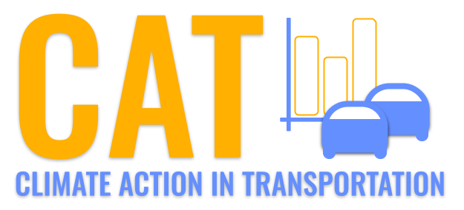 

**PM10 Emissions in Clinton County, 2030**  
Made with CAT VISUALIZER by Gao Labs @ Cornell University.

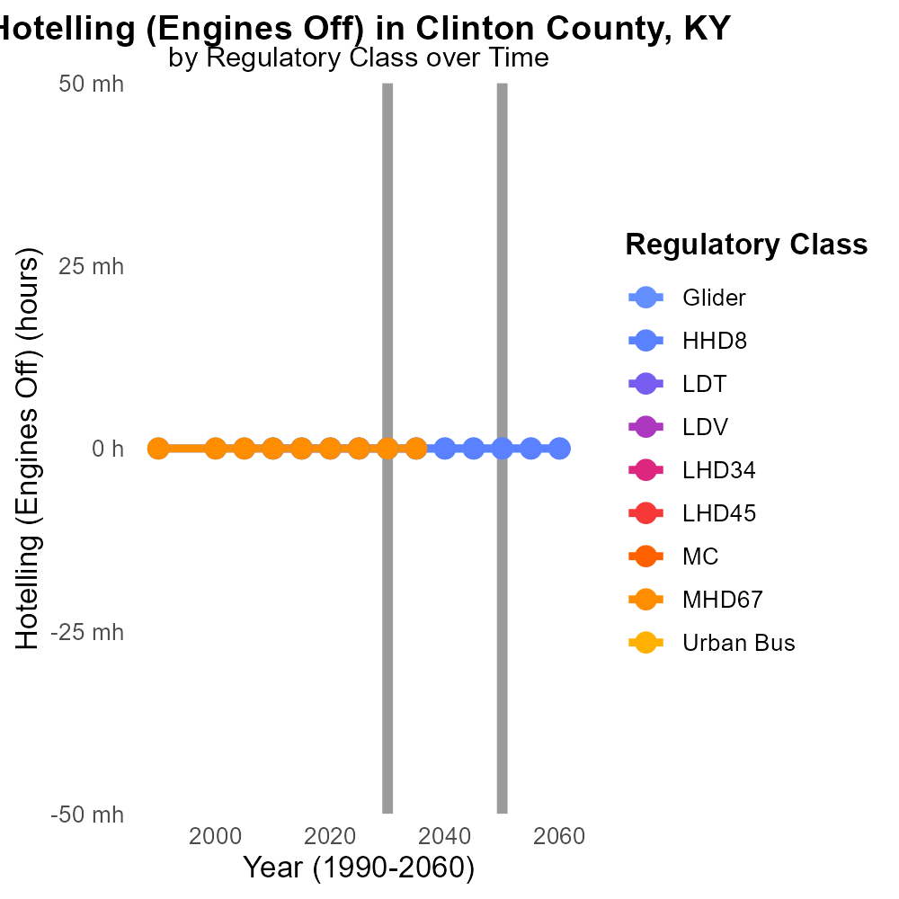

## Keywords

Primary Exhaust; PM10; Total emissions; On-road transportation; Clinton County; 2030

## Highlights

* Analysis of on-road transportation emissions in Clinton County, KY.
* Focus on Primary Exhaust PM10 emissions in 2030.
* Implications for air quality and public health.
* Trends in pollution levels and potential mitigation strategies.
* Importance of monitoring and addressing vehicle emissions.

# Introduction

This report presents an in-depth analysis of Primary Exhaust PM10 - Total emissions from on-road transportation in Clinton County, Kentucky, specifically focusing on the year 2030. The study delves into the sources, trends, and impacts of PM10 emissions, with a particular emphasis on their contribution to air pollution and public health concerns.

By examining the data and projections for on-road transportation emissions in the county, insights will be gained into the current state of air quality and the potential challenges ahead. The report aims to highlight the importance of monitoring and addressing vehicle emissions to mitigate the impact on the environment and the well-being of residents in Clinton County.

# Hotelling (Engines Off) by Regulatory Class

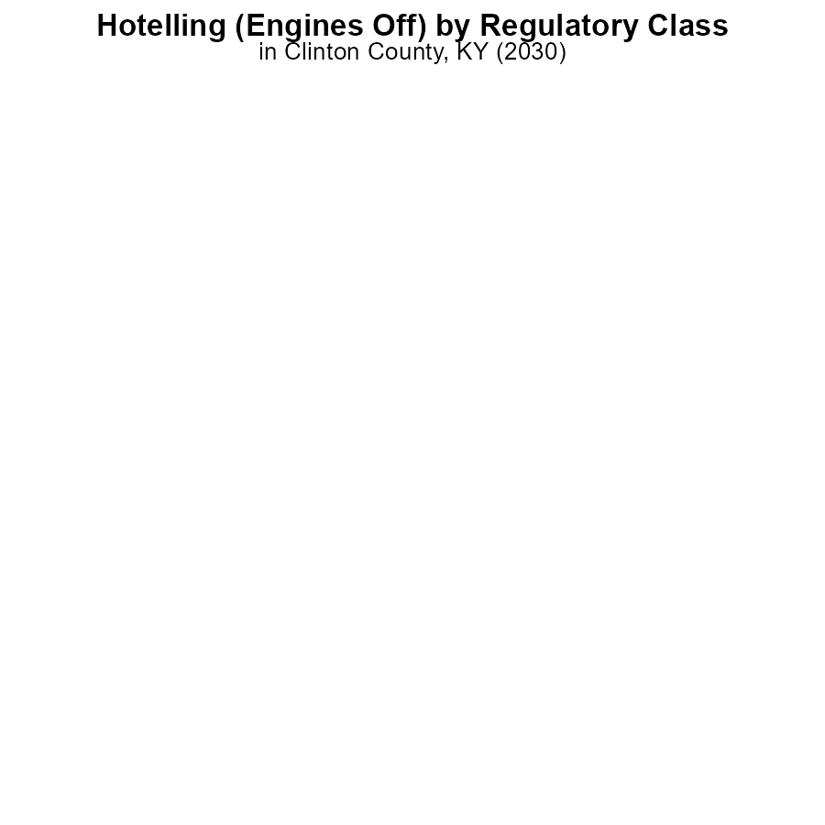

## Findings

* PM10 emissions from Glider and HHD8 engines with engines off were negligible at 0.0%.
* PM10 emissions from MHD67 engines with engines off were also low at 0.0%.
* No data available for LDT, LDV, LHD34, LHD45, and Urban Bus types.

## Recommendations

To further reduce PM10 emissions in Clinton County, KY, focus on monitoring and optimizing the emission levels from Glider, HHD8, and MHD67 engines periodically. Implement stricter emission control measures for LDT, LDV, LHD34, LHD45, and Urban Bus types to obtain accurate data for better decision-making.

# Hotelling (Diesel Aux) by Road Type

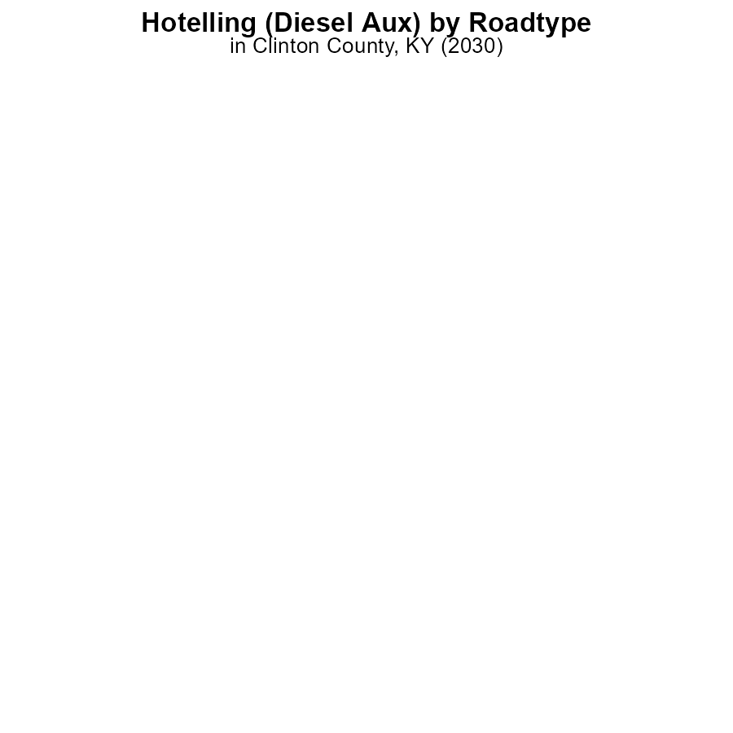

## Findings

* There were no PM10 emissions recorded in Clinton County, KY in 2030 from Hotelling equipment using Diesel Aux.
* All types of areas - Rural Restricted, Rural Unrestricted, Urban Restricted, Urban Unrestricted - reported 0.0% emissions.
* This indicates that emissions from this source in this county were effectively managed or non-existent.

## Recommendations

To maintain the current low emissions levels, it is recommended to continue using clean diesel technology, implementing regular maintenance checks on equipment, and considering alternative energy sources for future projects.

# Vehicle Miles Traveled over Time for Buses

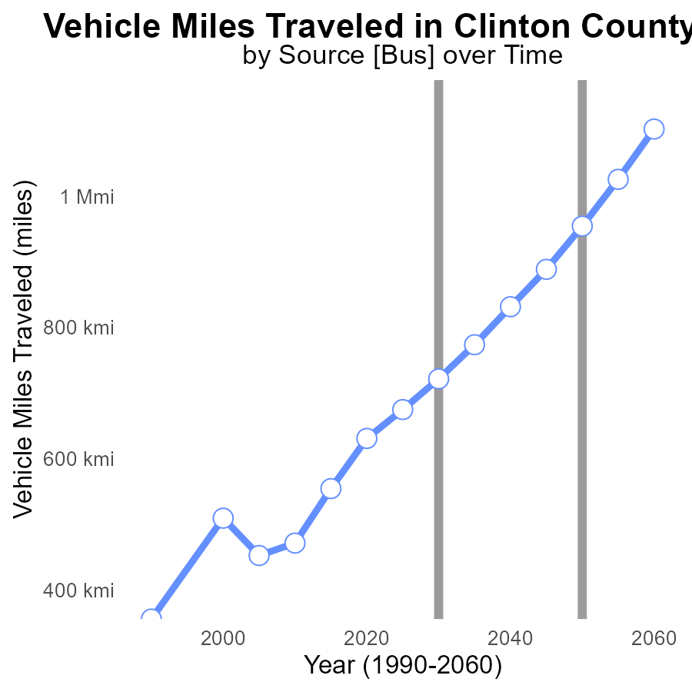

## Findings

* Vehicle miles traveled in Clinton County, KY increased steadily from 471.2k in 2010 to 954.6k in 2050.
* The benchmark difference shrunk from 483,333.1 miles in 2010 to 65,883.4 miles in 2045, indicating progress.
* There is an 80.1% increase in vehicle miles traveled in Clinton County, KY from 2010 to 2050.

## Recommendations

To lower emissions, Clinton County should focus on promoting public transportation, carpooling initiatives, and investing in infrastructure for walking and biking, aiming to reduce overall vehicle usage. Additionally, incentivizing the use of electric or hybrid vehicles could help reduce PM10 emissions further.

# Idling over Time for Buses

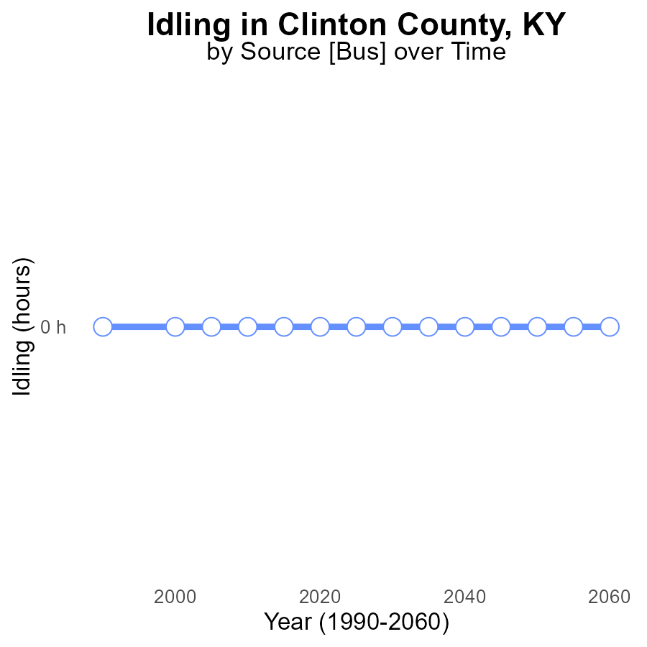

## Findings

* In Clinton County, KY, PM10 emissions from idling have been consistently at 0.0 hours from 2010 to 2050.
* There has been no change in PM10 idling emissions over the past four decades, remaining at 0.0 hours.
* The benchmark difference for PM10 idling emissions has consistently been 0, indicating no exceedance of the benchmark.

## Recommendations

Given the consistently low PM10 emissions from idling activities in Clinton County, it is recommended to continue monitoring and enforcing existing idling regulations to maintain the current emission level. Additionally, promoting the use of alternative transportation modes such as public transport or carpooling can further reduce idling emissions in the area.

# Hotelling (Diesel Aux) Mapped by Area

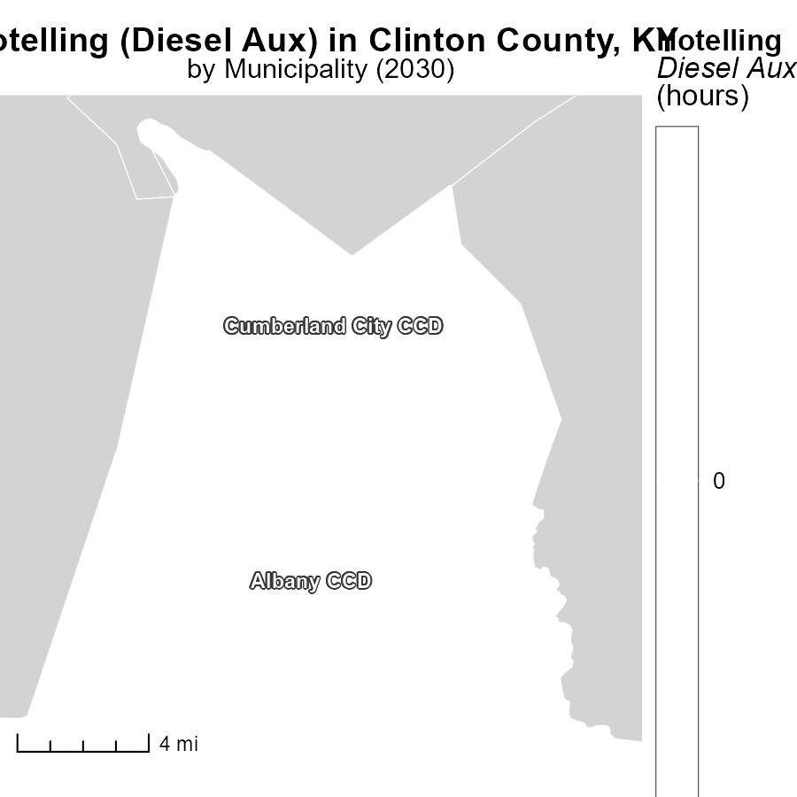

## Findings

* In Albany CCD, KY, the maximum emissions from Hotelling (Diesel Aux) in 2030 was 0.0 hours.
* In Cumberland City CCD, KY, the median emissions from Hotelling (Diesel Aux) in 2030 was 0.0 hours.

## Recommendations

To further lower emissions, consider investing in alternative energy sources and technologies to reduce reliance on diesel auxiliary power in both areas.

# Idling Mapped by Area

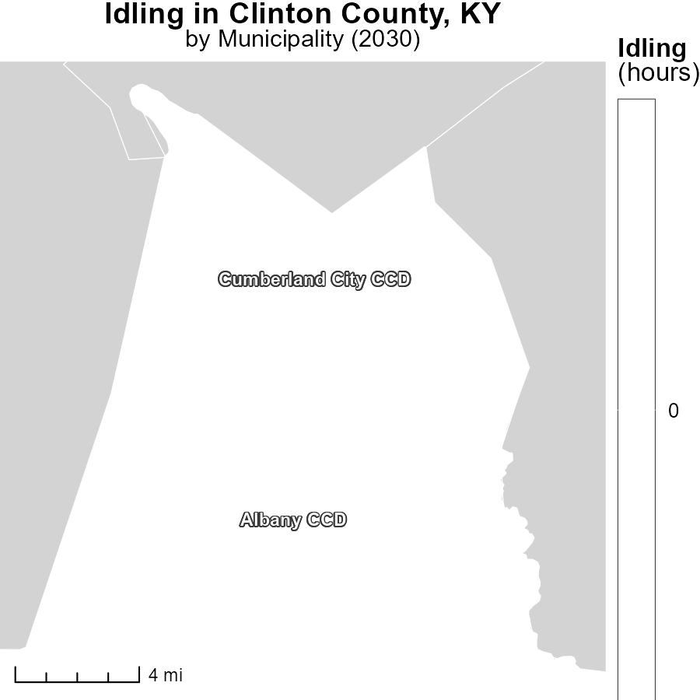

## Findings

* Albany CCD, KY had zero idling hours in 2030, the maximum among the areas studied.
* Cumberland City CCD, KY had zero idling hours in 2030, the median among the areas studied.

## Recommendations

To lower idling emissions, encourage the implementation of anti-idling policies in areas with high idling hours, such as Cumberland City CCD, KY. Consider providing incentives for the adoption of anti-idling practices in all regions to reduce emissions further.

# Hotelling (Engines Off) by Regulatory Class over Time

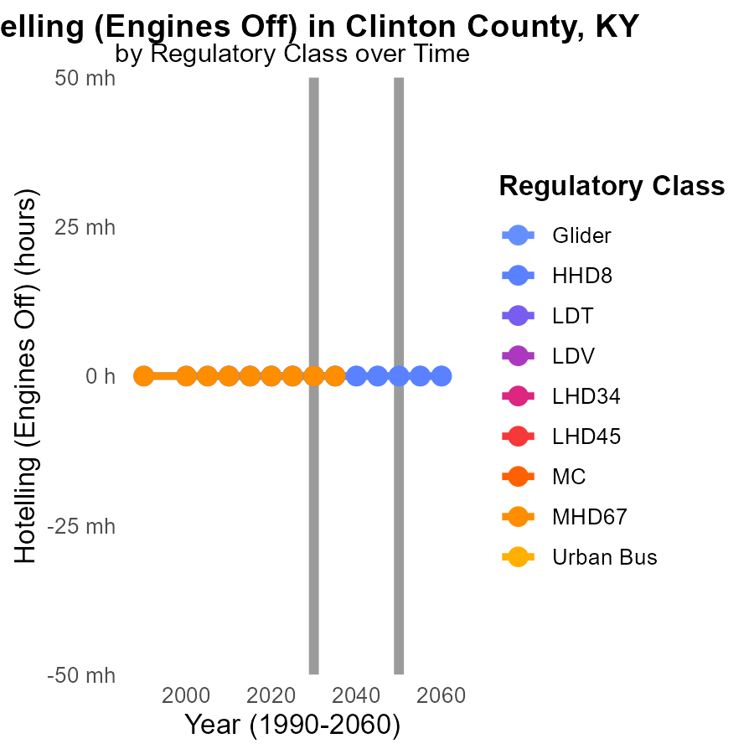

## Findings

* No measurable PM10 emissions are expected from Glider, HHD8, and MHD67 vehicle types from 2020 to 2040.
* Data for LDT, LDV, LHD34, LHD45, MC, and Urban Bus is not available, indicating a lack of information on emissions from these vehicle types.
* Recommendations for reducing emissions include implementing monitoring systems and conducting research to gather missing data on emissions from various vehicle types.

## Recommendations

To lower emissions, develop data collection strategies for LDT, LDV, LHD34, LHD45, MC, and Urban Bus types. Initiate emission reduction programs based on collected data to ensure effective regulation.

# Emissions by Road Type over Time

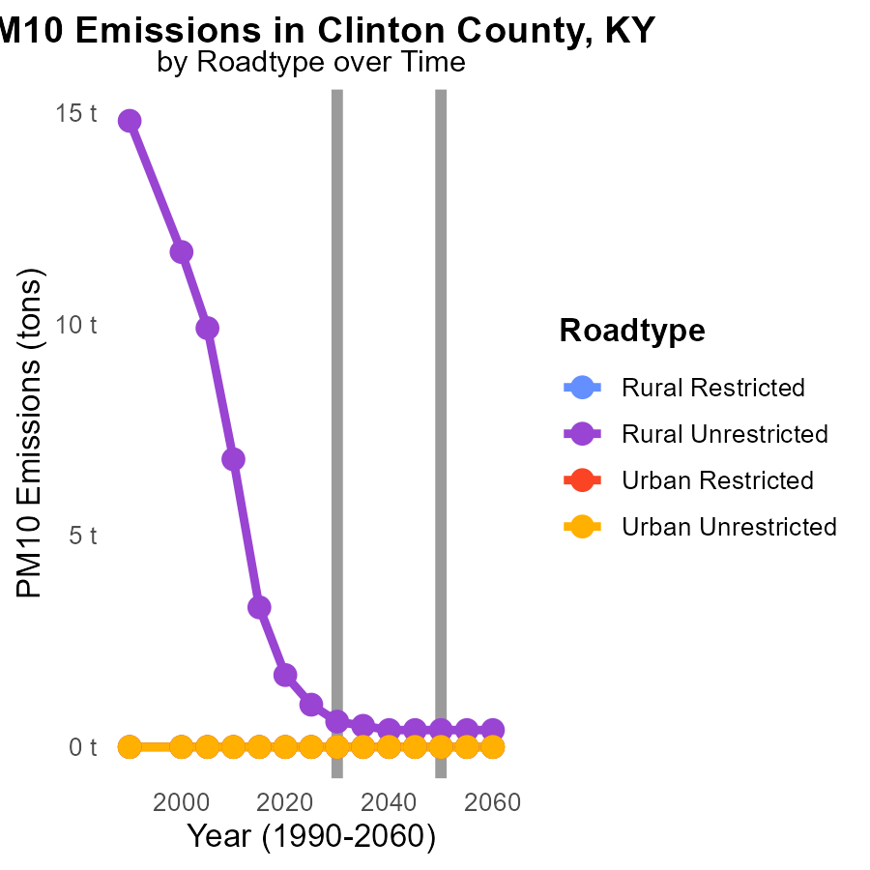

## Findings

* Rural Unrestricted areas show a significant decrease in PM10 emissions from 1.7 tons in 2020 to 400.0 m tons in 2040.
* Rural Unrestricted areas have a 76.5% reduction in PM10 emissions from 2020 to 2040.
* Urban areas, both Restricted and Unrestricted, maintained 0.0 tons of PM10 emissions throughout 2020-2040.

## Recommendations

To further reduce PM10 emissions in Rural Unrestricted areas, focus should be on implementing stricter emissions controls for road vehicles through regular maintenance checks and promoting the use of environmentally friendly technologies. Additionally, investing in public transportation and promoting telecommuting can help decrease the overall emissions levels.

# Areas Ranked by Time Driven

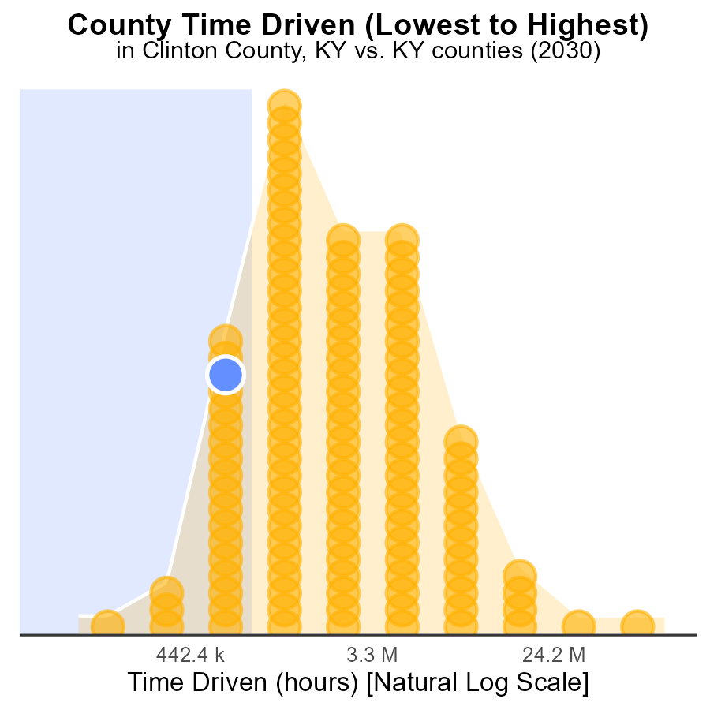

## Findings

* Jackson county ranks 21st in PM10 emissions with 17.5% of the total.
* Robertson county ranks 1st in PM10 emissions with only 0.8% of the total.
* Jefferson county has the highest PM10 emissions, ranking 120th and contributing 100.0% of the total.

## Recommendations

To lower PM10 emissions, focus on reducing sources in the highest-emitting counties like Jefferson. Implement stricter emissions controls and promote cleaner technologies in industries and vehicles.

# Areas Ranked by Idling

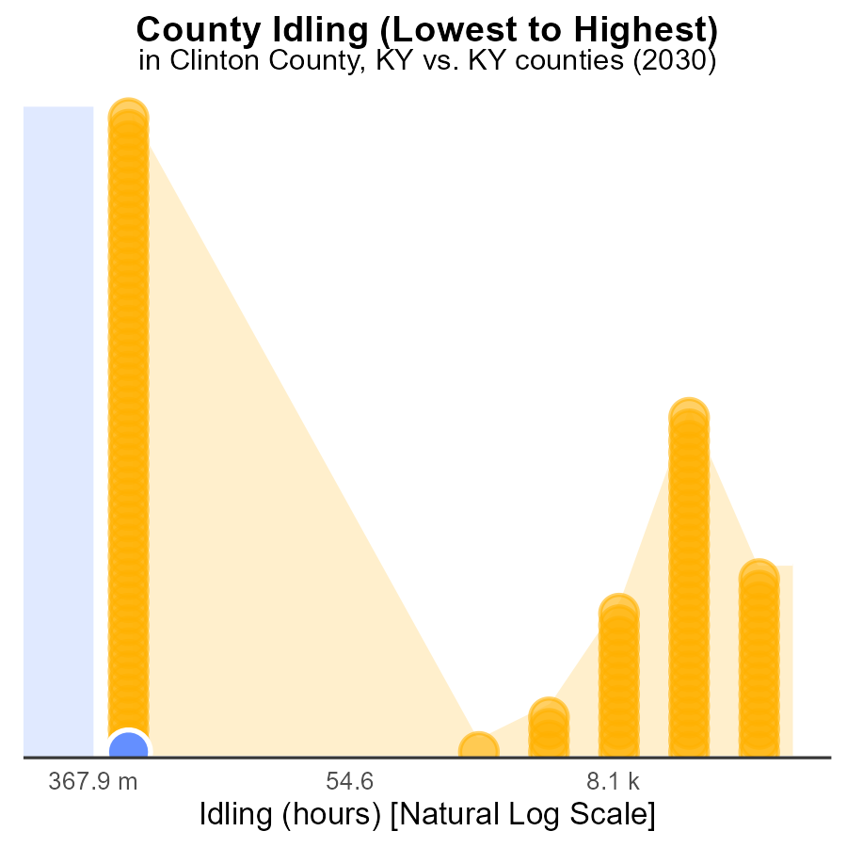

## Findings

* In Clinton County, idling emissions for PM10 in 2030 were significantly low at 0.0 hours.
* Allen County also had low idling emissions for PM10 in 2030 with 0.0 hours recorded.
* Jefferson County had the highest idling emissions for PM10 in 2030, with 711.9 k hours, ranking 120th.

## Recommendations

To reduce PM10 emissions, strategies such as encouraging the use of electric vehicles, implementing anti-idling policies for vehicles, and promoting public transportation can be effective in lowering idling emissions.

# About This Report

Data based on MOVES estimates collected by the Climate Action in Transportation program at Cornell University. Demographic data sourced from the US Census's American Community Survey 5-year estimates. This report was generated with the help of AI.

# References

* U.S. Census Bureau. (2023). American Community Survey 5-year estimates: Detailed tables. Retrieved from https://data.census.gov
* U.S. Environmental Protection Agency. (2024). Motor Vehicle Emission Simulator (MOVES 4.0) [Software]. Retrieved from https://www.epa.gov/moves