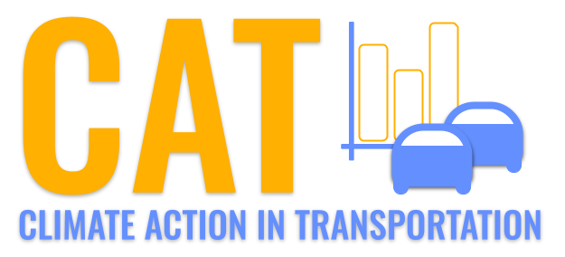 

**PM10 Emissions in Appanoose County, 2025**  
Made with CAT VISUALIZER by Gao Labs @ Cornell University.

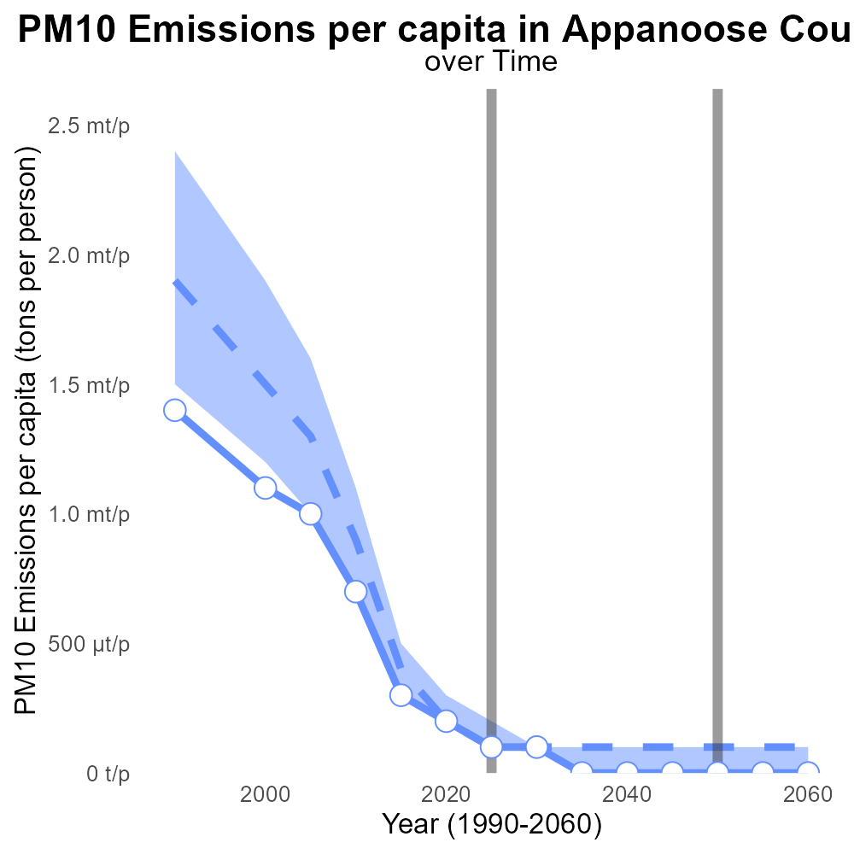

## Keywords

Primary Exhaust PM10; on-road transportation; Appanoose County; IA; 2025

## Highlights

* Study of PM10 emissions from on-road transportation in Appanoose County, IA.
* Analysis focuses on primary exhaust sources and total emissions for 2025.
* Importance of understanding air quality impact and potential health risks.
* Implications for local population and need for emission reduction strategies.
* Report aims to provide data-driven insights for informed decision-making.

# Introduction

This report presents a comprehensive analysis of Primary Exhaust PM10 - Total emissions from on-road transportation in Appanoose County, IA for the year 2025. The study delves into the specific sources of PM10 emissions originating from on-road vehicles, aiming to quantify the total impact on local air quality.

With a focus on primary exhaust sources, the report provides in-depth insights into the nature and extent of PM10 emissions attributed to on-road transportation activities. Understanding the levels of pollutants such as PM10 is essential for assessing the potential health risks posed to residents of Appanoose County and devising effective strategies for mitigating these emissions.

# Hotelling (Diesel Aux) Overall by Area

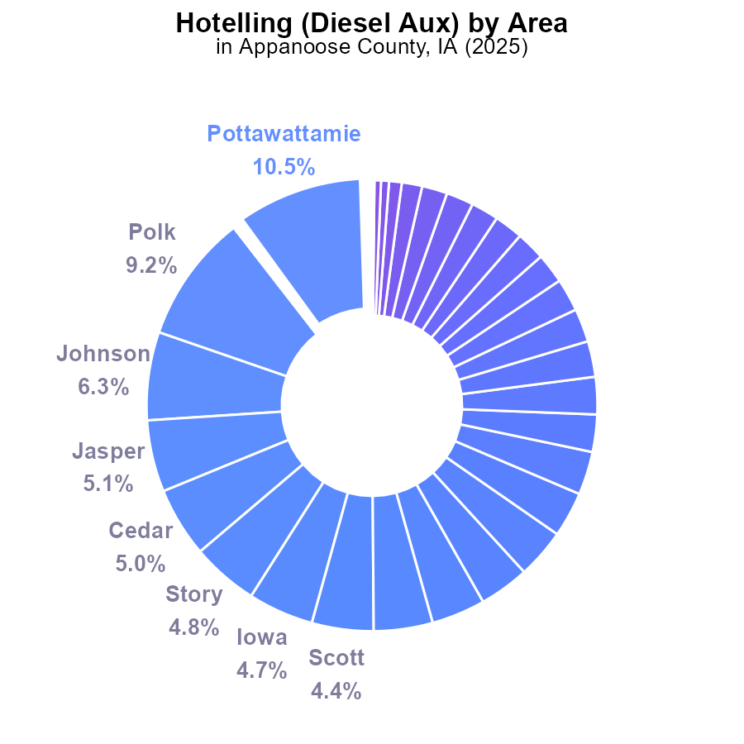

## Findings

* Top PM10 emitters in Appanoose County, IA were Pottawattamie (10.5%), Polk (9.2%), and Johnson (6.3%) contributing most emissions.
* Most counties had minimal PM10 emissions, with a significant number producing 0.0%, indicating room for improvement.
* Low emitters like Buchanan, Madison, and Wright produced 0.6%, 0.5%, and 0.2%, respectively, marking areas for targeted reduction efforts.

## Recommendations

Given the high emissions from Pottawattamie, Polk, and Johnson counties, focus on reducing emissions from diesel auxiliaries. For counties with low emissions like Buchanan, Madison, and Wright, implement stricter regulations to prevent any increase in emissions.

# Emissions Rate (per mile) Overall by Area

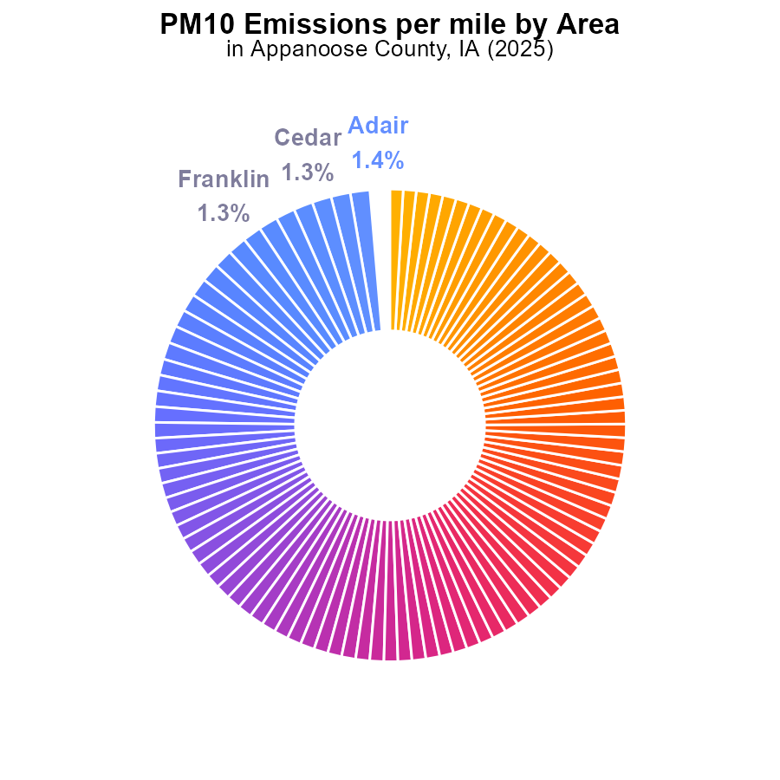

## Findings

* Highest PM10 emissions per mile in Adair with 12.4 tons, followed by Decatur and Cass at 12.2 and 12.1 tons respectively.
* Polk and Adams counties have the lowest PM10 emissions with 8.2 tons per mile.
* Emissions levels across counties show a relatively narrow range, from 8.2 to 12.4 tons per mile.

## Recommendations

To lower emissions, implement stricter vehicle emission standards, promote public transport, and incentivize electric vehicle adoption across all counties.

# Emissions Rate (per capita) Overall over Time

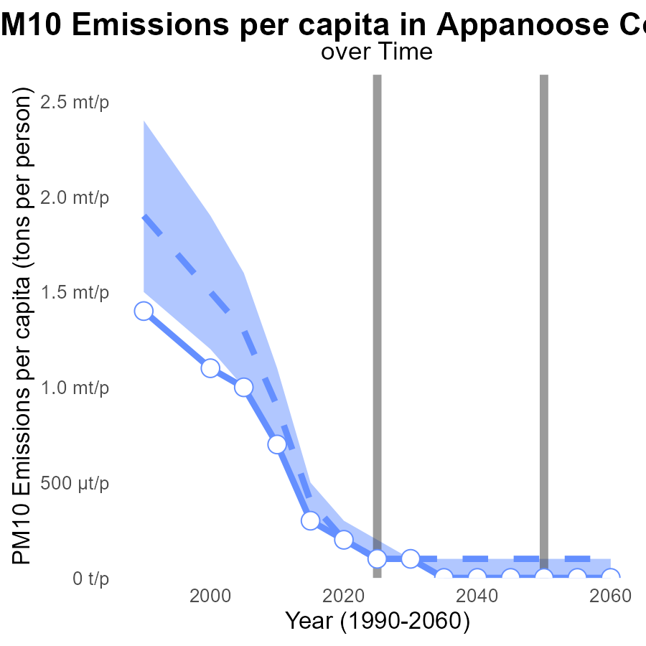

## Findings

* Emissions per capita of PM10 decreased from 951.7 µ in 2005 to 40.1 µ in 2045.
* The area consistently stayed below the median and upper 75th percentile in emissions per capita.
* Emissions are projected to continue declining to 0.0001 tons per person by 2045.

## Recommendations

To further reduce PM10 emissions, Appanoose County should focus on implementing stricter emission control regulations for industries and promoting cleaner technologies to meet the decreasing trend observed in emissions. Additionally, investing in renewable energy sources and promoting public transportation could further decrease per capita emissions. Continuous monitoring and periodic reassessment of emission sources are crucial to ensuring sustained progress towards lower emission levels.

# Idling Overall over Time

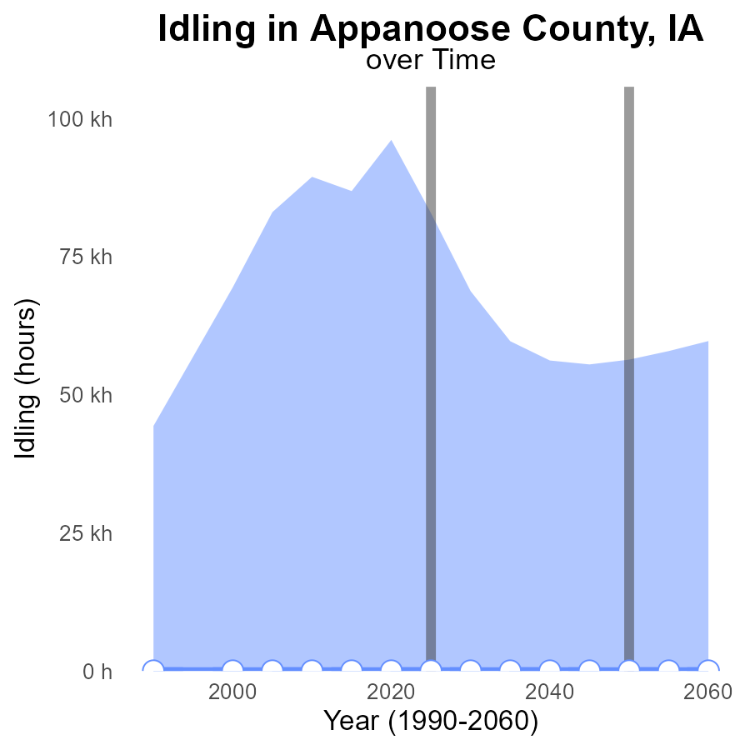

## Findings

* There were no PM10 emissions from idling in Appanoose County, IA from 2005 to 2045.

## Recommendations

Since there are no emissions recorded for PM10 from idling in the county, focus should be maintained on promoting zero-emission vehicles and encouraging the use of public transportation.

# Hotelling (Engines Off) in My Region

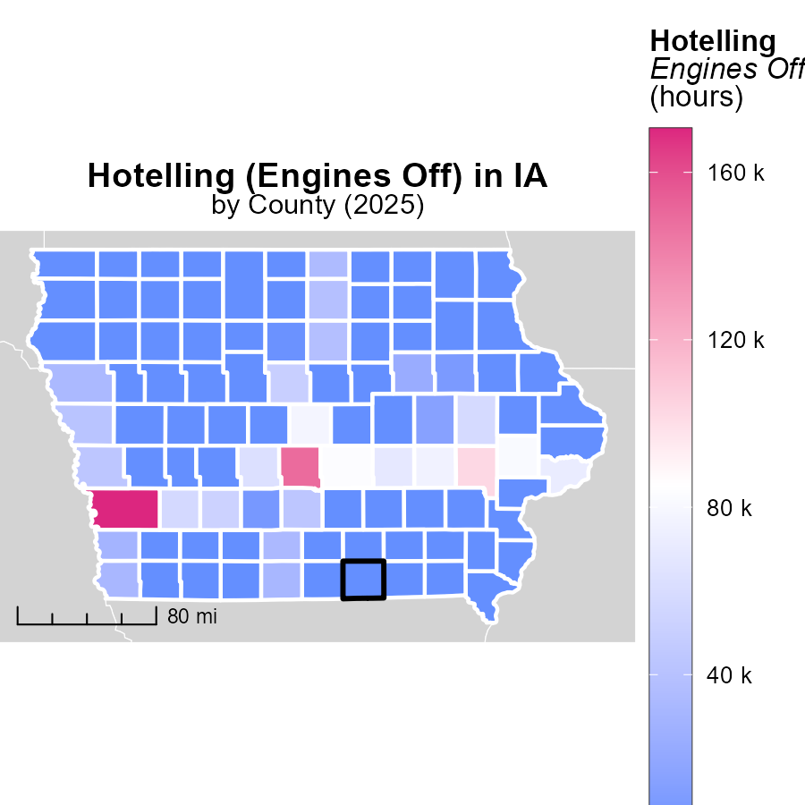

# Vehicle Miles Traveled Mapped by Area

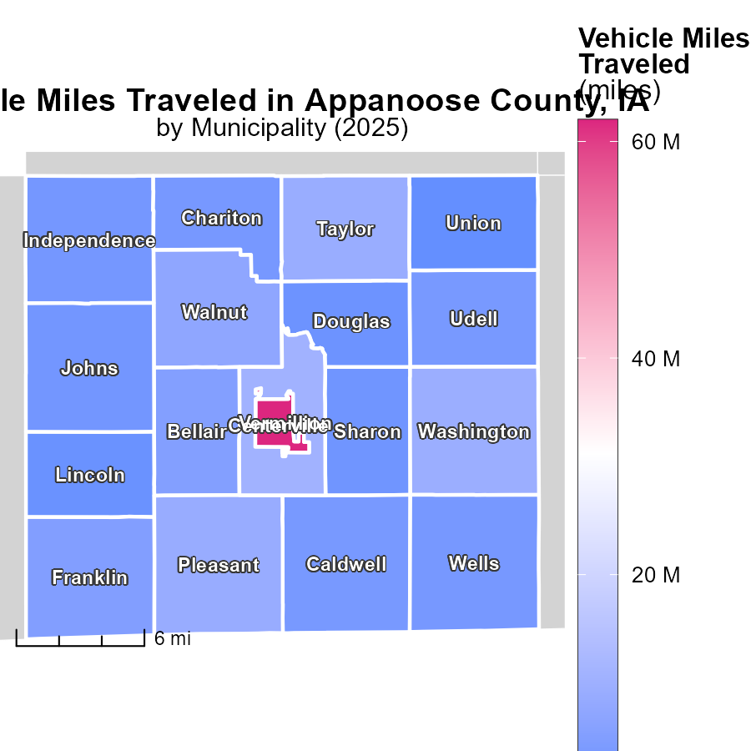

## Findings

* Centerville, IA has the highest vehicle miles traveled at 62.0 million miles.
* Caldwell, IA has a median vehicle miles traveled of 3.4 million miles.
* Union, IA has the lowest vehicle miles traveled at 513.2 thousand miles.

## Recommendations

To lower emissions, focus on reducing vehicle miles traveled in areas with high numbers like Centerville, IA through improved public transportation and infrastructure. Encourage carpooling and telecommuting to decrease the environmental impact.

# Emissions by Area over Time

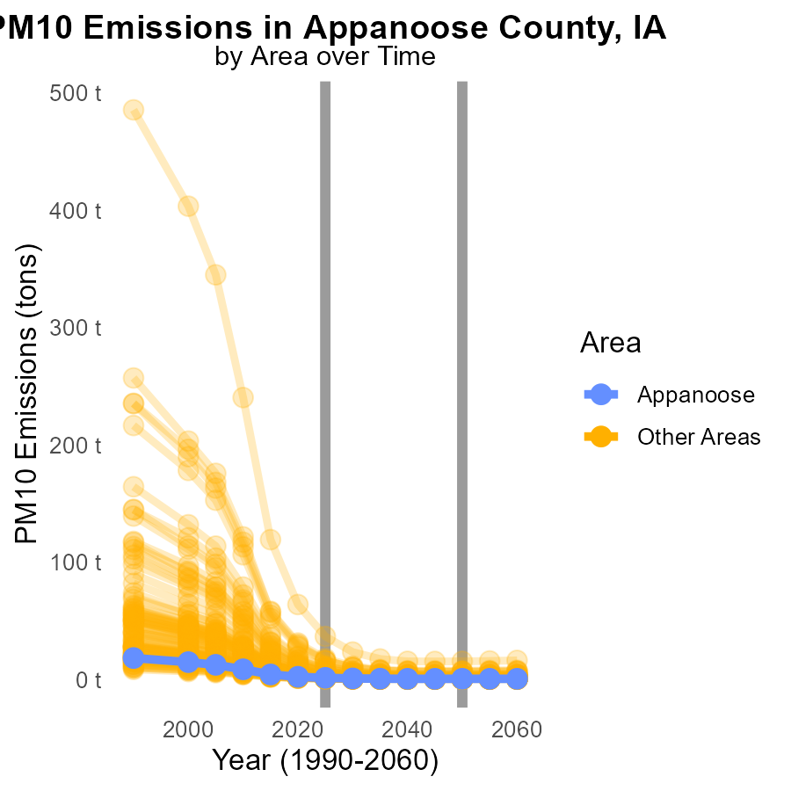

## Findings

* The highest emissions of PM10 in 2025 were seen in the max_county with 36.6 tons.
* The target_county had the lowest emissions in 2025 with only 1.3 tons of PM10.
* Emissions in min_county decreased slightly from 600.0 to 599.6 tons of PM10 from 2025 to 2035.

## Recommendations

To lower PM10 emissions, max_county should implement stricter emission control measures. Target_county should sustain current efforts. Min_county should focus on further reduction strategies.

# Population by Road Type over Time

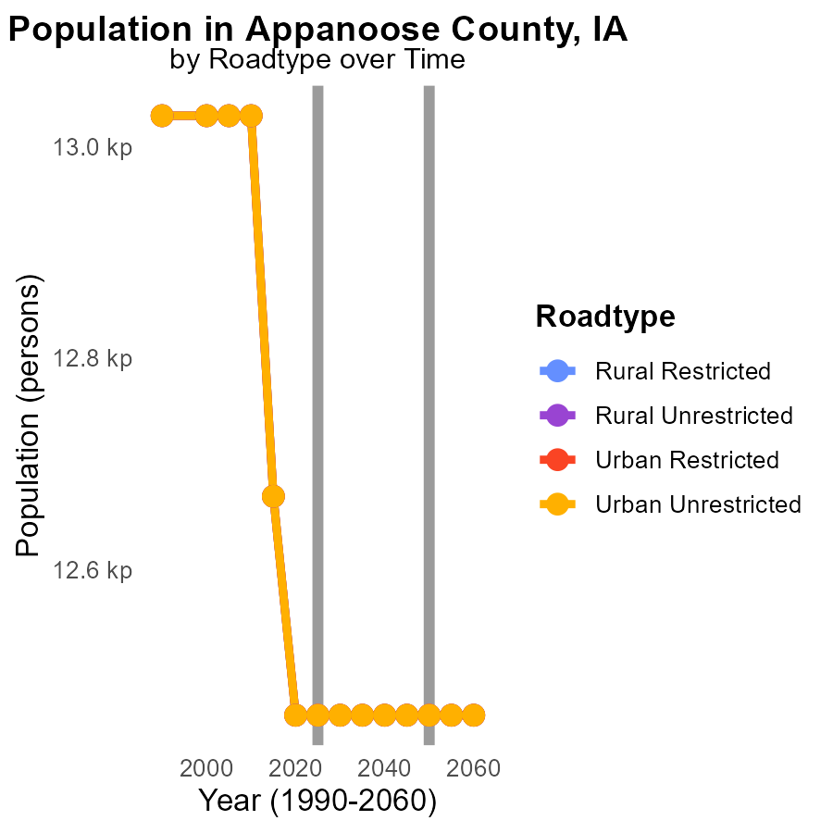

## Findings

* There was a consistent decrease in PM10 emissions across all road types from 2015 to 2035 in Appanoose County, IA.
* Emissions were highest in the year 2015 for all road types, with a reduction of 207 tons by the year 2035.
* Urban areas, both restricted and unrestricted, showed the same trend of decreasing emissions over the 20-year period.

## Recommendations

To further reduce PM10 emissions, focus on implementing stricter emission control regulations for vehicles and promoting the use of public transportation. Additionally, invest in infrastructure to support walking and biking in urban areas to decrease reliance on cars.

# Areas Ranked by Time Driven

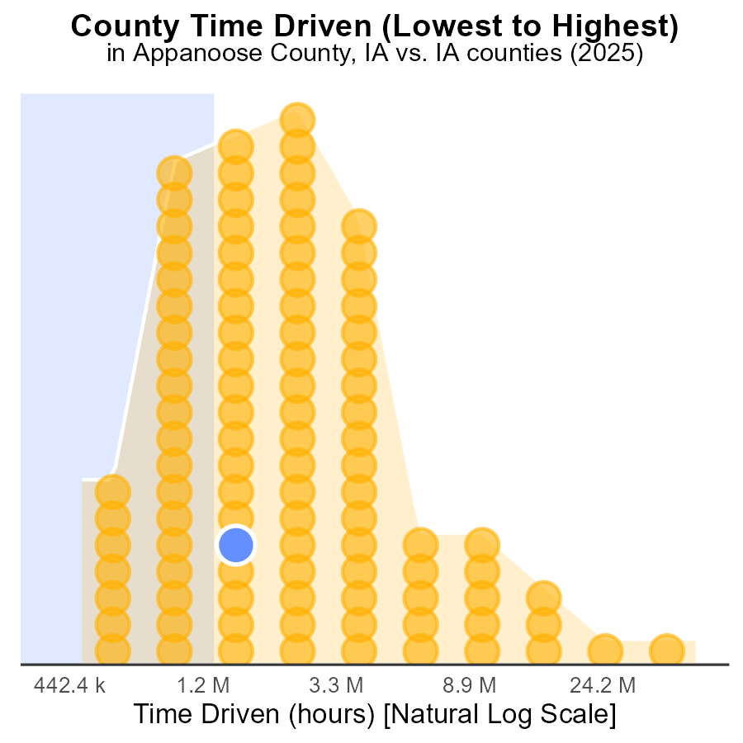

## Findings

* Polk county has the highest PM10 emissions with 133.3 million source hours, ranking 99th.
* Taylor county has the lowest PM10 emissions with 1.3 million source hours, ranking 1st.
* Polk county alone contributes to 100% of the PM10 emissions in the dataset.

## Recommendations

To lower PM10 emissions, focus on reducing sources in high-ranking counties like Polk by implementing stricter emission control measures and promoting cleaner technologies.

# Areas Ranked by Emissions

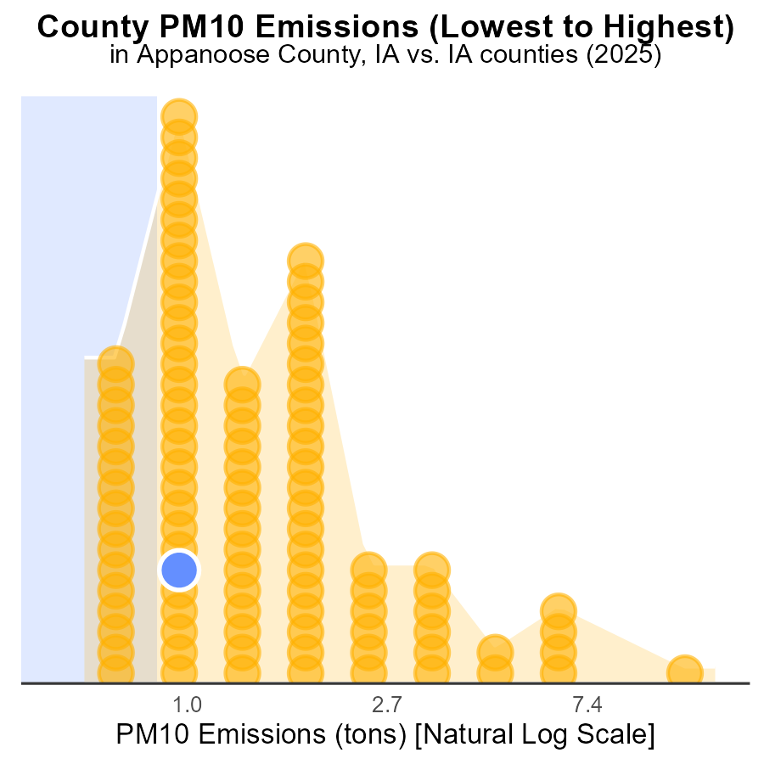

## Findings

* Polk county has the highest PM10 emissions with 36.6 tons.
* Adams county ranks 1st in emissions but contributes only 2.0% to the total.
* Counties like Appanoose, Palo Alto, and Butler have similar emissions, around 1.3 tons each.

## Recommendations

To lower PM10 emissions, focus on reducing industrial and transportation activities in Polk county. Encourage Adams county to maintain its low emissions while assisting counties like Appanoose, Palo Alto, and Butler in implementing emission reduction strategies.

# Conclusion

In conclusion, the data from the report on Primary Exhaust PM10 - Total emissions from on-road transportation in Appanoose County, IA in 2025 reveals important insights for targeted emission reduction efforts. Counties like Pottawattamie, Polk, and Johnson stand out as significant contributors to PM10 emissions, suggesting a need to focus on reducing emissions from diesel auxiliaries in these areas. Conversely, counties with minimal emissions such as Buchanan, Madison, and Wright present opportunities for targeted reduction strategies.

To further lower PM10 emissions, it is crucial to implement stricter vehicle emission standards, promote public transport, and incentivize electric vehicle adoption across all counties. The consistent decline in emissions per capita indicates progress, with projections suggesting a continued decrease by 2045. Moving forward, Appanoose County should concentrate on stricter emission control regulations for industries, promoting cleaner technologies, and investing in renewable energy sources to sustain the decreasing trend observed in emissions.

# About This Report

Data based on MOVES estimates collected by the Climate Action in Transportation program at Cornell University. Demographic data sourced from the US Census's American Community Survey 5-year estimates. This report was generated with the help of AI.

# References

* U.S. Census Bureau. (2023). American Community Survey 5-year estimates: Detailed tables. Retrieved from https://data.census.gov
* U.S. Environmental Protection Agency. (2024). Motor Vehicle Emission Simulator (MOVES 4.0) [Software]. Retrieved from https://www.epa.gov/moves