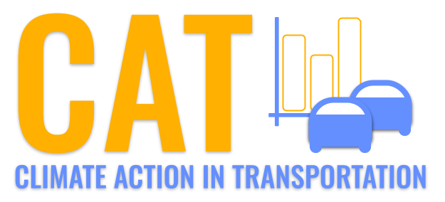 

**CO Emissions in Windham County, 2055**  
Made with CAT VISUALIZER by Gao Labs @ Cornell University.

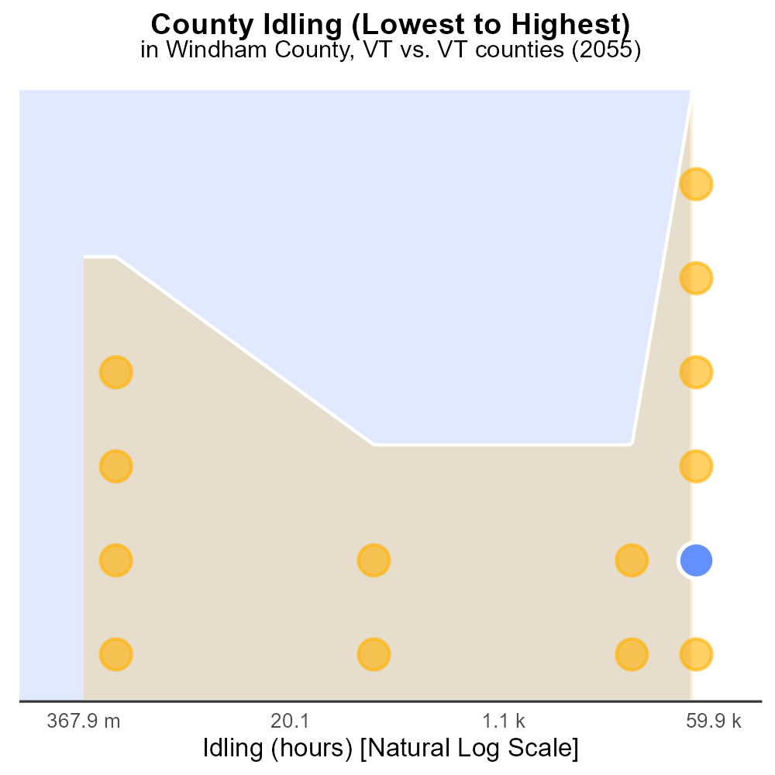

## Keywords

Carbon Monoxide emissions; on-road transportation; Windham County; VT; 2055

## Highlights

* CO emissions pose serious health risks to residents.
* On-road transport a key contributor to CO levels.
* 2055 data offers insights into future mitigation strategies.
* Windham County's unique characteristics affect emissions.
* Report utilizes data from multiple sources for accuracy.

# Introduction

Carbon Monoxide (CO) emissions from on-road transportation in Windham County, VT in 2055 are of critical concern due to their impact on air quality and public health. CO is a colorless, odorless gas that can be harmful when inhaled, leading to various health issues such as headaches, dizziness, and even death.

On-road transportation is a major source of CO emissions, with vehicles burning fossil fuels releasing this harmful gas into the atmosphere. Understanding the specific dynamics of CO emissions in Windham County in 2055 is crucial for developing effective mitigation strategies to reduce the health risks posed to residents. This report aims to analyze the data on CO emissions, considering Windham County's unique characteristics and utilizing information from various sources to provide a comprehensive overview.

# Emissions Rate (per mile) by Fuel Type

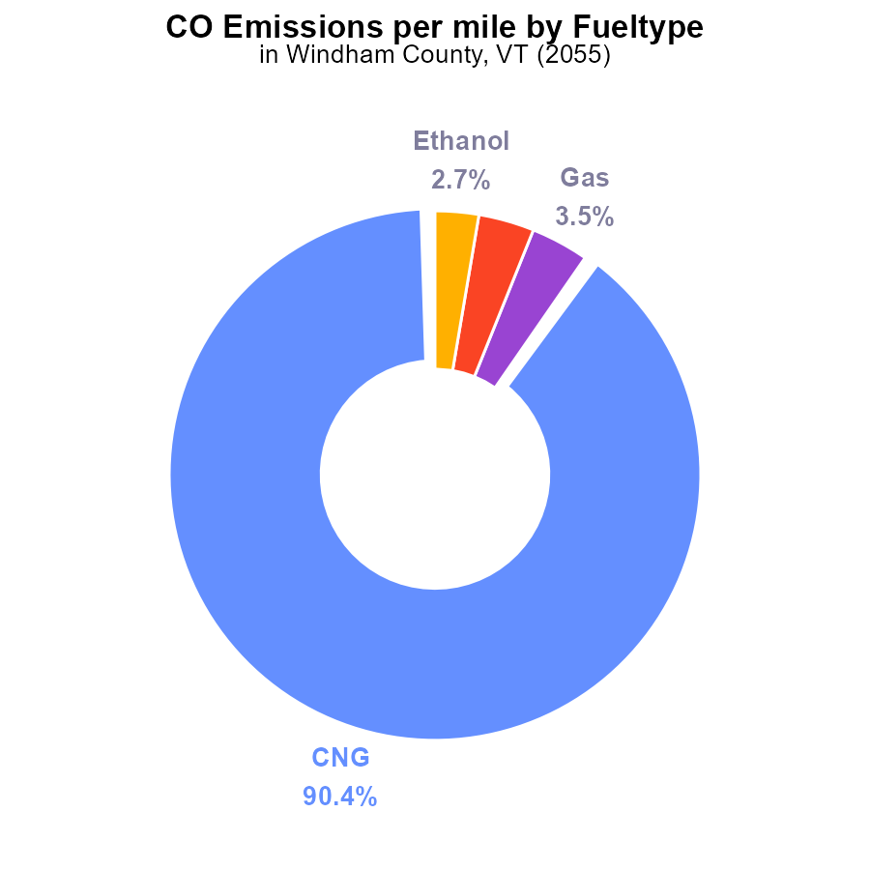

## Findings

* The largest share of emissions in Windham County comes from CNG vehicles at 90.4%.
* Gas and Diesel vehicles each contribute around 3.5% and 3.4% of the total emissions, respectively.
* Ethanol-powered vehicles, at 2.7%, have the least impact on emissions in the county.

## Recommendations

To lower emissions in Windham County, policymakers should focus on transitioning a significant portion of CNG vehicles to cleaner alternatives, such as electric or hydrogen-powered vehicles. Encouraging the use of alternative fuels for Gas and Diesel vehicles can also help reduce their emissions contributions. Additionally, promoting the adoption of more sustainable transportation modes can further decrease the overall emissions per mile in the county.

# Vehicle Miles Traveled by Fuel Type

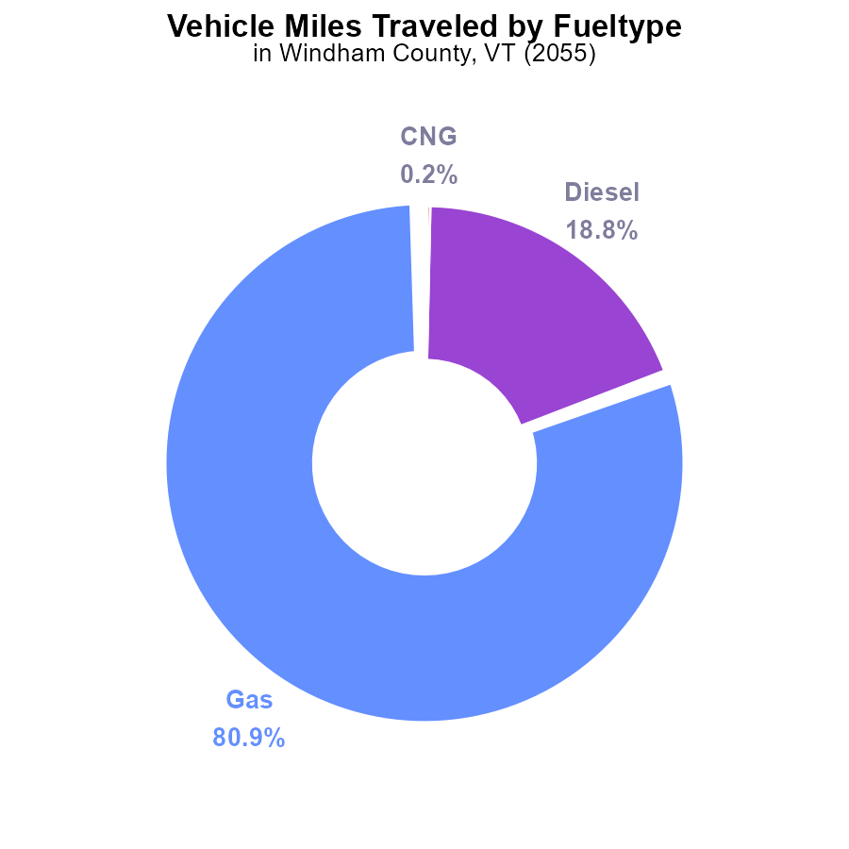

## Findings

* Gasoline vehicles account for 80.9% of CO emissions from vehicle miles traveled in Windham County, VT.
* Diesel vehicles contribute to 18.8% of CO emissions from vehicle miles traveled in the county.
* Alternative fuels, such as CNG and ethanol, make up a minimal percentage of CO emissions, with 0.2% and 0.1% respectively.

## Recommendations

To lower CO emissions from vehicle miles traveled in Windham County, VT, there should be a focus on reducing the usage of gasoline and diesel vehicles by promoting alternative fuel options and incentivizing the adoption of electric vehicles. Policies should be implemented to encourage the transition to cleaner transportation modes, such as improving public transportation infrastructure and investing in more charging stations for electric vehicles.

# Vehicle Miles Traveled over Time for Passenger Vehicles

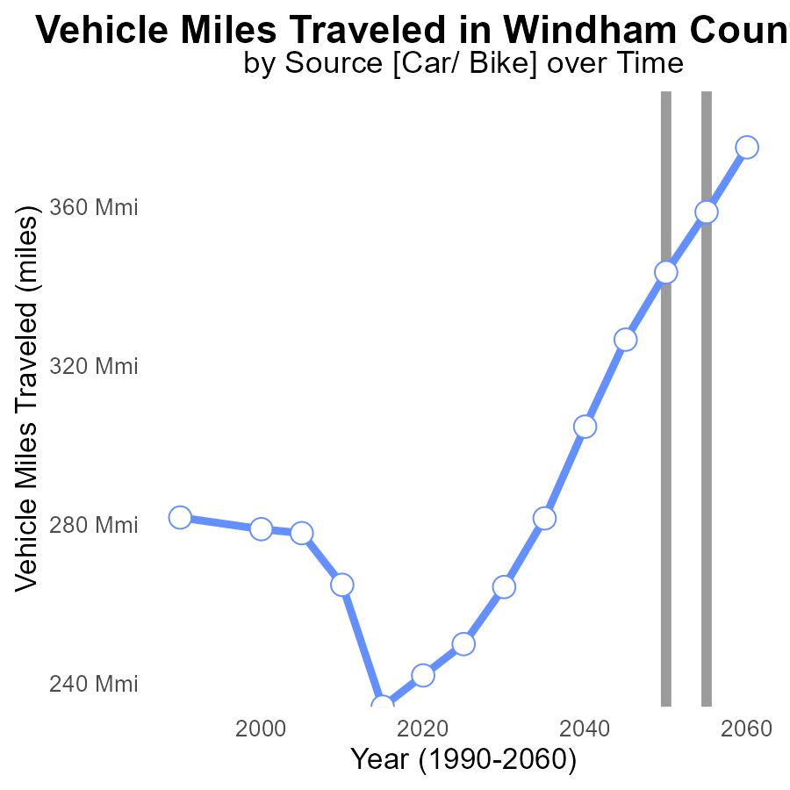

## Findings

* Vehicle miles traveled in Windham County, VT have been steadily increasing
* There was a decrease in vehicle miles traveled after 2050
* Significant reductions in vehicle miles traveled are needed to meet emission reduction goals

## Recommendations

To lower emissions, it is crucial to promote the use of public transportation, carpooling, biking, and walking. Implement policies such as congestion pricing and fuel taxes to reduce vehicle miles traveled.

# Emissions Rate (per mile) over Time for Passenger Vehicles

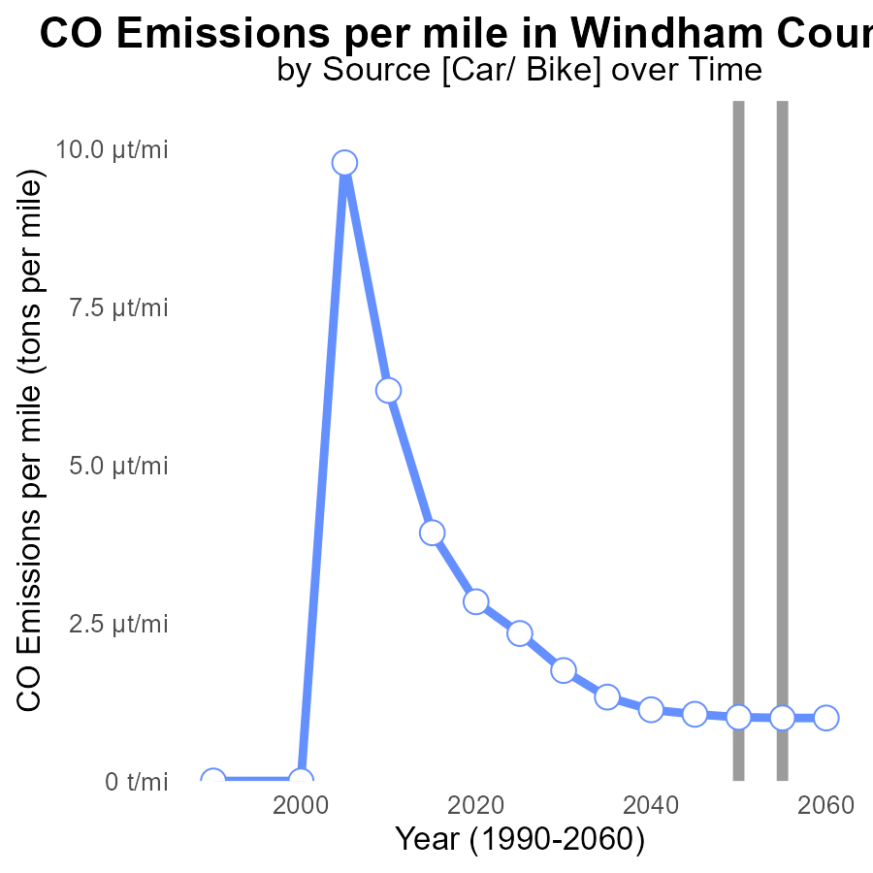

## Findings

* Emissions per mile decreased from 1.3 tons in 2035 to 996.5 tons in 2060.
* The benchmark difference decreased gradually over the years, reaching 0 in 2045.
* Overall, there was a significant reduction in emissions per mile over the 25-year period.

## Recommendations

To further decrease emissions in Windham County, VT, it is crucial to continue investing in renewable energy sources like wind and solar power. Implementing stricter vehicle emission standards and promoting public transportation can also help sustain the declining emissions trend.

# Hotelling (Diesel Aux) Mapped by Area

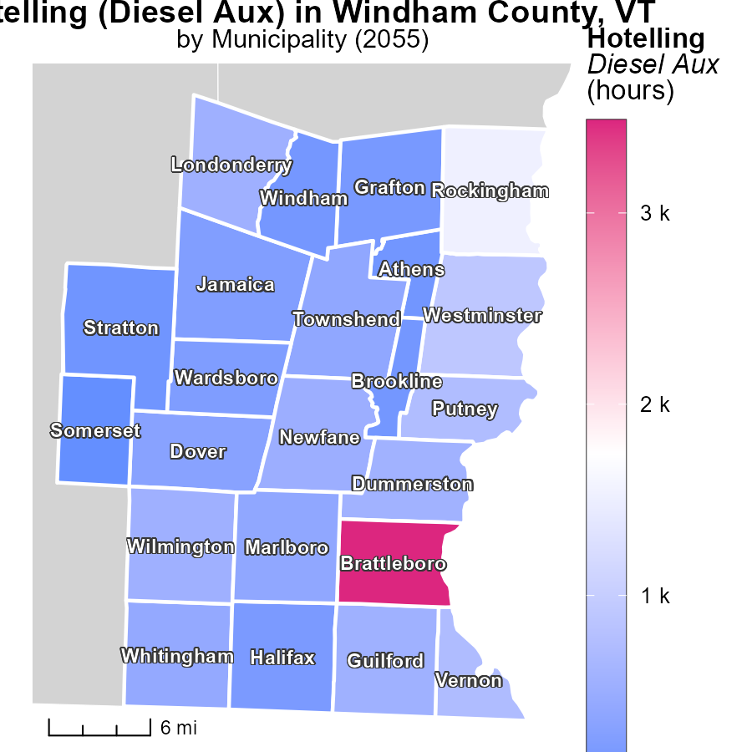

## Findings

* The highest emissions of 3.5 k were recorded in Brattleboro, VT.
* Townshend, VT had a median emission of 395.7, significantly lower than Brattleboro.
* Somerset, VT recorded the lowest emissions among the locations at 0.0.

## Recommendations

To lower emissions, consider implementing more environmentally friendly technologies such as electric or hybrid vehicles in high emitting areas like Brattleboro, and ensure proper maintenance of diesel auxiliary systems across all locations.

# Vehicle Starts in My Region

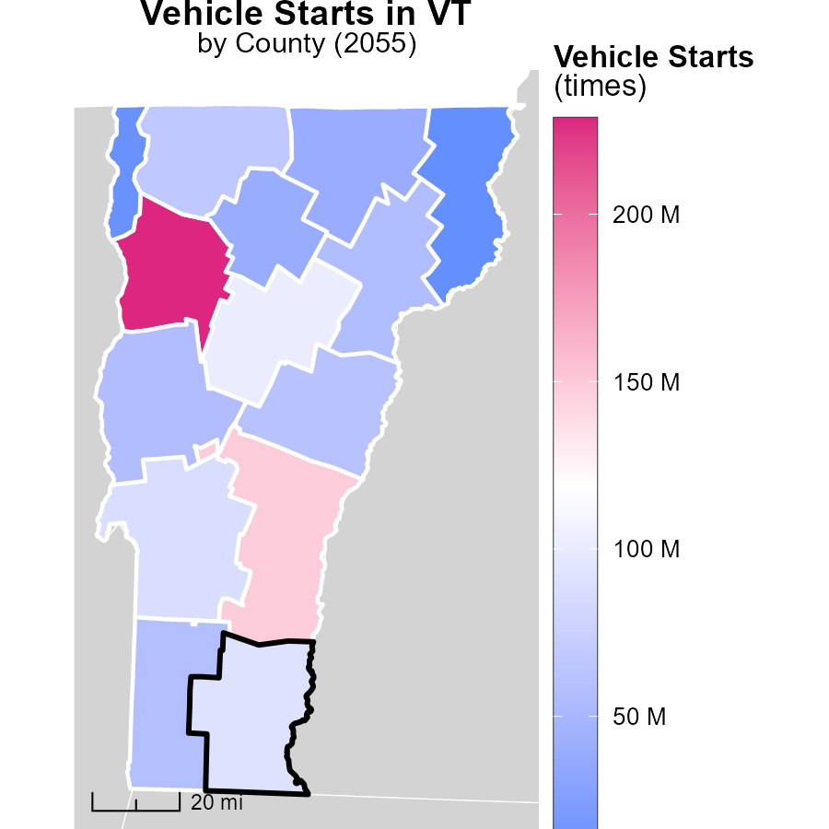

## Findings

* Chittenden County has the highest number of vehicle starts with 228.6 million times in 2055.
* Bennington County recorded a median of 58.3 million vehicle starts.
* Essex County had the fewest vehicle starts with 9.2 million times in 2055.

## Recommendations

To lower emissions, invest in public transportation systems to reduce the reliance on personal vehicles, particularly in counties with high vehicle starts. Implement carpooling initiatives and promote the use of electric vehicles to decrease emissions further.

# Hotelling (Diesel Aux) by Fuel Type over Time

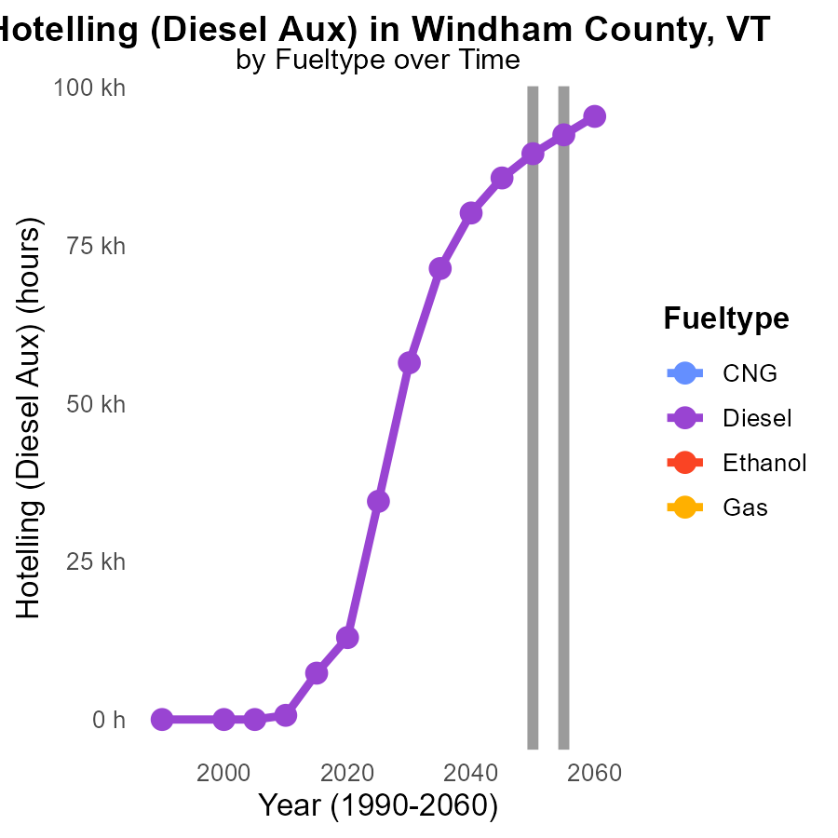

## Findings

* Annual diesel emissions are projected to decrease by 5.8% from 2050 to 2060.
* In 2045, diesel fuel emissions were 85.6 k (thousand) units, increasing by 3835.3 units since 2050.
* No data is available for CNG, ethanol, and gas emissions from 2045 to 2060 in Windham County, VT.

## Recommendations

To further reduce emissions, prioritize transitioning to cleaner fuel alternatives like CNG or ethanol. Invest in infrastructure for supporting these cleaner fuels and continue tracking and analyzing emissions data over time for informed decision-making.

# Vehicle Starts by Area over Time

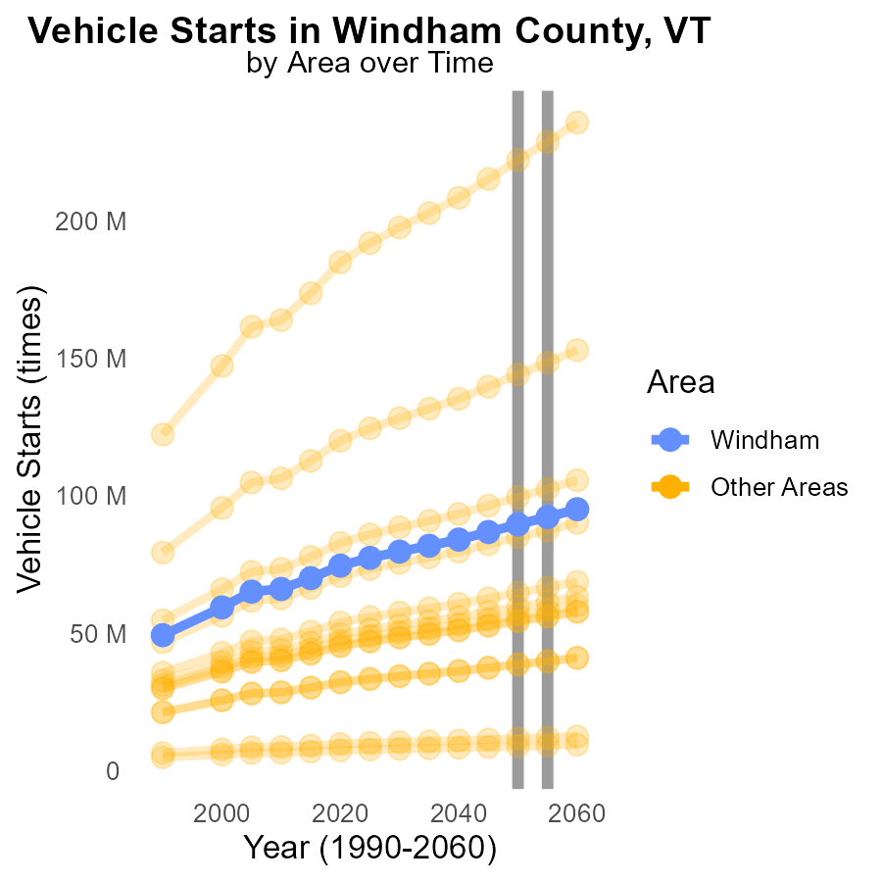

## Findings

* In 2055, the maximum county emitted 228.6 million tons of CO during vehicle starts.
* The minimum county emitted 9.2 million tons of CO, showing a decrease compared to 2050.
* The target county emissions were 92.2 million tons, with a reduction from 2050 levels.

## Recommendations

To lower CO emissions during vehicle starts, focus on strategies such as promoting electric vehicles, enhancing public transportation, and implementing stricter emission standards for vehicles in counties with higher emissions.

# Areas Ranked by Time Driven

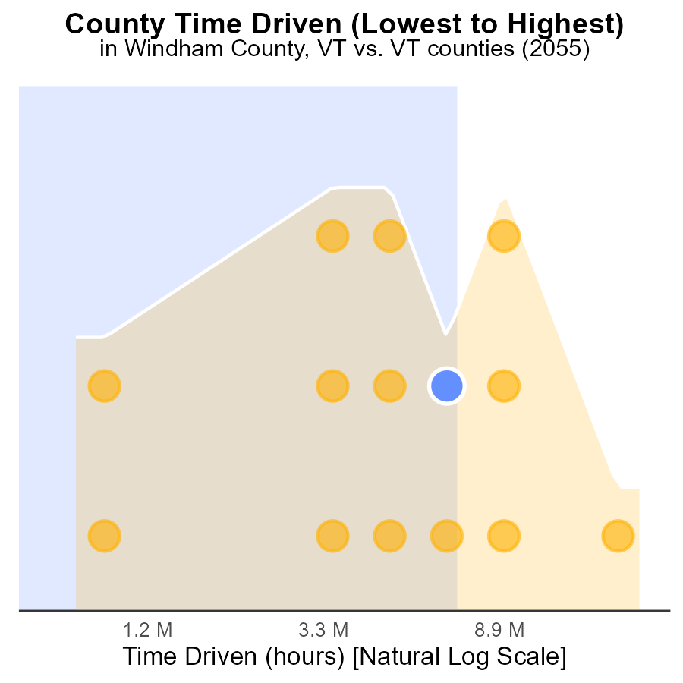

## Findings

* Chittenden county has the highest CO emissions with 55.6 million source hours.
* Essex county has the lowest CO emissions with 2.2 million source hours.
* Chittenden county's CO emissions rank at the 100th percentile, indicating the highest level among the counties.

## Recommendations

To lower emissions, focus on reducing CO output in Chittenden county through stricter regulations and incentivizing cleaner technologies. Encourage energy-efficient practices in high-emission counties like Washington.

# Areas Ranked by Idling

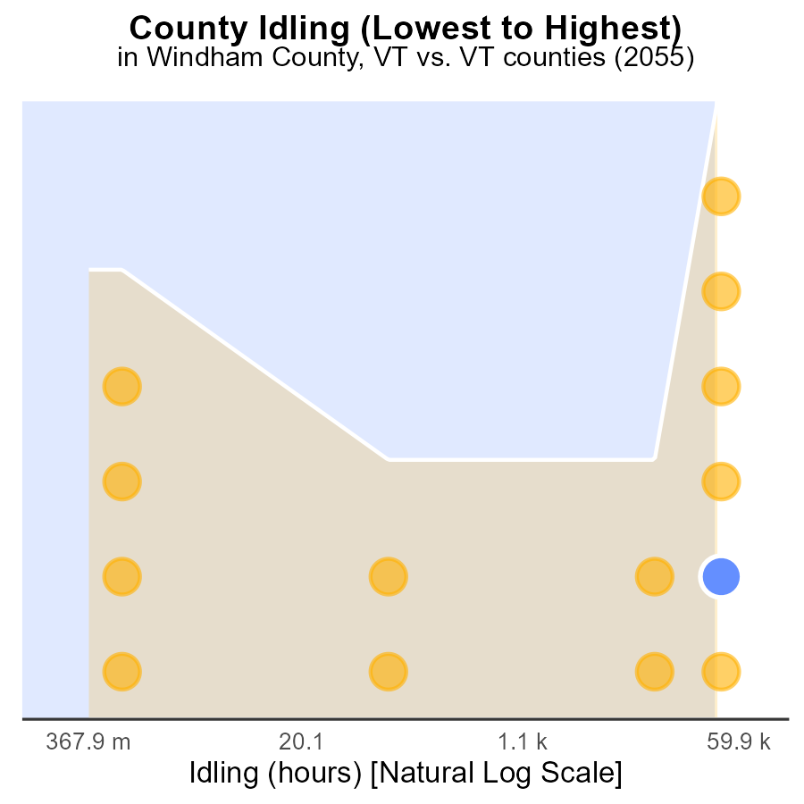

## Findings

* The county with the highest amount of idling hours is Windsor with 216.5k hours.
* Addison county has the least idling hours with 0.0 hours.
* Overall, the idling percentages range from 28.6% in Addison to 100% in Windsor.

## Recommendations

To reduce emissions, focus on implementing idling reduction campaigns in counties with high idle percentages like Windsor and Washington.

# Conclusion

In conclusion, the data on Carbon Monoxide (CO) emissions from on-road transportation in Windham County, VT in 2055 highlights the significant impact of CNG vehicles on overall emissions, while Gasoline vehicles remain the primary contributors to CO emissions. The findings underscore the importance of transitioning to cleaner alternatives such as electric or hydrogen-powered vehicles to mitigate emissions. Moreover, promoting sustainable transportation modes and reducing vehicle miles traveled are crucial steps towards meeting emission reduction goals.

The report suggests that investment in renewable energy sources, implementation of stricter vehicle emission standards, and the promotion of public transportation are vital strategies to sustain the declining emissions trend. By focusing on high-emission areas like Brattleboro and prioritizing counties with high vehicle starts such as Chittenden, substantial progress can be made in lowering CO emissions during vehicle starts. Continued tracking and analysis of emissions data, along with targeted initiatives like idling reduction campaigns in counties like Windsor, are essential for achieving long-term emission reduction objectives.

# About This Report

Data based on MOVES estimates collected by the Climate Action in Transportation program at Cornell University. Demographic data sourced from the US Census's American Community Survey 5-year estimates. This report was generated with the help of AI.

# References

* U.S. Census Bureau. (2023). American Community Survey 5-year estimates: Detailed tables. Retrieved from https://data.census.gov
* U.S. Environmental Protection Agency. (2024). Motor Vehicle Emission Simulator (MOVES 4.0) [Software]. Retrieved from https://www.epa.gov/moves