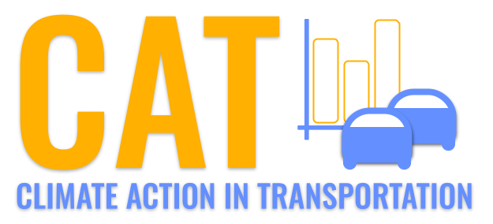 

**NOx Emissions in Saginaw County, 2060**  
Made with CAT VISUALIZER by Gao Labs @ Cornell University.

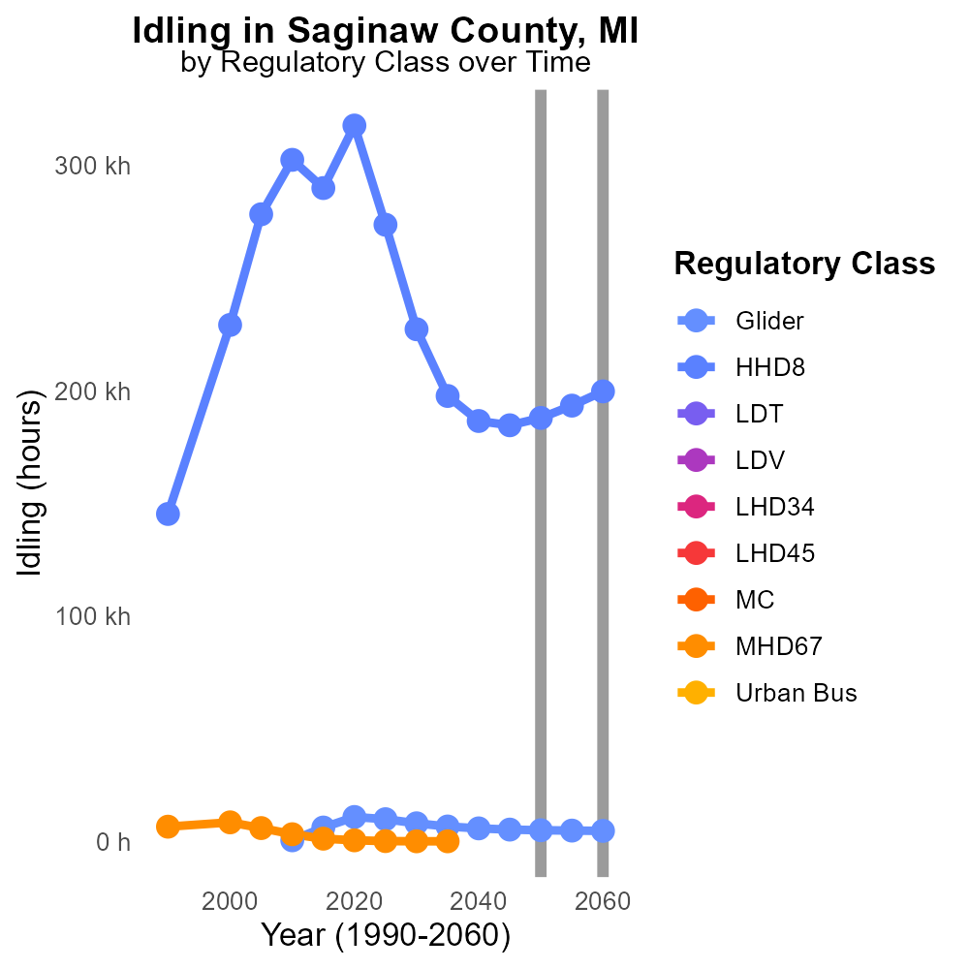

## Keywords

NOx emissions; on-road transportation; Saginaw County; 2060; environmental impact; air pollution

## Highlights

* In 2060, NOx emissions from on-road transport in Saginaw County raise environmental concerns.
* The excessive amount of NOx can lead to air pollution and impact human health.

# Introduction

Oxides of Nitrogen (NOx) emissions from on-road transportation have become a significant environmental concern in Saginaw County, Michigan, by the year 2060. With the increasing reliance on automobiles and the growth of the population, the emissions of NOx have surged, posing a threat to air quality and public health. NOx compounds are known for their detrimental effects on the environment, contributing to the formation of smog, acid rain, and ozone depletion.

Saginaw County, a once pristine region, now grapples with the consequences of high NOx emissions from vehicles. The elevated levels of NOx can lead to respiratory problems, cardiovascular issues, and other health complications among the residents. As we delve deeper into understanding the impact of NOx on the environment and public health, exploring mitigation strategies and sustainable transportation alternatives becomes imperative in order to alleviate the burden of on-road transportation emissions in Saginaw County.

# Emissions Rate (per mile) by Vehicle Type

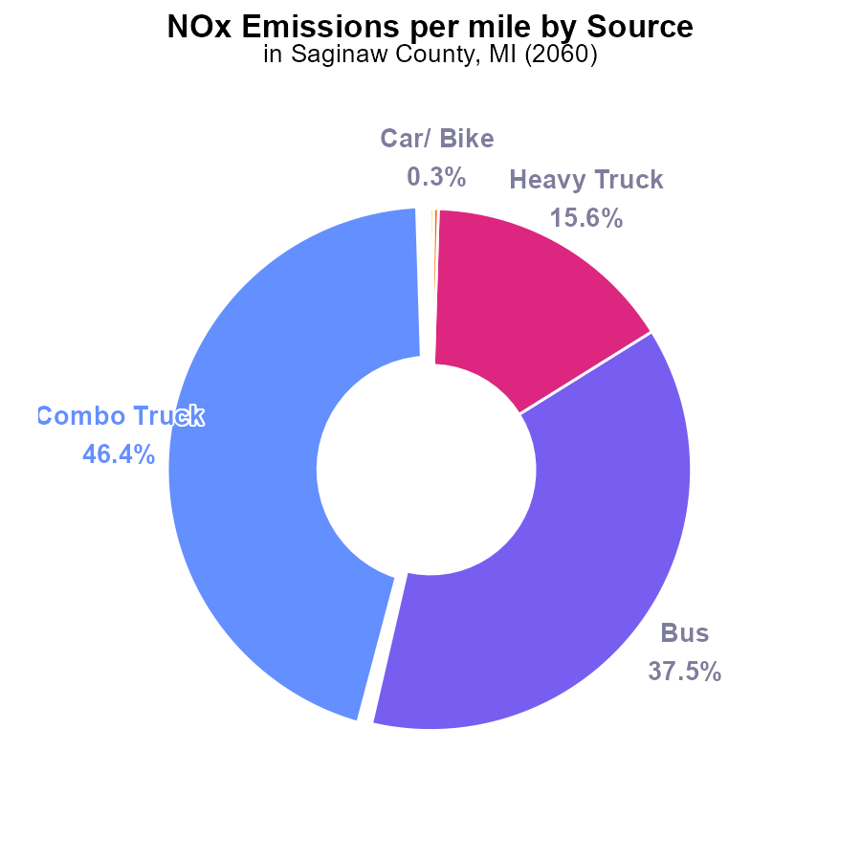

## Findings

* The highest contributor to NOx emissions per mile in Saginaw County in 2060 is Combo Trucks at 46.4%.
* Buses are the second-highest contributor, accounting for 37.5% of the emissions per mile.
* Heavy trucks, though fewer in number, still contribute significantly to emissions, making up 15.6% of the total.

## Recommendations

To lower the emission level of NOx in Saginaw County, focus should be on regulating and improving the emission controls on Combo Trucks and Buses, as they are the primary sources of NOx emissions. Implementing stricter emission standards and promoting the use of cleaner fuel technologies in these vehicles can help reduce the overall NOx emissions.

# Idling Overall by Area

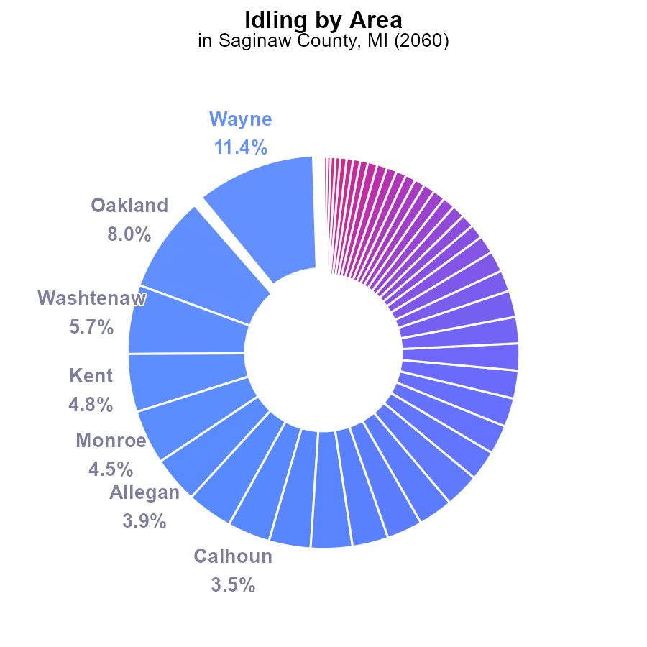

## Findings

* Top NOx emitters are Wayne County with 1.0 million idling hours (11.4%), followed by Oakland and Washtenaw Counties.
* Saginaw County emits 204.4 thousand idling hours (2.2%), ranking 19th in the state for NOx emissions.
* Counties like Alcona, Alger, Antrim, and others have negligible to zero contributions to NOx emissions.

## Recommendations

To lower NOx emissions, focus efforts on top emitters like Wayne, Oakland, and Washtenaw Counties by promoting anti-idling campaigns and implementing stricter idling regulations. Consider incentivizing the use of cleaner technologies.

# Hotelling (Diesel Aux) over Time for Buses

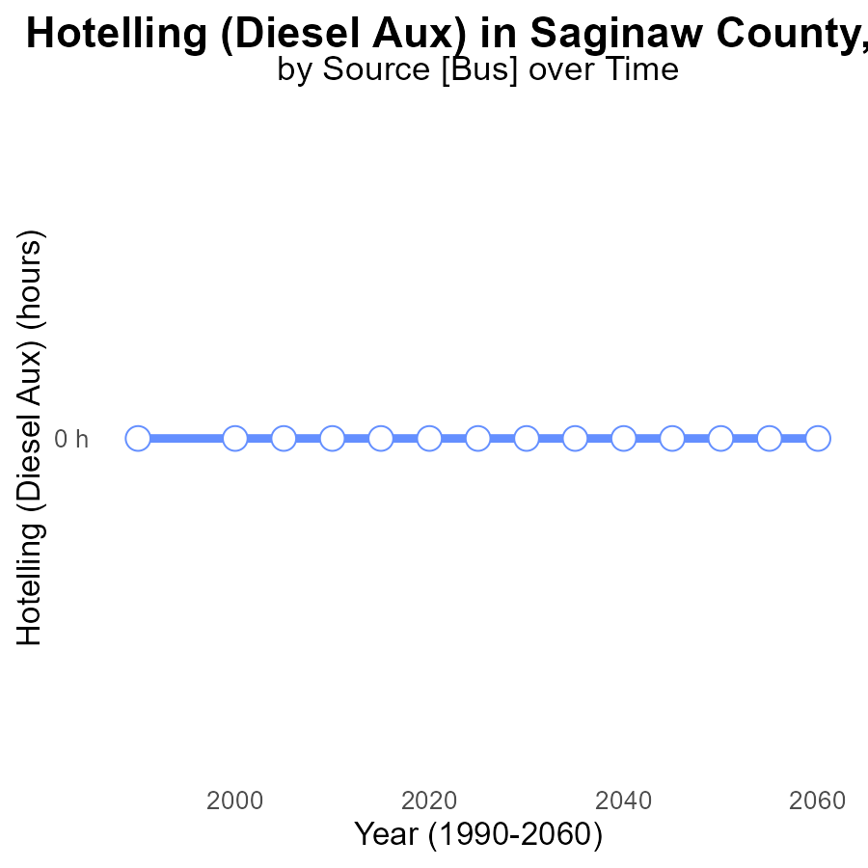

## Findings

* NOx emissions from Hotelling (Diesel Aux) in Saginaw County are consistently at 0.0 hours from 2040 to 2060.
* There is no difference between the actual emissions and the benchmark set for the area during this period.
* The emissions level seems to have remained stable at zero, indicating a potentially effective control measure in place.

## Recommendations

Given the stable and low emissions levels observed, it is essential to continue monitoring and enforcing the existing control measures to sustain the current emission rate. Moreover, conducting regular assessments of the control technologies and exploring potential upgrades to further minimize NOx emissions can be beneficial.

# Idling over Time for Buses

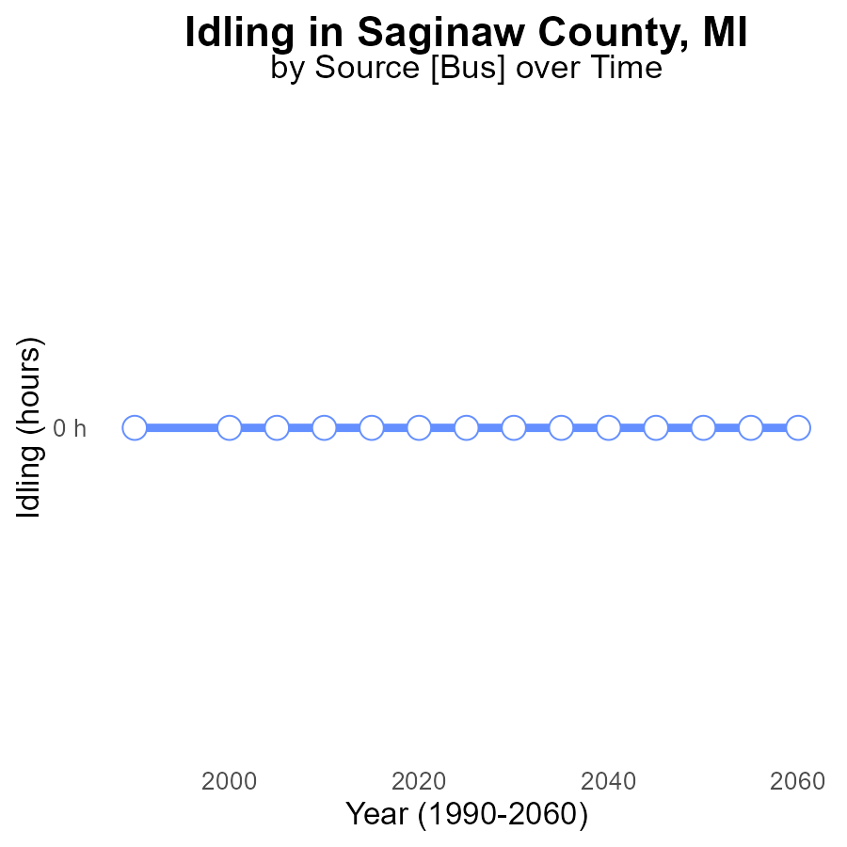

## Findings

* NOx emissions from idling in Saginaw County are consistently at 0.0 units between 2040 and 2060.
* There has been no change in NOx emissions over the 20-year period.
* The benchmark difference remains at 0, indicating that the emissions have not exceeded the set standard.

## Recommendations

Since emissions have been consistently at 0.0 units for 20 years, it is recommended to continue implementing and enforcing idling regulations to maintain this low level. Regular monitoring and public awareness campaigns can further support keeping emissions at bay.

# Emissions Rate (per vehicle) in My Region

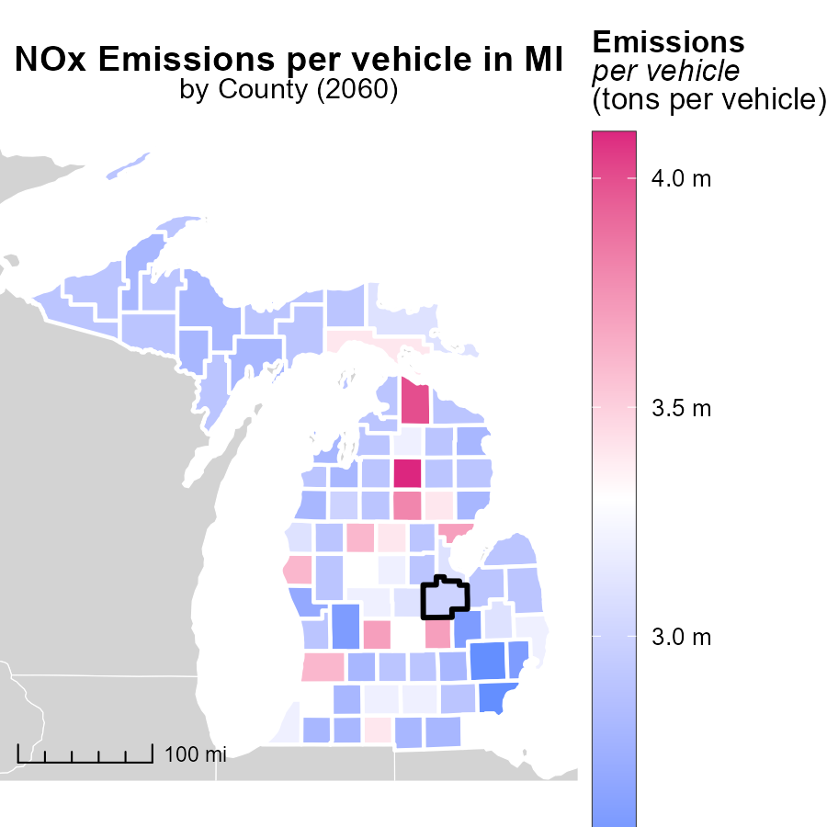

## Findings

* Crawford County, MI has the highest emissions per vehicle at 4.1 tons.
* Huron County, MI has emissions per vehicle at 2.9 tons, the median value.
* Wayne County, MI has the lowest emissions per vehicle at 2.5 tons.

## Recommendations

To lower emissions, focus on high-emitting areas like Crawford County by implementing vehicle emission standards and promoting electric vehicles. Encourage sustainable transportation choices in Huron County to maintain the median level. Wayne County can continue its efficient emissions per vehicle by investing in public transportation and biking infrastructure.

# Vehicle Starts Mapped by Area

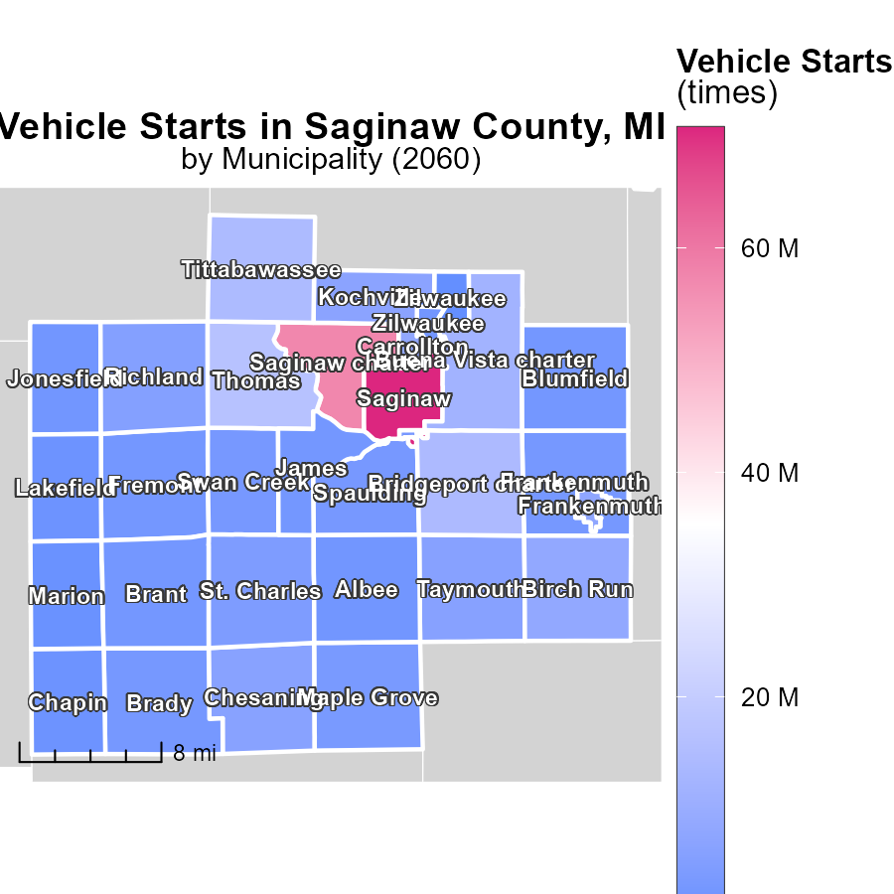

## Findings

* Saginaw, MI has the highest vehicle starts at 70.7 million.
* Swan Creek, MI has a median of 3.3 million vehicle starts.
* Zilwaukee, MI has the lowest vehicle starts at 128.5 thousand.

## Recommendations

To lower emissions levels, focus on reducing vehicle starts in areas with high counts like Saginaw, MI by promoting public transportation and carpooling. In areas with lower counts like Zilwaukee, MI, encourage the use of electric vehicles to further decrease emissions.

# Vehicles by Area over Time

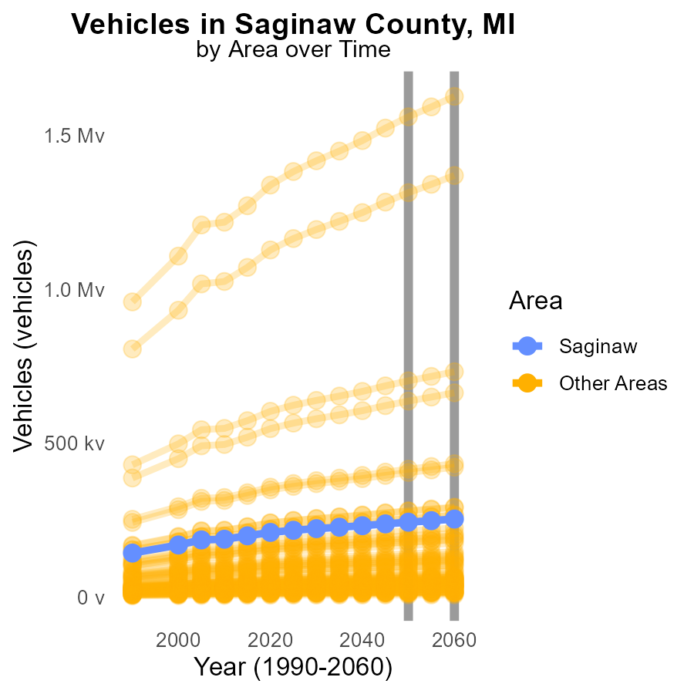

## Findings

* In 2060, min_county emissions were 7.4k tons, a decrease of 288.3 tons from 2050.
* In 2060, target_county emissions were 253.6k tons, a decrease of 10,152.9 tons from 2050.
* In 2060, max_county emissions were 1.6M tons, a decrease of 66,368 tons from 2050.

## Recommendations

To further reduce NOx emissions from vehicles by 2060-2070, focus on transitioning to electric vehicles, enhancing public transportation, and implementing stricter emissions regulations.

# Idling by Regulatory Class over Time

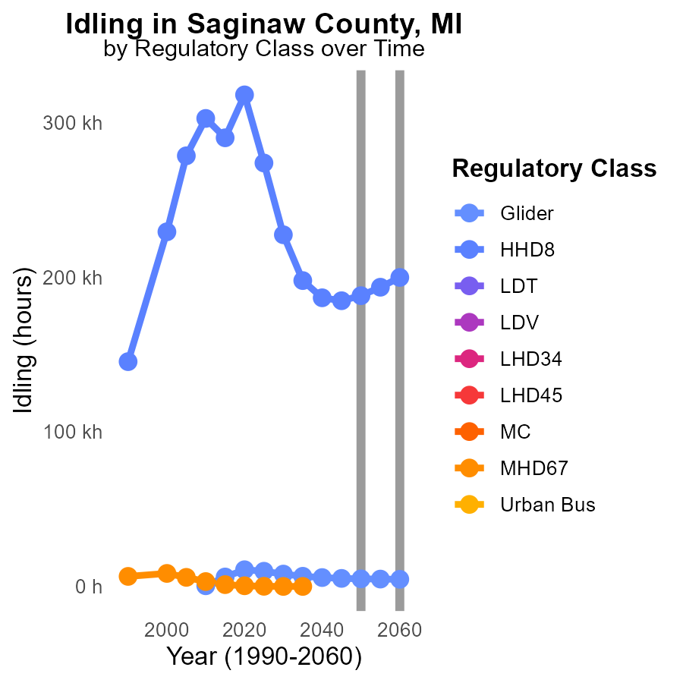

## Findings

* NOx emissions from Glider vehicles decreased by 3.2% from 2050 to 2060.
* NOx emissions from HHD8 vehicles increased by 6.3% from 2050 to 2060.
* NOx emissions from LDT, LDV, LHD34, LHD45, MC, MHD67, and Urban Bus remained constant with no data available.

## Recommendations

To reduce NOx emissions, consider implementing stricter regulations on HHD8 vehicles and monitor Glider emissions continuously. Invest in cleaner technology for all vehicle types.

# Areas Ranked by Hotelling (Engines Off)

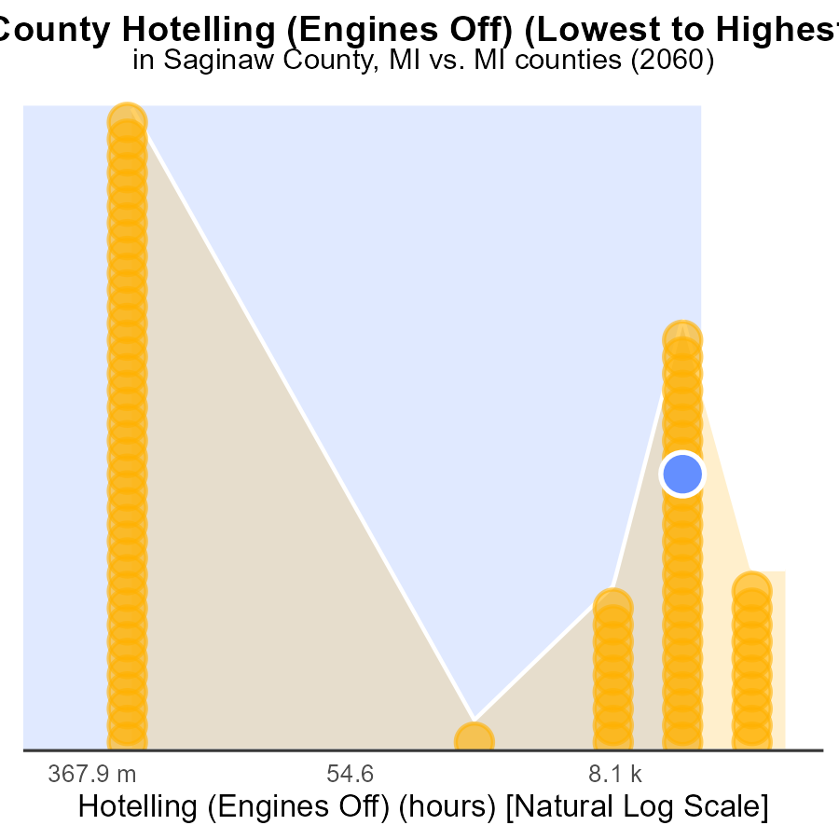

## Findings

* Wayne County has the highest NOx emissions at 582.8 k hours.
* Alcona County has the lowest emissions with 0.0 k hours.
* National average emissions fall within 65th to 83rd percentiles across counties.

## Recommendations

To lower emissions, incentivize Wayne County to reduce emissions by 20% in the next 5 years due to its highest emissions. Encourage Alcona County to maintain its emission-free status and assist all counties in achieving the national average percentile.

# Areas Ranked by Emissions Rate (per mile)

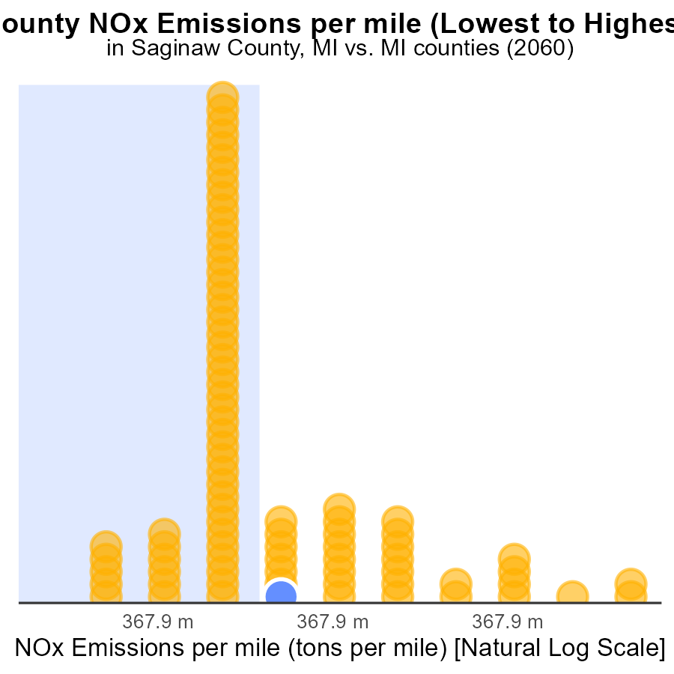

## Findings

* Crawford county has the highest NOx emissions per mile at 296.1 tons
* Wayne county has the lowest NOx emissions per mile at 196.1 tons
* The majority of counties have NOx emissions per mile above 220 tons

## Recommendations

To lower NOx emissions, counties should focus on improving vehicle efficiency, promoting public transportation, and implementing stricter emission standards for industries and vehicles.

# Conclusion

In conclusion, the data from Saginaw County in 2060 highlights the significant impact of on-road transportation on NOx emissions, with Combo Trucks and Buses being the primary contributors. To curtail NOx levels, stringent regulatory measures and the promotion of cleaner fuel technologies are imperative for these vehicles. Efforts should be concentrated on top emitters like Wayne, Oakland, and Washtenaw Counties by advocating anti-idling campaigns and incentivizing cleaner technologies.

Furthermore, the stable and low emissions from Hotelling in Saginaw County suggest the effectiveness of current control measures. Continued monitoring, enforcement, and periodic upgrades of control technologies are vital to sustain this progress. Electric vehicles, enhanced public transportation, and stricter emission standards can aid in reducing NOx emissions across counties. By focusing on decreasing vehicle starts, implementing vehicle emission standards, and supporting sustainable transportation choices, overall NOx emissions can be lowered for a greener and healthier environment in Saginaw County and beyond.

# About This Report

Data based on MOVES estimates collected by the Climate Action in Transportation program at Cornell University. Demographic data sourced from the US Census's American Community Survey 5-year estimates. This report was generated with the help of AI.

# References

* U.S. Census Bureau. (2023). American Community Survey 5-year estimates: Detailed tables. Retrieved from https://data.census.gov
* U.S. Environmental Protection Agency. (2024). Motor Vehicle Emission Simulator (MOVES 4.0) [Software]. Retrieved from https://www.epa.gov/moves