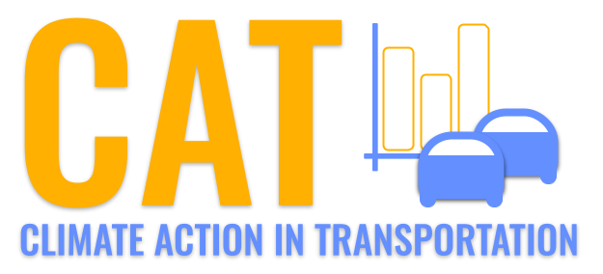 

**VOC Emissions in Twin Falls County, 2055**  
Made with CAT VISUALIZER by Gao Labs @ Cornell University.

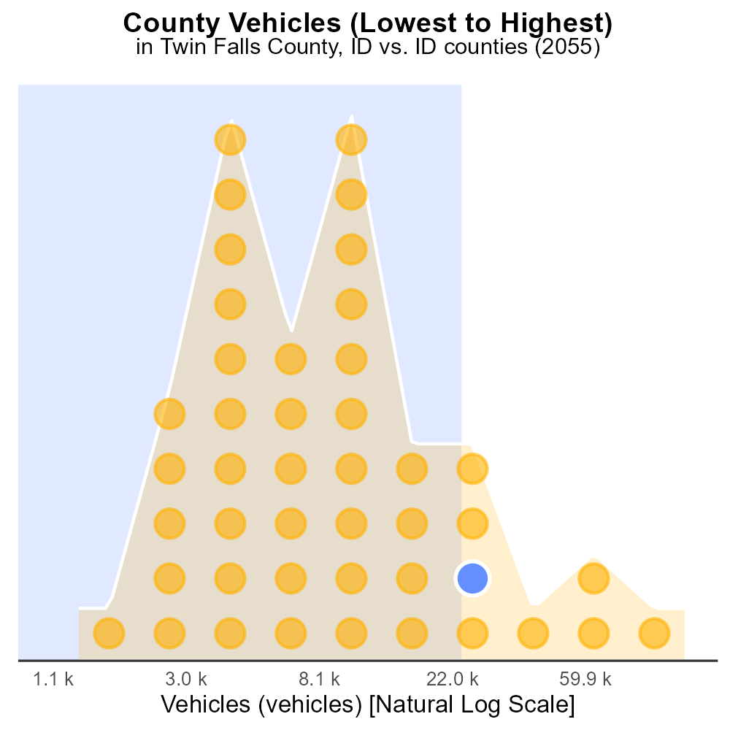

## Keywords

Volatile Organic Compounds; emissions; on-road transportation; Twin Falls County; ID; 2055

## Highlights

* Study on VOC emissions from on-road transport in 2055.
* Impacts of on-road transportation on air quality.
* Efforts to mitigate VOC emissions in Twin Falls County.
* Data analysis on VOC sources and trends.
* Recommendations for reducing VOC emissions.

# Introduction

In 2055, the issue of Volatile Organic Compounds (VOC) emissions from on-road transportation in Twin Falls County, Idaho, has become a significant concern. As the county grapples with the effects of increasing urbanization and industrialization, the impact of VOCs on air quality has drawn the attention of both researchers and policymakers.

This report presents a comprehensive analysis of VOC emissions from on-road transportation in Twin Falls County in 2055. By examining the sources, trends, and potential mitigation strategies for VOCs, this study aims to provide insights into the current state of air quality in the region and recommend measures to reduce harmful emissions.

# Emissions Rate (per vehicle) by Road Type

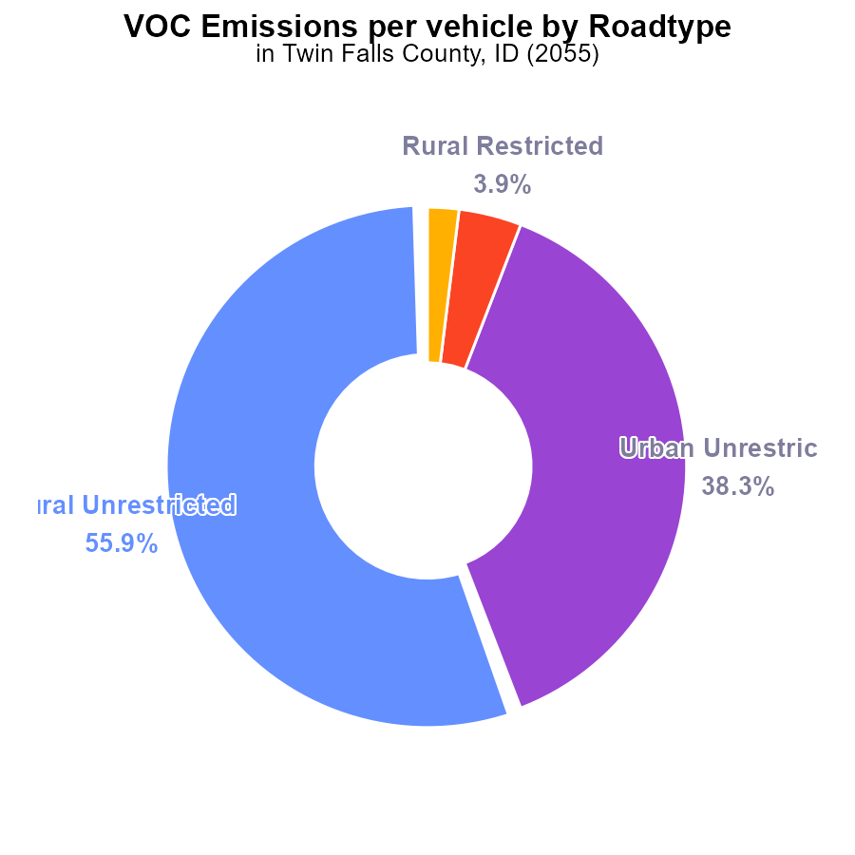

## Findings

* Rural unrestricted areas contribute 55.9% of VOC emissions per vehicle
* Urban unrestricted areas contribute 38.3% of VOC emissions per vehicle
* Rural restricted areas contribute only 3.9% while urban restricted areas contribute 2.0% of VOC emissions per vehicle

## Recommendations

To reduce VOC emissions, focus on implementing stricter regulations in rural unrestricted areas due to their significant contribution. Encourage the use of cleaner transportation methods in urban unrestricted areas to further decrease emissions. Additionally, incentivize the adoption of eco-friendly practices in all areas to collectively lower emissions.

# Population by Fuel Type

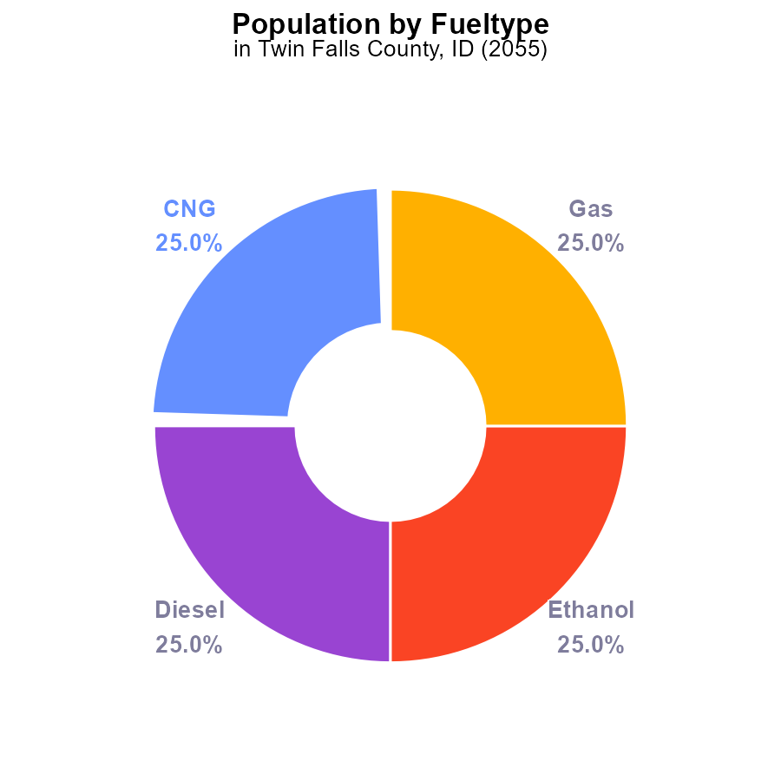

## Findings

* Twin Falls County, ID emitted 86.2 k pounds of VOC in 2055 for each type of fuel.
* VOC emissions from CNG, diesel, ethanol, and gas each contributed 25.0% to the total emissions.
* Emissions from population-related activities in Twin Falls County, ID require attention for VOC reduction.

## Recommendations

To lower VOC emissions in Twin Falls County, ID, it is crucial to invest in cleaner fuel technologies for CNG, diesel, ethanol, and gas. Implementing stricter emission standards for vehicles can significantly reduce overall VOC emissions.

# Time Driven over Time for Buses

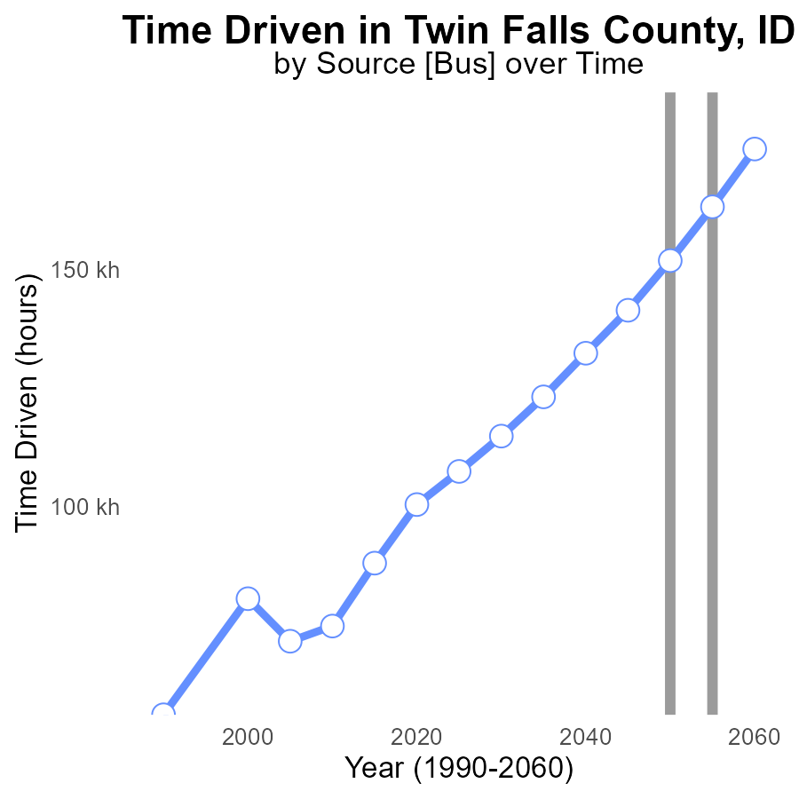

## Findings

* Volatile Organic Compound (VOC) emissions in Twin Falls County, ID have decreased by 18.8% from 2035 to 2060.
* The emissions reduction trend is not consistent annually; reductions vary year by year.
* Despite fluctuations, VOC emissions are projected to decrease further by 11.6% from 2045 to 2060.

## Recommendations

To sustain and enhance the declining trend in VOC emissions, policymakers should incentivize industries to adopt cleaner technologies. Implement stricter emission control regulations and conduct regular audits to ensure compliance. Encourage the public to use alternative transportation methods to reduce overall emissions.

# Vehicles over Time for Buses

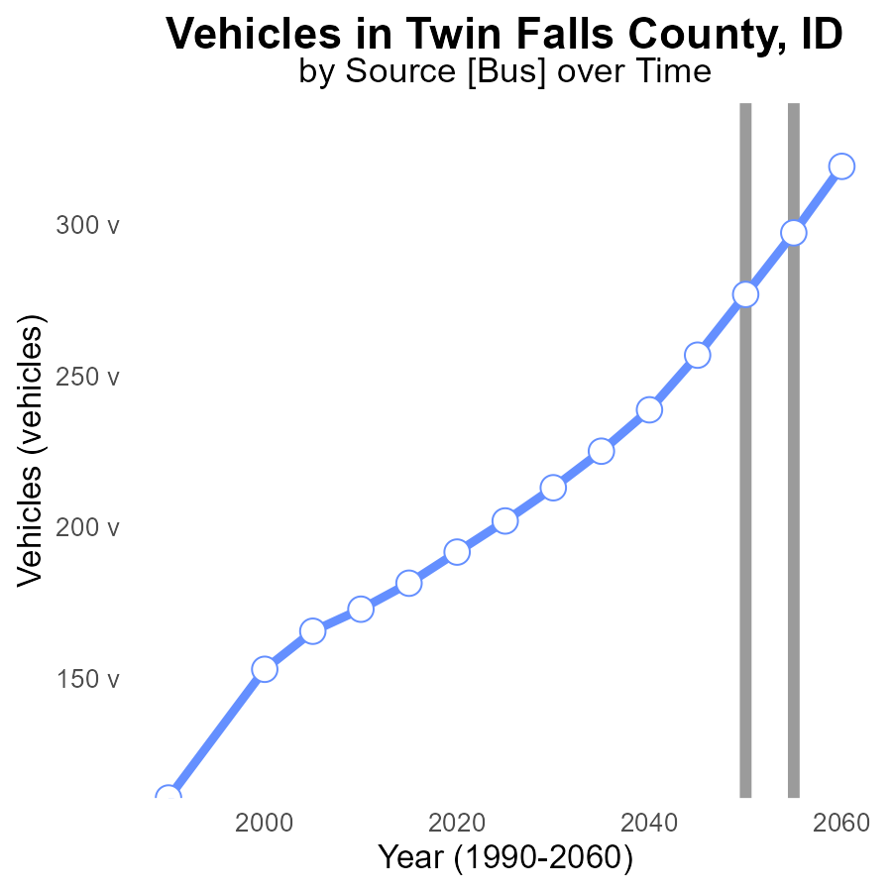

## Findings

* Between 2035 and 2060, VOC emissions from vehicles in Twin Falls County are projected to increase by 41.3%.
* By 2060, the VOC emissions are expected to decrease by 15.3% compared to 2050 levels.
* There is a consistent downward trend in VOC emissions after 2050, indicating potential success in emission reduction efforts.

## Recommendations

To lower VOC emissions further, implement policies to promote the use of electric vehicles, enhance public transportation systems, and incentivize carpooling to continue the downward trend observed after 2050.

# Time Driven in My Region

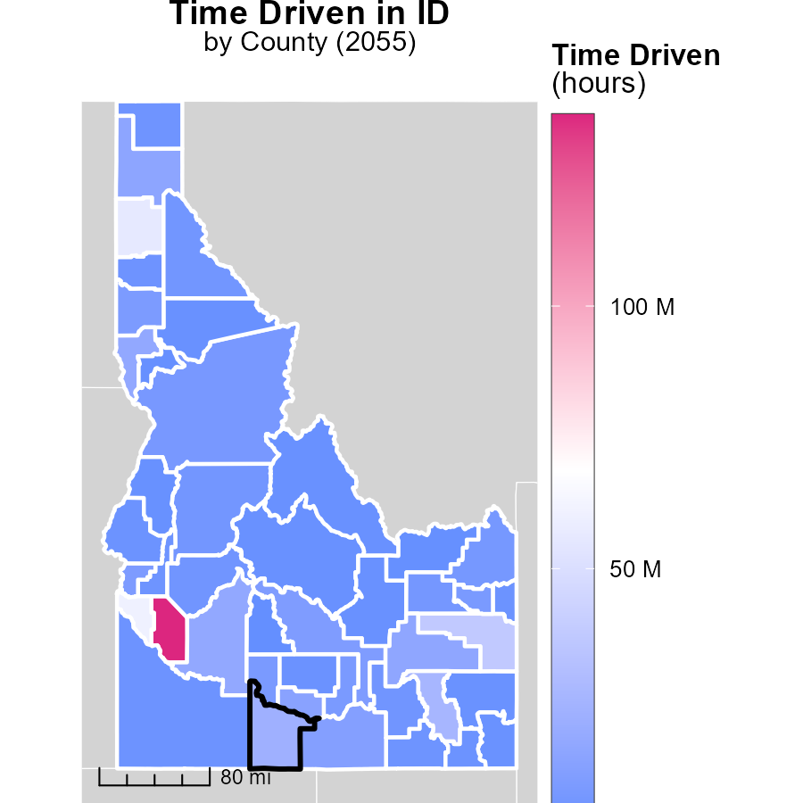

## Findings

* Ada County has the highest emissions with 136.4 million hours.
* Valley County has median emissions with 5.5 million hours.
* Camas County has the lowest emissions with 970.3 thousand hours.

## Recommendations

To reduce emissions, policies should focus on decreasing vehicle usage in Ada County, exploring sustainable transportation options in Valley County, and promoting energy-efficient practices in Camas County.

# Population in My Region

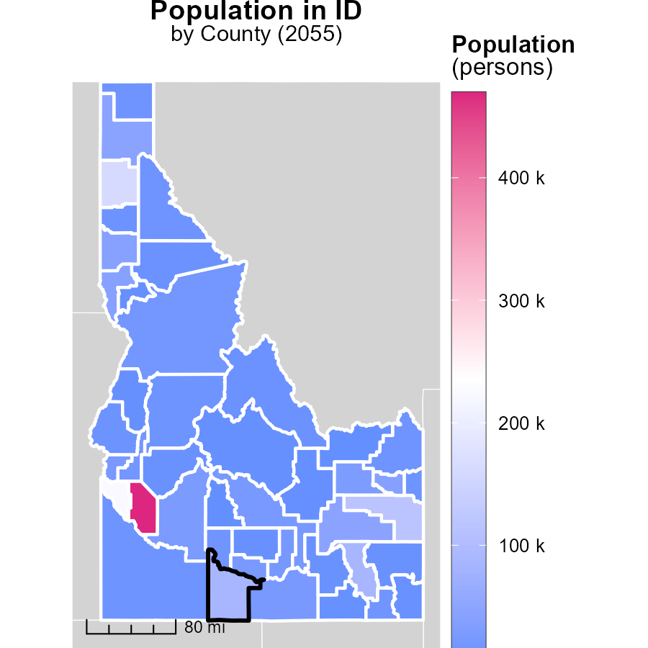

## Findings

* Ada County, ID has the highest population with 469.5k persons.
* Clark County, ID has the lowest population with 885 persons.
* There is a significant difference in population among the counties in Idaho.

## Recommendations

To lower emissions, targeted strategies for high-population areas like Ada County should be implemented. Sustainable transportation and energy-efficient initiatives can be effective. Conversely, in low-population areas such as Clark County, promoting communal transport and localized renewable energy sources would help reduce emissions.

# Population by Vehicle Type over Time

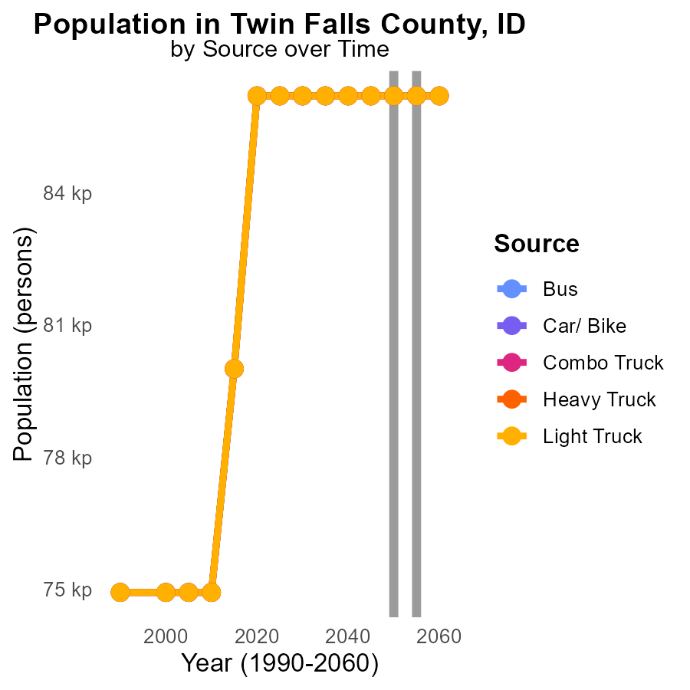

## Findings

* Emissions of Volatile Organic Compounds (VOC) in Twin Falls County, ID are consistent across different vehicle types from 2045 to 2060.
* The emissions remain unchanged from 2045 to 2060 for all vehicle categories, with a total emission of 86.2 k persons for each type.
* There is no projected decrease in VOC emissions for the specified vehicles in Twin Falls County, ID from 2045 to 2060.

## Recommendations

To lower VOC emissions, policymakers could consider implementing stricter emission standards for vehicles, promoting the use of electric vehicles, increasing public transportation options, and investing in infrastructure to support biking and walking. Additionally, encouraging telecommuting and implementing carpooling initiatives could help reduce vehicle emissions further.

# Hotelling (Engines Off) by Road Type over Time

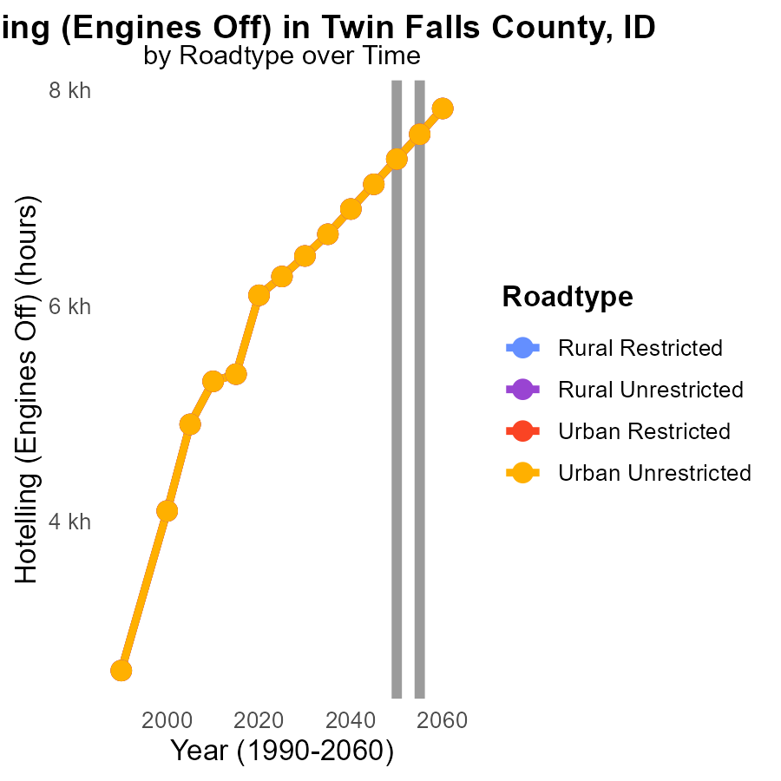

## Findings

* VOC emissions in Twin Falls County ranged from 7.1k to 7.8k in 2045-2060.
* Emissions in 2050 were stable at 7.4k across road types.
* By 2060, emissions decreased by 469.1 units in all urban and rural unrestricted areas.

## Recommendations

To reduce VOC emissions in Twin Falls County, a focused effort is needed to maintain the 2050 emission levels, especially in urban areas. Implementing stricter vehicle emission standards and promoting the use of public transportation can help achieve this goal. Additionally, investing in infrastructure to support electric vehicles and creating incentives for carpooling can further contribute to lowering emissions, ultimately leading to a healthier environment for all residents.

# Areas Ranked by Vehicles

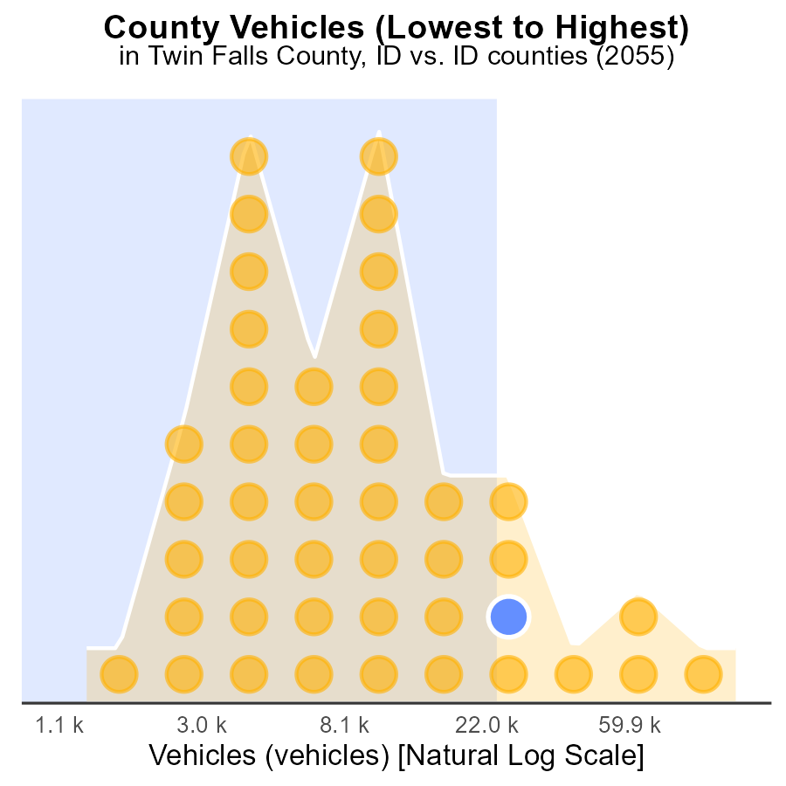

## Findings

* Ada county has the highest number of vehicles emitting VOCs at 342.5k.
* Together, Twin Falls, Bingham, and Elmore counties contribute to around 259k vehicle emissions.
* Camas county has the lowest number of vehicles emitting VOCs at only 3.6k.

## Recommendations

To lower VOC emissions, encourage public transportation use, implement vehicle emission testing, and promote electric vehicle adoption in Ada, Twin Falls, Bingham, Elmore, and Camas counties.

# Areas Ranked by Vehicle Miles Traveled

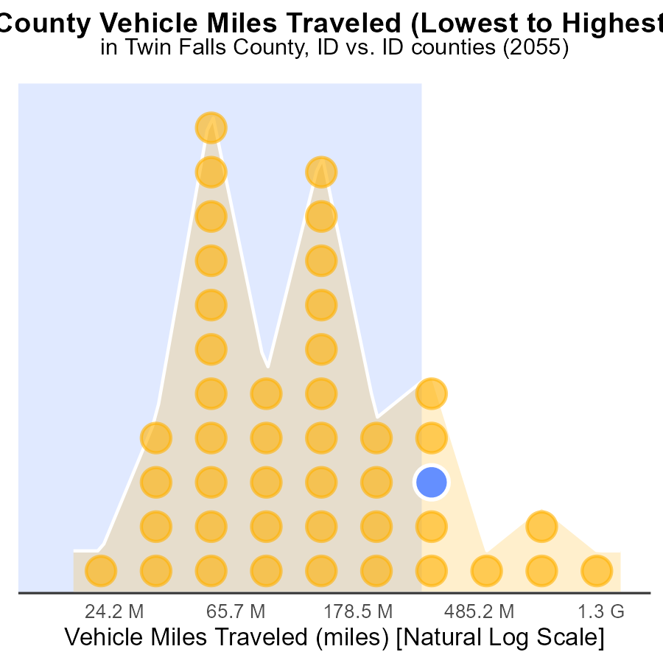

## Findings

* Ada County has the highest vehicle miles traveled (VMT) at 4.3 billion miles, ranking 44th nationally.
* Elmore County has the highest percentile of VMT at 88.6%.
* Camas County has the lowest VMT at 46.8 million miles, ranking 1st with only 2.3% percentile.

## Recommendations

To lower emissions, focus on minimizing vehicle miles traveled in high-ranking counties like Ada and Elmore by promoting carpooling, public transportation, and telecommuting. Encourage infrastructure development for eco-friendly modes of transportation.

# Conclusion

In conclusion, the data from the report on Volatile Organic Compounds (VOC) emissions from on-road transportation in Twin Falls County, ID in 2055 highlights the need for targeted strategies to continue reducing emissions. With rural unrestricted areas contributing significantly to VOC emissions per vehicle, it is imperative to implement stricter regulations in these regions. Urban unrestricted areas should focus on adopting cleaner transportation methods. Moreover, incentivizing eco-friendly practices across all areas can collectively lower emissions.

The report indicates a fluctuation in VOC emissions over the years, with a projected decrease by 11.6% from 2045 to 2060. To sustain and enhance this declining trend, investments in cleaner fuel technologies, stricter emission standards for vehicles, and promotion of alternative transportation methods are crucial. Additionally, policies promoting the use of electric vehicles, enhancing public transportation systems, and incentivizing carpooling are essential to further reduce emissions in Twin Falls County. By aligning regulatory measures with community initiatives and technological advancements, Twin Falls County can work towards a more sustainable and environmentally friendly future.

# About This Report

Data based on MOVES estimates collected by the Climate Action in Transportation program at Cornell University. Demographic data sourced from the US Census's American Community Survey 5-year estimates. This report was generated with the help of AI.

# References

* U.S. Census Bureau. (2023). American Community Survey 5-year estimates: Detailed tables. Retrieved from https://data.census.gov
* U.S. Environmental Protection Agency. (2024). Motor Vehicle Emission Simulator (MOVES 4.0) [Software]. Retrieved from https://www.epa.gov/moves