 

**NOx Emissions in Putnam County, 2055**  
Made with CAT VISUALIZER by Gao Labs @ Cornell University.

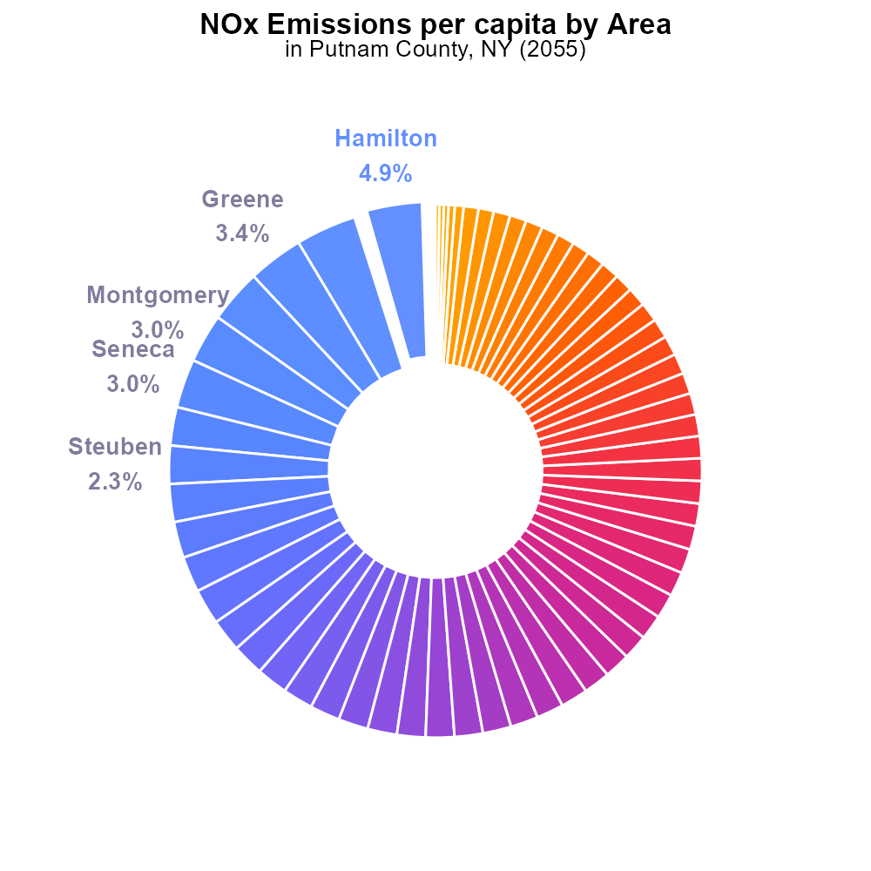

## Keywords

Oxides of Nitrogen; NOx emissions; on-road transportation; Putnam County; NY; 2055

## Highlights

* NOx emissions from on-road transport in Putnam County, NY in 2055.
* Implications of increased NOx emissions on air quality and health.
* Trends in NOx emissions and regulatory measures in the transportation sector.
* Potential strategies to reduce NOx emissions and improve air quality.
* Analysis of the impact of NOx emissions on the environment and public health.

# Introduction

The report focuses on the assessment of Oxides of Nitrogen (NOx) emissions from on-road transportation in Putnam County, NY in the year 2055. As NOx emissions continue to pose significant challenges to air quality and public health, understanding the specific sources and trends in this region is crucial for informed decision-making.

By examining the factors contributing to the increase in NOx emissions, exploring the regulatory landscape, and proposing mitigation strategies, this report aims to provide a comprehensive analysis of the impact of NOx emissions on the environment and public health in Putnam County, NY. The findings are essential for policymakers, stakeholders, and the community to develop effective solutions to address the growing concern of NOx emissions from on-road transportation.

# Emissions Rate (per capita) by Road Type

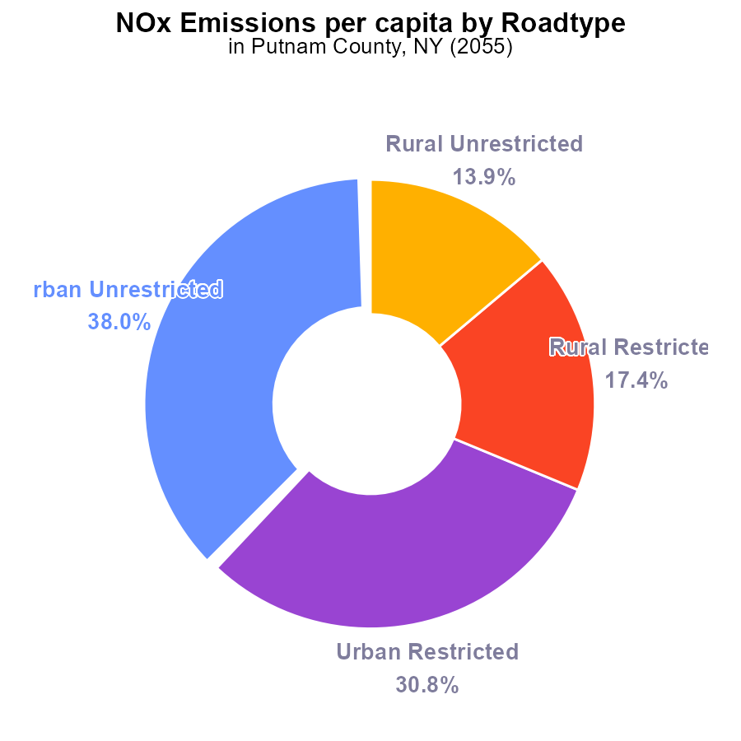

## Findings

* Urban areas have the highest NOx emissions per capita at 1.3 tons per person.
* Rural areas have lower emissions, with Rural Restricted at 586.5 µ tons per person and Rural Unrestricted at 469.0 µ tons per person.
* Overall, Urban areas contribute to 68.8% of NOx emissions in Putnam County.

## Recommendations

To lower the NOx emissions levels in Putnam County, it is recommended to focus on implementing stricter emission regulations in Urban areas, investing in cleaner technologies for transportation and industrial activities, and promoting public transportation and carpooling to reduce individual carbon footprints in these densely populated regions.

# Emissions Rate (per capita) Overall by Area

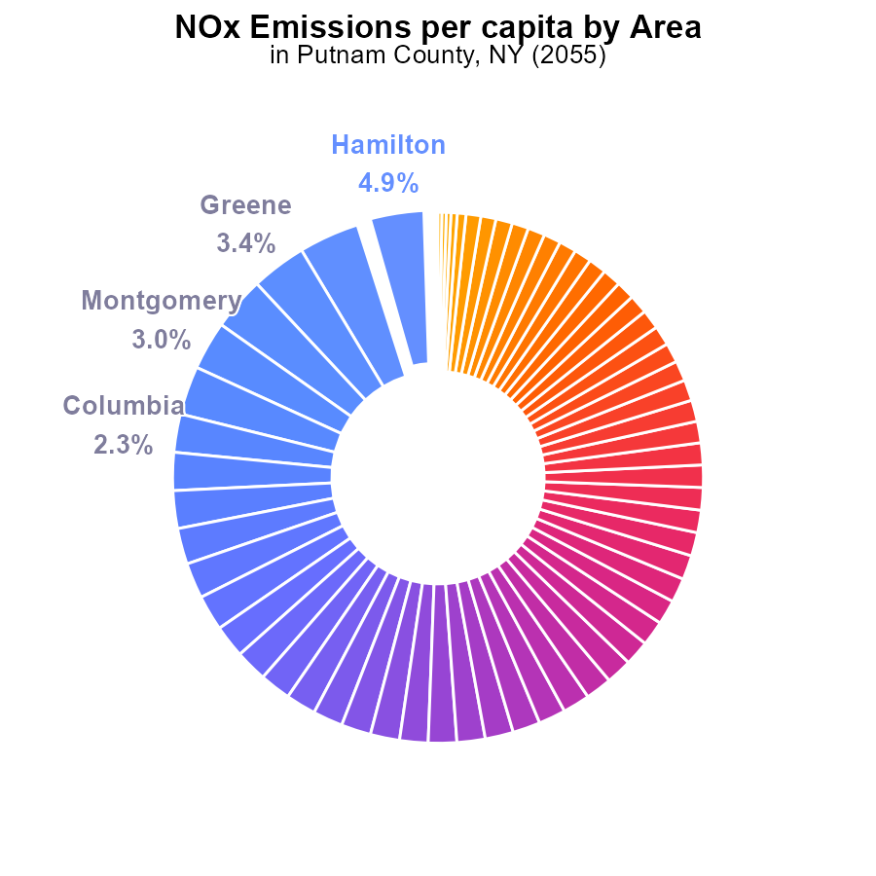

## Findings

* Counties with the highest NOx emissions per capita are Hamilton, Genesee, and Greene.
* Counties with the lowest NOx emissions per capita are Richmond, Queens, and Bronx.
* The top 10 counties emit 28.4% of the total NOx emissions per capita in Putnam County, NY.

## Recommendations

To lower emissions, focus efforts on counties with high emissions like Hamilton, Genesee, and Greene by incentivizing cleaner technologies and transportation.

# Emissions Rate (per vehicle) over Time for Passenger Vehicles

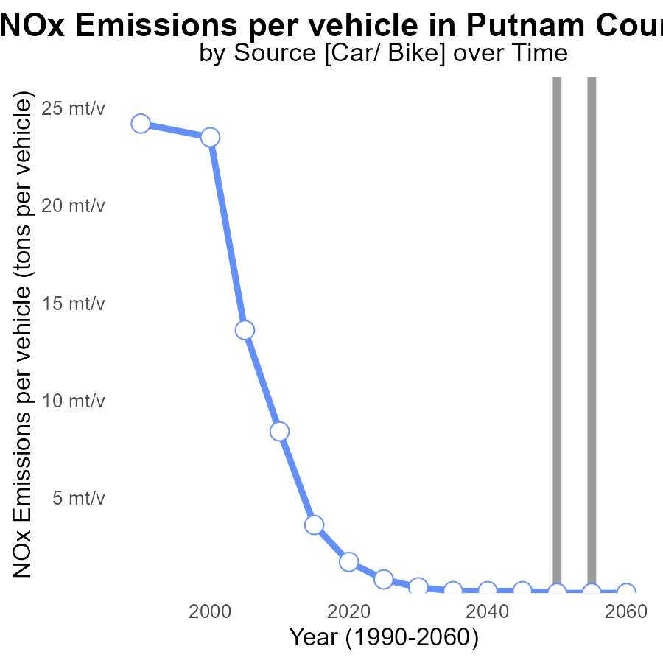

## Findings

* NOx emissions per vehicle decreased from 225.9 tons in 2035 to 144.5 tons in 2060.
* A consistent decrease in emissions was observed with a 36% reduction by 2060.
* After 2050, emissions stabilized around 150 tons per vehicle with no further decrease.

## Recommendations

To maintain the achieved reductions and further decrease emissions post-2050, a focus on promoting electric vehicles, improving public transportation, and incentivizing sustainable commuting practices is essential. Collaboration with industries to adopt cleaner technologies and enforce stringent emission standards can significantly contribute to lowering emissions.

# Hotelling (Diesel Aux) Overall over Time

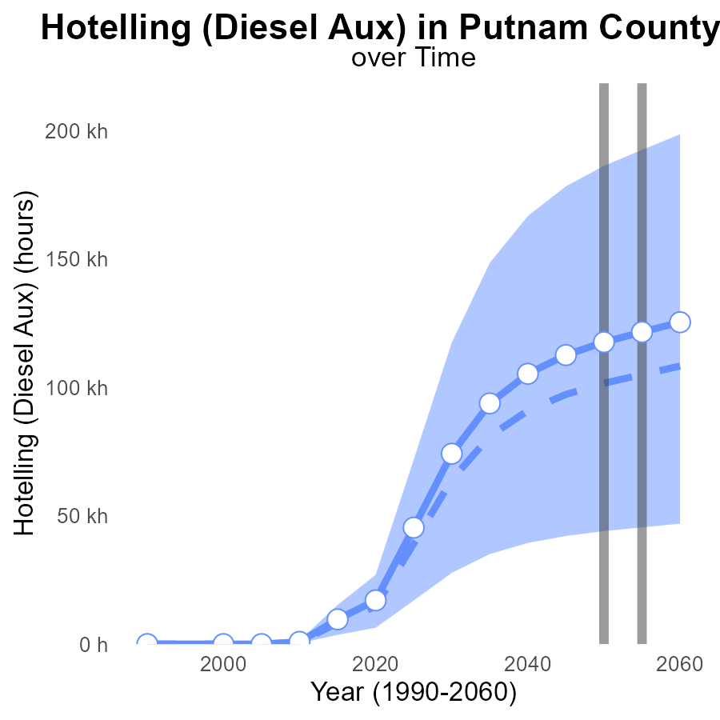

## Findings

* NOx emissions in Putnam County are projected to increase steadily over the next few decades.
* The difference from the median area is also expected to grow for NOx emissions from Hotelling (Diesel Aux).
* Benchmark difference suggests that the county needs to implement strategies to reduce emissions to meet targets.

## Recommendations

To lower NOx emissions, Putnam County should consider implementing stricter regulations on diesel auxiliary engines. Additionally, investing in cleaner fuel technologies and promoting public transportation can help reduce emissions effectively.

# Idling Mapped by Area

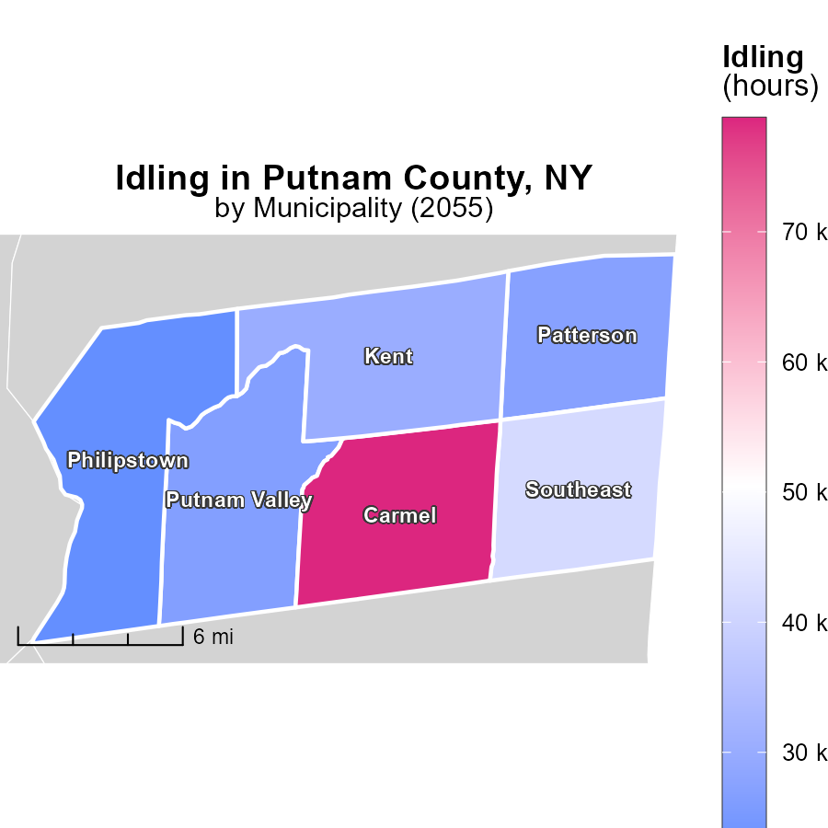

# Emissions Mapped by Area

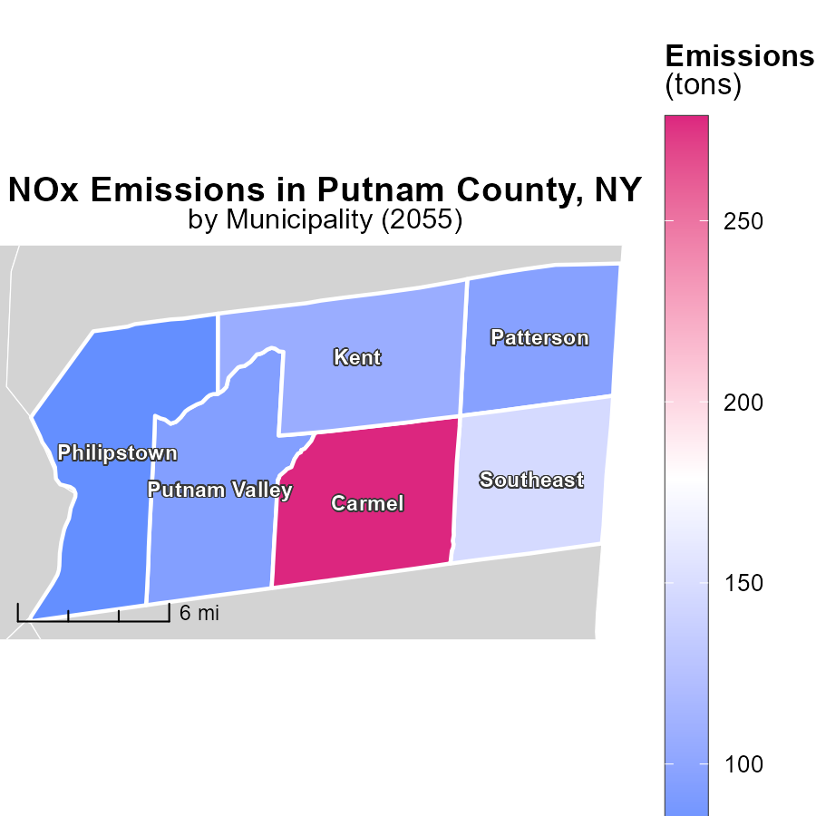

## Findings

* The highest emissions were in Carmel, NY with 278.7 tons.
* Patterson, NY had median emissions of 96.5 tons.
* Philipstown, NY had the lowest emissions at 79.1 tons.

## Recommendations

Local policymakers should target emission reduction efforts at Carmel, focusing on industries or activities leading to high emissions. Patterson should assess why its emissions are higher than Philipstown to determine mitigation strategies. Philipstown should continue efforts to maintain low emissions and serve as a model for neighboring areas.

# Emissions Rate (per capita) by Area over Time

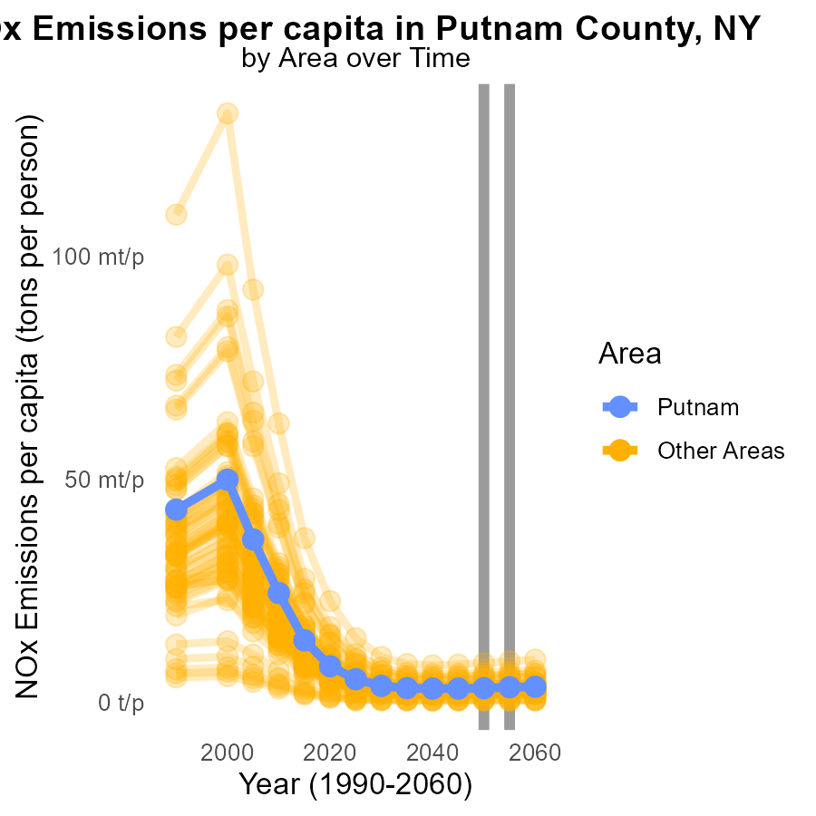

## Findings

* In 2055, the maximum county had 9.2 tons of NOx emissions per capita, decreasing by 0.04% compared to 2050.
* In 2055, the minimum county had 424.6 micrograms of NOx emissions per capita, remaining stable since 2050.
* In 2055, the target county had 3.4 tons of NOx emissions per capita, decreasing by 0.02% compared to 2050.

## Recommendations

To reduce NOx emissions per capita, focus on implementing stricter emission standards and promoting cleaner technologies in all counties. Encourage the adoption of renewable energy sources and invest in public transportation to mitigate emissions.

# Time Driven by Area over Time

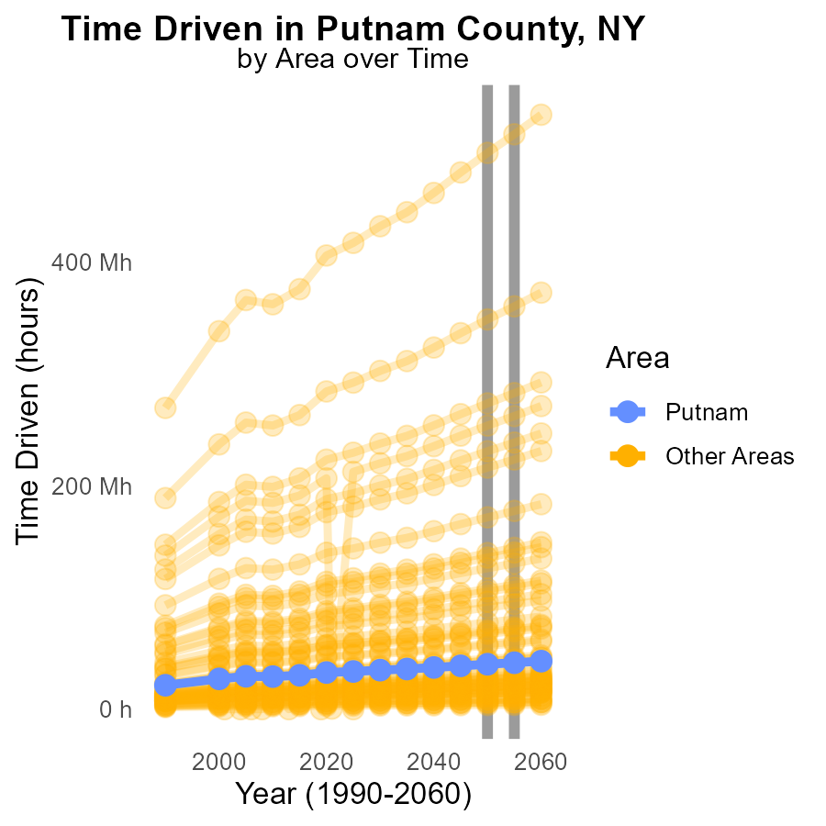

## Findings

* In 2055, min_county emitted 3.9 million tons of NOx, a decrease of 125,918.2 tons from 2050.
* In 2055, target_county emitted 41.6 million tons of NOx, a decrease of 1,355,335.4 tons from 2050.
* In 2055, max_county emitted 514.5 million tons of NOx, a decrease of 16,665,469.7 tons from 2050.

## Recommendations

To further reduce NOx emissions, measures such as increasing vehicle emission standards, promoting public transportation, and enforcing stricter industrial pollution controls should be implemented in the counties with the highest emissions.

# Areas Ranked by Emissions Rate (per capita)

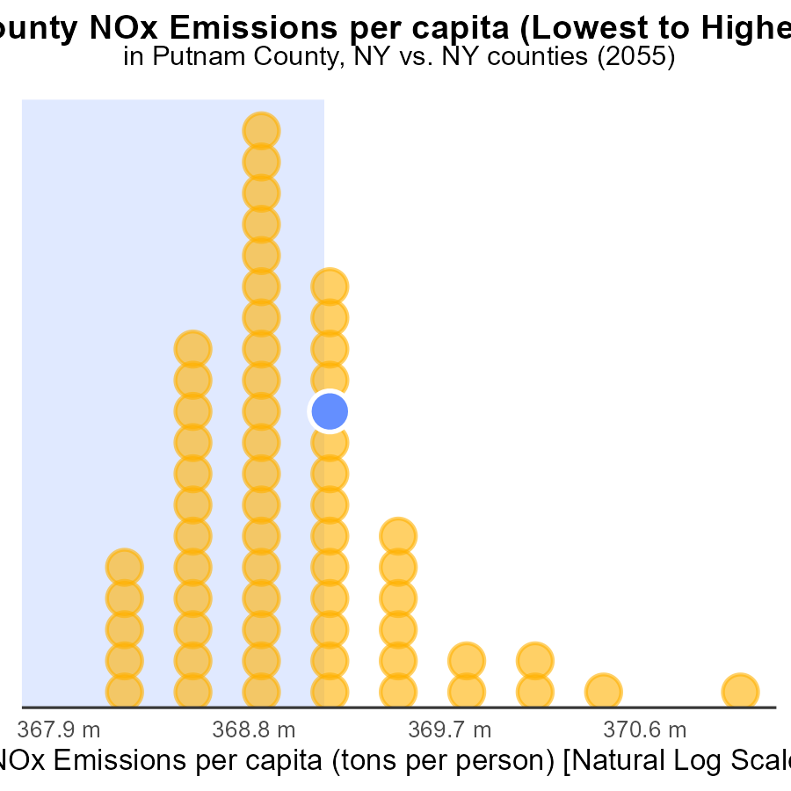

## Findings

* The highest NOx emissions per capita are in Kings county with 424.6 tons per person.
* Hamilton county ranks lowest in emissions with 9.2 tons per person, but it is at the 100th percentile for its emissions level.
* Putnam, Cattaraugus, and Sullivan counties have similar levels of emissions per capita, around 3.4 tons per person.

## Recommendations

To decrease emissions, focus on Kings county to significantly reduce its high rate. Implement stricter regulations and promote clean energy initiatives. Encourage sustainable transportation methods in all counties to decrease per capita emissions.

# Areas Ranked by Population

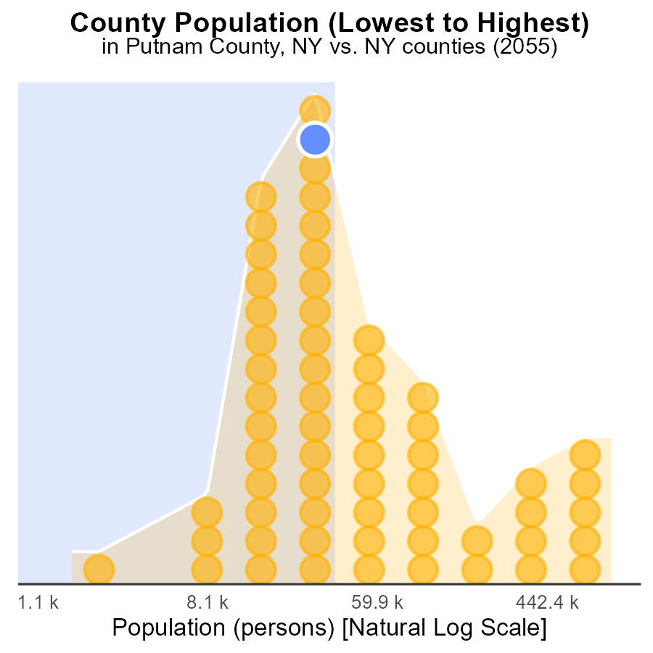

## Findings

* The county with the highest NOx emissions is Kings with 2.6M persons.
* Hamilton has the least NOx emissions with 4.5k persons.
* Putnam county emits NOx with 98.7k persons ranking 68th in emissions.

## Recommendations

To reduce emissions, focus on implementing NOx control measures in Kings county due to its high population. Encourage the use of cleaner energy sources in Putnam county. Monitor and maintain the low emissions in Hamilton county.

# About This Report

Data based on MOVES estimates collected by the Climate Action in Transportation program at Cornell University. Demographic data sourced from the US Census's American Community Survey 5-year estimates. This report was generated with the help of AI.

# References

* U.S. Census Bureau. (2023). American Community Survey 5-year estimates: Detailed tables. Retrieved from https://data.census.gov
* U.S. Environmental Protection Agency. (2024). Motor Vehicle Emission Simulator (MOVES 4.0) [Software]. Retrieved from https://www.epa.gov/moves