 

**CO Emissions in Essex County, 2005**  
Made with CAT VISUALIZER by Gao Labs @ Cornell University.

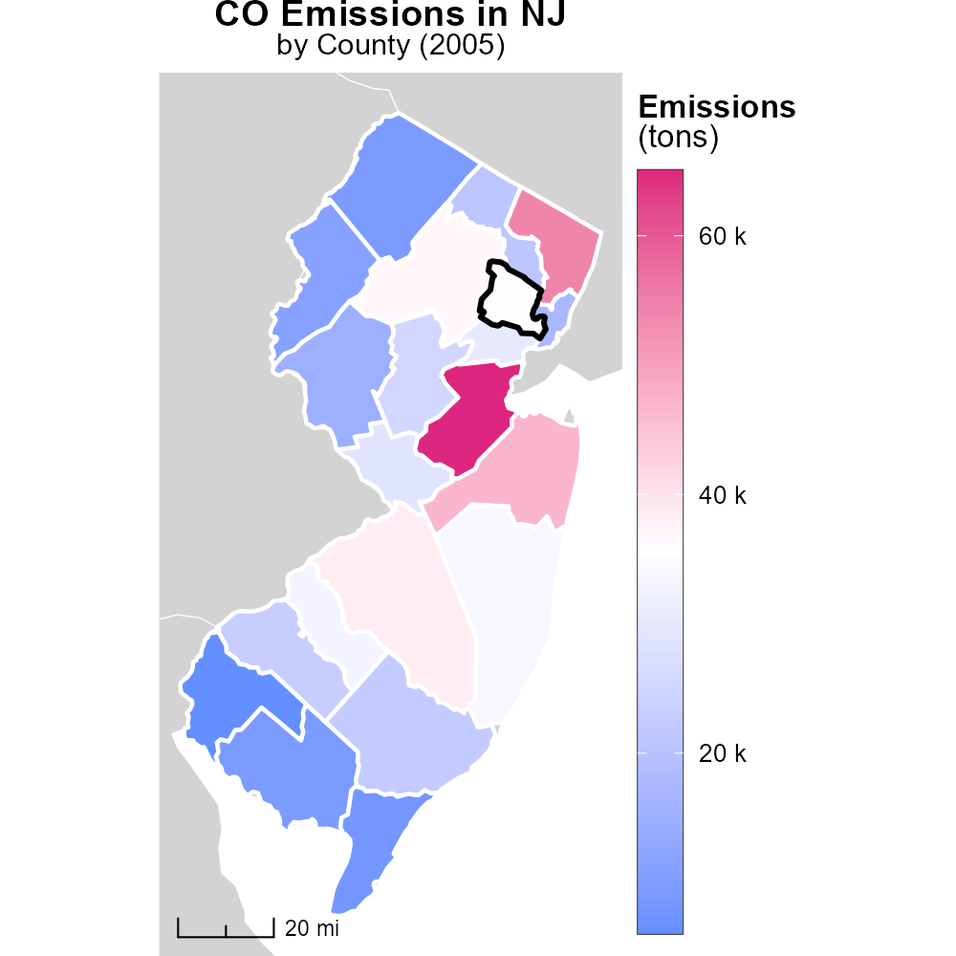

## Keywords

Carbon Monoxide emissions; On-road transportation; Essex County, NJ; 2005

## Highlights

* Analysis of CO emissions from on-road transportation in Essex County, NJ in 2005.
* Impact of transportation activities on air quality in the region.
* Identification of sources and trends of CO emissions in Essex County.
* Evaluation of the environmental and health implications of CO emissions.
* Recommendations for mitigation strategies to reduce CO emissions.

# Introduction

The report focuses on the assessment of Carbon Monoxide (CO) emissions originating from on-road transportation in Essex County, New Jersey, during the year 2005. With a growing concern for air quality and its impact on public health, understanding the sources and trends of CO emissions in this region is essential.

Transportation activities are known to be significant contributors to CO emissions, and a detailed analysis of these emissions can provide insights into the environmental and health implications for residents of Essex County. By examining the data from 2005, this report aims to shed light on the extent of CO pollution and propose mitigation strategies for a cleaner and healthier environment.

# Vehicle Miles Traveled by Road Type

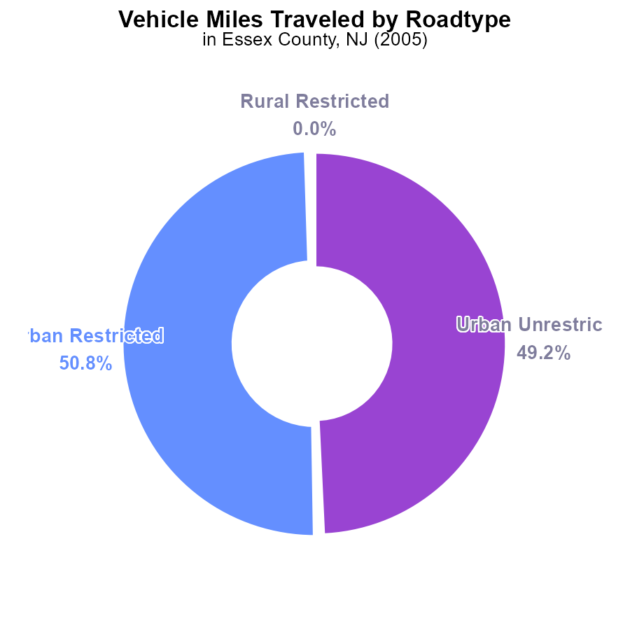

# Vehicle Starts by Fuel Type

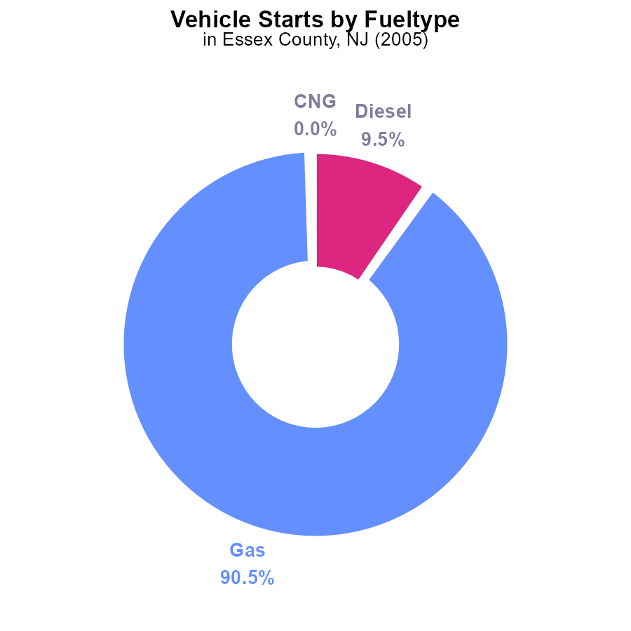

## Findings

* In 2005, Essex County, NJ, had 541.6 million vehicle starts emitting CO.
* Gasoline vehicles accounted for 90.5% (490.0 million) of the total emissions.
* Diesel vehicles contributed 9.5% (51.6 million), with CNG making up a negligible 0.0% (101.5 thousand).

## Recommendations

To reduce CO emissions, policymakers should focus on promoting alternative fuel vehicles, particularly CNG, and implementing stricter emission standards for gasoline and diesel vehicles.

# Vehicle Starts over Time for Buses

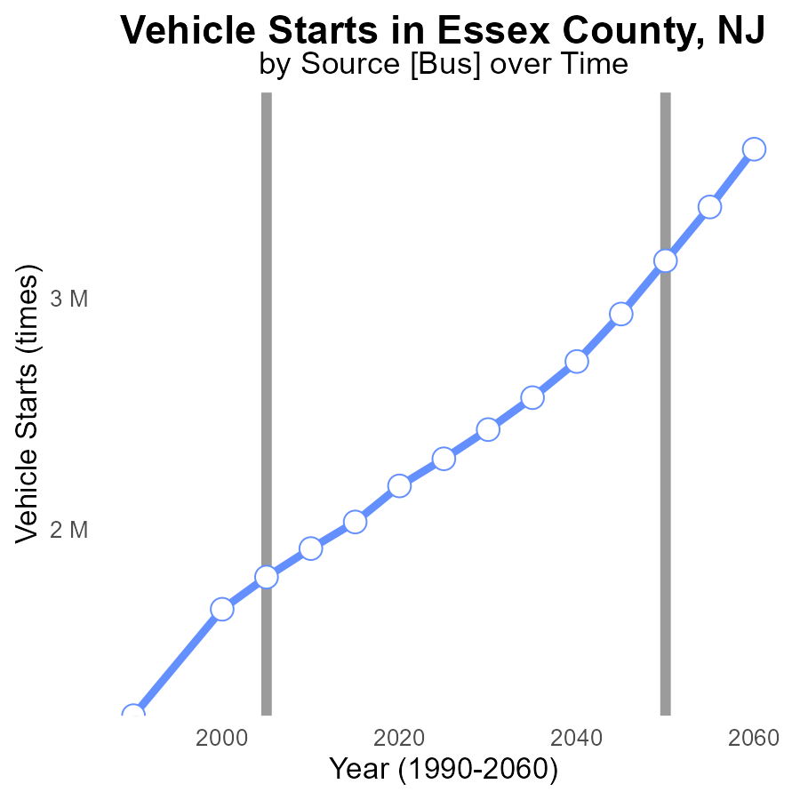

## Findings

* Vehicle starts in Essex County, NJ have steadily increased from 1.2 million in 1990 to 2.3 million in 2025.
* The benchmark difference, representing emissions reduction potential, decreased from 1,969,823.5 times in 1990 to 857,500.6 times in 2025.
* There was a 56% reduction in the benchmark difference between 1990 and 2025.

## Recommendations

To reduce emissions from vehicle starts in Essex County, implement stricter vehicle emission standards, incentivize electric vehicles, promote public transportation, and invest in biking infrastructure.

# Emissions Rate (per mile) over Time for Buses

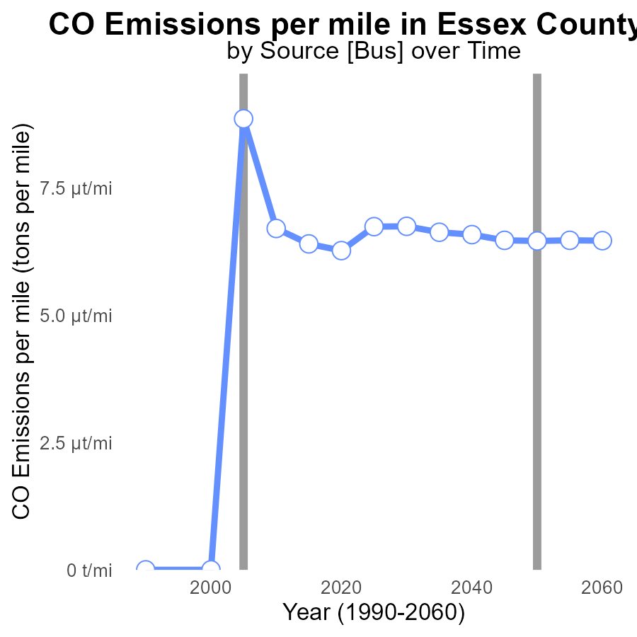

## Findings

* Emissions per mile have decreased by 76.6% from 1990 to 2025.
* Since 2005, emissions per mile have remained relatively stable, with minor fluctuations.
* Emissions per mile are projected to increase slightly by 2025 compared to 2020.

## Recommendations

To maintain the significant reduction achieved from 1990 to 2020, continue to promote the use of clean energy vehicles and public transportation. Implement stricter emissions regulations for vehicles to prevent the projected increase by 2025.

# Emissions in My Region

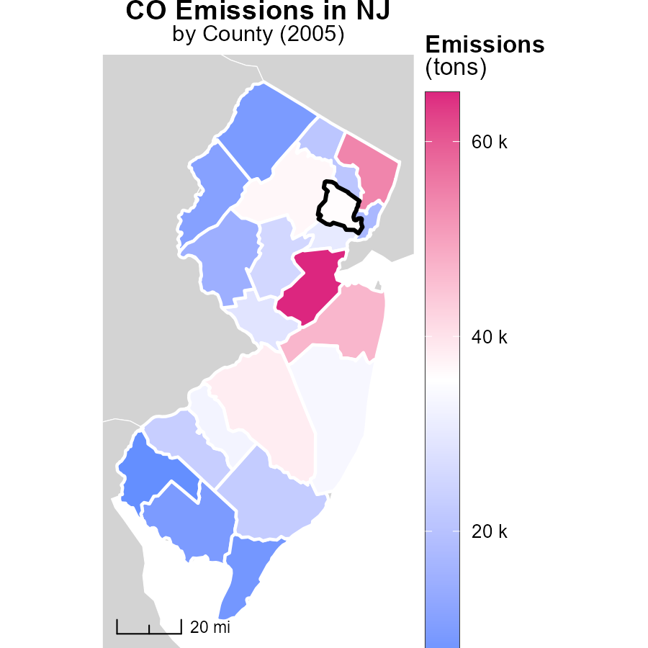

# Emissions Rate (per capita) Mapped by Area

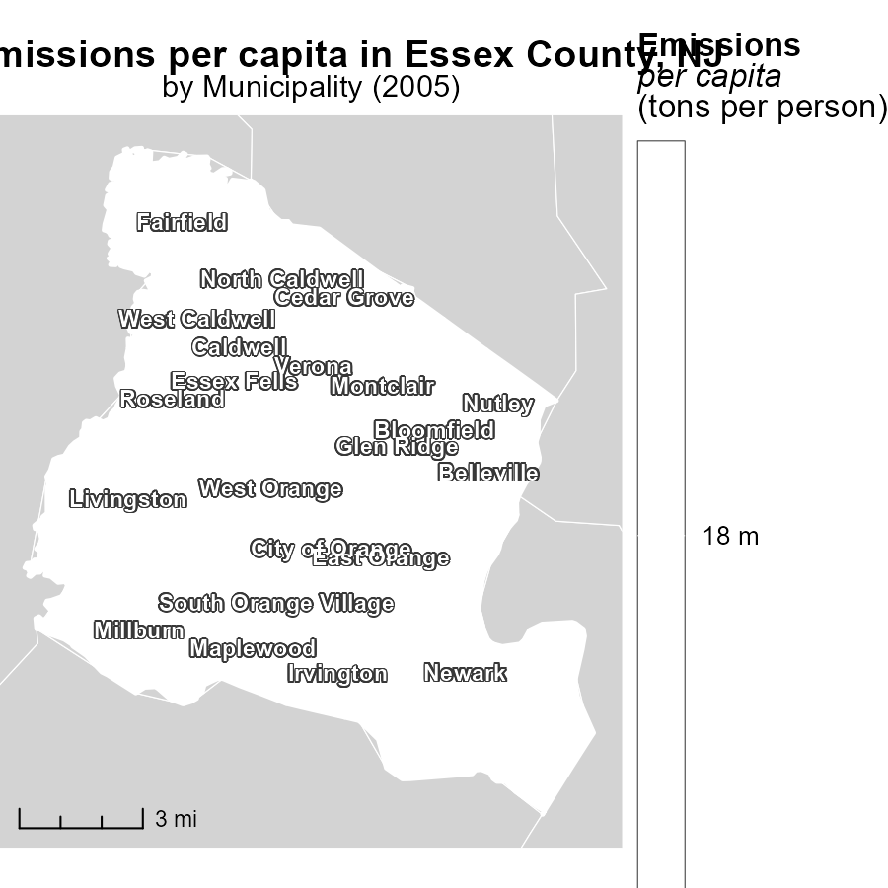

## Findings

* In 2005, the maximum emissions per capita in Belleville, NJ were 18.5 tons per person.
* The median emissions per capita in Maplewood, NJ were also 18.5 tons per person in 2005.
* West Orange, NJ had the minimum emissions per capita in 2005 at 18.5 tons per person.

## Recommendations

To lower emissions per capita, municipalities should focus on implementing sustainable transportation policies, promoting energy-efficient practices, and incentivizing renewable energy sources.

# Hotelling (Engines Off) by Vehicle Type over Time

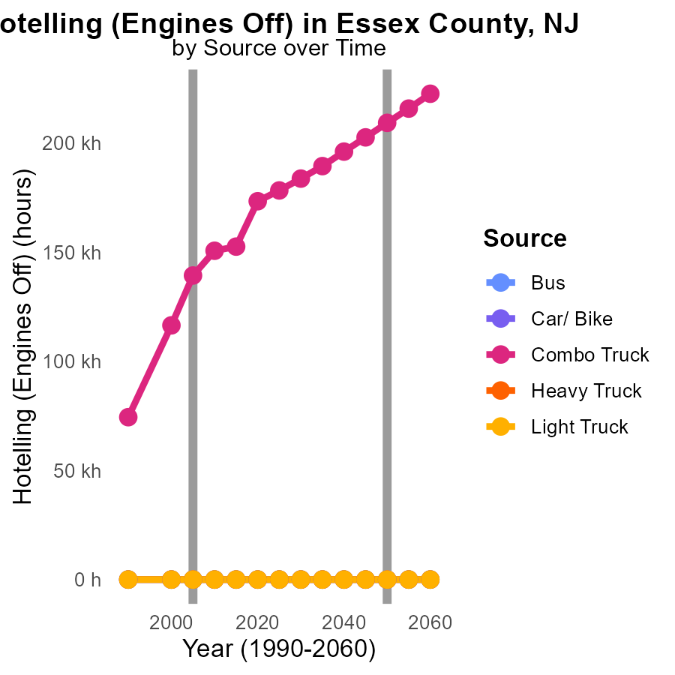

## Findings

* Combo Truck emissions decreased from 116.5 k in 2000 to 152.6 k in 2015
* Other vehicle categories (Bus, Car/Bike, Heavy Truck, Light Truck) maintained 0 emissions from 2000 to 2015
* Combo Truck emissions have steadily decreased over the years, with the biggest drop from 2005 to 2010

## Recommendations

To further reduce emissions in Essex County, NJ, focus on promoting the use of cleaner fuels for Combo Trucks as they are the main source of emissions. Implement stricter regulations on emissions for these trucks to ensure continuous decrease in emissions over the coming years.

# Vehicles by Area over Time

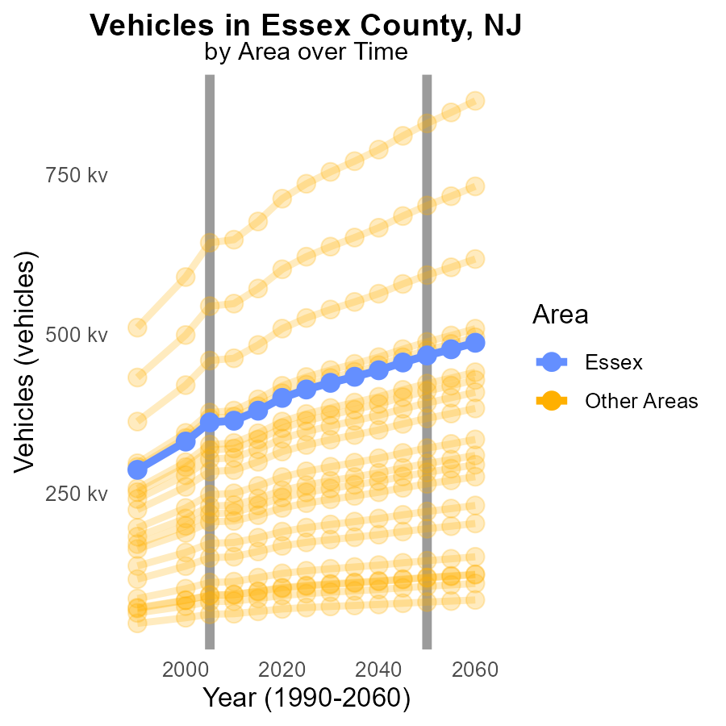

## Findings

* In 2005, the target county emitted 361.6k tons of CO from vehicles.
* The maximum emission in 2005 was 643.5k tons in the max county, while the minimum was 60.5k tons in the min county.
* Compared to the projected 2050 levels, emissions in 2005 were higher by 104951.3k tons, 187227.3k tons, and 19092.6k tons in the target, max, and min counties respectively.

## Recommendations

To lower vehicle emissions, the target county should implement stricter vehicle emission standards, promote electric vehicles, and invest in public transportation infrastructure to reduce reliance on private cars.

# Areas Ranked by Time Driven

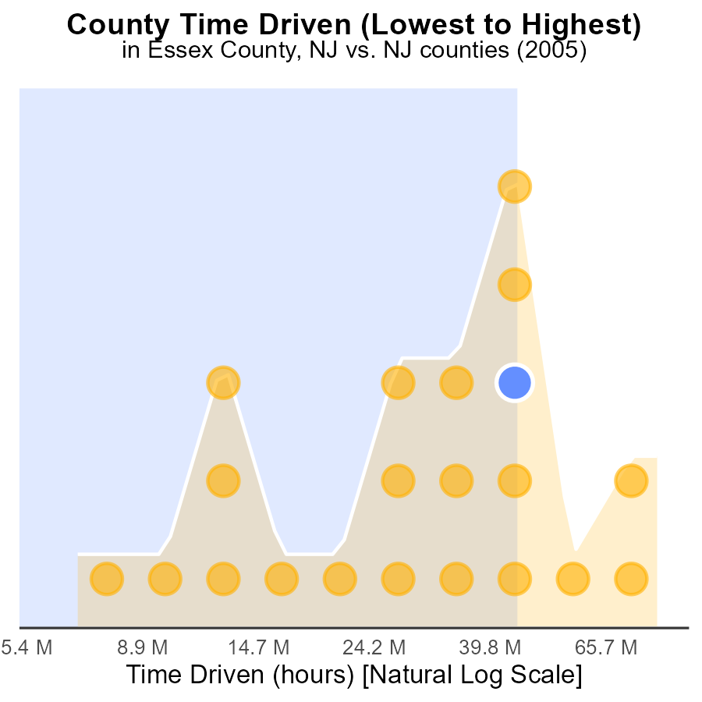

## Findings

* Middlesex County had the highest source hours with 225.5 million, ranking 21st and representing 100% of emissions.
* Morris County followed with 125.7 million source hours, ranking 17th and constituting 81.0% of emissions.
* Essex County had 121.6 million source hours, ranking 16th with 76.2% of emissions.

## Recommendations

To lower emissions, focus on counties with the highest source hours like Middlesex, Morris, and Essex by implementing strategies to reduce the number of hours driven, such as promoting public transportation, carpooling, and telecommuting to decrease overall emissions.

# Areas Ranked by Emissions Rate (per capita)

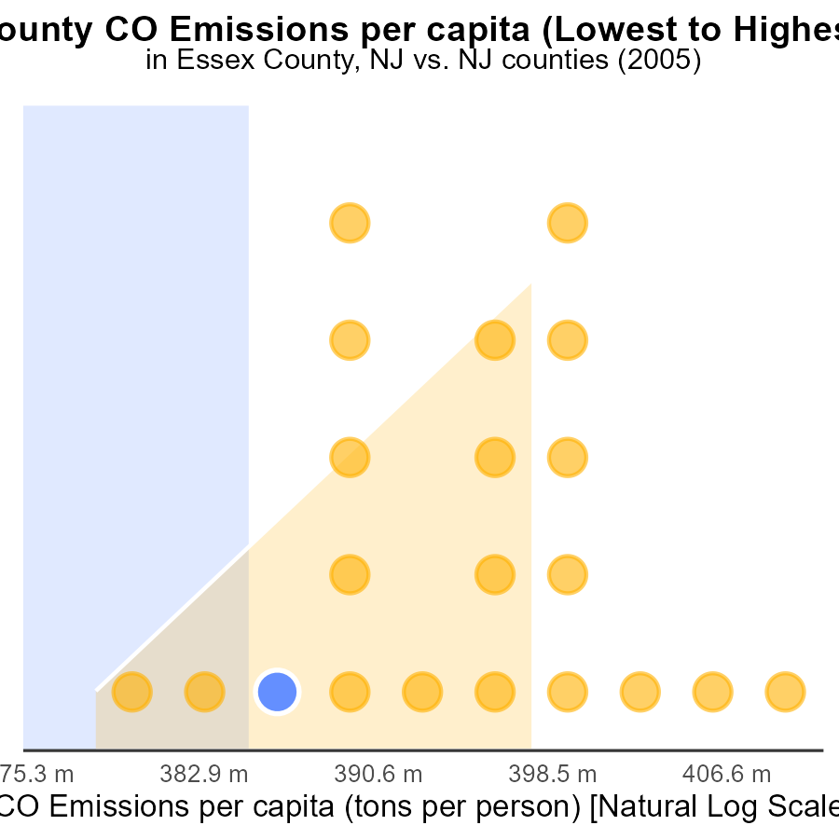

## Findings

* Hunterdon county had the highest CO emissions per capita in 2005, with 117.2 tons per person.
* Essex county ranked 3rd with 46.1 tons per person, representing 14.3% of the total emissions per capita.
* Union county had the highest percentage of emissions per capita, contributing 19.0% to the total.

## Recommendations

To lower emissions, focus on areas with high rates like Hunterdon. Encourage cleaner energy sources and stricter emission controls. Implement public transportation incentives.

# Conclusion

The analysis of Carbon Monoxide (CO) emissions from on-road transportation in Essex County, NJ in 2005 reveals the significant contribution of gasoline vehicles to the total emissions, accounting for 90.5%. Despite the steady increase in vehicle starts over the years, emissions per mile have decreased by 76.6% from 1990 to 2025. The data highlights the need for policymakers to shift focus towards promoting alternative fuel vehicles, particularly CNG, while enforcing stricter emission standards for gasoline and diesel vehicles to effectively reduce CO emissions. Municipalities should prioritize sustainable transportation policies, energy-efficient practices, and incentivizing renewable energy sources to lower emissions per capita. Furthermore, targeting vehicles like Combo Trucks, the main source of emissions in the county, with cleaner fuel initiatives and stricter regulations can lead to a continuous decrease in emissions over the coming years. By implementing these recommendations and investing in public transportation infrastructure, Essex County can work towards achieving a significant reduction in CO emissions and promoting a cleaner environment for its residents.

# About This Report

Data based on MOVES estimates collected by the Climate Action in Transportation program at Cornell University. Demographic data sourced from the US Census's American Community Survey 5-year estimates. This report was generated with the help of AI.

# References

* U.S. Census Bureau. (2023). American Community Survey 5-year estimates: Detailed tables. Retrieved from https://data.census.gov
* U.S. Environmental Protection Agency. (2024). Motor Vehicle Emission Simulator (MOVES 4.0) [Software]. Retrieved from https://www.epa.gov/moves