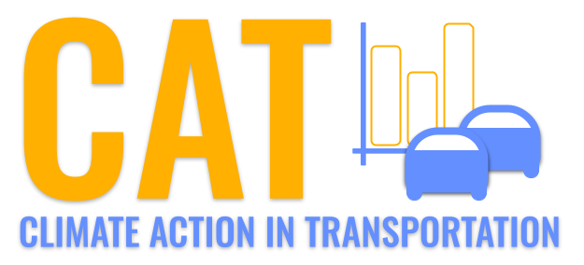 

**Carbon Emissions in Clearfield County, 2050**  
Made with CAT VISUALIZER by Gao Labs @ Cornell University.

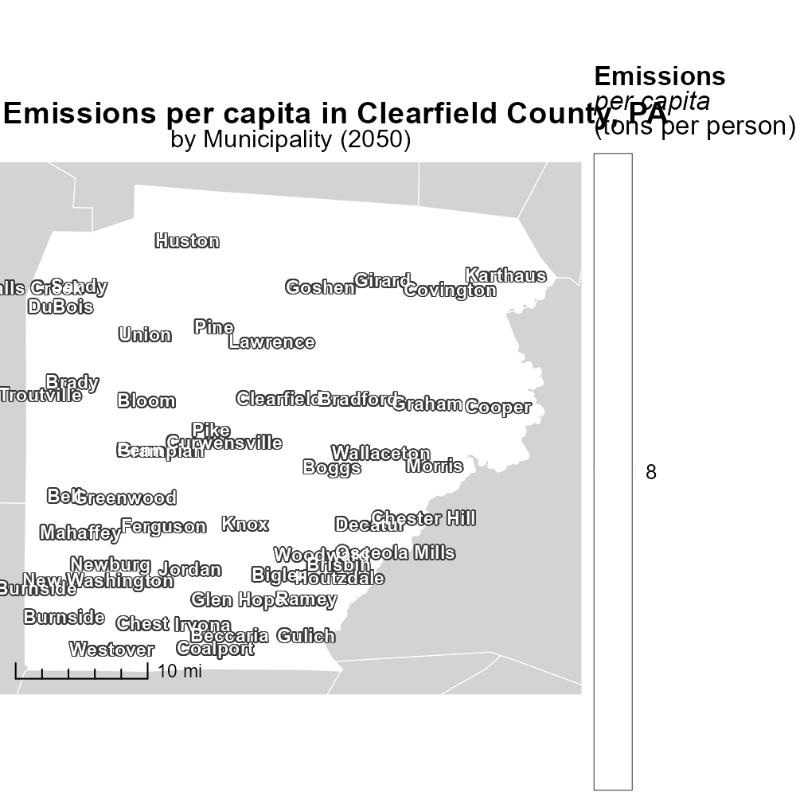

## Keywords

CO2 equivalent emissions; on-road transportation; Clearfield County; PA; 2050; report

## Highlights

* This report analyzes CO2 emissions from transportation in Clearfield County.
* Findings show trends in on-road transportation emissions in 2050.
* Data on CO2 equivalent emissions will guide future sustainability efforts.
* Insights will aid in implementing mitigation strategies for reducing emissions.
* Understanding 2050 emissions is crucial for informed decision-making.

# Introduction

This report delves into the CO2 equivalent emissions generated from on-road transportation in Clearfield County, PA, specifically focusing on the year 2050. As the world grapples with the pressing issue of climate change, understanding and mitigating emissions from transportation is crucial. Clearfield County, with its unique geographical and infrastructural characteristics, provides a fascinating case study for examining the environmental impact of on-road transportation in the future.

By investigating the trends and patterns of CO2 emissions in this region, this report aims to provide valuable insights that can inform policy-making and sustainability efforts. It is essential to comprehend the sources and levels of emissions in 2050 to develop effective strategies for reducing carbon footprints and promoting environmentally-friendly transportation practices in Clearfield County.

# Time Driven by Fuel Type

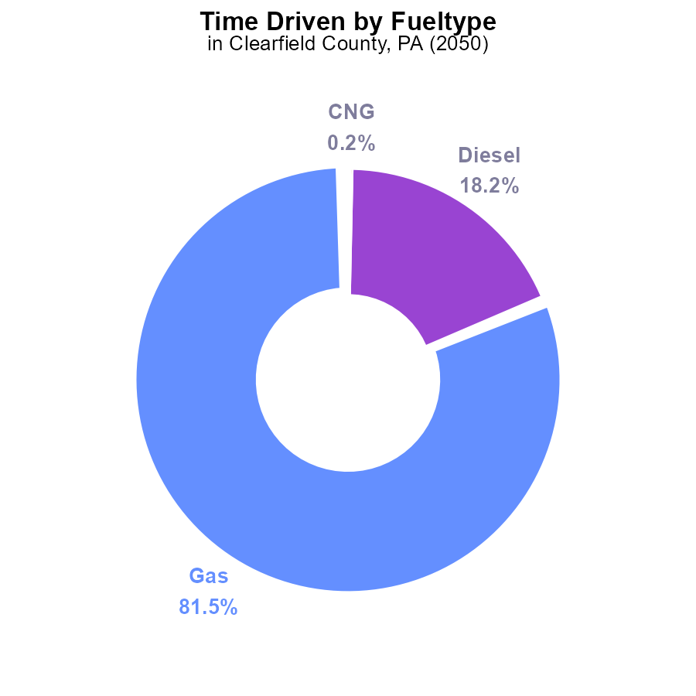

## Findings

* Gasoline contributes to 81.5% of CO2e emissions.
* Diesel contributes to 18.2% of CO2e emissions.
* CNG and ethanol combined contribute less than 1% of CO2e emissions.

## Recommendations

To lower emissions, prioritize reducing gasoline and diesel consumption through promoting electric vehicles and alternative transportation methods. Encourage the use of renewable energy sources to further decrease emissions.

# Time Driven by Vehicle Type

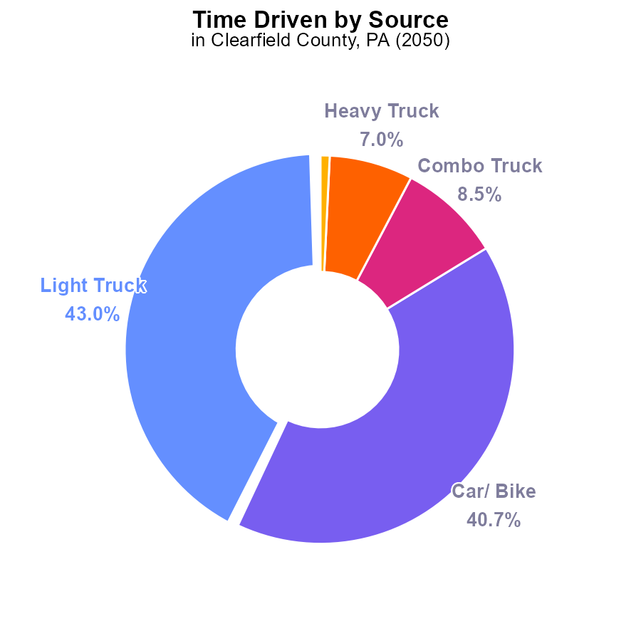

## Findings

* Light Trucks contribute 43.0% of CO2e emissions in Clearfield County.
* Cars/Bikes contribute 40.7% of the emissions, almost matching Light Trucks.
* Combining Light and Heavy Trucks, they account for 50% of total emissions.

## Recommendations

To lower emissions, initiatives targeting Light Trucks and Cars/Bikes should be prioritized due to their significant contribution. Implementing stricter emission standards for these vehicles and promoting alternative transportation methods can help reduce overall emissions.

# Idling Overall over Time

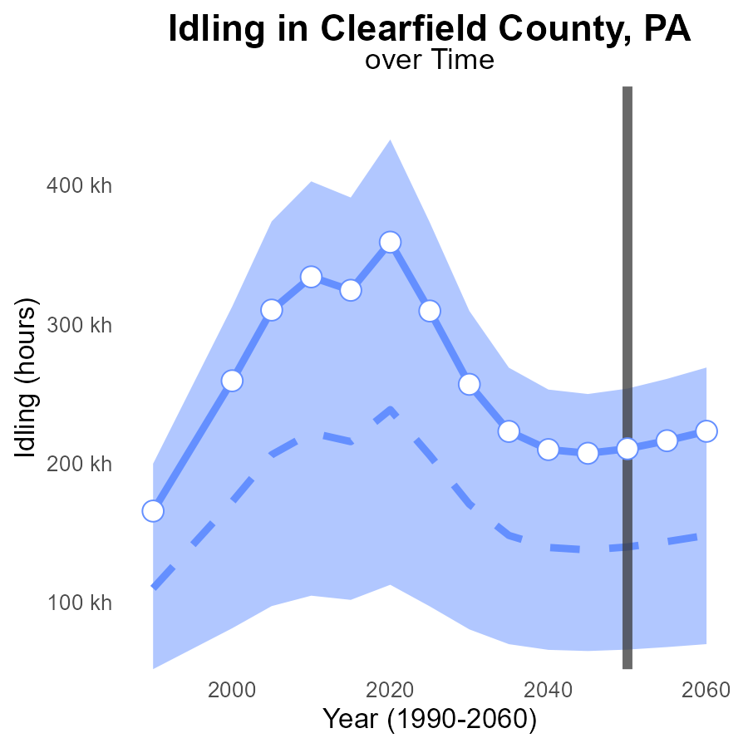

## Findings

* Emissions from idling in Clearfield County, PA are projected to increase steadily until 2060.
* The emissions in 2060 are estimated to be 223.0 k CO2e, with a difference of +74.8 k from the median area.
* The benchmark difference for 2050 is 0.0, indicating parity with the median area.

## Recommendations

To lower emissions, consider implementing idling reduction programs, promoting the use of idle-free technologies, and encouraging behavioral changes among drivers in Clearfield County, PA.

# Population Overall over Time

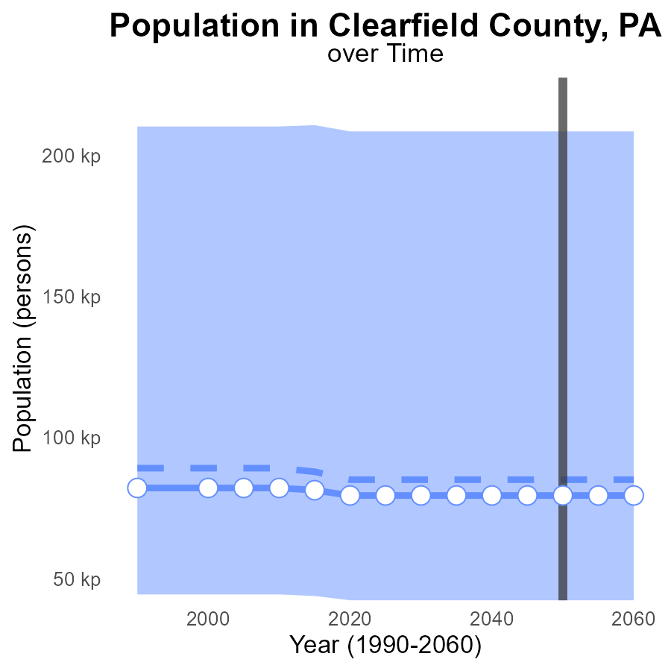

## Findings

* Emissions in Clearfield County are consistent at 79.5 k CO2e from 2030 to 2060.
* The emissions are 5.6 k CO2e below the median area value of 85,074 CO2e.
* Clearfield County falls within the lower 25% of CO2e emissions compared to other areas.

## Recommendations

To lower emissions, incentivize renewable energy initiatives. Encourage public transportation and promote energy-efficient practices in industries and households.

# Emissions Rate (per mile) in My Region

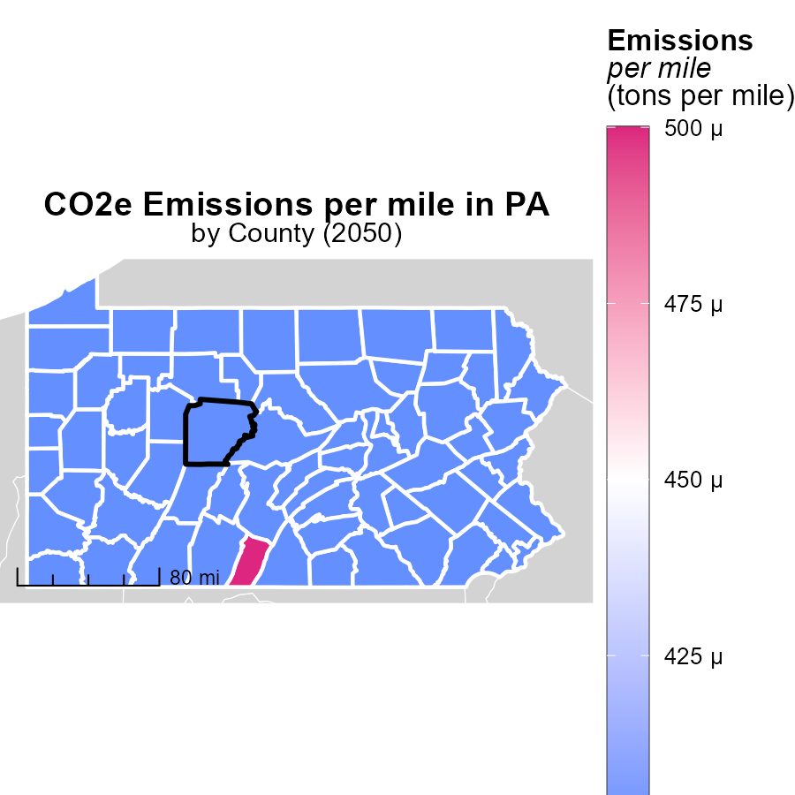

## Findings

* Fulton County, PA has the highest emissions per mile at 458.1 tons.
* Juniata County, PA has a median emissions rate of 437.5 tons per mile.
* York County, PA shows the lowest emissions per mile at 381.9 tons.

## Recommendations

To lower emissions, targeted policies in Fulton and Juniata counties are essential, focusing on transitioning to cleaner transportation methods. In York County, maintaining and incentivizing eco-friendly practices can further reduce emissions.

# Emissions Rate (per capita) Mapped by Area

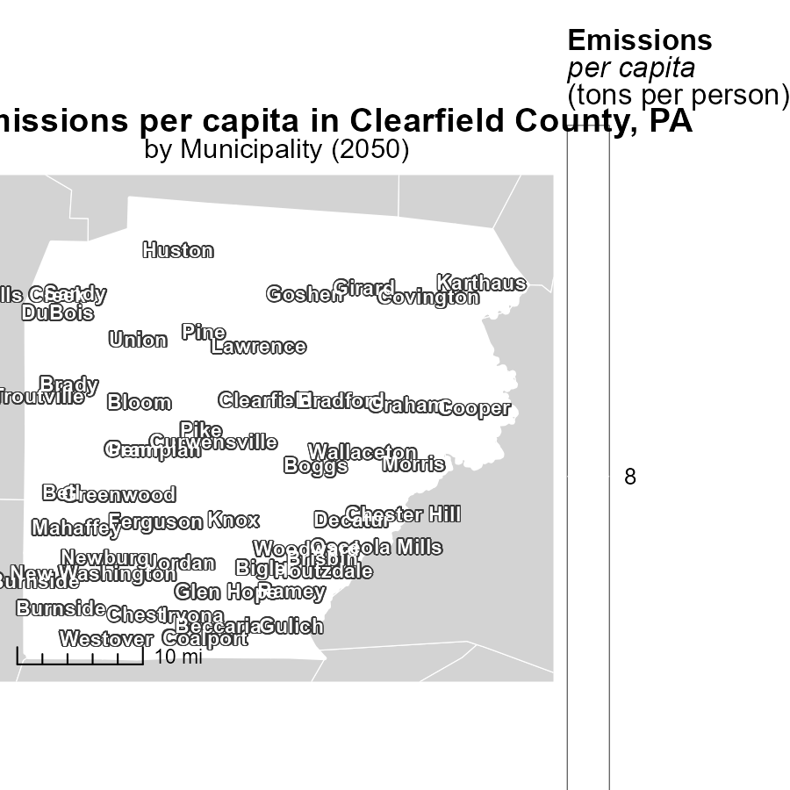

## Findings

* The maximum emissions per capita in 2050 were 8.0 tons/person in Beccaria, PA.
* The median emissions per capita in 2050 were 8.0 tons/person in Grampian, PA.
* The minimum emissions per capita in 2050 were 8.0 tons/person in Woodward, PA.

## Recommendations

To lower emissions per capita to sustainable levels, policies should target high-emitting areas like Beccaria while maintaining standards like Grampian and Woodward.

# Emissions Rate (per capita) by Road Type over Time

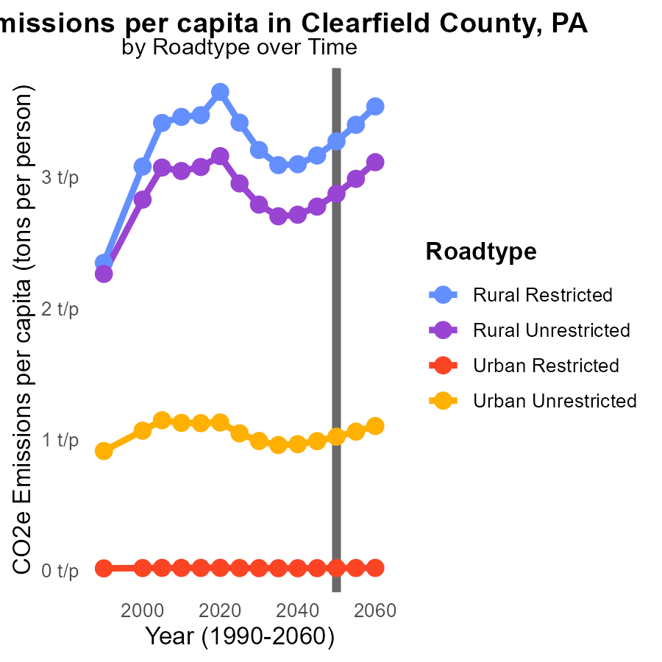

## Findings

* Emissions per capita in Clearfield County are generally increasing from 2040 to 2060 for all road types.
* The highest emissions per capita are observed in the Urban Unrestricted road type, with a slight decrease by 2060.
* Emissions per capita for Urban Restricted roads show a steady increase over the years, while Rural areas exhibit smaller increases.

## Recommendations

To lower emissions, focus on improving public transportation, promoting carpooling, incentivizing electric vehicles, and investing in infrastructure for non-motorized transportation modes.

# Hotelling (Diesel Aux) by Road Type over Time

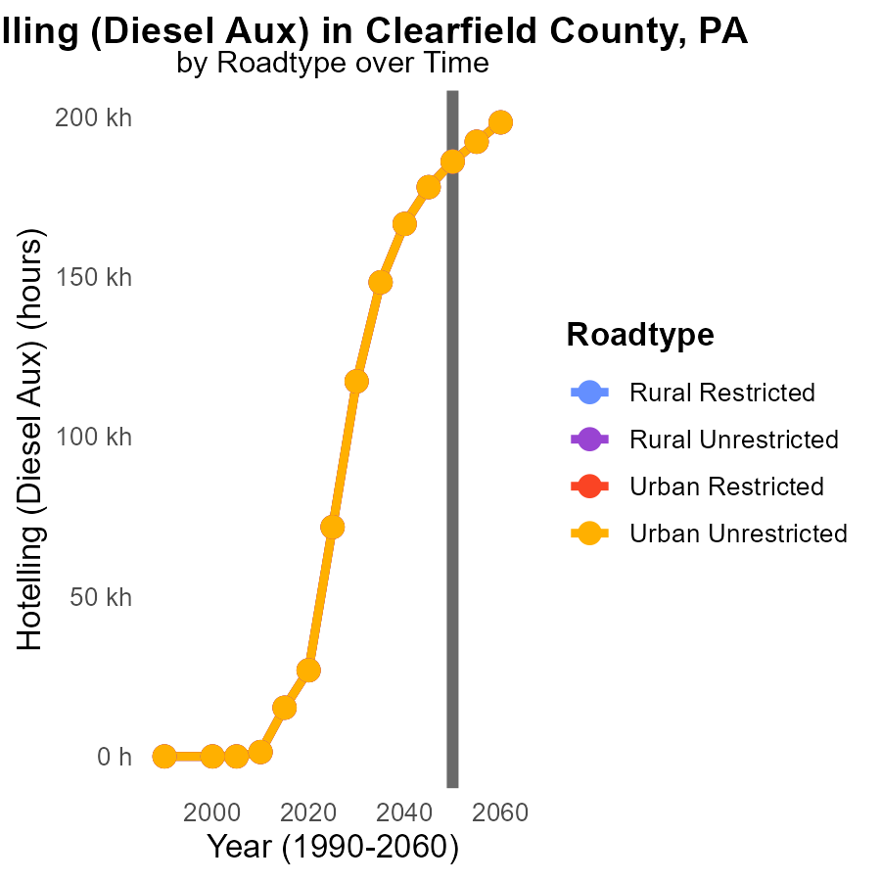

## Findings

* CO2e emissions in Clearfield County, PA are projected to increase from 186.0k in 2050 to 198.2k in 2060 for Rural Restricted areas.
* The percentage difference with 2050 levels by 2060 will be approximately 6.6% lower for all Urban areas compared to Rural areas.
* Emissions reductions strategies are recommended for Rural areas to reach emission levels closer to Urban areas by 2060.

## Recommendations

To lower emissions, implement stricter regulations on diesel auxiliary equipment in Rural areas. Encourage the use of cleaner technologies for road transportation in these areas.

# Areas Ranked by Vehicle Miles Traveled

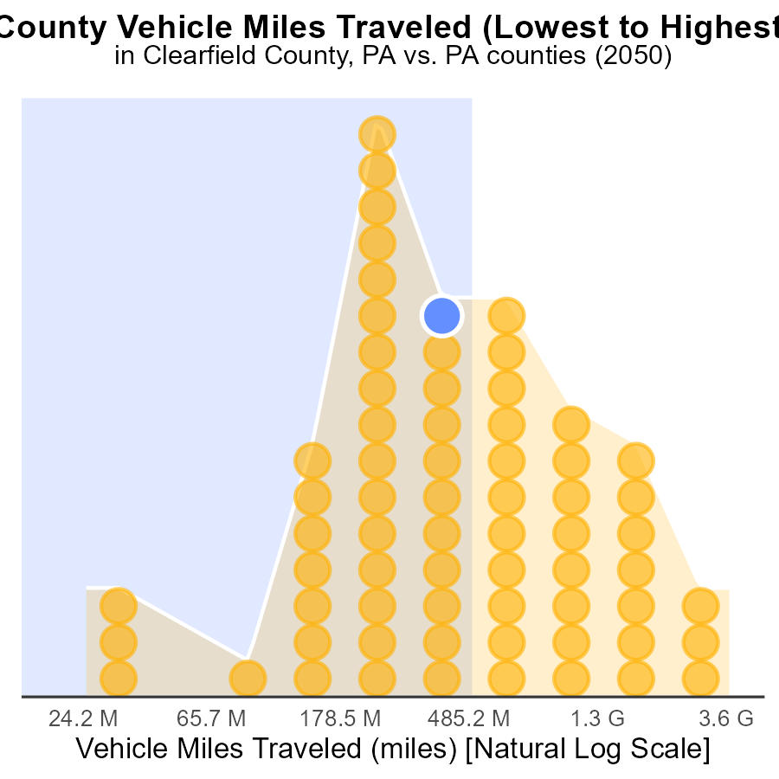

## Findings

* Allegheny County has the highest vehicle miles traveled (VMT) at 10.3 billion miles in 2050.
* Cameron County has the lowest VMT at 67.2 million miles in 2050, ranking 1st in the dataset.
* Clearfield, Fayette, and Bedford Counties have VMTs ranging from 1.3 to 1.4 billion miles, with percentile ranks from 37.0% to 58.2%.

## Recommendations

To lower emissions, focus on regions with high VMT like Allegheny County by promoting public transportation and carpooling. In low VMT areas, encourage walking and biking to reduce reliance on vehicles.

# Areas Ranked by Idling

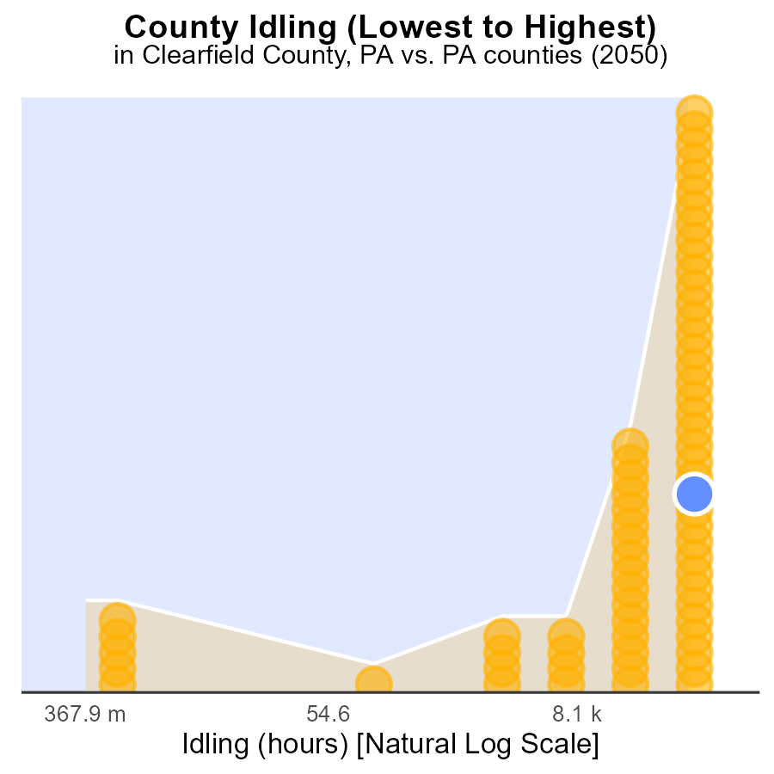

## Findings

* Berks County had the highest idling hours in 2050 with 460.7k hours.
* Cameron County had the lowest idling hours in 2050 with 0 hours.
* Overall, idling hours in Clearfield, Franklin, and Schuylkill counties were above 60% percentile.

## Recommendations

To lower emissions, Berks County should focus on reducing idling time through awareness campaigns and policies. Clearfield, Franklin, and Schuylkill counties need targeted initiatives to decrease idling below the 60% percentile.

# About This Report

Data based on MOVES estimates collected by the Climate Action in Transportation program at Cornell University. Demographic data sourced from the US Census's American Community Survey 5-year estimates. This report was generated with the help of AI.

# References

* U.S. Census Bureau. (2023). American Community Survey 5-year estimates: Detailed tables. Retrieved from https://data.census.gov
* U.S. Environmental Protection Agency. (2024). Motor Vehicle Emission Simulator (MOVES 4.0) [Software]. Retrieved from https://www.epa.gov/moves