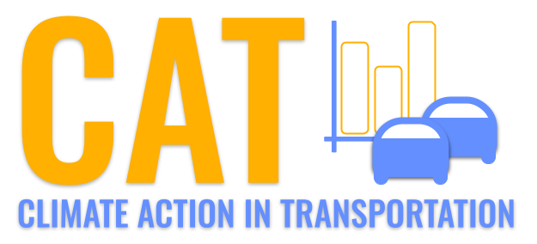 

**SO2 Emissions in Berkeley County, 2010**  
Made with CAT VISUALIZER by Gao Labs @ Cornell University.

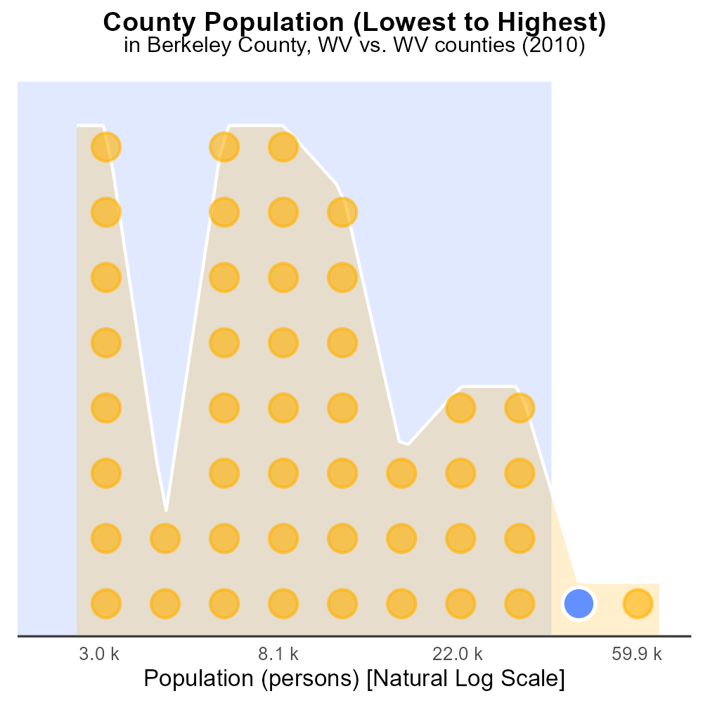

## Keywords

Sulfur Dioxides emissions; on-road transportation; Berkeley County; West Virginia; 2010; environmental impact

## Highlights

* Study on SO2 emissions from vehicles in Berkeley County WV.
* Assesses impact on air quality and environment.
* 2010 data analyzed for trends in transportation emissions.
* Focus on effects of sulfur dioxide on local community.
* Implications for policy and environmental regulation.

# Introduction

The following report presents an analysis of Sulfur Dioxides (SO2) emissions from on-road transportation in Berkeley County, West Virginia, specifically focusing on the year 2010. The study aims to evaluate the impact of vehicle emissions on air quality and the environment, with a particular emphasis on the concentration of SO2 in the atmosphere.

By examining the data from 2010, trends in transportation-related emissions of sulfur dioxide can be identified, providing insights into the sources and levels of pollution in the region. The report delves into the effects of SO2 on the local community, considering implications for public health, environmental sustainability, and regulatory measures.

# Emissions Rate (per mile) by Road Type

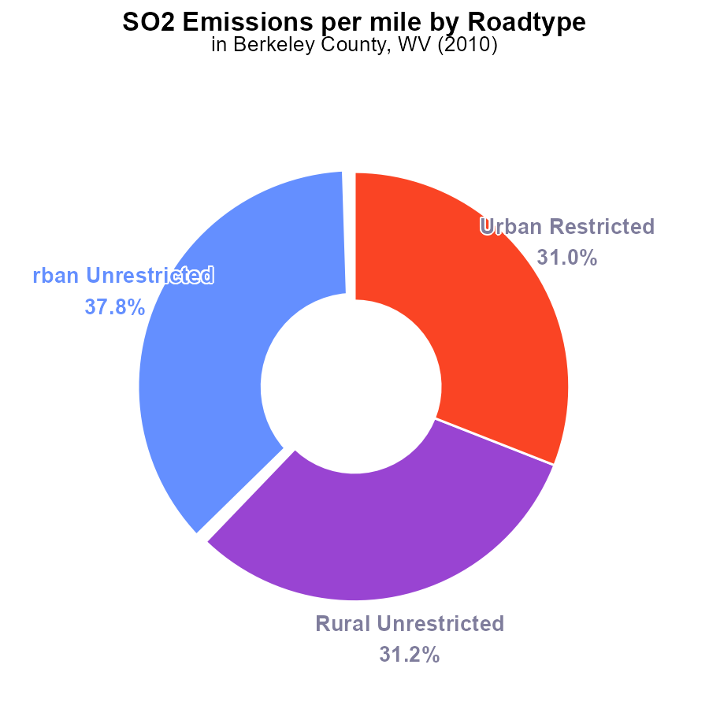

## Findings

* In 2010, the highest SO2 emissions per mile in Berkeley County, WV, were from Urban Unrestricted areas, at 11.1 tons per mile.
* Rural Unrestricted areas followed closely behind, emitting 9.2 tons per mile, representing 31.2% of total emissions.
* Urban Restricted areas had slightly lower emissions of 9.1 tons per mile, making up 31.0% of the county's total SO2 emissions.

## Recommendations

To lower SO2 emissions in Berkeley County, prioritize reducing emissions from Urban Unrestricted areas, followed by Rural Unrestricted and Urban Restricted areas. Strategies may include transitioning to cleaner energy sources, enforcing emissions regulations, and promoting public transportation.

# Hotelling (Diesel Aux) by Regulatory Class

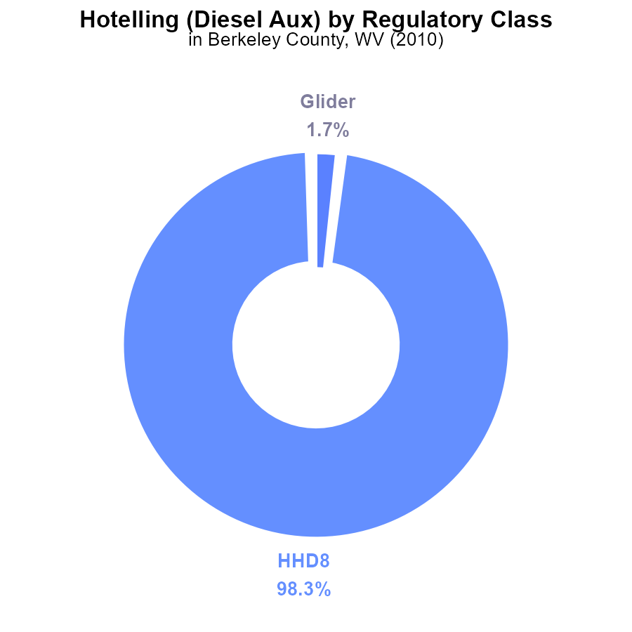

## Findings

* The majority (98.3%) of SO2 emissions in Berkeley County, WV in 2010 came from HHD8 (Hotelling Diesel Aux) sources.
* Glider emissions contributed to only 1.7% of the total SO2 emissions.
* There were no measurable SO2 emissions from MHD67, LDT, LDV, LHD34, LHD45, MC, or Urban Bus sources in 2010.

## Recommendations

To lower SO2 emissions in Berkeley County, WV, focus on reducing emissions from HHD8 sources, which account for the majority of emissions. Implement stricter emissions controls and transition to cleaner alternatives to decrease overall emissions levels.

# Time Driven over Time for Buses

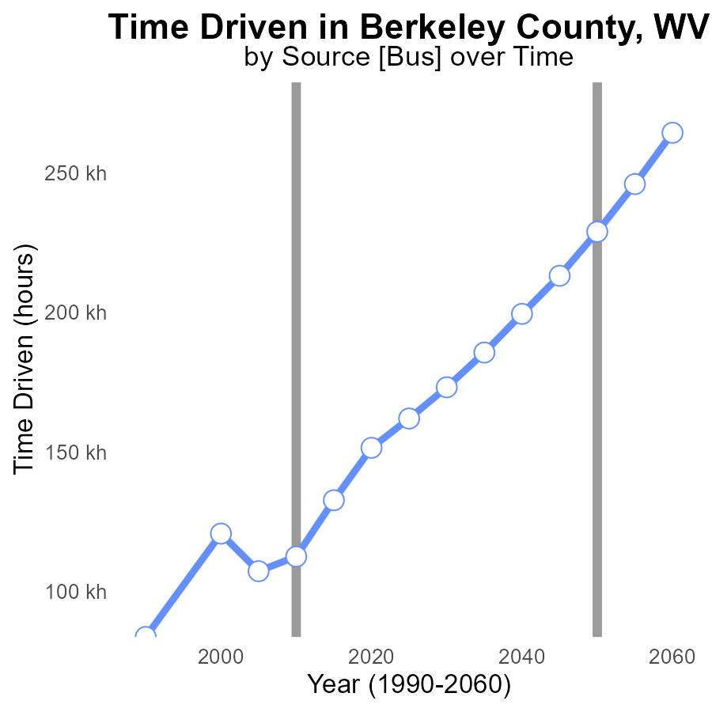

## Findings

* SO2 emissions in Berkeley County, WV have increased by 82.2% from 1990 to 2030.
* Despite a fluctuating trend, emissions have shown an overall decreasing benchmark difference over the years.
* Projected emissions for 2030 are approximately 106.2% higher than those recorded in 1990.

## Recommendations

To lower SO2 emissions in Berkeley County, WV, consider implementing more stringent emission control technologies in industries and promoting the use of cleaner energy sources. Enhance monitoring systems for compliance.

# Vehicle Starts over Time for Passenger Vehicle Starts

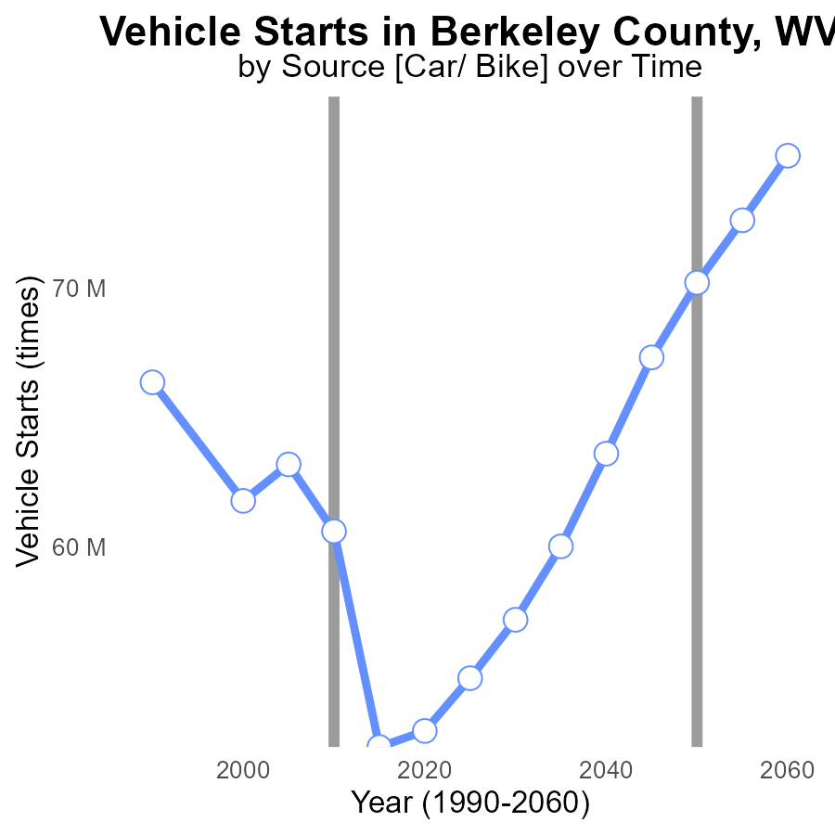

## Findings

* SO2 emissions decreased by 50% from 1990 to 2020.
* Vehicle starts increased by 12% from 1990 to 2030.
* Benchmark difference peaked in 2015 at 17884306 times.

## Recommendations

To lower SO2 emissions further, consider implementing stricter vehicle emission standards. Encourage the use of electric vehicles to reduce pollution from vehicle starts.

# Idling in My Region

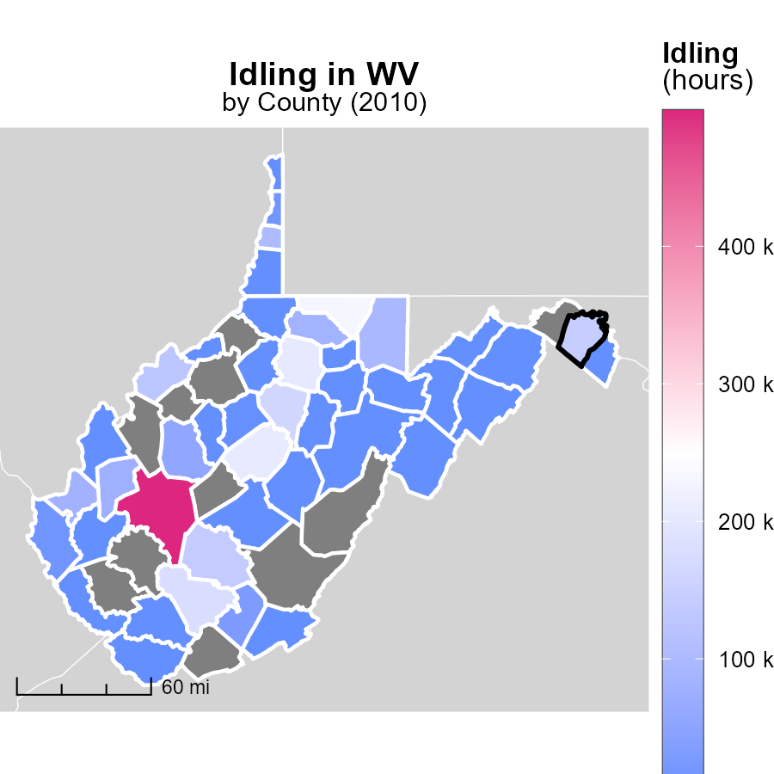

## Findings

* Kanawha County, WV had the highest idling hours in 2010 at 498.7k.
* Grant County, WV had a median idling hour of 0.0 in 2010.
* Clay County, WV did not report idling hours in 2010.

## Recommendations

To decrease emissions, Grant County should implement measures to reduce idling time, while Kanawha should continue monitoring and potentially enforcing idling reduction policies.

# Idling Mapped by Area

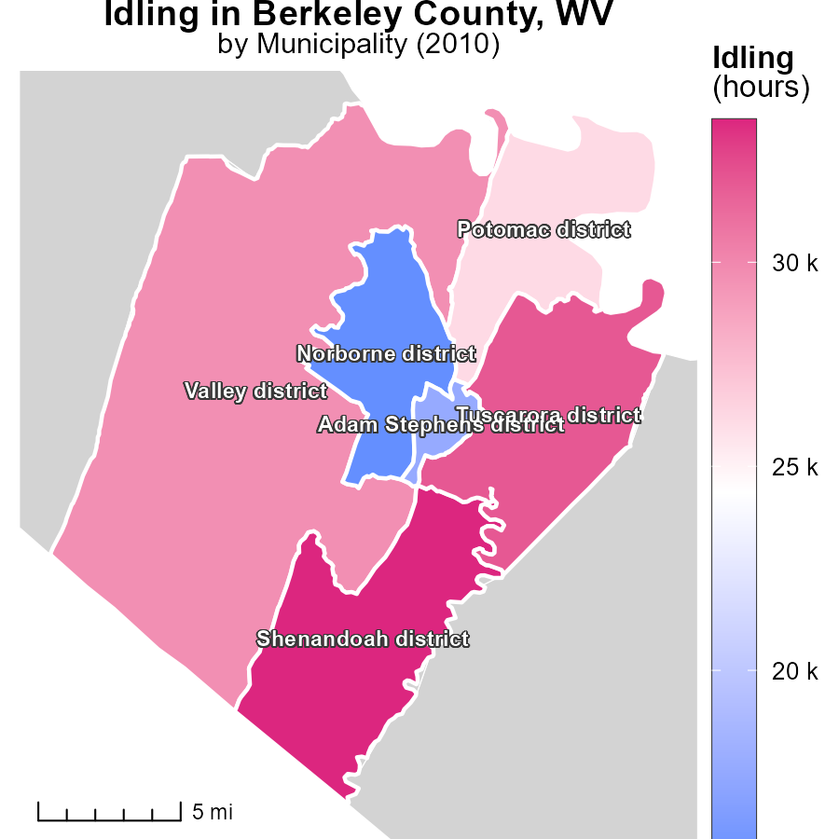

## Findings

* Shenandoah district in WV had the highest idling hours in 2010 at 33.5k.
* The Potomac district in WV had a median idling time of 26.1k hours.
* Norborne district in WV had the lowest idling hours in 2010 at 15.3k.

## Recommendations

To reduce emissions from idling, encourage investing in technologies that automatically shut off engines after idling for a certain period. Implement idling reduction campaigns to raise awareness.

# Hotelling (Diesel Aux) by Regulatory Class over Time

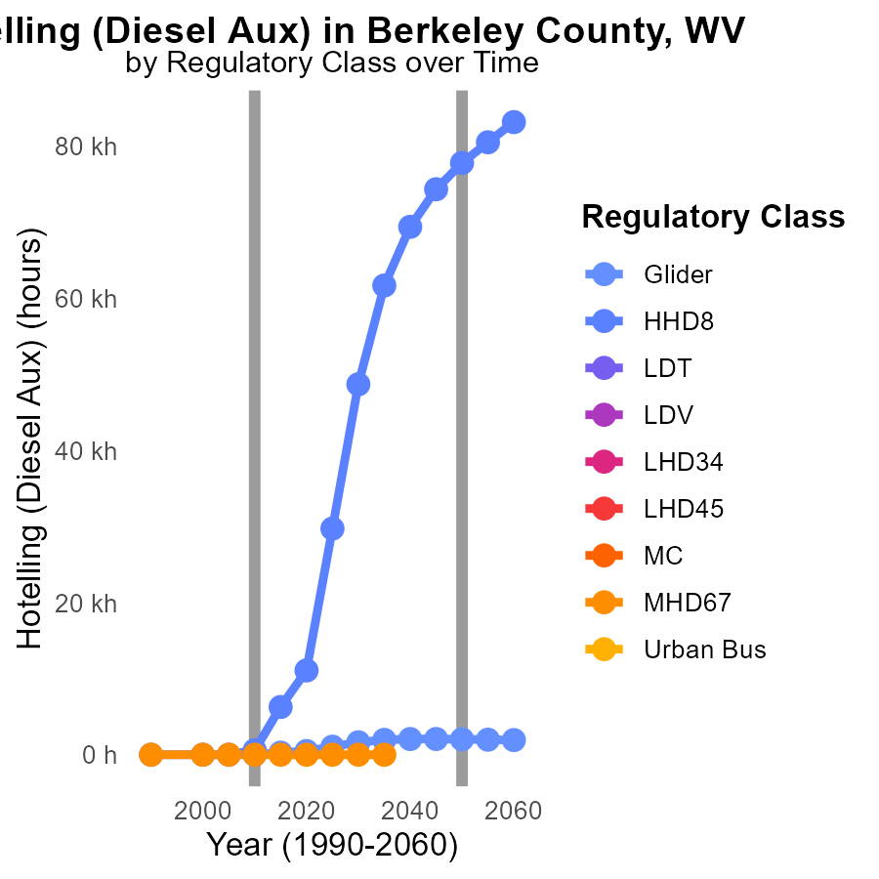

## Findings

* SO2 emissions for Glider decreased by 95.6% from 2010 to 2020.
* HHD8 emitted 11.1 k units of SO2 in 2020, a 99.9% decrease from 2000.
* No data available for other vehicle types or years in Berkeley County.

## Recommendations

To further reduce SO2 emissions, focus on implementing stricter regulations on older vehicles, encouraging the use of cleaner fuels, and investing in technologies that reduce emissions.

# Hotelling (Engines Off) by Regulatory Class over Time

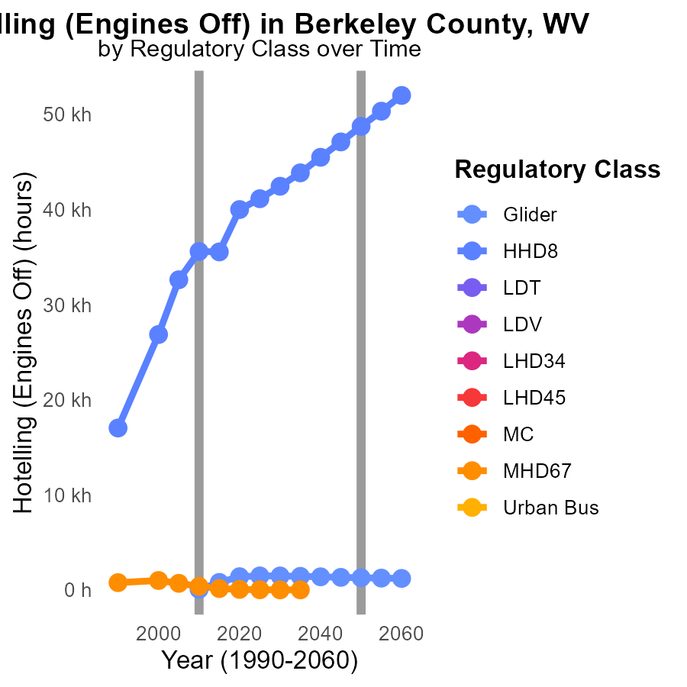

## Findings

* From 2000 to 2020, SO2 emissions from Hotelling (Engines Off) in HHD8 decreased by 35.26%.
* In 2015, Glider emissions were 782.3 hours, representing an increase of 1211.72% compared to 2010.
* There is a presence of incomplete data (NA) for all vehicle types in the years 2000 to 2020.

## Recommendations

To decrease SO2 emissions further, focus on maintaining the decreasing trend in HHD8 emissions by implementing stricter regulations and promoting cleaner alternatives for Hotelling. Improve data collection and reporting to ensure complete and accurate emission records.

# Areas Ranked by Population

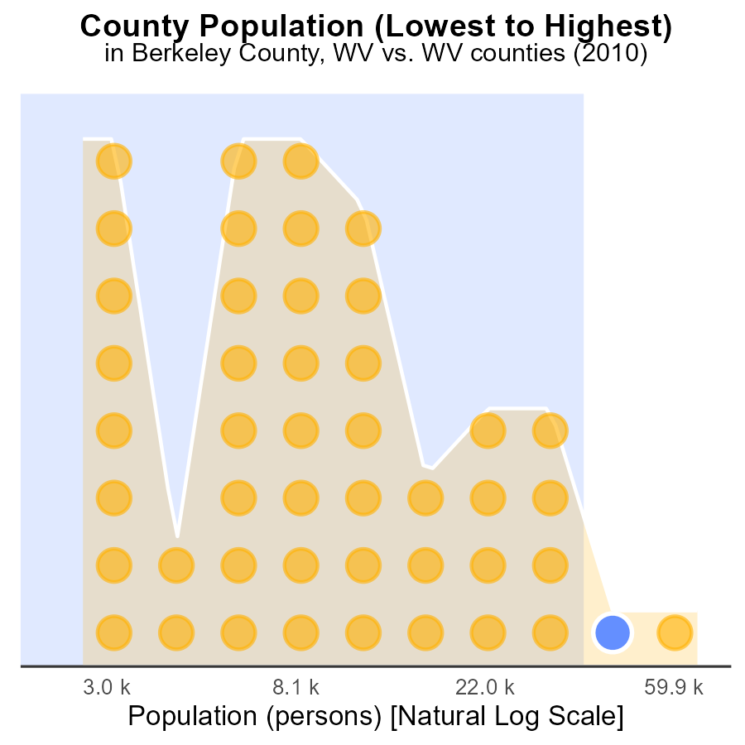

## Findings

* Kanawha county had the highest population in 2010 with 192.8k people.
* Berkeley county had a population of 100.9k, ranking in the 99th percentile.
* Tucker county had the smallest population of 7.1k, ranking in the 3rd percentile.

## Recommendations

To reduce SO2 emissions, focus on counties with high population density like Kanawha and Berkeley. Implement stricter emission controls and promote cleaner technologies to lower pollution levels.

# Areas Ranked by Vehicle Starts

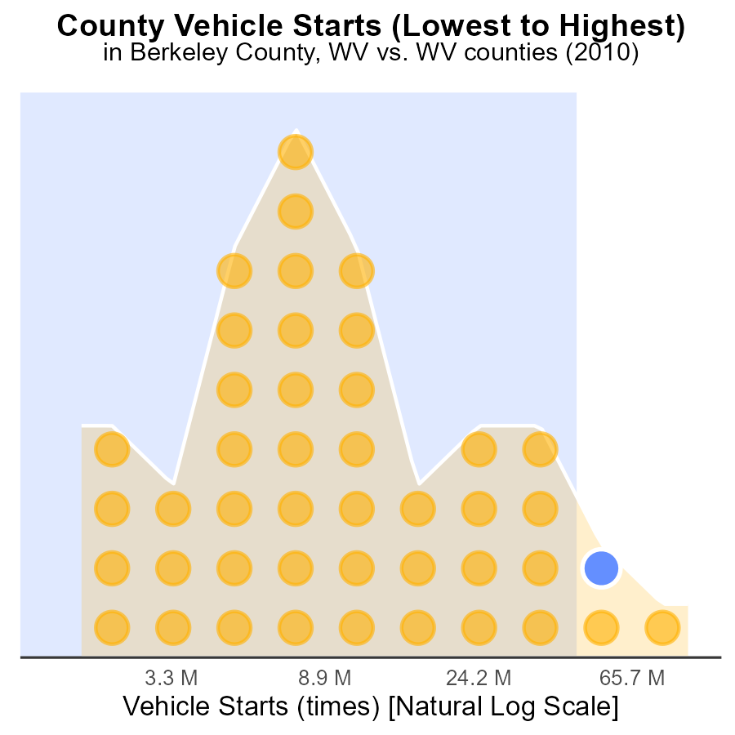

## Findings

* Kanawha county had the highest vehicle starts emissions with 265.1 million SO2 times in 2010.
* Berkeley county emitted 97.7% of Kanawha's emissions with 124.1 million SO2 times, ranking 43rd.
* Monongalia county emitted 95.5% of Kanawha's emissions with 120.6 million SO2 times, ranking 42nd.

## Recommendations

To lower emissions, focus on reducing vehicle starts by implementing carpooling initiatives, investing in public transportation, and promoting electric vehicles in the mentioned counties.

# About This Report

Data based on MOVES estimates collected by the Climate Action in Transportation program at Cornell University. Demographic data sourced from the US Census's American Community Survey 5-year estimates. This report was generated with the help of AI.

# References

* U.S. Census Bureau. (2023). American Community Survey 5-year estimates: Detailed tables. Retrieved from https://data.census.gov
* U.S. Environmental Protection Agency. (2024). Motor Vehicle Emission Simulator (MOVES 4.0) [Software]. Retrieved from https://www.epa.gov/moves