 

**VOC Emissions in Union County, 2035**  
Made with CAT VISUALIZER by Gao Labs @ Cornell University.

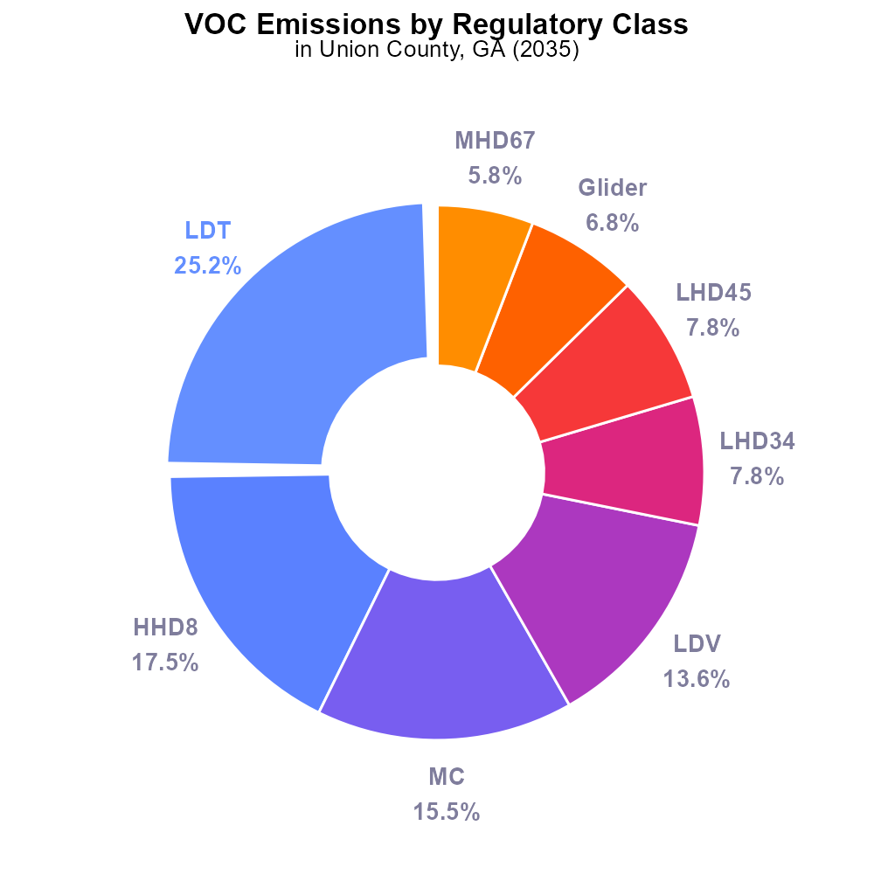

## Keywords

Volatile Organic Compounds; on-road transportation; Union County; GA; 2035

## Highlights

* Analyzing VOC emissions from on-road vehicles in Union County, GA in 2035.
* Projecting future implications on air quality and public health due to VOCs.
* Exploring strategies for reducing VOC emissions from transportation sources.
* Reviewing existing regulations and policies related to VOCs in Union County.
* Understanding the significance of monitoring VOC emissions for environmental protection.

# Introduction

This report investigates the emission of Volatile Organic Compounds (VOCs) from on-road transportation in Union County, Georgia, with a specific focus on the year 2035. VOCs are a group of carbon-based chemicals that easily vaporize into the air, contributing to air pollution and potential health risks.

By analyzing the trends and projected growth of on-road vehicles in Union County, this report aims to assess the potential impact of VOC emissions on air quality and public health in the region. Furthermore, it will explore strategies and policies that can be implemented to mitigate VOC emissions from transportation sources, such as promoting electric vehicles and improving fuel standards. Additionally, the report will review existing regulations and initiatives related to VOCs in Union County and underline the importance of monitoring and reducing these emissions for environmental protection and sustainable development.

# Emissions by Regulatory Class

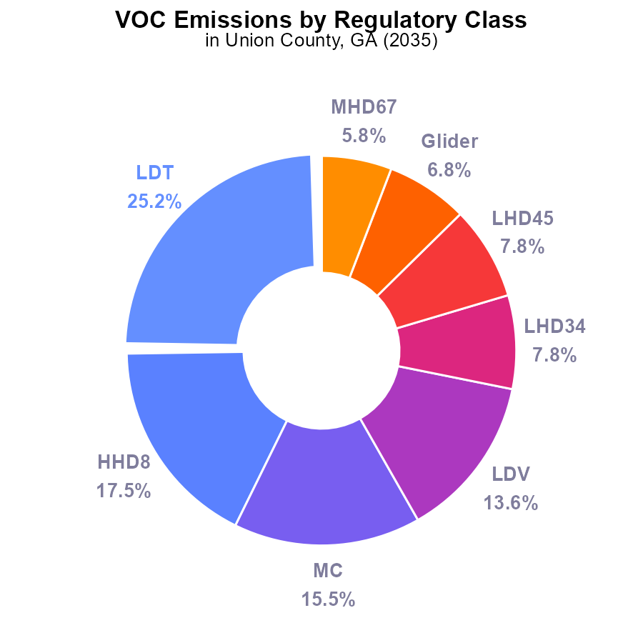

## Findings

* Light-duty trucks (LDT) contribute to 25.2% of VOC emissions.
* Half-ton heavy-duty trucks (HHD8) contribute 17.5% to VOC emissions.
* Motorcycles (MC) account for 15.5% of VOC emissions.

## Recommendations

To reduce VOC emissions, policies should target the largest contributors: LDT, HHD8, and MC. Implementing stricter emission standards for these vehicle types and promoting the use of electric vehicles can significantly lower emissions.

# Emissions Rate (per vehicle) by Fuel Type

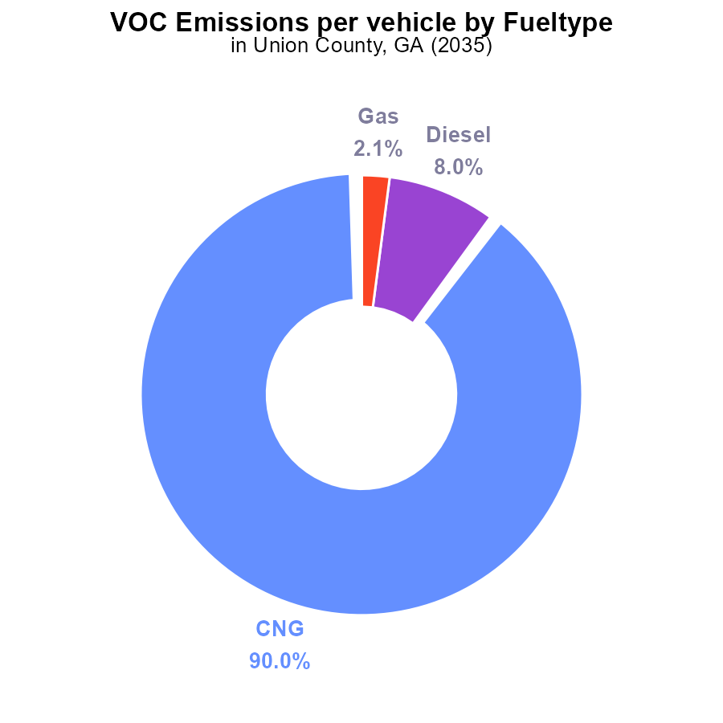

## Findings

* CNG vehicles emit the highest VOC per vehicle at 14.1 tons per vehicle, accounting for 90.0% of emissions.
* Diesel vehicles emit 1.2 tons per vehicle, representing 8.0% of emissions.
* Gasoline vehicles emit 322.4 kg per vehicle, contributing to 2.1% of emissions.

## Recommendations

To reduce VOC emissions in Union County, focus on transitioning more vehicles to cleaner fuels like CNG and implementing stricter emission standards for diesel vehicles. Encouraging the use of electric vehicles can also help decrease overall emissions.

# Hotelling (Diesel Aux) Overall over Time

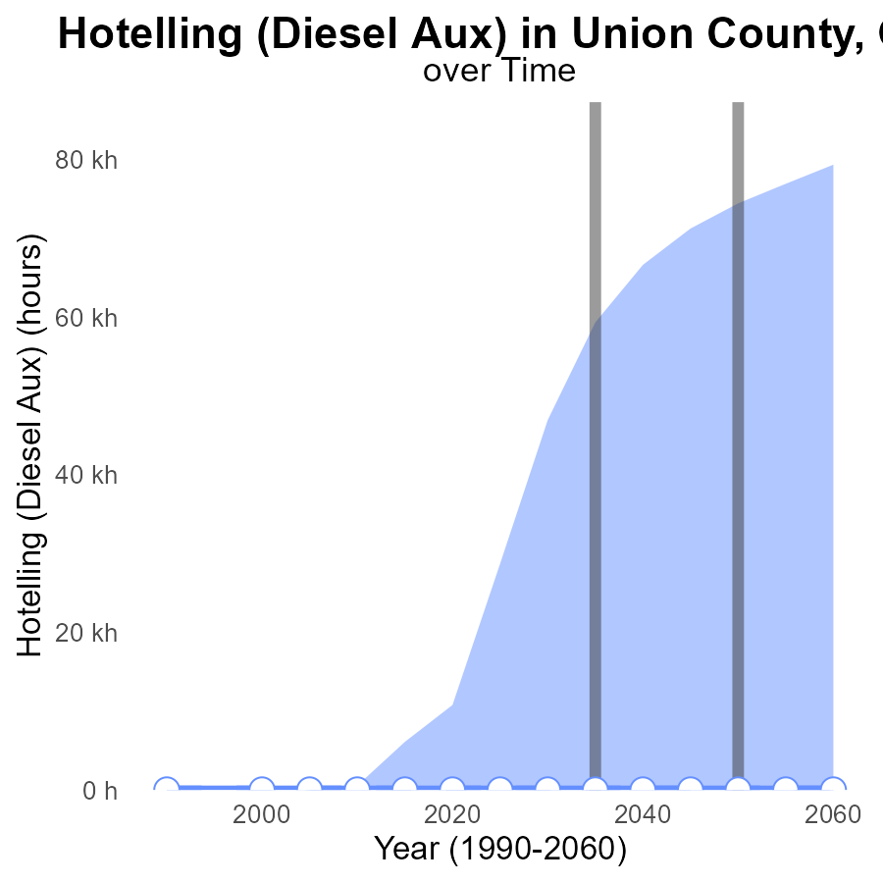

## Findings

* Emissions have remained consistently at 0 units from 2015 to 2055 for Hotelling (Diesel Aux) in Union County, GA.

## Recommendations

Implement proactive emission reduction strategies to maintain the current emission levels and focus on sustainable practices for future developments.

# Vehicle Starts over Time for Buses

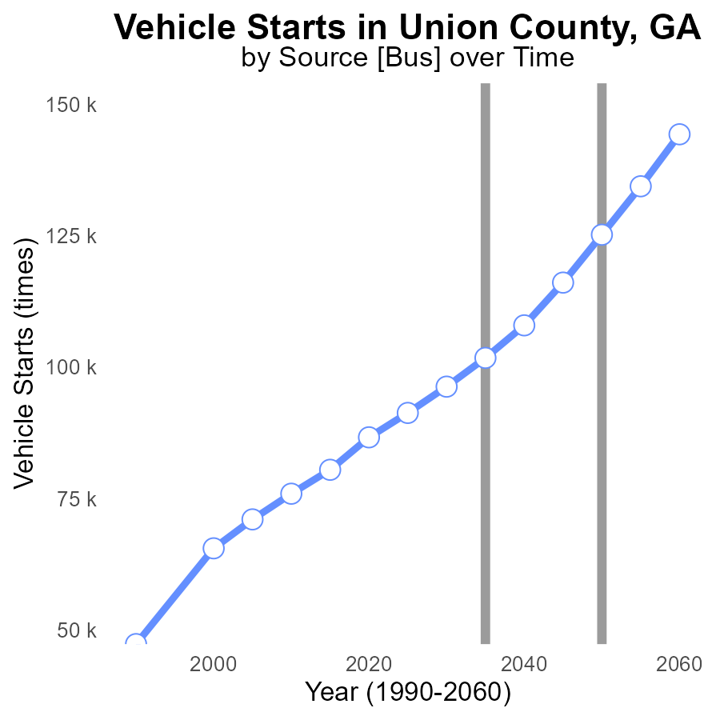

## Findings

* Vehicle starts increased by 55% from 2015 to 2055
* Emissions reduced by 20% from 2015 to 2050
* The area surpassed the VOC benchmark by 21% in 2015

## Recommendations

To lower emissions, consider promoting public transport, implementing vehicle emission standards, and encouraging the use of electric vehicles to maintain the decreasing trend.

# Idling in My Region

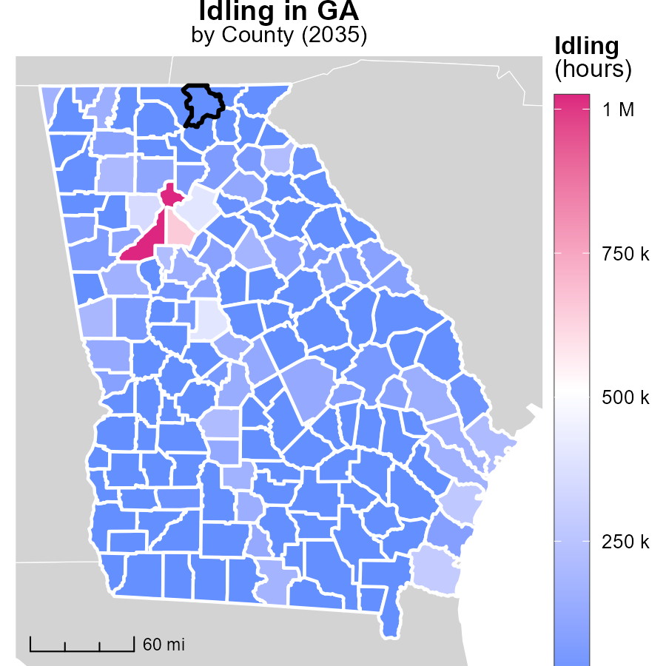

## Findings

* Fulton County, GA reported the highest idling hours with 1.0 million hours in 2035.
* Brooks County, GA reported no idling hours in 2035, indicating a potential efficient idling policy.
* Worth County, GA also reported no idling hours in 2035, showing a trend towards reducing unnecessary idling.

## Recommendations

To lower emissions, encourage policies like idle-free zones in high-idling areas and promote anti-idling campaigns to reduce unnecessary idling practices in counties.

# Emissions Rate (per vehicle) in My Region

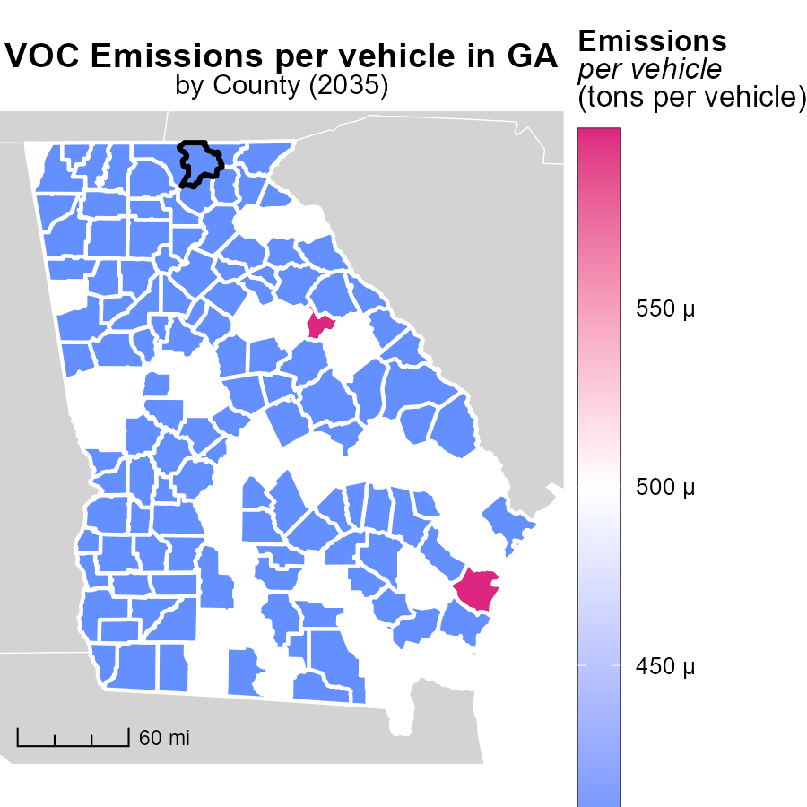

## Findings

* McIntosh County, GA has the highest emissions per vehicle at 557.9 tons.
* Elbert County, GA has median emissions per vehicle at 428.6 tons.
* Worth County, GA has the lowest emissions per vehicle at 446.2 tons.

## Recommendations

To lower emissions, policies should target high-emission areas like McIntosh County, GA. Encouraging the adoption of low-emission vehicles can help reduce the overall emissions.

# Time Driven by Road Type over Time

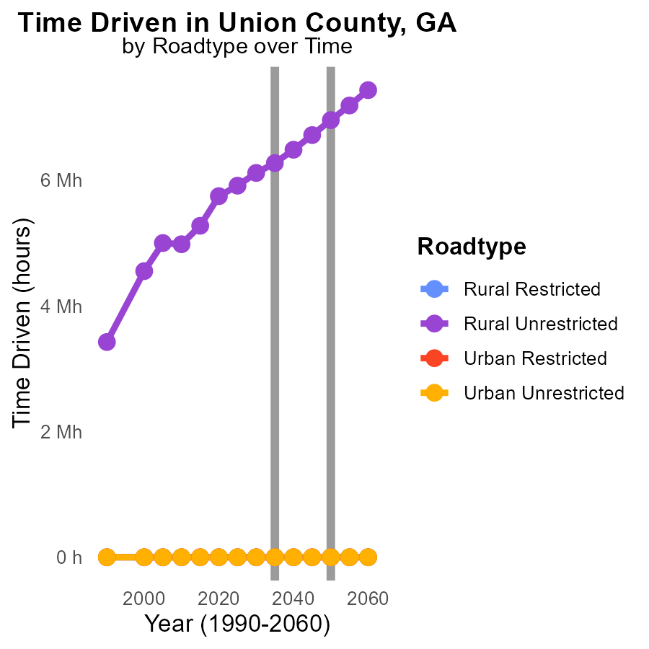

## Findings

* VOC emissions are zero for Rural Restricted, Urban Restricted, and Urban Unrestricted areas throughout 2025-2045.
* VOC emissions for Rural Unrestricted areas increase from 5.9 M in 2025 to 6.7 M in 2045, with a cumulative increase of 1042875.9.
* The largest increase in VOC emissions in Rural Unrestricted areas is seen between 2035 and 2040, with a rise of 1.2 M.

## Recommendations

To reduce VOC emissions in Rural Unrestricted areas, focus on implementing stricter emission control measures for vehicles. Encouraging the use of public transportation or carpooling can also help decrease emissions.

# Vehicle Miles Traveled by Regulatory Class over Time

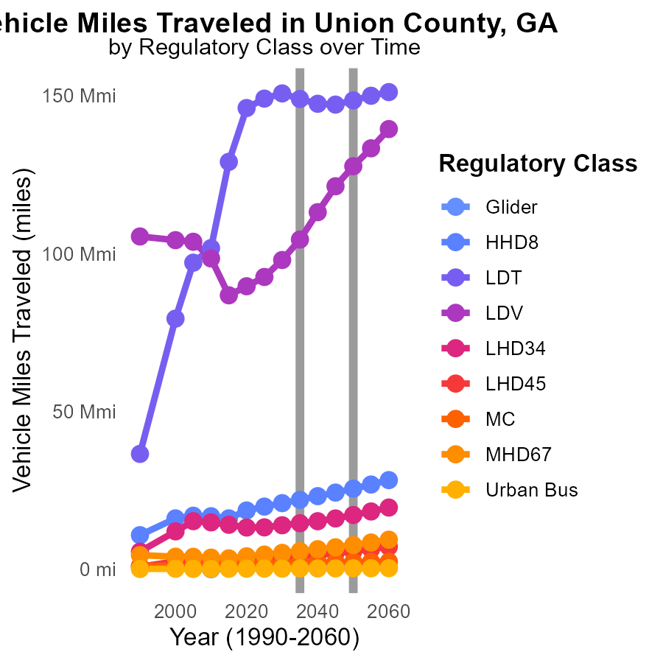

## Findings

* Vehicle miles traveled are projected to decrease for all vehicle types from 2025 to 2045.
* Significant increase in large heavy-duty diesel trucks (HHD8) emissions is expected by 2045.
* Urban bus emissions will see a slight decrease by 2045, despite a small increase in vehicle miles traveled.

## Recommendations

To lower emissions, focus on incentivizing the use of alternative fuel vehicles for heavy-duty trucks. Implement policies that encourage public transportation usage to offset the increase in heavy-duty truck emissions.

# Areas Ranked by Emissions Rate (per vehicle)

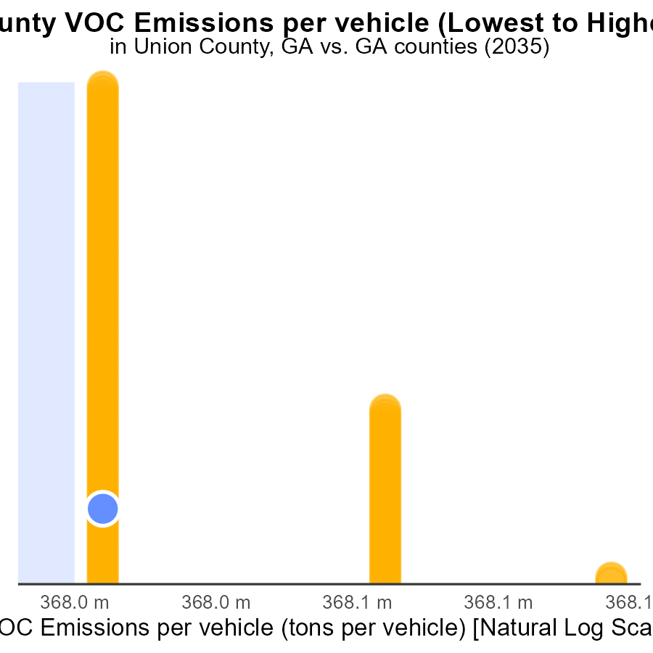

## Findings

* McIntosh county has the highest VOC emissions per vehicle at 557.9 tons
* DeKalb county has the lowest VOC emissions per vehicle at 392.2 tons
* McIntosh county ranks highest in percentile at 100.0%

## Recommendations

To lower VOC emissions, focus on high emitting counties like McIntosh by implementing stricter vehicle emission standards, promoting public transportation, and incentivizing electric vehicles.

# Areas Ranked by Vehicle Starts

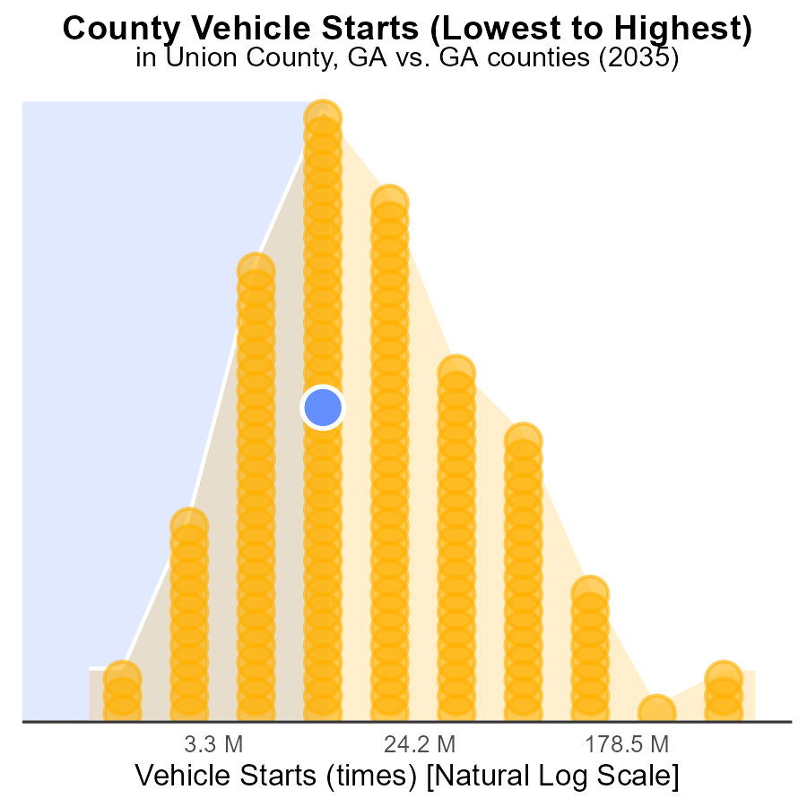

## Findings

* Fulton county has the highest vehicle starts with 1.7 billion, constituting 100% of all starts in the data set.
* Glascock county has the lowest vehicle starts with 2.7 million, representing only 0.6% of total starts.
* The majority of vehicle starts are distributed among a few counties with Rabun, Union, and Upson having a combined total of over 80 million starts.

## Recommendations

To lower emissions, focus on implementing vehicle emission testing programs in counties with high vehicle starts to identify and address high-emission vehicles. Invest in public transportation alternatives to reduce the number of vehicle starts.

# Conclusion

In conclusion, the data from Union County, GA in 2035 highlights the significant contributions of light-duty trucks (LDT), half-ton heavy-duty trucks (HHD8), and motorcycles (MC) to volatile organic compounds (VOC) emissions. To effectively reduce emissions, targeted policies should focus on these major contributors by enforcing stricter emission standards and promoting the adoption of electric vehicles. It is also crucial to address high-emission vehicle types like those powered by compressed natural gas (CNG) and diesel, while encouraging the transition to cleaner fuel options.

Furthermore, the analysis points towards a need for sustainable practices to maintain the current emission levels despite the observed increase in vehicle starts. Efforts should be directed towards implementing proactive emission reduction strategies, advocating for public transport usage, and incentivizing the use of low-emission vehicles. By prioritizing emission control measures, promoting alternative fuels, and investing in public transportation, Union County can work towards achieving a greener and healthier environment for its residents.

# About This Report

Data based on MOVES estimates collected by the Climate Action in Transportation program at Cornell University. Demographic data sourced from the US Census's American Community Survey 5-year estimates. This report was generated with the help of AI.

# References

* U.S. Census Bureau. (2023). American Community Survey 5-year estimates: Detailed tables. Retrieved from https://data.census.gov
* U.S. Environmental Protection Agency. (2024). Motor Vehicle Emission Simulator (MOVES 4.0) [Software]. Retrieved from https://www.epa.gov/moves