 

**PM10 Emissions in Sagadahoc County, 2015**  
Made with CAT VISUALIZER by Gao Labs @ Cornell University.

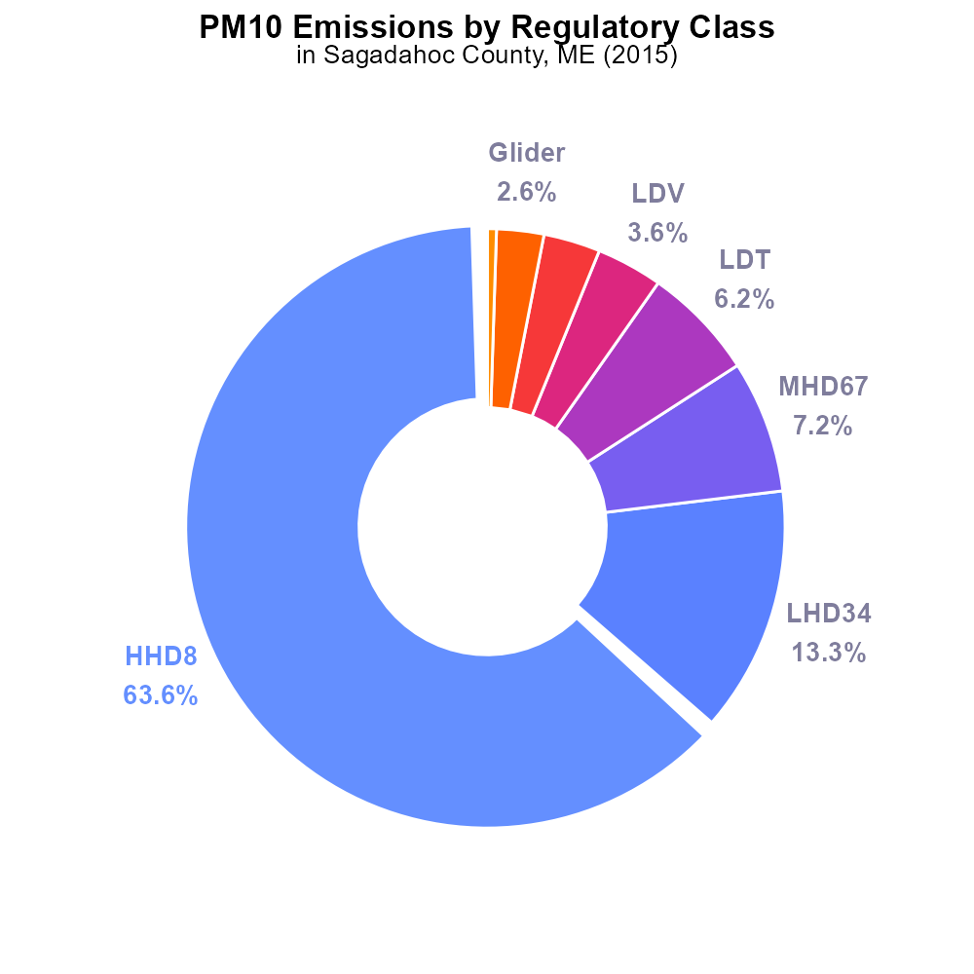

## Keywords

Primary Exhaust PM10; Total Emissions; On-road Transportation; Sagadahoc County; 2015

## Highlights

* Study on PM10 emissions from on-road transportation in Sagadahoc County, ME in 2015.
* Evaluation of primary exhaust sources contributing to air pollution in the county.
* Analysis of total PM10 emissions to assess environmental impact and public health implications.
* Insights into the levels of particulate matter released from on-road vehicles in the region.
* Understanding the significance of transportation-related emissions on air quality in Sagadahoc County.

# Introduction

Primary Exhaust PM10 emissions from on-road transportation play a crucial role in the overall air quality of Sagadahoc County, ME. This report aims to analyze and quantify the total PM10 emissions specifically attributed to on-road vehicles in the region during the year 2015. By focusing on this aspect of air pollution, we can gain valuable insights into the impact of transportation-related emissions on the environment and public health.

Through this study, we seek to identify the primary sources of exhaust pollutants contributing to PM10 levels in Sagadahoc County. The assessment of these emissions will provide a comprehensive understanding of the environmental implications and help in formulating sustainable strategies for air quality improvement.

# Emissions by Regulatory Class

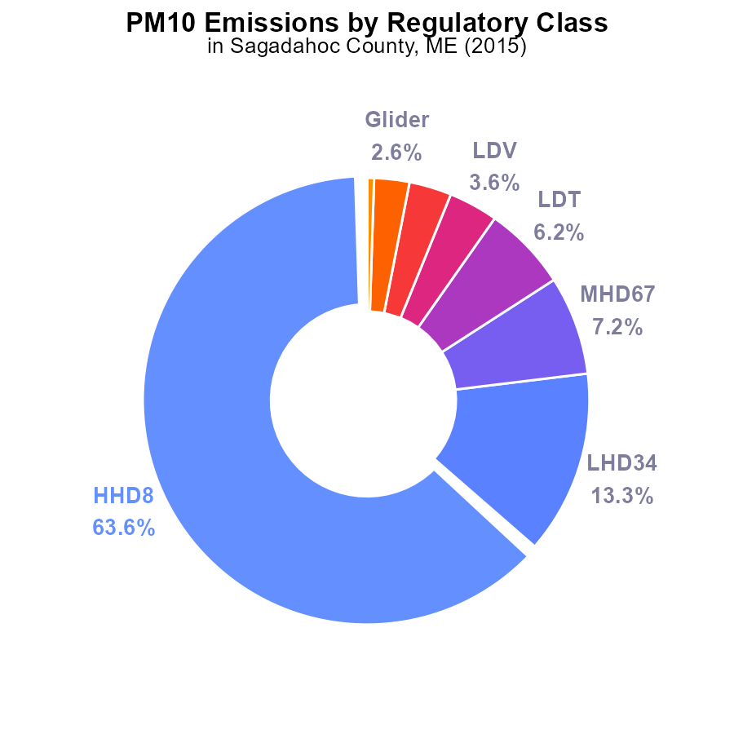

## Findings

* The top source of PM10 emissions in Sagadahoc County in 2015 was HHD8, accounting for 63.6% of total emissions.
* Combined, HHD8, LHD34, and MHD67 contributed to over 84% of PM10 emissions in the county.
* Urban buses did not emit any PM10 in 2015 in Sagadahoc County.

## Recommendations

To reduce PM10 emissions in Sagadahoc County, focus on mitigating emissions from HHD8, LHD34, and MHD67, as they collectively amount to a significant portion of emissions. Implementing stricter emission standards or promoting cleaner technologies for these sources could be effective in lowering overall emissions.

# Vehicle Starts by Fuel Type

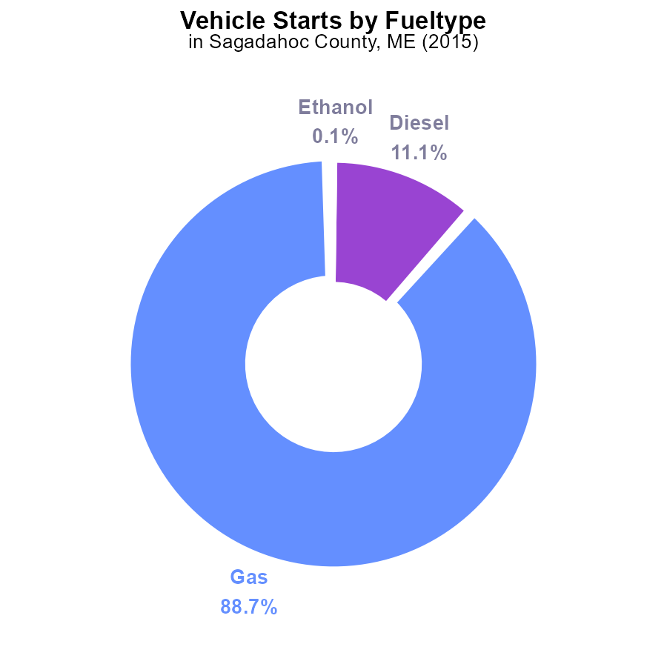

# Population over Time for Buses

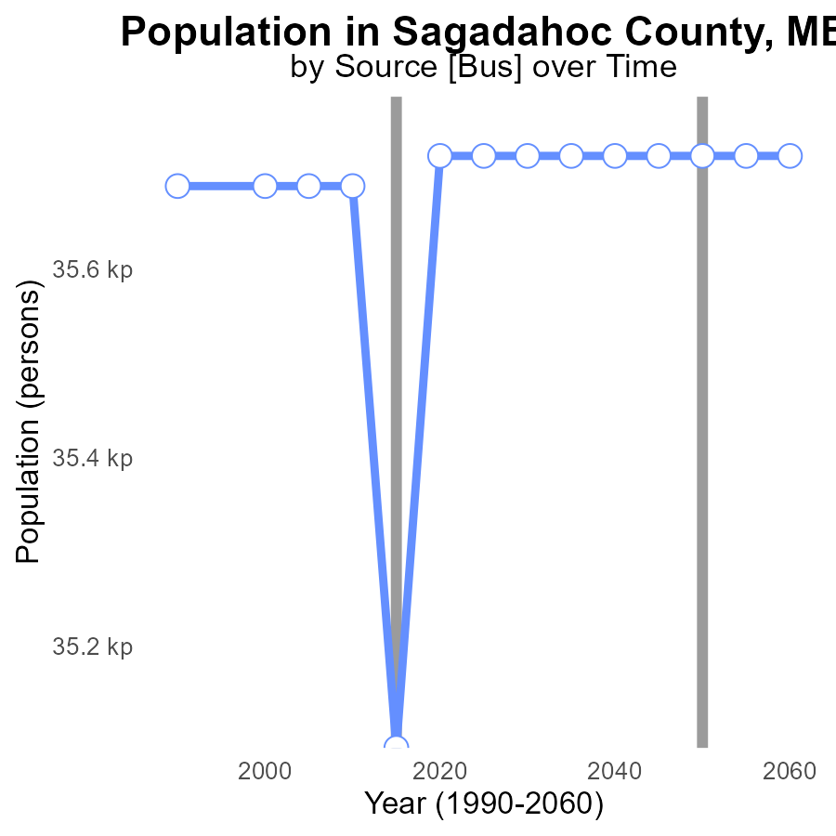

## Findings

* Stable PM10 emissions from 2000 to 2025.
* Significant decrease in PM10 emissions by 628 persons from 2015 to 2020.
* From 2020 to 2035, PM10 emissions remained steady at 35.7 k persons.

## Recommendations

To maintain the decreased PM10 emissions, focus on promoting sustainable transportation methods and enforcing stricter emissions standards for industries in Sagadahoc County.

# Vehicle Miles Traveled over Time for Buses

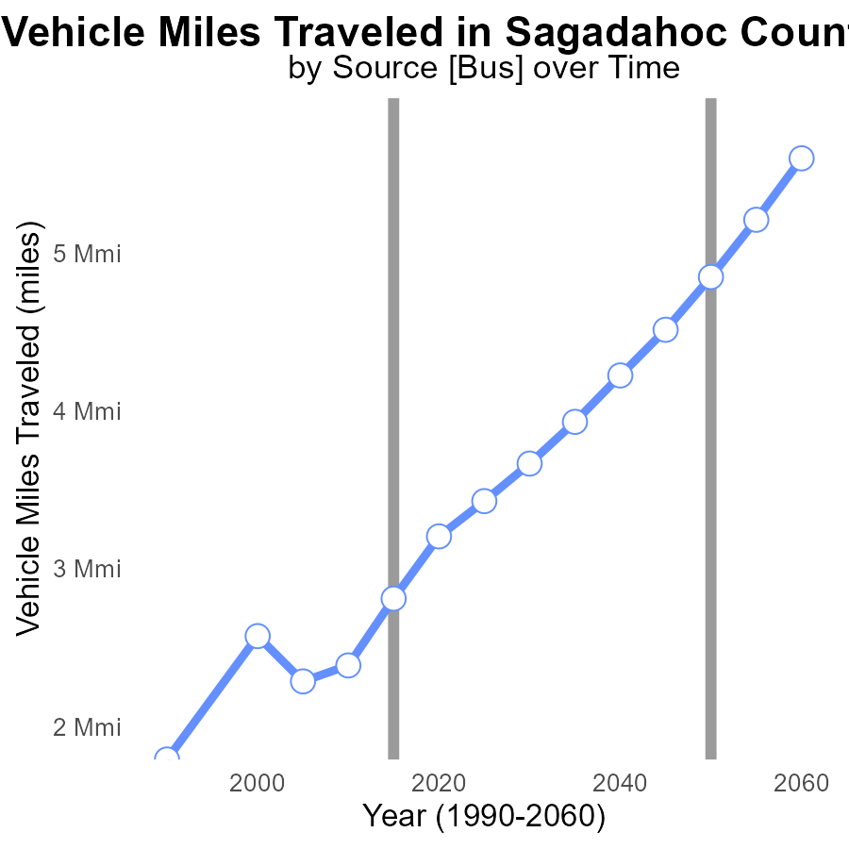

## Findings

* Vehicle miles traveled in Sagadahoc County increased by 50% from 2000 to 2035.
* PM10 emissions decreased by 4% between 2000 and 2020.
* There is a consistent trend of vehicles emitting lower PM10 levels per mile over the years.

## Recommendations

To further reduce emissions, consider promoting alternative transportation methods, enforcing stricter vehicle emission standards, and investing in infrastructure to support green transportation.

# Emissions Rate (per mile) Mapped by Area

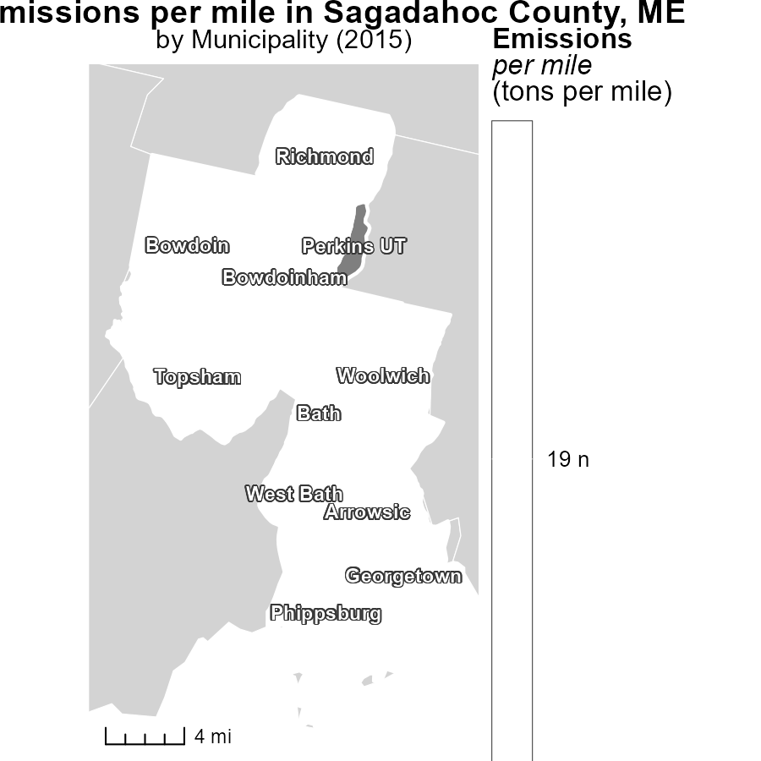

## Findings

* Arrowsic, ME had the highest emissions per mile at 19.2 tons
* Phippsburg, ME had a median emissions rate of 19.2 tons per mile
* Perkins UT, ME had the lowest emissions per mile

## Recommendations

Local authorities in Arrowsic, ME should focus on implementing emission-reducing transportation policies. Encouraging the use of public transport or carpooling could help reduce emissions. In Phippsburg, ME, initiatives to promote eco-friendly modes of transport should be considered to move away from the median emission level. Perkins UT, ME should continue their efforts to maintain a low emission rate and explore ways to further reduce emissions in transportation.

# Vehicle Starts Mapped by Area

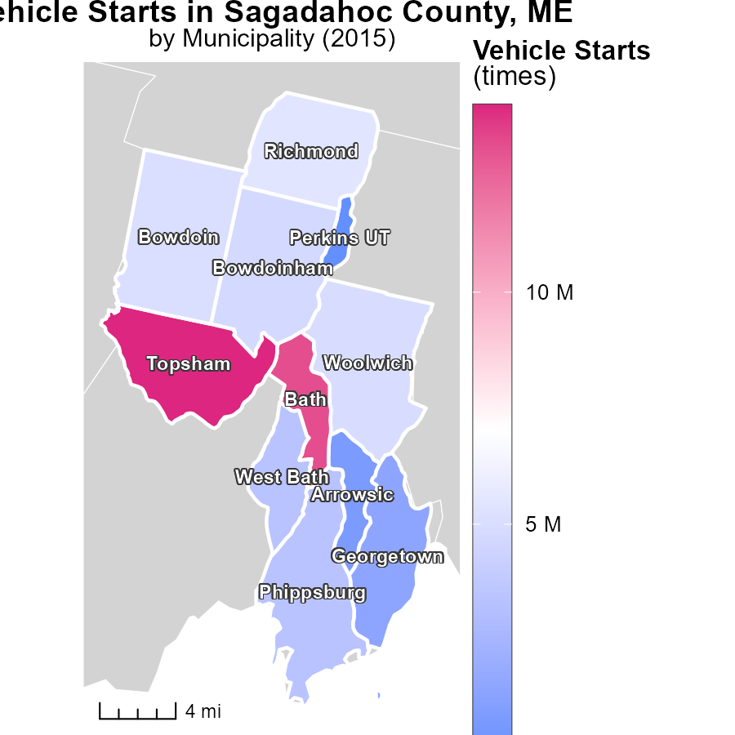

## Findings

* Topsham, ME had the highest vehicle starts in 2015 with 14.0 million times.
* Bowdoinham, ME had a median number of vehicle starts in 2015 with 4.8 million times.
* Perkins UT, ME had the lowest vehicle starts in 2015 with 0.0 times.

## Recommendations

To lower emissions, focus on reducing vehicle starts in areas with high numbers, like Topsham, ME. Encourage carpooling or use of public transportation. In areas with low starts, like Perkins UT, ME, promote efficient routes and maintenance to prevent unnecessary starts.

# Hotelling (Diesel Aux) by Vehicle Type over Time

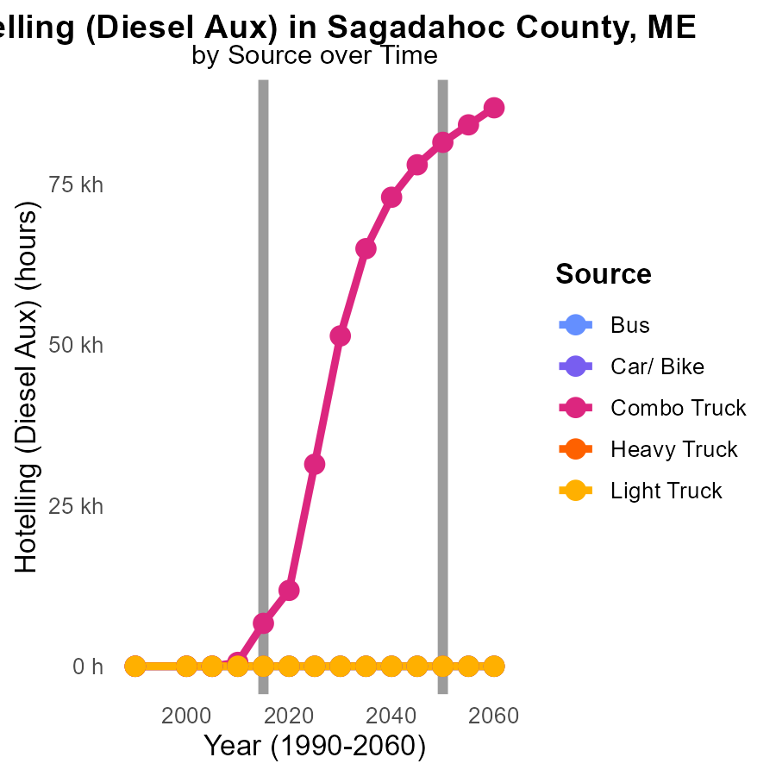

## Findings

* Combo Trucks showed a significant increase in emissions over the years.
* Other vehicle types like Bus, Heavy Truck, and Light Truck maintained a consistent emission level of 0.0.
* By 2025, Combo Trucks are projected to emit 31.4k units, a notable rise from 2005.

## Recommendations

To lower emissions, focus on implementing stricter regulations on Combo Trucks, such as mandatory emission control systems. Encourage the adoption of cleaner fuel options and promote vehicle maintenance to reduce emissions effectively.

# Emissions Rate (per capita) by Fuel Type over Time

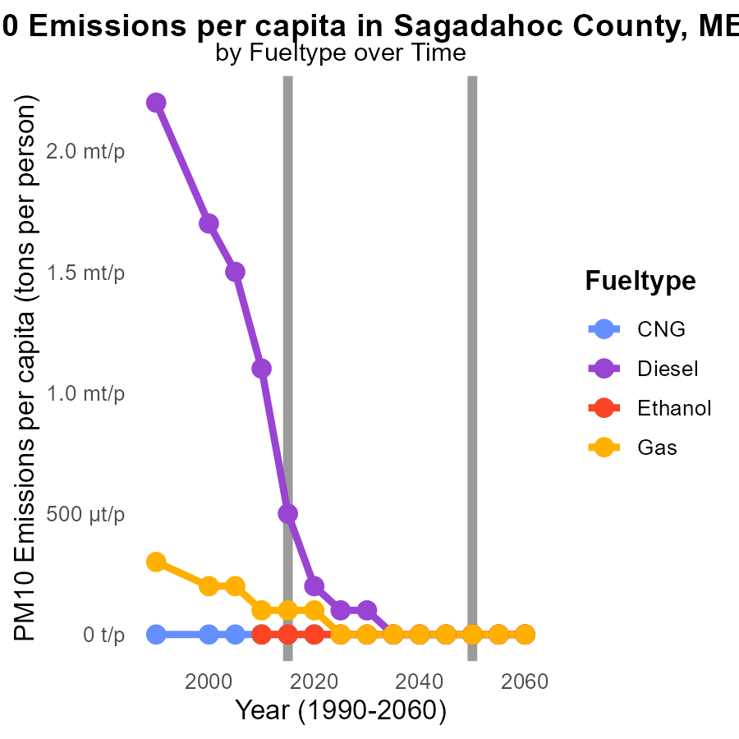

## Findings

* Diesel emissions per capita decreased from 1.5 tons in 2005 to 117.6 µ in 2025.
* Gas emissions per capita decreased from 154.1 µ in 2005 to 36.4 µ in 2025.
* Emissions from CNG and Ethanol remained at 0.0 tons per person from 2005 to 2025.

## Recommendations

To further reduce emissions in Sagadahoc County, focus on promoting cleaner fuel alternatives like CNG and Ethanol. Additionally, encourage the adoption of eco-friendly vehicles running on Gas and Diesel to sustain the declining emission trend.

# Areas Ranked by Hotelling (Engines Off)

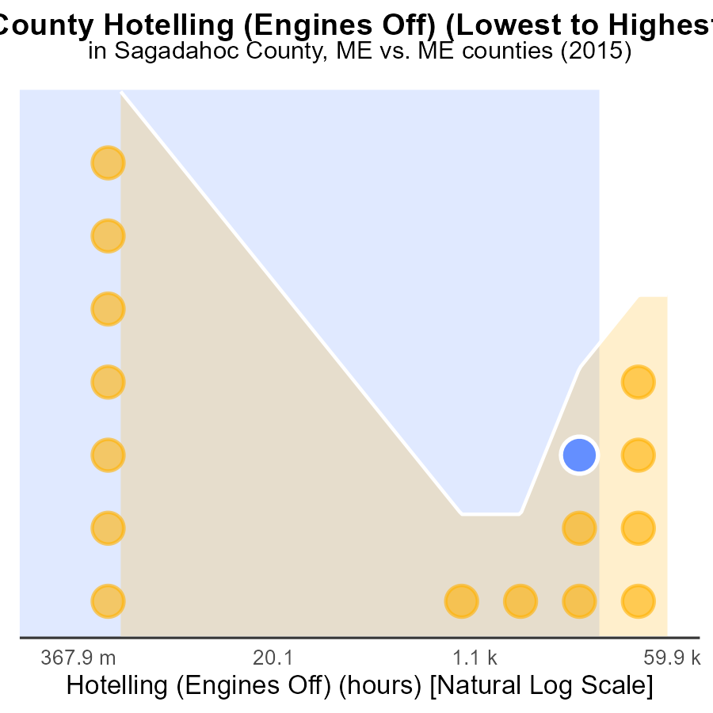

## Findings

* York county had the highest PM10 emissions in 2015 with 148.4 k hours.
* Franklin county had the lowest PM10 emissions in 2015 with 0.0 hours.
* Kennebec county had the highest percentile of 81.2% for PM10 emissions in 2015.

## Recommendations

To lower PM10 emissions, focus on implementing stricter regulations on engine use, particularly in counties with high emissions like York and Kennebec. Encourage the use of cleaner fuels and technologies.

# Areas Ranked by Hotelling (Diesel Aux)

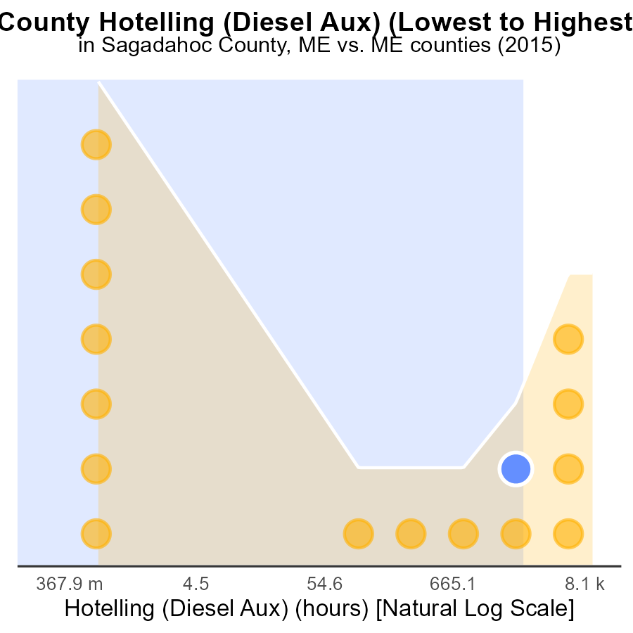

## Findings

* York county had the highest PM10 emissions with 26.6 k hours.
* Kennebec had the highest percentile of 81.2% despite emitting 17.2 k hours.
* Franklin emitted the least PM10 at 0.0 hours, ranking first with a percentile of 43.8%.

## Recommendations

To reduce PM10 emissions, focus efforts on high-emitting counties like York and Kennebec through stricter regulations, promoting cleaner technologies, and increasing public transportation options.

# Conclusion

In conclusion, Sagadahoc County faces significant challenges in reducing PM10 emissions from on-road transportation despite stable emissions from 2000 to 2025. The data highlights specific sources like HHD8, LHD34, and MHD67 that are major contributors to the county's PM10 emissions. While there has been a notable decrease in emissions between 2015 and 2020, maintaining this progress requires a focus on promoting sustainable transportation methods and enforcing stricter emission standards. To further decrease emissions, initiatives should target areas with high emissions per mile like Arrowsic and Phippsburg, while also addressing the increase in Combo Truck emissions projected for 2025. Encouraging the adoption of cleaner fuel alternatives like CNG and Ethanol, along with stricter regulations on engine use, can aid in lowering emissions. Local authorities should collaborate to implement emission-reducing transportation policies and promote eco-friendly modes of transport to achieve long-term improvements in Sagadahoc County's air quality.

# About This Report

Data based on MOVES estimates collected by the Climate Action in Transportation program at Cornell University. Demographic data sourced from the US Census's American Community Survey 5-year estimates. This report was generated with the help of AI.

# References

* U.S. Census Bureau. (2023). American Community Survey 5-year estimates: Detailed tables. Retrieved from https://data.census.gov
* U.S. Environmental Protection Agency. (2024). Motor Vehicle Emission Simulator (MOVES 4.0) [Software]. Retrieved from https://www.epa.gov/moves