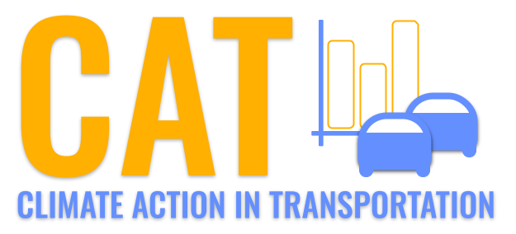 

**VOC Emissions in Gilmer County, 2040**  
Made with CAT VISUALIZER by Gao Labs @ Cornell University.

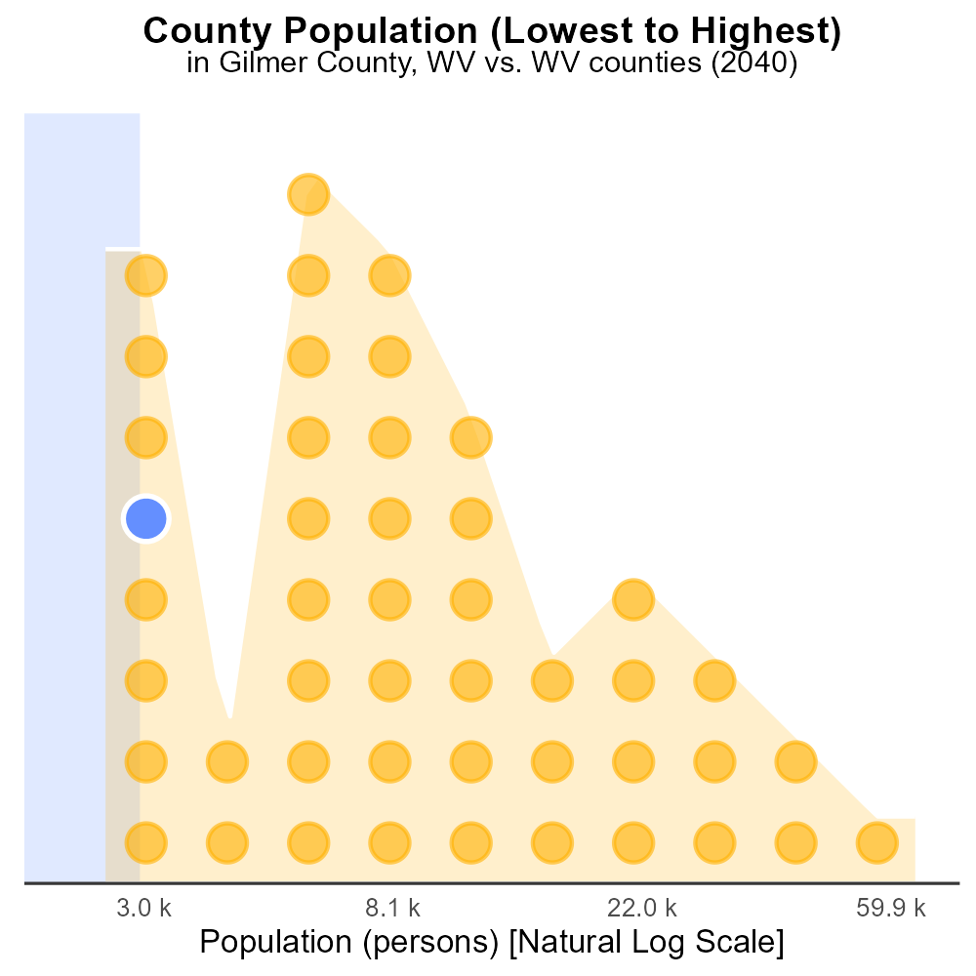

## Keywords

Volatile Organic Compounds; emissions; on-road transportation; Gilmer County; WV; 2040

## Highlights

* Study on VOC emissions from on-road transport in Gilmer County, WV in 2040.
* Assessment of the impact of future transportation on air quality in the county.
* Analyzing sources and levels of VOC emissions for effective mitigation strategies.
* Understanding the environmental and health implications of increased VOCs.
* Recommendations for policy measures to control VOC emissions in Gilmer County.

# Introduction

The report examines the projected Volatile Organic Compounds (VOC) emissions originating from on-road transportation in Gilmer County, West Virginia, in the year 2040. With a specific focus on the potential environmental and health impacts, this study aims to provide a thorough analysis of the sources and levels of VOCs in the county's air.

By comprehensively evaluating the anticipated changes in transportation patterns and vehicle technologies by 2040, the report seeks to facilitate an understanding of how these factors might influence VOC emissions. Through this analysis, the report aims to offer recommendations for effective mitigation strategies and policy measures to control and reduce VOC emissions, ensuring a sustainable and healthy environment for the residents of Gilmer County.

# Emissions by Fuel Type

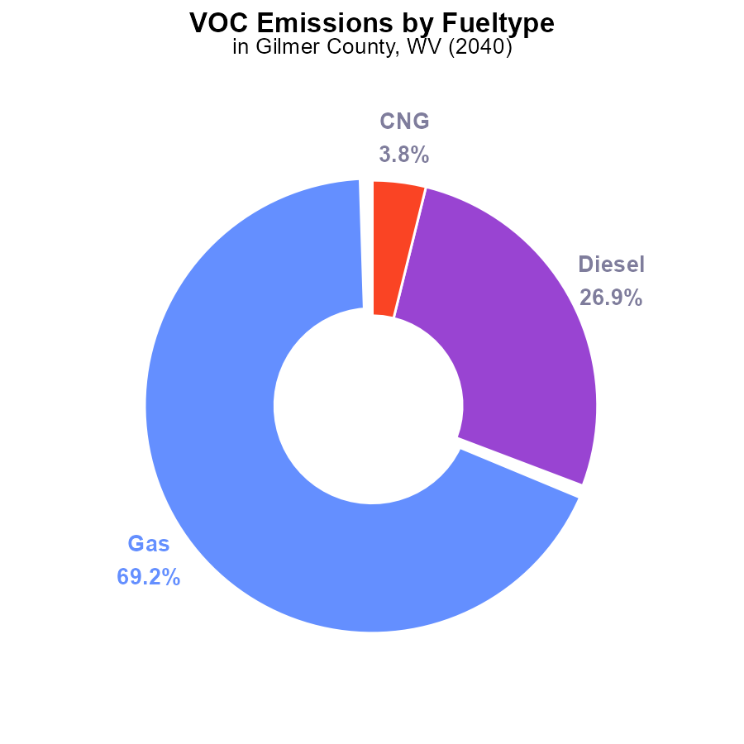

## Findings

* Gas emissions are 1.8 tons, representing 69.2% of total VOC emissions.
* Diesel emissions stand at 700.0 tons, accounting for 26.9% of the total.
* CNG and Ethanol emissions are minimal, at 100.0 tons (3.8%) and 0.0 tons (0.0%) respectively.

## Recommendations

To lower VOC emissions in Gilmer County, focus on reducing gas and diesel usage through incentivizing electric vehicles, promoting public transportation, and enforcing stricter emission standards for vehicles and industries.

# Hotelling (Diesel Aux) by Road Type

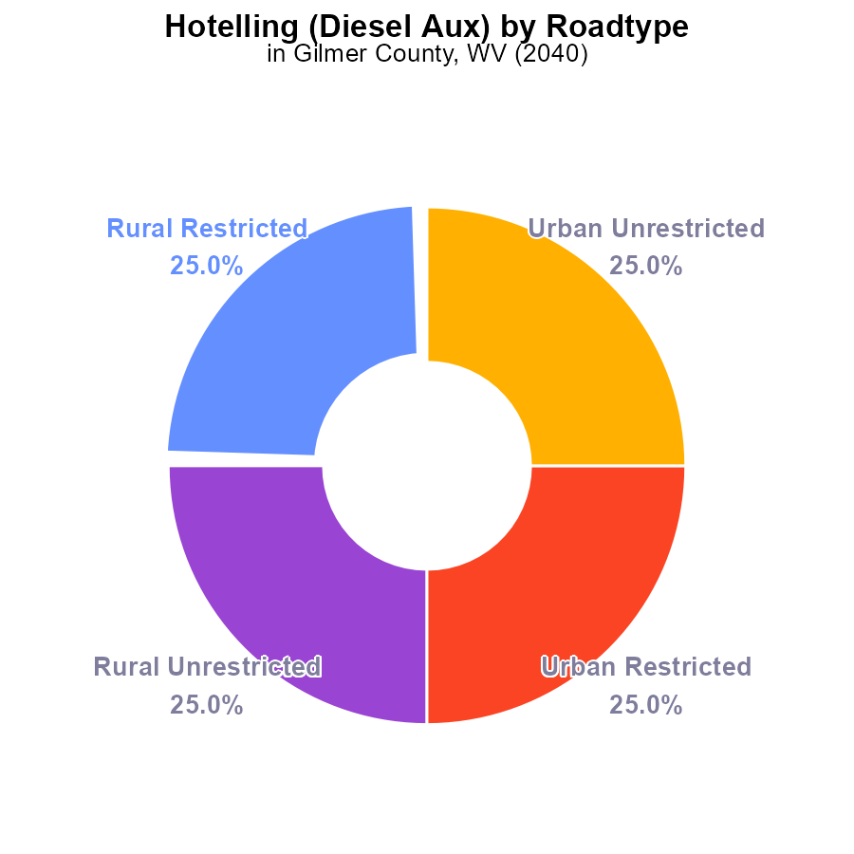

# Emissions Rate (per capita) over Time for Passenger Vehicles

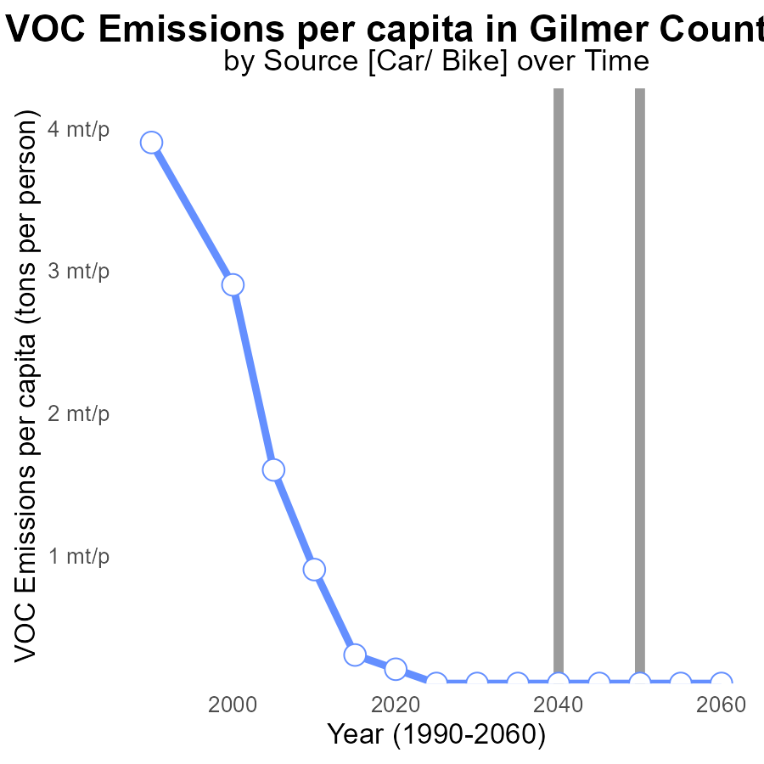

## Findings

* Emissions per capita decreased from 200.8 tons in 2020 to 100.4 tons in 2030.
* After 2030, emissions remained constant at 100.4 tons per person until 2060.

## Recommendations

Implement sustainable transportation policies to maintain the decreasing trend in emissions per capita. Encourage the use of electric vehicles and public transportation.

# Emissions Rate (per vehicle) over Time for Buses

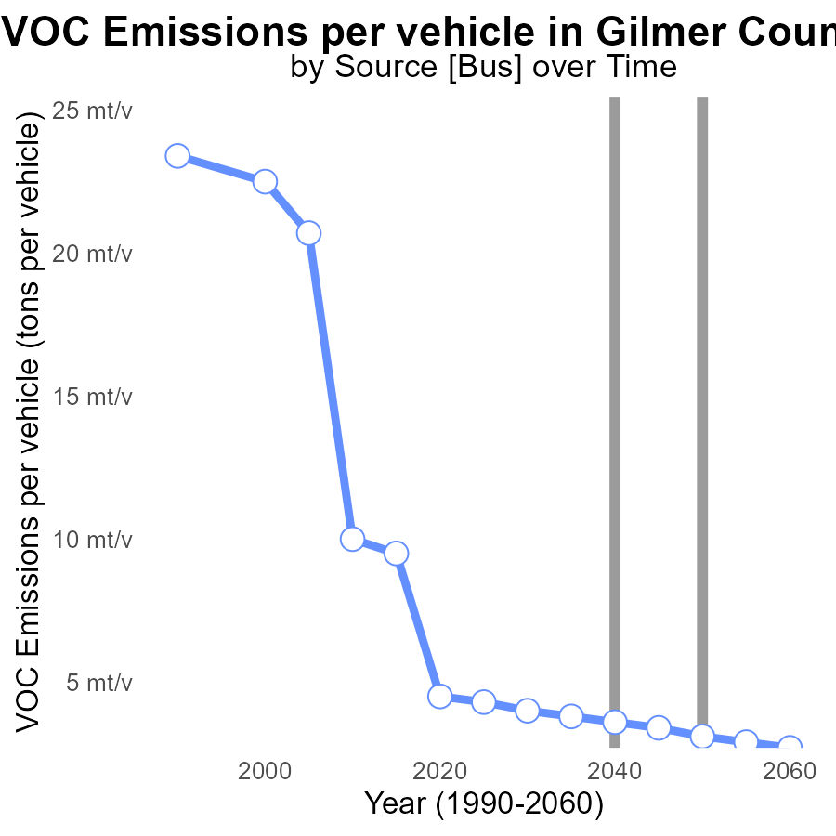

## Findings

* Emissions per vehicle in Gilmer County, WV have decreased steadily from 4.5 tons in 2020 to 2.7 tons in 2060.
* The benchmark difference shows a consistent improvement, reaching -0.0005 tons in 2040 before eventually stabilizing at 0.0004 tons in 2060.
* By 2060, emissions per vehicle are projected to be 39.9% lower compared to 2020 levels in Gilmer County.

## Recommendations

To continue lowering VOC emissions per vehicle, policymakers should incentivize the adoption of cleaner technologies in vehicles, invest in public transportation, and promote carpooling to reduce the number of vehicles on the road.

# Vehicle Starts Mapped by Area

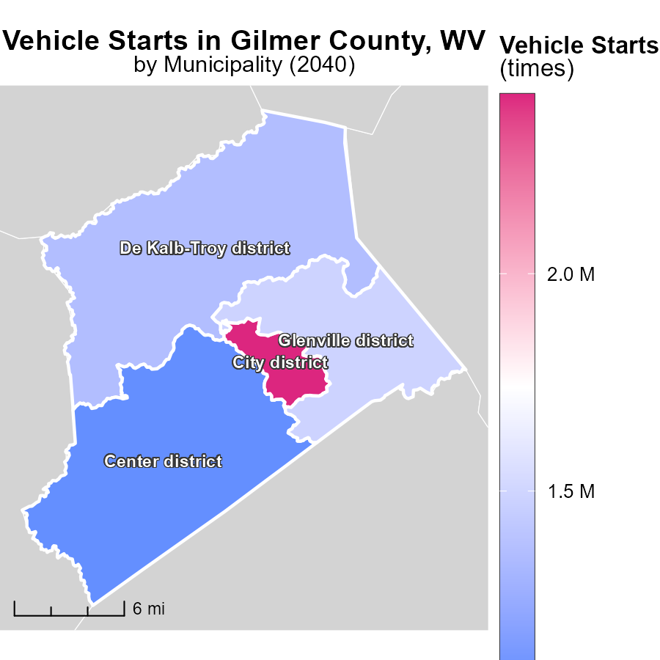

## Findings

* City district, WV has the highest number of vehicle starts with 2.4 million.
* Glenville district, WV has a median number of vehicle starts at 1.5 million.
* Center district, WV has the lowest vehicle starts at 1.1 million.

## Recommendations

To lower emissions, focus on improving public transport in City district, WV due to the high number of vehicle starts. Encourage carpooling and implement policies to promote electric vehicles.

# Vehicles in My Region

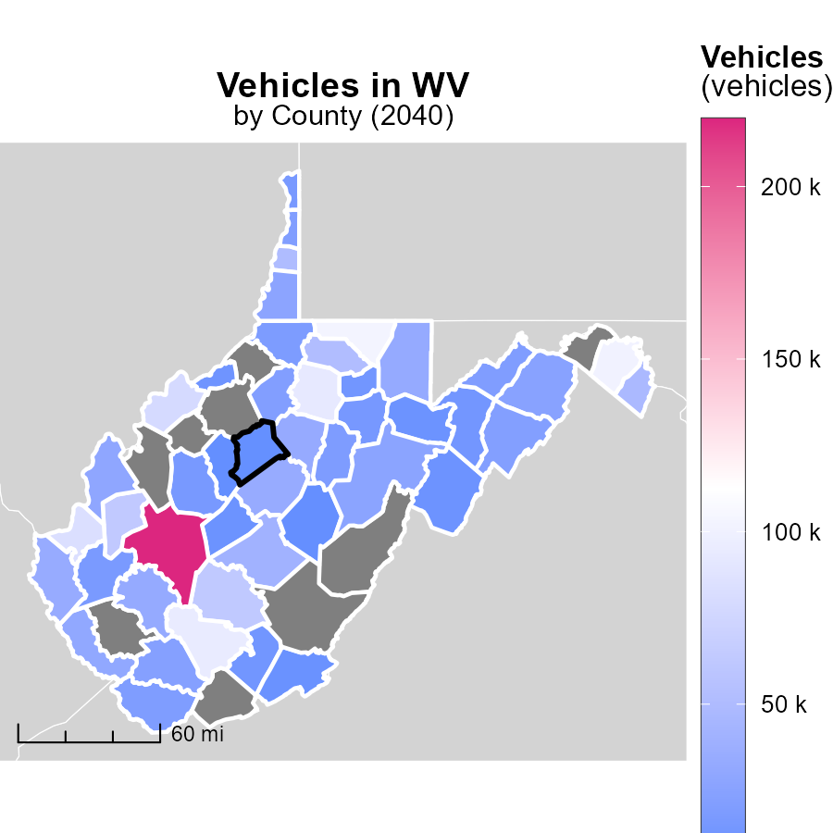

## Findings

* Kanawha County, WV has the highest vehicle emissions at 219.5k
* Wyoming County, WV has a median of 23.0k vehicle emissions
* Calhoun County, WV shows the lowest vehicle emissions at 5.7k

## Recommendations

To reduce emissions, encourage public transportation, carpooling, and use of electric vehicles in all counties.

# Population by Fuel Type over Time

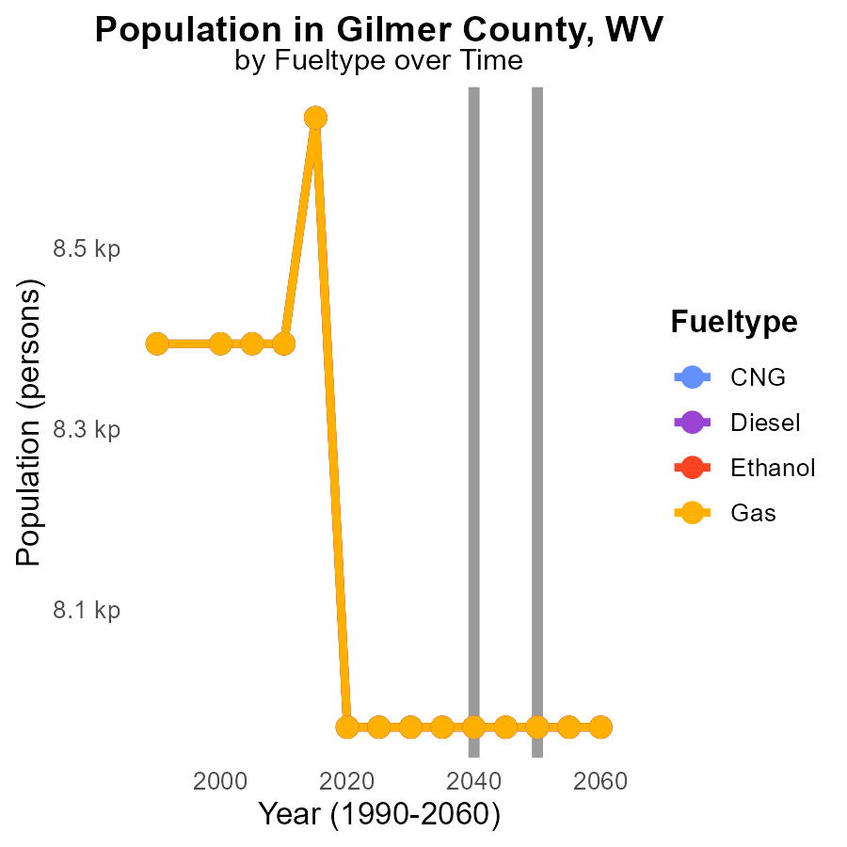

## Findings

* Emissions from various fuel types in Gilmer County, WV are consistent from 2030 to 2050, with 8.0 k emissions for CNG, Diesel, Ethanol, and Gas.
* No significant reduction or increase in emissions was observed over the 20-year period.
* A detailed analysis suggests a stable emission trend in Gilmer County, WV across different fuel types from 2030 to 2050.

## Recommendations

To lower emissions, policymakers should focus on implementing stricter emission control measures on industries and vehicles, promoting public transportation, incentivizing the use of electric vehicles, and investing in renewable energy sources.

# Hotelling (Engines Off) by Area over Time

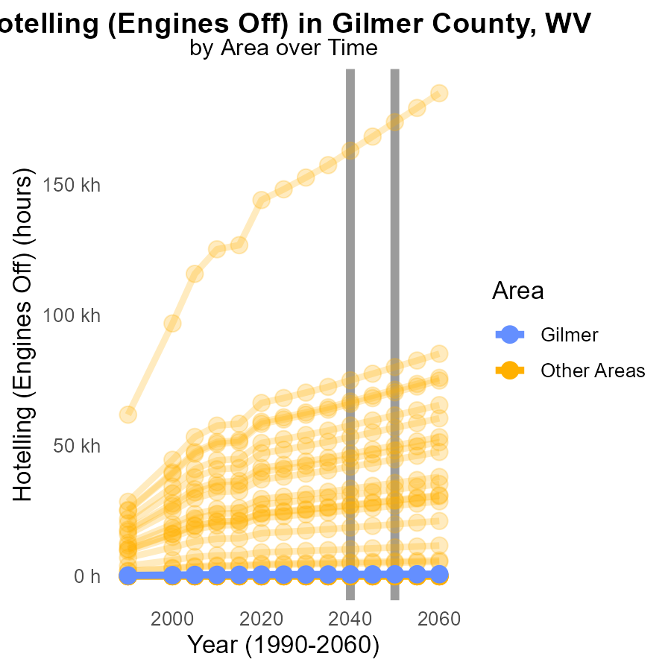

## Findings

* In 2040, VOC emissions from hotelling with engines off in Max County were 651.4 hours.
* This value is 43.8 hours higher than the emissions in 2050.

## Recommendations

To reduce VOC emissions in hotelling activities with engines off in Max County, measures should focus on optimizing engine operation, promoting alternative energy sources, and implementing emission control technologies. Regular maintenance of vehicles and education on eco-friendly practices can also contribute to lowering emission levels.

# Areas Ranked by Population

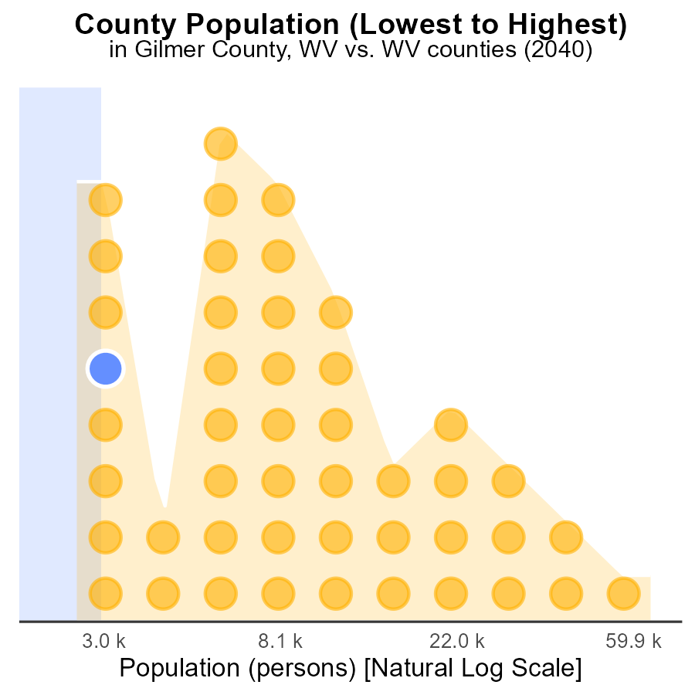

## Findings

* Kanawha County has the highest population with 181.0k persons.
* Gilmer County has the lowest population with 8.0k persons.
* Tucker County has a population of 6.9k persons, contributing to 3.0% of Kanawha County's population.

## Recommendations

To lower VOC emissions, focus on densely populated areas like Kanawha County by promoting public transportation, carpooling, and implementing stricter regulations on industrial emissions.

# Areas Ranked by Emissions Rate (per vehicle)

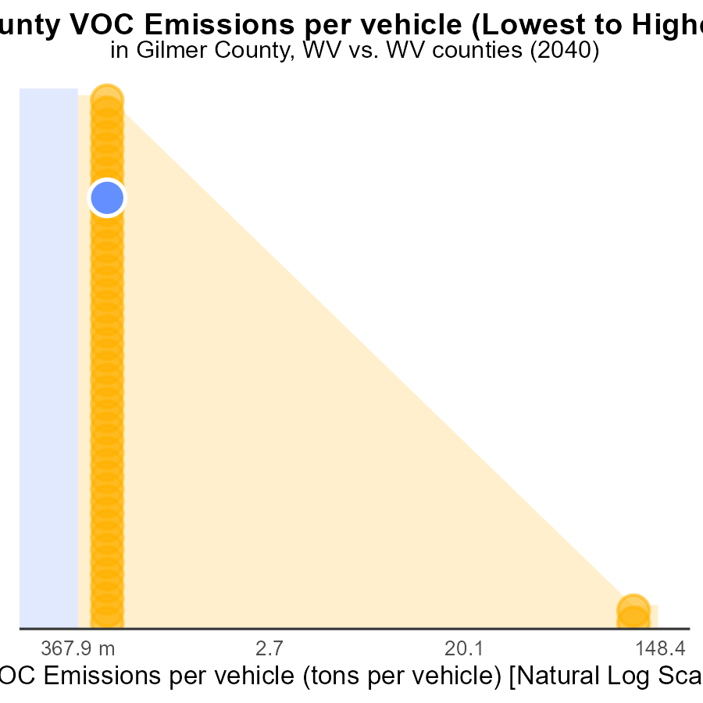

## Findings

* The county with the highest VOC emissions per vehicle is Berkeley with 371.4 tons per vehicle.
* Clay County has the highest rank, with 402.1 tons per vehicle, placing it in the 100th percentile.
* The counties with the highest percentage of emissions are Wood, Gilmer, and Calhoun, ranging from 76.1% to 80.4%.

## Recommendations

To lower emissions, these counties should consider implementing stricter vehicle emission standards and promoting the use of public transportation to reduce the number of vehicles on the road.

# Conclusion

In conclusion, the data from Gilmer County, WV in 2040 provides valuable insights into the state of volatile organic compounds (VOC) emissions from on-road transportation. Gas and diesel emissions remain the primary contributors, while CNG and ethanol emissions are minimal. Strategies to reduce VOC emissions should prioritize incentivizing electric vehicles, promoting public transportation, and enforcing stricter emission standards.

Emissions per capita have shown a decreasing trend, emphasizing the importance of sustainable transportation policies. Encouraging the adoption of cleaner technologies in vehicles and investing in public transportation are crucial steps to maintain this positive trajectory. Additionally, focusing on densely populated areas like Kanawha County and counties with high VOC emissions per vehicle, such as Berkeley and Clay County, can significantly impact lowering overall emissions in the region.

# About This Report

Data based on MOVES estimates collected by the Climate Action in Transportation program at Cornell University. Demographic data sourced from the US Census's American Community Survey 5-year estimates. This report was generated with the help of AI.

# References

* U.S. Census Bureau. (2023). American Community Survey 5-year estimates: Detailed tables. Retrieved from https://data.census.gov
* U.S. Environmental Protection Agency. (2024). Motor Vehicle Emission Simulator (MOVES 4.0) [Software]. Retrieved from https://www.epa.gov/moves