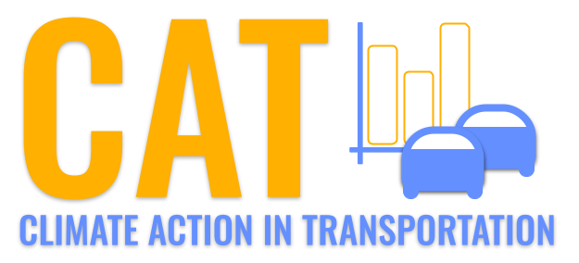 

**PM2.5 Emissions in Randolph County, 2035**  
Made with CAT VISUALIZER by Gao Labs @ Cornell University.

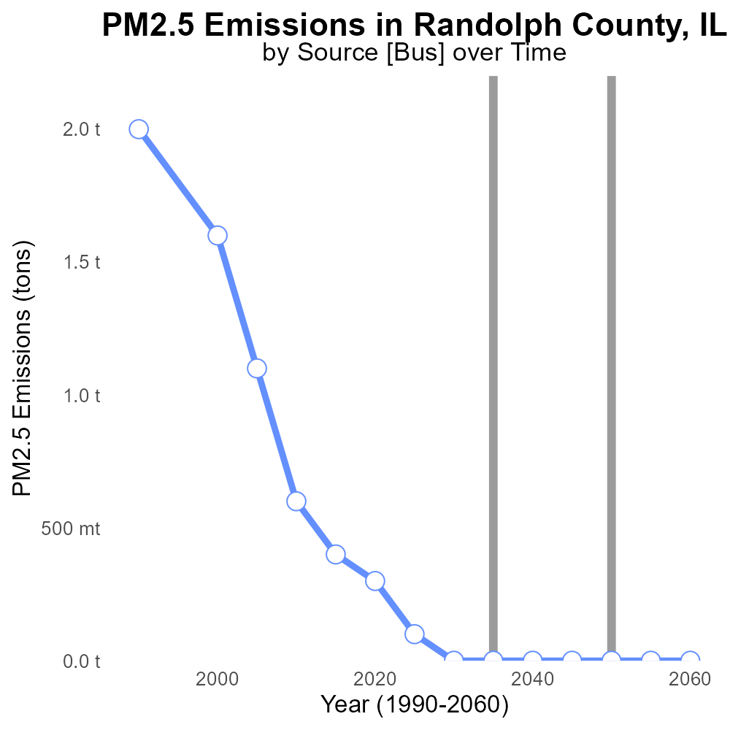

## Keywords

Primary Exhaust PM2.5; Total emissions; On-road transportation; Randolph County; IL; 2035

## Highlights

* Examination of PM2.5 emissions from on-road transportation in Randolph County.
* Evaluation of primary exhaust sources contributing to PM2.5 emissions.
* Forecasting total emissions and implications for air quality in 2035.
* Assessment of the impact of transportation trends on air pollution levels.
* Recommendations for mitigation strategies to reduce PM2.5 emissions.

# Introduction

The report focuses on analyzing the primary exhaust PM2.5 emissions from on-road transportation in Randolph County, Illinois, projected for the year 2035. By examining the sources of PM2.5 emissions originating specifically from on-road vehicles, the study aims to provide valuable insights into the key contributors to air pollution in the region. With a forecast of total emissions in 2035, the report will offer a comprehensive overview of the current state of air quality and the expected trends in PM2.5 levels attributed to transportation activities.

The evaluation will also consider the potential implications of these emissions on public health and the environment, highlighting the urgent need for effective mitigation strategies to tackle the growing issue of air pollution in Randolph County.

# Emissions by Road Type

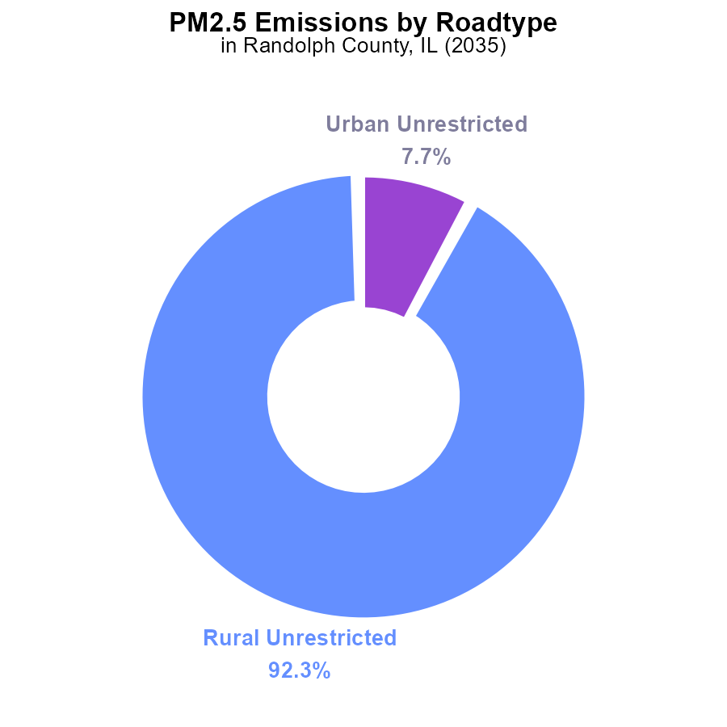

## Findings

* Rural unrestricted areas are the main source of PM2.5 emissions at 92.3%.
* Urban unrestricted areas contribute 7.7% of the PM2.5 emissions.
* No emissions were reported from the rural or urban restricted areas.

## Recommendations

To reduce PM2.5 emissions in Randolph County, focus should primarily be on implementing measures in rural unrestricted areas. Urban areas also require attention to further decrease emissions. Monitoring systems should be set up to track changes accurately.

# Emissions Rate (per mile) by Road Type

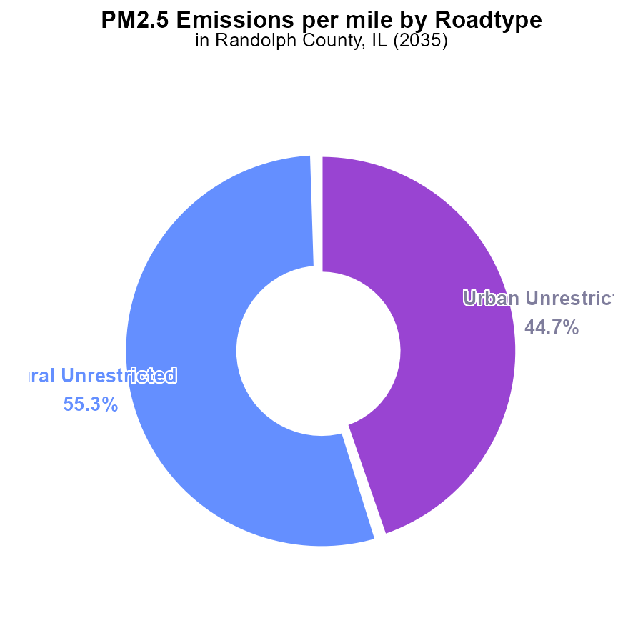

## Findings

* Rural unrestricted areas contribute 55.3% of PM2.5 emissions per mile.
* Urban unrestricted areas contribute 44.7% of PM2.5 emissions per mile.

## Recommendations

To reduce emissions in Randolph County, IL, initiatives should focus on improving vehicle efficiency in rural and urban areas to decrease PM2.5 emissions. Implementing stricter emission standards for vehicles and promoting the use of public transportation can also help lower overall emissions.

# Emissions over Time for Buses

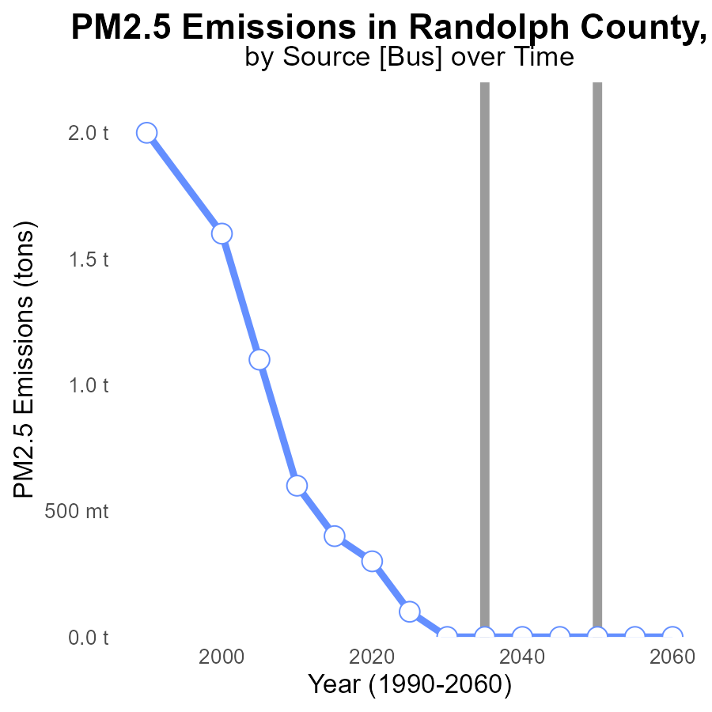

## Findings

* PM2.5 emissions in Randolph County decreased from 400.0 tons in 2015 to 100.0 tons in 2025.
* A steady decline is observed, reaching 0.0 tons in 2030, with no emissions projected from 2030 onwards.
* The benchmark difference shows consistent improvement, with reductions from -0.4 in 2015 to -0.1 in 2025.

## Recommendations

The reductions in PM2.5 emissions indicate progress, yet further steps can be taken. Continuous monitoring and enforcement of emission regulations, investment in cleaner technologies, and promotion of sustainable practices can help maintain the decreasing trend and ensure sustained emission-free years post-2030.

# Vehicle Miles Traveled Overall over Time

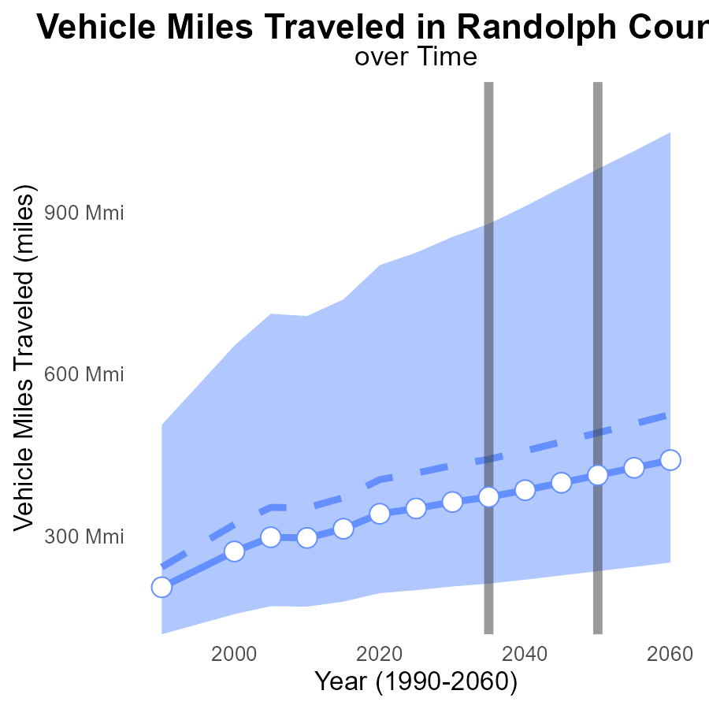

## Findings

* Vehicle miles traveled in Randolph County, IL have been consistently increasing over the years.
* The benchmark difference shows a decreasing trend, with a significant drop from 2015 to 2050.
* By 2050, vehicle miles traveled are projected to reach 412.4 million, with a difference of 78.6 million from the median area.

## Recommendations

To lower emissions, Randolph County should focus on promoting alternative transportation methods such as public transportation, carpooling, cycling, and walking. Implementing policies to encourage telecommuting and reducing the need for physical commuting can significantly reduce vehicle miles traveled. Investment in infrastructure to support these alternatives is crucial for success.

# Hotelling (Engines Off) in My Region

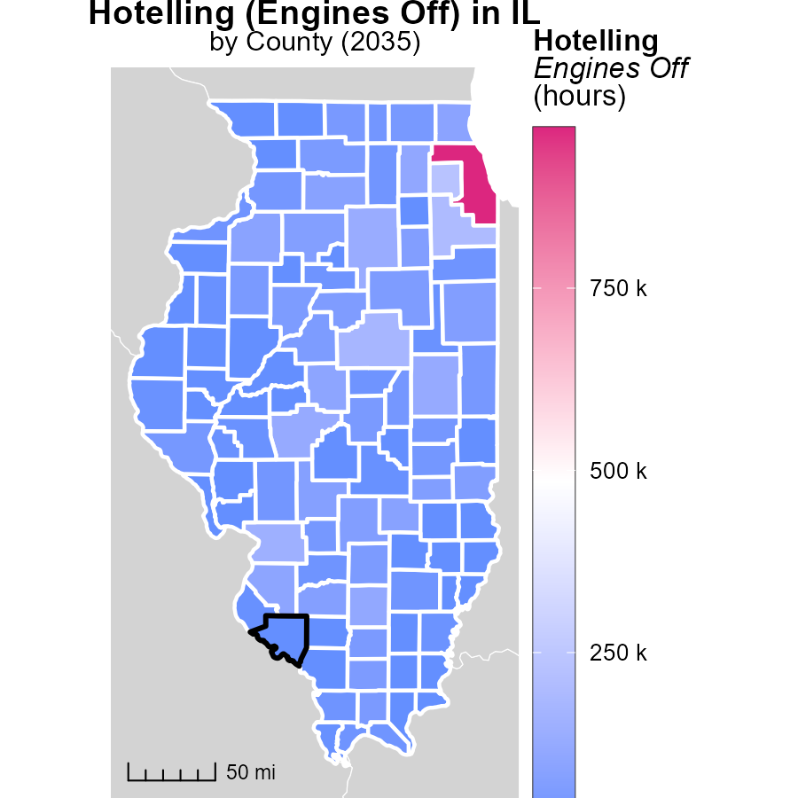

## Findings

* In Cook County, IL, the maximum emissions from Hotelling (Engines Off) in 2035 were 970.0 k hours.
* Pulaski County, IL, had a median emission of 23.6 k hours in the same year.
* Wabash County, IL, had the lowest emissions in 2035 with 0.0 k hours.

## Recommendations

To lower emissions, incentivize engine-off initiatives in Cook County, IL, to reduce emissions in high-impact areas. Implement similar programs in Pulaski County, IL, focusing on median emissions, and initiate awareness campaigns in Wabash County, IL, to maintain their low emission levels.

# Population Mapped by Area

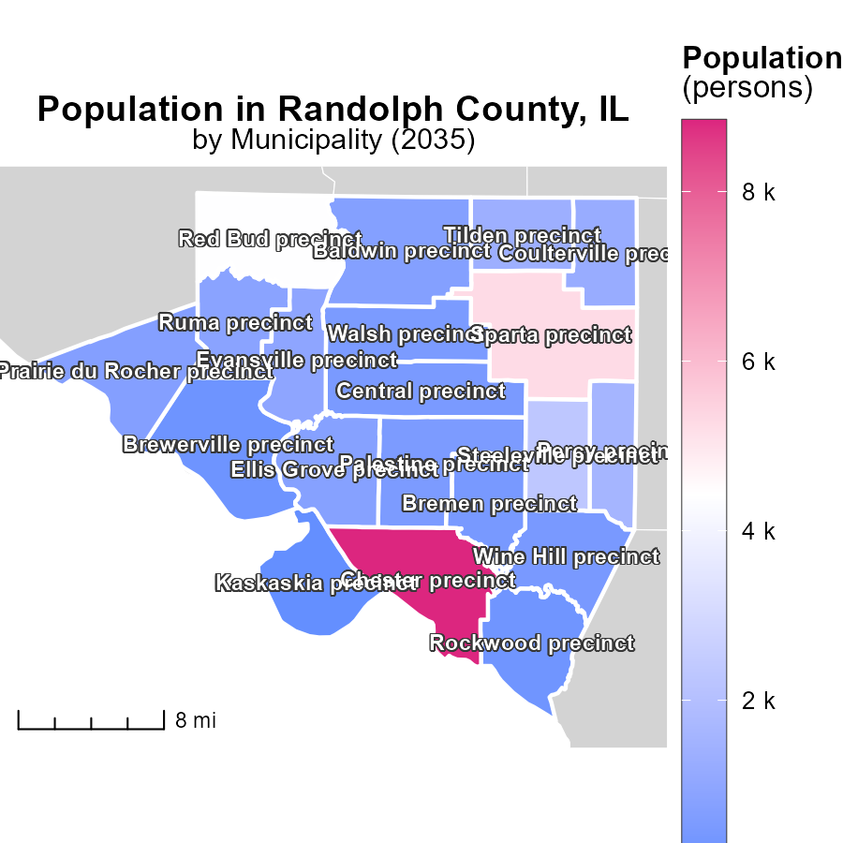

## Findings

* The population of Chester precinct, IL is 8.8k, representing the highest emissions.
* Ellis Grove precinct, IL with 773 persons has a mid-level impact on emissions.
* Kaskaskia precinct, IL, with a population of 29 persons, accounts for the lowest emissions.

## Recommendations

To lower emissions, focus on reducing energy consumption in high-population areas like Chester precinct. Implement community-wide energy efficiency programs. Encourage public transportation use. In low-population areas like Kaskaskia precinct, promote sustainable practices like solar energy use.

# Hotelling (Engines Off) by Area over Time

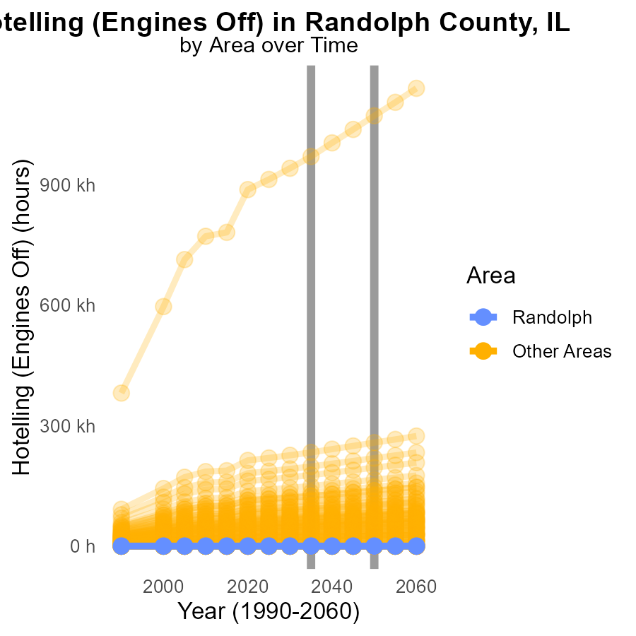

## Findings

* In 2035, maximum PM2.5 emissions in the county were 970,000 kg.
* There were no PM2.5 emissions in the county in the same year.
* Overall, there was an increase of 101,472.1 kg of PM2.5 emissions compared to 2050 levels.

## Recommendations

To lower emissions, focus on reducing sources like vehicular emissions and industrial activities. Implement stricter regulations and promote cleaner technologies.

# Idling by Area over Time

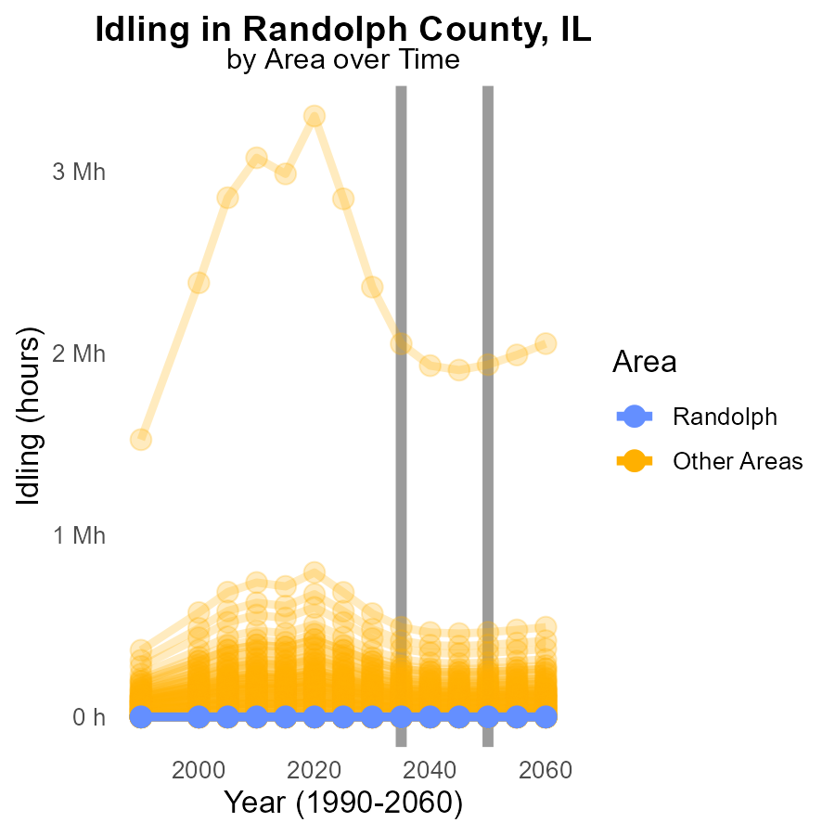

## Findings

* In 2035, max_county reported an idling emissions value of 2.1 million, a decrease of 114610.7 compared to 2050.
* In 2035, min_county reported consistently low idling emissions of 0.0, with no change from 2050 levels.

## Recommendations

To decrease idling emissions, focus on implementing stricter regulations and incentives for low-emission vehicles. Max_county should continue efforts to reduce emissions, while min_county should maintain current levels.

# Areas Ranked by Emissions Rate (per capita)

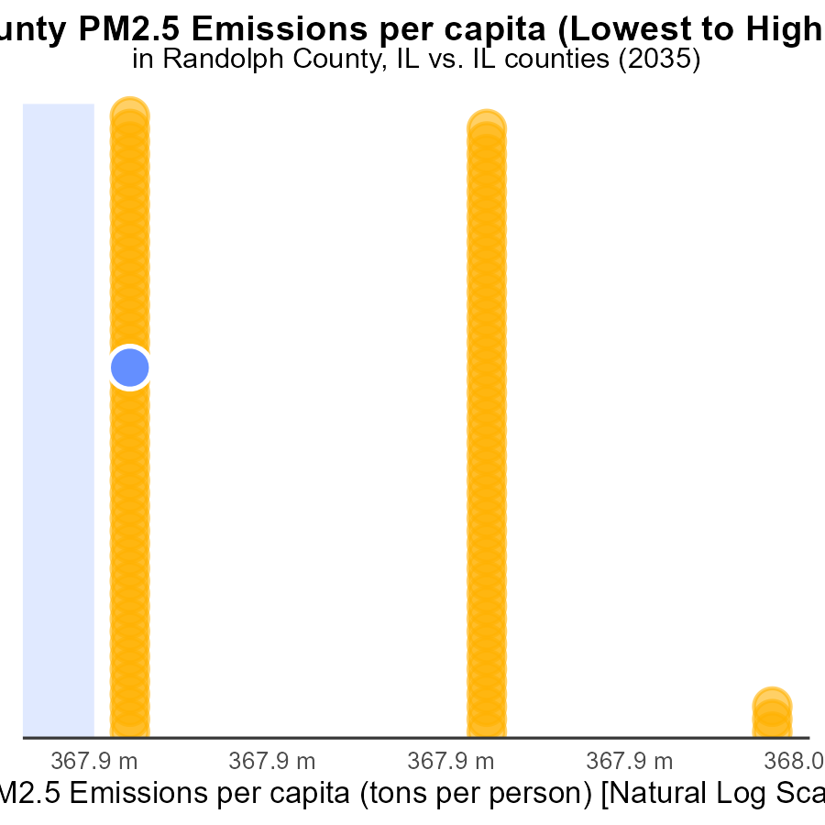

## Findings

* Cumberland county has the highest PM2.5 emissions per capita at 203.9 tons/person.
* Cook county ranks 1st with the lowest emissions per capita at 20.1 tons/person.
* Jersey county has high emissions per capita, ranking 31st with 41.3 tons/person.

## Recommendations

To lower emissions, focus on industries or activities contributing the most in high-emission counties like Cumberland and Jersey. Implement stricter emission regulations in these areas.

# Areas Ranked by Vehicle Starts

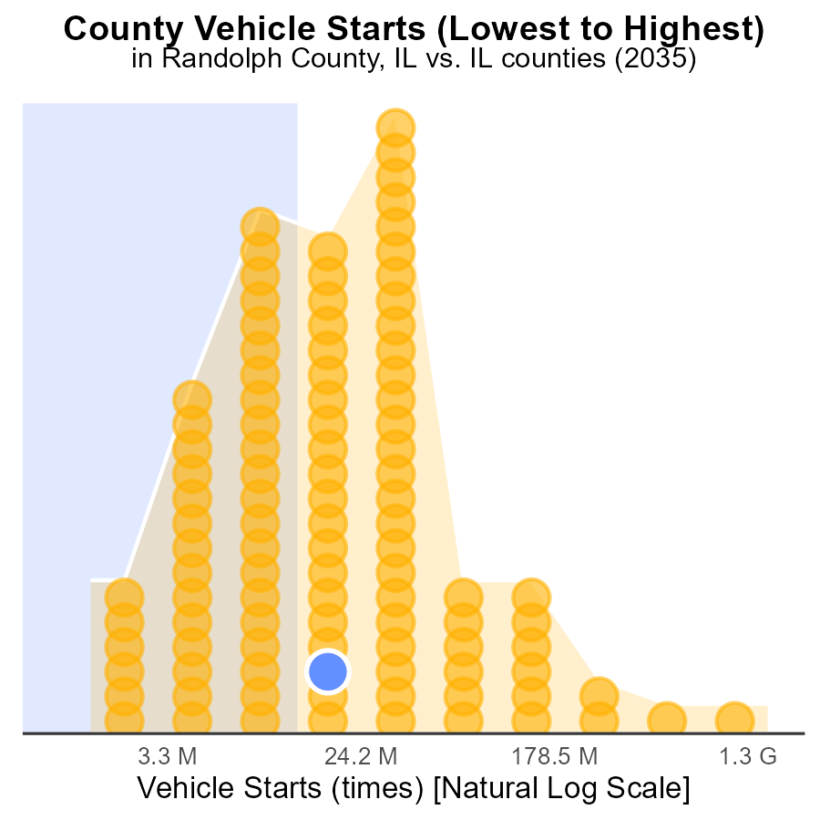

## Findings

* Cook county has the highest number of vehicle starts with 4.4 billion.
* Hardin county has the lowest number of vehicle starts with 4.0 million.
* Piatt county has the highest percentile of vehicle starts with 44.1%.

## Recommendations

To lower emissions, Cook county should focus on reducing the number of vehicle starts given its significantly high level. Implementing measures such as promoting public transportation, carpooling, and investing in electric vehicles could help reduce emissions in these areas.

# Conclusion

In conclusion, the data on Primary Exhaust PM2.5 emissions from on-road transportation in Randolph County, IL in 2035 highlights the significant contributions from rural unrestricted areas. These regions account for the vast majority of PM2.5 emissions, necessitating focused efforts to improve vehicle efficiency and implement stricter emission standards. While a commendable decline in overall emissions has been observed, further steps are essential to sustain this progress post-2030.

To maintain the decreasing trend of PM2.5 emissions, continuous monitoring, and stringent enforcement of emission regulations are crucial. Investments in cleaner technologies, promotion of sustainable practices, and the encouragement of alternative transportation methods can all contribute to reducing emissions and improving air quality in Randolph County. By prioritizing these strategies, the county can work towards achieving emission-free years beyond 2030 and create a healthier environment for its residents.

# About This Report

Data based on MOVES estimates collected by the Climate Action in Transportation program at Cornell University. Demographic data sourced from the US Census's American Community Survey 5-year estimates. This report was generated with the help of AI.

# References

* U.S. Census Bureau. (2023). American Community Survey 5-year estimates: Detailed tables. Retrieved from https://data.census.gov
* U.S. Environmental Protection Agency. (2024). Motor Vehicle Emission Simulator (MOVES 4.0) [Software]. Retrieved from https://www.epa.gov/moves