 

**PM10 Emissions in Campbell County, 2025**  
Made with CAT VISUALIZER by Gao Labs @ Cornell University.

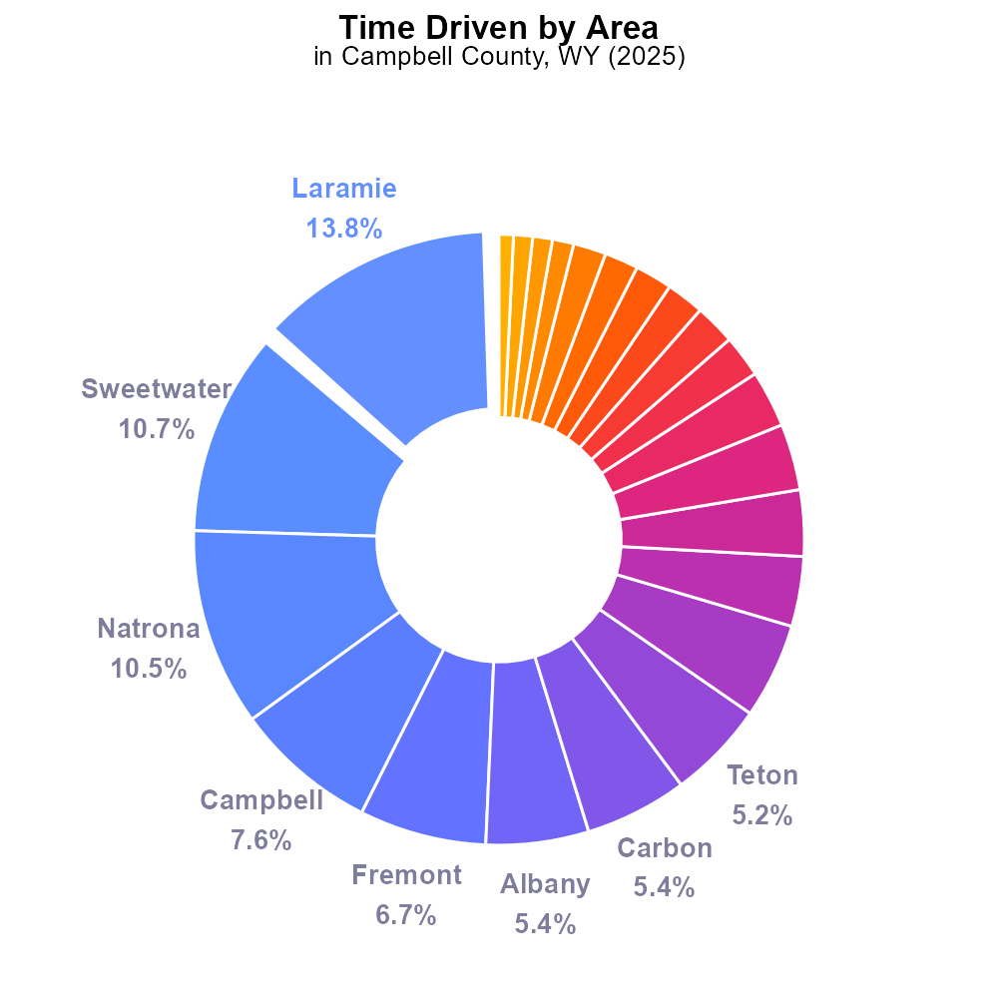

## Keywords

Primary Exhaust PM10; Total emissions; on-road transportation; Campbell County; 2025

## Highlights

* Analysis of PM10 emissions from on-road transportation in Campbell County, WY.
* Comparison of PM10 emissions to regulatory standards.
* Identification of key contributors to PM10 emissions.
* Implications for air quality and public health in the region.
* Recommendations for reducing PM10 emissions in the future.

# Introduction

The following report provides a comprehensive analysis of primary exhaust PM10 emissions from on-road transportation in Campbell County, Wyoming, for the year 2025. PM10 refers to particulate matter with a diameter of 10 micrometers or less, which can have significant impacts on air quality and public health.

By examining the total emissions of PM10 specifically from on-road transportation sources, this report aims to assess the level of pollution in the region and compare it to regulatory standards. Additionally, the report identifies key contributors to PM10 emissions and their implications for air quality and public health. Recommendations for reducing PM10 emissions in the future will also be discussed.

# Time Driven Overall by Area

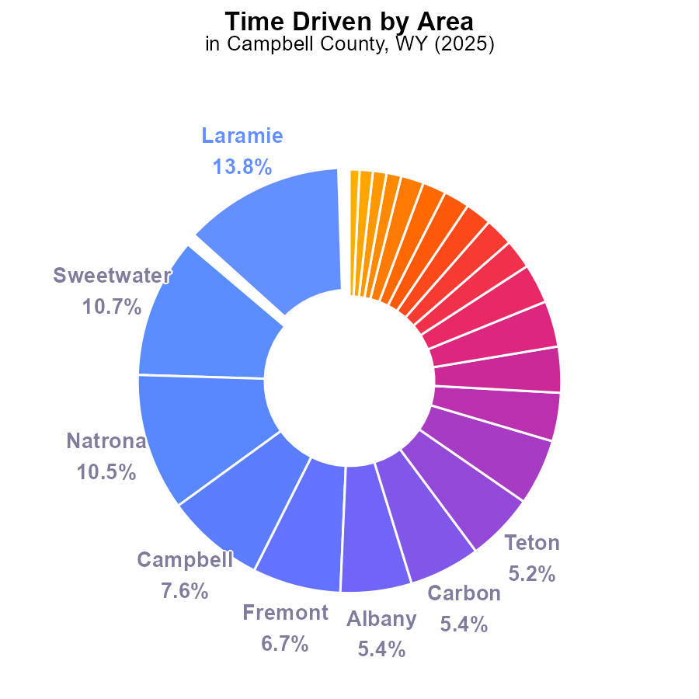

## Findings

* Laramie has the highest PM10 emissions with 33.1 million hours, accounting for 13.8% of the total.
* The top three contributors to PM10 emissions are Laramie, Sweetwater, and Natrona counties, collectively representing 35% of the total emissions.
* Hot Springs county has the lowest PM10 emissions at 1.8 million hours, contributing only 0.8% to the total.

## Recommendations

To lower PM10 emissions, focus on reducing emissions in top-contributing counties like Laramie, Sweetwater, and Natrona. Implement stricter emission regulations and promote cleaner energy sources.

# Hotelling (Diesel Aux) by Regulatory Class

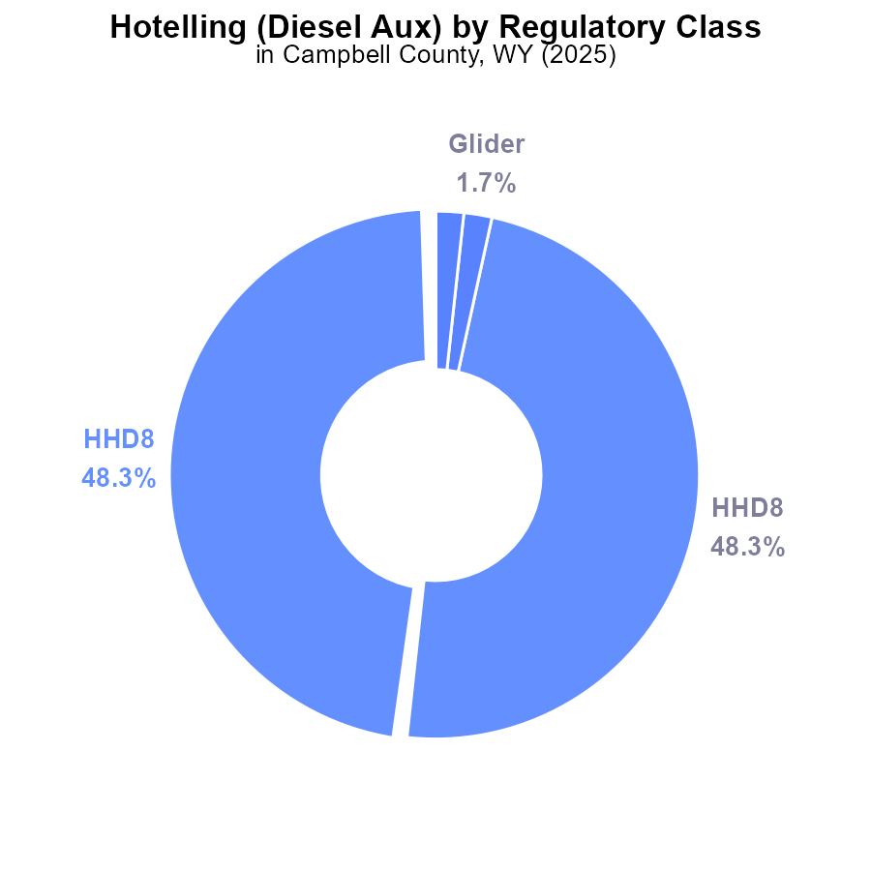

## Findings

* 48.3% of PM10 emissions in Campbell County, WY in 2025 were from HHD8 Hotelling (Diesel Aux) for hours
* 1.7% of PM10 emissions were from Glider in the same year and location.
* There were no emissions recorded for MHD67, LDT, LDV, LHD34, LHD45, MC, or Urban Bus categories.

## Recommendations

To lower PM10 emissions in Campbell County, focus on reducing emissions from HHD8 Hotelling (Diesel Aux) and Glider vehicles. Implement stricter emission standards for these vehicles and incentivize the adoption of cleaner technologies.

# Vehicle Miles Traveled over Time for Passenger Vehicles

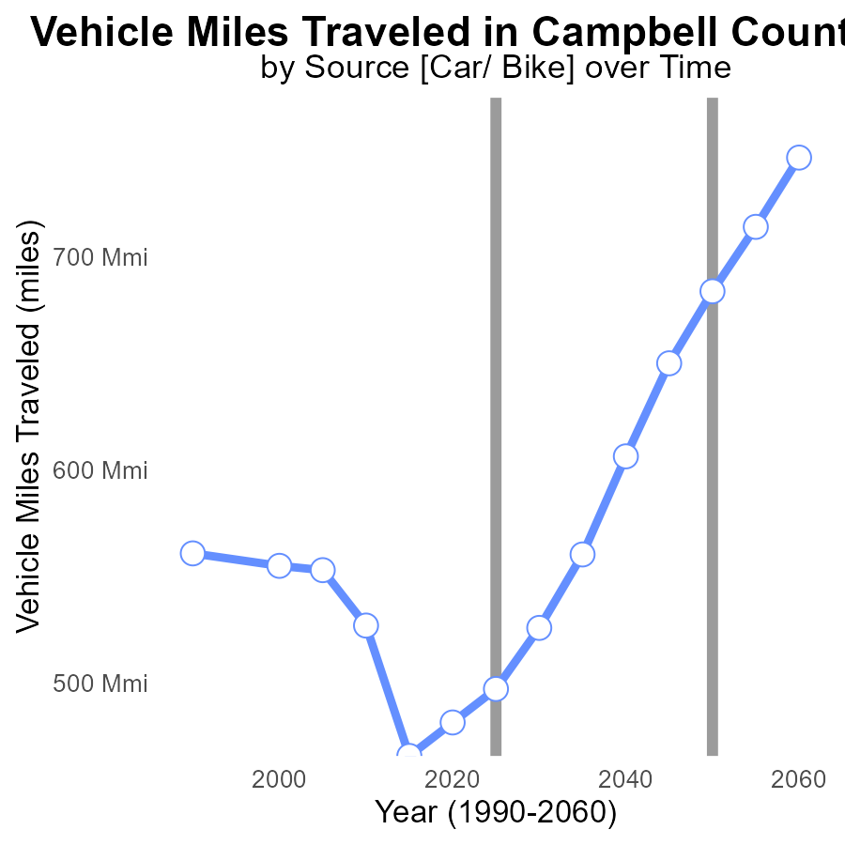

## Findings

* Vehicle miles traveled decreased by 14.0% from 2005 to 2045.
* Benchmark difference decreased by 74.2% from 2005 to 2045.
* Campbell County saw a consistent reduction in PM10 emissions over the years.

## Recommendations

To further reduce emissions, encourage the adoption of electric vehicles, promote public transportation, implement carpooling initiatives, and incentivize telecommuting.

# Vehicle Miles Traveled Overall over Time

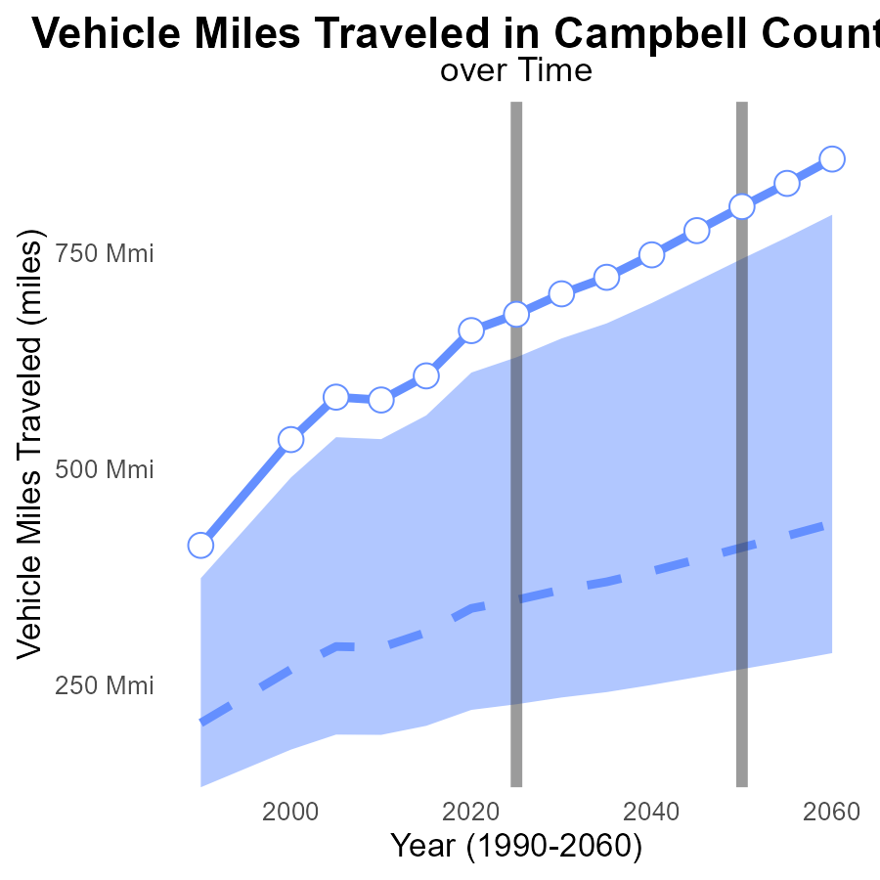

## Findings

* Vehicle miles traveled in Campbell County has consistently increased over the years.
* The PM10 emissions data is directly proportional to the increase in vehicle miles traveled.
* Benchmark difference shows the area is above the 75th percentile for vehicle miles traveled.

## Recommendations

To lower PM10 emissions in Campbell County, consider implementing policies to reduce vehicle miles traveled, such as promoting public transportation, carpooling, and investing in infrastructure to support walking and cycling.

# Emissions Rate (per capita) Mapped by Area

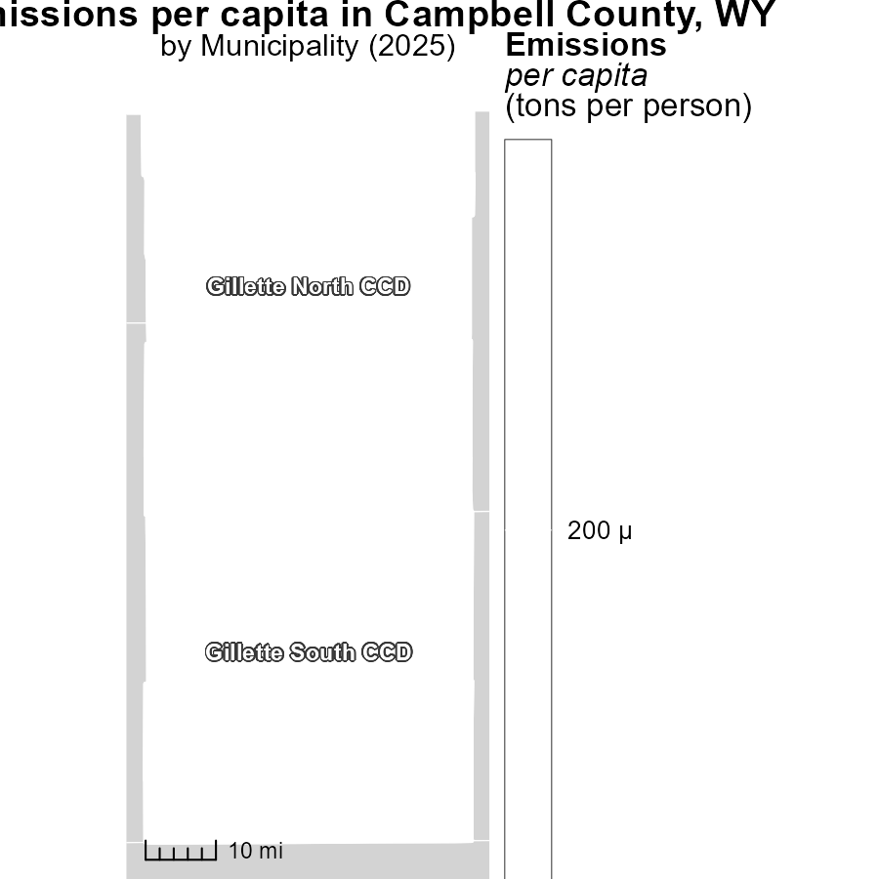

## Findings

* In 2025, the maximum per capita emissions in Gillette North CCD, WY were 234.3 tons per person.
* The median per capita emissions in Gillette North CCD, WY were 234.3 tons per person in 2025.
* The minimum per capita emissions in Gillette South CCD, WY were 234.3 tons per person in 2025.

## Recommendations

To lower emissions levels, targeted strategies should be implemented in Gillette North and South CCDs. This could involve promoting renewable energy sources, improving energy efficiency, and implementing stricter regulations on emissions from industries.

# Emissions Rate (per mile) Mapped by Area

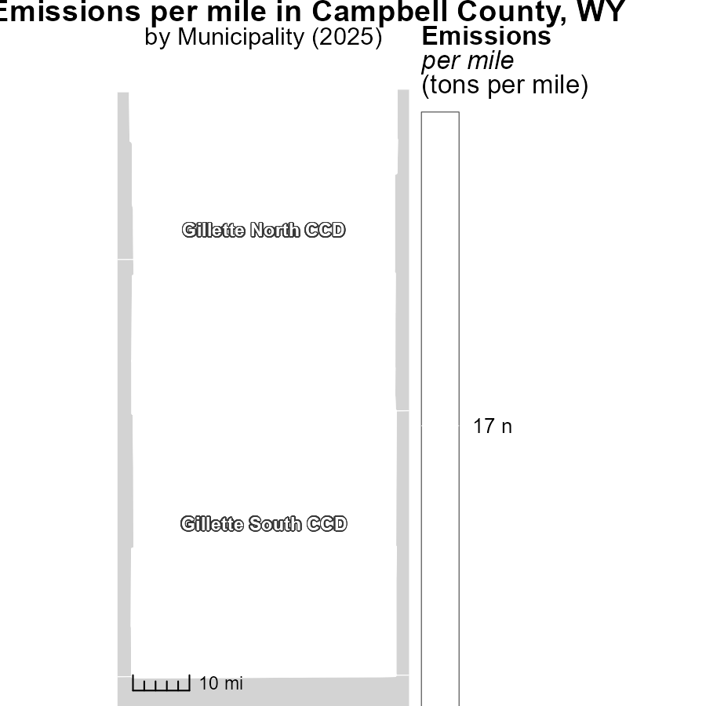

## Findings

* The maximum emissions per mile in Gillette North CCD, WY is 16.7 tons
* The median emissions per mile in Gillette North CCD, WY is 16.7 tons
* The minimum emissions per mile in Gillette South CCD, WY is 16.7 tons

## Recommendations

Efforts should focus on reducing emissions in Gillette North CCD, WY, particularly around the median level, to bring down overall emissions levels in the region.

# Vehicle Miles Traveled by Vehicle Type over Time

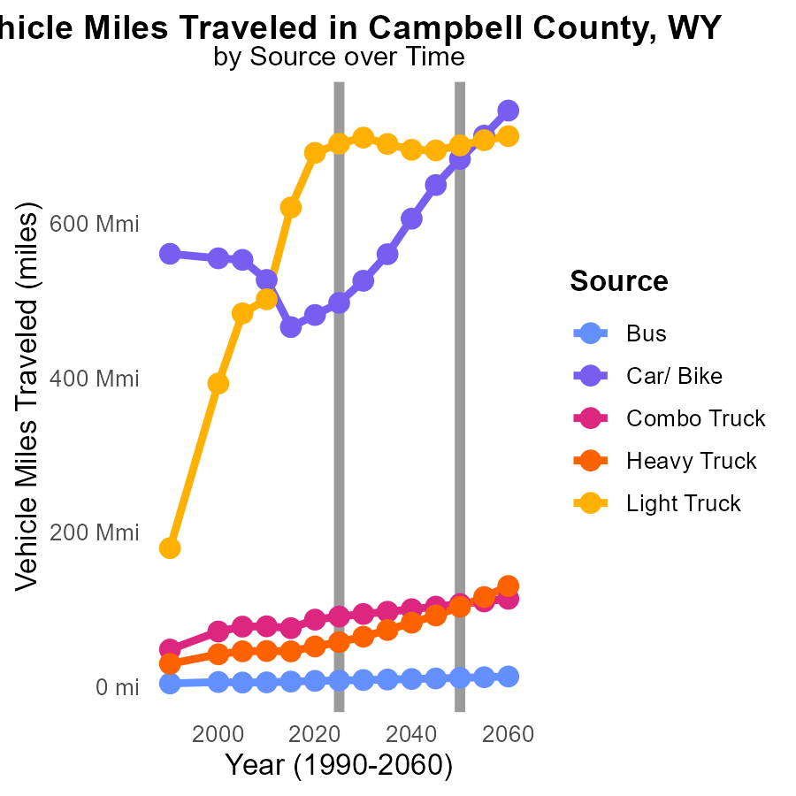

## Findings

* From 2015 to 2035, Bus miles traveled will increase by 2.6 million miles, a 43.3% rise.
* Car/Bike emissions will increase from 466.0 million miles in 2015 to 560.4 million miles in 2035, a 20.3% increase.
* Light Truck usage will decrease from 620.9 million miles in 2015 to 703.2 million miles in 2035, a decrease of 11.6%.

## Recommendations

Encouraging the use of public transportation over single-occupancy vehicles, promoting the adoption of electric vehicles in all transportation sectors, and implementing stricter emission standards for trucks.

# Emissions Rate (per vehicle) by Road Type over Time

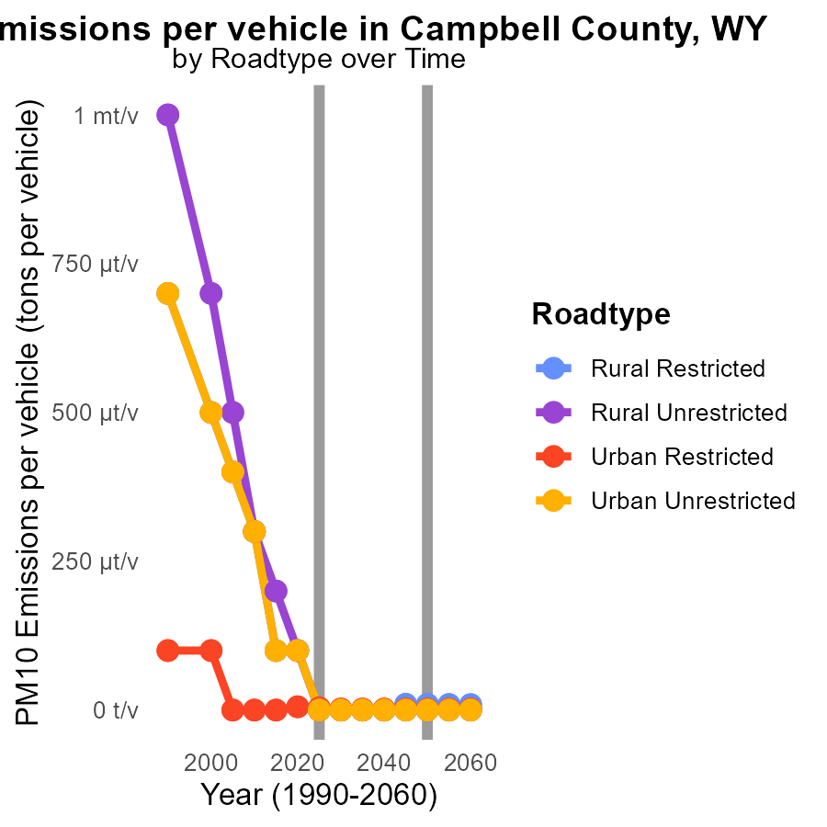

## Findings

* PM10 emissions per vehicle decreased from 2015 to 2035 for all road types in Campbell County, WY.
* The most significant reduction occurred in Urban Restricted areas with a decrease of 10.3 tons per vehicle from 2015 to 2035.
* Overall, emissions reductions were achieved in both Rural and Urban areas across different road types.

## Recommendations

To further lower emissions, focus on developing and promoting cleaner vehicle technologies, implementing stricter vehicle emission standards, and enhancing public transportation infrastructure to reduce vehicle dependency.

# Areas Ranked by Vehicle Starts

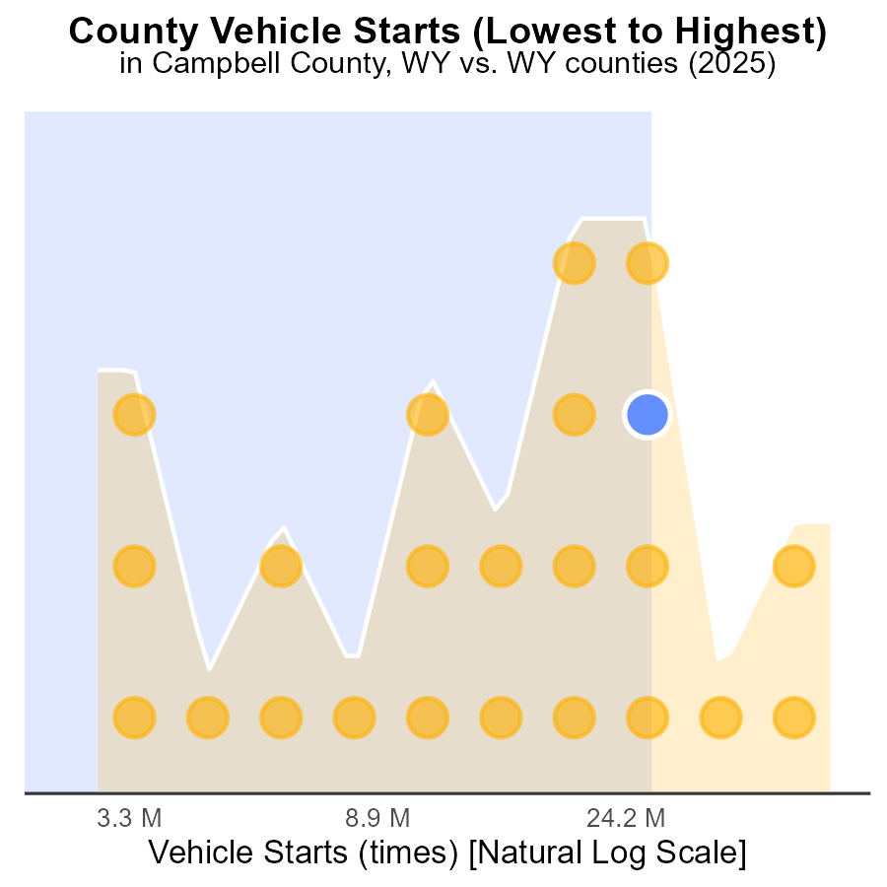

## Findings

* Laramie has the highest number of vehicle starts with 149.7 million.
* Hot Springs has the lowest number of vehicle starts with only 7.8 million.
* Laramie is at full capacity with a percentile rank of 100% for vehicle starts.

## Recommendations

To reduce emissions, Laramie should focus on promoting public transportation and carpooling to decrease the number of vehicle starts. Implementing policies to incentivize the use of electric vehicles can also help lower emissions.

# Areas Ranked by Hotelling (Engines Off)

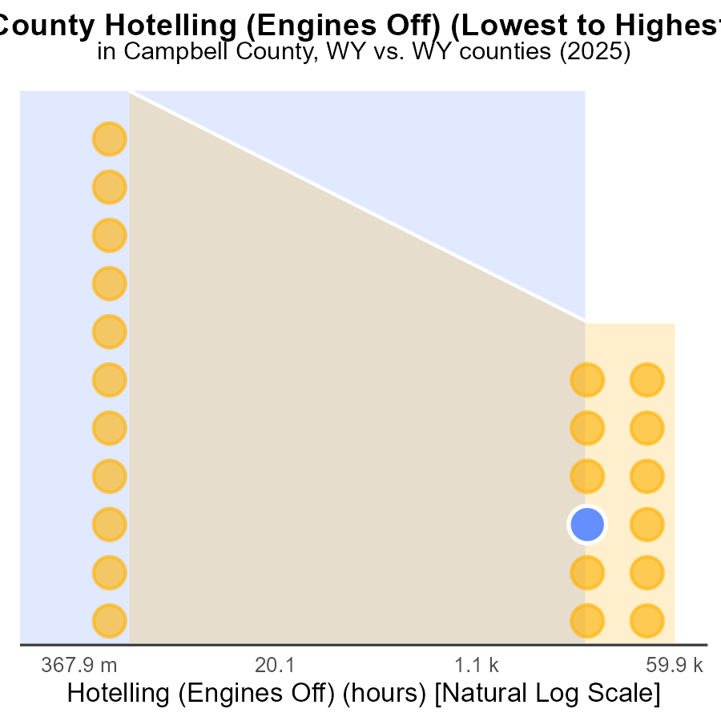

## Findings

* Highest PM10 emissions in Sweetwater county with 169.6k hours.
* Campbell and Sheridan counties show 26.6k and 23.3k emissions, respectively.
* Big Horn county has the lowest emissions with 0.0 hours.

## Recommendations

To lower PM10 emissions: incentivize engines off policies, invest in cleaner technologies, and promote public transportation to reduce vehicle emissions, focusing efforts on counties with the highest levels.

# Conclusion

The data from the report on Primary Exhaust PM10 - Total emissions from on-road transportation in Campbell County, WY in 2025 shed light on the current situation and potential strategies for emission reduction. With the top contributors to PM10 emissions being identified as Laramie, Sweetwater, and Natrona counties, efforts to lower emissions should concentrate on these areas through implementing stricter regulations and promoting cleaner energy sources. Additionally, focusing on reducing emissions from specific vehicle categories such as HHD8 Hotelling (Diesel Aux) and Glider vehicles can significantly contribute to a decrease in overall PM10 emissions.

Moreover, the report highlights a consistent reduction in PM10 emissions over the years in Campbell County, indicating the efficacy of existing policies. To further enhance these efforts and continue reducing emissions, encouraging the adoption of electric vehicles, promoting public transportation, and incentivizing telecommuting can play a pivotal role. Additionally, considering the correlation between PM10 emissions and vehicle miles traveled, policies to reduce vehicle miles traveled, such as promoting public transportation and carpooling, can be instrumental in achieving long-term emission reduction goals.

# About This Report

Data based on MOVES estimates collected by the Climate Action in Transportation program at Cornell University. Demographic data sourced from the US Census's American Community Survey 5-year estimates. This report was generated with the help of AI.

# References

* U.S. Census Bureau. (2023). American Community Survey 5-year estimates: Detailed tables. Retrieved from https://data.census.gov
* U.S. Environmental Protection Agency. (2024). Motor Vehicle Emission Simulator (MOVES 4.0) [Software]. Retrieved from https://www.epa.gov/moves