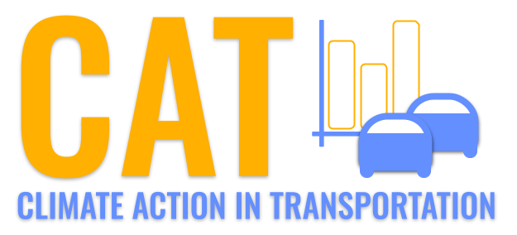 

**CO Emissions in Coffee County, 2030**  
Made with CAT VISUALIZER by Gao Labs @ Cornell University.

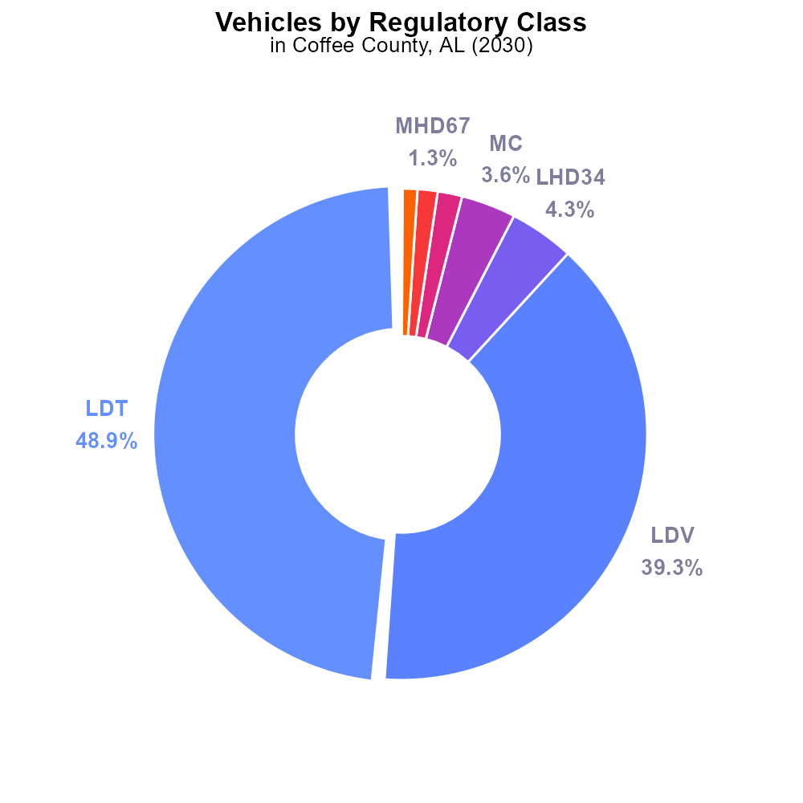

## Keywords

Carbon Monoxide emissions; on-road transportation; Coffee County AL; 2030

## Highlights

* Analysis of CO emissions from on-road vehicles in Coffee County, AL.
* Implications of transportation choices on air quality in the region.
* Potential health and environmental impacts of high CO levels.
* Comparison of CO emission levels to regulatory standards.
* Recommendations for reducing CO emissions and improving air quality.

# Introduction

In 2030, the issue of Carbon Monoxide (CO) emissions from on-road transportation in Coffee County, Alabama has come under increasing scrutiny. This report seeks to analyze the levels of CO emissions originating from various types of vehicles within the county and assess their impact on local air quality. The transportation sector is a significant contributor to air pollution, and understanding the dynamics of CO emissions is crucial for informing policy decisions and mitigation strategies.

With projections indicating a rise in vehicle numbers and traffic congestion in the region, it is imperative to address the potential health and environmental implications of elevated CO levels. This report will evaluate the current CO emission levels in Coffee County, compare them to established regulatory standards, and provide recommendations to reduce emissions and enhance air quality for the well-being of residents.

# Vehicles by Regulatory Class

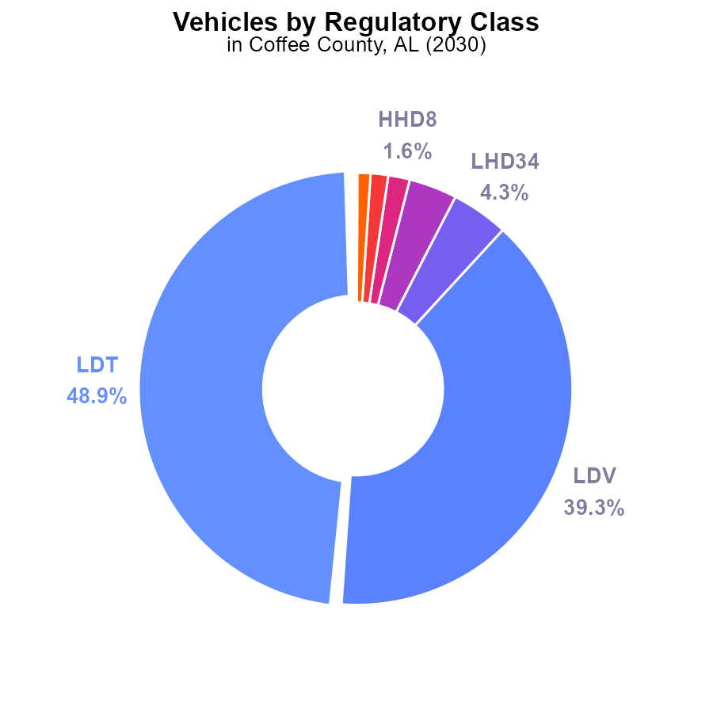

## Findings

* Most emissions in Coffee County, AL in 2030 are from LDT and LDV vehicles, totaling 88.2%.
* Motorcycles and larger vehicles (LHD34, MC) contribute to 9.5% of emissions combined.
* Urban buses and gliders have minimal emissions impact, accounting for less than 0.1%.

## Recommendations

To lower emissions, focus on reducing emissions from LDT and LDV vehicles as they contribute the most. Implementing stricter emissions standards for these vehicles and promoting electric or hybrid options can help significantly decrease overall emissions.

# Hotelling (Engines Off) Overall by Area

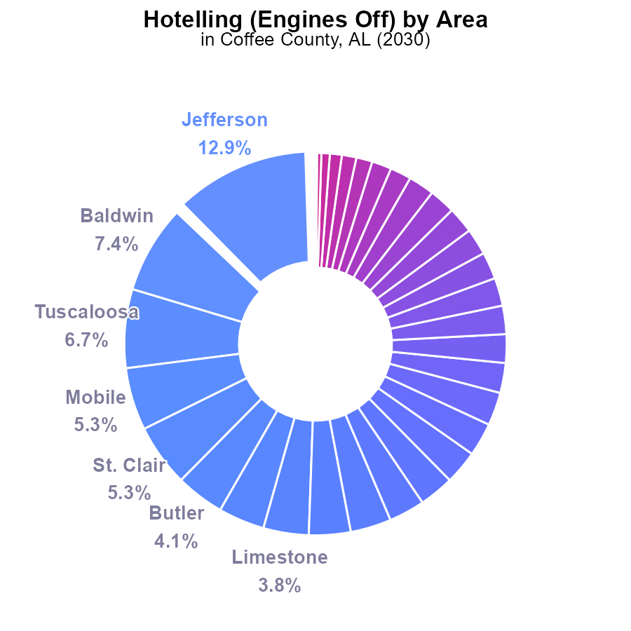

## Findings

* Top 5 emitting counties: Jefferson 12.9%, Baldwin 7.4%, Tuscaloosa 6.7%, Mobile 5.3%, St. Clair 5.3%.
* 29 counties contribute less than 1.0% emissions each.
* 12 counties have 0.0% emissions recorded.

## Recommendations

To address emissions, focus on counties with highest percentages like Jefferson, Baldwin, and Tuscaloosa. Encourage cleaner transportation methods and invest in eco-friendly infrastructures.

# Vehicles over Time for Passenger Vehicles

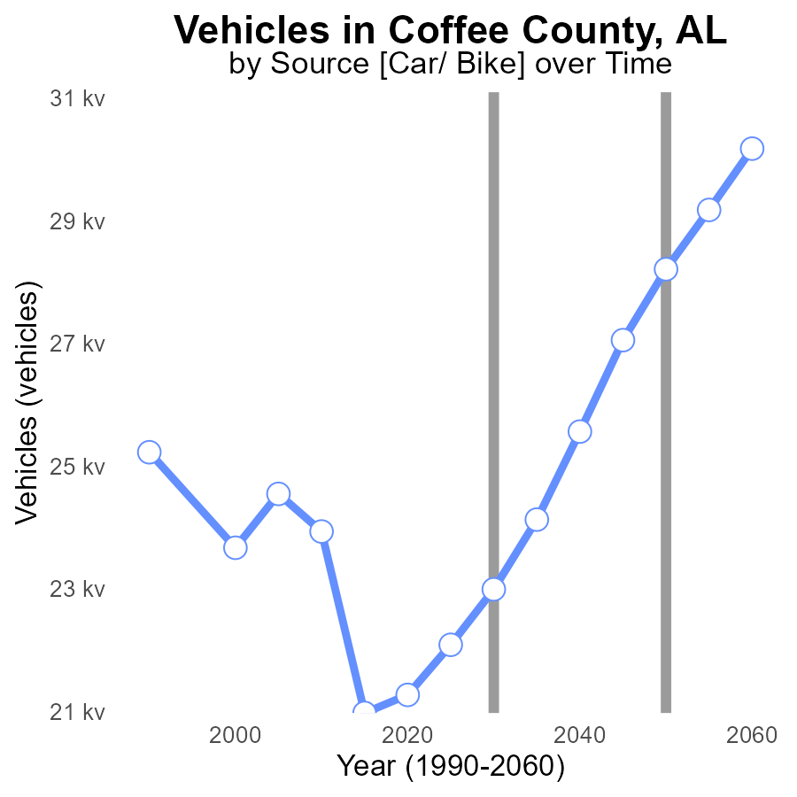

## Findings

* Emissions from vehicles in Coffee County, AL have decreased by 21.7% from 2010 to 2050.
* The difference between the actual emissions and the benchmark has steadily decreased over the years.
* By 2050, emissions from vehicles are projected to be 28.2k, which aligns with the benchmark.

## Recommendations

To maintain the decreasing trend in emissions, policymakers should continue promoting the adoption of electric or hybrid vehicles, improve public transportation infrastructure to reduce individual car usage, and incentivize carpooling and biking within the community.

# Vehicles over Time for Buses

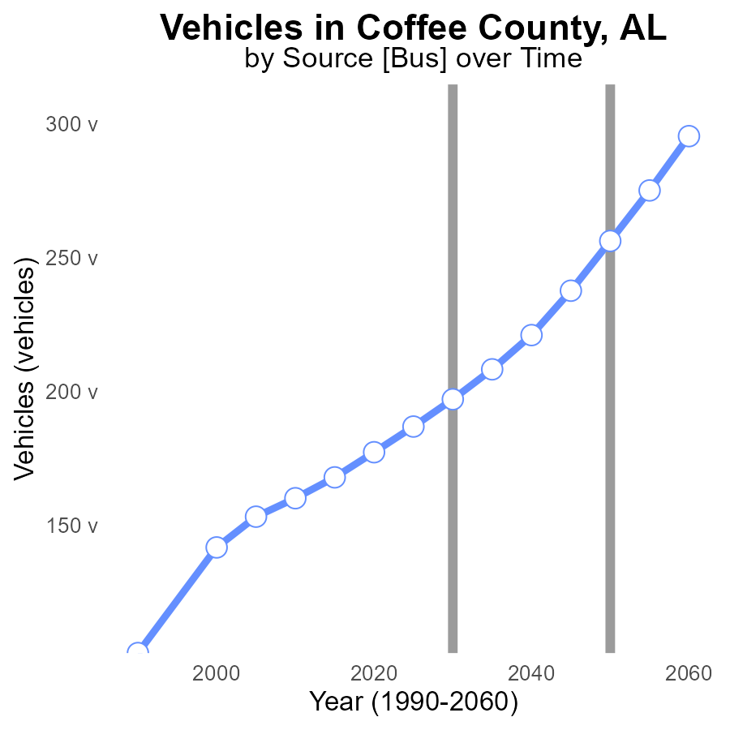

## Findings

* Emissions from vehicles in Coffee County, AL have been decreasing over the years.
* There was a significant drop in vehicle emissions from 2010 to 2050, with a reduction of 96.2 CO units.
* By 2050, emissions are projected to reach the lowest point, with a benchmark difference of 0.0 CO units.

## Recommendations

To further lower emissions, policymakers should incentivize the adoption of electric vehicles, improve public transportation infrastructure, and promote carpooling and telecommuting. Implementing stricter vehicle emission standards and investing in renewable energy sources will also aid in reducing emissions levels directly connected to the data provided.

# Emissions Rate (per mile) Mapped by Area

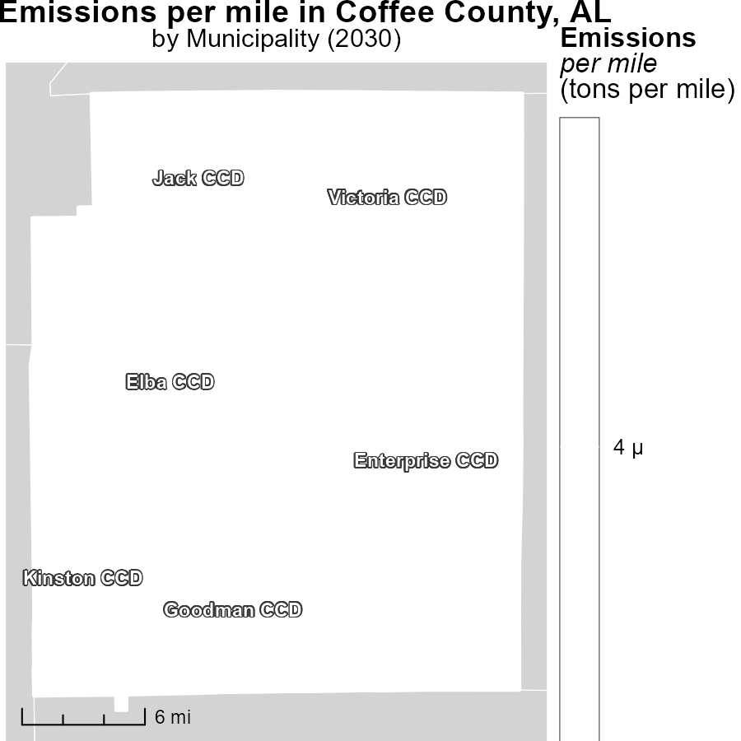

## Findings

* Elba CCD, AL emits a maximum of 4.0 tons per mile.
* Jack CCD, AL emits a median of 4.0 tons per mile.
* Victoria CCD, AL emits a minimum of 4.0 tons per mile.

## Recommendations

To reduce emissions per mile, strategies such as promoting carpooling, using electric vehicles, and improving public transportation should be considered in Elba, Jack, and Victoria CCDs.

# Population Mapped by Area

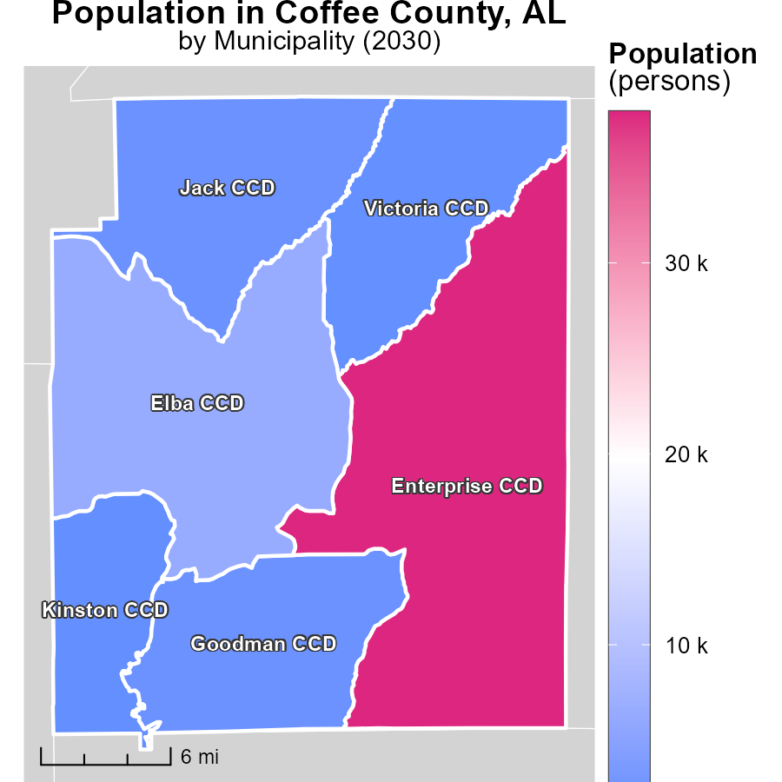

## Findings

* The population of Enterprise CCD, AL is 37.9 thousand, the highest among the three studied areas.
* Goodman CCD, AL has a population of 2.2 thousand, making it the median population among the areas.
* Kinston CCD, AL has the smallest population with 1.6 thousand people.

## Recommendations

To lower emissions levels in these areas, policies should focus on high population areas like Enterprise CCD by promoting sustainable transportation and energy-efficient practices. Initiatives in Goodman CCD should aim to maintain the median emission levels through community engagement. In Kinston CCD, efforts should be made to support low-emission transportation options and increase awareness about energy conservation.

# Time Driven by Area over Time

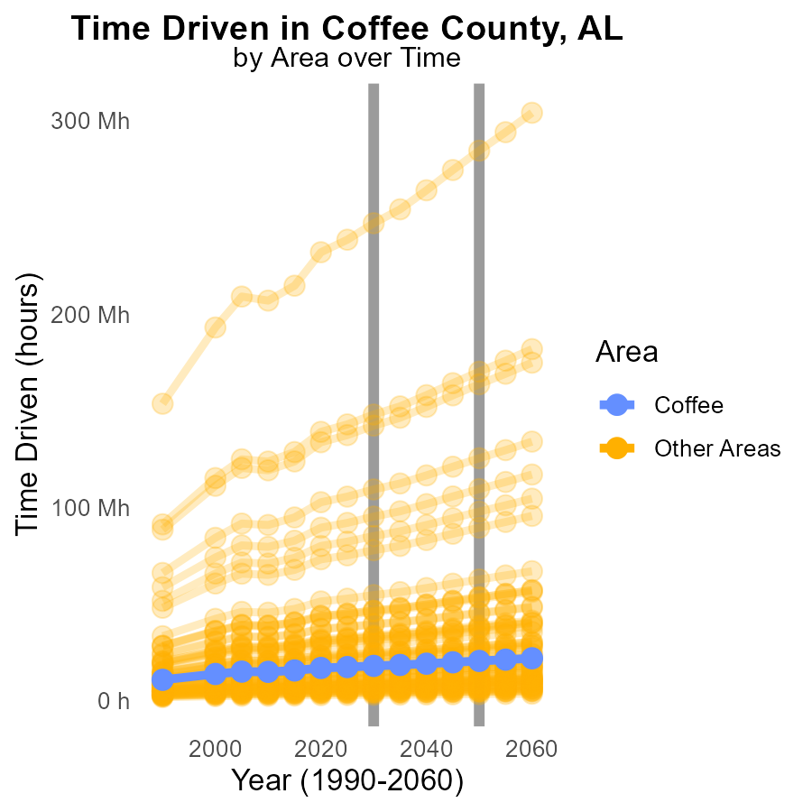

## Findings

* In 2030, the target county emitted 17.8 million hours of CO
* The maximum emissions in 2030 were 247.0 million hours from the max county.
* In contrast, the min county emitted the lowest amount, 2.8 million hours of CO in 2030.

## Recommendations

To reduce emissions, the max county should implement stricter regulations or incentivize cleaner technologies. The min county could share best practices with others. The target county could focus on promoting telecommuting to lower emissions from transportation.

# Population by Fuel Type over Time

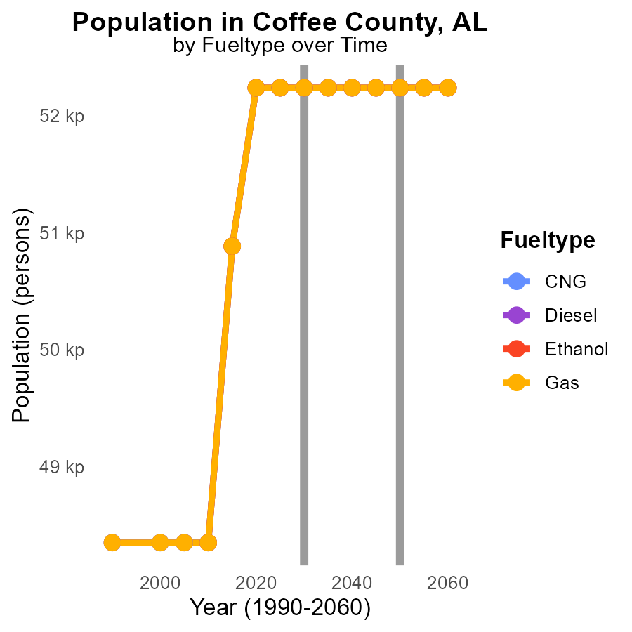

## Findings

* Emissions from different fuel types in Coffee County, AL are consistently 52.2k from 2020 to 2040.
* There is no change in emissions for Compressed Natural Gas (CNG), Diesel, Ethanol, and Gasoline over the years.
* The data suggests a lack of progress in reducing emissions from transportation in the specified period.

## Recommendations

To lower emission levels, policymakers should focus on promoting alternative fuel sources, incentivizing electric vehicles, and implementing stricter emission standards for vehicles in Coffee County, AL.

# Areas Ranked by Vehicles

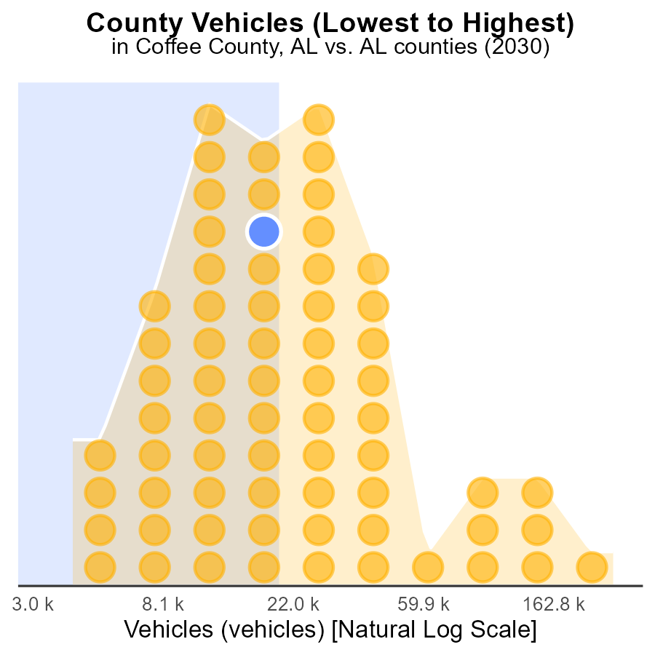

## Findings

* Jefferson County has the highest vehicle emissions with 731.9 k
* Perry County has the lowest vehicle emissions with 11.0 k
* Tallapoosa County and Coffee County have similar vehicle emissions at around 53.0-53.6 k

## Recommendations

To lower emissions, focus on implementing stricter vehicle emissions standards in Jefferson County, incentivizing the use of electric vehicles in Perry County, and promoting carpooling initiatives in Tallapoosa and Coffee counties.

# Areas Ranked by Vehicle Miles Traveled

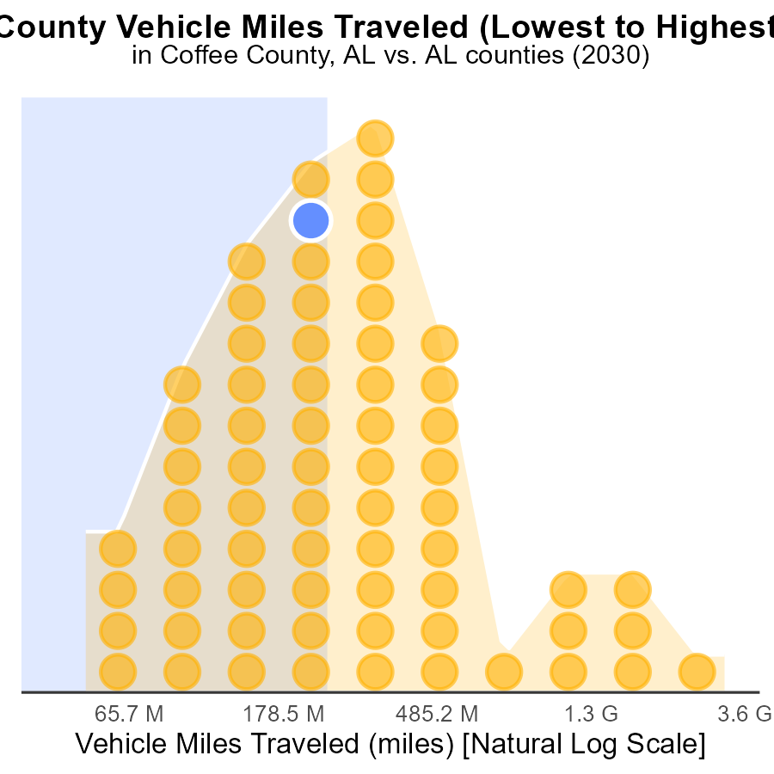

## Findings

* Jefferson county ranks highest in vehicle miles traveled with 8.8 billion miles.
* Perry county has the lowest vehicle miles traveled with 134.3 million miles.
* Coffee, Tallapoosa, and Lawrence counties are all within a close range of vehicle miles traveled, ranking 35th, 34th, and 36th respectively.

## Recommendations

To lower emissions, focus on incentivizing public transportation and carpooling in high-ranking counties like Jefferson. Encourage the use of electric vehicles in low-ranking counties like Perry. Implement road maintenance to improve fuel efficiency in medium-ranking counties like Coffee, Tallapoosa, and Lawrence.

# Conclusion

In conclusion, the data from Coffee County, AL in 2030 highlights the significant contribution of LDT and LDV vehicles to carbon monoxide emissions. By focusing on reducing emissions from these vehicles through stricter standards and promoting alternatives such as electric or hybrid options, a substantial decrease in overall emissions can be achieved. Efforts should also target counties with high emissions percentages like Jefferson, Baldwin, and Tuscaloosa, while promoting sustainable transportation methods and eco-friendly infrastructures.

Over the years, there has been a positive trend in decreasing vehicle emissions, indicating some success in emission mitigation strategies. To sustain this progress, policymakers must continue to encourage the adoption of electric vehicles, enhance public transportation systems, and incentivize practices like carpooling and biking. By aligning with projected emission benchmarks and emphasizing sustainable transportation initiatives, Coffee County can strive towards a greener and healthier future.

# About This Report

Data based on MOVES estimates collected by the Climate Action in Transportation program at Cornell University. Demographic data sourced from the US Census's American Community Survey 5-year estimates. This report was generated with the help of AI.

# References

* U.S. Census Bureau. (2023). American Community Survey 5-year estimates: Detailed tables. Retrieved from https://data.census.gov
* U.S. Environmental Protection Agency. (2024). Motor Vehicle Emission Simulator (MOVES 4.0) [Software]. Retrieved from https://www.epa.gov/moves