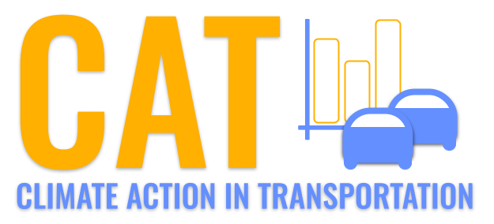 

**PM10 Emissions in Noble County, 2030**  
Made with CAT VISUALIZER by Gao Labs @ Cornell University.

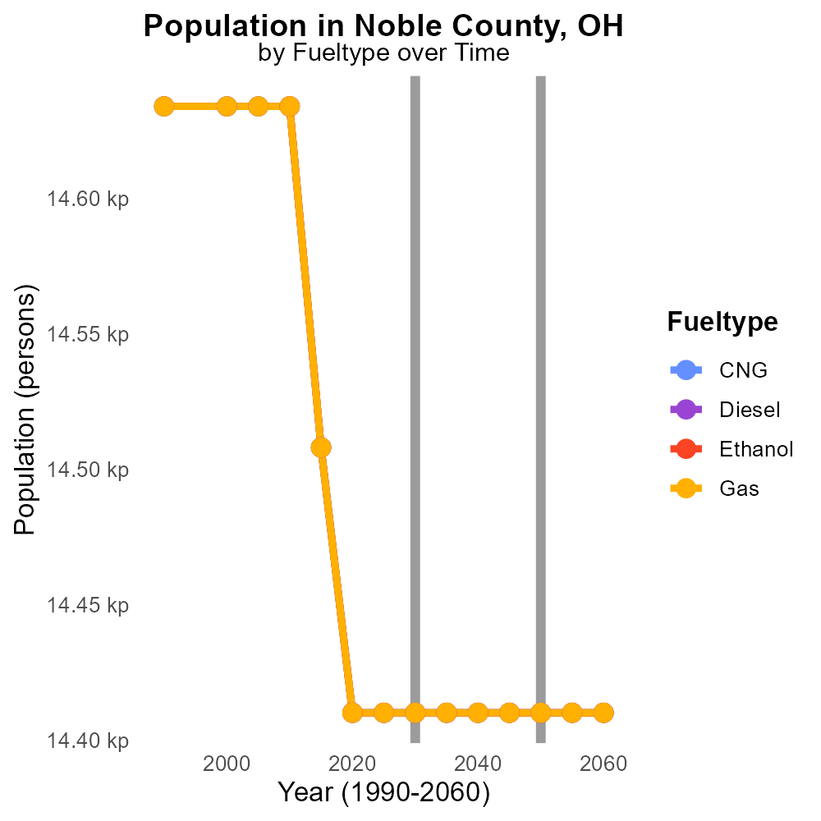

## Keywords

Primary Exhaust PM10; Total emissions; On-road transportation; Noble County, OH; 2030

## Highlights

* Investigation of PM10 emissions from on-road transportation in Noble County, OH.
* Analysis focuses on primary exhaust sources of PM10 emissions in 2030.
* Assessment of total on-road transportation emissions to understand environmental impact.
* Data on PM10 levels crucial for formulating mitigation strategies in the region.
* Findings will provide insights for policy-making and sustainable development in Noble County.

# Introduction

In 2030, the primary exhaust PM10 emissions from on-road transportation in Noble County, OH have become a significant environmental concern. This report delves into an in-depth investigation of the total emissions of PM10 attributed to on-road transportation in the county. The focus is on assessing the primary exhaust sources of PM10 emissions specifically originating from vehicles on the road.

Understanding and quantifying these emissions are essential for formulating effective mitigation strategies to curb pollution levels and protect public health. The data collected on PM10 levels will serve as a valuable tool for policymakers and stakeholders in making informed decisions to promote sustainable development and reduce the environmental impact of on-road transportation in Noble County.

# Vehicle Starts by Vehicle Type

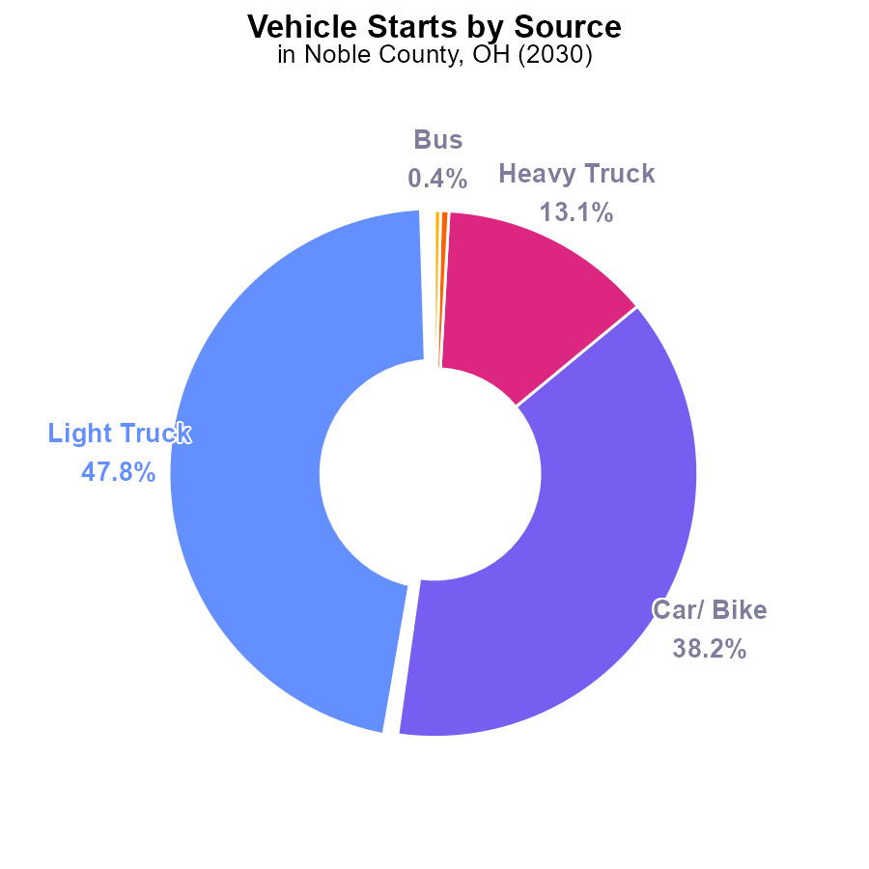

## Findings

* Light trucks contribute to 47.8% of PM10 emissions from vehicle starts in Noble County, OH in 2030.
* Cars and bikes contribute to 38.2% of PM10 emissions from vehicle starts in Noble County, OH in 2030.
* Heavy trucks account for 13.1% of PM10 emissions from vehicle starts in Noble County, OH in 2030.

## Recommendations

To lower PM10 emissions, consider promoting public transportation, investing in electric vehicle infrastructure, and enforcing emission standards for trucks.

# Hotelling (Engines Off) by Vehicle Type

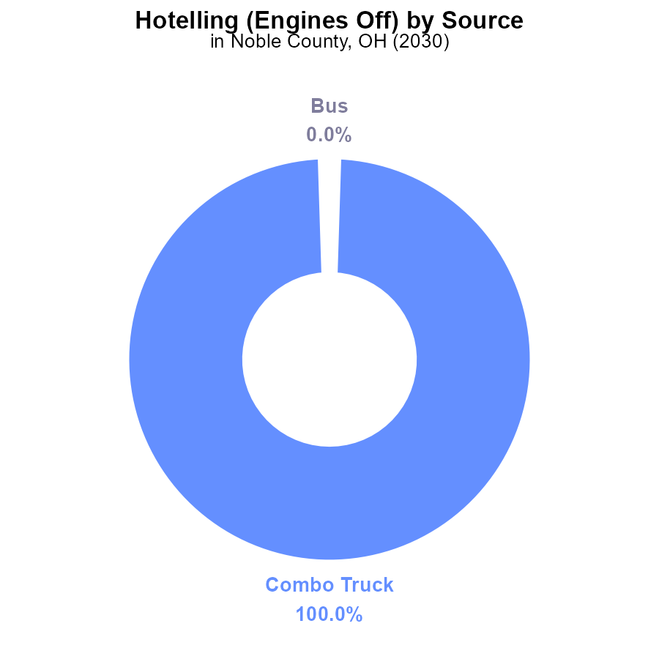

# Vehicle Starts Overall over Time

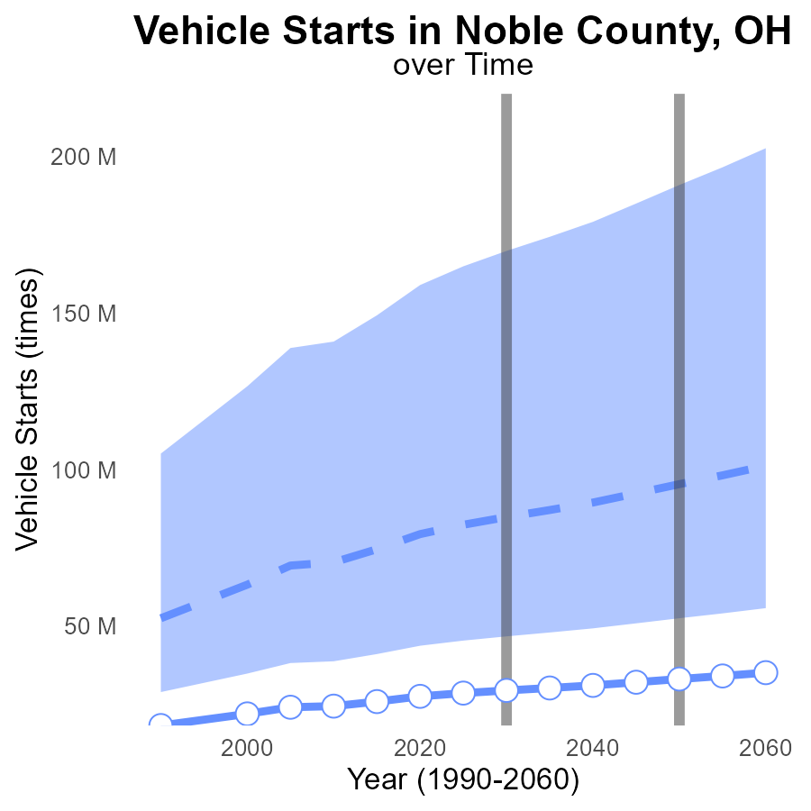

## Findings

* PM10 emissions from vehicle starts in Noble County, OH, have steadily increased from 24.4 M in 2010 to 33.0 M in 2050.
* The difference from the median area emissions has also consistently widened, reaching -62.3 M in 2050.
* Noble County's benchmark difference has decreased over time, dropping from 8662920 in 2010 to 0 in 2050.

## Recommendations

To lower PM10 emissions, implement stricter vehicle emission standards, promote electric vehicles, and invest in public transportation to reduce vehicle starts.

# Idling over Time for Buses

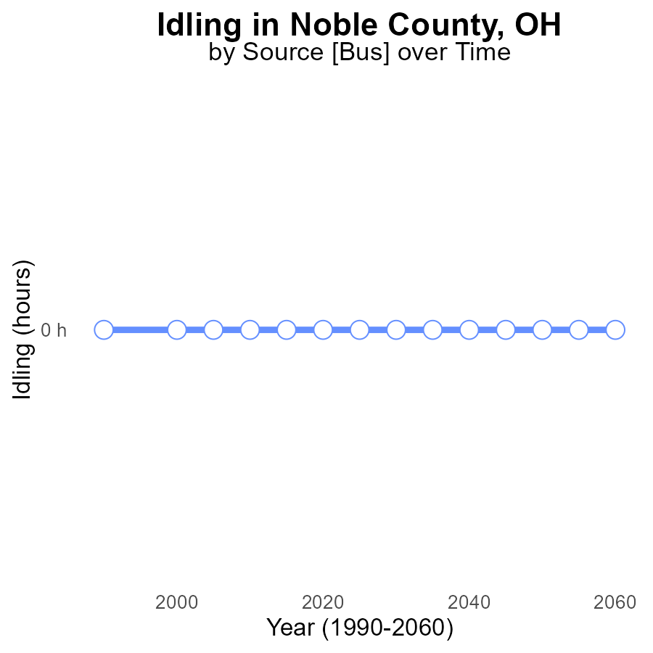

## Findings

* No PM10 emissions from idling in Noble County, OH from 2010 to 2050.
* The benchmark difference is consistent at 0 throughout the years.
* There is no projected change in idling emissions in the foreseeable future.

## Recommendations

Since there are no PM10 emissions from idling in Noble County, OH, maintaining this zero emission level is crucial. Continual monitoring and enforcement of anti-idling regulations, along with promoting the use of electric vehicles, can further ensure that emissions remain at zero.

# Hotelling (Engines Off) in My Region

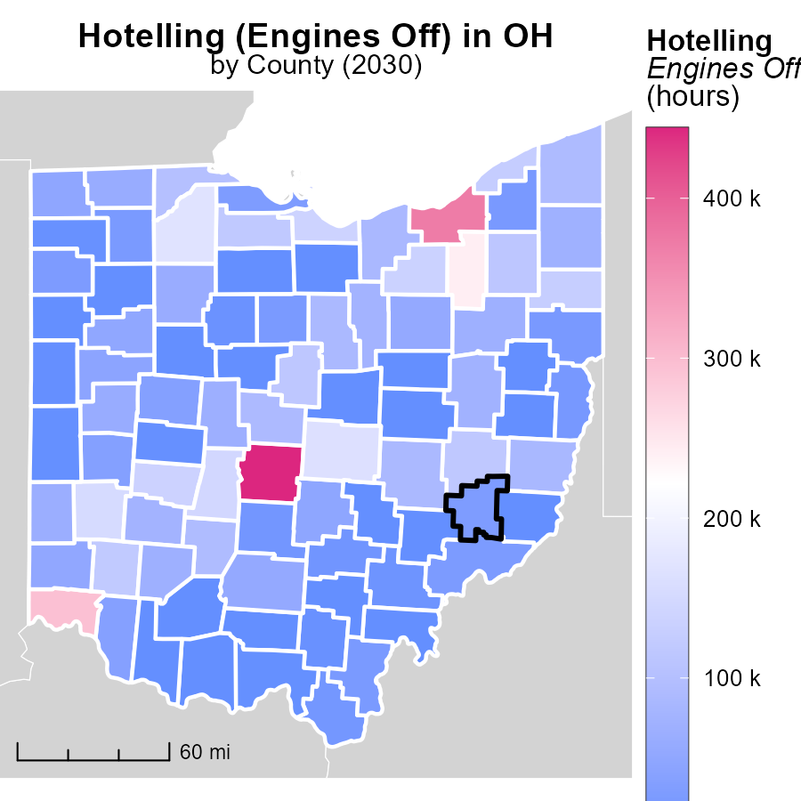

## Findings

* Franklin County, OH reported the highest emissions with 443.7 k hours.
* Auglaize County, OH had a median emission level of 44.3 k hours.
* Vinton County, OH reported no emissions for this category.

## Recommendations

Local authorities should focus on promoting engine-off policies in high emitting areas to reduce emissions in Franklin and Auglaize counties, while exploring potential strategies to maintain Vinton County's zero-emission status.

# Vehicle Miles Traveled in My Region

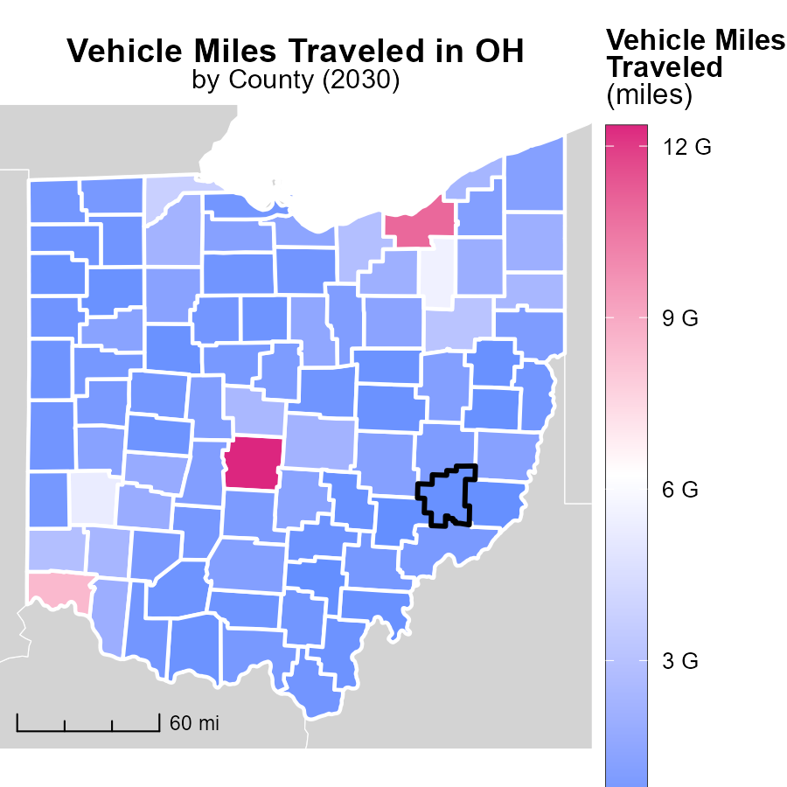

## Findings

* In Franklin County, OH, the maximum vehicle miles traveled is 12.4 billion miles.
* In Washington County, OH, the median vehicle miles traveled is 795.2 million miles.
* In Morgan County, OH, the minimum vehicle miles traveled is 153.6 million miles.

## Recommendations

To lower emissions, focus on reducing vehicle miles traveled by promoting public transportation, carpooling, and telecommuting. Invest in infrastructure to support active transportation like cycling and walking.

# Population by Fuel Type over Time

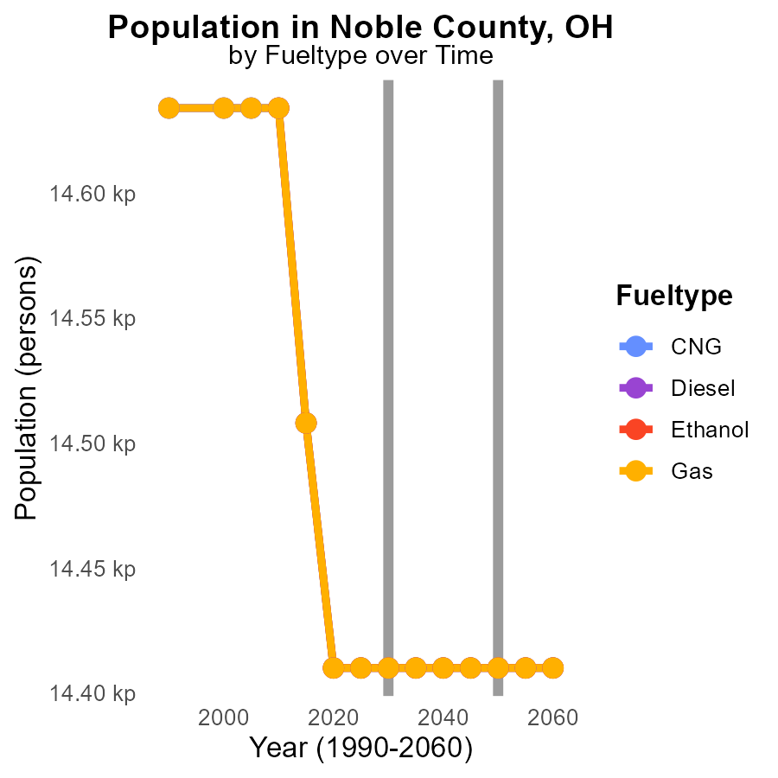

## Findings

* Emissions for PM10 in Noble County, OH, are constant from 2020 to 2040 for all fuel types
* All fuel types contribute equally to PM10 emissions in Noble County, OH, with 14.4 k reported for each year
* There is no change in the PM10 emissions trend when comparing to 2050 levels

## Recommendations

To lower PM10 emissions in Noble County, OH, considering all fuel types contribute equally, implementing county-wide initiatives promoting alternative energy sources, investing in public transportation, and encouraging the use of electric vehicles could be effective strategies.

# Hotelling (Diesel Aux) by Road Type over Time

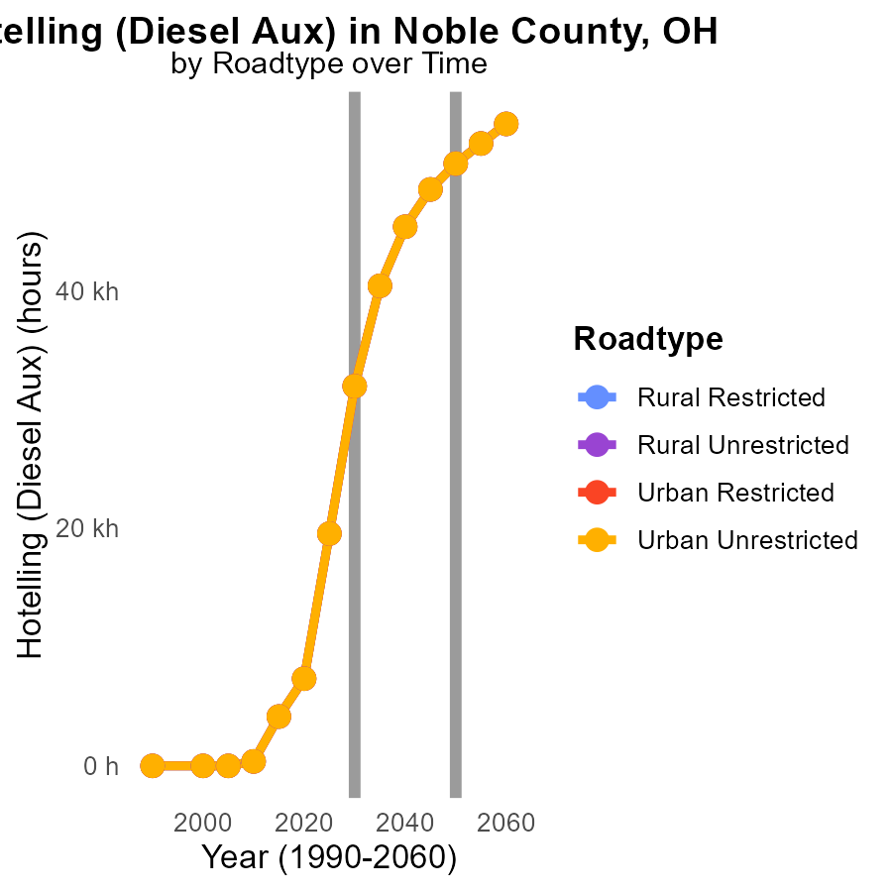

## Findings

* PM10 emissions in Noble County, OH are projected to decrease by approximately 86% from 2020 to 2040.
* The highest emissions are expected in 2040 for all road types, with Urban Unrestricted showing the greatest emissions at 45.4k.
* Emissions from Rural Restricted areas will decrease significantly by 2040, with a 99.9% reduction compared to 2020 levels.

## Recommendations

To lower emissions, focus on implementing stricter emissions standards for diesel auxiliary sources in Noble County, particularly targeting Urban Unrestricted areas. Encourage the adoption of cleaner technologies in transportation and construction sectors to achieve substantial reductions by 2040.

# Areas Ranked by Hotelling (Engines Off)

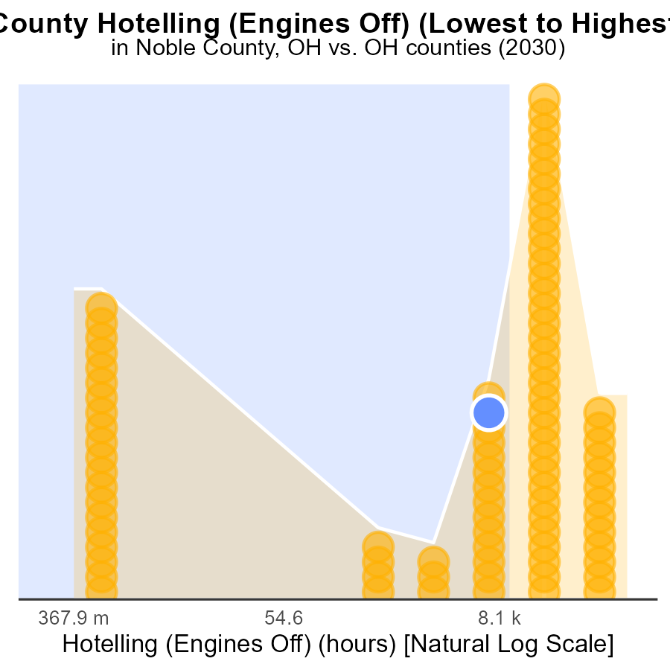

## Findings

* Adams county had the lowest PM10 emissions at 0.0 hours and ranked 1st.
* Franklin county had the highest PM10 emissions at 443.7k hours, ranking 88th and contributing 100% to total emissions.
* Overall, Noble, Paulding, and Ottawa counties had similar PM10 emissions, ranging between 26.3k to 27.9k hours.

## Recommendations

To lower emissions, focus on reducing Hotelling activities in high-ranking counties like Franklin. Implement strict regulations on engine idling and promote the use of electric vehicles.

# Areas Ranked by Population

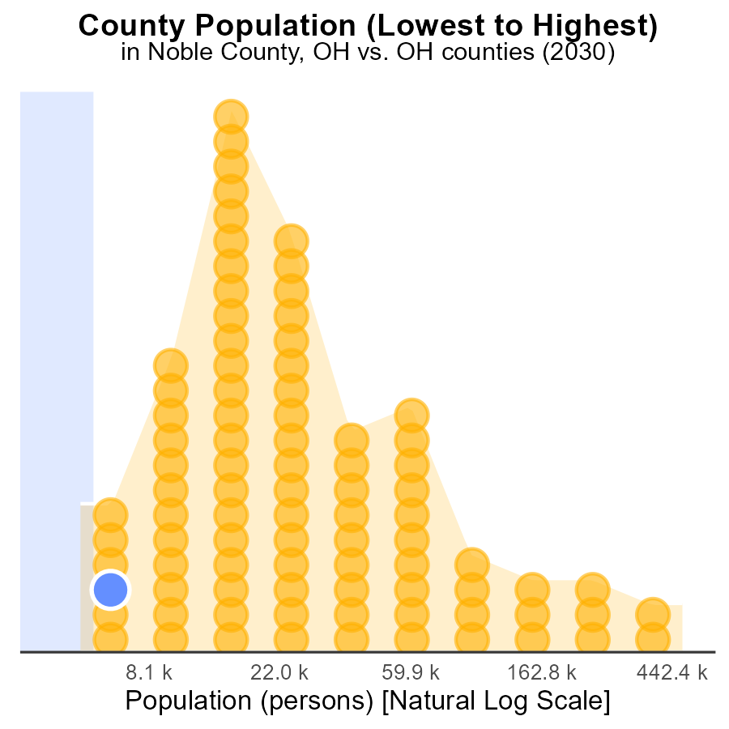

## Findings

* Franklin county has the highest population with 1.3 million people, representing 100% of the population data.
* Noble county comes in 6th with a population of 14.4k, accounting for 3.4% of the population data.
* Vinton county ranks 2nd in population with 13.0k people, making up 1.1% of the population data.

## Recommendations

To reduce PM10 emissions, focus on high population areas like Franklin county where 100% of the population resides. Implement stricter emission controls, promote clean energy alternatives, and enhance public transport to mitigate pollution levels.

# Conclusion

In conclusion, the data reveals a concerning increase in PM10 emissions from on-road transportation in Noble County, OH, from 2010 to 2050. Light trucks, cars, and bikes are the primary contributors to these emissions, indicating the urgent need for targeted interventions. Implementing measures such as promoting public transportation, investing in electric vehicle infrastructure, and enforcing emission standards for trucks are crucial steps towards curbing emissions.

Furthermore, while there are no PM10 emissions from idling in Noble County, maintaining this zero-emission level is essential. Local authorities should continue monitoring and enforcing anti-idling regulations, along with encouraging the use of electric vehicles. Additionally, focusing on areas with high emissions such as Franklin County, prioritizing engine-off policies, and promoting cleaner technologies are key strategies to reduce pollution levels. By adopting these approaches and addressing the specific challenges posed by different vehicle types and fuel sources, Noble County can work towards a cleaner and healthier environment for its residents.

# About This Report

Data based on MOVES estimates collected by the Climate Action in Transportation program at Cornell University. Demographic data sourced from the US Census's American Community Survey 5-year estimates. This report was generated with the help of AI.

# References

* U.S. Census Bureau. (2023). American Community Survey 5-year estimates: Detailed tables. Retrieved from https://data.census.gov
* U.S. Environmental Protection Agency. (2024). Motor Vehicle Emission Simulator (MOVES 4.0) [Software]. Retrieved from https://www.epa.gov/moves