 

**Carbon Emissions in Rio Arriba County, 2030**  
Made with CAT VISUALIZER by Gao Labs @ Cornell University.

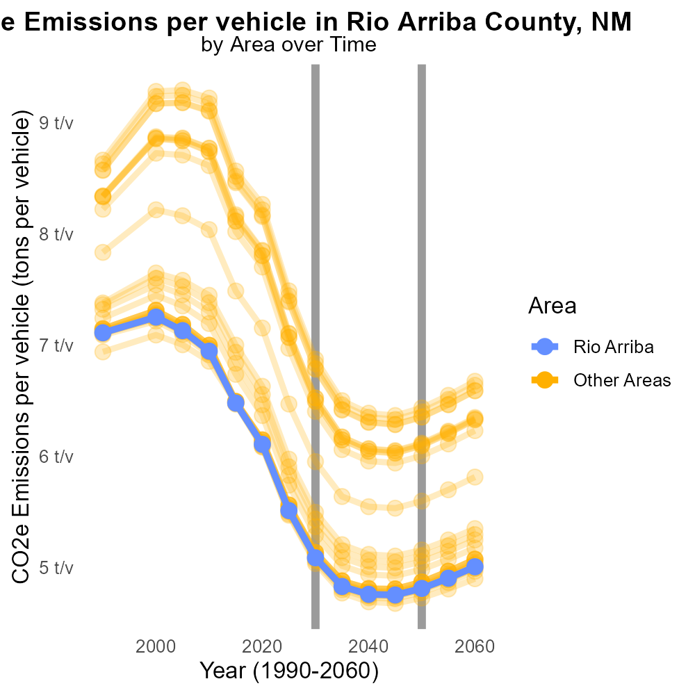

## Keywords

CO2 equivalent emissions; on-road transportation; Rio Arriba County; 2030; transportation emissions; climate impact

## Highlights

* Examining CO2 equivalent emissions from on-road transportation in Rio Arriba County, NM in 2030.
* Addressing the environmental implications of transportation emissions in a specific county.
* Understanding the impact of on-road transportation on climate change at the local level.
* Analyzing future trends and challenges related to CO2 emissions from vehicles in the county.
* Offering insights into potential strategies for reducing transportation-related carbon emissions.

# Introduction

In this report, we delve into the analysis of CO2 equivalent emissions stemming from on-road transportation within Rio Arriba County, New Mexico, specifically focusing on the year 2030. With an ever-growing concern over the environmental impact of transportation emissions, it becomes imperative to investigate the contribution of this sector to the county's overall carbon footprint. Through examining the data and trends, we aim to shed light on the magnitude of these emissions and their potential implications for the local climate.

The findings of this report will not only provide a comprehensive understanding of the current state of transportation emissions in Rio Arriba County but also offer valuable insights into future trajectories and challenges that need to be addressed. By identifying key sources of CO2 equivalent emissions from on-road transportation, we can explore mitigation strategies and sustainable solutions to reduce carbon output in the county, contributing to a more environmentally conscious and sustainable future.

# Time Driven by Road Type

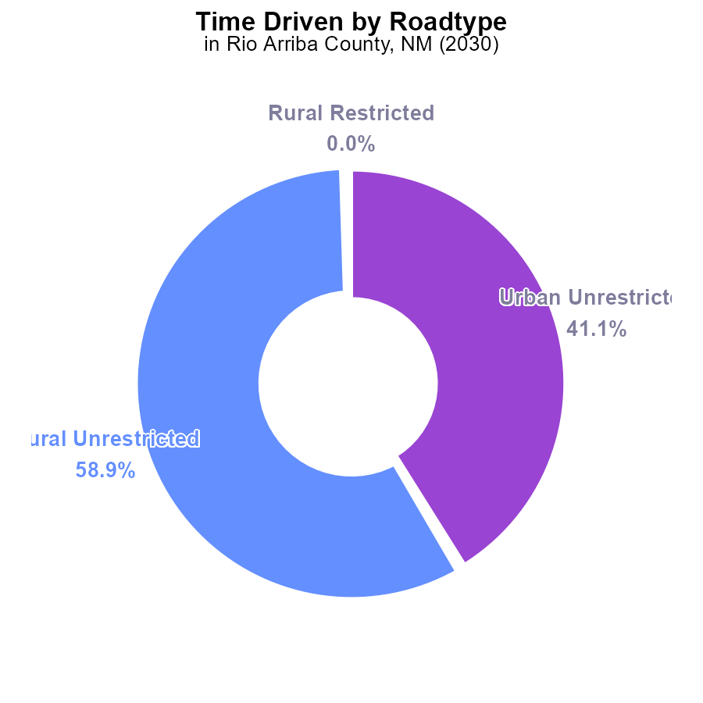

## Findings

* Rural Unrestricted emissions in Rio Arriba County in 2030 were 10.1 M CO2e, representing 58.9% of total emissions.
* Urban Unrestricted emissions were 7.0 M CO2e, accounting for 41.1% of total emissions in the county.
* No emissions were reported for Rural or Urban Restricted areas in the county during the specified period.

## Recommendations

To lower emissions in Rio Arriba County, focus on reducing CO2e in Rural and Urban Unrestricted areas by promoting carpooling, utilizing public transportation, and implementing cleaner fuel technologies.

# Vehicle Starts Overall by Area

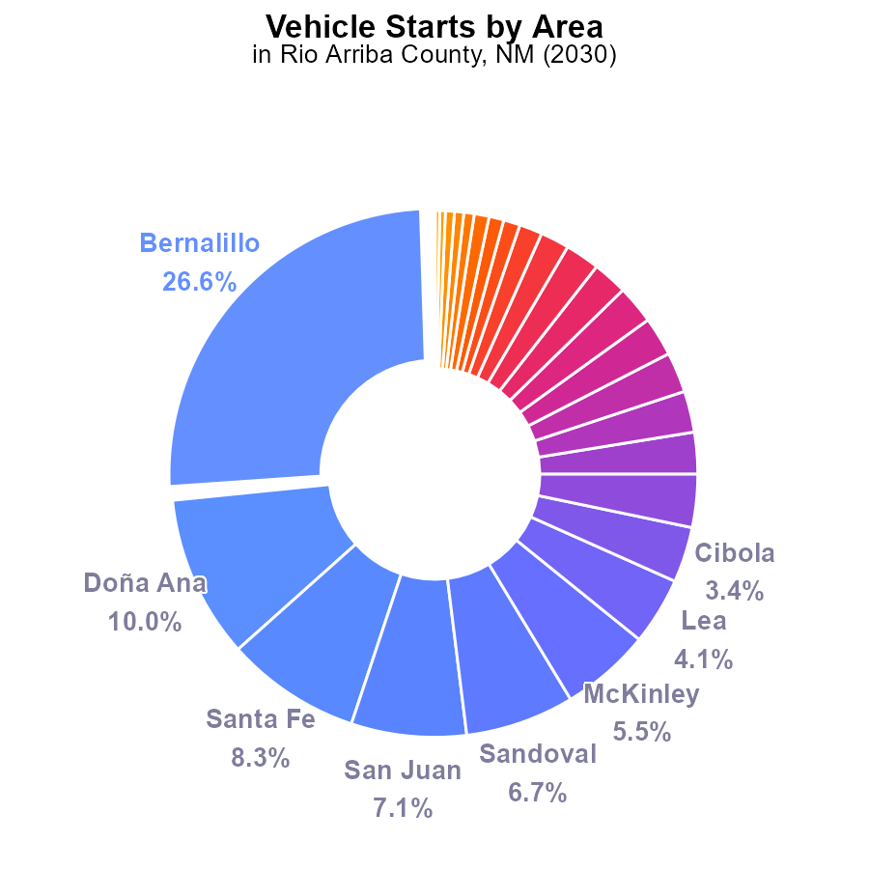

## Findings

* Top CO2e emitters: Bernalillo (26.6%), Doña Ana (10.0%), Santa Fe (8.3%).
* Small counties contribute <3% each to emissions.
* Rio Arriba emits the same as Quay, though ranks as lowest population wise.

## Recommendations

To lower emissions, prioritize high emitters (Bernalillo, Doña Ana, Santa Fe) for vehicle start reduction initiatives. Educate the public on reducing vehicle use.

# Time Driven over Time for Buses

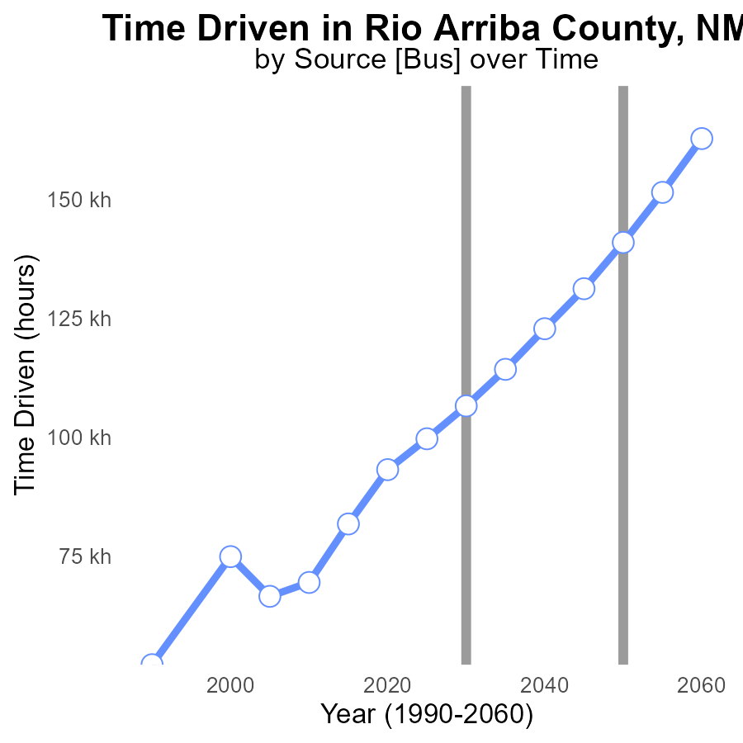

## Findings

* Emissions in Rio Arriba County have consistently increased over the years
* The benchmark difference has been steadily decreasing since 2010
* By 2050, emissions are projected to reach 140.9 k CO2e

## Recommendations

To lower emissions, policymakers should prioritize implementing stricter regulations and incentives for transitioning to renewable energy sources. Encouraging the adoption of electric vehicles and enhancing public transportation can also help reduce emissions.

# Hotelling (Engines Off) Overall over Time

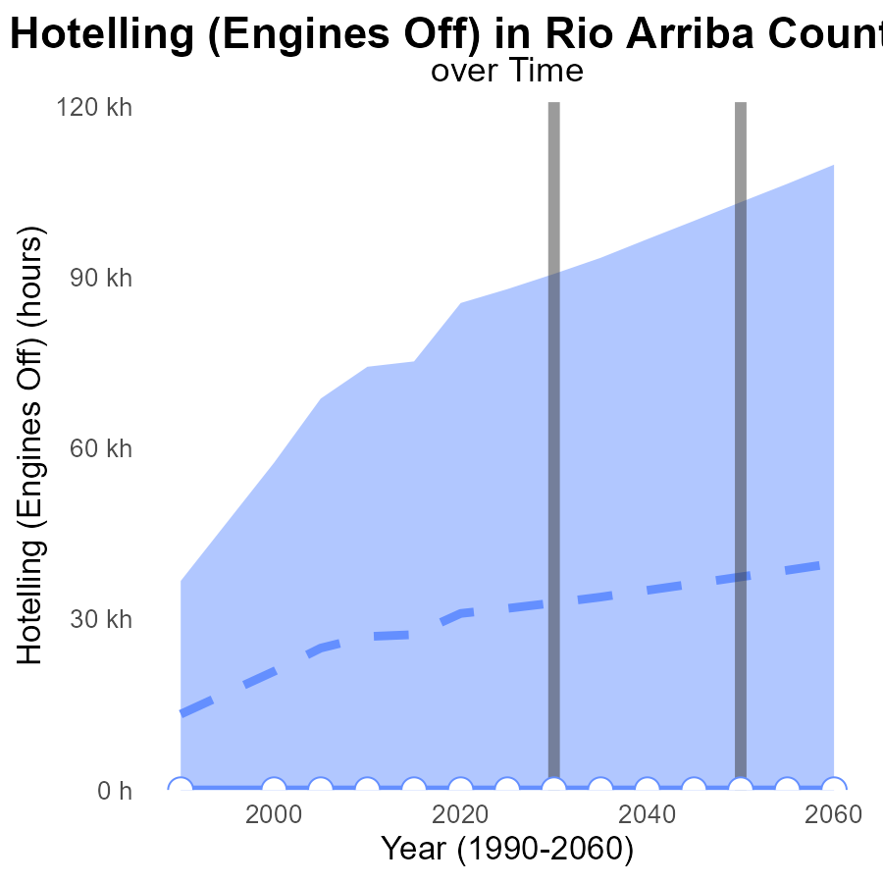

## Findings

* Emissions in Rio Arriba County remained steady at 0.0 CO2e from 2010 to 2050.
* The emissions were consistently lower by approximately -26.9 k to -37.4 k compared to the median area.
* No significant change in emissions is projected for the next few decades based on the data.

## Recommendations

To lower emissions in Rio Arriba County, a comprehensive analysis of other sources of greenhouse gases beyond Hotelling (Engines Off) in vehicles is necessary. Implementing stricter regulations on industries and promoting the use of electric vehicles could significantly reduce emissions in the county.

# Emissions Rate (per mile) in My Region

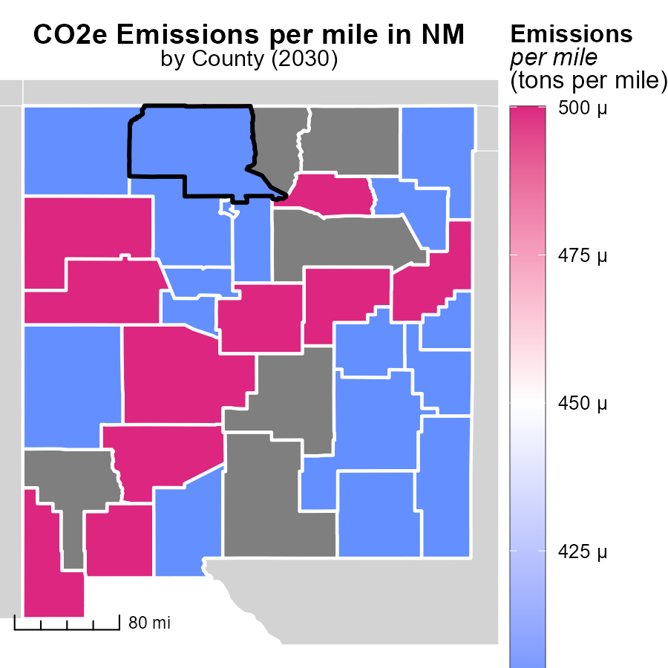

## Findings

* Cibola County, NM has the highest emissions per mile at 514.0 tons.
* Curry County, NM has a median emissions rate of 421.6 tons per mile.
* Valencia County, NM has the lowest emissions per mile at 445.2 tons.

## Recommendations

To lower emissions, focus on reducing vehicle miles traveled in Cibola County. Encourage public transportation and carpooling initiatives. In Curry County, invest in eco-friendly transportation options. Implement policies to promote biking and walking in Valencia County.

# Time Driven in My Region

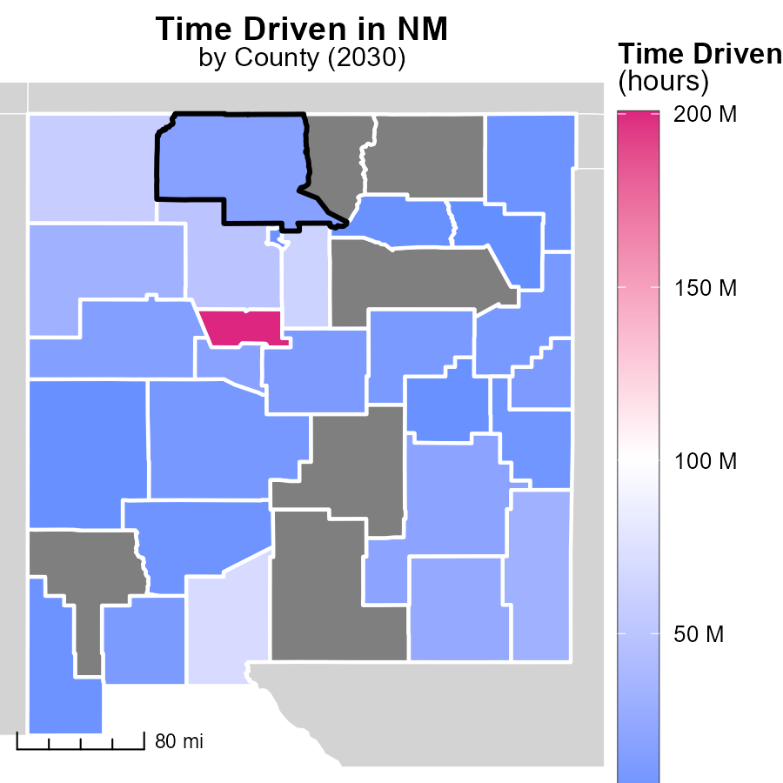

## Findings

* Bernalillo County, NM has the highest emissions with 200.6 million hours.
* Curry County, NM shows a median emission level of 12.1 million hours.
* Harding County, NM has the lowest emissions at 370.9 thousand hours.

## Recommendations

To lower emissions, focus on reducing vehicle usage in Bernalillo County, NM, promoting public transportation in Curry County, NM, and implementing energy-efficient practices in Harding County, NM.

# Emissions Rate (per vehicle) by Area over Time

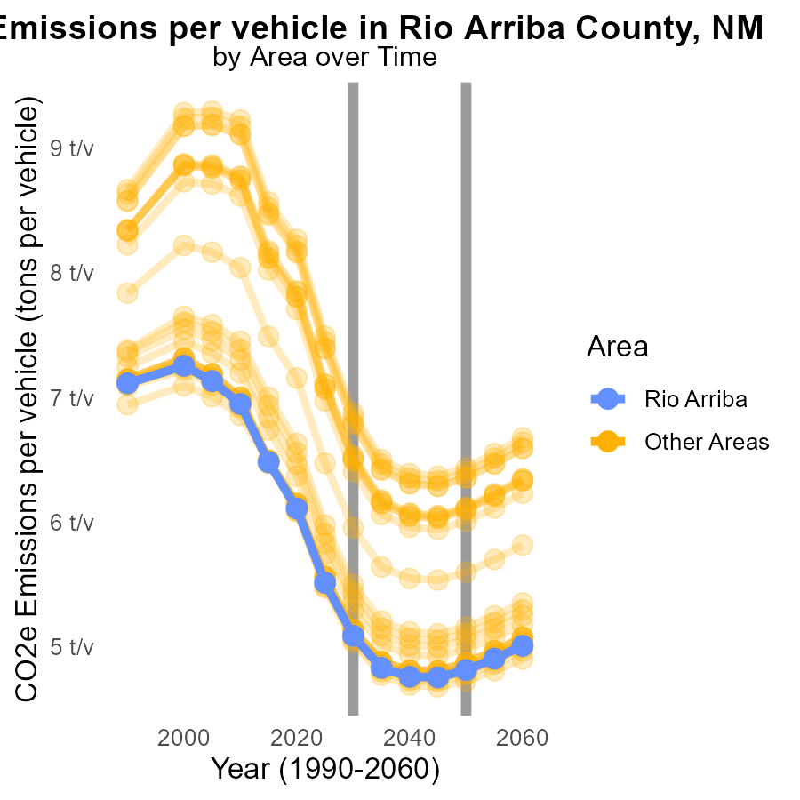

## Findings

* Emissions per vehicle in min_county by 2030: 5.0 tons, a decrease of 0.31 tons compared to 2050.
* Emissions per vehicle in max_county by 2030: 6.9 tons, a decrease of 0.4374 tons compared to 2050.
* Emissions per vehicle in target_county by 2030: 5.1 tons, a decrease of 0.275 tons compared to 2050.

## Recommendations

To lower emissions in all counties, focus on implementing stricter vehicle emissions standards, promoting the adoption of electric vehicles, and enhancing public transportation infrastructure to reduce individual vehicle usage.

# Emissions Rate (per capita) by Road Type over Time

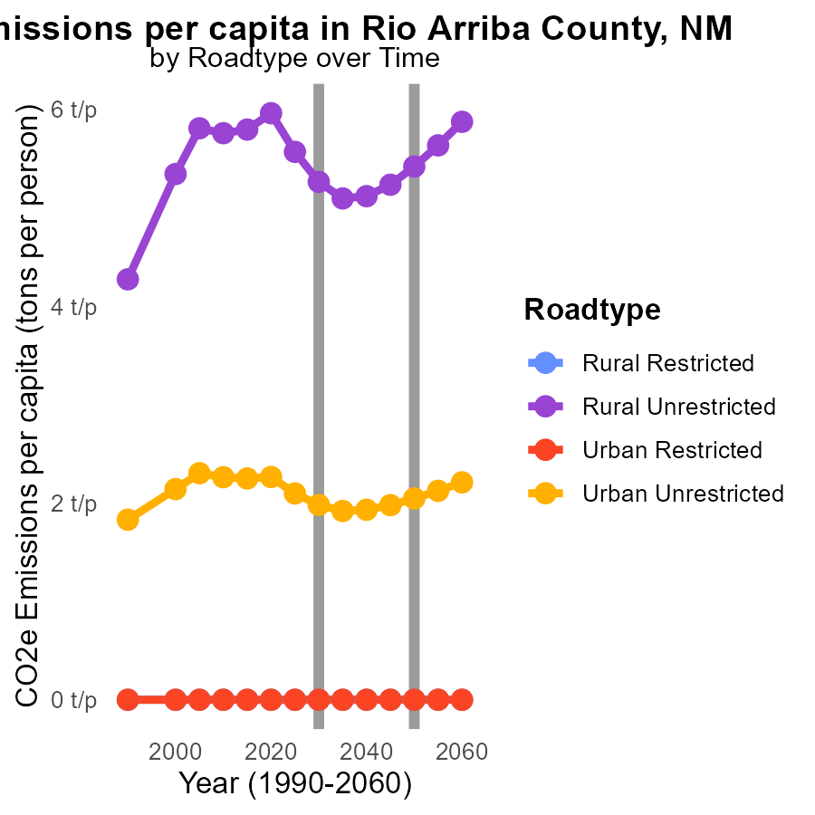

## Findings

* Rural Unrestricted areas had the highest CO2e emissions per capita in 2020, with 6.0 tons per person.
* Emissions decreased over the years in all road types, except for Rural Unrestricted areas in 2030 with 5.3 tons per person.
* In Urban Unrestricted areas, emissions per capita reduced from 2.3 tons per person in 2020 to 1.9 tons per person in 2040.

## Recommendations

To decrease emissions in Rural Unrestricted areas, focus on implementing stricter regulations and promoting alternative transportation methods. In Urban Unrestricted areas, continue investing in public transportation and infrastructure for walking and cycling.

# Areas Ranked by Vehicle Starts

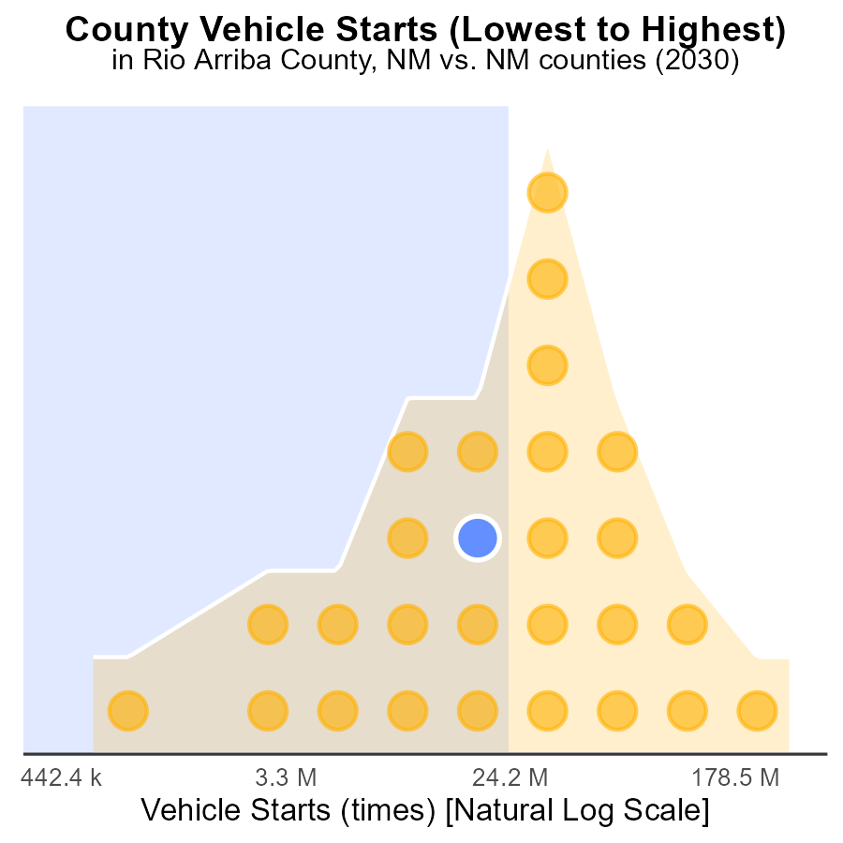

## Findings

* Bernalillo county has the highest number of vehicle starts with 806.5 million.
* Quay county has the highest percentage of vehicle starts compared to other counties with 48.1%.
* Harding county has the lowest number of vehicle starts with 1.6 million.

## Recommendations

To lower emissions, consider incentivizing carpooling and public transportation in counties with high vehicle starts such as Bernalillo and Quay. Implement stricter vehicle emission standards and promote the use of electric vehicles.

# Areas Ranked by Emissions Rate (per mile)

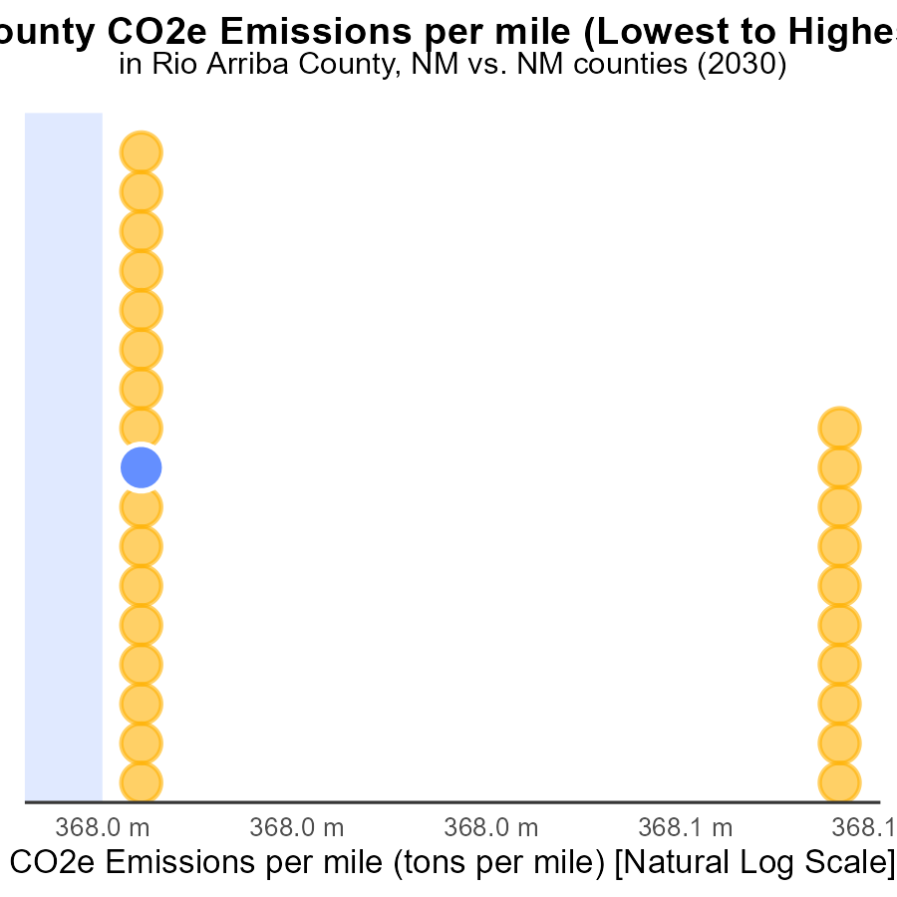

## Findings

* Guadalupe County has the highest emissions per mile at 517.8 tons, ranking 27th.
* Catron County has the lowest emissions per mile at 420.8 tons, ranking 1st.
* On average, emissions per mile range between 420.8 and 517.8 tons across the counties.

## Recommendations

Policymakers should focus on promoting public transportation and carpooling initiatives to decrease emissions per mile. Implementing incentives for electric vehicles can also contribute to emission reduction.

# About This Report

Data based on MOVES estimates collected by the Climate Action in Transportation program at Cornell University. Demographic data sourced from the US Census's American Community Survey 5-year estimates. This report was generated with the help of AI.

# References

* U.S. Census Bureau. (2023). American Community Survey 5-year estimates: Detailed tables. Retrieved from https://data.census.gov
* U.S. Environmental Protection Agency. (2024). Motor Vehicle Emission Simulator (MOVES 4.0) [Software]. Retrieved from https://www.epa.gov/moves