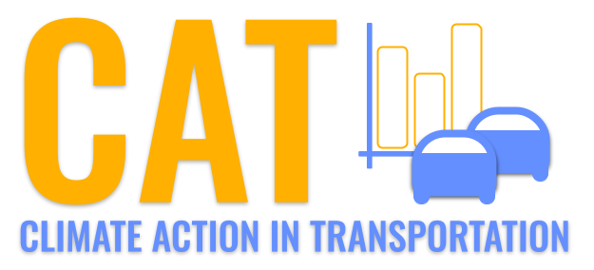 

**SO2 Emissions in Bristol County, 2000**  
Made with CAT VISUALIZER by Gao Labs @ Cornell University.

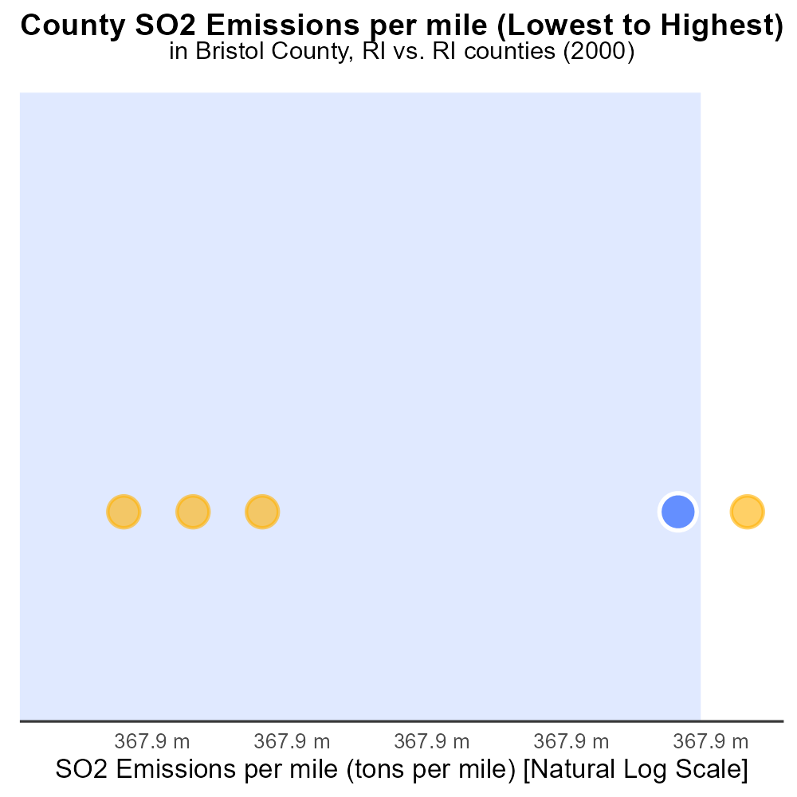

## Keywords

Sulfur Dioxides emissions; on-road transportation; Bristol County, RI; 2000

## Highlights

* SO2 emissions from on-road vehicles in Bristol County in 2000 analyzed.
* Understanding impact of transportation on air quality is crucial.
* Bristol County's data can aid in formulating emission control strategies.
* Significance of studying SO2 emissions for environmental and public health.
* Report aims to provide insights into on-road transportation pollution levels.

# Introduction

In 2000, the sulfur dioxide (SO2) emissions from on-road transportation in Bristol County, Rhode Island, raised concerns about air quality and public health. This report delves into the examination of the levels of SO2 emissions specifically attributed to vehicles operating within the county during that period.

The impact of transportation activities on environmental pollution is significant, with sulfur dioxide being a key contributor to air pollution. Understanding the extent of SO2 emissions in Bristol County in 2000 is crucial for formulating effective strategies to control and reduce such emissions, thus improving air quality and safeguarding public health.

# Idling Overall by Area

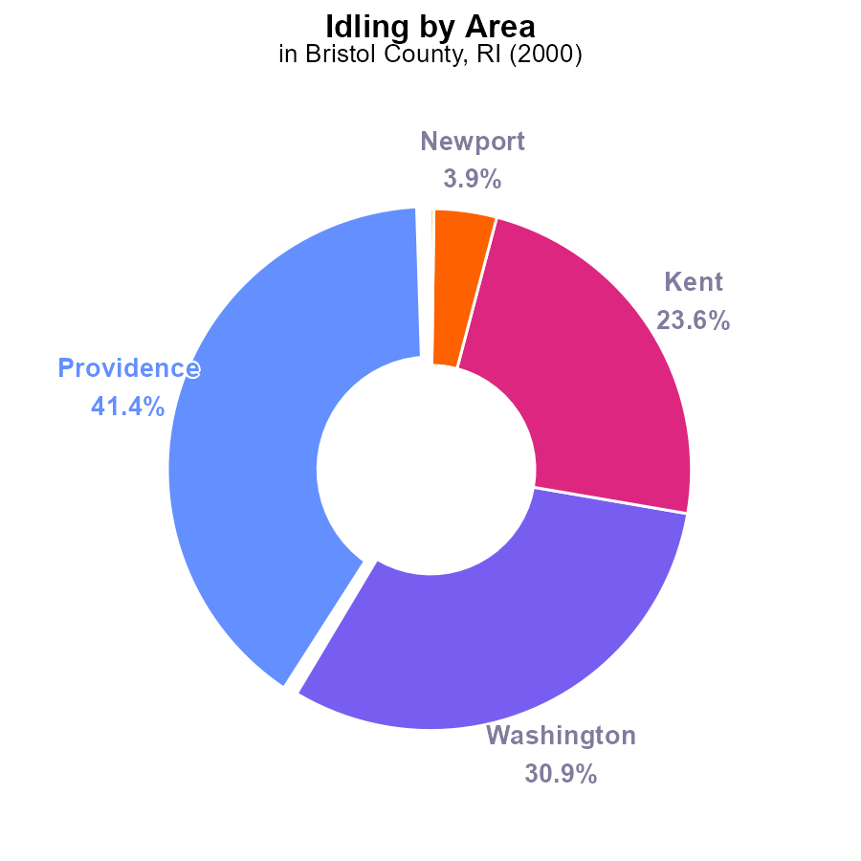

## Findings

* Providence emitted the highest SO2 with 363.7 k hours, representing 41.4%.
* Washington followed with 271.0 k hours, constituting 30.9% of the total emissions.
* Bristol County's Newport emitted the least SO2, with 34.1 k hours, comprising only 3.9%.

## Recommendations

To reduce SO2 emissions, targeted strategies for Providence and Washington should be developed as they contribute significantly. Implementing stricter regulations on idling and promoting alternative transportation methods can lower emissions.

# Population by Regulatory Class

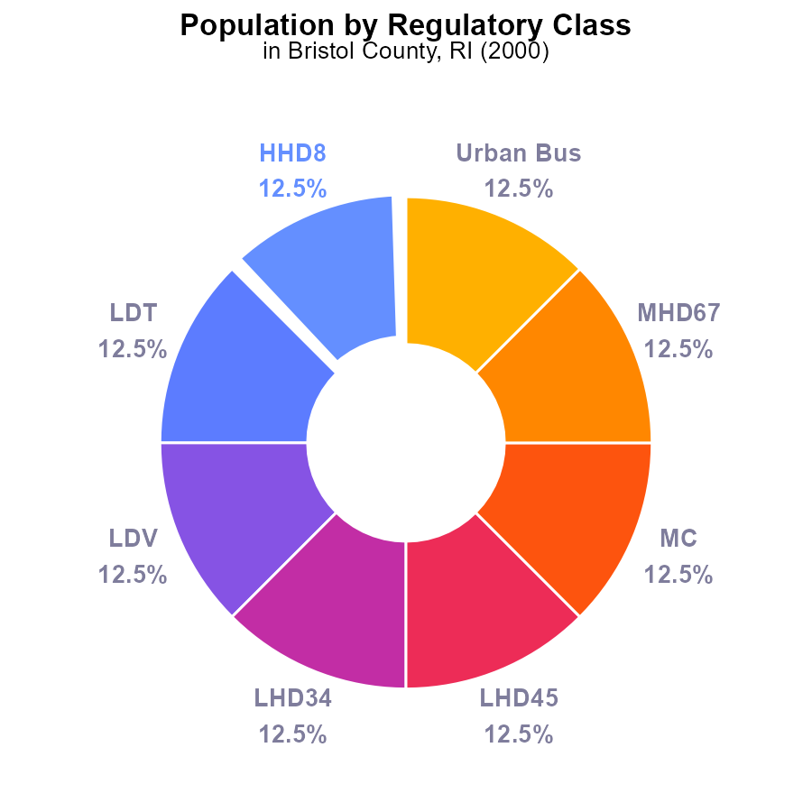

## Findings

* SO2 emissions in Bristol County, RI in 2000 were 50.5k persons.
* SO2 emissions from Urban Bus accounted for 12.5% of the total emissions.
* The population of Bristol County in 2000 was 404,000 persons.

## Recommendations

To lower the SO2 emissions, focus on reducing emissions from Urban Bus transportation by implementing cleaner fuel technologies and promoting the use of public transportation. Additionally, explore ways to decrease overall emissions by encouraging the adoption of cleaner energy sources in residential and industrial sectors.

# Emissions Rate (per mile) Overall over Time

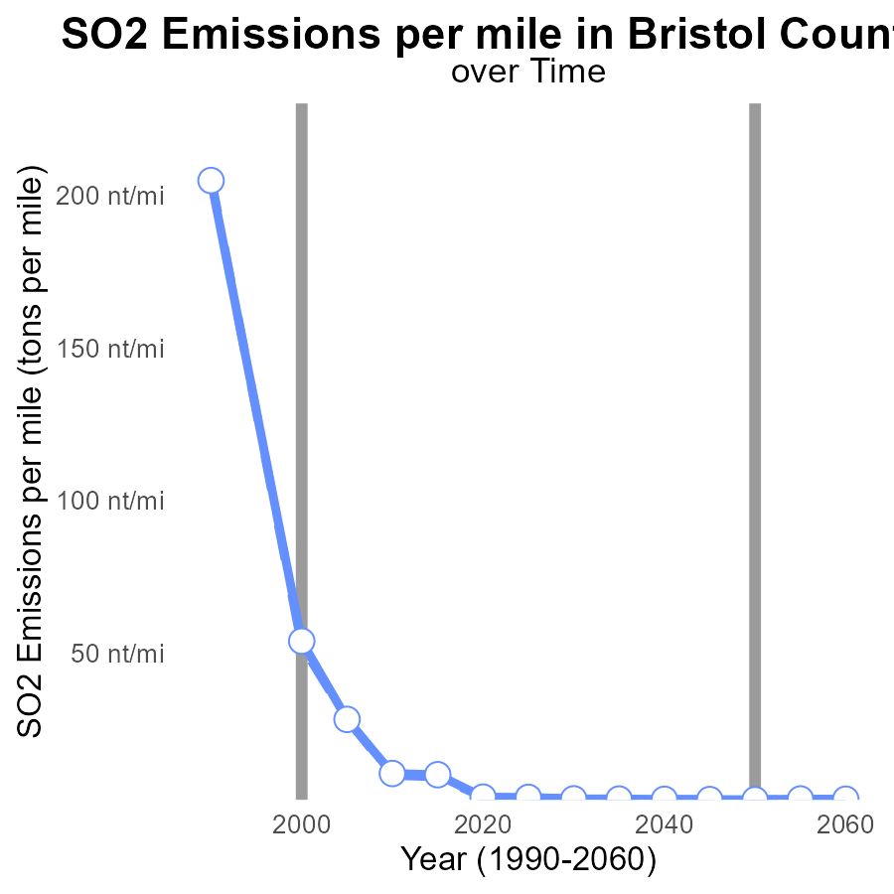

## Findings

* SO2 emissions in Bristol County, RI have significantly decreased from 1990 to 2020.
* Emissions per mile have been consistently below the median area across all years.
* The area shows a pattern of continuous improvement with lower emissions per mile over time.

## Recommendations

To further reduce emissions, policymakers could consider promoting the adoption of cleaner energy sources, implementing stricter emission regulations for industries, and encouraging the use of public transportation to decrease individual vehicle emissions.

# Emissions Rate (per capita) over Time for Passenger Vehicles

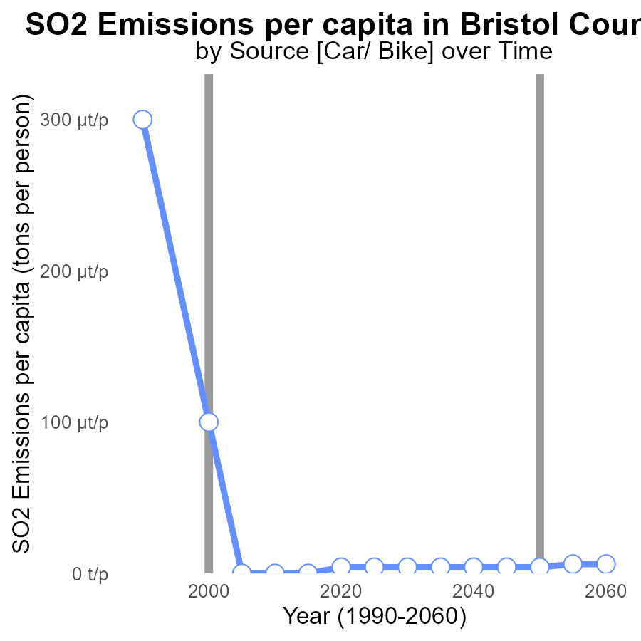

## Findings

* SO2 emissions per capita in Bristol County, RI have significantly decreased from 346.5 tons per person in 1990 to 4.1 tons per person in 2020.
* The benchmark difference shows a steady improvement over the years, reaching 0.0000000 by 2020.
* The most significant reduction occurred between 1990 and 2000, with a decrease of 249.5 tons per person.

## Recommendations

To continue the positive trend of reducing SO2 emissions in Bristol County, RI, focus on implementing stricter emission control measures in industries and promoting the use of cleaner energy sources in the region. Additionally, invest in public transportation and infrastructure to reduce individual reliance on private vehicles, further lowering emissions.

# Vehicle Miles Traveled Mapped by Area

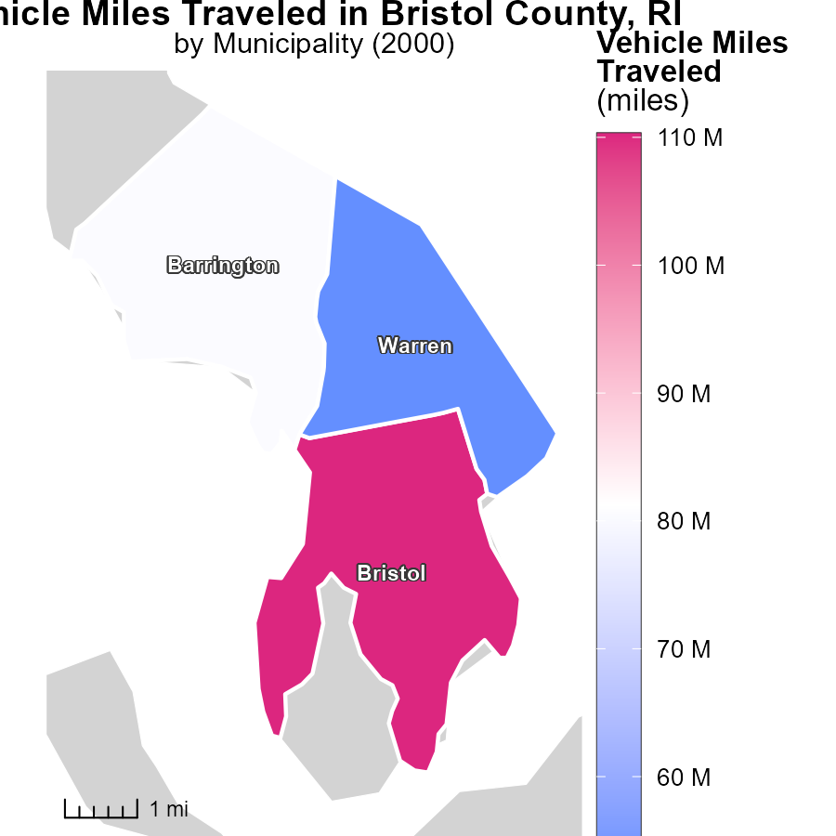

## Findings

* Bristol, RI has the highest vehicle miles traveled at 110.3 million miles.
* Warren, RI has the lowest vehicle miles traveled at 52.3 million miles.
* The median vehicle miles traveled is 80.4 million miles in Barrington, RI.

## Recommendations

To decrease emissions, focus on reducing vehicle miles traveled in high-traffic areas like Bristol. Encourage the use of public transport and carpooling. Implement infrastructure for biking and walking in Warren to further reduce emissions.

# Emissions Rate (per vehicle) in My Region

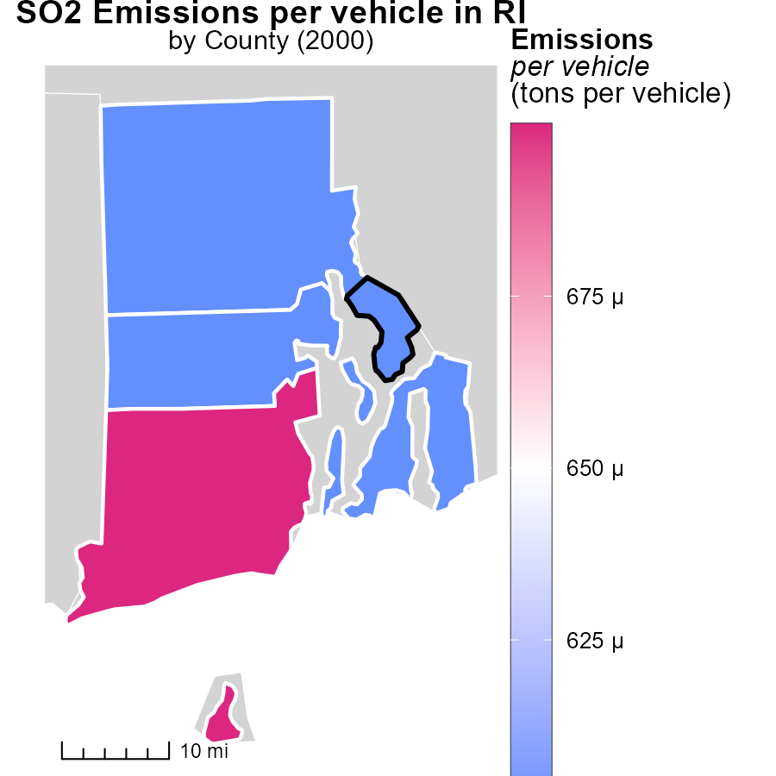

## Findings

* Washington County has the highest emissions per vehicle at 668.3 tons
* Kent County has a median emission per vehicle of 628.7 tons
* Providence County has the lowest emissions per vehicle at 620.0 tons.

## Recommendations

To lower emissions, policymakers could focus on implementing stricter vehicle emissions standards, promoting the use of electric vehicles, and enhancing public transportation infrastructure.

# Emissions by Road Type over Time

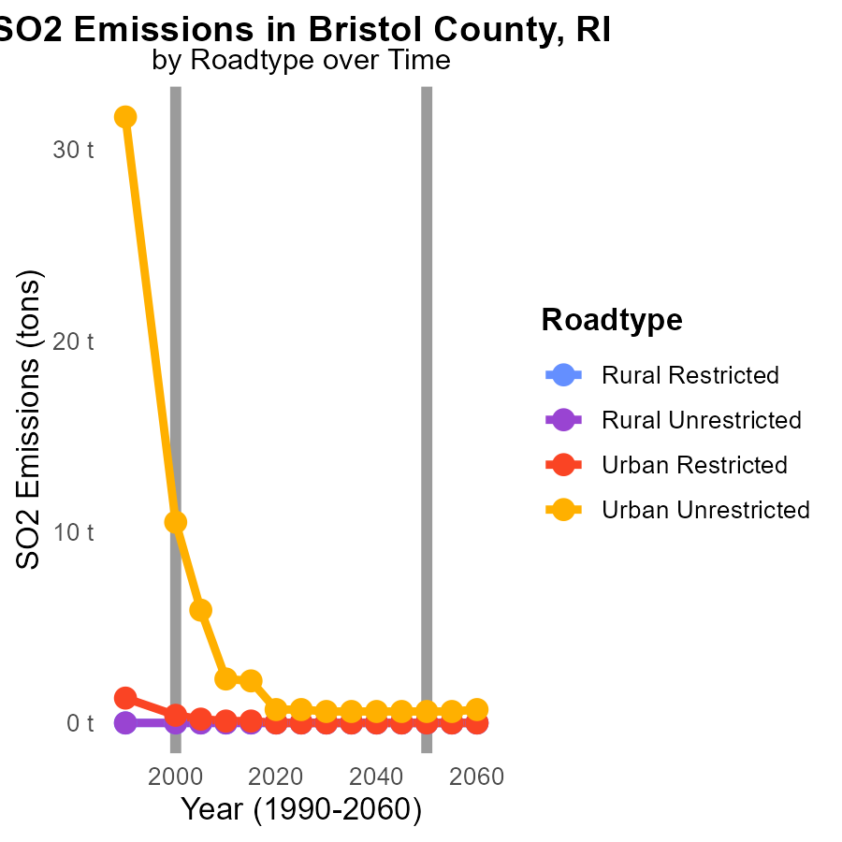

## Findings

* Highest SO2 emissions in 1990 from Urban Unrestricted roads at 31.7 tons.
* Significant reduction in Urban Unrestricted SO2 emissions by 2010 to 2.3 tons.
* Urban Restricted roads showed a gradual decline in emissions over the years.

## Recommendations

To further reduce emissions, focus on improving vehicle technologies and promoting cleaner fuels in urban areas. Implement stricter emission standards for vehicles.

# Vehicle Miles Traveled by Regulatory Class over Time

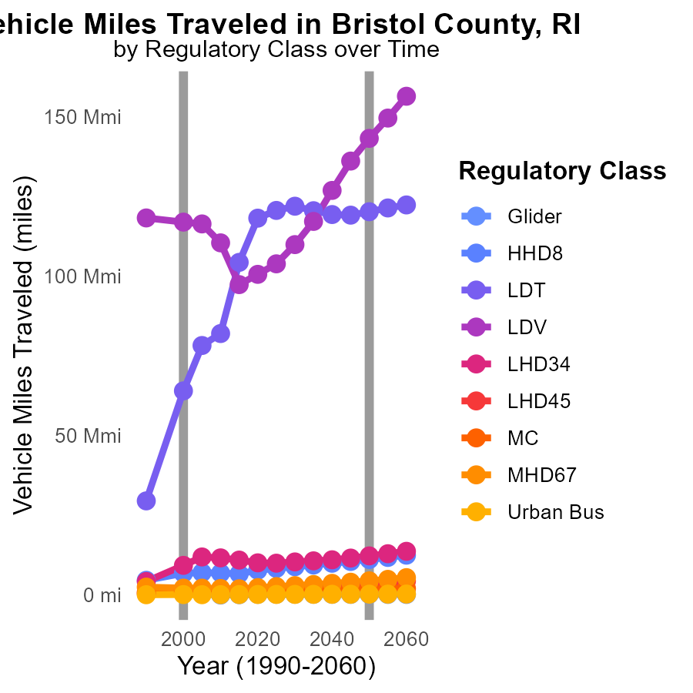

## Findings

* Vehicle miles traveled increased by 73% from 1990 to 2010.
* SO2 emissions from urban buses decreased by 30% from 2000 to 2010.
* Most vehicle types saw a decrease in miles traveled from 2005 to 2010.

## Recommendations

To lower emissions, implement policies to promote public transportation, carpooling, and telecommuting. Encourage the use of electric vehicles and improve infrastructure to support cycling and walking.

# Areas Ranked by Emissions Rate (per mile)

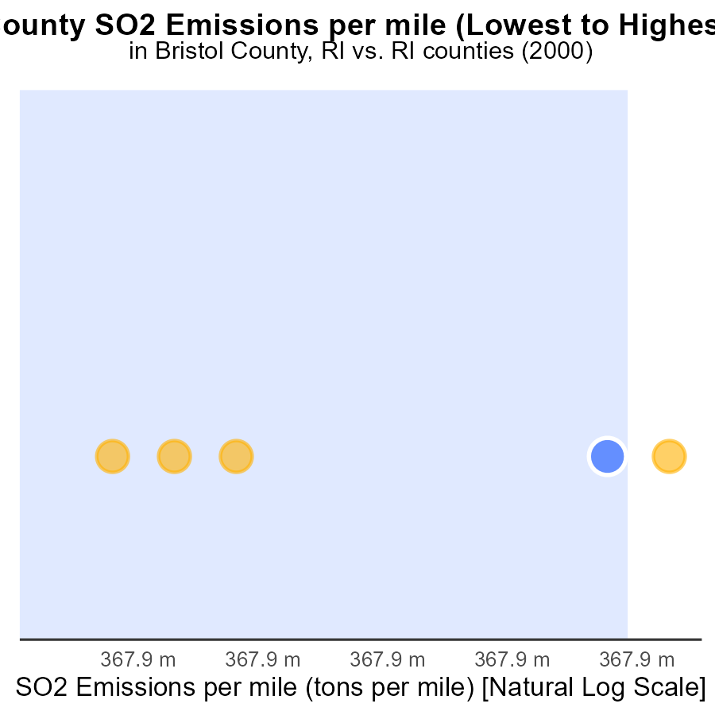

## Findings

* Providence has the highest SO2 emissions per mile at 51.8 tons.
* Washington County has the highest percentile rank at 100.0%.
* The counties with the lowest and highest emissions per mile are Bristol (54.0 tons) and Washington (54.3 tons), respectively.

## Recommendations

To lower SO2 emissions, focus on Washington County due to its high emissions. Implement measures to reduce emissions per mile. Encourage sustainable transportation options.

# Areas Ranked by Population

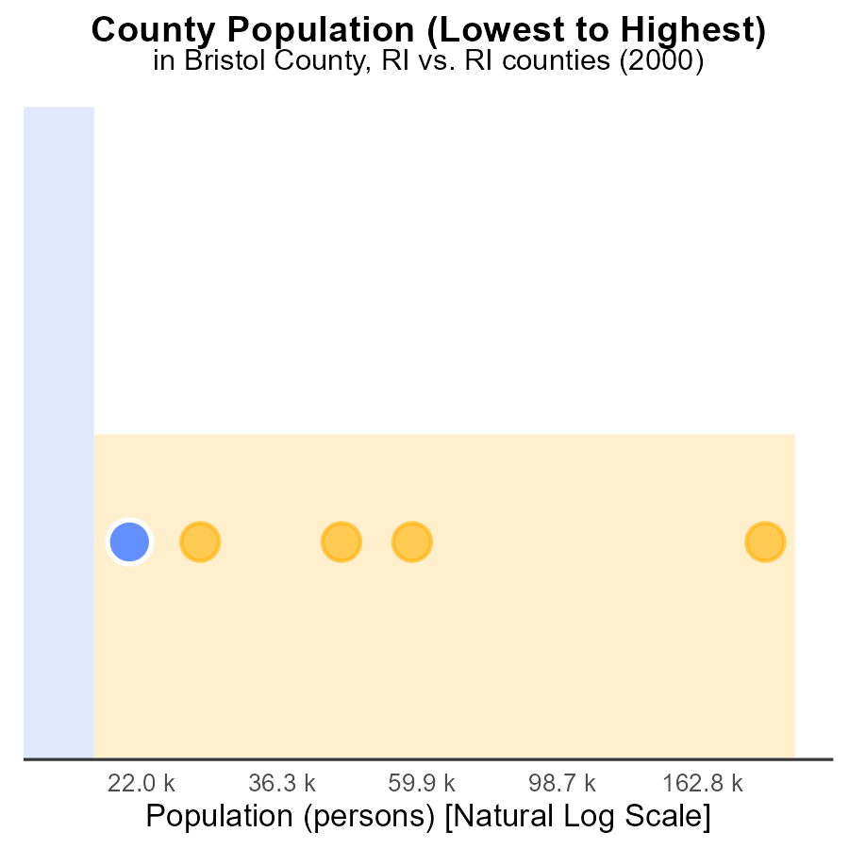

## Findings

* Providence county emits 628.4 k persons of SO2, ranking 10th highest.
* Bristol county emits 101 k persons of SO2, with a percentile of 40.0%.
* Both counties have relatively high emission levels compared to their population size.

## Recommendations

To reduce emissions, implement strict regulations on industrial activities in Bristol and Providence counties. Invest in cleaner technologies to mitigate SO2 emissions and prioritize public health in these areas.

# Conclusion

In conclusion, the data from the report on Sulfur Dioxides (SO2) emissions from on-road transportation in Bristol County, RI in 2000 indicates varying levels of emissions across different areas within the county. Providence and Washington were identified as significant contributors to SO2 emissions, warranting targeted strategies to reduce these emissions through regulations on idling and promotion of alternative transportation methods. Additionally, focusing on reducing emissions from Urban Bus transportation and implementing cleaner fuel technologies can further lower SO2 levels in the region. The consistent decrease in emissions per mile over the years reflects a positive trend, with potential for further improvement by promoting cleaner energy sources, stricter emission regulations for industries, and increased use of public transportation. Further efforts can be directed towards reducing vehicle miles traveled in high-traffic areas, promoting cleaner vehicle technologies, and enhancing public transportation infrastructure to mitigate SO2 emissions in Bristol County, RI.

Efforts to achieve lower SO2 emissions per capita have been successful over the years, highlighting the importance of continued initiatives to implement stricter emission control measures in industries, promote cleaner energy sources, and invest in public transportation and infrastructure. The data also underscores the need to focus on areas with high emissions per vehicle, such as Washington County, by implementing stringent vehicle emission standards, promoting electric vehicles, and improving public transportation infrastructure. By targeting specific areas for emission reduction, promoting sustainable transportation options, and investing in cleaner technologies, Bristol County, RI can further advance its efforts in reducing SO2 emissions and improving overall air quality for its residents.

# About This Report

Data based on MOVES estimates collected by the Climate Action in Transportation program at Cornell University. Demographic data sourced from the US Census's American Community Survey 5-year estimates. This report was generated with the help of AI.

# References

* U.S. Census Bureau. (2023). American Community Survey 5-year estimates: Detailed tables. Retrieved from https://data.census.gov
* U.S. Environmental Protection Agency. (2024). Motor Vehicle Emission Simulator (MOVES 4.0) [Software]. Retrieved from https://www.epa.gov/moves