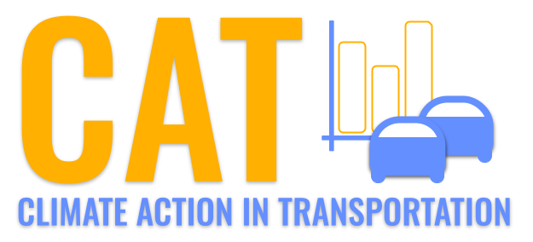 

**VOC Emissions in Kershaw County, 2000**  
Made with CAT VISUALIZER by Gao Labs @ Cornell University.

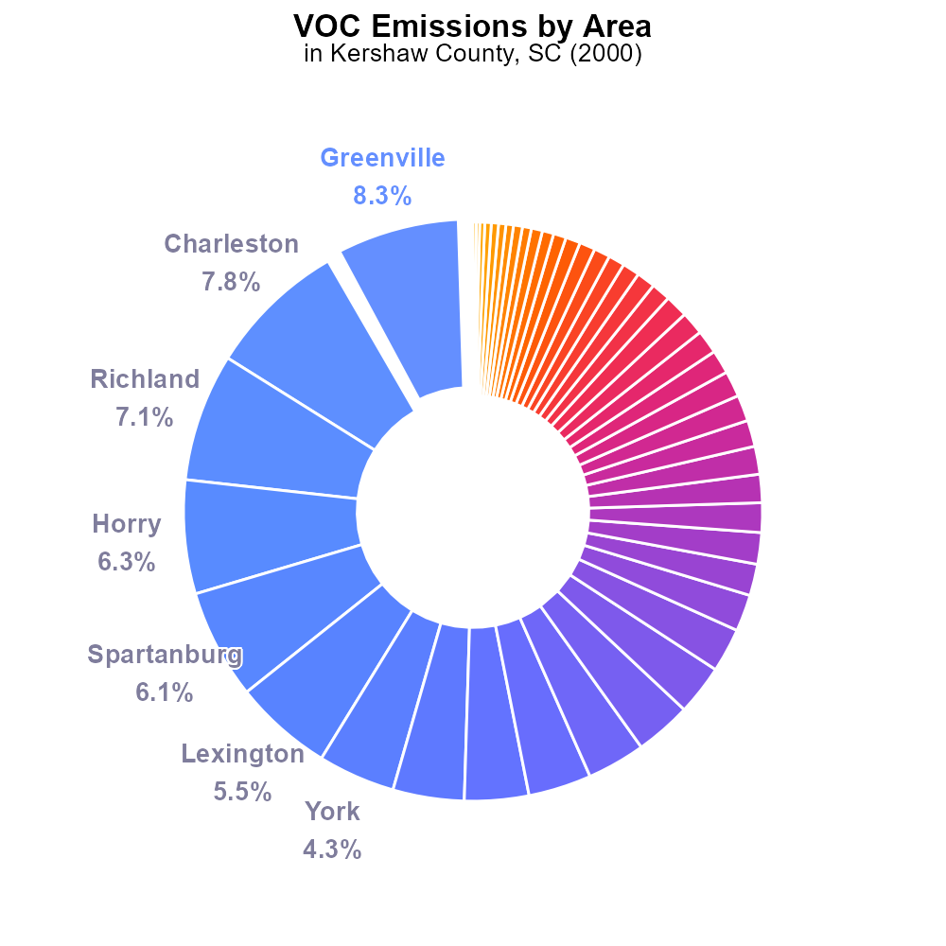

## Keywords

Volatile Organic Compounds; on-road transportation; Kershaw County; South Carolina; emissions; 2000

## Highlights

* Study on VOC emissions from on-road transport in Kershaw County, SC.
* VOCs pose environmental and health hazards, impacting air quality.
* Analysis of emission trends and sources for targeted mitigation strategies.
* Year 2000 data used to understand VOC contribution from transportation.
* Comprehensive report to inform policymakers and promote sustainable practices.

# Introduction

The report focuses on the Volatile Organic Compounds (VOC) emissions originating from on-road transportation in Kershaw County, South Carolina in the year 2000. VOCs, a group of carbon-based chemicals, are known for their detrimental effects on both the environment and public health. By examining the specific contributions of on-road transportation to VOC emissions, this study aims to provide insights into air quality challenges in the region.

Furthermore, the report delves into the trends and sources of VOC emissions to formulate targeted strategies for mitigation and reduction. The use of 2000 data allows for a retrospective analysis, shedding light on the historical impact of transportation activities on VOC levels in Kershaw County. The findings and recommendations outlined in this comprehensive report are vital for policymakers and stakeholders looking to address environmental concerns and promote sustainable practices for transportation in the region.

# Emissions Rate (per mile) by Regulatory Class

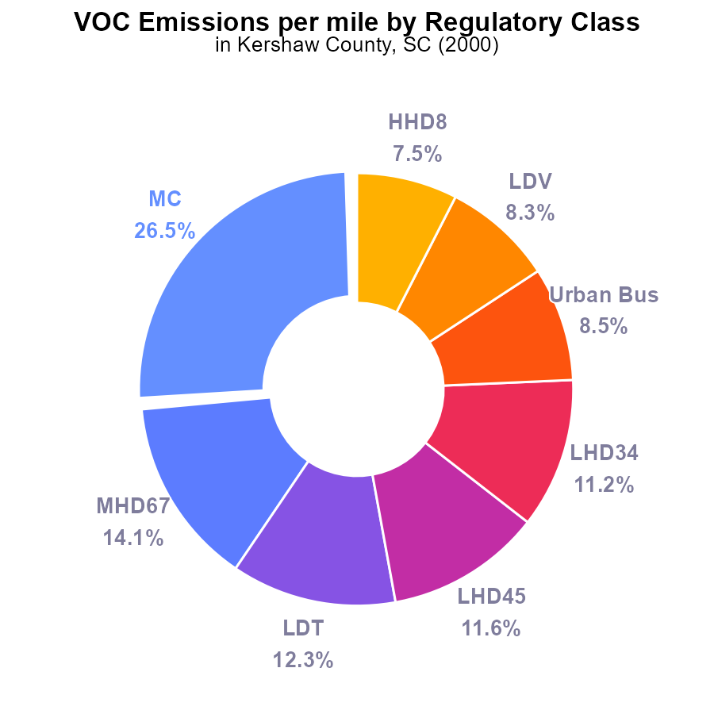

# Emissions Overall by Area

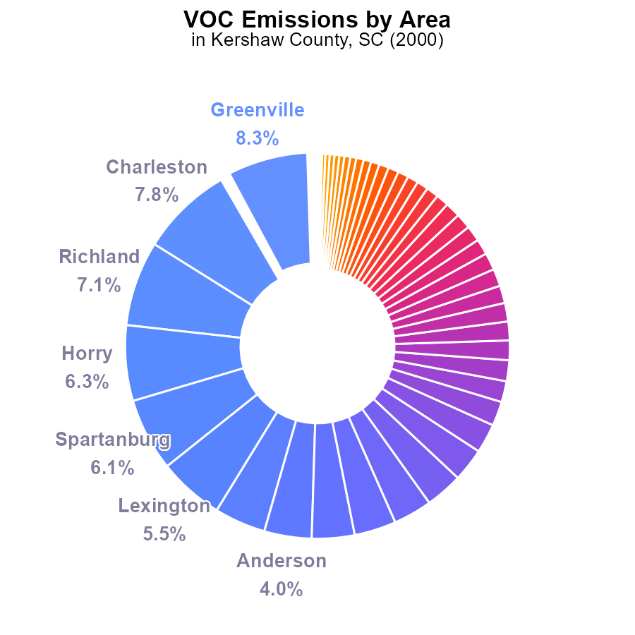

## Findings

* Top emitters (Greenville, Charleston, Richland) contribute 23.2% of VOC emissions.
* Majority of counties (36 out of 46) emit less than 2% of total VOC emissions.
* Kershaw County emits 932.4 tons of VOC, ranking 23rd among counties.

## Recommendations

To reduce VOC emissions, focus on top emitters by implementing stricter regulations or incentives. Encourage lower-emission transportation and industries in high-impact counties.

# Time Driven over Time for Passenger Time Driven

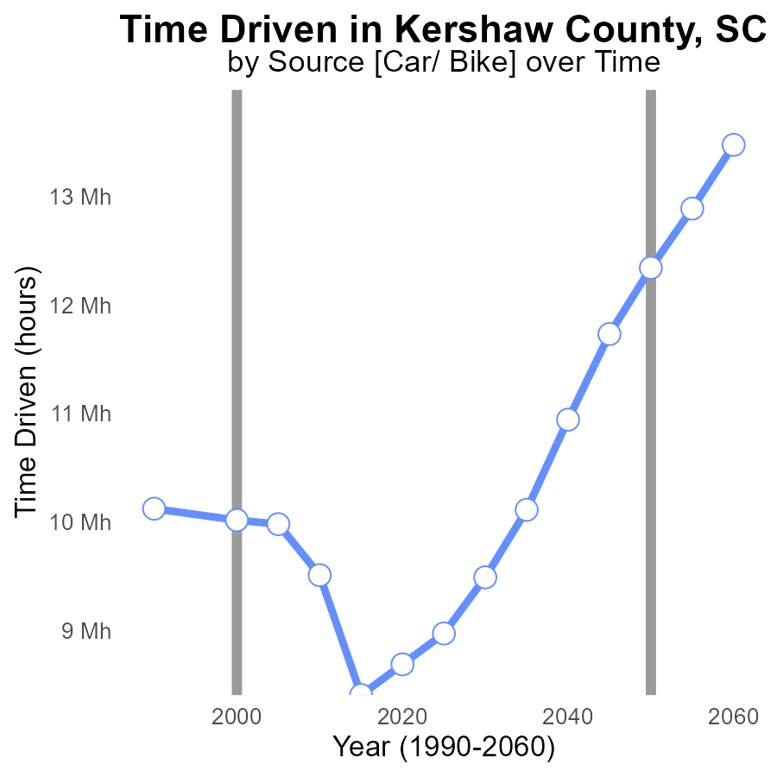

## Findings

* VOC emissions in Kershaw County, SC decreased by 16.8% from 1990 to 2020.
* The greatest decrease in VOC emissions occurred from 2010 to 2015, with a 27% reduction.
* Overall, VOC emissions in Kershaw County have shown a downward trend over the past three decades.

## Recommendations

To further reduce VOC emissions in Kershaw County, policymakers should focus on promoting the adoption of cleaner technologies in industries, improving transportation systems to reduce vehicle emissions, and implementing stricter regulations on air pollution. Additionally, incentivizing the use of low-emission vehicles and enhancing public awareness campaigns on air quality can aid in sustaining the declining trend of VOC emissions.

# Vehicle Miles Traveled Overall over Time

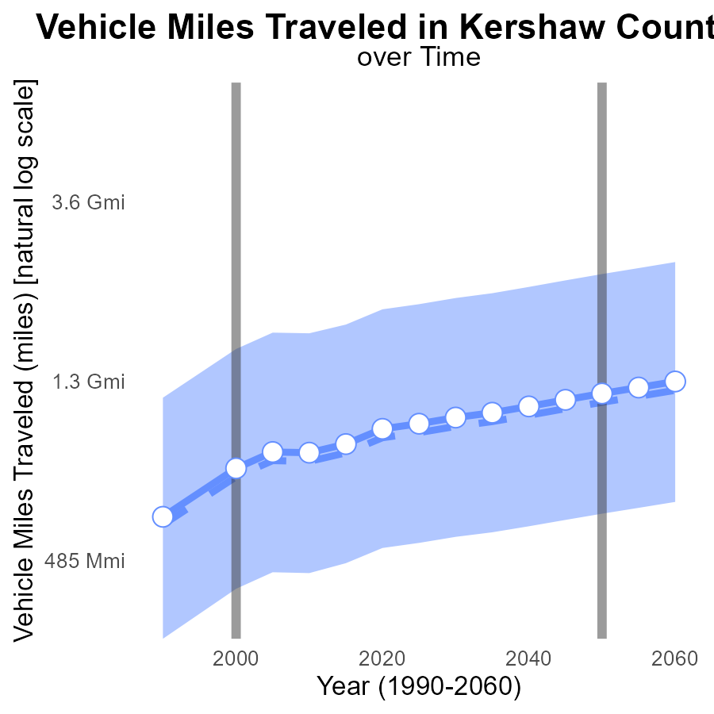

## Findings

* Vehicle miles traveled in Kershaw County, SC have consistently increased over the years from 1990 to 2020.
* The benchmark difference between Kershaw County and the median area has also grown, indicating higher emissions.
* Kershaw County falls within the upper 75th percentile of vehicle miles traveled compared to other areas.

## Recommendations

To lower emissions, policymakers should focus on promoting public transportation, implementing carpooling initiatives, and investing in infrastructure to support walking and biking.

# Time Driven Mapped by Area

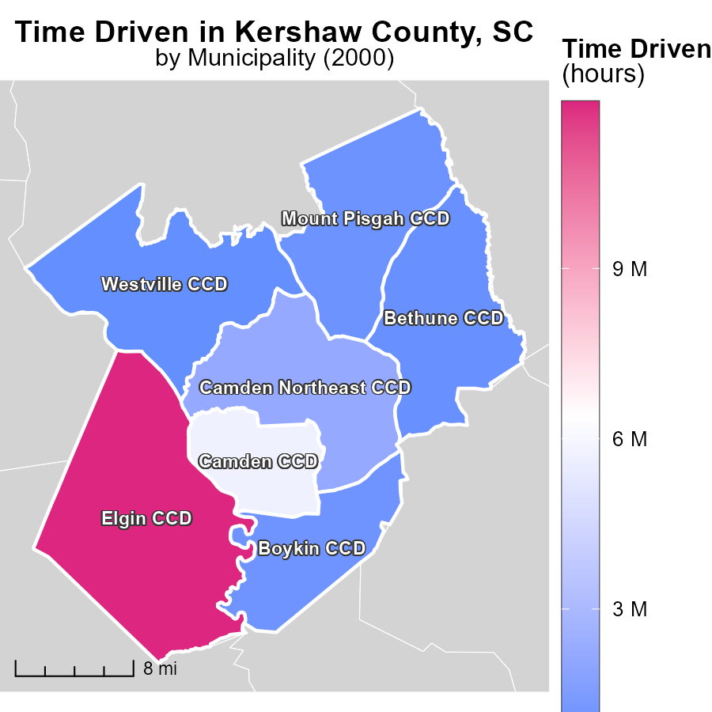

## Findings

* The maximum emissions in Elgin CCD, SC were 11.9 million hours.
* Boykin CCD, SC had median emissions of 1.1 million hours.
* Westville CCD, SC showed the minimum emissions with 823.9 thousand hours.

## Recommendations

To lower emissions, focus on reducing the hours by implementing energy-efficient practices in these areas, especially in Elgin CCD, SC, where the emissions are significantly higher.

# Idling Mapped by Area

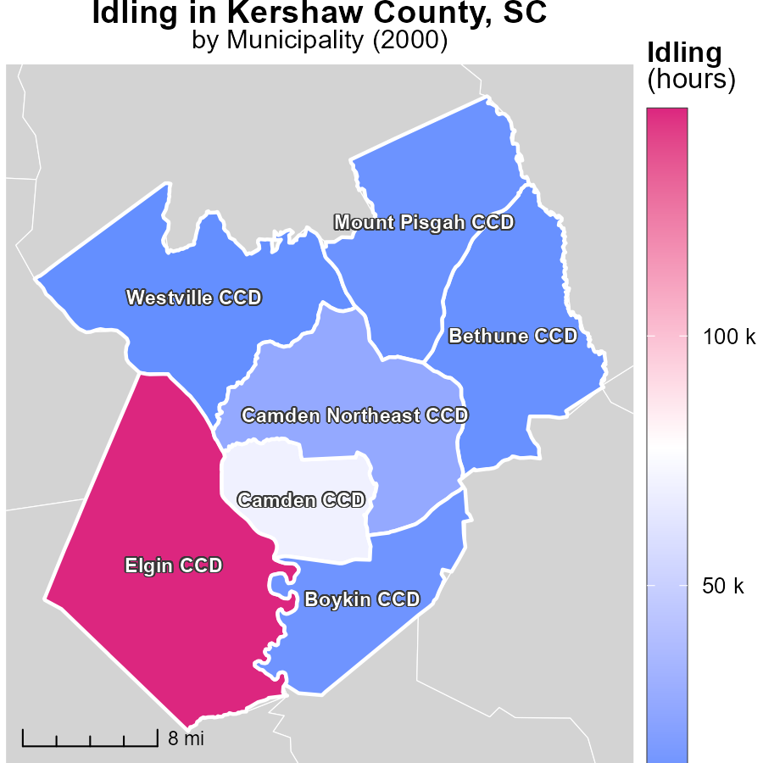

## Findings

* The highest idling emissions were 145.5 k hours in Elgin CCD, SC.
* Boykin CCD, SC had median idling emissions of 13.5 k hours.
* Westville CCD, SC had the lowest idling emissions at 10.0 k hours.

## Recommendations

To reduce idling emissions, targeted interventions should focus on high-emission areas like Elgin CCD, SC. Implementing idling reduction strategies in transportation and enforcing anti-idling regulations can help lower emissions in these areas.

# Vehicle Starts by Fuel Type over Time

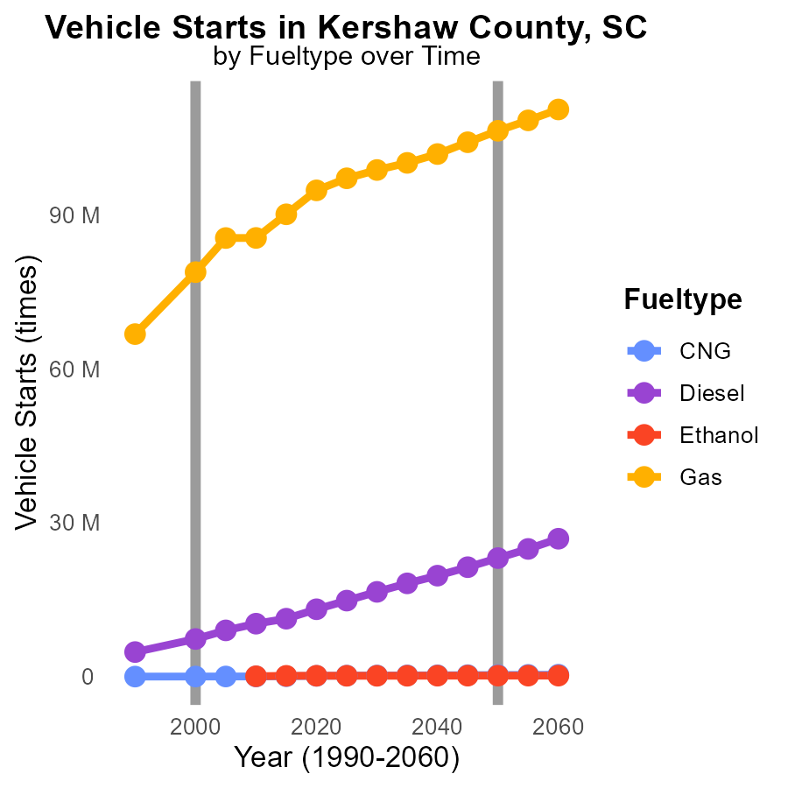

## Findings

* Diesel vehicle starts have decreased by 24.6% from 2000 to 2010.
* Gasoline vehicle starts remained constant from 2005 to 2010.
* Ethanol vehicle starts account for only 0.1% of total vehicle starts in 2010.

## Recommendations

To lower emissions: promote the transition to alternative fuel vehicles like CNG and ethanol, incentivize the use of cleaner fuels, and implement stricter regulations on diesel vehicle usage.

# Hotelling (Diesel Aux) by Regulatory Class over Time

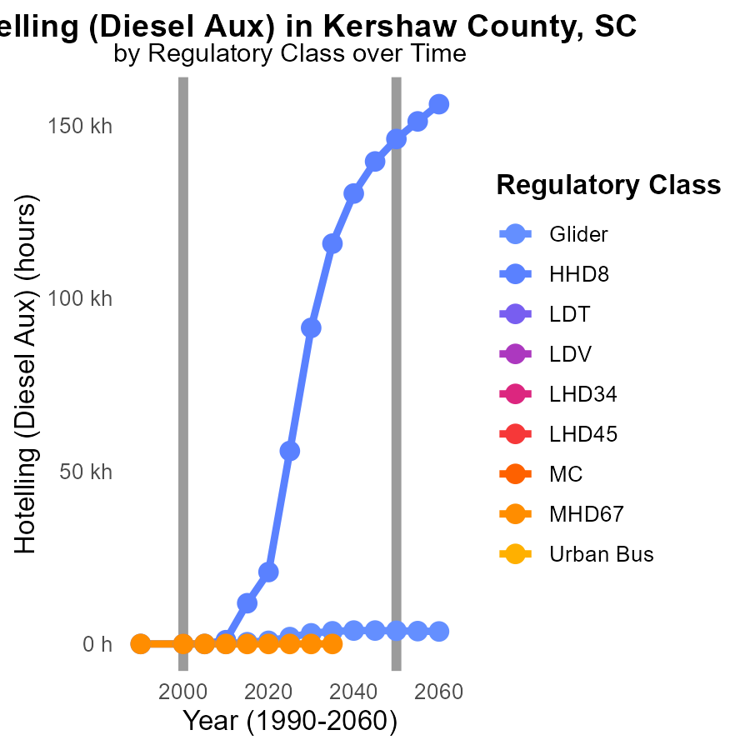

## Findings

* VOC emissions from Glider in 2010 were 18.3 units, a significant increase compared to 2050 projections.
* HHD8 category had zero emissions in 1990, 2000, and 2005, but emitted 1.1k units in 2010.
* Several vehicle categories like LDT, LDV, LHD34, and others showed no emissions across all years.

## Recommendations

To reduce VOC emissions in Kershaw County, SC, focus on regulating categories like Glider and HHD8 that showed increases. Promote cleaner technologies in these sectors to align with emission reduction targets.

# Areas Ranked by Emissions Rate (per capita)

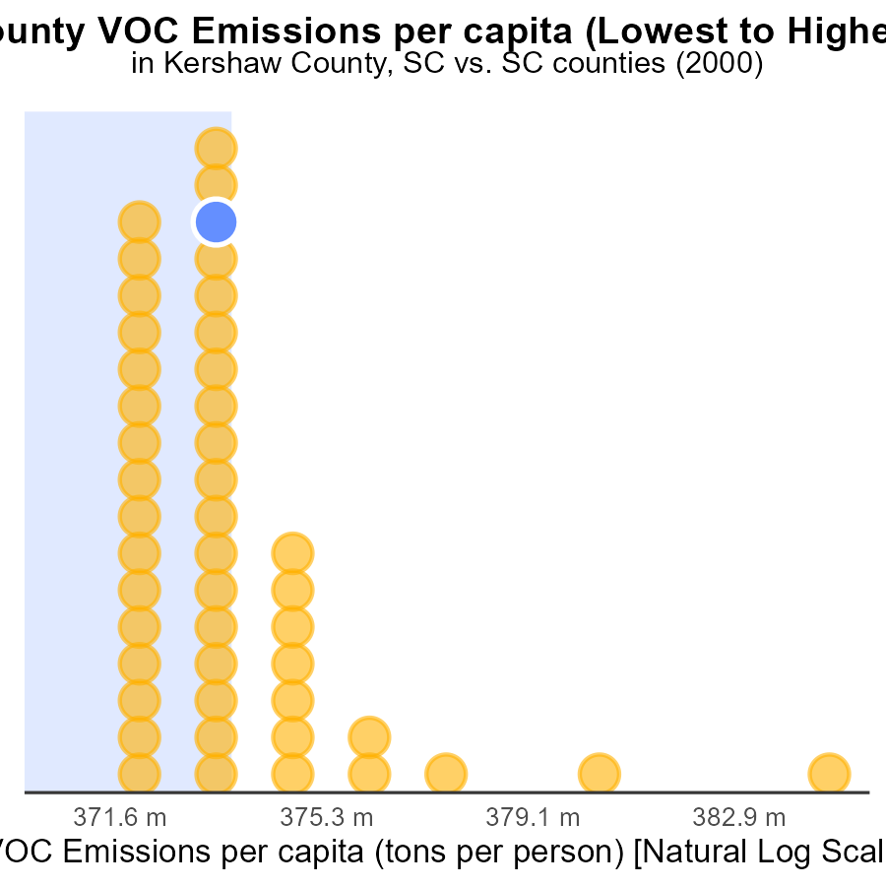

## Findings

* Jasper County has the highest VOC emissions per capita at 47.3 tons per person.
* Abbeville County has the lowest VOC emissions per capita at 9.1 tons per person.
* Overall, VOC emissions per capita are highest in Jasper County, ranking it at 100.0% in the dataset.

## Recommendations

To lower VOC emissions, focusing on Jasper County is vital due to its substantially higher emissions per capita. Implementing targeted reduction measures, such as improving industrial emission controls and promoting cleaner transportation, could effectively decrease the county's emission levels.

# Areas Ranked by Time Driven

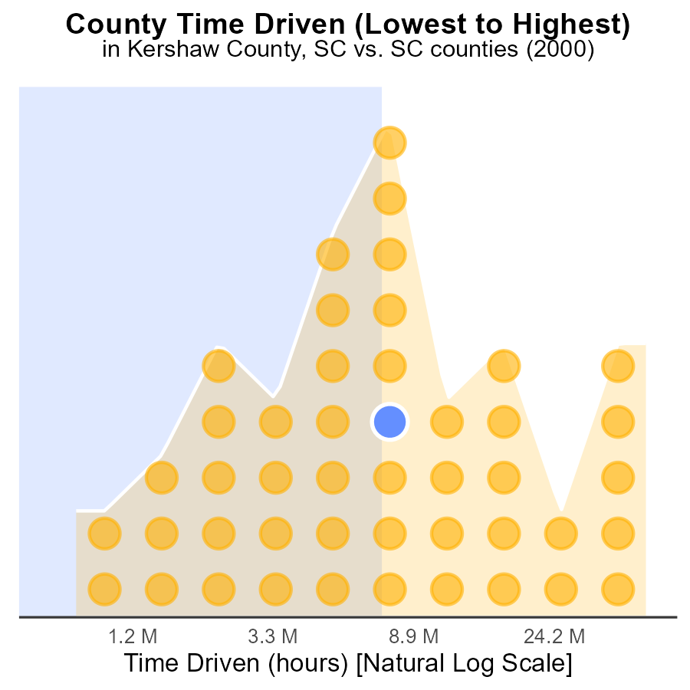

## Findings

* Greenville County has the highest VOC emissions with 126.3 million source hours.
* Darlington County ranks 26th with 19.4 million source hours, constituting 56.5% of the percentile.
* Allendale County ranks 1st with the lowest emissions at 2.2 million source hours, contributing 2.2% of the total VOC emissions.

## Recommendations

To lower VOC emissions, focus on Greenville County by implementing stricter regulations on VOC-producing activities. Encourage Darlington County to reduce emissions further to improve air quality. Support Allendale County in maintaining their low emission levels through sustainable practices.

# Conclusion

In conclusion, the data on Volatile Organic Compounds (VOC) emissions from on-road transportation in Kershaw County, SC in 2000 reveals significant insights. Kershaw County ranks 23rd in VOC emissions among counties, emitting 932.4 tons of VOC. The county has shown a decreasing trend in emissions, with a notable 16.8% reduction from 1990 to 2020.

Moving forward, to continue reducing VOC emissions in Kershaw County, policymakers should concentrate on implementing cleaner technologies in industries, improving transportation systems to decrease vehicle emissions, and enforcing stricter air pollution regulations. Promoting the use of low-emission vehicles, enhancing public awareness campaigns on air quality, and investing in infrastructure for walking and biking can further aid in sustaining the declining trend of VOC emissions. By focusing on these strategies, Kershaw County can contribute to the overall reduction of VOC emissions and work towards a more environmentally sustainable future.

# About This Report

Data based on MOVES estimates collected by the Climate Action in Transportation program at Cornell University. Demographic data sourced from the US Census's American Community Survey 5-year estimates. This report was generated with the help of AI.

# References

* U.S. Census Bureau. (2023). American Community Survey 5-year estimates: Detailed tables. Retrieved from https://data.census.gov
* U.S. Environmental Protection Agency. (2024). Motor Vehicle Emission Simulator (MOVES 4.0) [Software]. Retrieved from https://www.epa.gov/moves