 

**PM2.5 Emissions in Lake County, 2005**  
Made with CAT VISUALIZER by Gao Labs @ Cornell University.

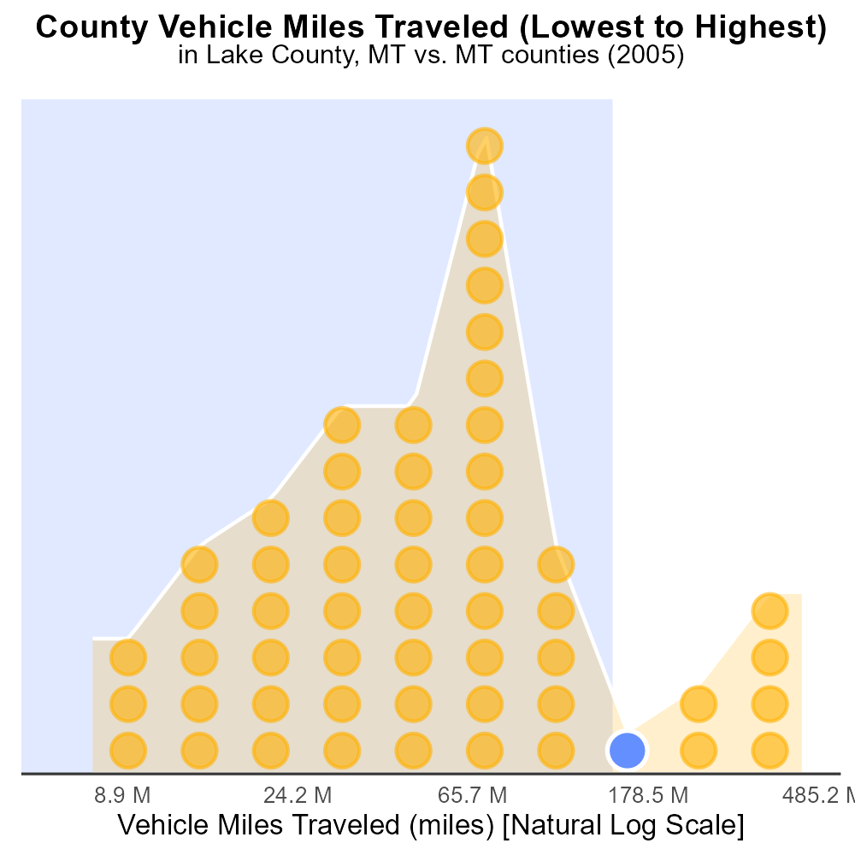

## Keywords

Primary Exhaust PM2.5; Total emissions; on-road transportation; Lake County; MT; 2005

## Highlights

* Analysis of PM2.5 emissions from on-road transportation in Lake County, MT.
* Focus on primary exhaust sources and total emissions in the year 2005.
* Implications for air quality and public health in the region.
* Data-driven approach to understanding pollution levels in Lake County.
* Key findings to inform future environmental policies and initiatives.

# Introduction

In this report, we delve into the primary exhaust PM2.5 emissions originating from on-road transportation in Lake County, Montana, specifically focusing on the total emissions recorded in the year 2005. By assessing the levels of particulate matter pollution generated by vehicles in this region, we aim to gain insights into the environmental impact of transportation activities on air quality.

The study will explore the sources and distribution of PM2.5 emissions, with a particular emphasis on primary exhaust emissions. Understanding the contribution of on-road transportation to the overall pollution load in Lake County is crucial for developing effective mitigation strategies and safeguarding public health. Through a data-driven analysis, we seek to inform policymakers and stakeholders about the critical need for sustainable transportation practices and policies to reduce emissions and ensure a cleaner, healthier environment for all residents.

# Vehicles by Fuel Type

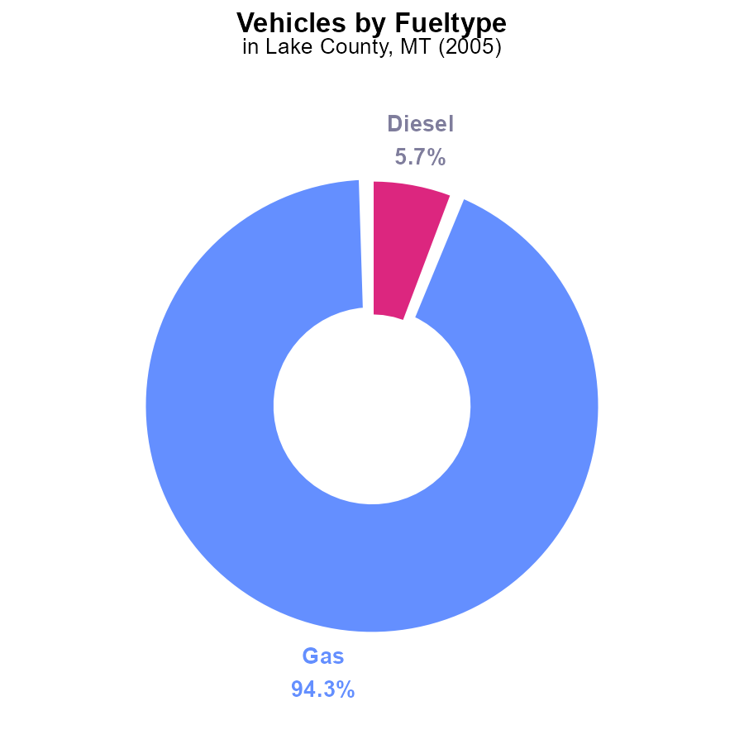

## Findings

* In 2005, the primary source of PM2.5 emissions in Lake County, MT, was gas vehicles at 94.3%.
* Diesel vehicles contributed to 5.7% of PM2.5 emissions in the county in 2005.
* CNG vehicles had a negligible impact on PM2.5 emissions, accounting for 0.0% in 2005.

## Recommendations

To lower PM2.5 emissions in Lake County, MT, a focus should be placed on reducing emissions from gas and diesel vehicles. This could be achieved by promoting the adoption of electric vehicles, improving public transportation systems, and implementing stricter vehicle emissions standards.

# Emissions Rate (per vehicle) by Regulatory Class

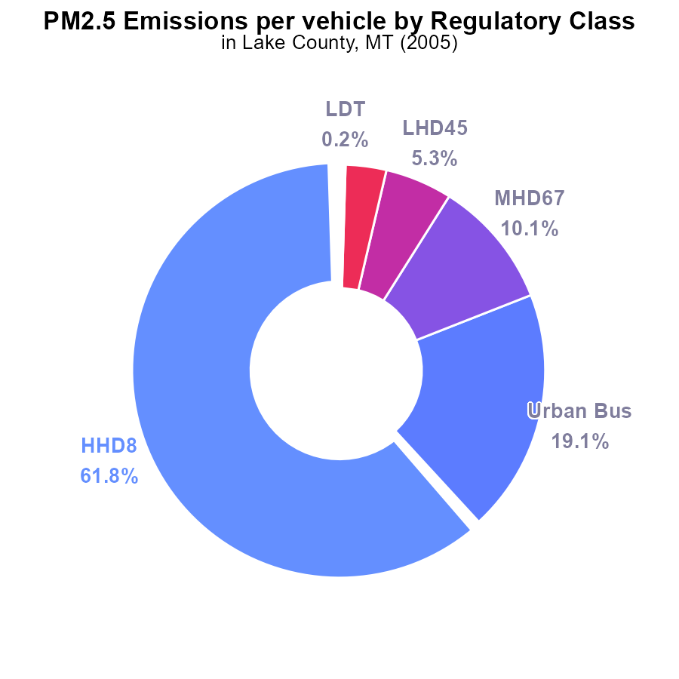

## Findings

* In Lake County, MT in 2005, the highest PM2.5 emissions per vehicle came from HHD8 trucks at 45.6 tons per vehicle, representing 61.8% of total emissions.
* Urban buses were the second-largest contributor at 14.1 tons per vehicle, accounting for 19.1% of the total emissions.
* Medium-heavy duty trucks (MHD67) released 7.4 tons of PM2.5 per vehicle, making up 10.1% of the total emissions.

## Recommendations

To reduce emissions, policymakers should focus on implementing stricter regulations for HHD8 trucks, enhancing public transportation to reduce reliance on urban buses, and incentivizing the transition to cleaner fuel sources for medium-heavy duty trucks.

# Hotelling (Diesel Aux) over Time for Passenger Vehicles

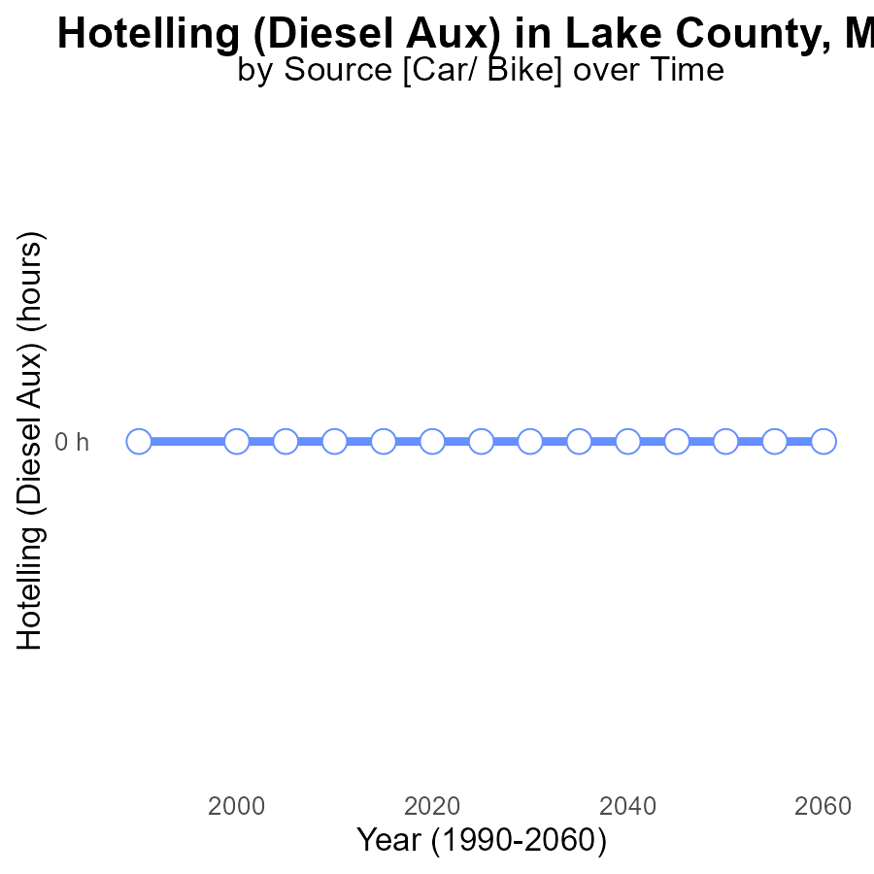

## Findings

* PM2.5 emissions from Hotelling (Diesel Aux) in Lake County, MT have been consistently 0 hours in the years 1990 to 2025.

## Recommendations

Since emissions have been consistently at 0 hours for Hotelling (Diesel Aux), the focus should be on maintaining and enforcing existing regulations to sustain this low level of emissions.

# Vehicle Starts Overall over Time

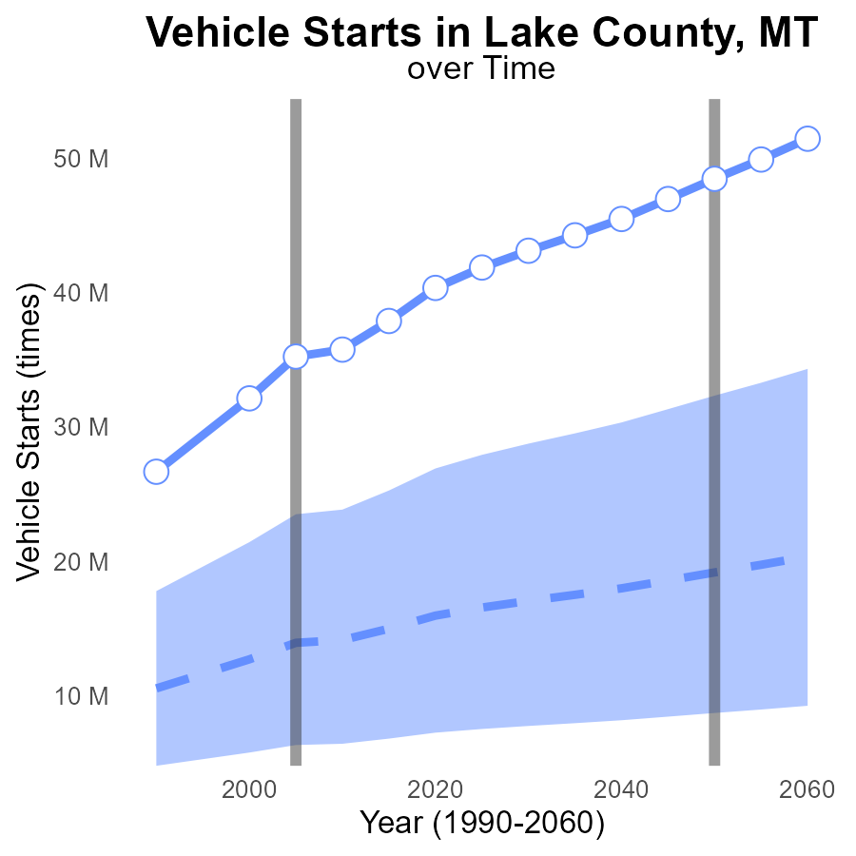

## Findings

* Emissions of PM2.5 from vehicle starts have consistently increased in Lake County, MT from 1990 to the projected 2025.
* The emissions in 2025 are expected to be 41.9 million times, which is 25.3 million times more than the median area.
* The upper 75th percentile of areas has the highest emissions with 27,932,169 times in 2025, significantly higher compared to Lake County's emissions.

## Recommendations

To lower PM2.5 emissions, policymakers in Lake County should consider promoting green vehicle initiatives, improving public transportation systems to reduce individual car usage, and implementing stricter vehicle emission standards to align with those of the top 25% of areas with lower emissions.

# Vehicle Miles Traveled Mapped by Area

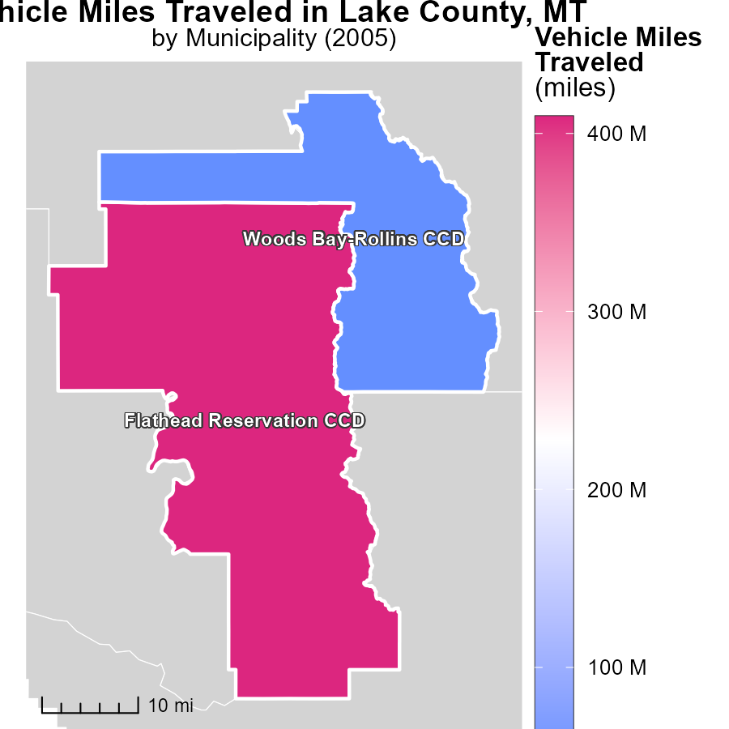

## Findings

* In 2005, Flathead Reservation CCD, MT had the highest 409.4 million vehicle miles traveled.
* Woods Bay-Rollins CCD, MT recorded a median of 46.5 million vehicle miles traveled in the same year.

## Recommendations

To decrease emissions linked to vehicle miles traveled, solutions such as promoting public transportation, carpooling initiatives, and providing incentives for using eco-friendly vehicles should be considered.

# Emissions Rate (per mile) Mapped by Area

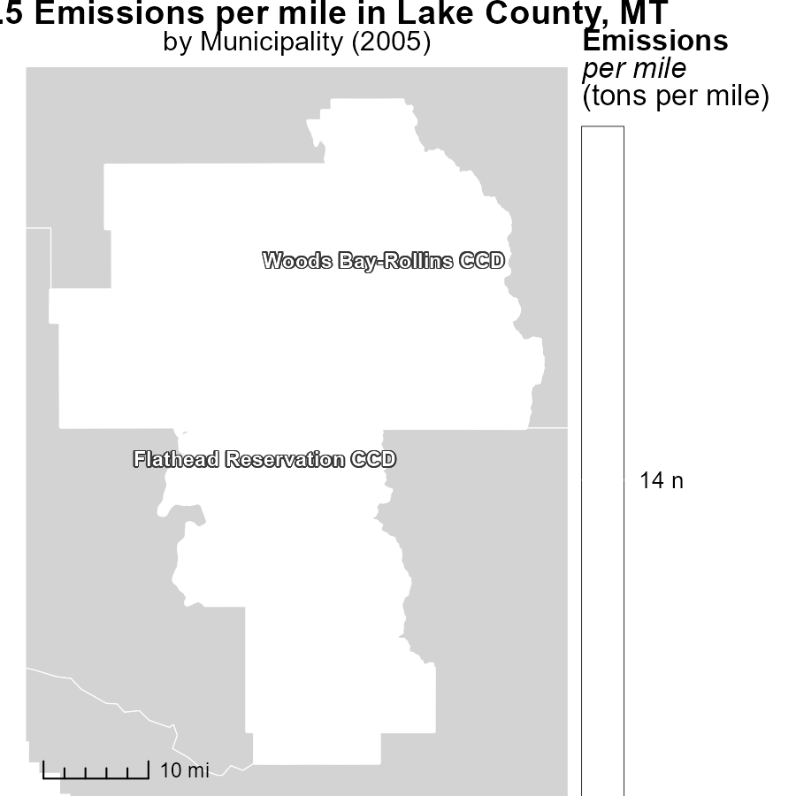

## Findings

* In 2005, Flathead Reservation CCD, MT had a maximum emission of 14.5 tons per mile.
* In the same year, Woods Bay-Rollins CCD, MT had a median emission of 14.5 tons per mile.

## Recommendations

To reduce emissions, incentivize the adoption of cleaner transportation modes such as electric vehicles and public transport in areas with high emissions per mile.

# Vehicle Miles Traveled by Regulatory Class over Time

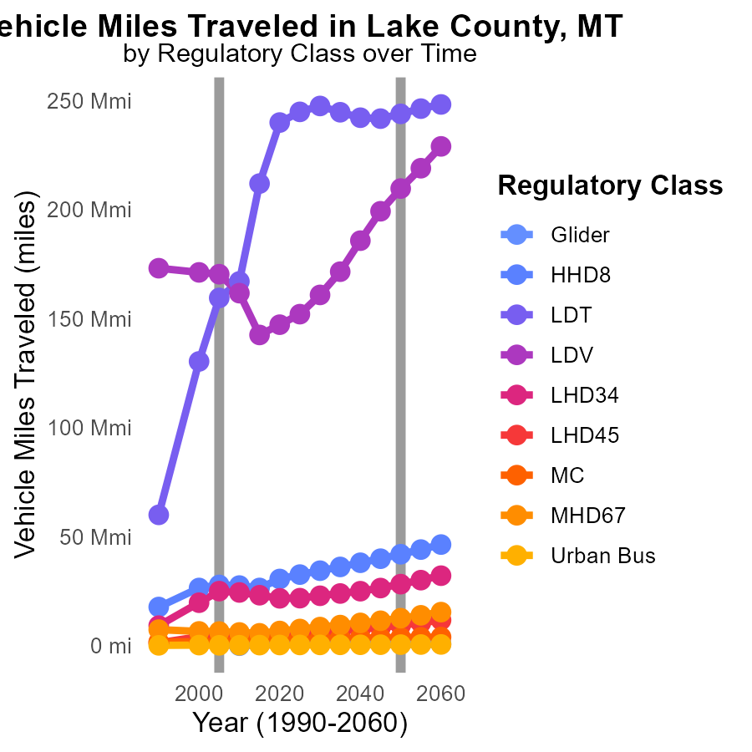

## Findings

* From 2000 to 2015, LDV emissions decreased by 16.7%.
* Urban Bus emissions increased by 26.1% from 2010 to 2015.
* HHD8 emissions decreased by 6.2% from 2000 to 2015.

## Recommendations

To reduce emissions, focus on promoting alternatives to urban bus transport, such as carpooling and investing in electric vehicles. Implement stricter emissions standards for HHD8 vehicles to further reduce pollution.

# Hotelling (Diesel Aux) by Fuel Type over Time

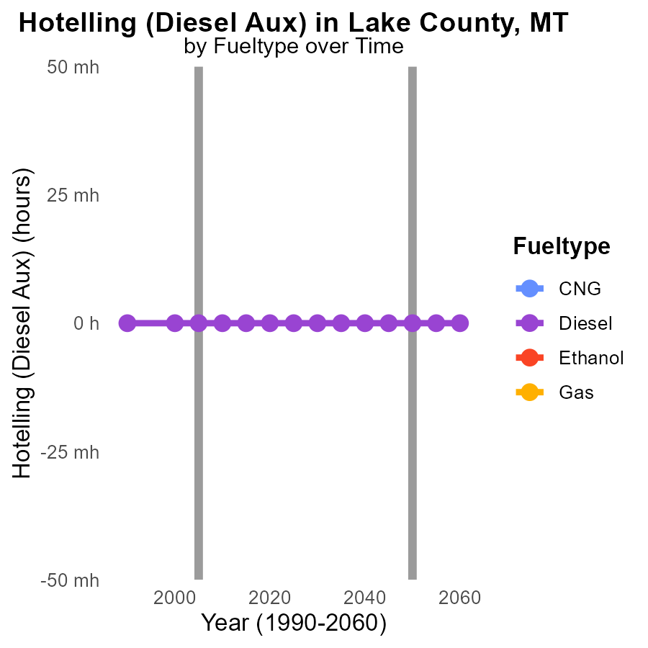

## Findings

* No PM2.5 emissions were recorded for Diesel fuel type from 2000 to 2015.
* Ethanol and Gas fuel types have no data available for PM2.5 emissions from 2000 to 2015.
* CNG fuel type has no data available for PM2.5 emissions from 2000 to 2015.

## Recommendations

To lower PM2.5 emissions in Lake County, MT, it is crucial to gather data on PM2.5 emissions for all fuel types used from 2000 to 2015. Once data is available, policies can be implemented to reduce emissions from the most polluting fuel types.

# Areas Ranked by Hotelling (Engines Off)

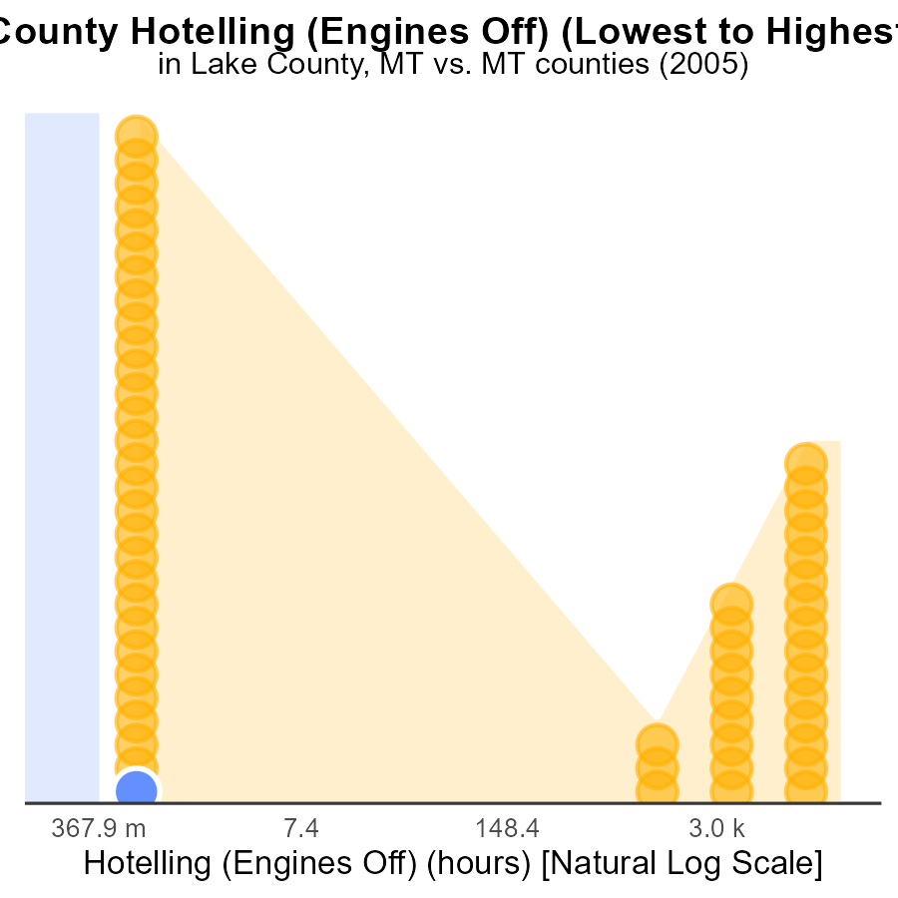

## Findings

* Lake county had the lowest PM2.5 emissions with 0.0 hours.
* Yellowstone county had the highest PM2.5 emissions with 51.0k hours.
* Yellowstone county's emissions ranked 56th out of counties, being at the 100th percentile.

## Recommendations

To reduce emissions, focus on implementing strategies in Yellowstone county, such as promoting engine-off practices to lower PM2.5 levels. Encourage similar initiatives in Lake county to maintain their low emission levels.

# Areas Ranked by Vehicle Miles Traveled

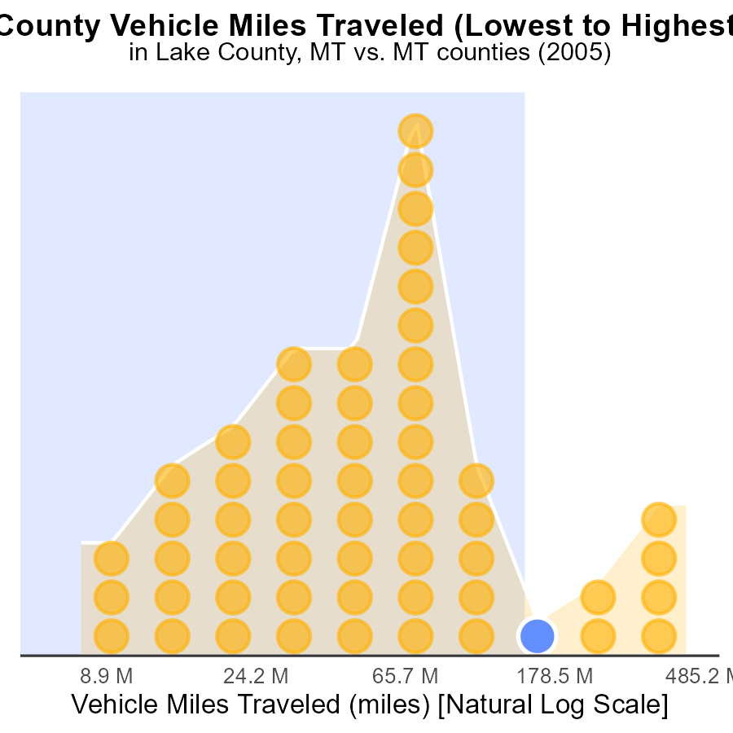

## Findings

* Yellowstone county has the highest vehicle miles traveled with 1.2 billion miles.
* Petroleum county has the lowest vehicle miles traveled with 20.3 million miles.
* Lewis and Clark county ranks highest in percentile of emissions at 91.1%.

## Recommendations

To reduce emissions, focus on Yellowstone county by promoting carpooling, public transportation, and developing walkable communities to decrease vehicle miles traveled.

# Conclusion

In conclusion, the data from the report on Primary Exhaust PM2.5 - Total emissions from on-road transportation in Lake County, MT in 2005 highlight the significant contribution of gas vehicles to PM2.5 emissions in the area. To effectively lower PM2.5 emissions, initiatives should be focused on reducing emissions from gas and diesel vehicles, promoting the adoption of electric vehicles, improving public transportation infrastructure, and implementing stricter vehicle emissions standards. Additionally, attention should be paid to specific vehicle types like HHD8 trucks, urban buses, and medium-heavy duty trucks to target the highest contributors to emissions in Lake County.

Furthermore, the report underscores the importance of monitoring and regulating emissions from different fuel types and areas with high vehicle miles traveled. Recommendations include promoting cleaner transportation modes, incentivizing eco-friendly vehicle usage, investing in public transportation, and enforcing stricter emissions standards. By implementing these strategies, Lake County can work towards reducing PM2.5 emissions and improving air quality for its residents.

# About This Report

Data based on MOVES estimates collected by the Climate Action in Transportation program at Cornell University. Demographic data sourced from the US Census's American Community Survey 5-year estimates. This report was generated with the help of AI.

# References

* U.S. Census Bureau. (2023). American Community Survey 5-year estimates: Detailed tables. Retrieved from https://data.census.gov
* U.S. Environmental Protection Agency. (2024). Motor Vehicle Emission Simulator (MOVES 4.0) [Software]. Retrieved from https://www.epa.gov/moves