 

**PM2.5 Emissions in Sioux County, 2040**  
Made with CAT VISUALIZER by Gao Labs @ Cornell University.

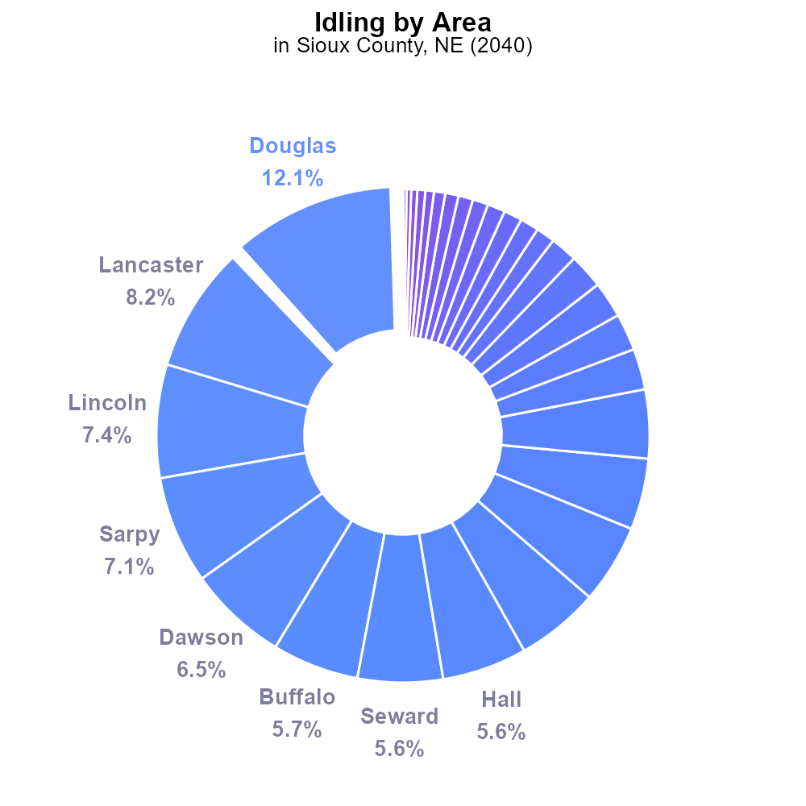

## Keywords

Primary Exhaust PM2.5; Total emissions; on-road transportation; Sioux County; NE; 2040

## Highlights

* Study on PM2.5 emissions from on-road transport in Sioux County, NE.
* Analysis of primary exhaust pollutants in 2040.
* Evaluation of total emissions impact on air quality.
* Potential trends and implications for public health.
* Recommendations for mitigation strategies and policy interventions.

# Introduction

This report examines the primary exhaust PM2.5 emissions from on-road transportation in Sioux County, NE, projected for the year 2040. The focus is on understanding the total emissions of PM2.5 from various vehicles and their impact on air quality in the region.

By analyzing the trends and sources of primary exhaust pollutants, this study aims to provide valuable insights into the environmental challenges faced by Sioux County. The report will also evaluate the potential implications of these emissions on public health and suggest recommendations for mitigation strategies and policy interventions to address the issue effectively.

# Idling Overall by Area

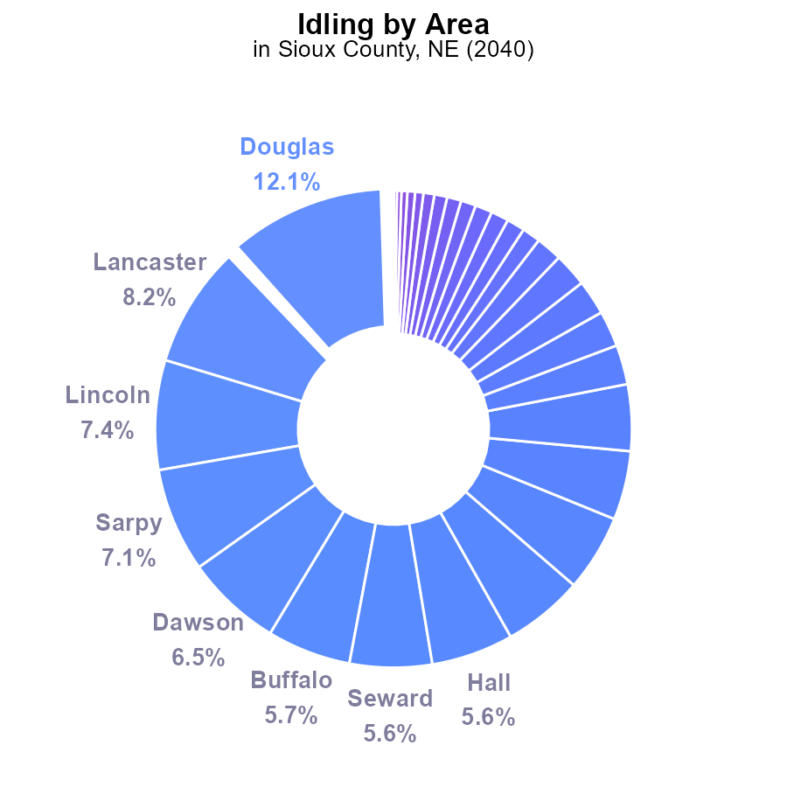

## Findings

* The top 5 counties for PM2.5 emissions due to idling in 2040 in Sioux County, NE are Douglas (12.1%), Lancaster (8.2%), Lincoln (7.4%), Sarpy (7.1%), and Dawson (6.5%).
* 33 counties, including Sioux county itself, contributed 0% of the total PM2.5 emissions due to idling in 2040.
* Idling emissions are notably concentrated, with a few counties contributing the majority of emissions, indicating potential areas for targeted mitigation efforts.

## Recommendations

To lower PM2.5 emissions due to idling, focus on counties with significant contributions like Douglas, Lancaster, and Lincoln by implementing idling reduction programs, promoting the use of electric vehicles, and improving public transportation.

# Vehicle Starts by Fuel Type

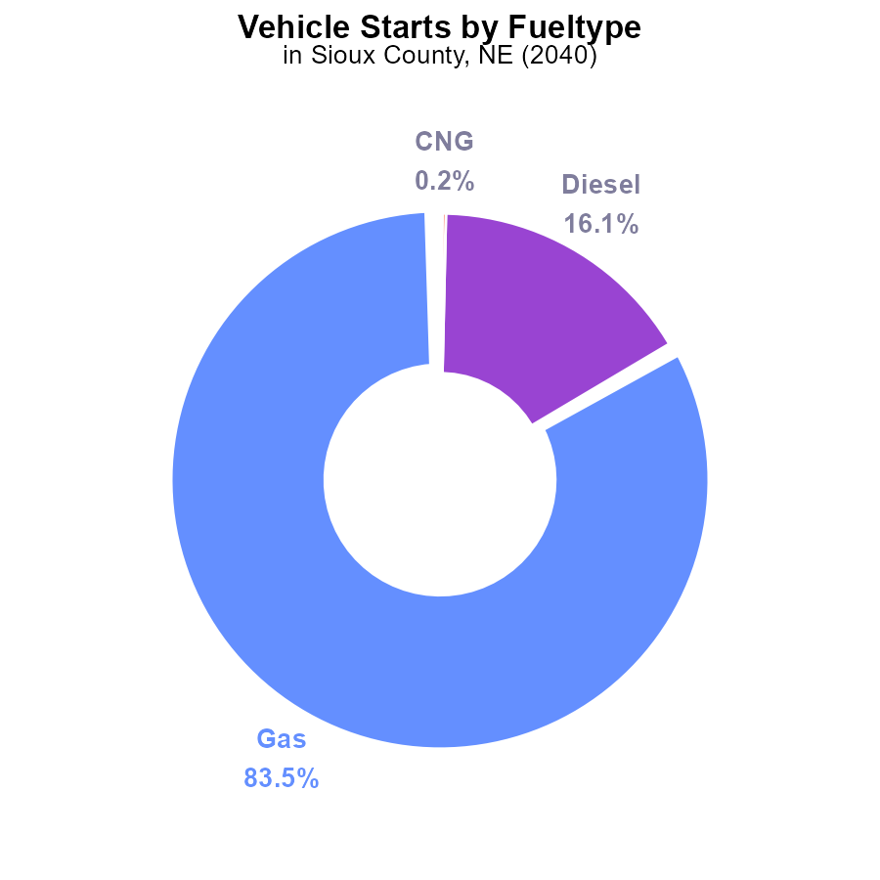

## Findings

* 83.5% of PM2.5 emissions in Sioux County, NE in 2040 were from gas vehicles.
* Diesel vehicles accounted for 16.1% of the PM2.5 emissions.
* CNG and Ethanol vehicles contributed negligibly to the PM2.5 emissions, with 0.2% and 0.1% respectively.

## Recommendations

To lower PM2.5 emissions, policymakers should prioritize reducing gas vehicle usage, possibly through incentives for electric vehicles. Additionally, promoting cleaner fuel alternatives like CNG and Ethanol could further decrease emissions.

# Emissions Rate (per capita) over Time for Passenger Vehicles

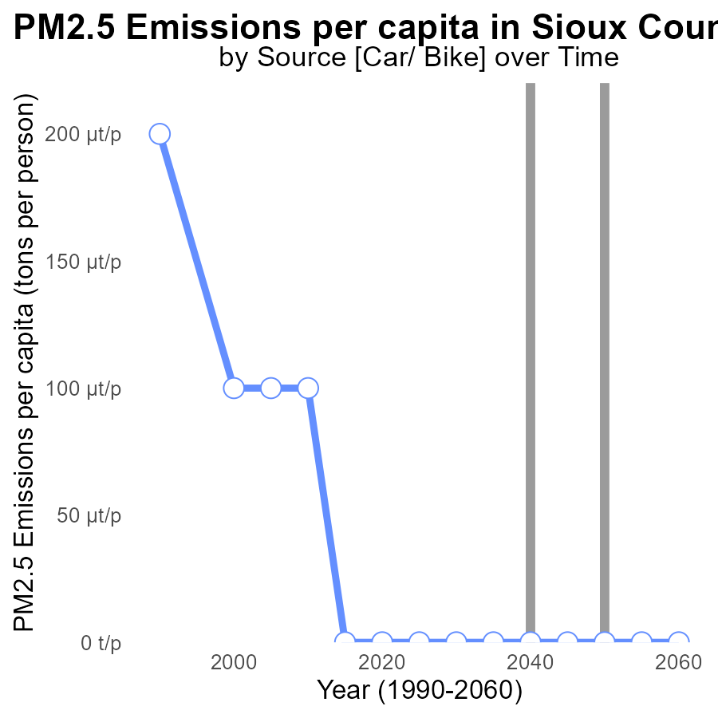

## Findings

* Sioux County, NE has consistently maintained zero PM2.5 emissions per capita from 2020 to 2060.

## Recommendations

Given the remarkable track record of zero emissions per capita in Sioux County, NE, it is vital to continue investing in clean energy sources and promoting sustainable practices to maintain this exceptional level of emissions and serve as a positive example for other regions striving for environmental excellence.

# Vehicles over Time for Passenger Vehicles

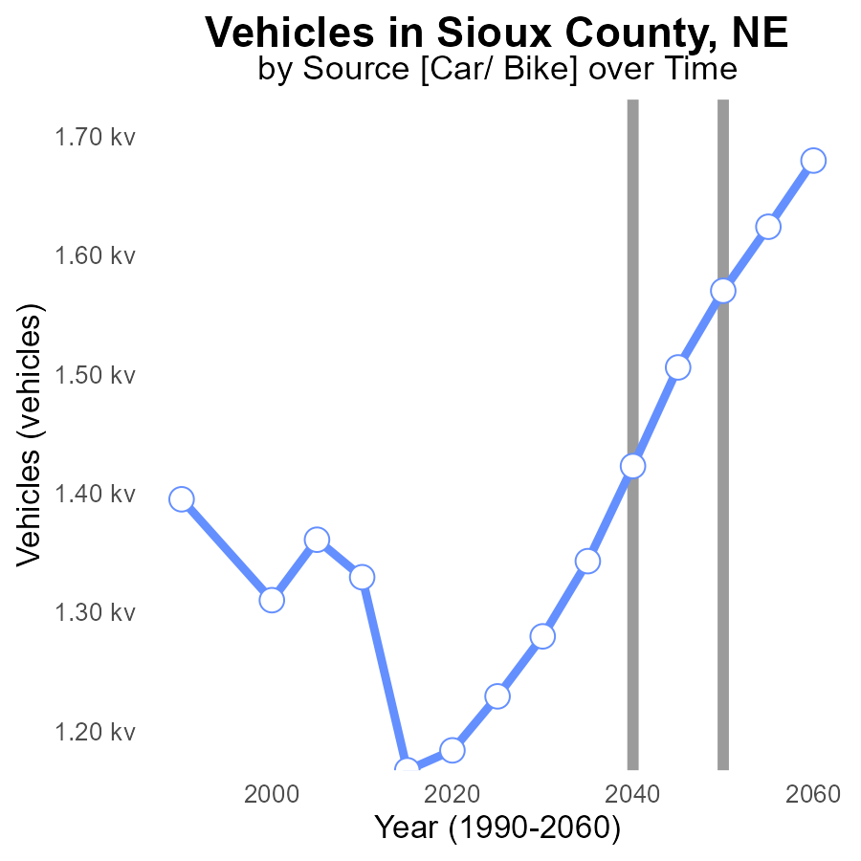

# Population in My Region

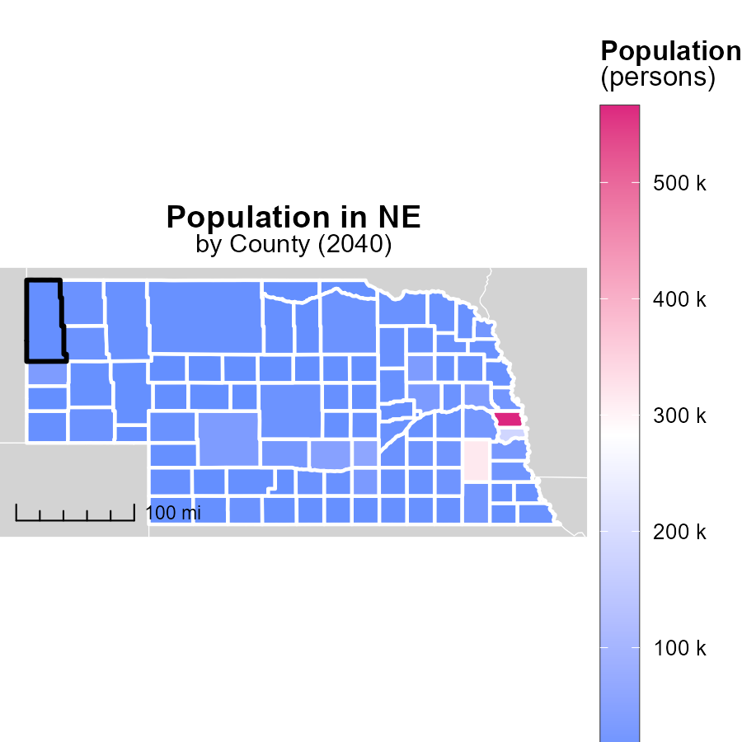

## Findings

* Douglas County, NE has the highest population with 565.7k persons.
* Clay County, NE has a median population of 6.2k persons.
* McPherson County, NE has the lowest population at 420 persons.

## Recommendations

To lower emissions, target high population areas like Douglas County for efficient public transport and encourage carpooling. Implement green spaces to improve air quality in densely populated areas and promote telecommuting in smaller communities to reduce emissions.

# Emissions Mapped by Area

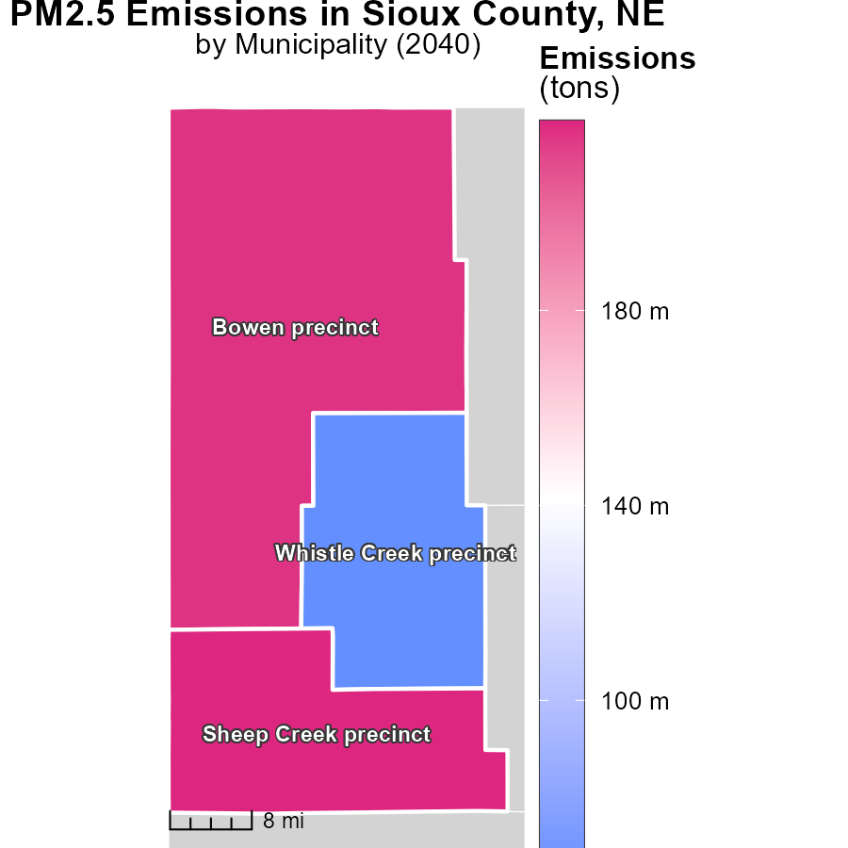

## Findings

* The maximum emissions in Sheep Creek precinct, NE, were 218.8 tons in 2040.
* Bowen precinct, NE, had median emissions of 216.5 tons in 2040.
* Whistle Creek precinct, NE, had the lowest emissions at 64.7 tons in 2040.

## Recommendations

To decrease emissions, initiatives should focus on areas with high emissions like Sheep Creek precinct. Implementing stricter emission regulations and promoting sustainable practices can help lower levels in Bowen precinct. Encouraging the adoption of cleaner technologies and practices could further reduce emissions in Whistle Creek precinct.

# Vehicle Miles Traveled by Vehicle Type over Time

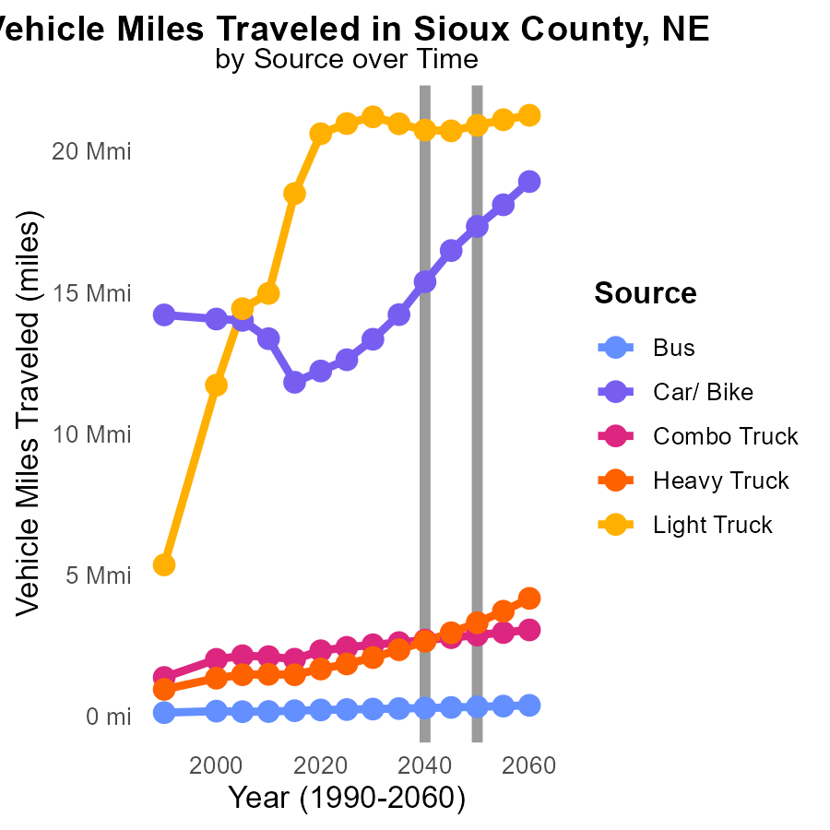

## Findings

* By 2050, Bus vehicle miles traveled are projected to increase by 29.7% compared to 2030 levels.
* Car/ Bike vehicle miles traveled are estimated to rise by 30.1% from 2030 to 2050.
* Light Truck miles traveled are expected to decrease by 1.4% from 2030 to 2050.

## Recommendations

To decrease emissions, encourage the use of public transportation or carpooling to reduce individual vehicle usage. Promote biking and walking infrastructure to lower reliance on cars and trucks, leading to reduced emissions. Implement policies for electric or hybrid vehicles to transition towards cleaner transportation methods.

# Emissions by Fuel Type over Time

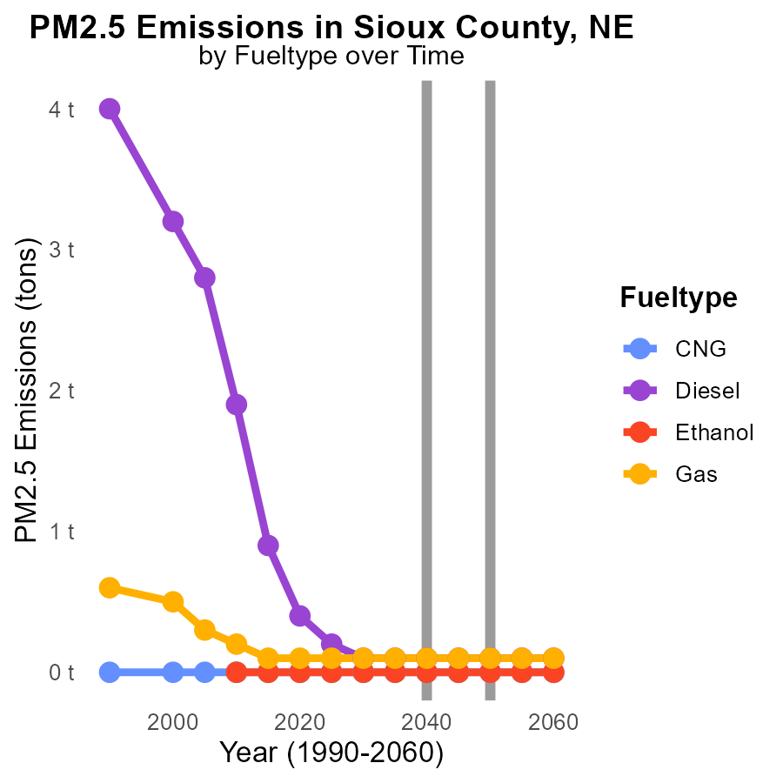

## Findings

* In Sioux County, NE, PM2.5 emissions from CNG and Ethanol will remain at 0 tons from 2030 to 2050.
* Diesel and Gas emissions will stay constant at 100.0 tons from 2030 to 2050.
* No change in emissions levels across fuel types is projected in Sioux County, NE until 2050.

## Recommendations

To decrease emissions, focus should be on transitioning to cleaner energy sources or improving the efficiency of existing fuel types. Implement stricter regulations on emissions to encourage innovation and investment in sustainable practices.

# Areas Ranked by Emissions Rate (per mile)

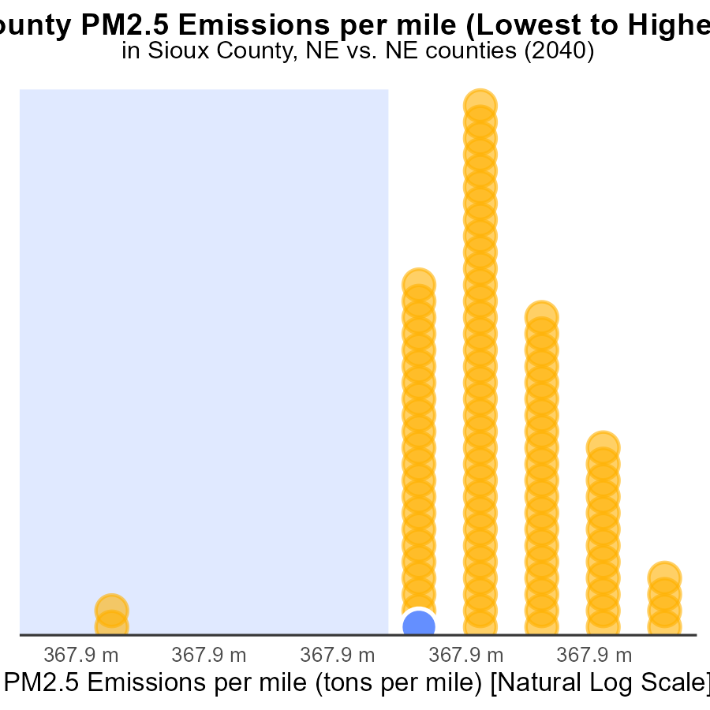

## Findings

* Sioux and Logan counties have emissions per mile of 2.4 tons, ranking 3rd and 4th respectively.
* Arthur and Madison have no emissions per mile, ranking at the top 2 positions.
* Banner County has the highest emissions per mile at 4.8 tons, ranking 93rd.

## Recommendations

To reduce emissions, prioritize interventions in Sioux and Logan. Encourage zero-emission vehicles. Implement clean transport initiatives in Banner County to lower emissions.

# Areas Ranked by Hotelling (Diesel Aux)

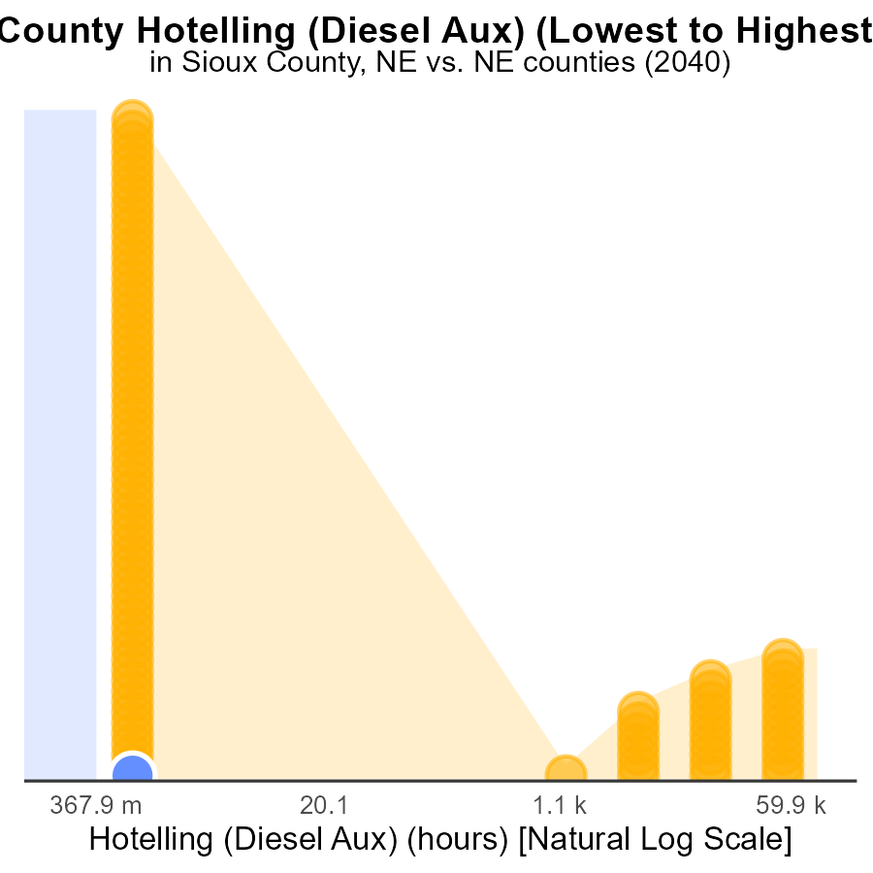

## Findings

* Sioux county has negligible PM2.5 emissions from Hotelling (Diesel Aux) sources.
* Antelope county also shows minimal emissions from Hotelling (Diesel Aux) sources.
* Douglas county emits 263.5 k PM2.5 from Hotelling (Diesel Aux), ranking 93rd nationally.

## Recommendations

To reduce PM2.5 emissions, focus on counties like Douglas with high emissions from Hotelling (Diesel Aux) sources. Implement stricter emission control measures and incentivize cleaner technologies.

# Conclusion

In conclusion, the data from the report on Primary Exhaust PM2.5 - Total emissions from on-road transportation in Sioux County, NE in 2040 reveals critical insights for targeted mitigation efforts. The concentration of idling emissions in a few key counties like Douglas, Lancaster, and Lincoln highlights the need for tailored interventions such as idling reduction programs and promotion of electric vehicles. With gas vehicles contributing significantly to PM2.5 emissions, policy focus on reducing their usage and promoting cleaner fuel alternatives like CNG and Ethanol is essential.

Sioux County's impressive record of maintaining zero PM2.5 emissions per capita underscores the importance of continued investment in clean energy sources and sustainable practices. By targeting high population areas for efficient public transport and implementing emission reduction strategies in precincts with high emissions, Sioux County can lead by example in environmental excellence. Encouraging the shift towards cleaner transportation methods and stricter emission regulations will be crucial for achieving and sustaining lower emissions levels.

# About This Report

Data based on MOVES estimates collected by the Climate Action in Transportation program at Cornell University. Demographic data sourced from the US Census's American Community Survey 5-year estimates. This report was generated with the help of AI.

# References

* U.S. Census Bureau. (2023). American Community Survey 5-year estimates: Detailed tables. Retrieved from https://data.census.gov
* U.S. Environmental Protection Agency. (2024). Motor Vehicle Emission Simulator (MOVES 4.0) [Software]. Retrieved from https://www.epa.gov/moves