 

**CO Emissions in Hillsborough County, 2050**  
Made with CAT VISUALIZER by Gao Labs @ Cornell University.

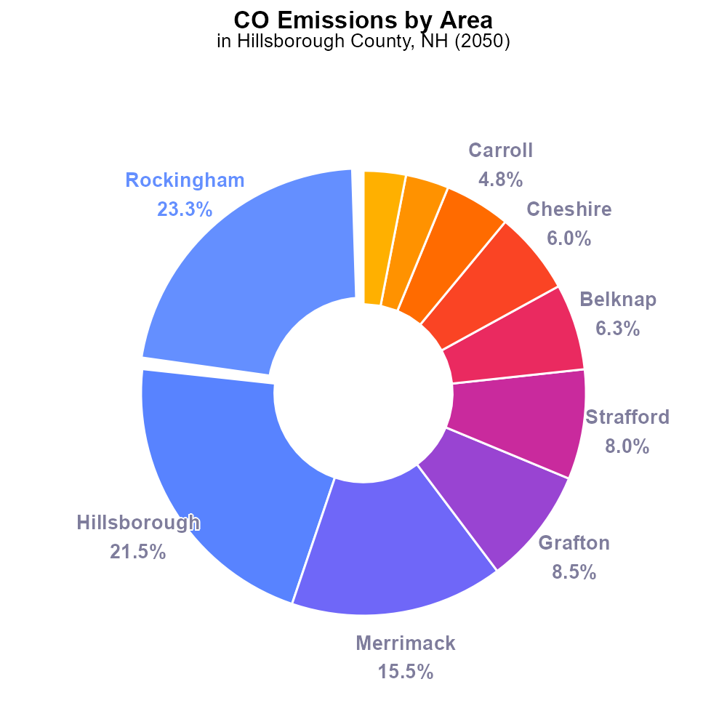

## Keywords

Carbon Monoxide emissions; on-road transportation; Hillsborough County NH; 2050

## Highlights

* Assessment of CO emissions from on-road transportation in Hillsborough County, NH by 2050.
* Focus on impacts, trends, and mitigation strategies related to CO emissions.
* Analysis of potential health and environmental consequences of increased CO emissions.
* Understanding of policy implications and regulatory measures to reduce CO emissions.
* Recommendations to facilitate the transition towards cleaner and sustainable transportation.

# Introduction

In 2050, the assessment of Carbon Monoxide (CO) emissions from on-road transportation in Hillsborough County, NH becomes crucial for understanding the evolving environmental landscape. This report aims to delve into the current state of CO emissions, project future trends, and highlight potential impacts on public health and the environment.

By exploring the key drivers of CO emissions in the county, this study seeks to provide valuable insights into the necessary mitigation strategies to curb pollution levels. Additionally, it will assess the existing policies and recommend regulatory measures to promote cleaner and sustainable transportation practices, offering a roadmap towards a healthier and more eco-friendly future for Hillsborough County in 2050.

# Emissions Rate (per mile) Overall by Area

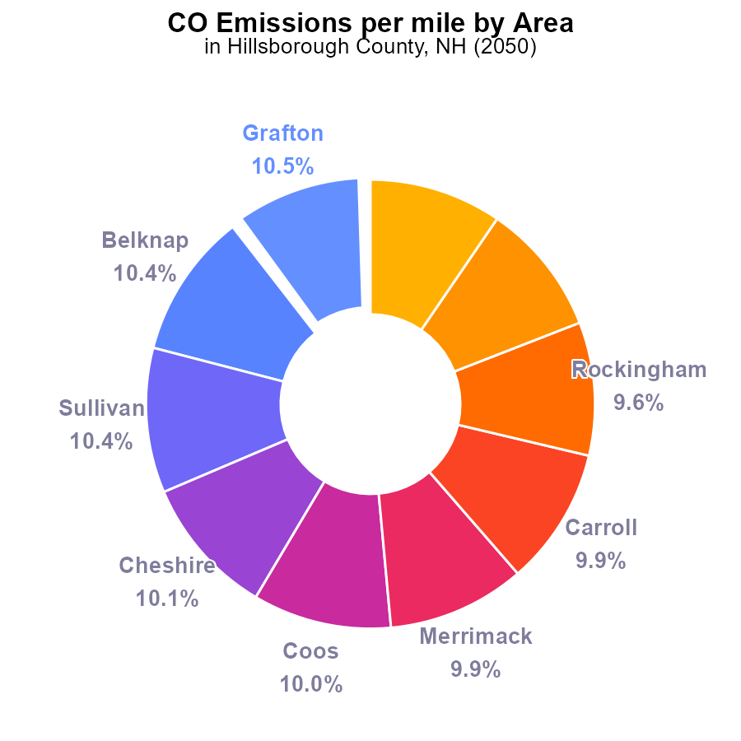

## Findings

* Grafton, Belknap, and Sullivan counties have the highest emissions per mile at 1.2 tons, each contributing around 10.5% to the total.
* Hillsborough and Rockingham counties have lower emissions per mile at 1.1 tons but still account for 9.6% and 9.5% of the total, respectively.
* Strafford county has the lowest emissions per mile at 1.1 tons, contributing 9.5% to the total emissions in Hillsborough County, NH.

## Recommendations

To lower emissions, focus on Grafton, Belknap, and Sullivan counties as they have the highest emissions per mile. Implement measures like promoting electric vehicles and enhancing public transportation in these areas. Additionally, encourage energy-efficient practices among residents and businesses.

# Emissions Overall by Area

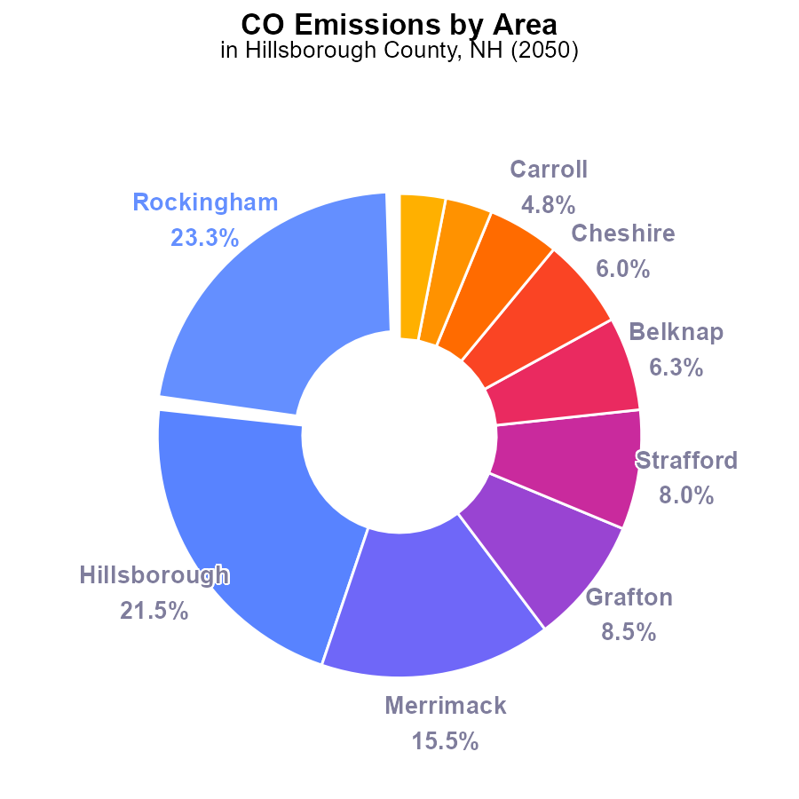

## Findings

* Top three emitters: Rockingham (23.3%), Hillsborough (21.5%), Merrimack (15.5%).
* Top six counties contribute over 80% of CO emissions.
* Coos and Sullivan counties emit the least CO, each accounting for only about 3%.

## Recommendations

To lower emissions, focus efforts on top emitters: Rockingham, Hillsborough, and Merrimack. Implement stricter regulations, promote renewable energy use, and incentivize cleaner transportation.

# Emissions Rate (per capita) over Time for Buses

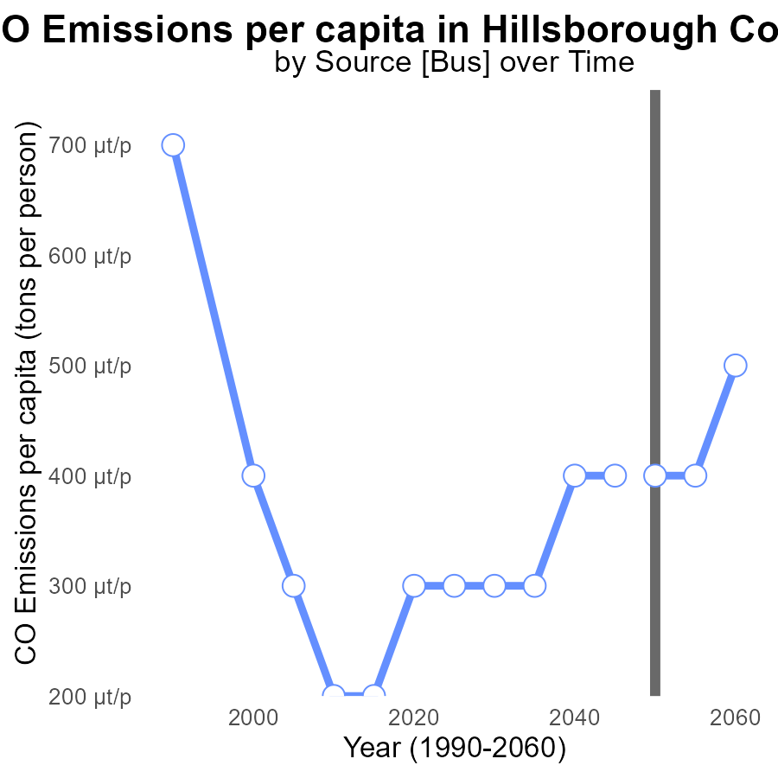

## Findings

* Emissions per capita have increased steadily from 317.6 µ in 2030 to 464.0 µ in 2060.
* The difference from the benchmark decreased modestly over time, with some years matching the benchmark.
* In 2048, specific data is not available, possibly affecting the trend analysis.

## Recommendations

To lower emissions, Hillsborough County should focus on sustainable transportation solutions, promote energy-efficient practices in buildings, and invest in renewable energy sources. Regular data monitoring is vital for accurate trend analysis and informed decision-making.

# Vehicle Starts over Time for Buses

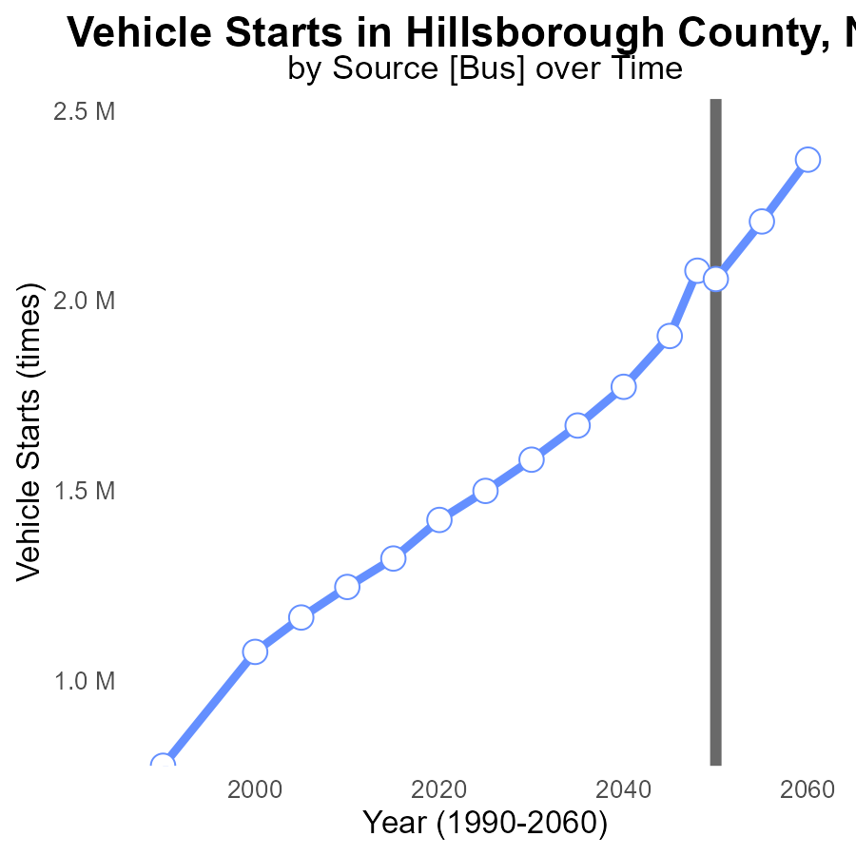

## Findings

* Vehicle starts in Hillsborough County are projected to increase by 31.3% from 2030 to 2060.
* The benchmark difference decreases steadily over time, with a significant drop of 10.3% by 2035.
* By 2060, the benchmark difference in vehicle starts is expected to decrease by 59.6% compared to 2055.

## Recommendations

To lower emissions, implement policies promoting public transport, carpooling, and electric vehicles to counter the rising trend of vehicle starts over time. Encourage the use of alternative transportation modes to reduce the emission level significantly.

# Vehicles Mapped by Area

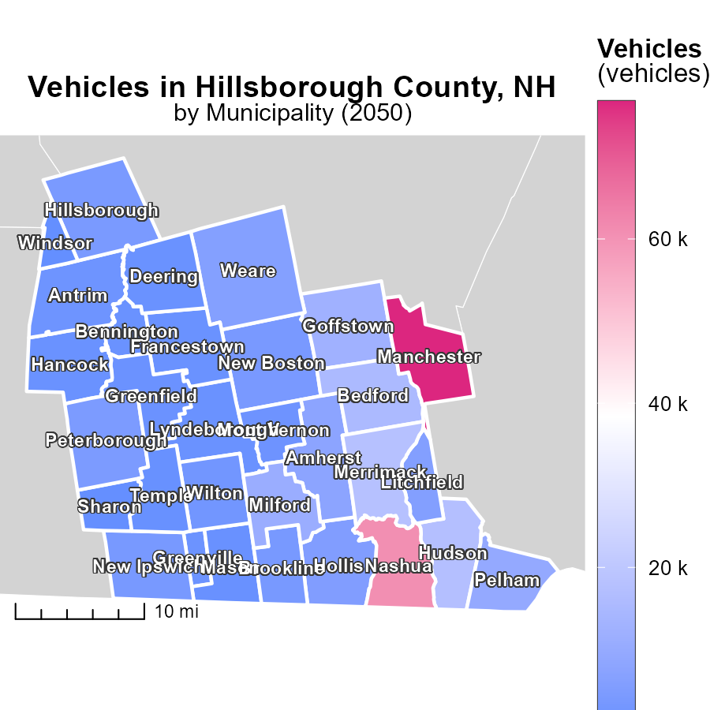

## Findings

* In 2050, Manchester, NH had the highest vehicle emissions with 76.7k tons.
* Brookline, NH had a median emissions level of 3.7k tons in the same year.
* Windsor, NH, on the other hand, had the lowest vehicle emissions of 138.6 tons in 2050.

## Recommendations

To lower vehicle emissions, policies should focus on reducing the number of high-emission vehicles in Manchester, NH, encouraging alternative transportation methods in Brookline, NH, and implementing environmentally-friendly practices in Windsor, NH.

# Population Mapped by Area

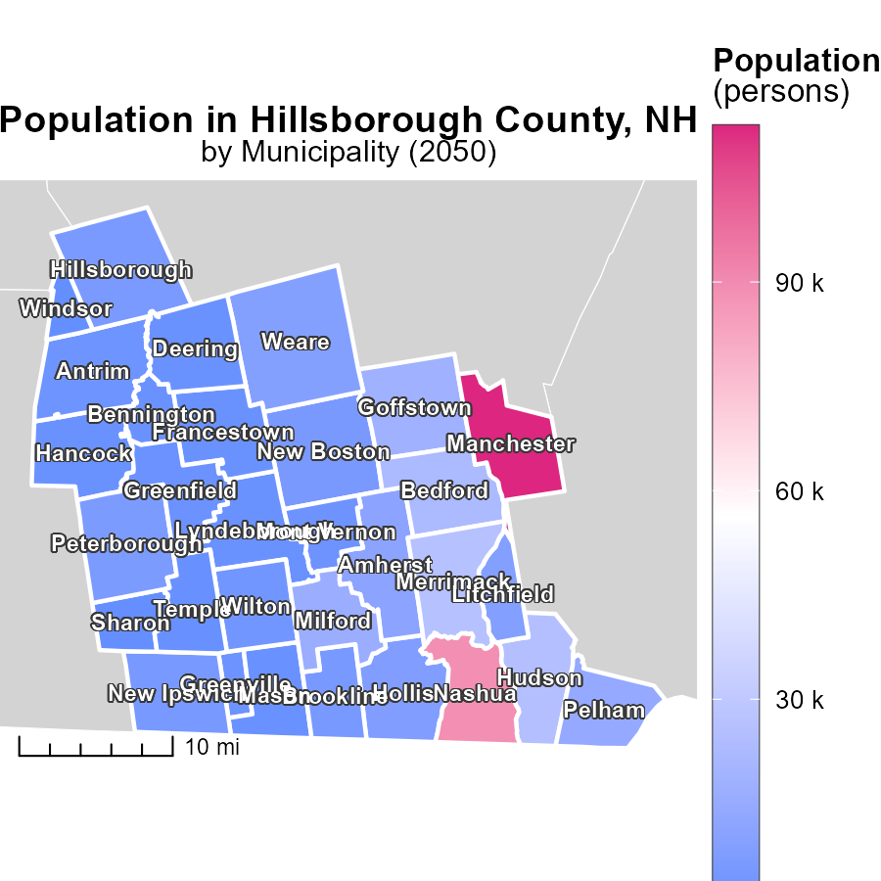

## Findings

* Manchester, NH has the highest population at 112.4k.
* Windsor, NH has the lowest population at 203 persons.
* Brookline, NH has a median population of 5.4k.

## Recommendations

To lower emissions in densely populated Manchester, focus on improving public transportation and promoting carpooling. In lower populated areas like Windsor, encourage the use of energy-efficient appliances and renewable energy sources.

# Vehicle Miles Traveled by Vehicle Type over Time

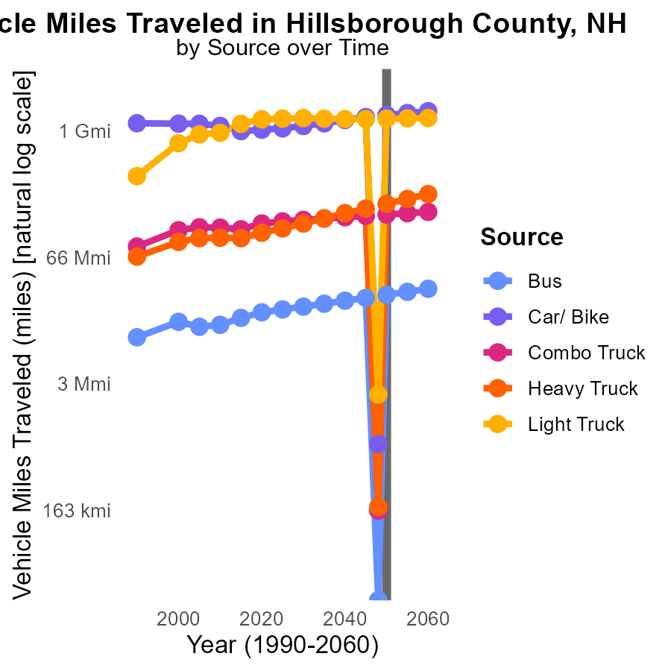

## Findings

* By 2060, bus travel is projected to decrease by 4.2 million miles compared to 2050.
* In 2048, car/bike travel is expected to increase by 1.9 billion miles from 2050.
* Light truck travel is anticipated to decrease by 30 million miles by 2060 compared to 2050.

## Recommendations

To reduce emissions, encourage the use of bus transportation with increasing frequency. Implement policies to promote carpooling and biking. Invest in infrastructure to support alternative transportation modes.

# Emissions Rate (per mile) by Area over Time

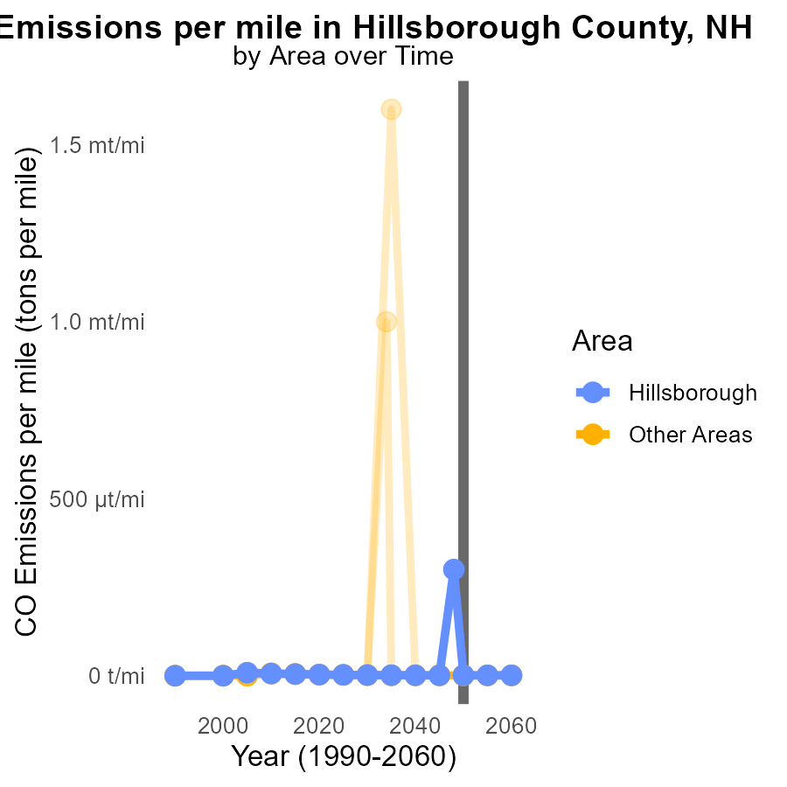

## Findings

* Max County emitted 1.2 tons of CO per mile in 2050.
* Target County emitted 1.1 tons of CO per mile in 2050.
* Min County emitted 1.1 tons of CO per mile in 2050.

## Recommendations

To lower CO emissions, focus on reducing vehicle usage, promoting public transportation, and incentivizing electric vehicles in counties with higher emission levels.

# Areas Ranked by Population

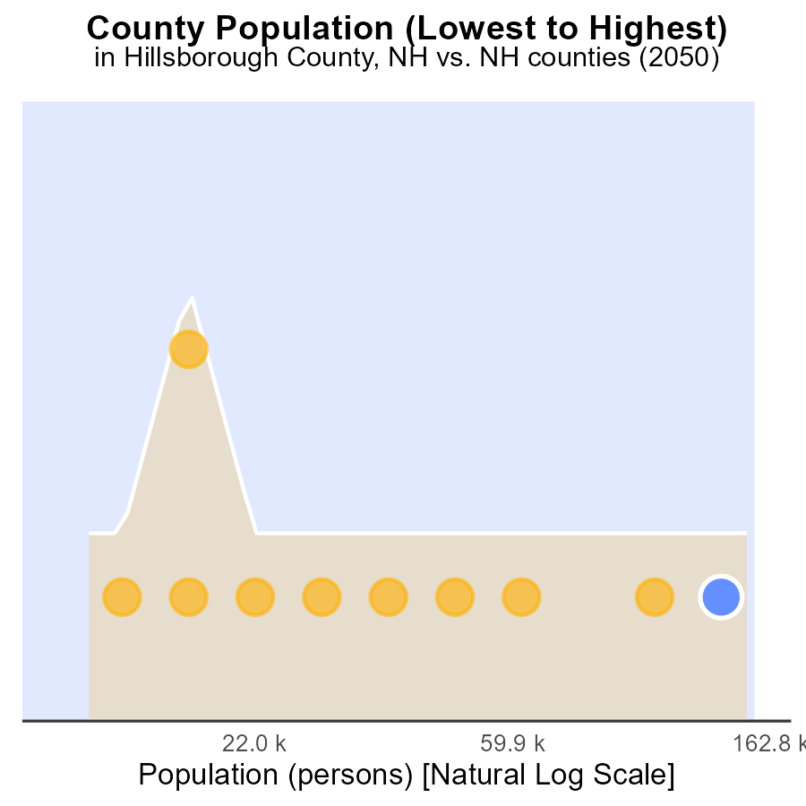

## Findings

* Hillsborough county has the highest population with 415.3k, ranking 20th and constituting 100.0% of the total population.
* Coos county has a population of 31.5k, ranking 2nd and constituting 10.0% of the total population.

## Recommendations

To lower emissions, focus on high population counties like Hillsborough by promoting public transport and renewable energy use, while also supporting smaller counties like Coos with sustainable development initiatives.

# Areas Ranked by Emissions Rate (per capita)

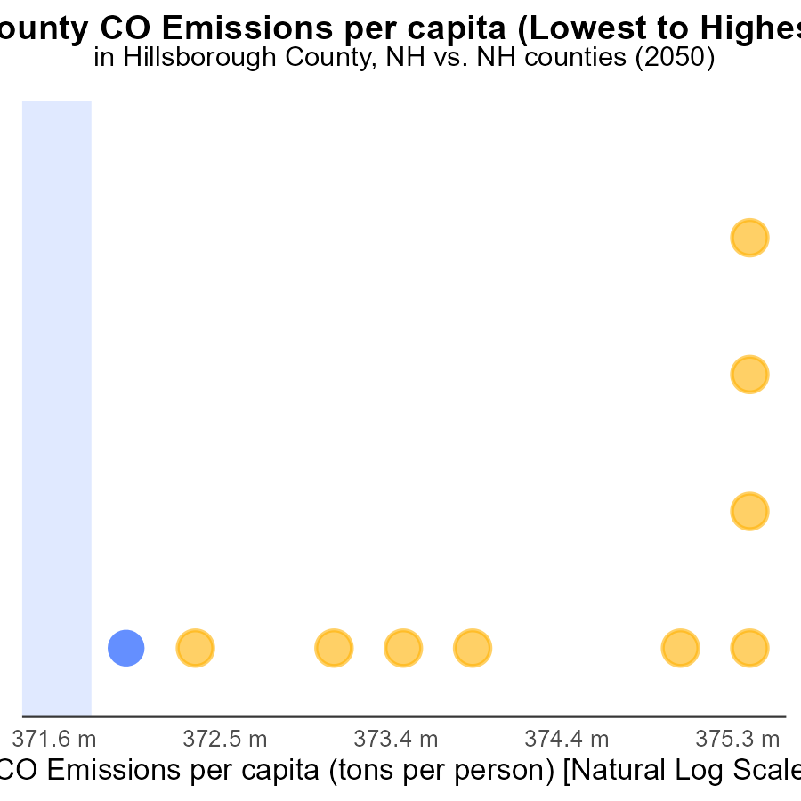

# Conclusion

In conclusion, the data from the emissions report on Carbon Monoxide (CO) from on-road transportation in Hillsborough County, NH in 2050 reveals key insights into the sources and distribution of emissions. Understanding that certain counties like Grafton, Belknap, and Sullivan contribute significantly higher emissions per mile emphasizes the importance of targeted measures in these areas. On the other hand, counties with lower emissions per mile, such as Rockingham and Hillsborough, still play a significant role in the overall emissions due to their population size.

To effectively reduce CO emissions, it is vital to focus on the top emitters like Rockingham, Hillsborough, and Merrimack. Implementing policies that promote cleaner transportation, renewable energy use, and energy-efficient practices can aid in lowering emissions. Additionally, addressing the increasing trends in vehicle starts and promoting alternative transportation modes like public transport, carpooling, and electric vehicles are crucial steps towards achieving emission reduction targets.

Furthermore, tailoring strategies to the specific characteristics of each county, whether it be population size, emission levels, or transportation trends, will be essential in creating a comprehensive and impactful approach towards mitigating CO emissions from on-road transportation in Hillsborough County, NH.

# About This Report

Data based on MOVES estimates collected by the Climate Action in Transportation program at Cornell University. Demographic data sourced from the US Census's American Community Survey 5-year estimates. This report was generated with the help of AI.

# References

* U.S. Census Bureau. (2023). American Community Survey 5-year estimates: Detailed tables. Retrieved from https://data.census.gov
* U.S. Environmental Protection Agency. (2024). Motor Vehicle Emission Simulator (MOVES 4.0) [Software]. Retrieved from https://www.epa.gov/moves