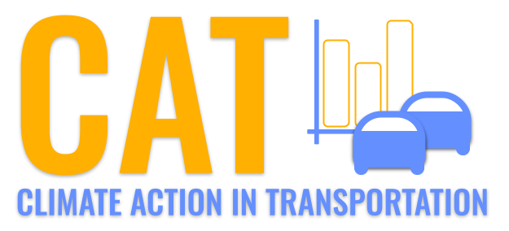 

**Carbon Emissions in Barnstable County, 2020**  
Made with CAT VISUALIZER by Gao Labs @ Cornell University.

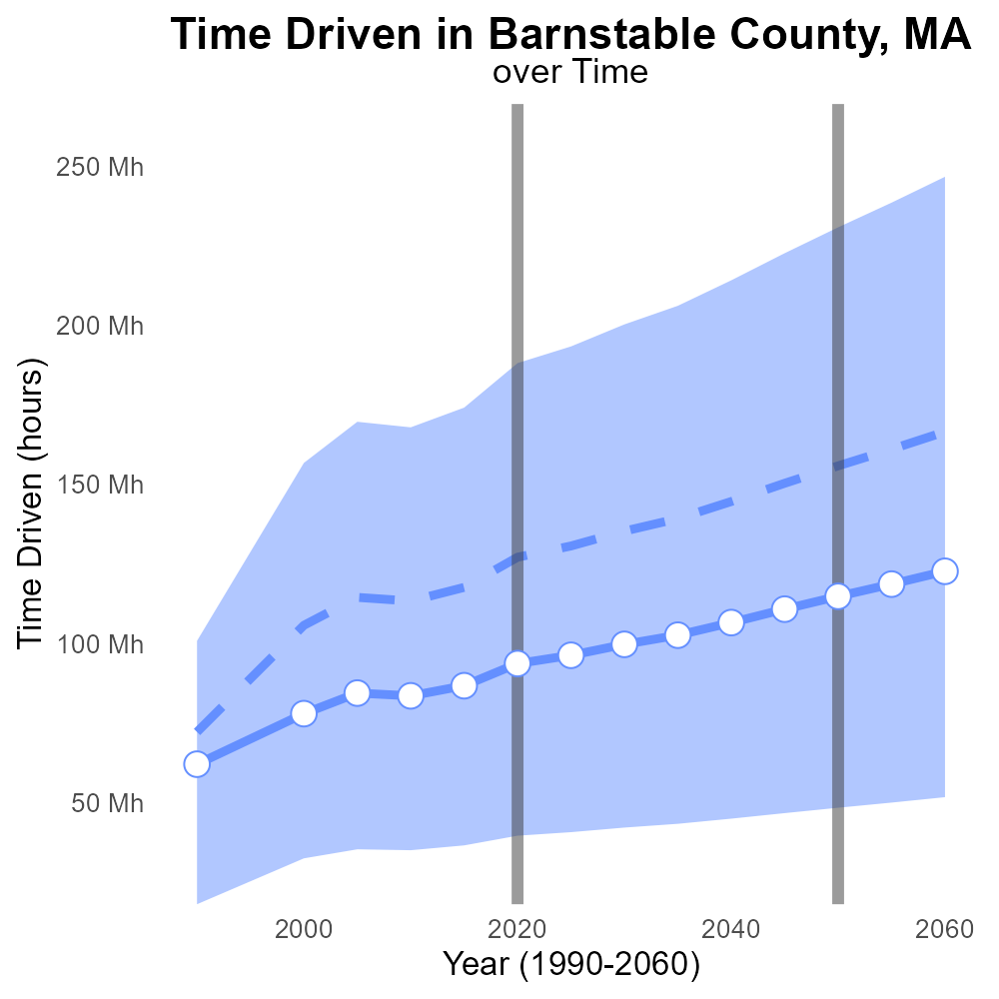

## Keywords

CO2 Equivalent emissions; on-road transportation; Barnstable County; MA; 2020; report

## Highlights

* Evaluating CO2 emissions from on-road transport in Barnstable Co., MA.
* Transport sector's impact on environment in Barnstable Co.
* An overview of on-road transportation emissions in 2020.
* Analyzing the carbon footprint of transportation in a specific region.
* Importance of understanding and reducing CO2 emissions.

# Introduction

In 2020, the assessment of CO2 Equivalent emissions from on-road transportation in Barnstable County, Massachusetts, provides valuable insights into the environmental impact of the transport sector within the region. This report aims to delve into the specific data regarding greenhouse gas emissions attributed to on-road vehicles in 2020. By focusing on a localized area like Barnstable County, a more detailed analysis of transportation-related emissions can be conducted to understand the carbon footprint associated with daily commuting and commercial activities.

This report not only highlights the levels of CO2 Equivalent emissions but also serves as a critical evaluation of current trends, potential mitigation strategies, and the importance of sustainable transportation practices for mitigating climate change effects. Understanding and reducing these emissions are crucial steps towards achieving a more environmentally sustainable future for Barnstable County.

# Population by Regulatory Class

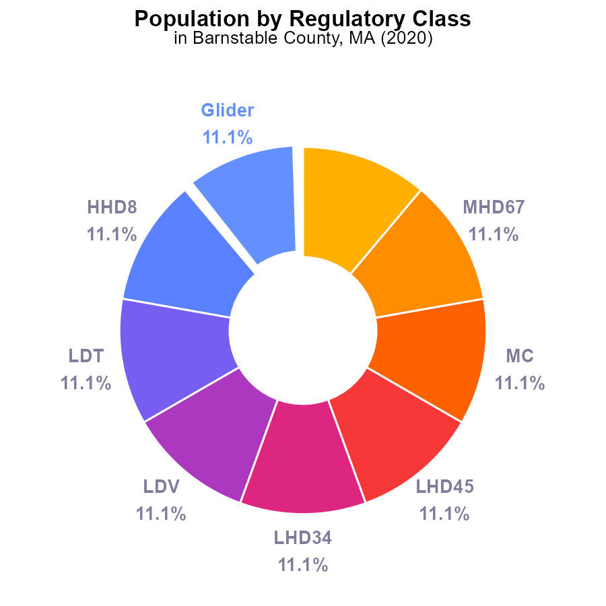

## Findings

* In 2020, glider, HHD8, LDT, LDV, LHD34, LHD45, MC, MHD67, and Urban Bus each contributed 11.1% to the total CO2e emissions in Barnstable County.
* The total CO2e emissions for all types in Barnstable County in 2020 was 1,921.5 k CO2e.
* Population of Barnstable County in 2020 is unspecified but crucial to accurately assess per capita emissions.

## Recommendations

To reduce emissions, focus on sectors with high contributions like gliders, HHD8, LDT, LDV, and others. Implement stricter regulations, promote sustainable transportation, and invest in renewable energy sources.

# Emissions by Vehicle Type

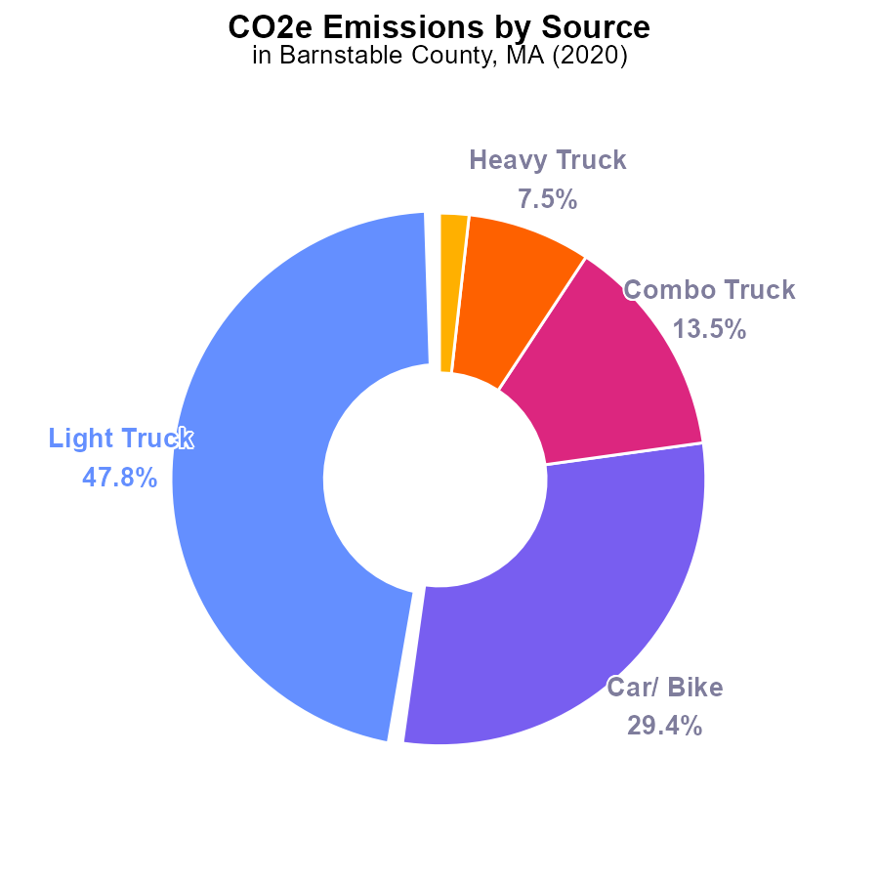

## Findings

* In 2020, light trucks were the largest CO2e emitters in Barnstable County, MA, accounting for 47.8% of total emissions.
* Cars/ bikes followed, contributing 29.4% of emissions, while combo trucks emitted 13.5%.
* Heavy trucks and buses were smaller contributors, with 7.5% and 1.8% of the emissions, respectively.

## Recommendations

To reduce emissions in Barnstable County, policymakers should focus on promoting the use of alternative transportation methods such as public transit or carpooling to decrease the reliance on light and combo trucks. Encouraging the adoption of electric vehicles can also significantly lower emissions.

# Time Driven Overall over Time

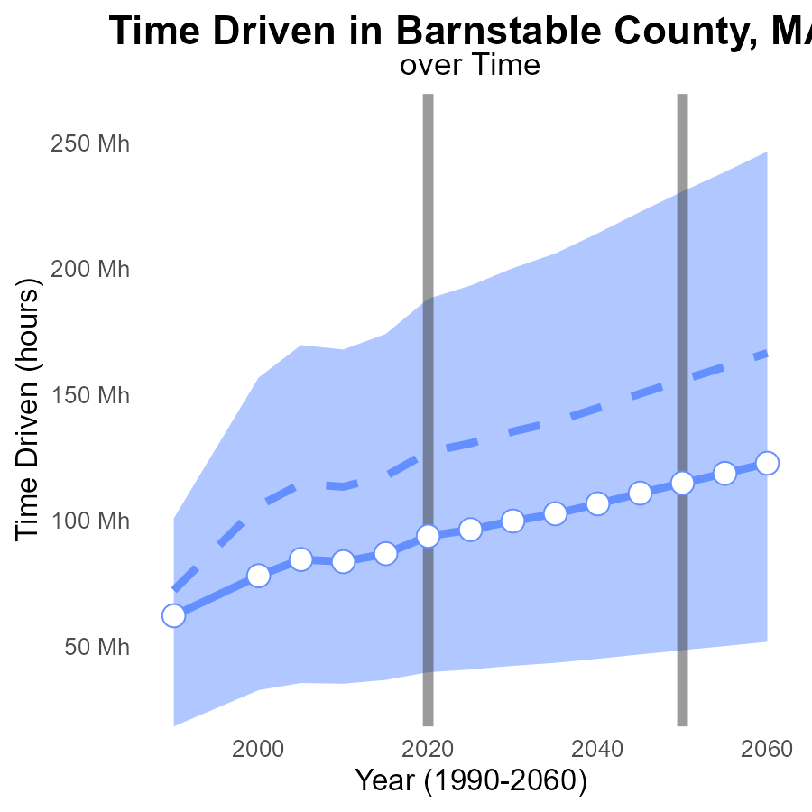

# Hotelling (Engines Off) Overall over Time

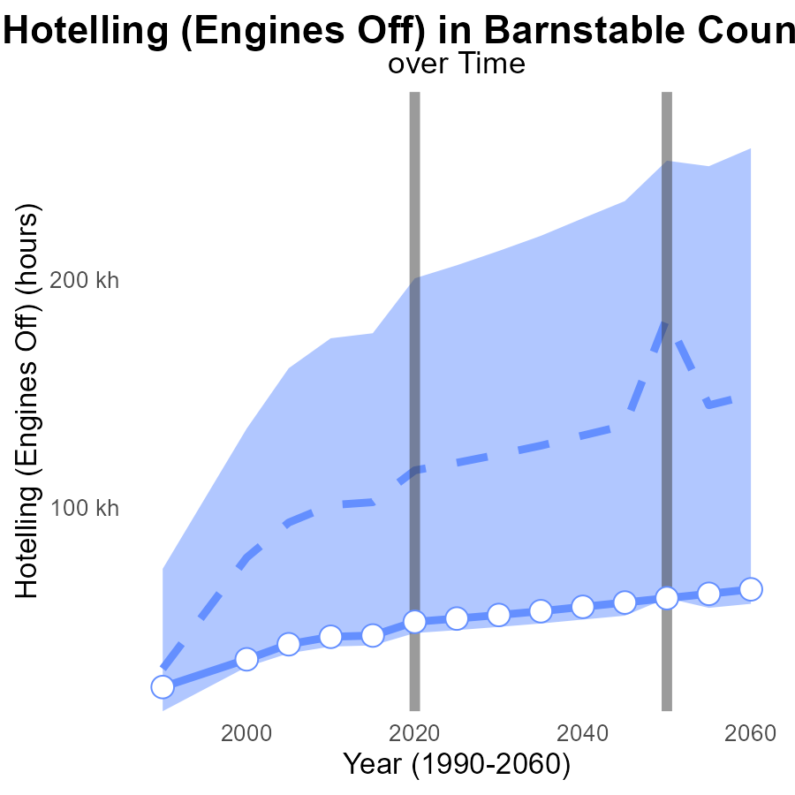

## Findings

* Emissions in Barnstable County have consistently been below the median area's emissions since 2000.
* Emissions are projected to decrease by 25.6% from 2020 to 2040, indicating a positive trend in emission reduction.
* Barnstable County's emissions show a decline trend compared to the upper 75% of areas, suggesting effective emission management.

## Recommendations

To further lower emission levels, Barnstable County should invest in renewable energy sources and promote energy-efficient practices. Implementing stricter emission regulations for vehicles and industries can also help maintain the decreasing trend observed in the data.

# Vehicles in My Region

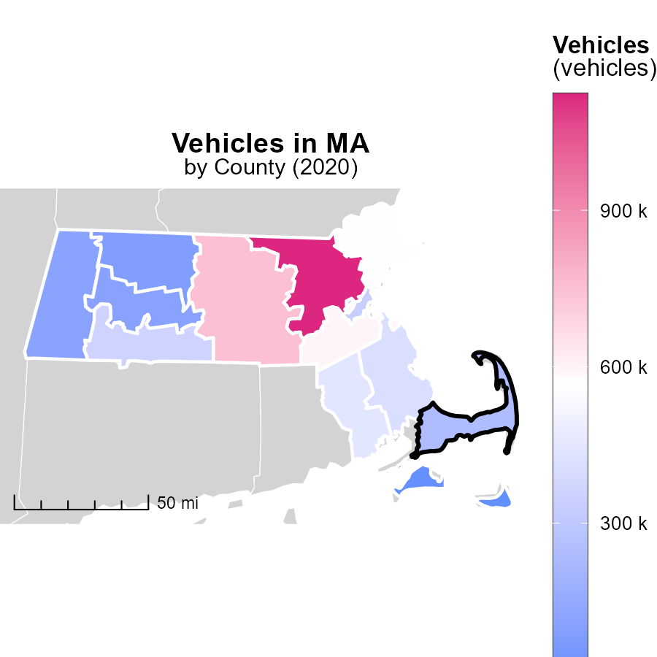

## Findings

* Middlesex County, MA had the highest vehicle emissions with 1.1 million units.
* Suffolk County, MA had a medium level of vehicle emissions with 334.4 thousand units.
* Nantucket County, MA had the lowest vehicle emissions with 7.2 thousand units.

## Recommendations

To lower vehicle emissions, incentivize public transportation, carpooling, and electric vehicle adoption. Implement stricter vehicle emission standards and promote biking and walking infrastructure.

# Time Driven Mapped by Area

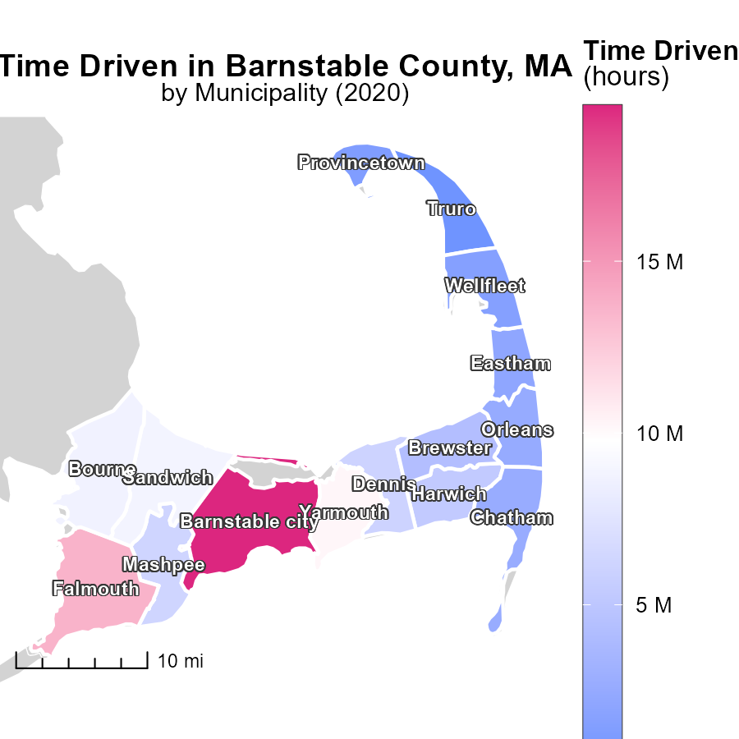

## Findings

* Barnstable city, MA had the highest time-driven emissions at 19.5 million hours.
* Harwich, MA had a median of 5.3 million hours of time-driven emissions.
* Some areas in MA had minimal time-driven emissions, such as one location with 0.0 hours.

## Recommendations

To lower emissions, focus on reducing vehicle usage through carpooling, public transportation incentives, and promoting telecommuting in high-emission areas.

# Idling by Vehicle Type over Time

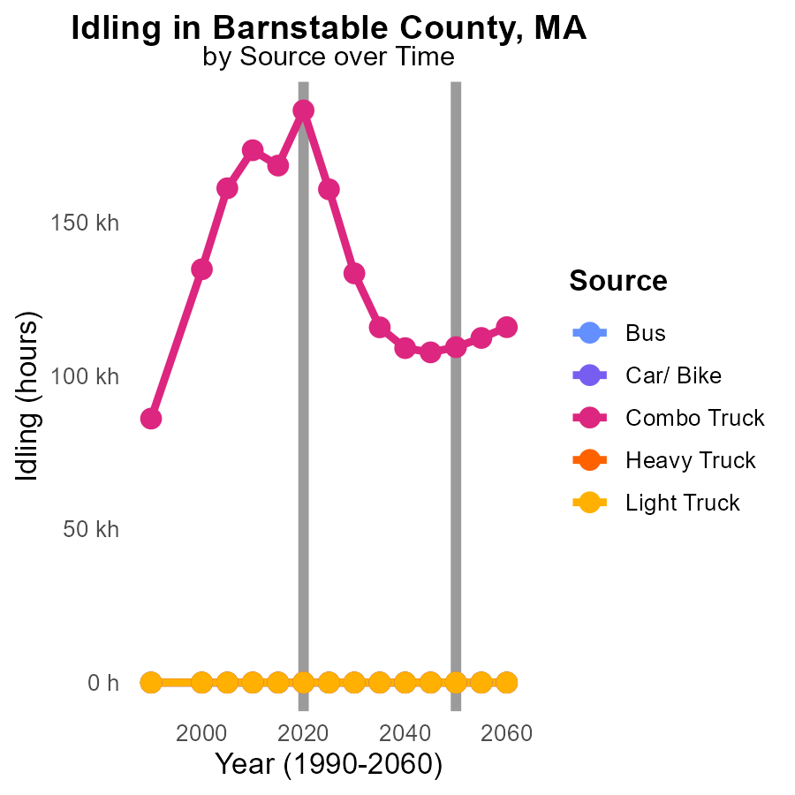

## Findings

* Idling emissions from Combo Trucks significantly decreased from 2010 to 2030.
* All other vehicle types showed no idling emissions from 2010 to 2030.
* An evident positive trend in reducing idling emissions in Barnstable County by 2030.

## Recommendations

To further reduce emissions, focus on promoting anti-idling campaigns for Combo Trucks. Implement stricter idling regulations for commercial vehicles to maintain the decreasing trend.

# Vehicle Miles Traveled by Fuel Type over Time

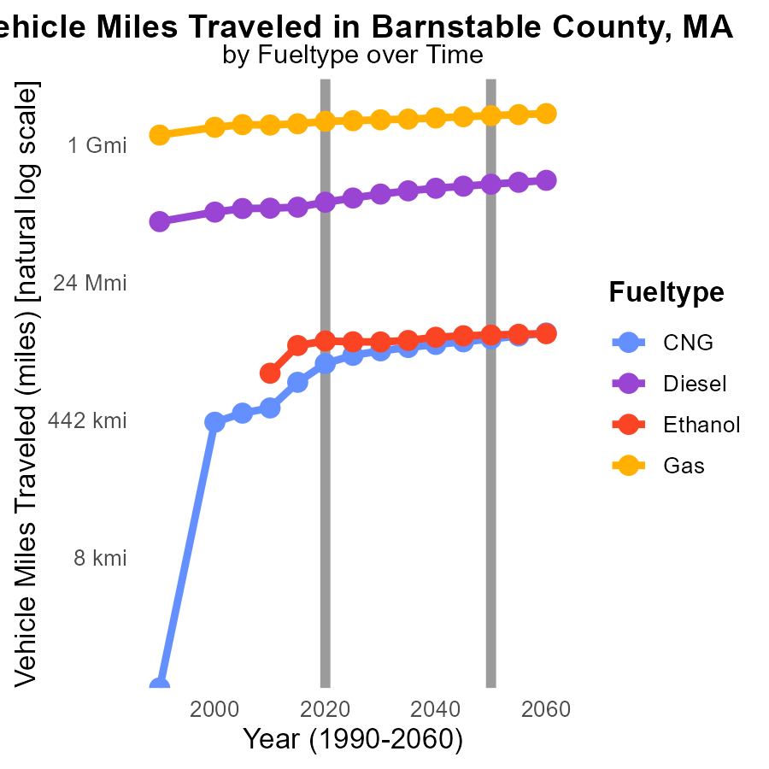

## Findings

* Diesel fuel type displays the highest CO2e emissions from vehicle miles traveled throughout 2010-2030.
* Gas fuel type shows a noticeable decrease in CO2e emissions from 2010 to 2030.
* Ethanol fuel type maintains relatively stable CO2e emissions from 2015 to 2030.

## Recommendations

To lower emissions, focus on transitioning vehicles from Diesel to alternative fuels. Incentivize Electric Vehicle adoption, promote public transportation, and increase fuel efficiency standards.

# Areas Ranked by Idling

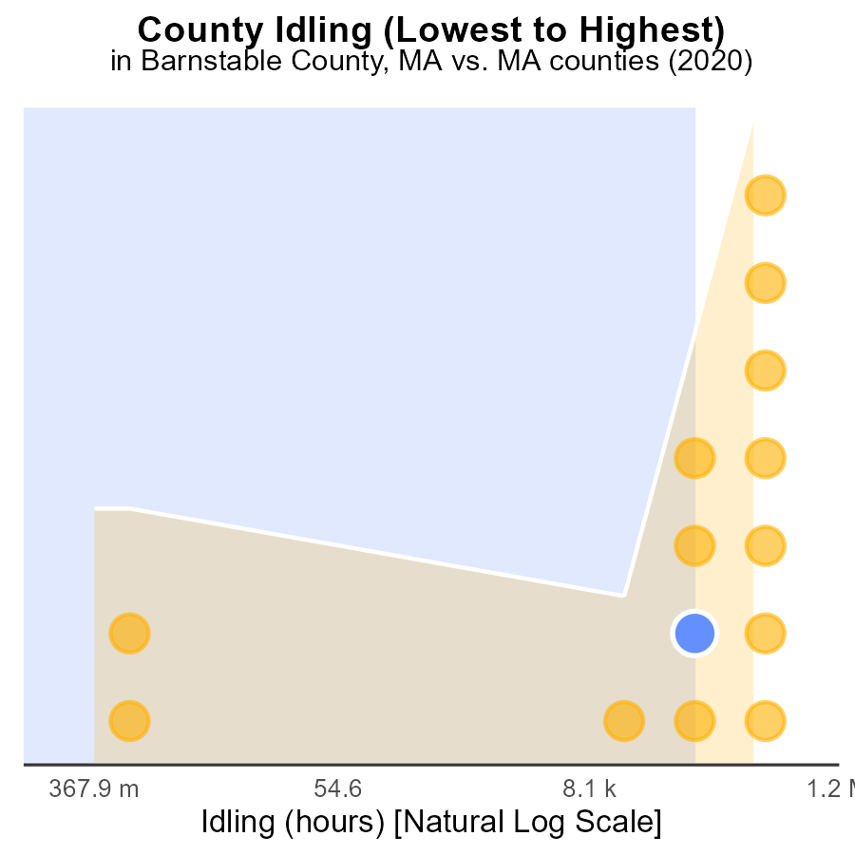

## Findings

* Middlesex county had the highest idling hours in 2020 at 1.6 million.
* Berkshire county had the highest idling percentage at 42.9%.
* Dukes county had the lowest idling hours, with 0 hours in 2020.

## Recommendations

To reduce emissions, focus on Middlesex and Berkshire counties by promoting anti-idling campaigns, incentivizing the use of electric vehicles, and improving public transportation to lower idling times.

# Areas Ranked by Vehicle Miles Traveled

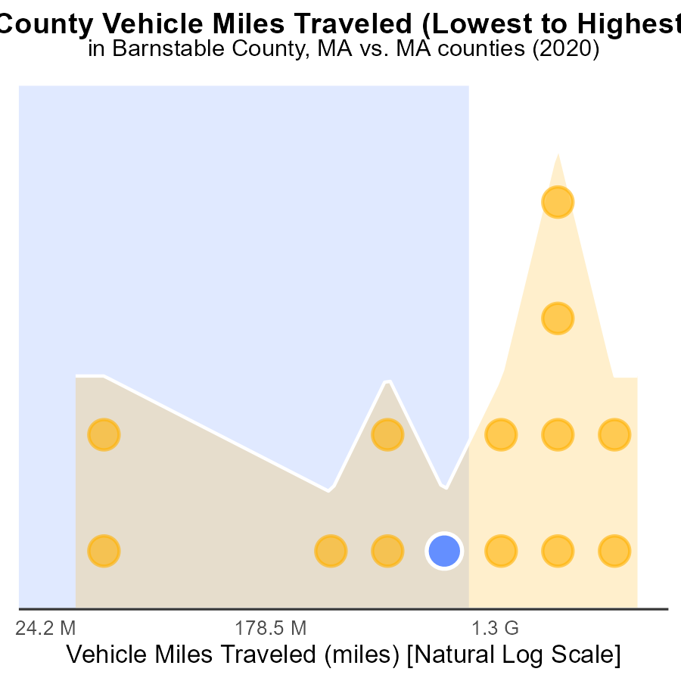

## Findings

* Middlesex county had the highest VMT with 13.3 billion miles traveled.
* Suffolk county had the highest percentile of emissions at 50.0%.
* Nantucket county had the lowest emissions percentile at 7.1%.

## Recommendations

To lower emissions, prioritize investments in public transportation in Middlesex and Suffolk counties where VMT and emissions are high. Encourage carpooling and promote electric vehicle usage across all counties.

# Conclusion

The data on CO2 equivalent emissions from on-road transportation in Barnstable County, MA in 2020 highlights the significant contributions of various vehicle types to the total emissions. Light trucks emerged as the largest emitters, followed by cars/bikes and combo trucks. However, heavy trucks and buses made smaller contributions to the overall emissions. The data underscores the importance of focusing on sectors with high emissions like gliders, HHD8, LDT, LDV, and others for effective mitigation strategies.

Furthermore, the trend of decreasing emissions from 2020 to 2040 by 25.6% indicates a positive trajectory in emission reduction efforts within Barnstable County. This decline trend, when compared to other areas, suggests that the current emission management strategies are effective. Moving forward, the county should continue investing in renewable energy sources, promoting sustainable transportation practices, and enforcing stricter emission regulations to maintain and further reduce emission levels.

# About This Report

Data based on MOVES estimates collected by the Climate Action in Transportation program at Cornell University. Demographic data sourced from the US Census's American Community Survey 5-year estimates. This report was generated with the help of AI.

# References

* U.S. Census Bureau. (2023). American Community Survey 5-year estimates: Detailed tables. Retrieved from https://data.census.gov
* U.S. Environmental Protection Agency. (2024). Motor Vehicle Emission Simulator (MOVES 4.0) [Software]. Retrieved from https://www.epa.gov/moves