 

**NOx Emissions in Newport County, 2010**  
Made with CAT VISUALIZER by Gao Labs @ Cornell University.

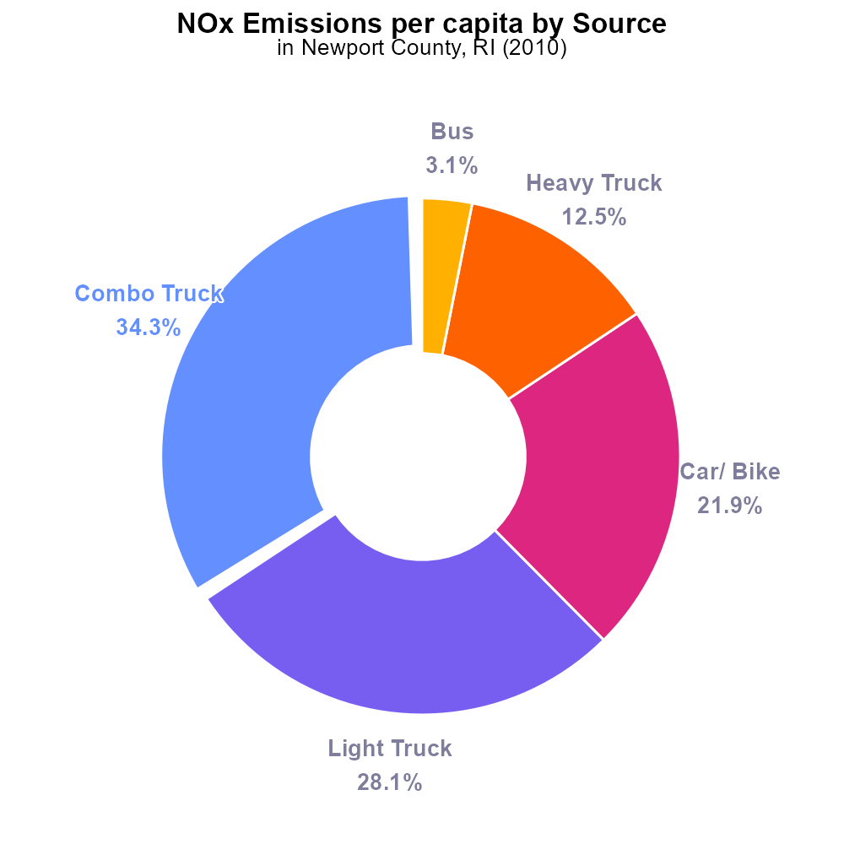

## Keywords

Oxides of Nitrogen; NOx emissions; on-road transportation; Newport County; RI; 2010

## Highlights

* NOx emissions from on-road transport in Newport County in 2010.
* Analysis of environmental impact and health risks.
* Sources of NOx emissions in the transportation sector.
* Impact on air quality and potential mitigation strategies.
* Importance of addressing NOx emissions for public health.

# Introduction

In 2010, the levels of Oxides of Nitrogen (NOx) emissions from on-road transportation in Newport County, Rhode Island, raised concerns about their environmental impact and potential health risks. This report aims to analyze the sources and distribution of NOx emissions specifically within the transportation sector of Newport County during the mentioned year. By examining the data on NOx emissions, we can understand the extent of their contribution to air pollution and their implications on air quality in the region.

The study will also investigate potential mitigation strategies to reduce NOx emissions from on-road transportation for the purpose of improving public health and environmental sustainability. It is crucial to address and limit NOx emissions from the transportation sector to safeguard the well-being of the residents and environment of Newport County.

# Vehicle Starts Overall by Area

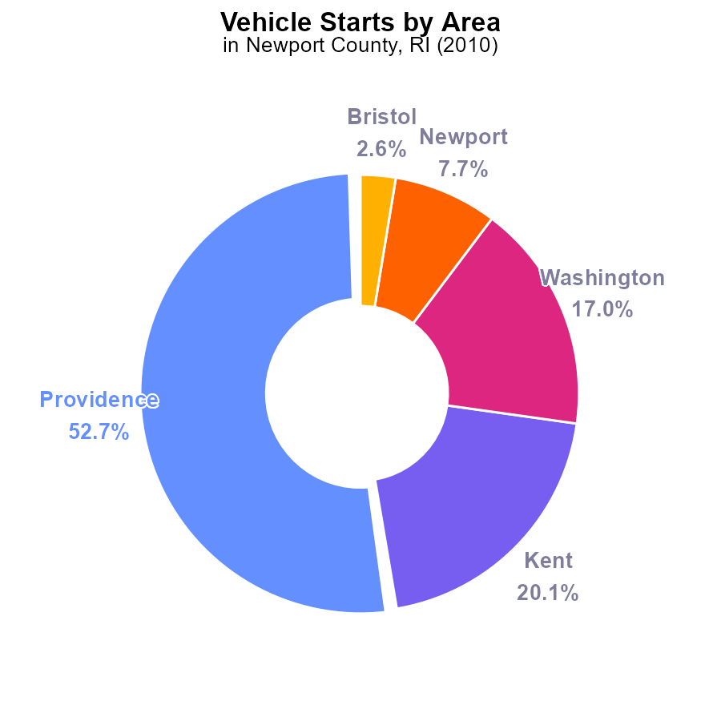

## Findings

* Providence County had the highest NOx emissions in 2010 at 507.6 million times
* Kent County and Washington County followed with 193.9 million times and 163.4 million times, respectively
* Newport County had the lowest NOx emissions at 74 million times, accounting for 7.7% of the total emissions

## Recommendations

To lower NOx emissions in Newport County, focus on reducing vehicle starts by promoting carpooling, adopting electric vehicles, and improving public transportation.

# Emissions Rate (per capita) by Vehicle Type

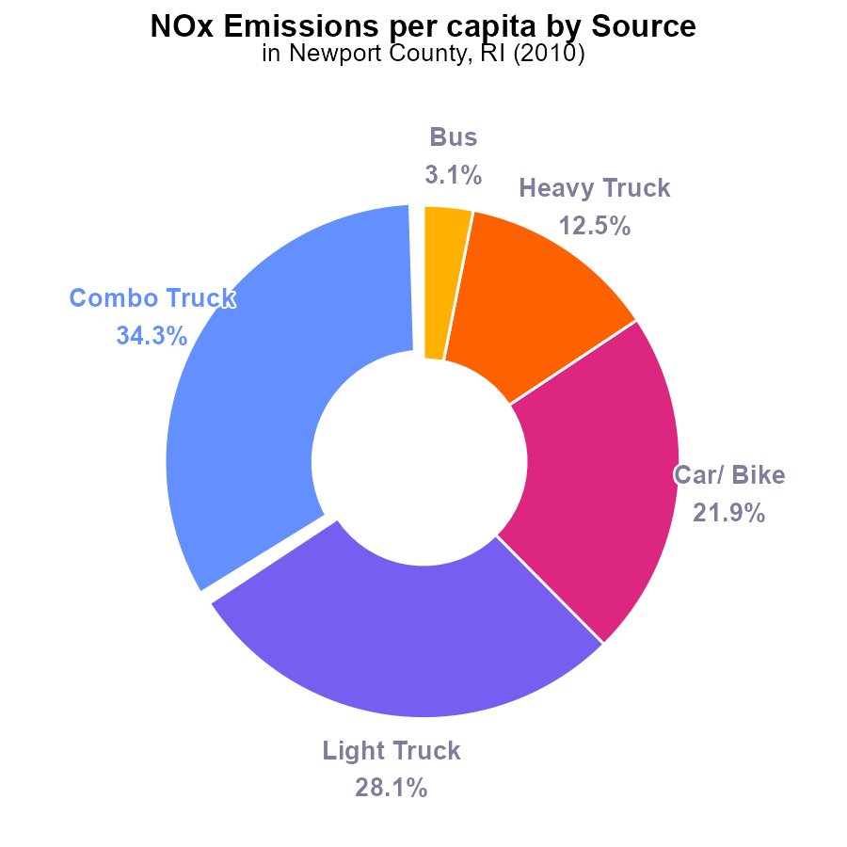

## Findings

* Combo Trucks have the highest NOx emissions per capita at 4.9 tons per person, representing 34.3% of total emissions.
* Light Trucks follow with 4.0 tons per person, contributing 28.1% to the total emissions.
* Cars/Bikes emit 3.1 tons per person, making up 21.9% of the total NOx emissions in the county.

## Recommendations

To lower the emission level, it is recommended to focus on reducing emissions from Combo Trucks, Light Trucks, and Cars/Bikes by implementing stricter emission standards, promoting the use of electric vehicles, and investing in public transport.

# Time Driven over Time for Passenger Time Driven

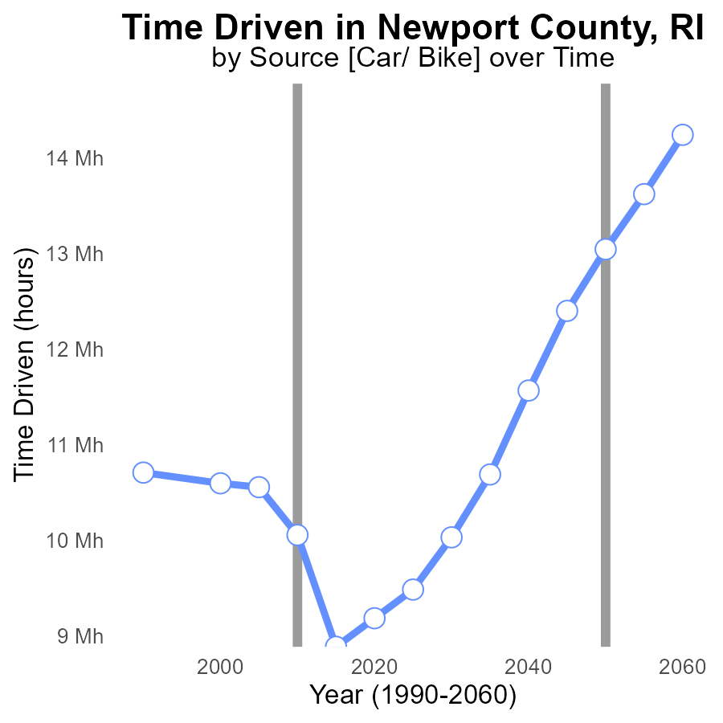

## Findings

* NOx emissions in Newport County, RI have decreased over time.
* The benchmark difference has fluctuated but remained overall high.
* Emissions are expected to increase slightly in 2030 compared to 2025.

## Recommendations

To continue reducing NOx emissions, policies promoting cleaner transportation and industry practices should be implemented. Close monitoring of emissions data is crucial to ensure progress towards lower levels.

# Vehicles over Time for Passenger Vehicles

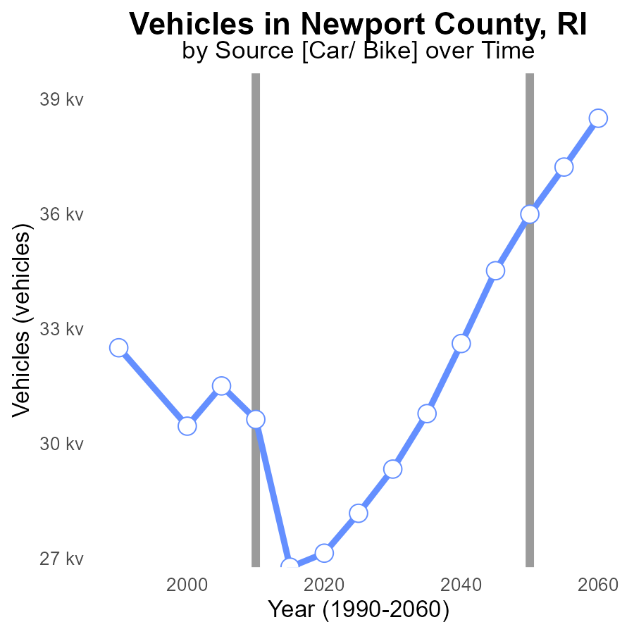

## Findings

* From 1990 to 2030, NOx emissions from vehicles in Newport County decreased by 3.2 k (9.8%)
* Despite minor fluctuations, emissions remained relatively stable over the years.
* The largest reduction in emissions occurred between 2015 and 2020, with a decrease of 3.7 k (14%).

## Recommendations

To further reduce NOx emissions from vehicles in Newport County, initiatives such as promoting electric vehicles, implementing stricter emission standards, and investing in public transportation can be considered. Encouraging carpooling and reducing traffic congestion can also aid in lowering emissions.

# Emissions Rate (per capita) Mapped by Area

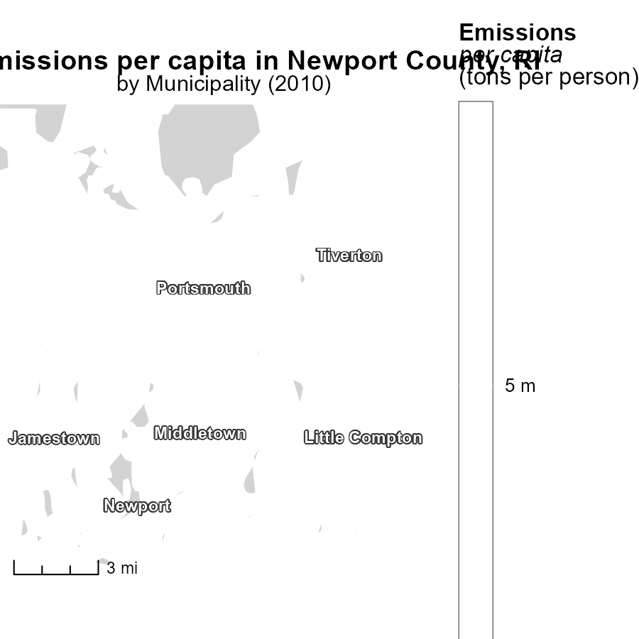

## Findings

* Jamestown, RI has the highest emissions per capita in 2010 at 4.8 tons per person.
* Newport, RI represents the median emissions per capita in 2010 at 4.8 tons per person.
* The minimum emissions per capita in 2010 for Rhode Island is found in '..., RI', with unspecified values.

## Recommendations

To lower emissions in Rhode Island, strategies focusing on high emitting regions like Jamestown should be prioritized. Implementing policies to reduce emissions from transportation and energy sectors can help reach a more sustainable emission level.

# Hotelling (Engines Off) Mapped by Area

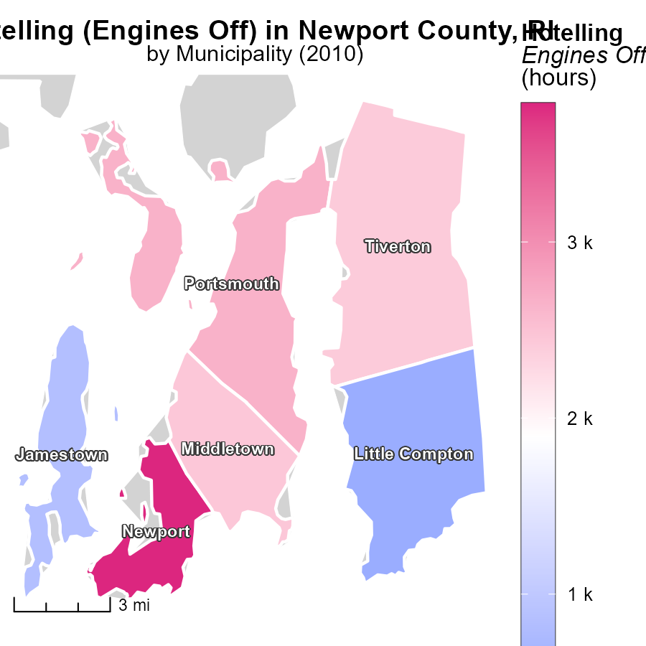

## Findings

* Newport, RI had the highest emissions with 3.8 k hours.
* Tiverton, RI had median emissions with 2.4 k hours.
* There were no reported emissions in other locations in RI.

## Recommendations

To lower emissions, focus on reducing engine idling in areas with high emission hours like Newport, RI. Implement awareness campaigns on idling reduction.

# Population by Regulatory Class over Time

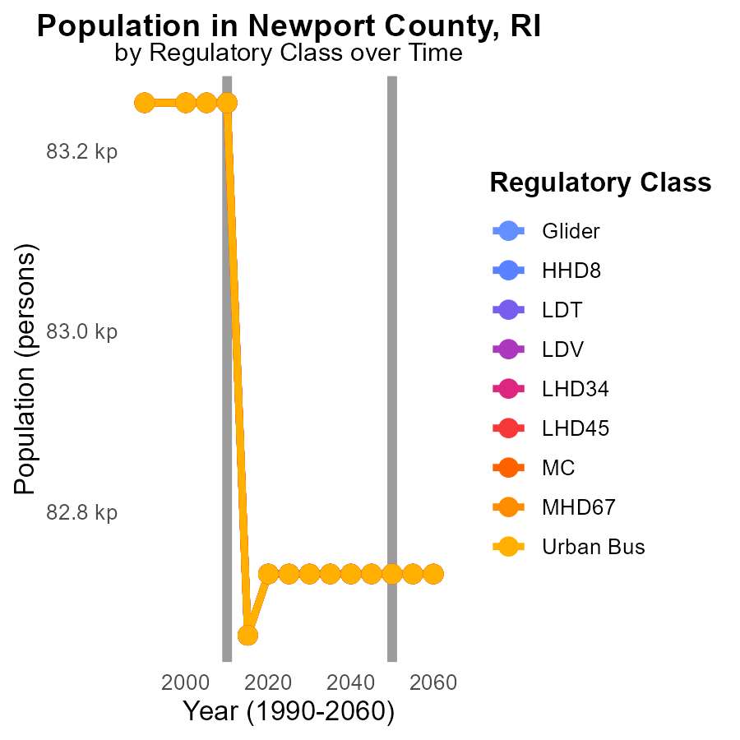

## Findings

* NOx emissions have decreased by an average of 0.6% annually in Newport County, RI from 2000 to 2020.
* The highest NOx emissions in 2010 were from Gliders and HDV, each at 83.3k, with a decrease of 522 from 2005 to 2010.
* Despite slight fluctuations in emissions across different vehicle types, all showed reductions by 2020, aligning with regulations.

## Recommendations

Continued enforcement of emission standards and incentivizing the use of low-emission vehicles are essential to maintain the downward trend in NOx emissions. Targeting further reductions from Gliders and HDV categories could be a priority.

# Vehicle Miles Traveled by Vehicle Type over Time

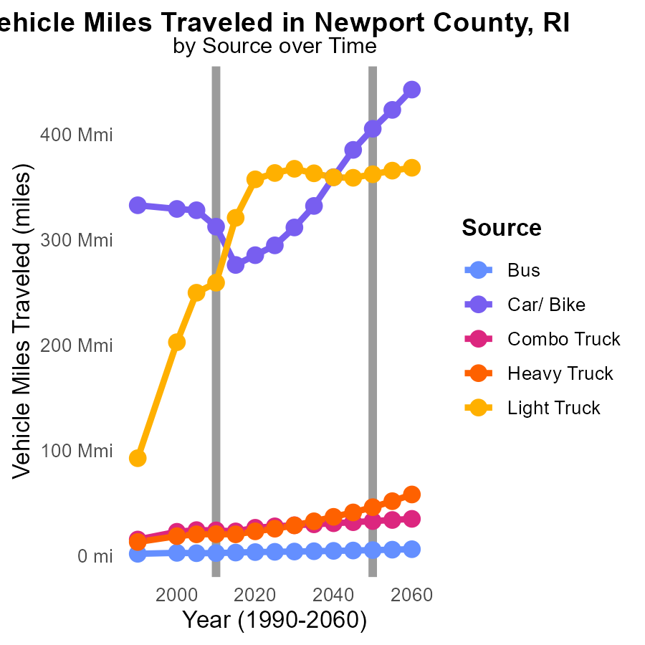

## Findings

* Bus emissions decreased by 13.8% from 2000 to 2020.
* Light truck emissions increased by 77.6% from 2000 to 2020.
* In 2020, heavy trucks had the highest emissions among vehicle types at 23.3 million.

## Recommendations

To reduce emissions, focus on improving public transportation efficiency by optimizing bus routes and shifting to low-emission buses. Encourage the use of electric vehicles for light trucks. Implement strict emission standards for heavy trucks.

# Areas Ranked by Emissions Rate (per mile)

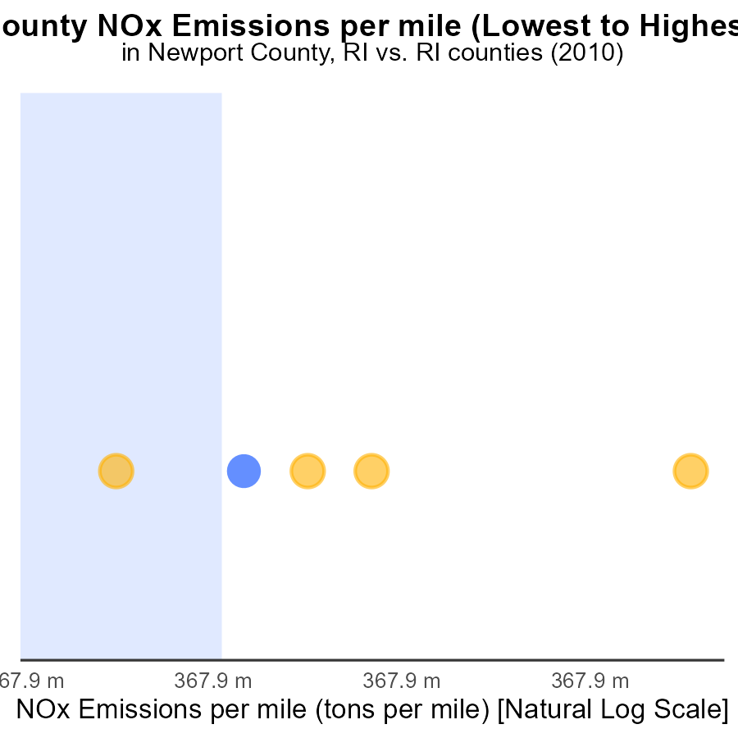

## Findings

* Providence County has the highest NOx emissions per mile at 2.0 tons.
* Washington County has the highest rate_vmt at 2.4 µ.
* Bristol County has the lowest NOx emissions per mile at 1.8 tons.

## Recommendations

To lower NOx emissions, target measures in Providence and Washington Counties due to their high emissions per mile. Consider implementing vehicle emissions testing, promoting public transportation, and encouraging the use of electric vehicles.

# Areas Ranked by Hotelling (Engines Off)

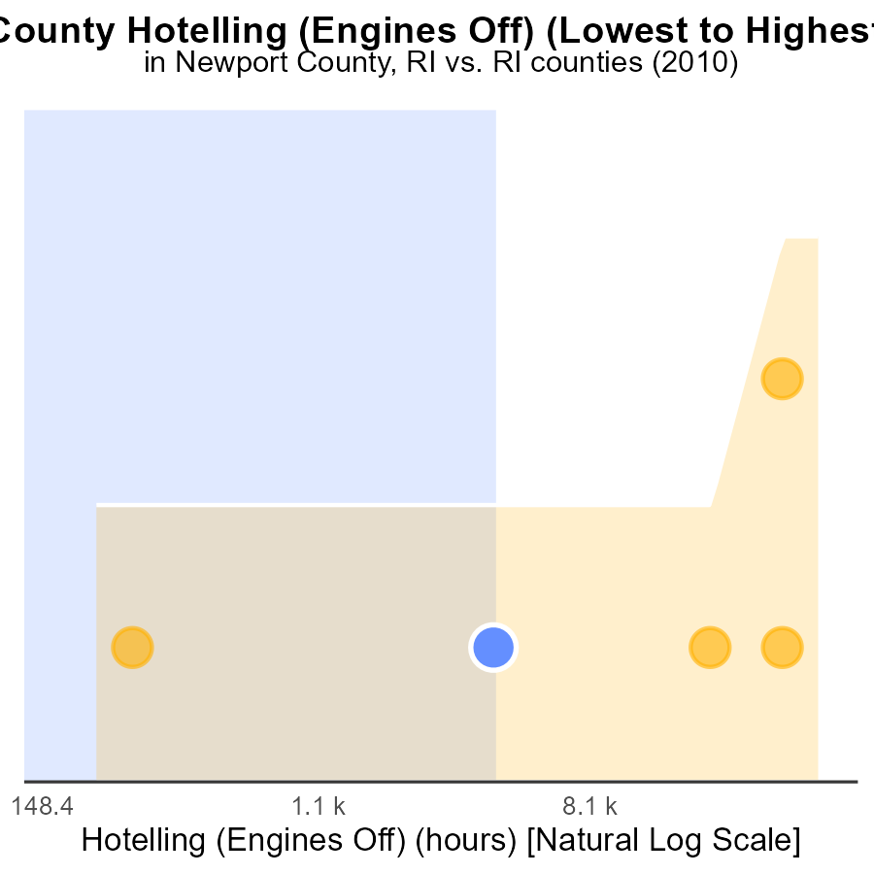

## Findings

* Providence had the highest NOx emissions in 2010 with 117.6k hotelling hours.
* Kent had the highest percentile of NOx emissions at 60.0%.
* Bristol had the lowest NOx emissions in 2010 with 584.9 hotelling hours.

## Recommendations

To lower emissions, focus on reducing hotelling hours in high-emission counties like Providence and Kent, promoting more efficient engine use.

# Conclusion

In conclusion, Newport County, RI had the lowest NOx emissions in 2010 compared to other counties in the state. With only 74 million times of emissions, accounting for 7.7% of the total, Newport County has shown positive trends in reducing NOx emissions.

The data indicates that focusing on vehicle types such as Combo Trucks, Light Trucks, and Cars/Bikes, which contribute significantly to emissions per capita, could greatly impact reducing NOx emissions. Implementing measures like promoting electric vehicles, adopting stricter emission standards, and investing in public transportation can help further lower emissions.

Overall, the findings suggest that implementing targeted strategies to reduce emissions from transportation sectors and encouraging cleaner practices can lead to a sustained decrease in NOx emissions. Close monitoring of emission data and continued efforts towards adopting low-emission vehicles are crucial in ensuring a more environmentally friendly future for Newport County, RI.

# About This Report

Data based on MOVES estimates collected by the Climate Action in Transportation program at Cornell University. Demographic data sourced from the US Census's American Community Survey 5-year estimates. This report was generated with the help of AI.

# References

* U.S. Census Bureau. (2023). American Community Survey 5-year estimates: Detailed tables. Retrieved from https://data.census.gov
* U.S. Environmental Protection Agency. (2024). Motor Vehicle Emission Simulator (MOVES 4.0) [Software]. Retrieved from https://www.epa.gov/moves