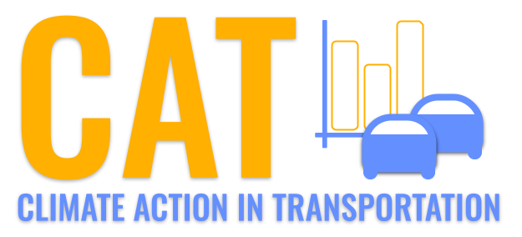 

**VOC Emissions in Navajo County, 2005**  
Made with CAT VISUALIZER by Gao Labs @ Cornell University.

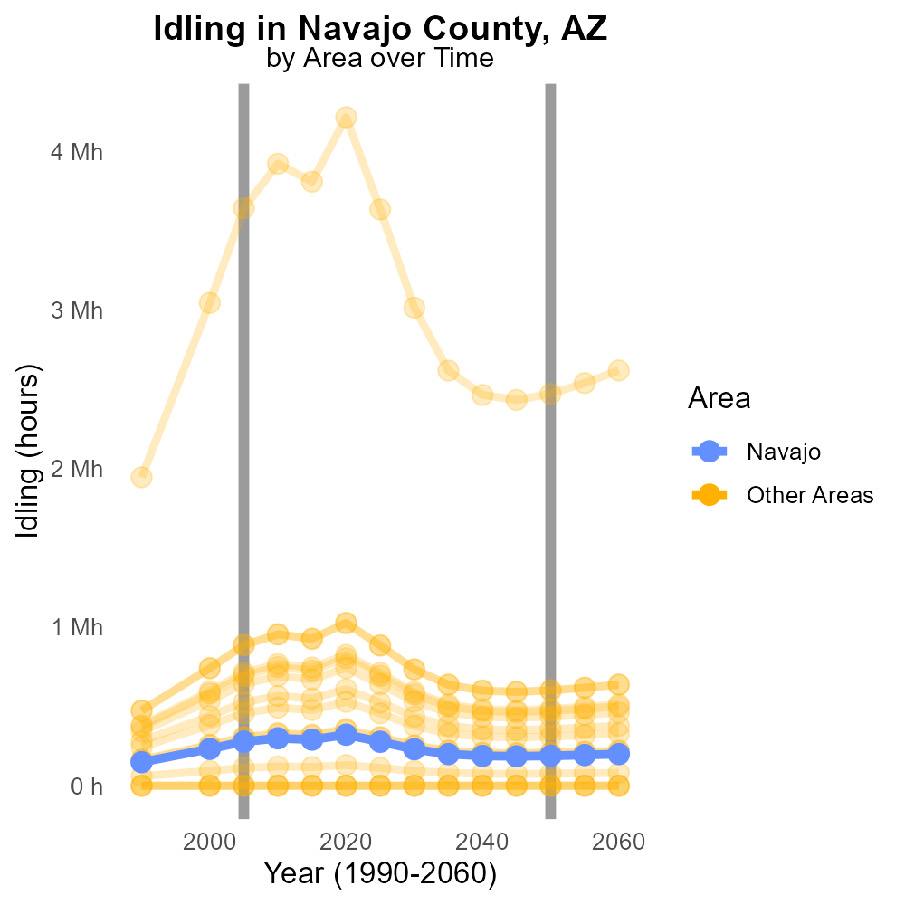

## Keywords

Volatile Organic Compounds; emissions; on-road transportation; Navajo County; AZ; 2005

## Highlights

* Study on VOC emissions from on-road transportation in Navajo County, AZ in 2005.
* Focus on understanding the impact of transportation on air quality.
* Analysis of VOC types, sources, and levels in the study area.
* Importance of addressing VOC emissions for environmental and public health.
* Findings may guide strategies for reducing VOC emissions in the region.

# Introduction

In 2005, a comprehensive study was conducted to assess the Volatile Organic Compounds (VOC) emissions originating from on-road transportation in Navajo County, AZ. This research aimed to examine the impact of vehicular activities on air quality and public health in the region. The study focused on identifying the types of VOCs, their sources, and the levels of emission that contribute to the overall air pollution in Navajo County.

Understanding the composition and volume of VOCs emitted from on-road transportation is crucial for formulating effective strategies to mitigate air pollution. Addressing VOC emissions is essential to protect the environment and public health, making it imperative to analyze the data collected in 2005 and develop appropriate measures for reducing emissions in Navajo County, AZ moving forward.

# Time Driven by Vehicle Type

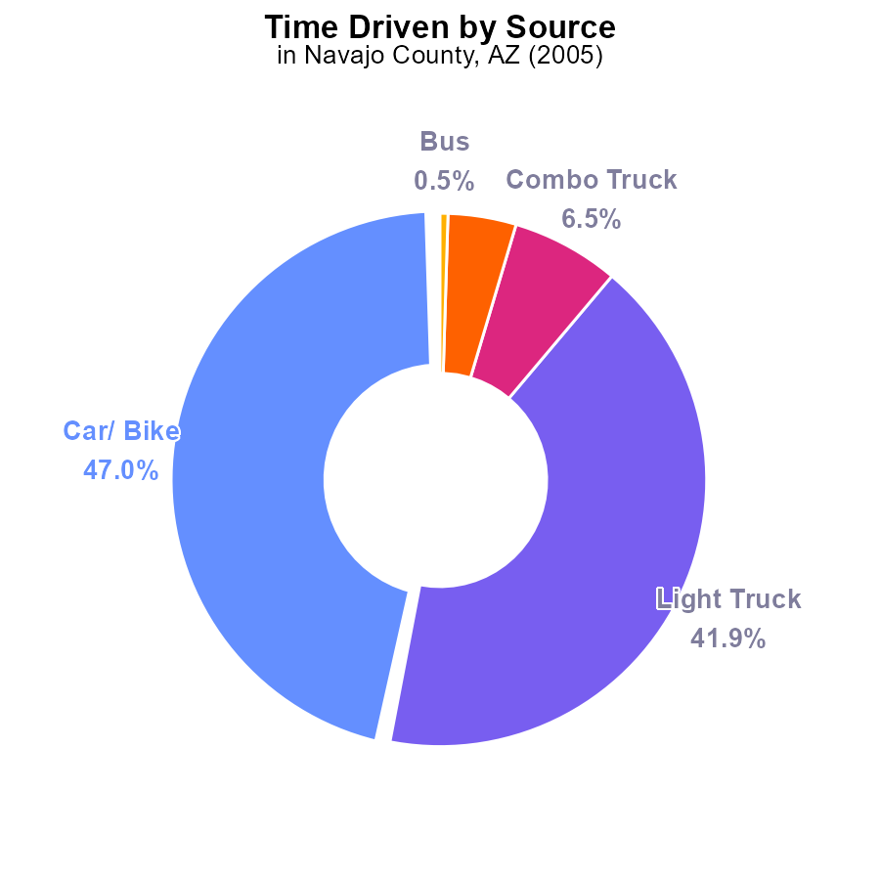

## Findings

* The highest VOC emissions in Navajo County, AZ in 2005 came from cars/bikes and light trucks, accounting for 88.9% combined.
* Combo trucks and heavy trucks contributed to 10.6% of the total VOC emissions, with heavy trucks being the lowest emitter.
* Buses had the lowest contribution to VOC emissions in 2005, only accounting for 0.5% of the total emissions in Navajo County.

## Recommendations

To reduce VOC emissions in Navajo County, policymakers should prioritize implementing stricter emissions standards for cars, bikes, and light trucks, as they are the primary contributors. Encouraging the use of cleaner fuel technologies and promoting public transportation usage can also help lower emissions from heavy trucks and buses.

# Vehicles Overall by Area

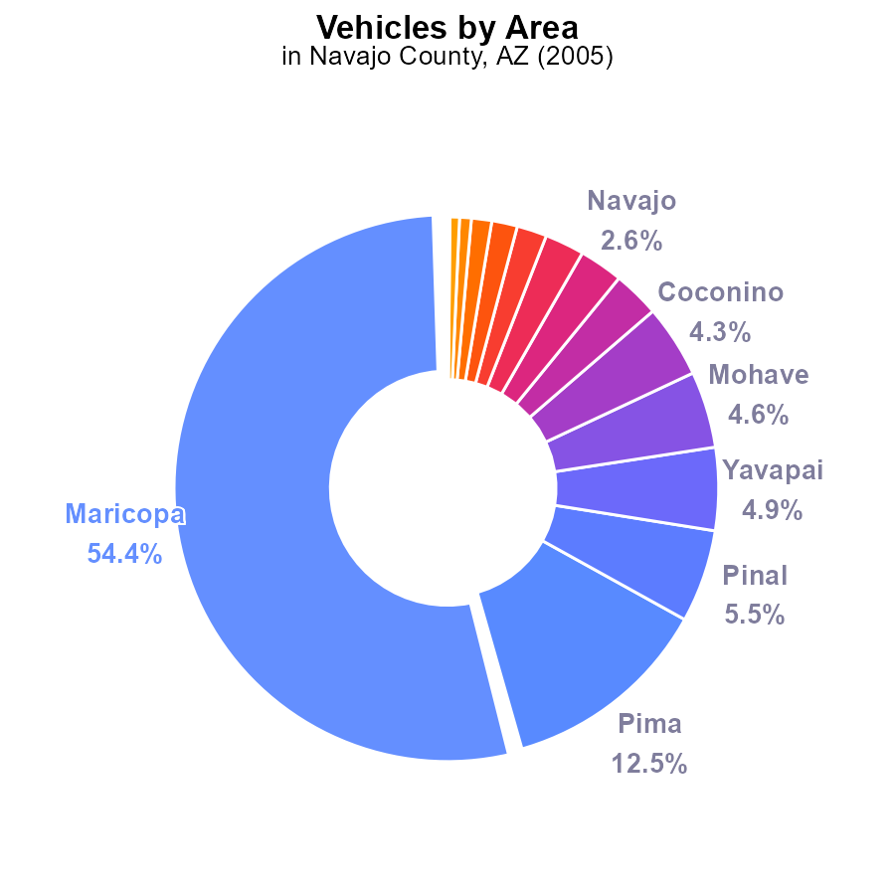

## Findings

* Maricopa County had the highest VOC emissions from vehicles in Navajo County, AZ in 2005, accounting for 54.4%.
* The top three contributors, Maricopa, Pima, and Pinal counties, made up 72.4% of the total VOC emissions from vehicles.
* The bottom five contributors, Santa Cruz, Graham, and Greenlee counties, collectively accounted for only 1.4% of the total VOC emissions.

## Recommendations

To lower VOC emissions, focus on implementing stricter vehicle emission standards in high-contributing counties like Maricopa, Pima, and Pinal. Encourage the use of eco-friendly transportation methods to reduce pollution from vehicles.

# Vehicles over Time for Passenger Vehicles

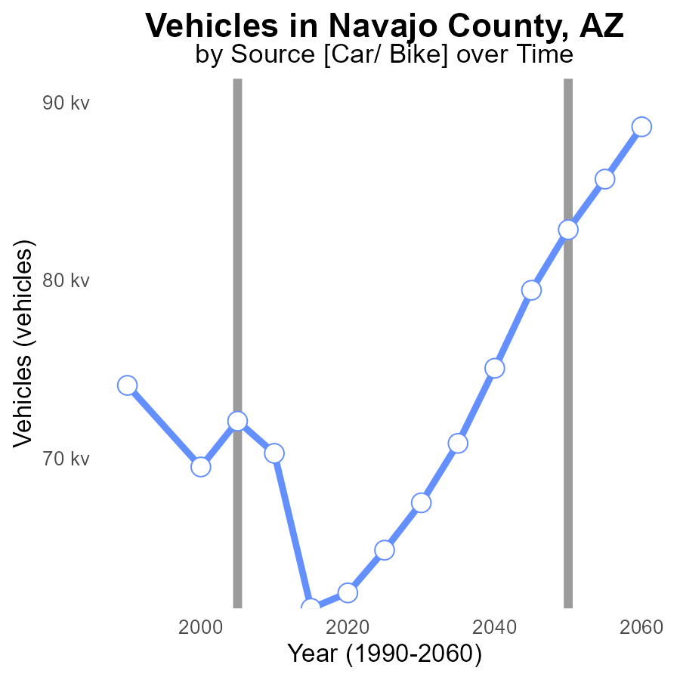

## Findings

* Volatile organic compound (VOC) emissions from vehicles in Navajo County, AZ have decreased by 13.6% from 1990 to 2025.
* The benchmark difference has fluctuated, with the highest difference of 21,242.8 in 2015 compared to 1990.
* Despite slight fluctuations, vehicle VOC emissions have remained relatively stable from 2000 to 2025.

## Recommendations

To further reduce VOC emissions from vehicles in Navajo County, AZ, policymakers should consider promoting the adoption of electric vehicles, implementing stricter emissions standards, and investing in public transportation infrastructure to reduce reliance on personal vehicles.

# Emissions Rate (per vehicle) Overall over Time

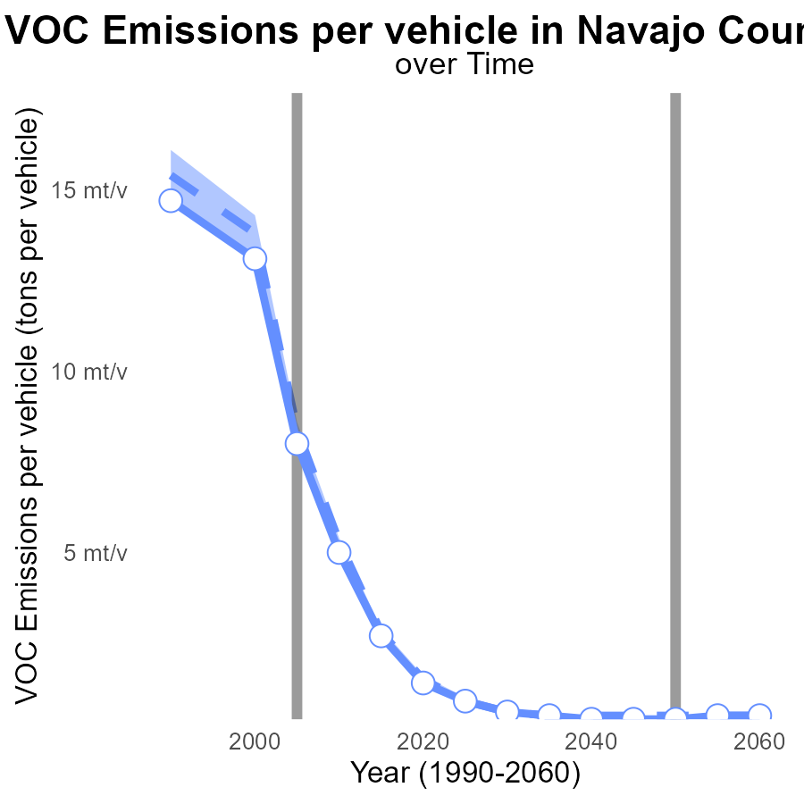

## Findings

* Navajo County has shown a decreasing trend in VOC emissions per vehicle from 1990 to 2025.
* Emissions in Navajo County are consistently below both the median area and upper 75th percentile of areas.
* There is an evident disparity in emissions between Navajo County and benchmark levels.

## Recommendations

Implement stricter vehicle emissions standards to further reduce VOC emissions per vehicle. Invest in public transportation to decrease reliance on personal vehicles.

# Vehicles Mapped by Area

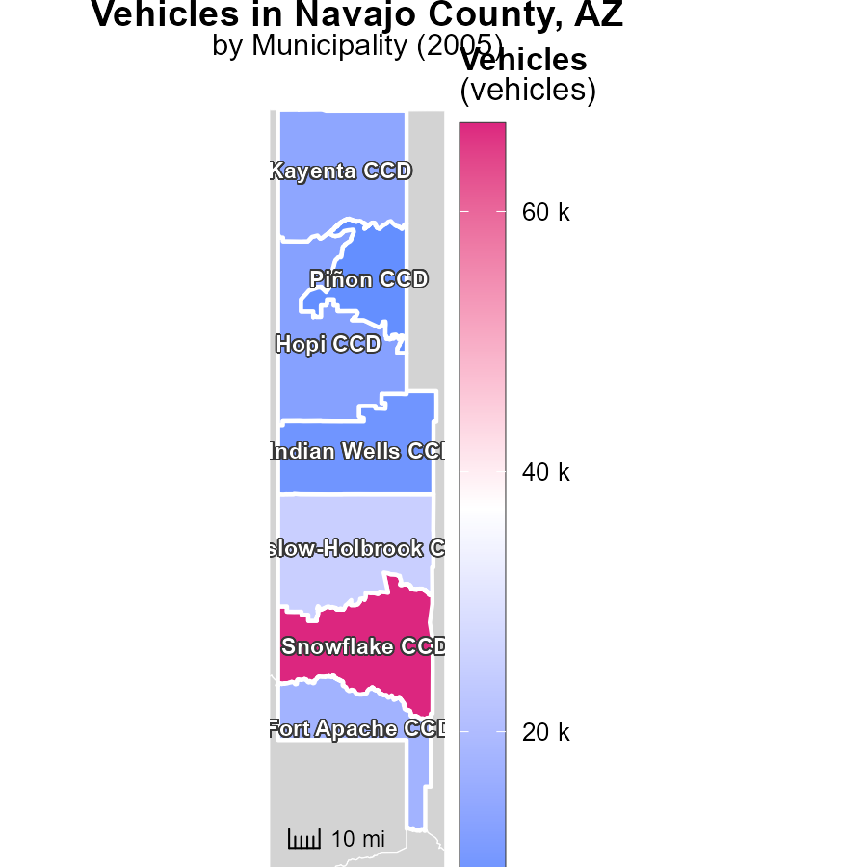

## Findings

* Snowflake CCD, AZ had the highest vehicle emissions in 2005 with 66.7 thousand tons.
* Kayenta CCD, AZ had 14.0 thousand tons of vehicle emissions in 2005, representing the median value.
* Piñon CCD, AZ had the lowest vehicle emissions in 2005, with 7.7 thousand tons.

## Recommendations

To reduce vehicle emissions, consider promoting public transportation, carpooling, and investing in electric vehicles to mitigate the emissions levels from vehicles in these areas.

# Vehicles in My Region

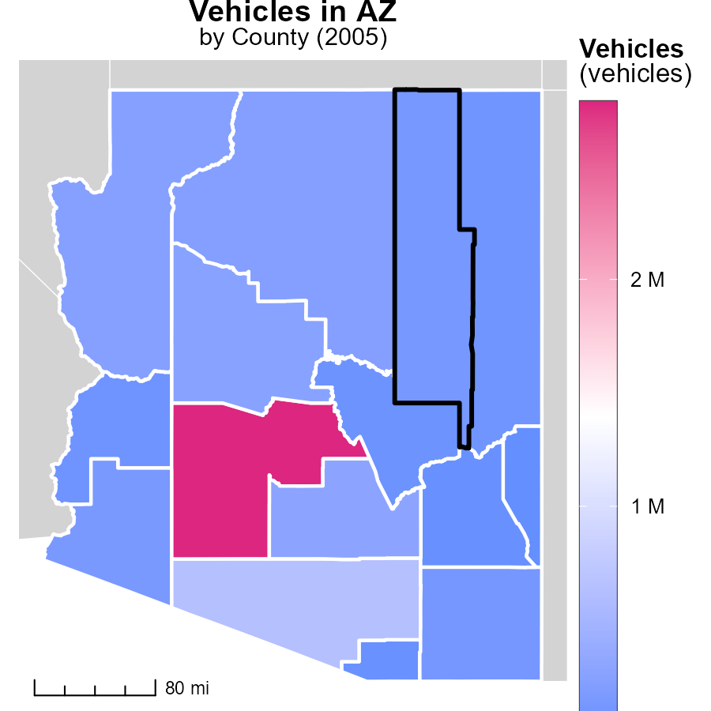

## Findings

* Maricopa County, AZ emitted 2.8 million metric tons of vehicle emissions in 2005.
* Navajo County, AZ had a median vehicle emission of 133.5 thousand metric tons in 2005.
* Greenlee County, AZ had the lowest vehicle emissions in 2005, totaling 7.1 thousand metric tons.

## Recommendations

To reduce vehicle emissions, focus on improving public transportation, promoting carpooling, and investing in infrastructure to support electric vehicles. Implement stricter vehicle emission standards and incentivize the adoption of greener technologies.

# Emissions Rate (per capita) by Area over Time

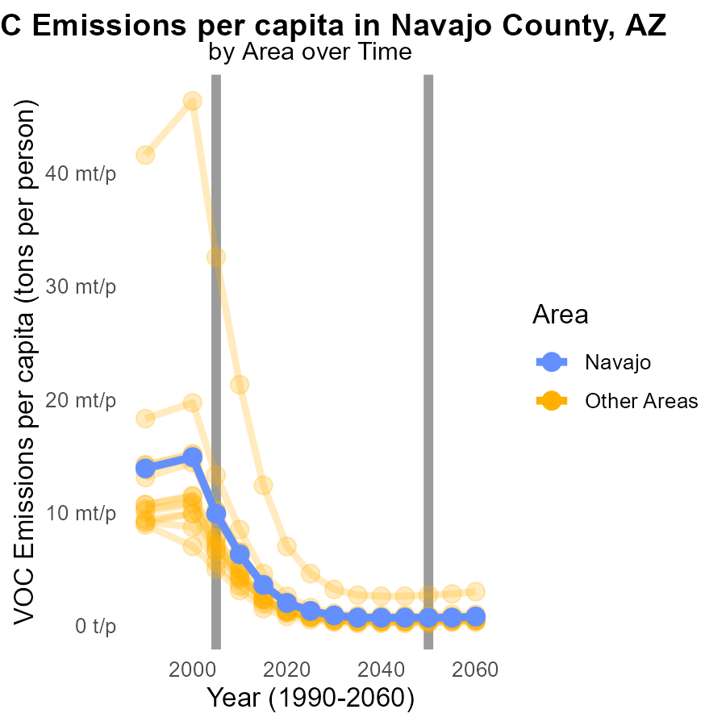

## Findings

* In 2005, max county had 32.6 tons of VOC emissions per person, while min county had 5.0 tons, with a target county at 9.9 tons.
* There was a decrease in VOC emissions per person between 2005 and the projected 2050 levels, with reductions ranging from 0.0048 to 0.0299 tons.
* Overall, there is a significant variation in VOC emissions per capita among different counties in the specified year.

## Recommendations

Policy measures should target counties with high VOC emissions to align them with the lower-emission counties. Implement stricter regulations and incentives to encourage a reduction in VOC emissions across all counties.

# Idling by Area over Time

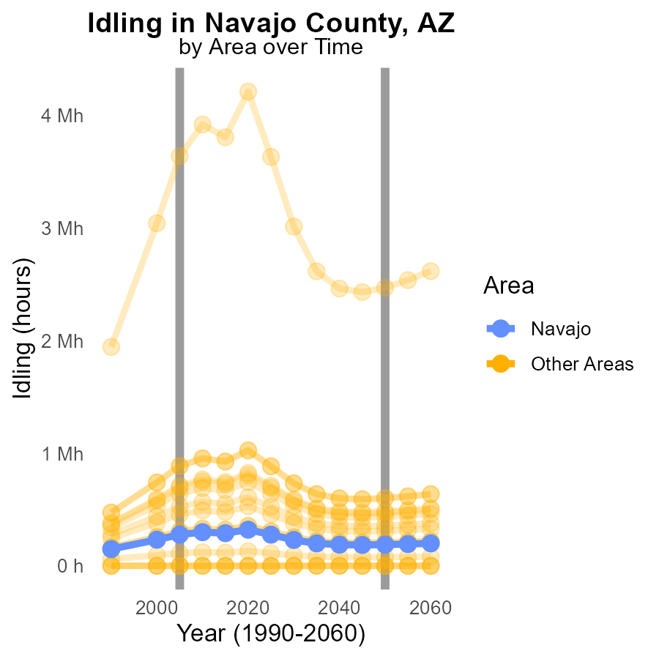

## Findings

* Idling VOC emissions in min_county were consistently 0.0 for the years 2005-2015.
* In 2005, max_county emitted 3.6 million units of VOC through idling, forecasting a decrease of 1,170,481.5 units by 2050.
* Target_county in 2005 released 277.7 thousand units of VOC while idling, with a projected reduction of 89,288.4 units by 2050.

## Recommendations

To lower VOC emissions from idling, min_county should continue its trend of zero emissions by implementing stricter idling regulations. Max_county should adopt emission reduction strategies to achieve the 2050 target. Target_county must focus on implementing idling reduction programs to reach the emissions reduction goal.

# Areas Ranked by Vehicle Starts

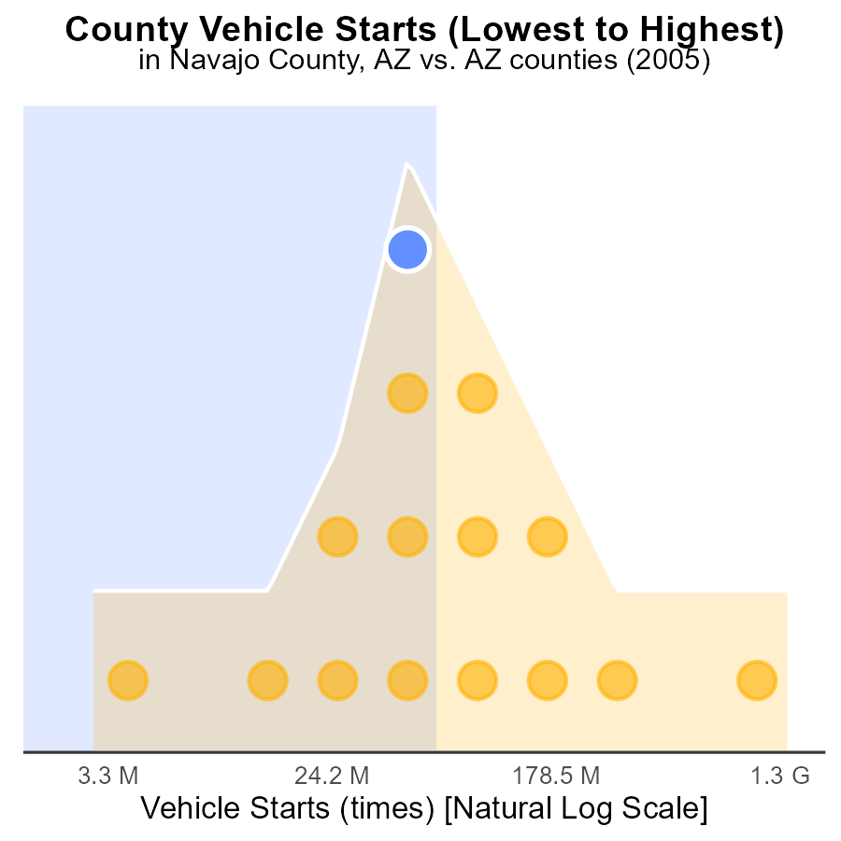

## Findings

* Maricopa county had the highest VOC emissions from vehicle starts in 2005 with 4.0 billion times.
* Greenlee county had the lowest VOC emissions from vehicle starts in 2005, accounting for just 6.7% of the total.
* Collectively, the top 5 counties contributed to 267.5 million vehicle starts, which represents 82.7% of the total emissions.

## Recommendations

To lower the emissions level, focus on implementing stricter vehicle emissions standards across all counties. Encourage the adoption of electric vehicles to reduce VOC emissions significantly.

# Areas Ranked by Vehicle Miles Traveled

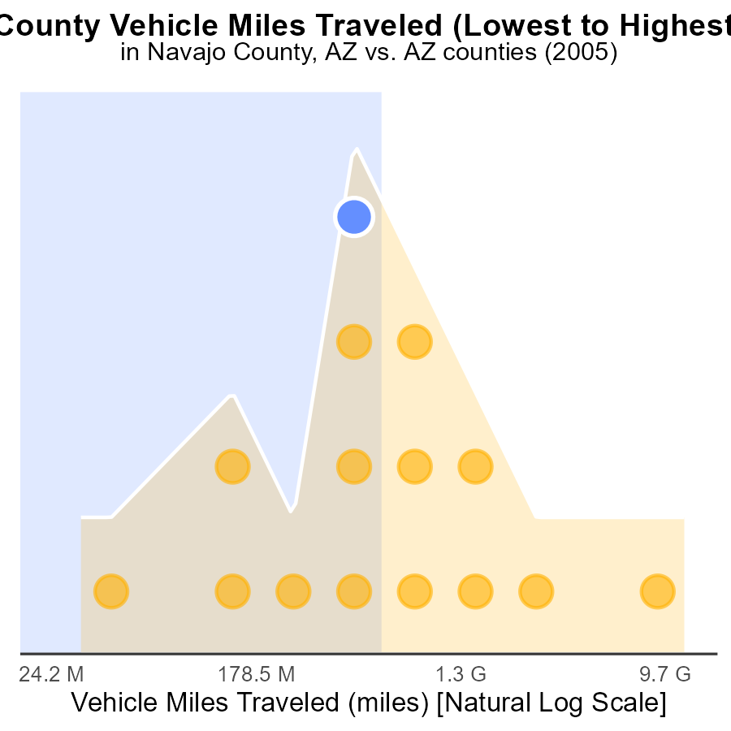

## Findings

* Maricopa has the highest VMT of 33.1 billion miles in 2005.
* Greenlee has the lowest VMT of 87.3 million miles in 2005.
* Maricopa accounts for 100% of the VMT percentile in 2005.

## Recommendations

To reduce emissions, focus on Maricopa County due to its highest VMT contribution. Implement measures like promoting public transportation, carpooling, and biking infrastructure to reduce vehicle dependency.

# Conclusion

In conclusion, the analysis of volatile organic compound (VOC) emissions from on-road transportation in Navajo County, AZ in 2005 reveals a predominance of emissions from cars/bikes and light trucks, comprising 88.9% of the total emissions. Conversely, buses had the lowest contribution with only 0.5%. To mitigate VOC emissions, policymakers should prioritize implementing stringent emission standards for primary contributors like cars, bikes, and light trucks, and promote cleaner fuel technologies. Additionally, encouraging the use of public transportation can help reduce emissions from heavy trucks and buses. Moreover, focusing on high-contributing counties such as Maricopa, Pima, and Pinal in implementing stricter regulations and introducing eco-friendly transportation methods can lead to a significant reduction in VOC emissions. Overall, the data indicates a decreasing trend in VOC emissions per vehicle in Navajo County, signaling positive strides towards a cleaner environment through targeted policy interventions and the adoption of greener technologies.

# About This Report

Data based on MOVES estimates collected by the Climate Action in Transportation program at Cornell University. Demographic data sourced from the US Census's American Community Survey 5-year estimates. This report was generated with the help of AI.

# References

* U.S. Census Bureau. (2023). American Community Survey 5-year estimates: Detailed tables. Retrieved from https://data.census.gov
* U.S. Environmental Protection Agency. (2024). Motor Vehicle Emission Simulator (MOVES 4.0) [Software]. Retrieved from https://www.epa.gov/moves