 

**PM10 Emissions in Trinity County, 2030**  
Made with CAT VISUALIZER by Gao Labs @ Cornell University.

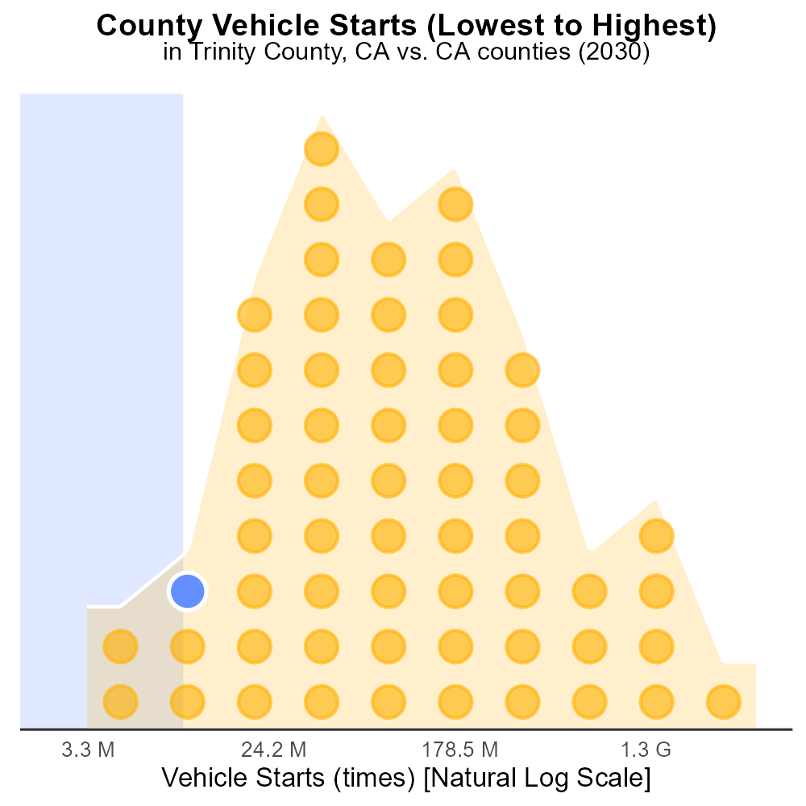

## Keywords

Primary Exhaust PM10; Total emissions; on-road transportation; Trinity County; California; 2030

## Highlights

* An examination of Primary Exhaust PM10 emissions in Trinity County, CA in 2030.
* Focus on total emissions from on-road transportation for a comprehensive analysis.
* Assessment of the environmental impact and potential health risks.
* Insights into the effectiveness of current mitigation strategies.
* Implications for future policy recommendations to achieve cleaner air.

# Introduction

This report provides an in-depth analysis of Primary Exhaust PM10 emissions from on-road transportation in Trinity County, California, projected for the year 2030. By focusing on total emissions, the report aims to offer a comprehensive understanding of the environmental impact and potential health risks associated with these pollutants.

Through this analysis, insights will be gained into the effectiveness of current mitigation strategies and the feasibility of achieving cleaner air in Trinity County. The findings of this report will have important implications for shaping future policy recommendations and initiatives aimed at reducing on-road transportation emissions for a healthier and more sustainable environment.

# Emissions by Regulatory Class

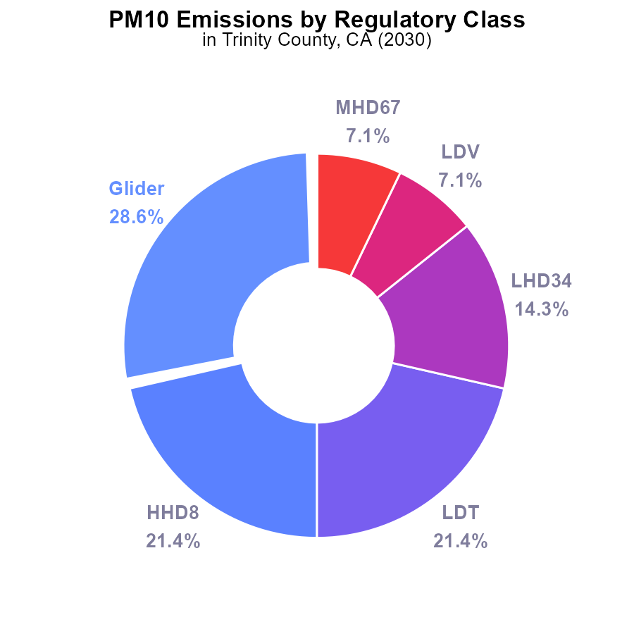

## Findings

* The top two sources of PM10 emissions in Trinity County in 2030 are Glider and HHD8, accounting for 50% of total emissions.
* LDT, LHD34, LDV, and MHD67 each contribute around 7-21% to the total PM10 emissions in 2030.
* The categories of LHD45, MC, and Urban Bus do not contribute to PM10 emissions in Trinity County in 2030.

## Recommendations

To lower PM10 emissions in Trinity County, focus on reducing emissions from Glider and HHD8, as they contribute the most. Implement stricter regulations or incentivize the adoption of cleaner technology in these sectors to achieve significant emission reductions.

# Emissions Rate (per capita) by Road Type

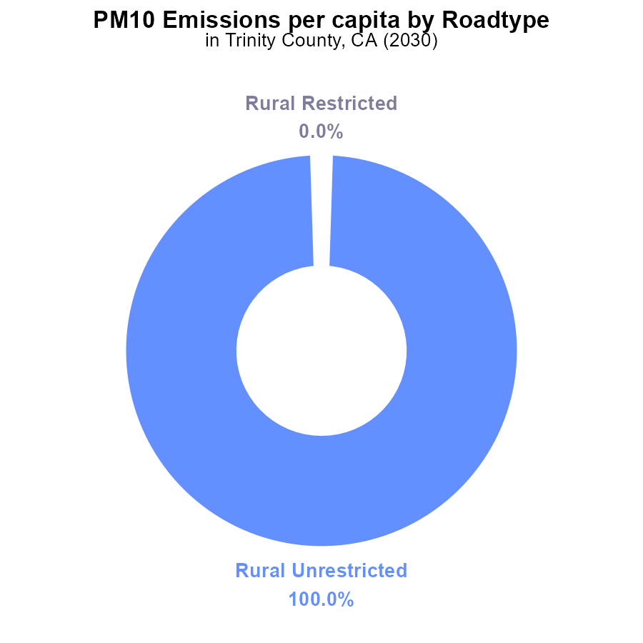

## Findings

* In 2030, PM10 emissions in Trinity County were 111.6 tons per person.
* Rural Unrestricted areas contributed 100% of the PM10 emissions per capita.
* No PM10 emissions were reported in Rural Restricted, Urban Restricted, or Urban Unrestricted areas.

## Recommendations

To lower PM10 emissions in Trinity County, focus should primarily target reducing emissions in Rural Unrestricted areas through stricter regulations and improved monitoring systems. Implementing emission control technologies in industries and promoting cleaner energy sources can help achieve a significant decrease in emissions.

# Idling over Time for Passenger Idling

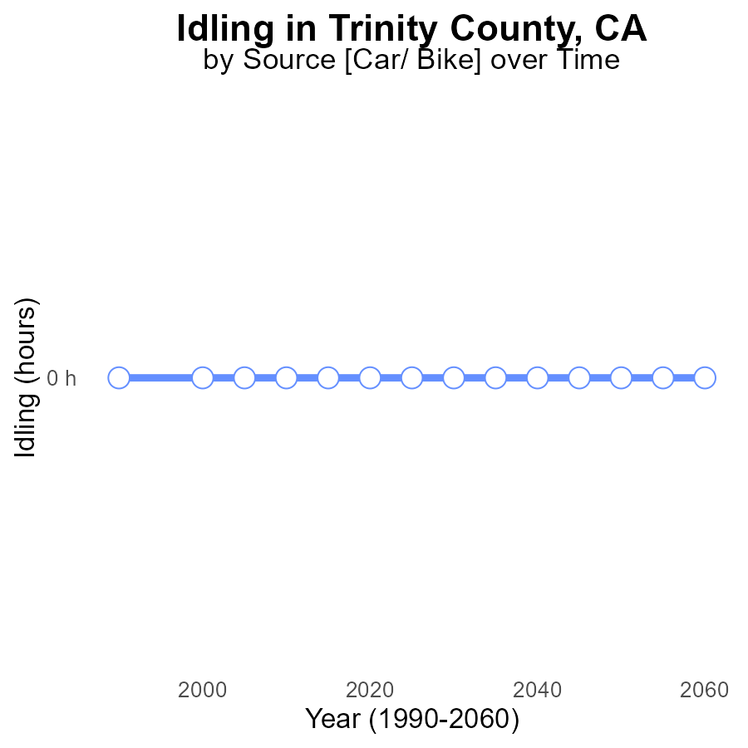

## Findings

* No PM10 emissions from idling have been reported in Trinity County, CA from 2010 to 2050.

## Recommendations

Since there are currently no PM10 emissions from idling in Trinity County, CA, it is recommended to maintain and continue efforts to minimize idling in the future to prevent any potential increase in emissions.

# Emissions Rate (per capita) over Time for Buses

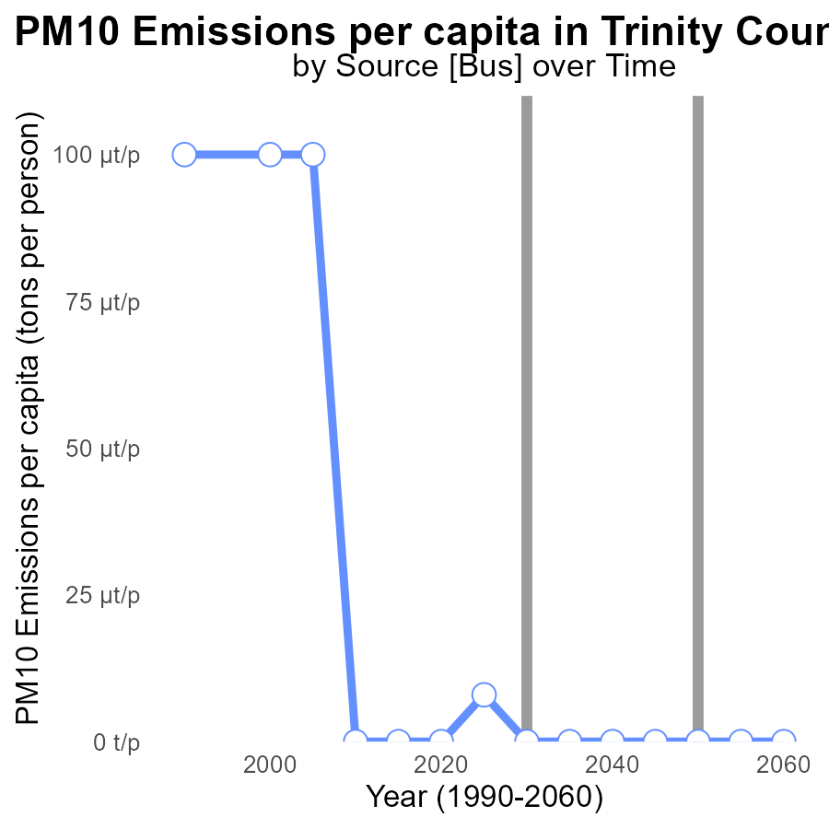

## Findings

* Emissions per capita of PM10 in Trinity County decreased from 43.8 tons per person in 2010 to 8.0 tons per person in 2025.
* In 2030, the emissions dropped to zero and remained so until 2050.
* There was a slight decrease in emissions per capita from 2020 to 2025, with a difference of -8e-06 tons per person.

## Recommendations

To continue the positive trend of reducing emissions, Trinity County should invest in sustainable transportation methods, promote renewable energy sources, and implement stricter regulations on industrial emissions.

# Emissions Mapped by Area

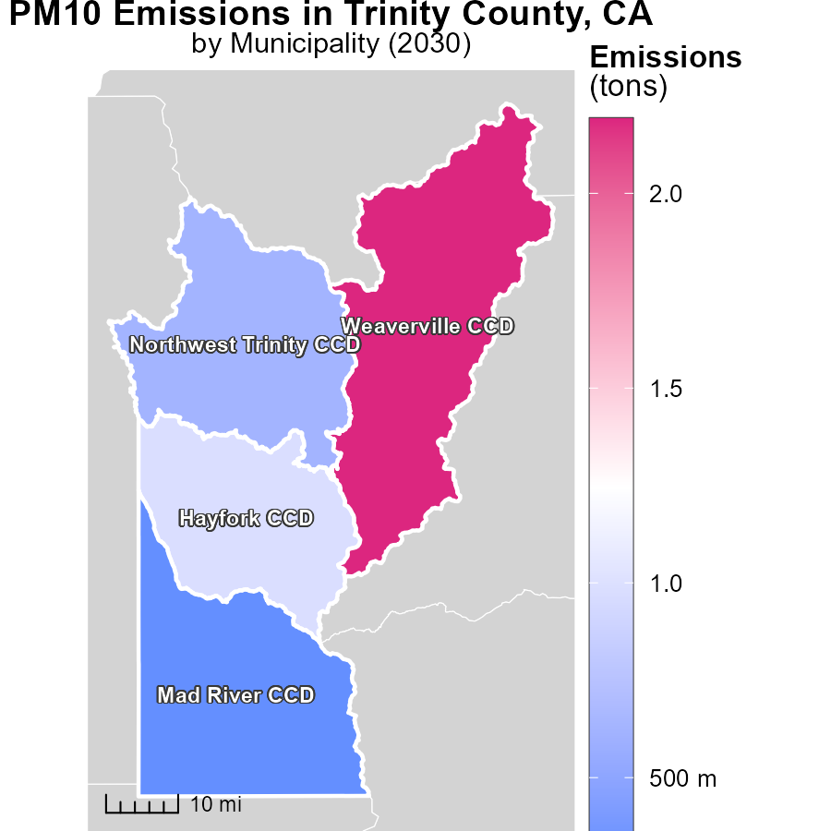

## Findings

* The maximum emissions in 2030 for Weaverville CCD, CA are 2.2 tons.
* The median emissions in 2030 for Hayfork CCD, CA are 982.1 tons.
* The minimum emissions in 2030 for Mad River CCD, CA are 301.4 tons.

## Recommendations

To lower emissions, focus on reducing emissions in Weaverville CCD, which has the lowest emissions; implement measures to decrease emissions in Hayfork CCD to move closer to the minimum emission levels seen in Mad River CCD.

# Time Driven Mapped by Area

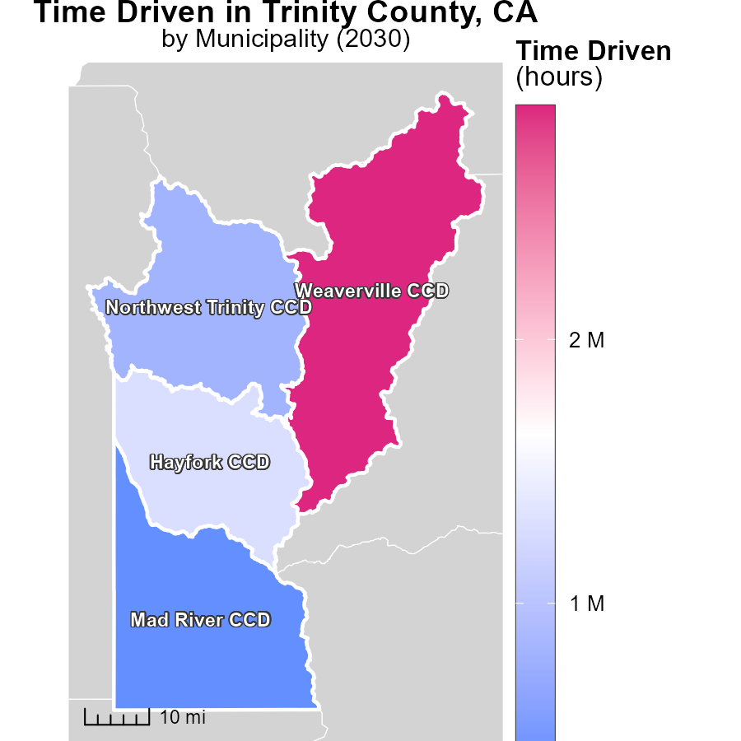

## Findings

* Weaverville CCD, CA has the highest maximum hourly emissions at 2.9 million units.
* Hayfork CCD, CA shows median emissions of 1.3 million units per hour.
* Mad River CCD, CA has the lowest hourly emissions with 396.9 thousand units.

## Recommendations

To lower emissions, focus on reducing activities that contribute to high emissions in Weaverville CCD, while implementing measures to decrease emissions in Hayfork and Mad River CCDs below current levels.

# Emissions Rate (per vehicle) by Regulatory Class over Time

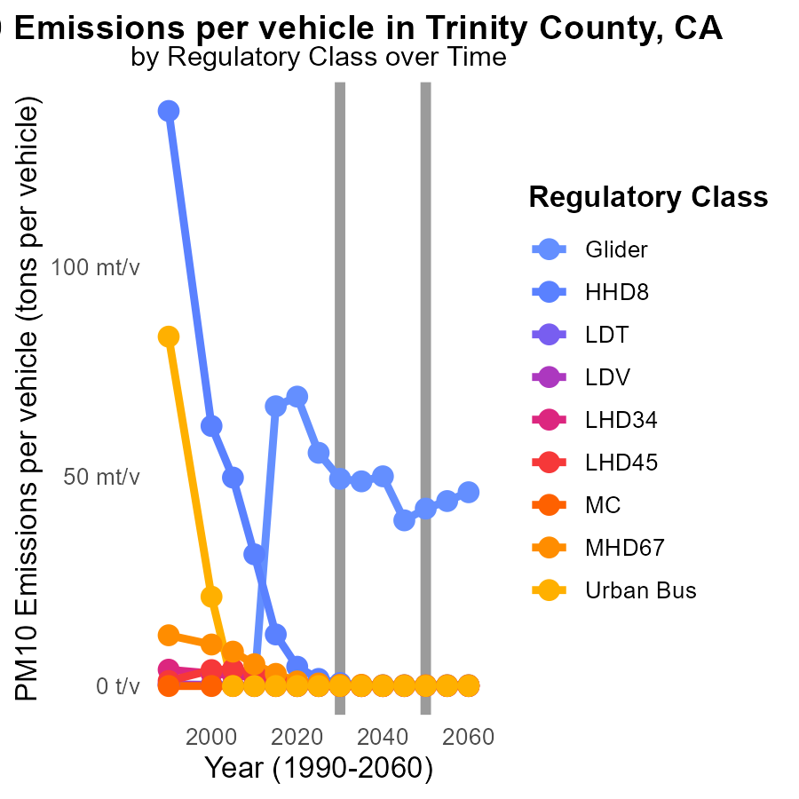

## Findings

* PM10 emissions for Glider vehicles decrease by 26.70% from 2020 to 2040.
* HHD8 vehicles reduce PM10 emissions by 0.44 tons per vehicle from 2020 to 2040.
* LDV emissions remain stable at around 11.7 µ tons per vehicle for the period 2035-2040.

## Recommendations

To further decrease PM10 emissions, strategies could focus on enhancing the efficiency of Glider vehicles, incentivizing the replacement of older HHD8 vehicles, and promoting the stabilization of LDV emissions at the achieved levels.

# Vehicles by Area over Time

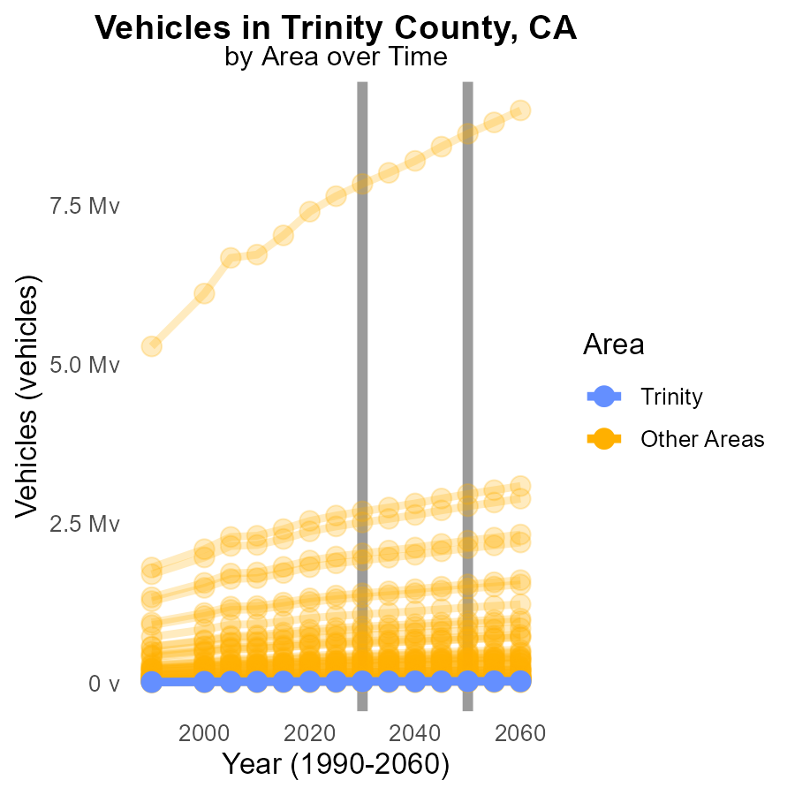

## Findings

* In 2030, the minimum PM10 emissions from vehicles in min_county were 8.1k, showing a decrease of 692.1 from the 2050 target.
* On the other hand, max_county emitted 7.8M PM10, which is 787.26k higher than the 2050 target.
* Target_county had 22.7k PM10 emissions in 2030, exceeding the 2050 target by 1949.1.

## Recommendations

To reduce PM10 emissions from vehicles, implement stricter vehicle emission standards, promote electric vehicles, and enhance public transport infrastructure. Establish comprehensive monitoring systems.

# Areas Ranked by Hotelling (Engines Off)

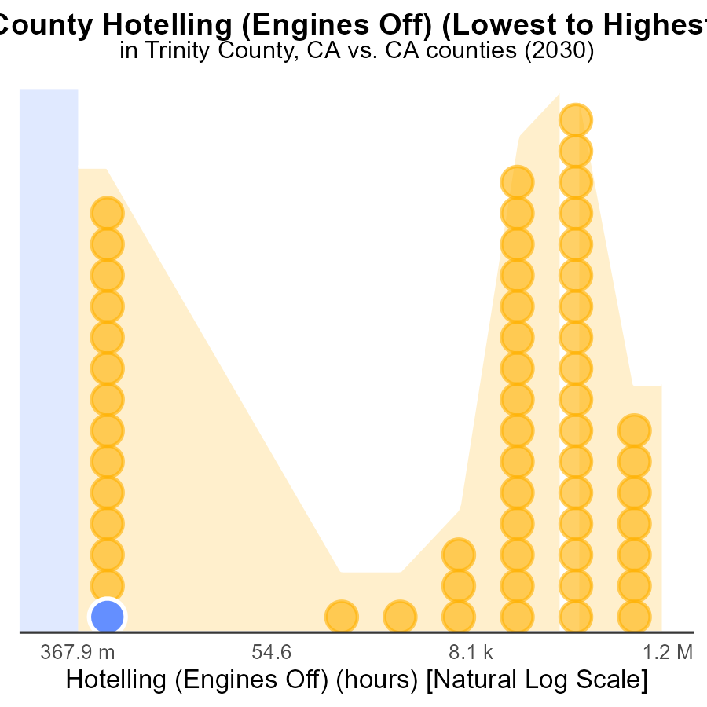

## Findings

* Trinity County has the lowest PM10 emissions from idling hotelling engines.
* Los Angeles County ranks 58th out of all counties for PM10 emissions from idling hotelling engines.
* Overall, Los Angeles County contributes to 100% of the PM10 emissions from idling hotelling engines.

## Recommendations

To lower PM10 emissions from idling hotelling engines, implement stricter regulations and incentives for alternative transportation modes in Los Angeles County specifically to effectively reduce emissions.

# Areas Ranked by Vehicle Starts

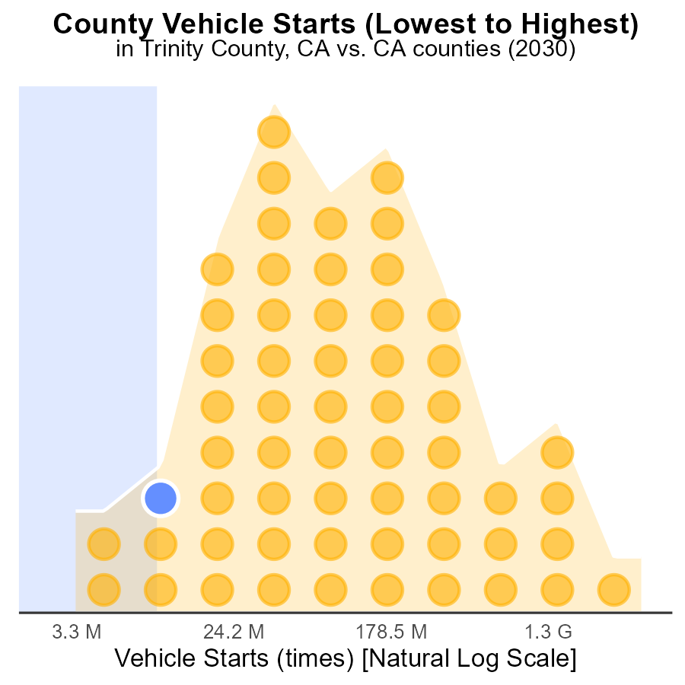

## Findings

* Los Angeles has the highest number of vehicle starts with 11.9 billion, ranking 58th nationally.
* Plumas County ranks 6th nationally with 37.9 million vehicle starts, representing 10.3% of total emissions.
* Alpine County has the lowest emissions, ranking 1st with 8.8 million vehicle starts, contributing 1.7% to the total emissions.

## Recommendations

To lower emissions, focus on reducing vehicle starts in counties with the highest percentile, such as Los Angeles. Implement public transportation improvements and carpooling incentives.

# Conclusion

In conclusion, the data from the report on Primary Exhaust PM10 - Total emissions from on-road transportation in Trinity County, CA in 2030 shows a clear breakdown of sources and areas contributing to PM10 emissions. The focus for emission reduction should target Glider and HHD8 vehicles, as they are the top sources of emissions, while implementing stricter regulations and promoting cleaner technology. It is also crucial to address emissions in Rural Unrestricted areas, which currently contribute 100% of PM10 emissions per capita. Efforts to minimize idling, invest in sustainable transportation methods, and promote renewable energy sources will be vital to continue the positive trend of reducing emissions seen over the years. Additionally, concentrating on reducing emissions in specific CCDs with higher emission levels, like Weaverville, Hayfork, and Mad River, can further aid in achieving lower overall emissions for Trinity County.

# About This Report

Data based on MOVES estimates collected by the Climate Action in Transportation program at Cornell University. Demographic data sourced from the US Census's American Community Survey 5-year estimates. This report was generated with the help of AI.

# References

* U.S. Census Bureau. (2023). American Community Survey 5-year estimates: Detailed tables. Retrieved from https://data.census.gov
* U.S. Environmental Protection Agency. (2024). Motor Vehicle Emission Simulator (MOVES 4.0) [Software]. Retrieved from https://www.epa.gov/moves