 

**NOx Emissions in Dakota County, 2055**  
Made with CAT VISUALIZER by Gao Labs @ Cornell University.

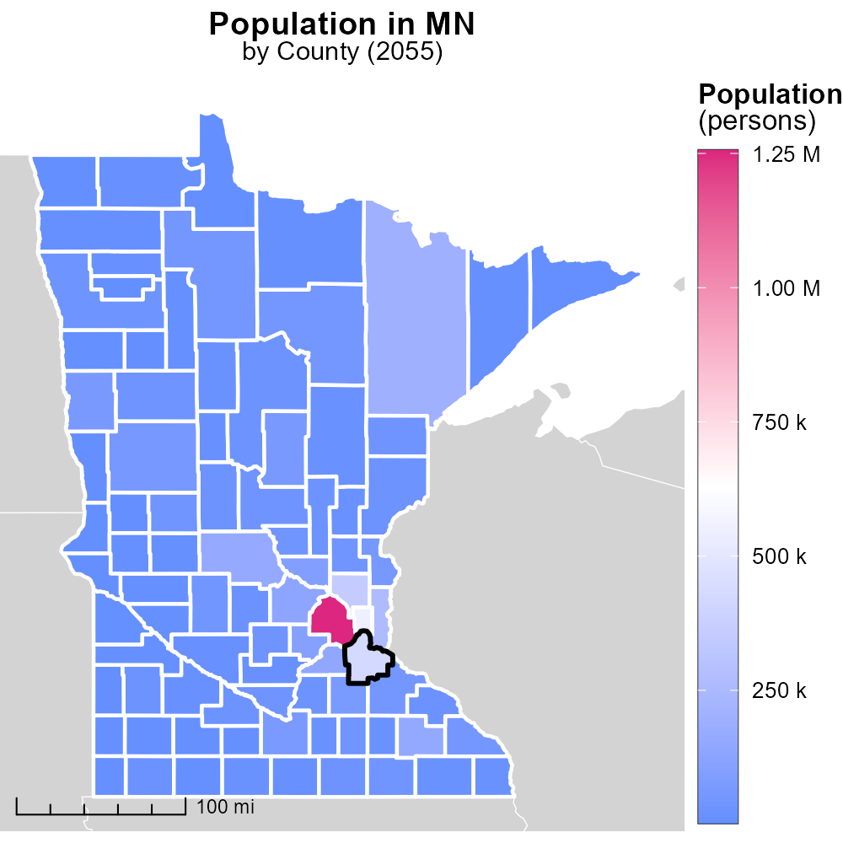

## Keywords

Oxides of Nitrogen; NOx emissions; on-road transportation; Dakota County; MN; 2055

## Highlights

* NOx emissions from on-road transportation in Dakota County in 2055 are a crucial environmental concern.
* The impact of NOx emissions on air quality and public health is a significant issue.
* Understanding the sources and effects of NOx emissions is essential for effective mitigation strategies.
* This report aims to analyze the trends, causes, and potential solutions for NOx emissions in the transportation sector.
* The findings will provide valuable insights for policy-makers and stakeholders in Dakota County.

# Introduction

In 2055, the levels of Oxides of Nitrogen (NOx) emissions from on-road transportation in Dakota County, MN have become a pressing issue. NOx emissions contribute significantly to air pollution, smog formation, and adverse health effects, making it a paramount concern for environmental and public health professionals. This report will delve into the sources, trends, and impacts of NOx emissions in the transportation sector within Dakota County.

By evaluating the current state of NOx emissions in on-road transportation, this report aims to provide recommendations for reducing these harmful pollutants and enhancing air quality. The ultimate goal is to explore sustainable solutions and policy measures that can effectively curb NOx emissions in Dakota County for a cleaner and healthier future.

# Vehicle Starts by Road Type

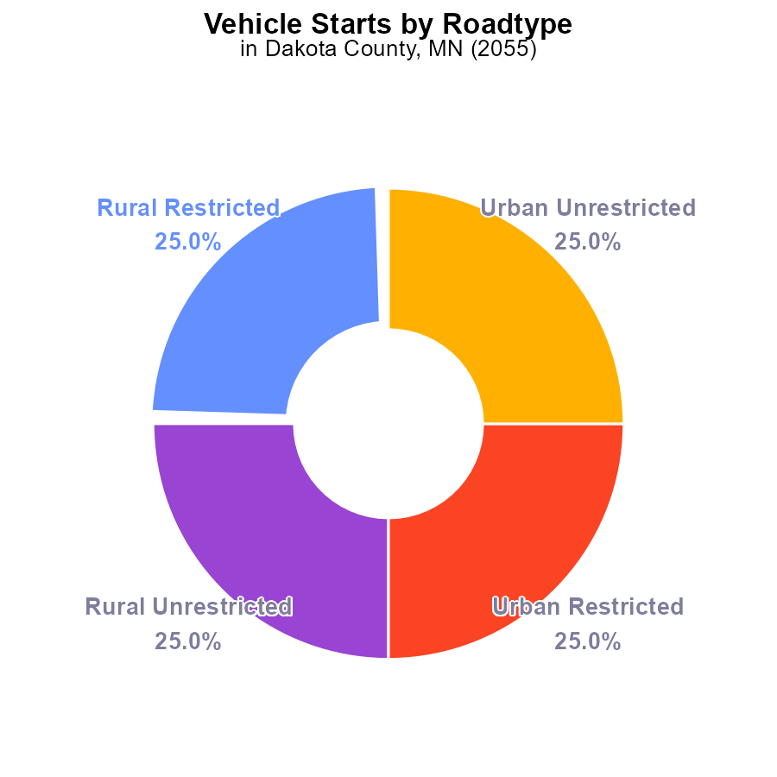

## Findings

* NOx emissions in Dakota County, MN in 2055 are coming from vehicle starts.
* Rural Restricted, Rural Unrestricted, Urban Restricted, and Urban Unrestricted areas all contribute equally to NOx emissions at 25% each.

## Recommendations

To lower NOx emissions, focus on reducing vehicle start frequency through promoting carpooling, expanding public transportation, and incentivizing the use of electric vehicles in all areas of Dakota County, MN.

# Population by Fuel Type

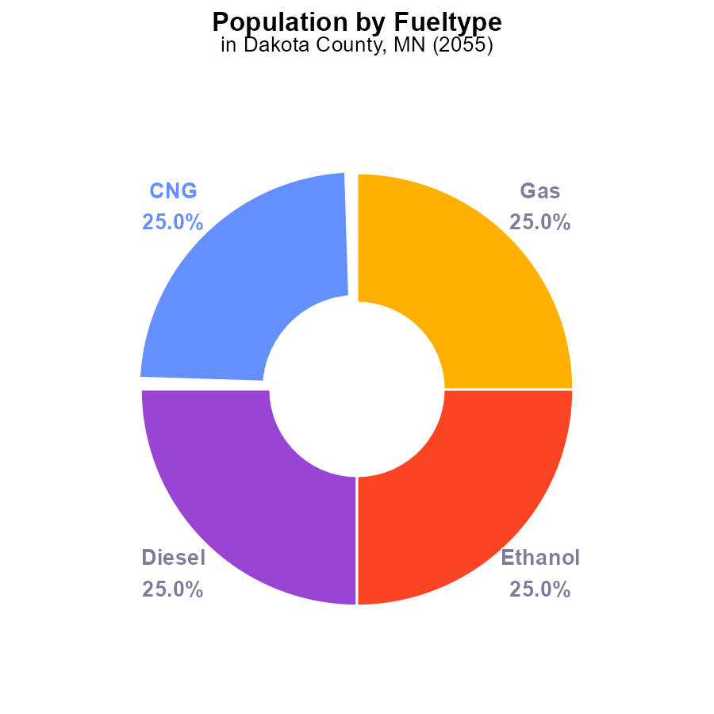

# Vehicle Miles Traveled Overall over Time

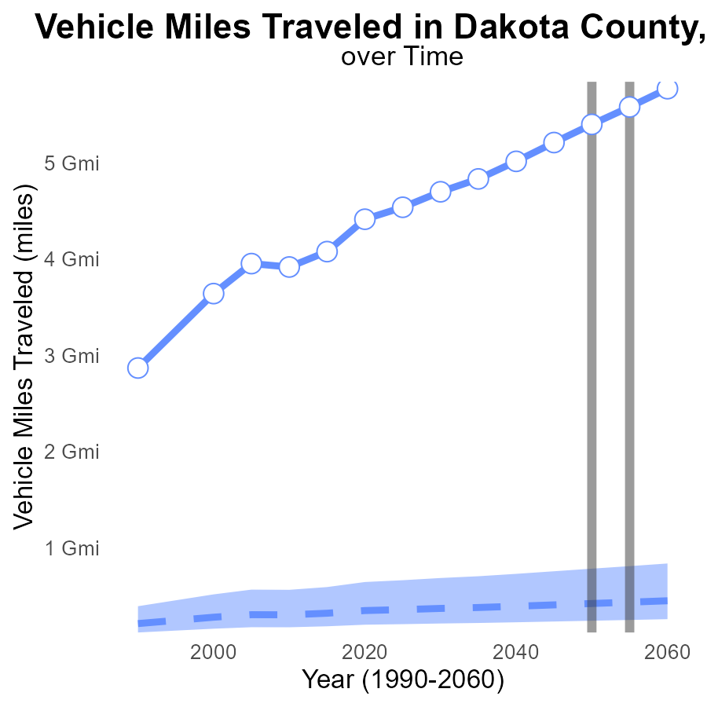

## Findings

* NOx emissions in Dakota County are consistently above the median area levels, increasing from 4.8 G in 2035 to 5.8 G in 2060.
* Regarding vehicle miles traveled, Dakota County trends show a continuous increase from 377,778,744 miles in 2035 to 447,790,830 miles in 2060.
* Benchmark differences highlight a widening gap in NOx emissions compared to upper 75th percentile areas and a significant deviation from the lower 25th percentile areas by 2060.

## Recommendations

To lower NOx emissions in Dakota County, policymakers should focus on reducing vehicle miles traveled by promoting public transportation, biking, and walking infrastructure. Implement stricter emissions standards for vehicles and incentivize electric vehicle usage.

# Emissions Rate (per vehicle) Overall over Time

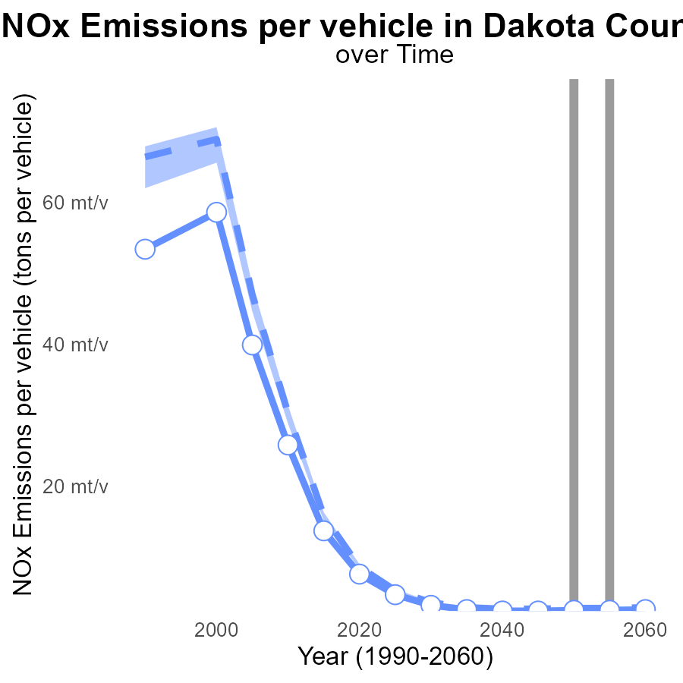

## Findings

* NOx emissions per vehicle decreased by 326.4 µ tons from the median in 2035.
* By 2060, this difference narrowed to 276.0 µ tons.
* Benchmark difference remained stable around 0.0001 tons below the median during 2035-2060.

## Recommendations

To reduce NOx emissions further, incentivize vehicle upgrades for cleaner models. Implement stricter emission standards for vehicles to align with the benchmark values observed.

# Hotelling (Engines Off) Mapped by Area

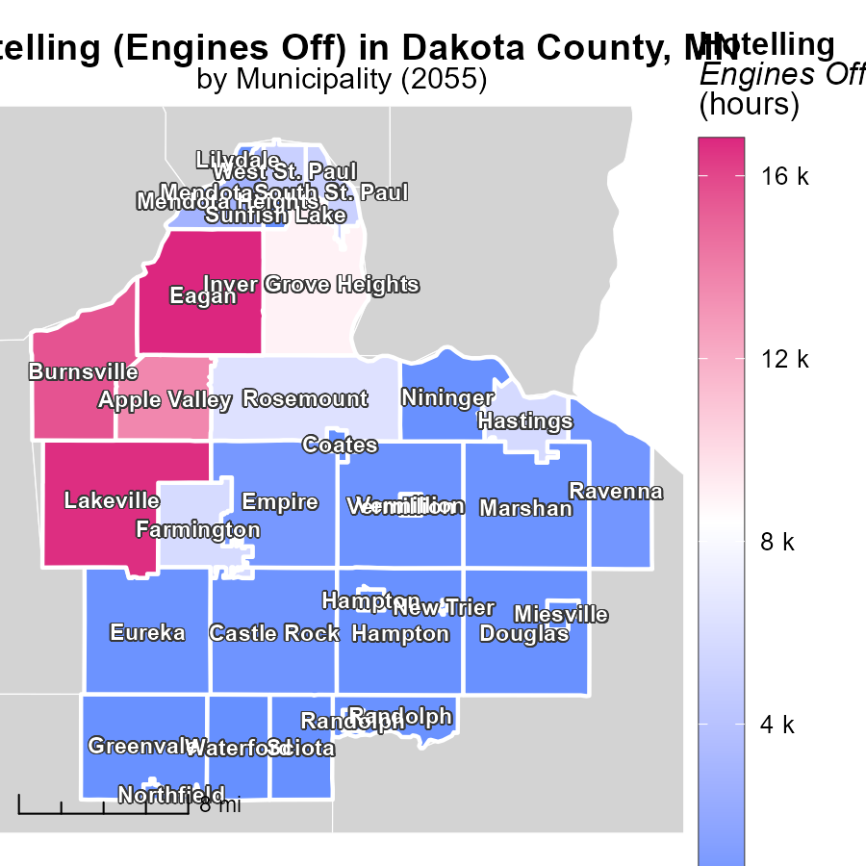

## Findings

* The maximum hotelling emissions in Eagan, MN were 16.8 k hours.
* Northfield, MN had median emissions of 240.6 hours.
* The minimum hotelling emissions occurred in New Trier, MN at 21.3 hours.

## Recommendations

To lower emissions, consider implementing policies to reduce engine idling and encourage the use of alternative transportation methods. Encourage the adoption of electric vehicles and promote carpooling among residents in high-emission areas.

# Population in My Region

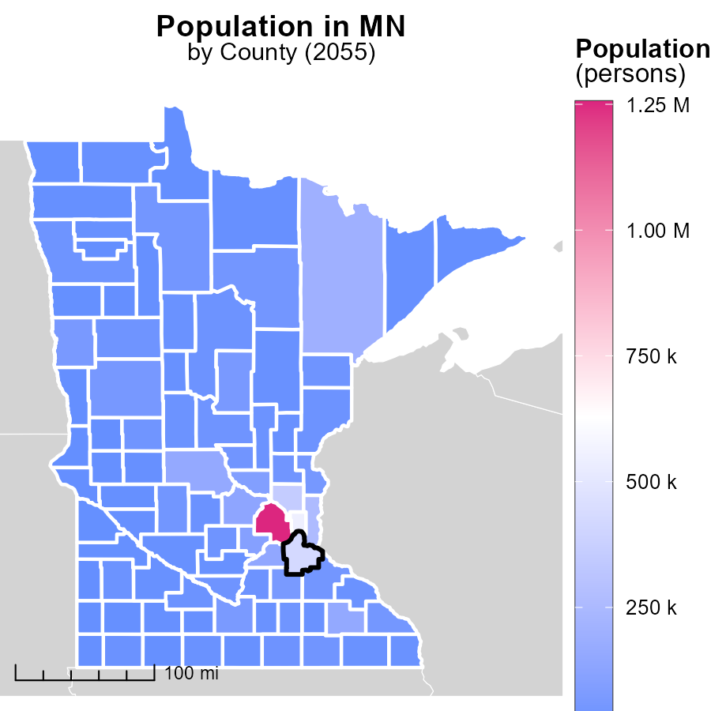

## Findings

* Hennepin County, MN has the highest population with 1.3 million persons.
* Nobles County, MN has a median population of 21.7 thousand persons.
* Traverse County, MN has the lowest population with 3.3 thousand persons.

## Recommendations

To lower emissions, focus on areas with higher populations, like Hennepin County, by implementing public transportation systems. Encourage sustainable practices in medium-sized populations like Nobles County, while supporting Traverse County with community-based renewable energy projects.

# Vehicles by Vehicle Type over Time

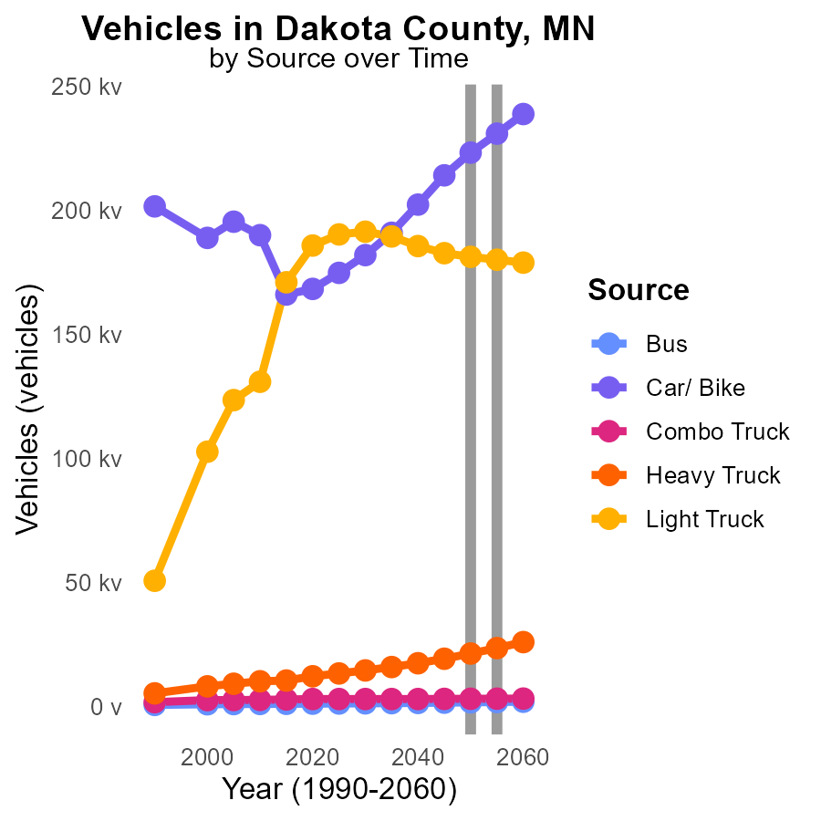

## Findings

* From 2050 to 2060, Bus NOx emissions are projected to decrease by 15.3%.
* Car/ Bike emissions are expected to decrease by 6.95% from 2050 to 2060.
* Heavy Truck emissions are forecasted to decrease by 21.5% between 2050 and 2060.

## Recommendations

Encourage the adoption of cleaner fuel technologies in buses, cars, and trucks. Implement stricter emission standards to accelerate the reduction further.

# Emissions Rate (per mile) by Vehicle Type over Time

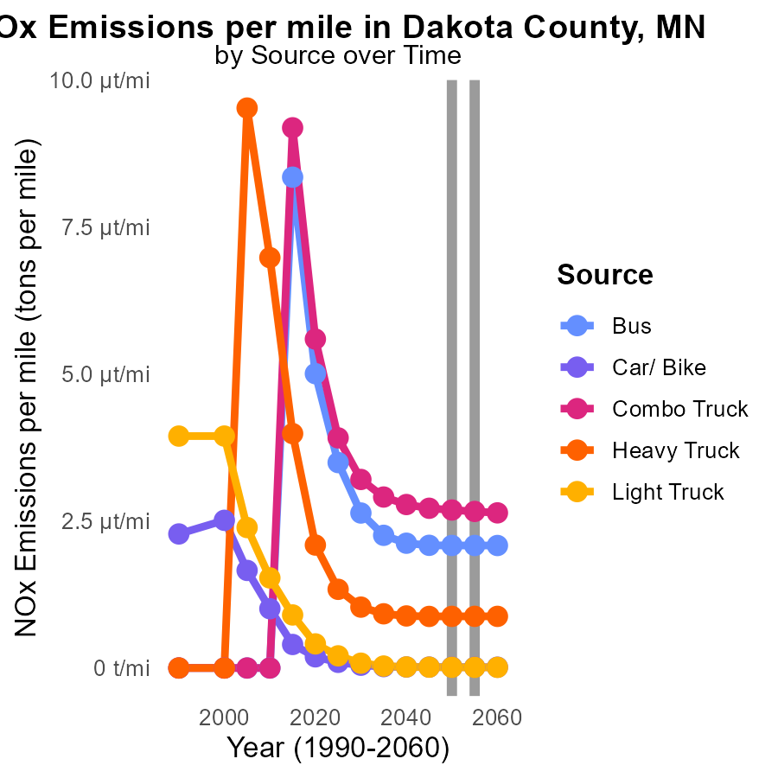

## Findings

* NOx emissions for buses remain constant at 2.1 µ per mile from 2045 to 2060.
* Car/Bike NOx emissions decrease from 15.5 n per mile in 2045 to 13.7 n per mile in 2060.
* Heavy truck emissions stay stable around 878 n per mile from 2045 to 2060.

## Recommendations

To reduce NOx emissions, focus on enhancing public transportation infrastructure to increase bus ridership. Encourage the use of electric vehicles. Implement stricter emission standards for heavy trucks.

# Areas Ranked by Hotelling (Engines Off)

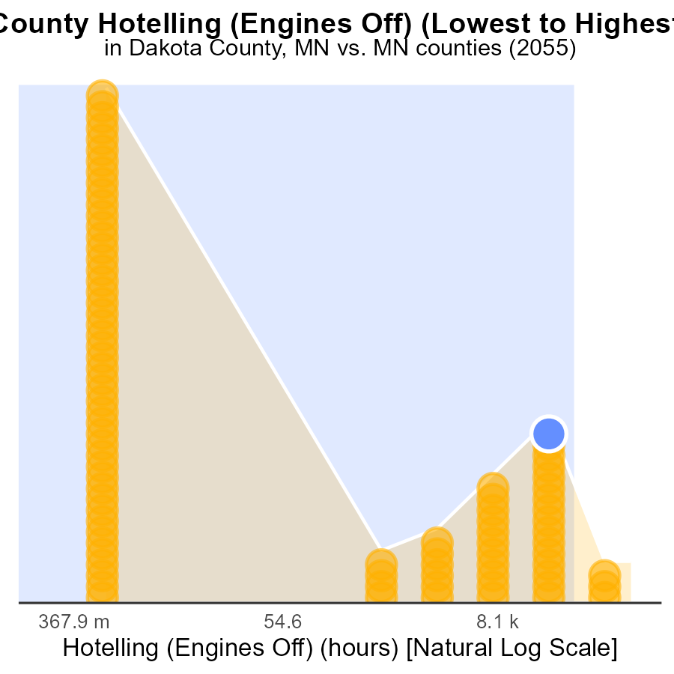

## Findings

* Hennepin county has the highest NOx emissions with 534.6k hours.
* Aitkin county has the lowest NOx emissions with 0.0 hours.
* Stearns county ranks highest at 85th percentile for NOx emissions.

## Recommendations

To lower NOx emissions, focus efforts on reducing engine idling in counties with high emission levels such as Hennepin, Stearns, and Dakota. Implement strict idling policies for vehicles to minimize emissions.

# Areas Ranked by Emissions Rate (per mile)

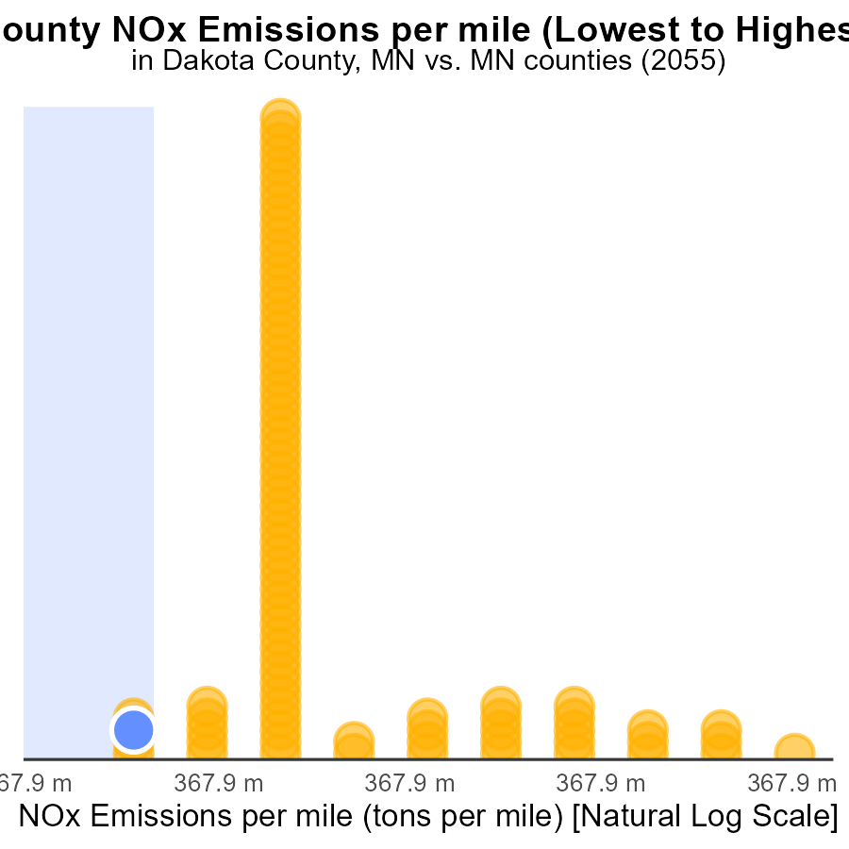

## Findings

* Pine county has the highest NOx emissions per mile at 306.2 tons.
* Hennepin county has the lowest NOx emissions per mile at 190.9 tons.
* Dakota and Washington counties have relatively similar NOx emissions per mile at around 200 tons.

## Recommendations

To lower NOx emissions, focus on reducing vehicle miles traveled in Pine county, improve transportation efficiency in Hennepin county, and implement stricter emission controls in Dakota and Washington counties.

# About This Report

Data based on MOVES estimates collected by the Climate Action in Transportation program at Cornell University. Demographic data sourced from the US Census's American Community Survey 5-year estimates. This report was generated with the help of AI.

# References

* U.S. Census Bureau. (2023). American Community Survey 5-year estimates: Detailed tables. Retrieved from https://data.census.gov
* U.S. Environmental Protection Agency. (2024). Motor Vehicle Emission Simulator (MOVES 4.0) [Software]. Retrieved from https://www.epa.gov/moves