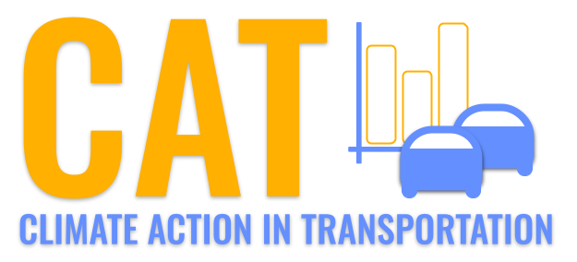 

**SO2 Emissions in De Baca County, 2025**  
Made with CAT VISUALIZER by Gao Labs @ Cornell University.

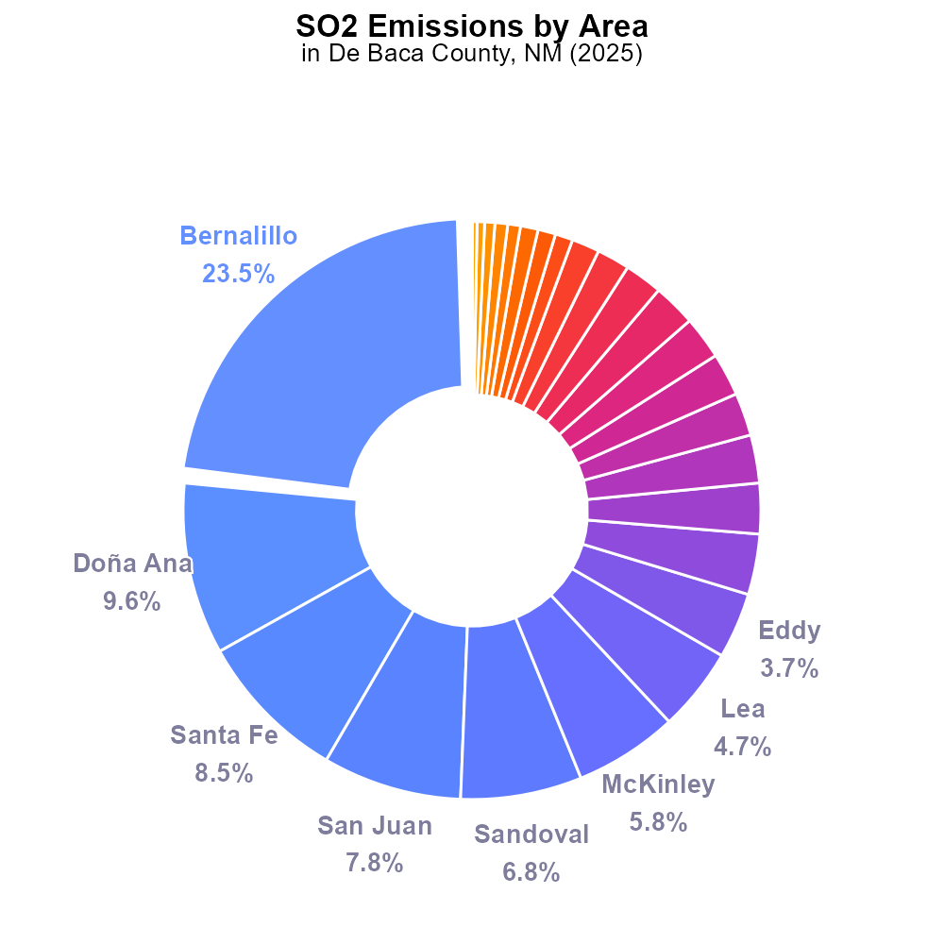

## Keywords

Sulfur Dioxides emissions; on-road transportation; De Baca County; NM; 2025

## Highlights

* Sulfur Dioxides emissions from on-road transportation in De Baca County.
* Impact assessment of SO2 emissions in De Baca County, NM, 2025.
* Analyzing the trends of on-road transportation emissions in a specific region.

# Introduction

In 2025, the levels of Sulfur Dioxides (SO2) emissions from on-road transportation in De Baca County, New Mexico, have become a growing concern due to their potential impact on air quality and public health.

This report aims to analyze the trends, sources, and implications of SO2 emissions from on-road transportation in De Baca County, providing valuable insights to policymakers and stakeholders for effective mitigation strategies.

# Emissions Overall by Area

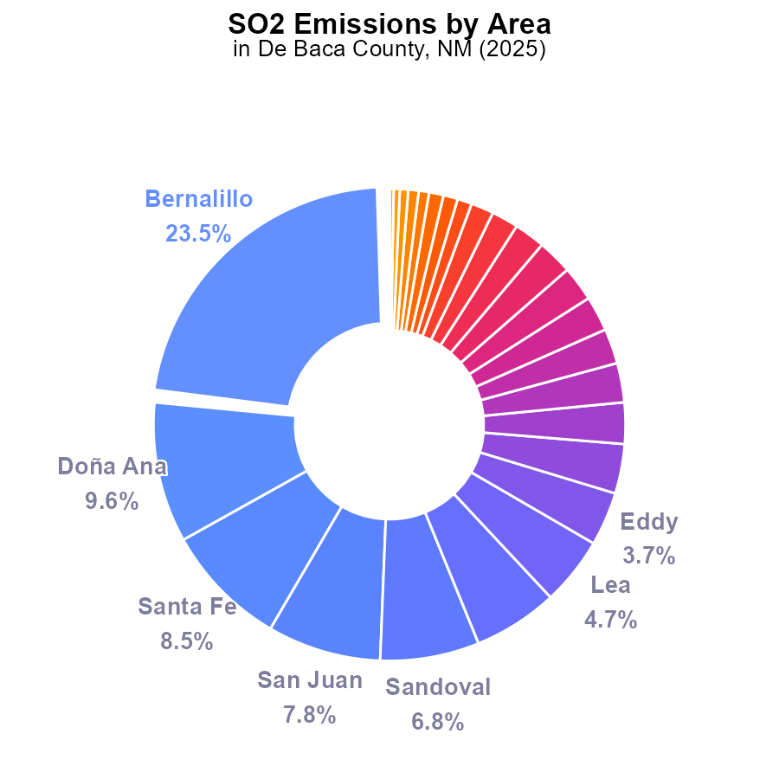

## Findings

* The highest SO2 emission in De Baca County, NM in 2025 is from Bernalillo with 16.6 tons (23.5%).
* The lowest SO2 emissions come from Catron, Harding, and De Baca at 0.0-300.0 tons, each contributing less than 1%.
* The top five contributing Counties make up more than half of the total SO2 emissions in De Baca County.

## Recommendations

To lower SO2 emissions, focus on implementing stricter emission controls in high-emitting Counties like Bernalillo. Consider promoting cleaner energy sources and incentivizing industries to adopt cleaner technologies to reduce overall emissions.

# Emissions Rate (per vehicle) by Road Type

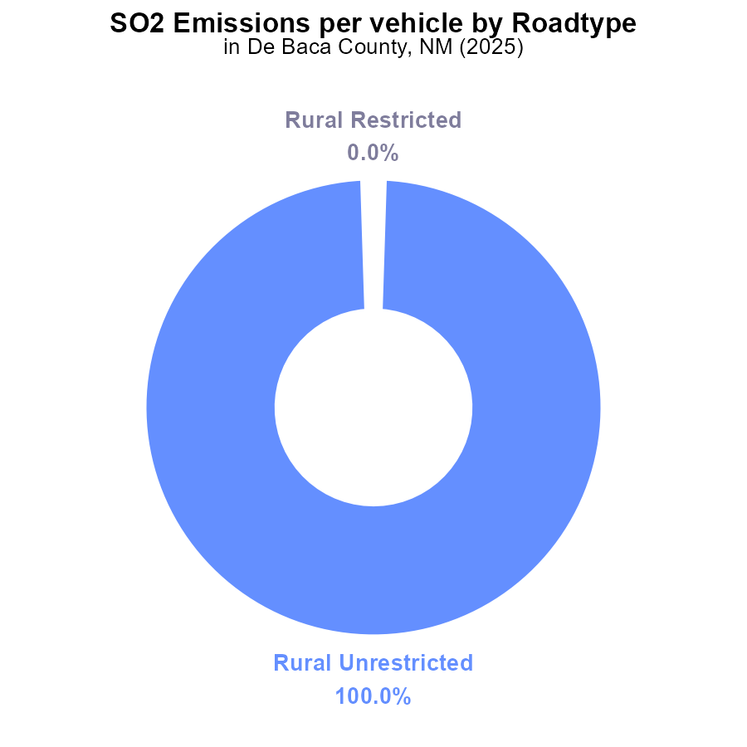

## Findings

* Emissions of SO2 in De Baca County, NM in 2025 are 32.4 tons per vehicle for Rural Unrestricted vehicles.
* Rural Restricted, Urban Restricted, and Urban Unrestricted vehicles in De Baca County, NM did not emit any SO2 in 2025.

## Recommendations

To lower SO2 emissions in De Baca County, NM, focus on reducing emissions from Rural Unrestricted vehicles by implementing stricter emission standards and promoting the use of cleaner fuels.

# Emissions Rate (per vehicle) Overall over Time

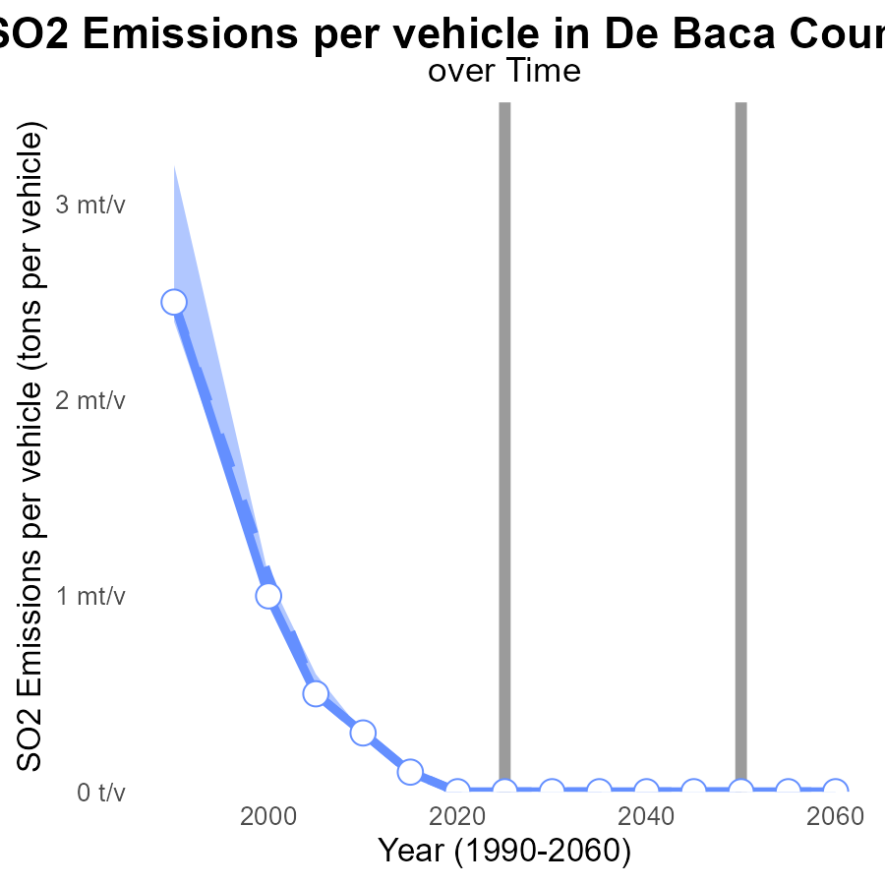

## Findings

* De Baca County's SO2 emissions per vehicle decreased by about 471.9 tons per vehicle from 2005 to 2045.
* The emissions were consistently below the upper 75th percentile and median areas' emissions over the years.
* In 2015, there was a notable deviation with emissions higher by 122.3 nanotons compared to the median area.

## Recommendations

To further reduce emissions, De Baca County should invest in promoting cleaner vehicle technologies, stricter vehicle emission standards enforcement, and public transportation incentives.

# Vehicle Miles Traveled over Time for Buses

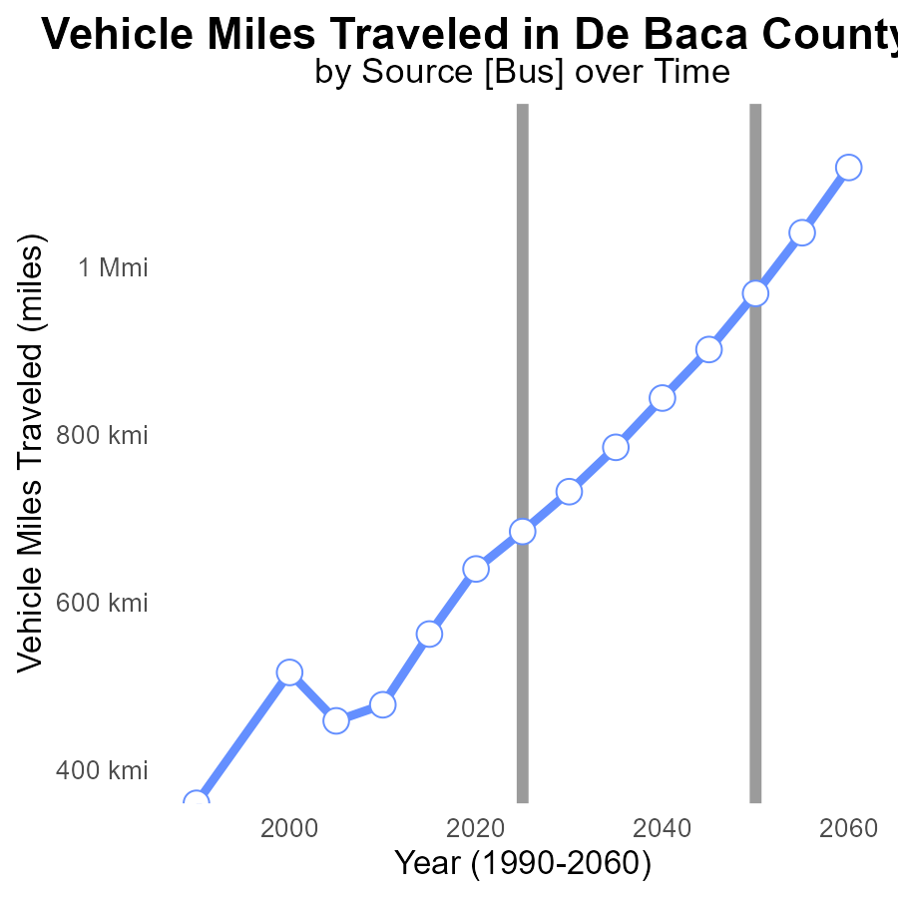

## Findings

* De Baca County, NM had an increasing trend in SO2 emissions from 2005 to 2045.
* Vehicle miles traveled decreased by 19.3% from 2005 to 2045 in De Baca County, NM.
* There was a significant deviation from the benchmark SO2 emissions levels over time, indicating the need for mitigation strategies.

## Recommendations

To lower emissions, invest in public transportation to reduce vehicle miles traveled. Implement clean energy initiatives to decarbonize the transport sector. Enforce stricter emission standards for vehicles in the county.

# Hotelling (Engines Off) in My Region

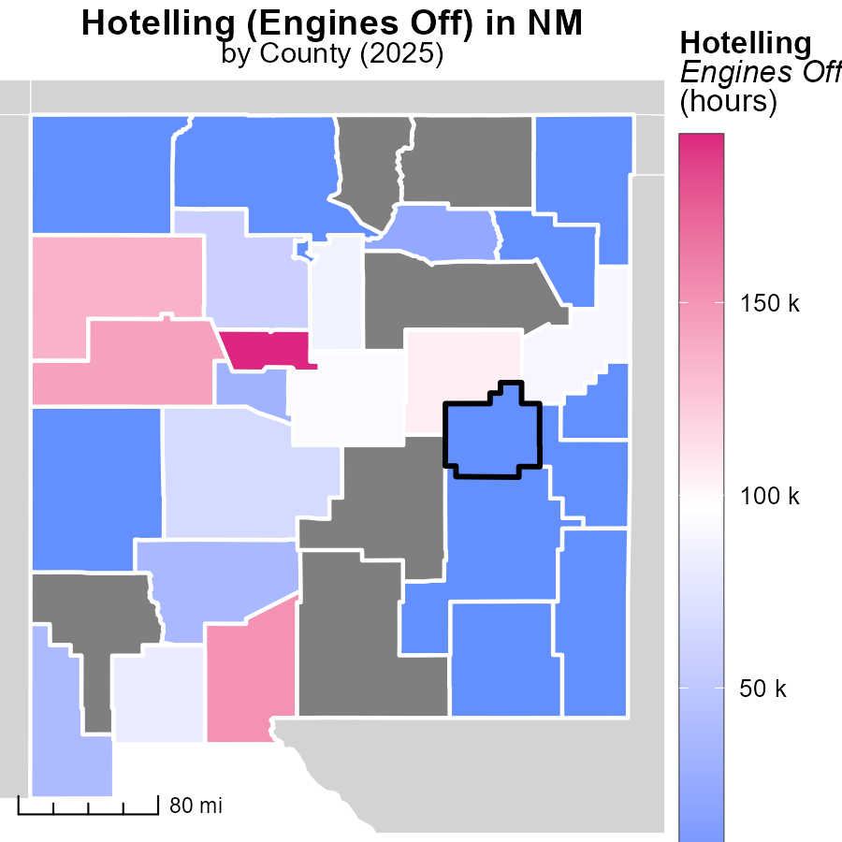

## Findings

* Bernalillo County, NM has the highest emissions with 193.5k hours
* Valencia County, NM has median emissions with 31.9k hours
* Union County, NM has the lowest emissions with 0.0 hours

## Recommendations

To lower emissions, focus on reducing engine idling in Bernalillo County, consider implementing idle reduction programs in Valencia County, and ensure continued effort to maintain low emissions in Union County.

# Vehicle Miles Traveled Mapped by Area

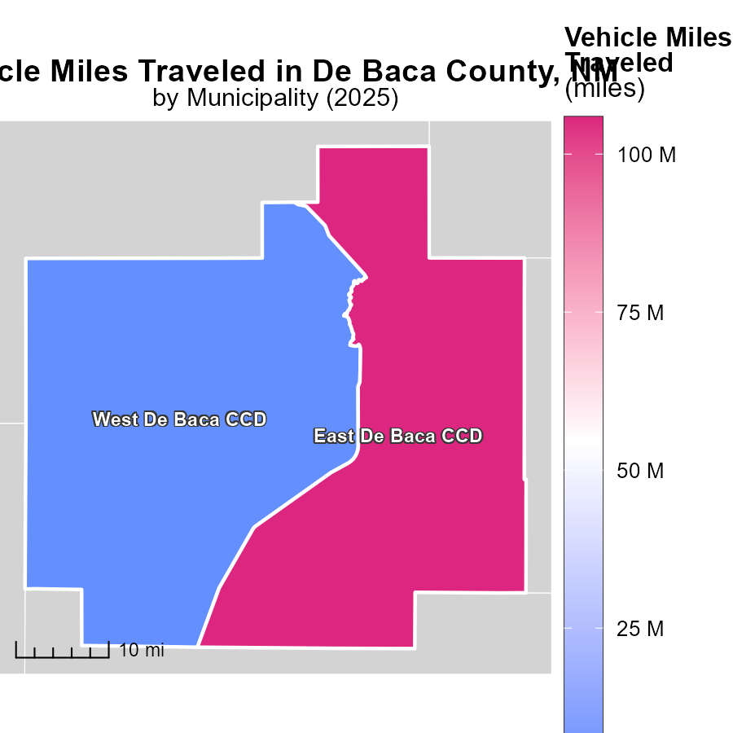

## Findings

* The maximum vehicle miles traveled in East De Baca CCD, NM in 2025 was 105.8 million miles.
* The median vehicle miles traveled in West De Baca CCD, NM in 2025 was 3.1 million miles.

## Recommendations

To lower emissions resulting from vehicle miles traveled, policymakers could consider promoting carpooling, expanding public transportation options, and encouraging the use of electric vehicles, especially in areas with high mileage rates like East De Baca CCD, NM.

# Emissions Rate (per capita) by Area over Time

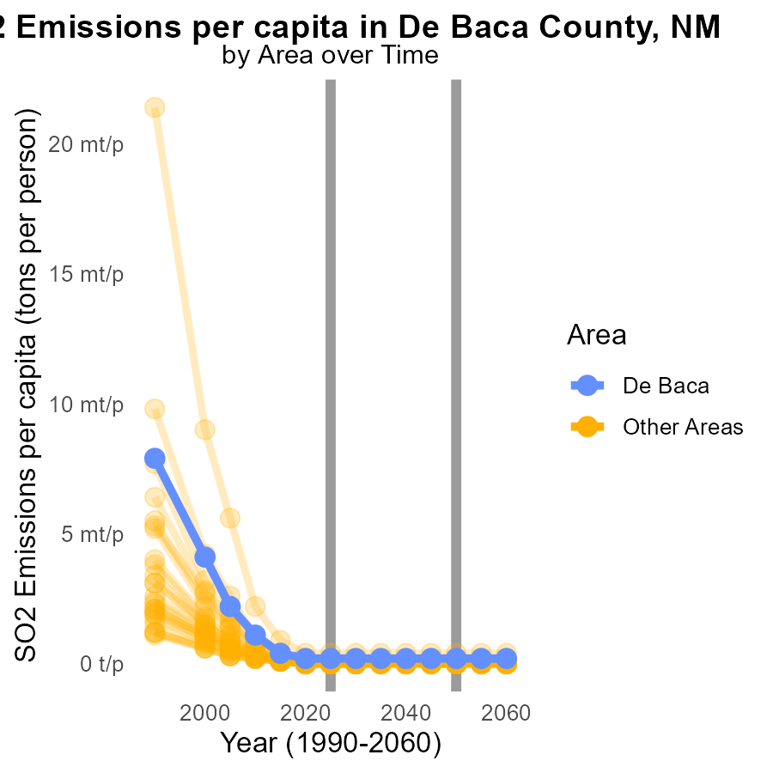

## Findings

* The highest SO2 emission per capita in 2025 is 392.1 tons in max_county.
* The average SO2 emission per capita in 2025 for min_county is 31.6 tons.
* The target_county had an SO2 emission per capita of 150.4 tons in 2025.

## Recommendations

To lower SO2 emissions, focus on reducing emissions in max_county to approach levels seen in min_county. Implement stricter emissions control measures in target_county to decrease per capita emissions.

# Emissions Rate (per vehicle) by Regulatory Class over Time

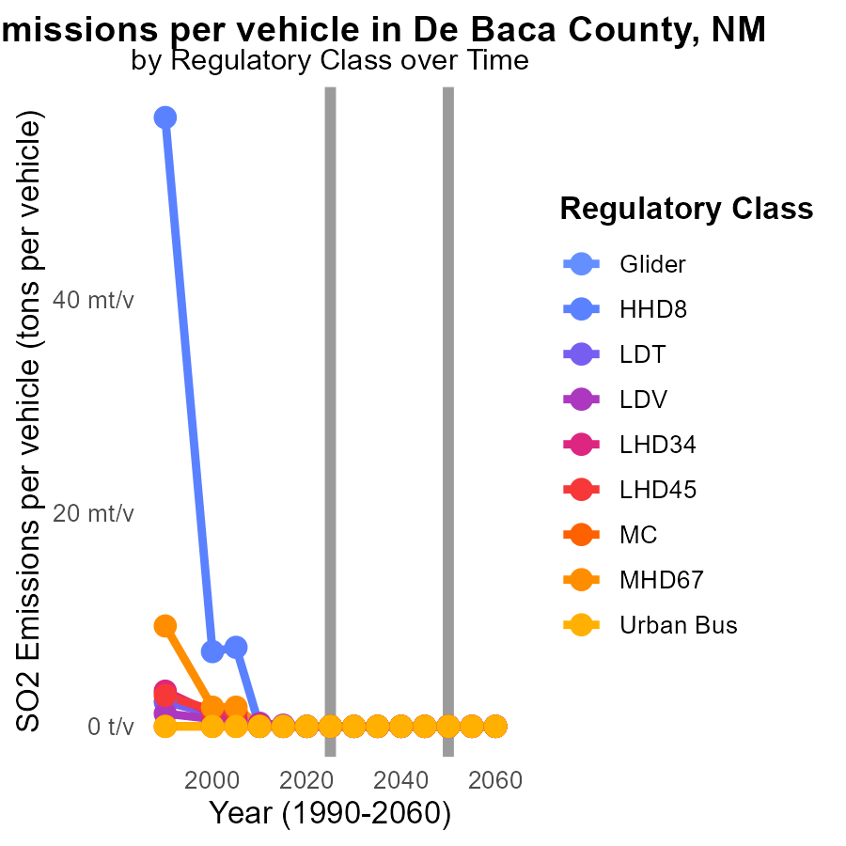

## Findings

* Significant decrease in SO2 emissions per vehicle for LDT and LDV classes from 2015 to 2035.
* Consistent zero emissions for all vehicle classes over the 2015-2035 period.
* No noticeable difference in emissions for other vehicle classes over the specified years.

## Recommendations

Given the consistent zero emissions for all vehicle classes in De Baca County, focus on sustaining and incentivizing the use of cleaner technologies and alternative fuels to maintain emissions at negligible levels.

# Areas Ranked by Hotelling (Diesel Aux)

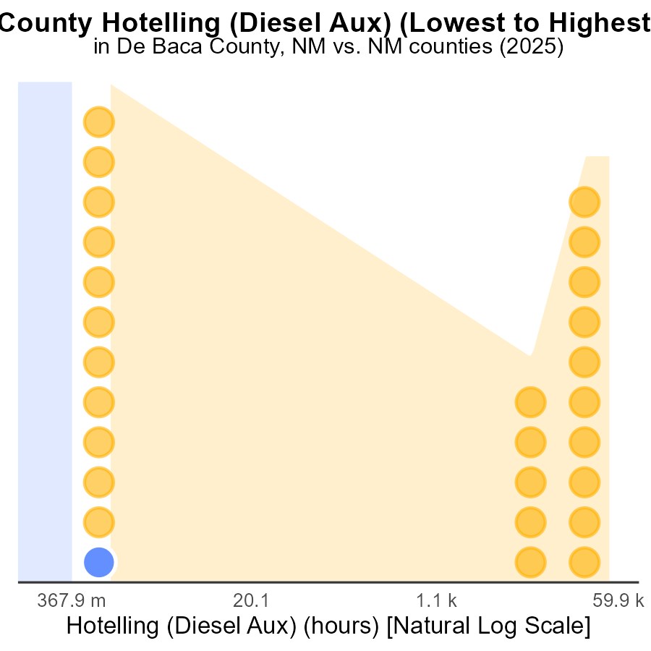

## Findings

* De Baca county has no emissions of SO2 from Hotelling (Diesel Aux) in 2025.
* Catron county ranks 2nd in emissions of SO2 from Hotelling (Diesel Aux) in 2025.
* Bernalillo county is the top emitter of SO2 from Hotelling (Diesel Aux) in 2025, contributing 100.0% of the emissions.

## Recommendations

To lower SO2 emissions, policymakers could incentivize industries in Bernalillo county to transition to cleaner energy sources. De Baca county's successful emission reduction strategies may offer valuable insights for other regions.

# Areas Ranked by Vehicle Miles Traveled

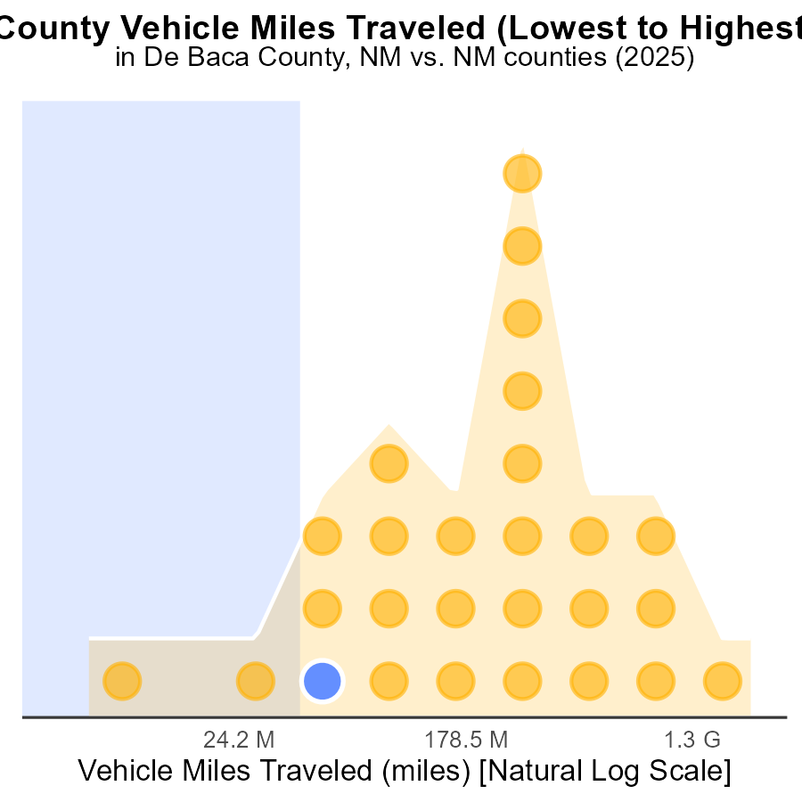

## Findings

* Bernalillo county has the highest vehicle miles traveled (VMT) in 2025, accounting for 100% of emissions.
* Los Alamos county is the fourth in VMT with 166.5 million miles, contributing 14.8% of emissions.
* Harding county ranks first with 17.3 million VMT, representing 3.7% of emissions.

## Recommendations

To decrease emissions, Bernalillo county should focus on promoting public transportation and carpooling to reduce VMT. Los Alamos county could implement stricter vehicle emission standards. Harding county needs to invest in infrastructure to support alternative transportation methods.

# Conclusion

In conclusion, the analysis of SO2 emissions from on-road transportation in De Baca County, NM in 2025 highlights a concerning trend, with some counties showing high levels of emissions while others are successfully keeping them at minimal levels. The data indicates the necessity for targeted interventions to lower emissions in high-contributing areas like Bernalillo, while also implementing strategies to maintain low emissions in counties like Catron, Harding, and De Baca.

Efforts to reduce SO2 emissions should focus on implementing stricter emission controls in high-emitting counties, promoting cleaner energy sources, incentivizing industries to adopt cleaner technologies, and investing in public transportation. Furthermore, the success of De Baca County in maintaining negligible emissions across various vehicle classes underscores the importance of sustaining and incentivizing the use of cleaner technologies. By targeting specific areas and adopting a multi-faceted approach, De Baca County can work towards achieving lower overall SO2 emissions from on-road transportation.

# About This Report

Data based on MOVES estimates collected by the Climate Action in Transportation program at Cornell University. Demographic data sourced from the US Census's American Community Survey 5-year estimates. This report was generated with the help of AI.

# References

* U.S. Census Bureau. (2023). American Community Survey 5-year estimates: Detailed tables. Retrieved from https://data.census.gov
* U.S. Environmental Protection Agency. (2024). Motor Vehicle Emission Simulator (MOVES 4.0) [Software]. Retrieved from https://www.epa.gov/moves