 

**CO Emissions in Ozaukee County, 2000**  
Made with CAT VISUALIZER by Gao Labs @ Cornell University.

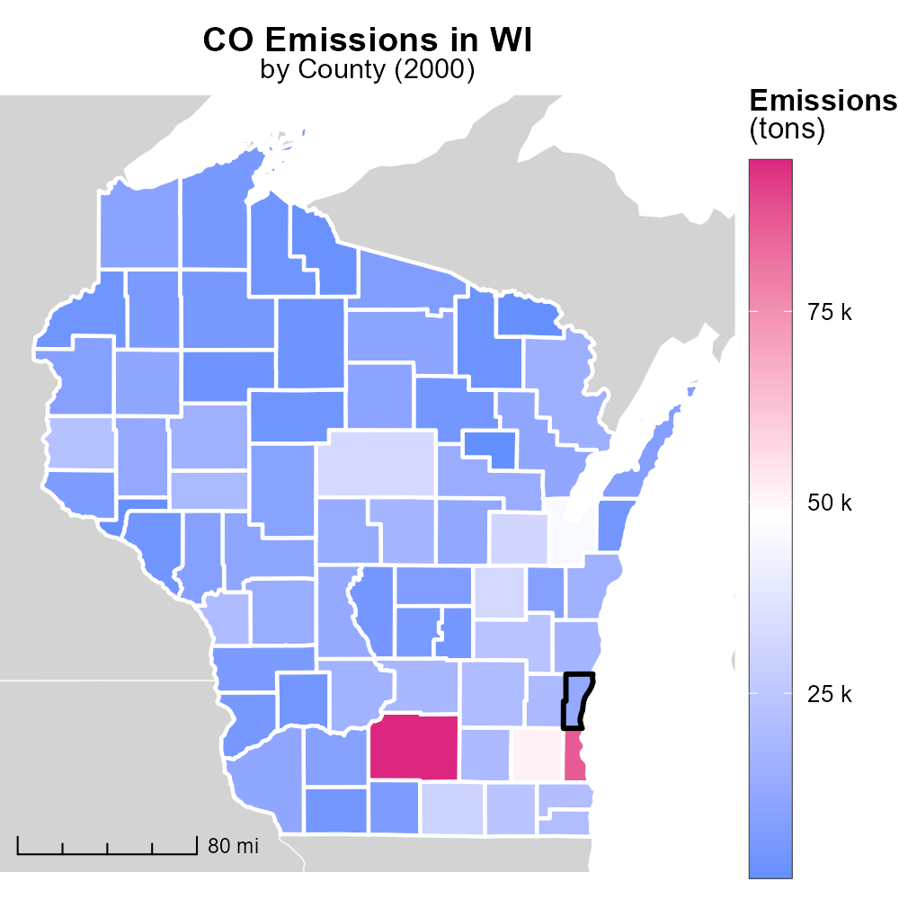

## Keywords

Carbon Monoxide emissions; on-road transportation; Ozaukee County; Wisconsin; 2000; environmental impact

## Highlights

* CO emissions from on-road transportation in Ozaukee County, WI in 2000 analyzed.
* Impact of transportation on air quality assessed through CO levels.
* Findings contribute to understanding environmental challenges in the region.
* Insights can guide future policies for reducing CO emissions.
* Importance of monitoring and addressing transportation-related pollution emphasized.

# Introduction

In 2000, the levels of Carbon Monoxide (CO) emissions from on-road transportation in Ozaukee County, Wisconsin became a growing concern due to their potential environmental impact. This report aims to analyze the extent and implications of CO emissions from vehicles in the region, shedding light on the air quality challenges faced by the residents.

The data collected and analyzed will help in understanding the specific contribution of transportation activities to CO pollution in Ozaukee County. By studying the trends in CO emissions over the course of the year, valuable insights can be gained to inform future policy decisions aimed at reducing emissions and improving air quality for both current and future generations.

# Hotelling (Diesel Aux) by Road Type

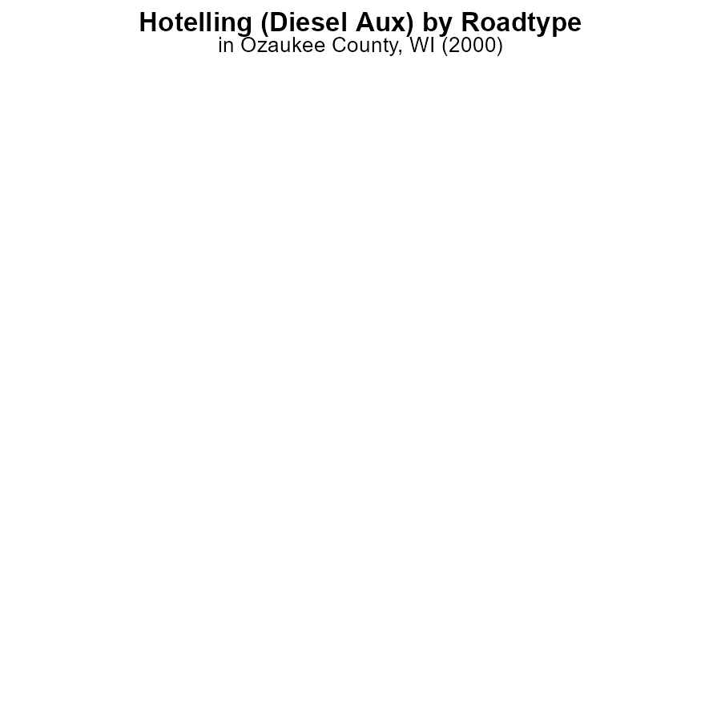

## Findings

* In 2000, CO emissions from Hotelling (Diesel Aux) in Ozaukee County, WI were 0.0 hours for all urban and rural areas.

## Recommendations

To lower emissions, further investigation into the data collection process is needed to ensure accuracy. Consider implementing stricter regulations on diesel auxiliary engines.

# Vehicle Miles Traveled by Regulatory Class

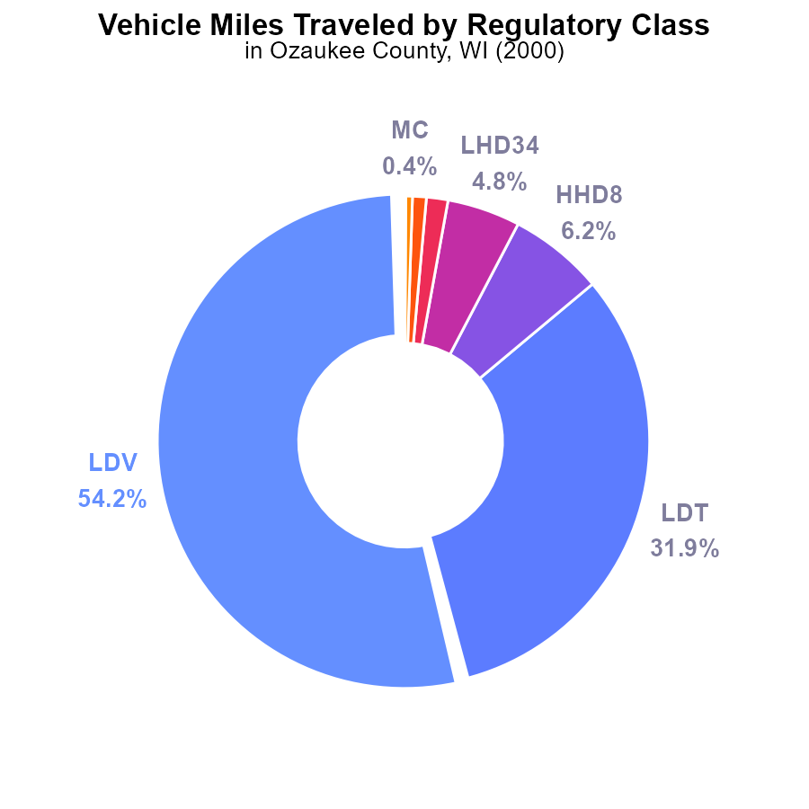

## Findings

* The highest contribution to CO emissions is from LDVs at 54.2% with 510.6 million miles.
* LDTs contribute 31.9% (300.7 million miles) to the CO emissions in Ozaukee County.
* Other vehicle types such as HHD8, LHD34, and MHD67 contribute smaller percentages, with the least from Urban Buses at 0.1%.

## Recommendations

To reduce CO emissions in Ozaukee County, focus on reducing emissions from LDVs and LDTs by promoting the use of public transportation, carpooling, and implementing stricter vehicle emission standards.

# Vehicle Miles Traveled over Time for Buses

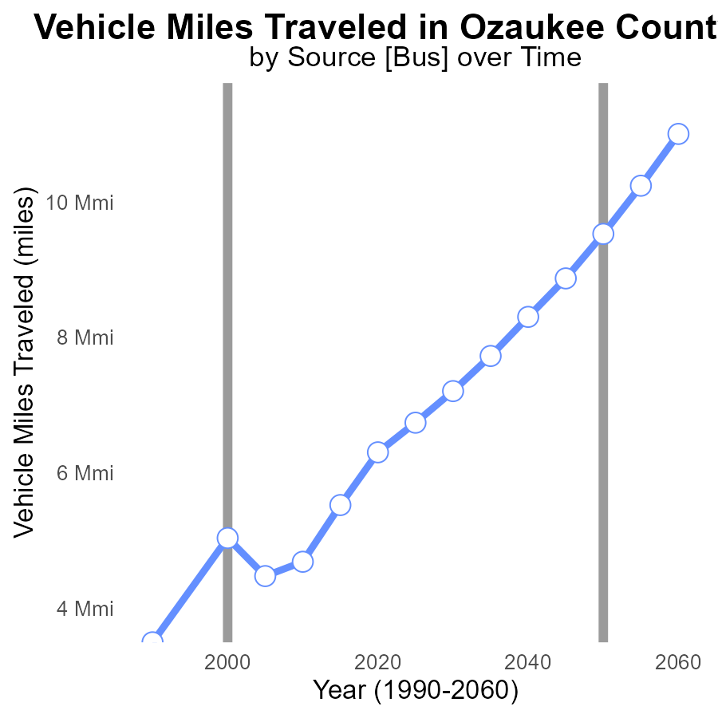

## Findings

* Vehicle miles traveled in Ozaukee County have increased by 80% from 3.5 million in 1990 to 6.3 million in 2020.
* The difference between the benchmark and actual vehicle miles traveled has decreased by 46% from 1990 to 2020.
* While the overall trend shows an increase in vehicle miles traveled, there was a slight decrease from 2015 to 2020 by 8%.

## Recommendations

To lower emissions, policymakers could consider implementing measures to promote public transportation, carpooling, and the use of electric vehicles. Encouraging telecommuting and remote working options can also help reduce the vehicle miles traveled.

# Idling Overall over Time

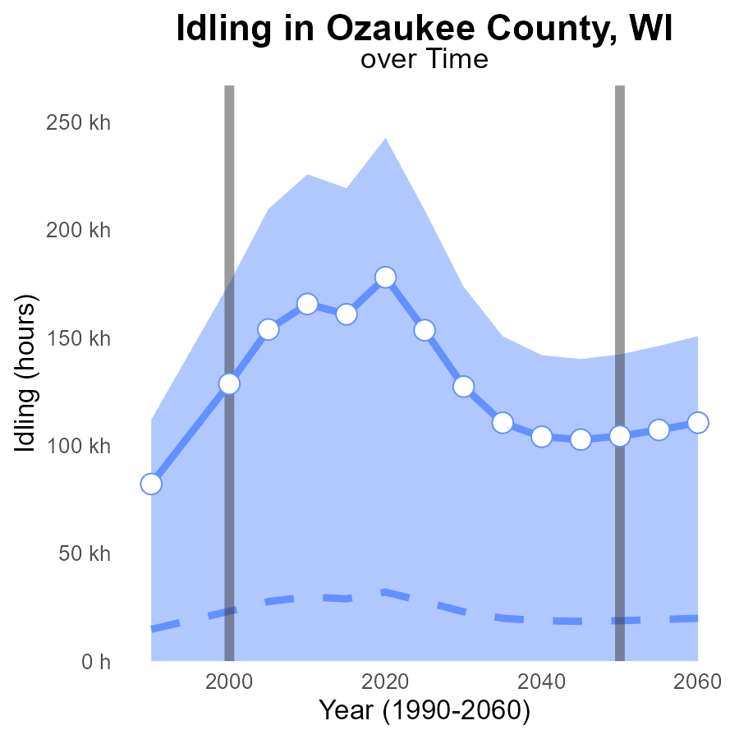

## Findings

* Idling emissions in Ozaukee County increased consistently from 1990 to 2020.
* The current idling emissions in 2020 are 146.0k hours, significantly higher than the median of 31973.30 hours.
* The upper 75th percentile of idling emissions for areas is at 242621.7 hours, suggesting a need for reduction efforts.

## Recommendations

To lower idling emissions in Ozaukee County, immediate strategies are advised. Implement anti-idling campaigns, support hybrid/electric vehicle adoption, and monitor idling times for commercial vehicles.

# Emissions Rate (per mile) in My Region

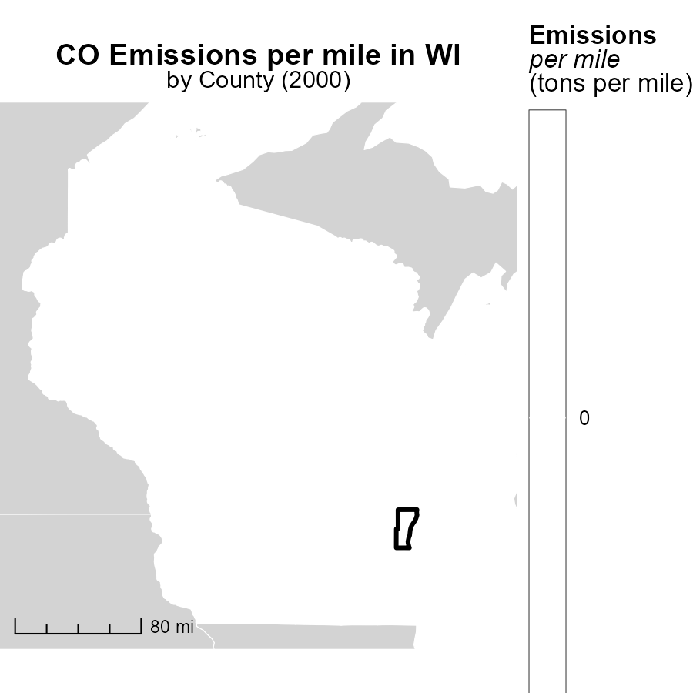

## Findings

* Adams County, WI has the highest emissions per mile at 18.5 tons.
* Manitowoc County, WI has a median emissions rate of 19.2 tons per mile.
* Wood County, WI has the lowest emissions per mile at 20.0 tons.

## Recommendations

To lower emissions, focus on implementing cleaner transportation methods, promoting carpooling, and increasing public transportation options in these counties.

# Emissions in My Region

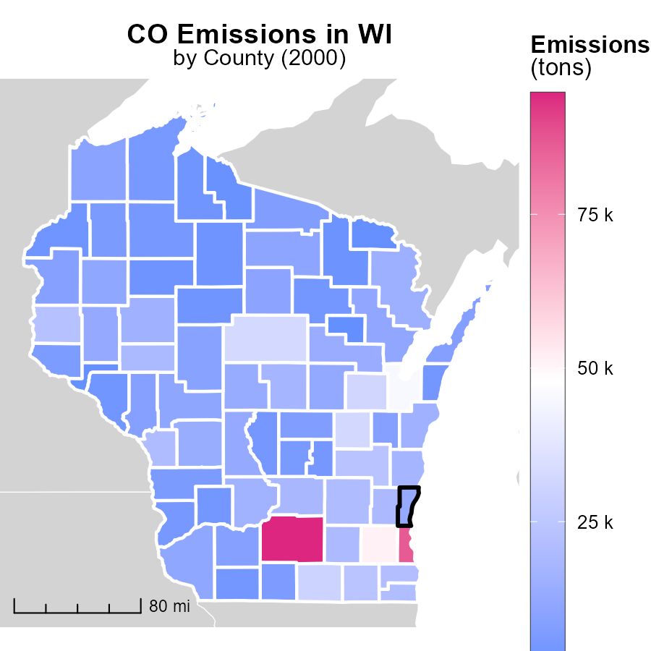

## Findings

* Dane County, WI has the highest emissions with 94.7 thousand tons.
* Menominee County, WI has the lowest emissions with 896.9 tons.
* There is a significant emission difference between Dane and Menominee counties.

## Recommendations

To lower emissions, focus on industries in Dane County for major reductions. Consider providing incentives for cleaner technologies in Menominee County to maintain low emissions.

# Emissions Rate (per capita) by Area over Time

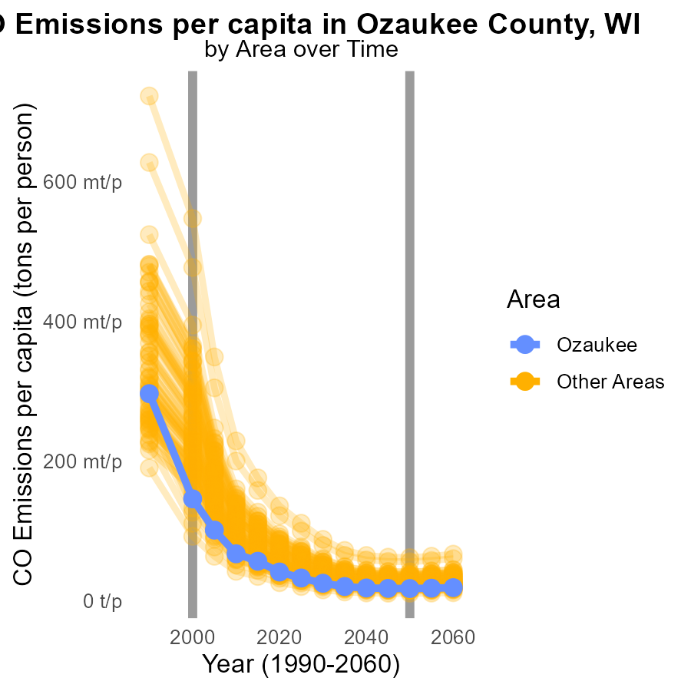

## Findings

* In 2000, the maximum county emitted 547.6 tons of CO per capita
* In 2000, the minimum county emitted 92.1 tons of CO per capita
* In 2000, the target county emitted 145.8 tons of CO per capita

## Recommendations

To reduce emissions, target areas with higher emissions for tailored reduction strategies, prioritize areas where the reduction has a significant impact based on the emission levels.

# Emissions Rate (per capita) by Regulatory Class over Time

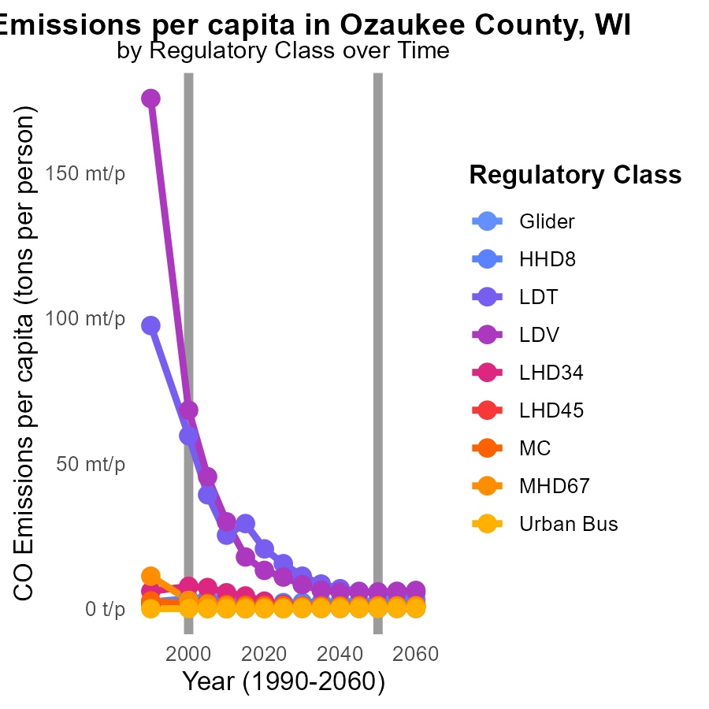

## Findings

* In 1990, LDV emissions were 175.5 million tons and reduced to 29.9 million tons in 2010.
* Between 1990 and 2010, MC emissions decreased from 2.7 million tons to 1.4 million tons.
* Emissions from MHD67 saw a significant decrease from 11.2 million tons in 1990 to 893.6 tons in 2010.

## Recommendations

To lower emissions, focus on LDV and MHD67 categories by promoting the use of cleaner vehicles and improving public transportation. Implement stricter regulations on emissions for MC category.

# Areas Ranked by Vehicle Starts

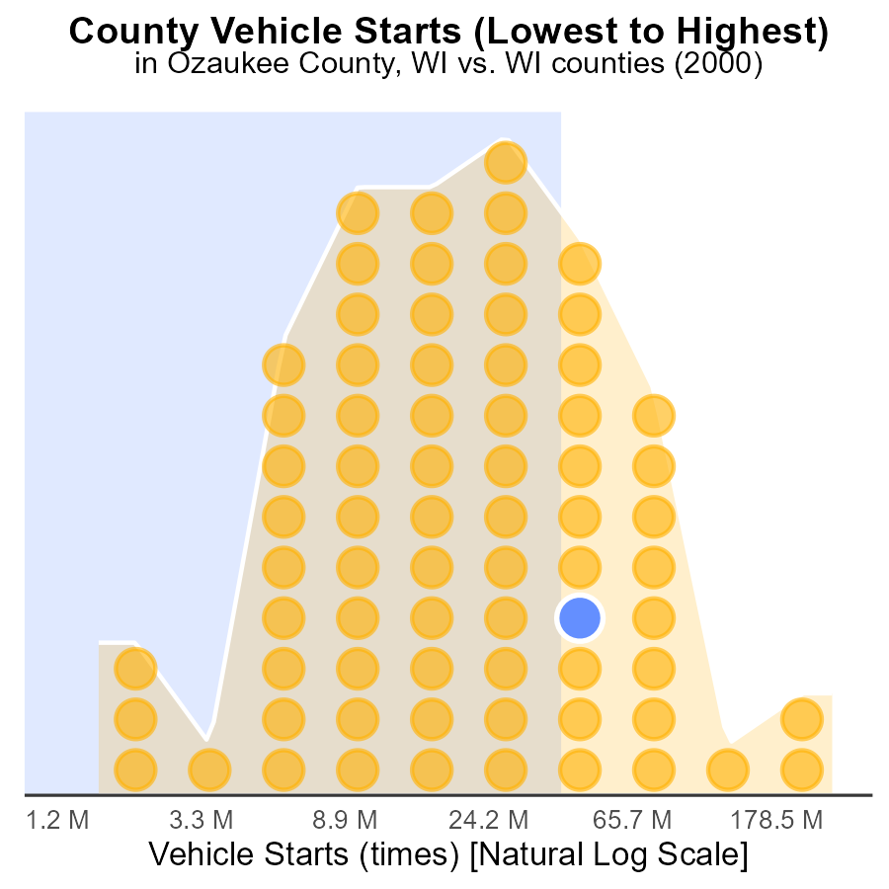

# Areas Ranked by Hotelling (Engines Off)

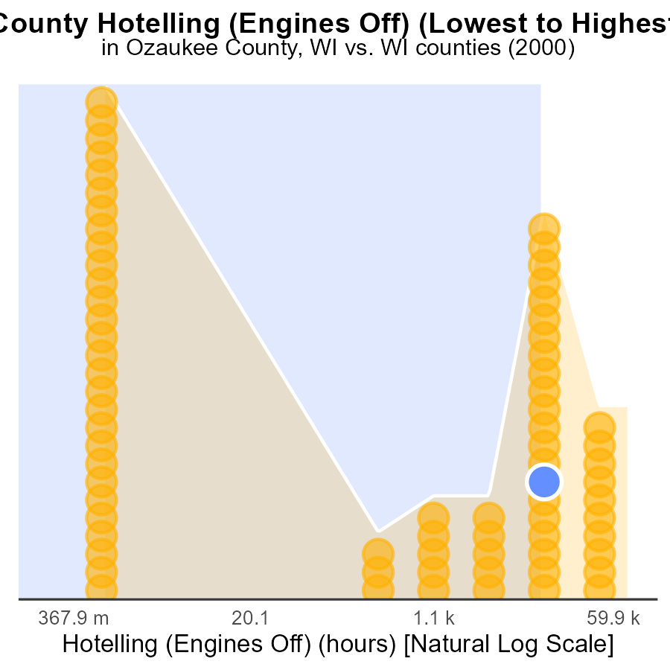

## Findings

* Highest CO emissions in Dane county at 220.1k hours
* Adams county has the lowest CO emissions among the listed counties
* Sheboygan county ranks highest in percentile for emissions despite being third in total emissions

## Recommendations

To reduce emissions, implement engine-off policies in high-emission areas like Dane county. Encourage Adams county's emissions reduction practices in other counties. Investigate Sheboygan county's emissions sources to address high percentiles.

# Conclusion

In conclusion, the data on Carbon Monoxide (CO) emissions from on-road transportation in Ozaukee County, WI in 2000 highlights key insights for policymakers and environmentalists. The findings indicate that LDVs and LDTs are the primary contributors to CO emissions, emphasizing the importance of targeting these vehicles for emission reduction strategies. Furthermore, the increase in vehicle miles traveled over the years calls for immediate action to promote alternative transportation methods such as public transport and carpooling.

To effectively lower CO emissions in Ozaukee County, implementing stricter regulations on diesel engines, promoting the use of electric vehicles, and reducing idling emissions are crucial steps. Additionally, tailored reduction strategies based on emission levels per capita and per mile can help target areas with higher emissions effectively. By focusing on cleaner transportation methods and incentivizing the adoption of eco-friendly practices, significant progress can be made towards reducing CO emissions and improving air quality in Ozaukee County.

# About This Report

Data based on MOVES estimates collected by the Climate Action in Transportation program at Cornell University. Demographic data sourced from the US Census's American Community Survey 5-year estimates. This report was generated with the help of AI.

# References

* U.S. Census Bureau. (2023). American Community Survey 5-year estimates: Detailed tables. Retrieved from https://data.census.gov
* U.S. Environmental Protection Agency. (2024). Motor Vehicle Emission Simulator (MOVES 4.0) [Software]. Retrieved from https://www.epa.gov/moves