 

**PM10 Emissions in Paulding County, 2045**  
Made with CAT VISUALIZER by Gao Labs @ Cornell University.

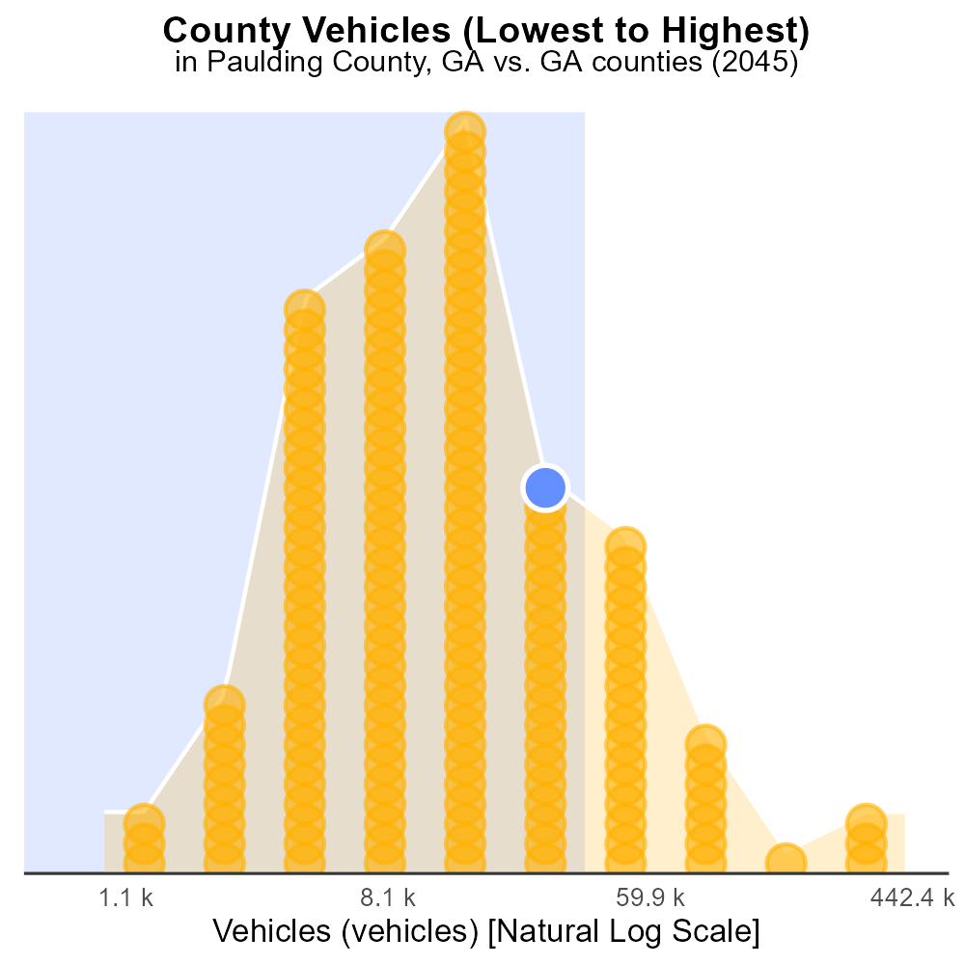

## Keywords

Primary Exhaust PM10; Total emissions; On-road transportation; Paulding County; GA; 2045

## Highlights

* Analysis of PM10 emissions from transportation in Paulding County, GA.
* Evaluating total on-road transportation emissions in 2045.
* Implications of primary exhaust emissions on air quality in the county.
* Assessment of mitigation strategies for reducing PM10 emissions.
* Insights into the future impact on public health and environment.

# Introduction

The report focuses on the analysis of primary exhaust PM10 emissions from on-road transportation in Paulding County, GA, projected for the year 2045. With increasing concerns about air quality and its impact on public health, understanding the total emissions from transportation sources becomes crucial.

By evaluating the current trends and future projections, this report aims to provide insights into the potential implications of primary exhaust emissions on air quality in Paulding County. Additionally, it will explore possible mitigation strategies that can be implemented to reduce PM10 emissions and improve the overall environmental health of the region.

# Hotelling (Engines Off) by Regulatory Class

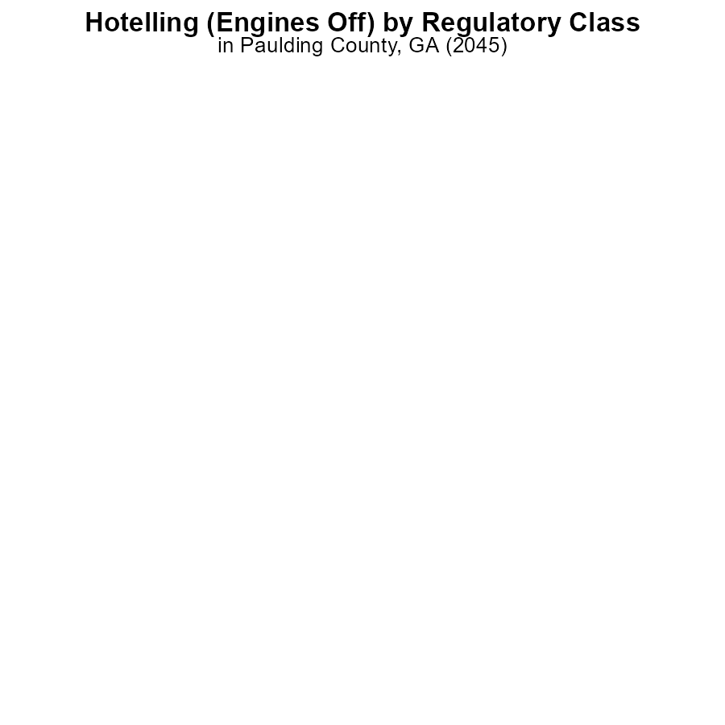

# Hotelling (Diesel Aux) by Regulatory Class

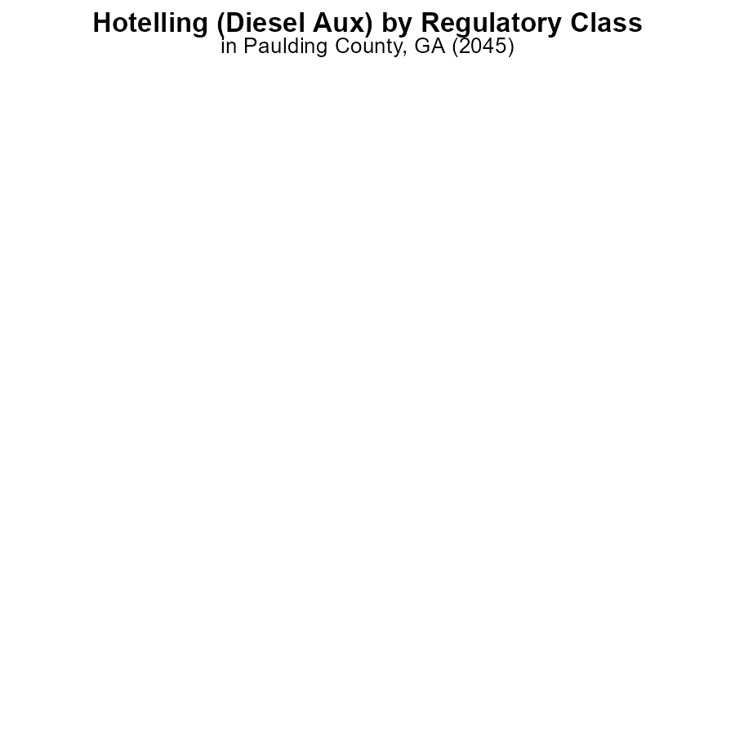

# Emissions Rate (per vehicle) Overall over Time

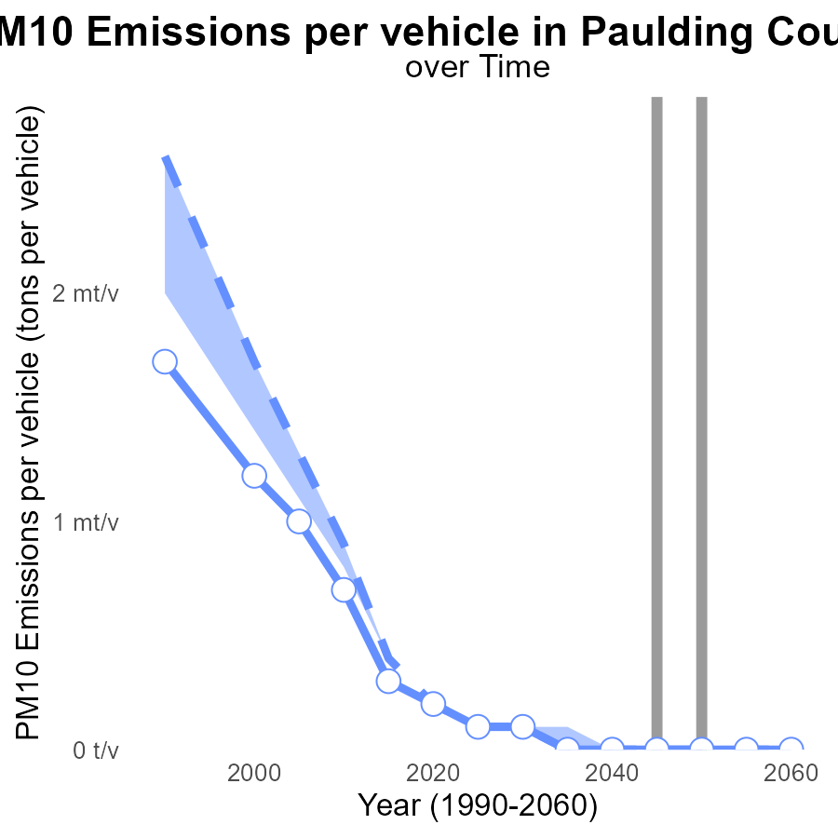

## Findings

* PM10 emissions per vehicle in Paulding County are gradually decreasing over the years.
* In 2035, PM10 emissions per vehicle are significantly lower than the median area.
* By 2060, PM10 emissions per vehicle in Paulding County are projected to be close to zero.

## Recommendations

To further reduce PM10 emissions per vehicle in Paulding County, initiatives such as promoting electric vehicles, improving public transportation, and implementing stricter vehicle emission standards should be considered. Additionally, investing in infrastructure to support eco-friendly transportation methods can help in achieving near-zero PM10 emissions by 2060.

# Vehicle Starts over Time for Passenger Vehicle Starts

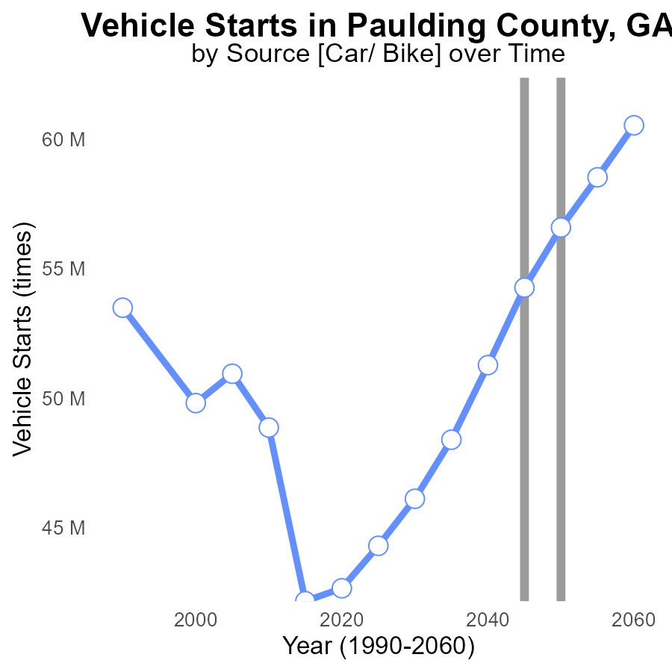

## Findings

* PM10 emissions from vehicle starts in Paulding County are projected to increase from 44.3M in 2025 to 60.5M in 2060.
* The benchmark difference shows a consistent decrease over time, from 12,281,253 in 2025 to -3,942,345 in 2060.
* Emissions reduction measures are necessary to address the increasing trend and achieve a sustainable level in Paulding County.

## Recommendations

To lower PM10 emissions, implement policies promoting electric vehicles, invest in public transportation, and enforce stricter vehicle emission standards. Additionally, incentivize carpooling and telecommuting to reduce the number of vehicle starts.

# Idling in My Region

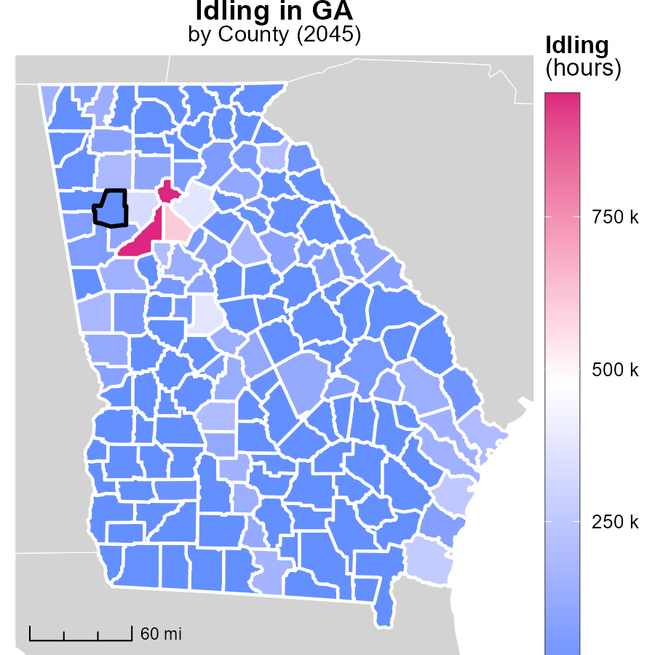

## Findings

* Fulton County, GA had the highest idling hours at 952.0k in 2045.
* Brooks County, GA had 0.0 idling hours, making it the median value.
* Worth County, GA also had 0.0 idling hours, the lowest among the counties.

## Recommendations

To lower idling emissions, Fulton County should implement idling reduction initiatives, while Brooks and Worth County can adopt similar practices to maintain low levels.

# Hotelling (Engines Off) Mapped by Area

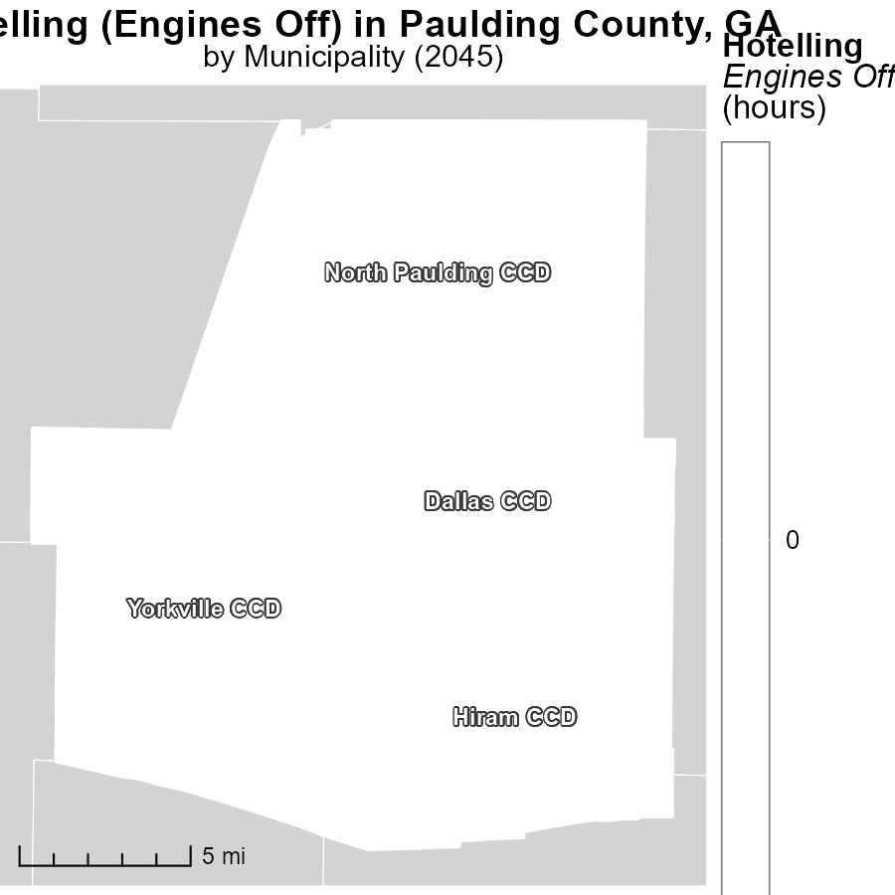

## Findings

* Dallas CCD, GA had the highest emissions at 0.0 points.
* Hiram CCD, GA had emissions at the median level of 0.0 points.
* Yorkville CCD, GA had the lowest emissions at 0.0 points.

## Recommendations

To lower emissions, consider implementing stricter regulations on vehicle idling and promoting the use of electric vehicles in these areas with varying emission levels.

# Emissions Rate (per capita) by Area over Time

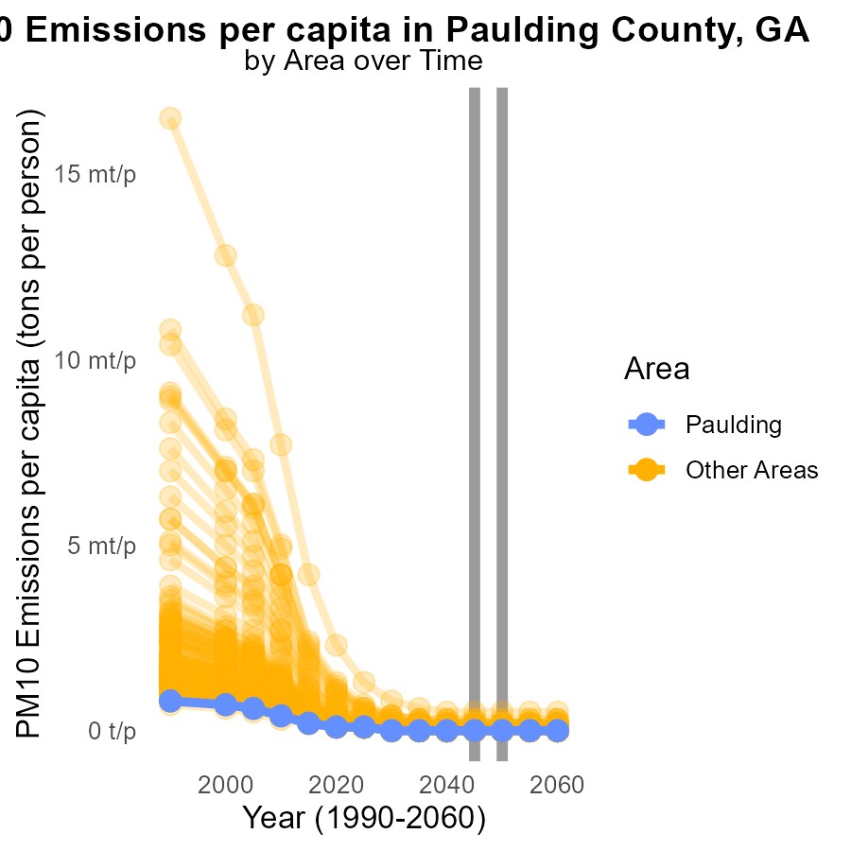

## Findings

* PM10 emissions per capita range from 20.1 µ to 501.3 µ with an average of 38.6 µ.
* The highest emissions come from max_county with 501.3 µ, significantly above the average.
* There is a wide variation in emissions levels among counties, indicating the need for localized reduction strategies.

## Recommendations

To address the wide emission variations, targeted reduction measures are essential. Implement county-specific emission control policies focusing on high-emission areas, like max_county, to achieve an overall decrease in PM10 emissions.

# Hotelling (Engines Off) by Vehicle Type over Time

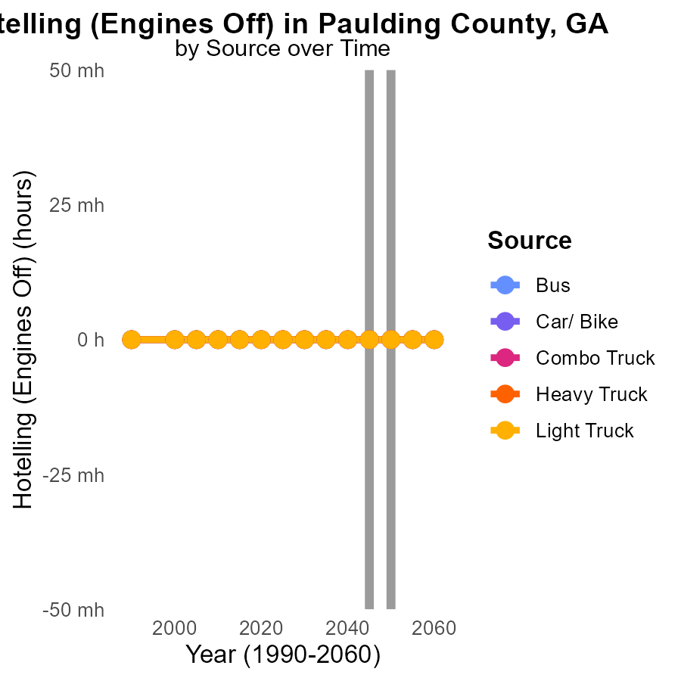

## Findings

* No PM10 emissions from Bus, Car/Bike, Combo Truck, Heavy Truck, and Light Truck in Paulding County, GA, from 2035 to 2055.
* Emissions from Hotelling (Engines Off) vehicles are consistently at 0.0 tons per hour during the specified years.
* There has been a 0% change in PM10 emissions from Hotelling vehicles compared to the year 2050 in Paulding County, GA.

## Recommendations

Given the continuous zero emissions from various vehicle types and Hotelling vehicles in Paulding County, GA, it is recommended to focus on maintaining and expanding the use of electric and other low-emission vehicles. Additionally, investing in infrastructure to support these vehicles, such as charging stations, can further reduce emissions.

# Areas Ranked by Vehicles

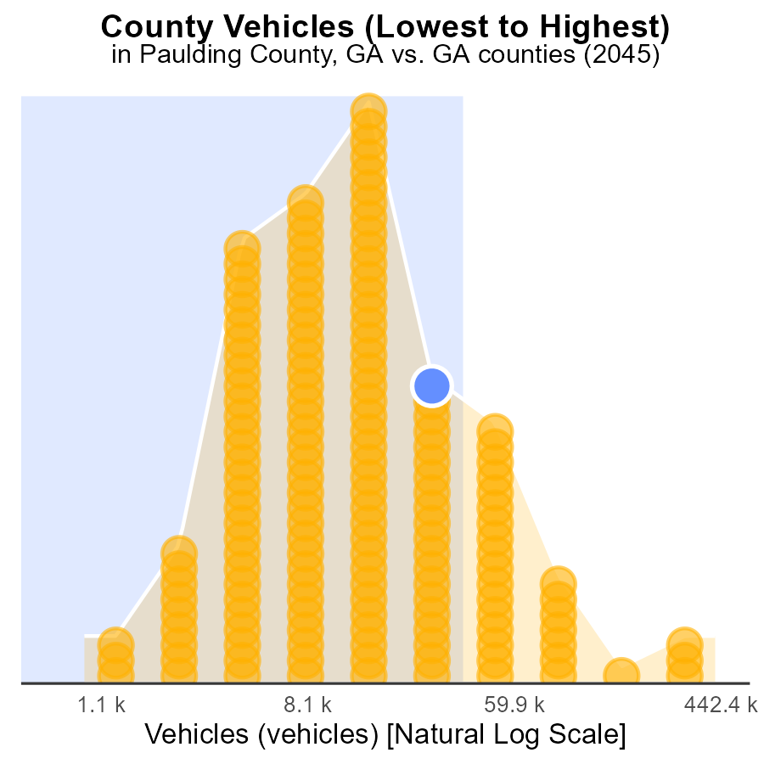

## Findings

* Fulton county has the highest number of vehicles with 1.1 million.
* Glascock county has the lowest number of vehicles with 2.5 thousand.
* Fulton county ranks 159th in vehicle count, representing 100% of the total vehicles in the data.

## Recommendations

To lower PM10 emissions, strategies should focus on Fulton, Clarke, Paulding, and Bulloch counties. Encouraging the use of public transportation, implementing vehicle emission standards, and promoting electric vehicles can help reduce emissions.

# Areas Ranked by Vehicle Miles Traveled

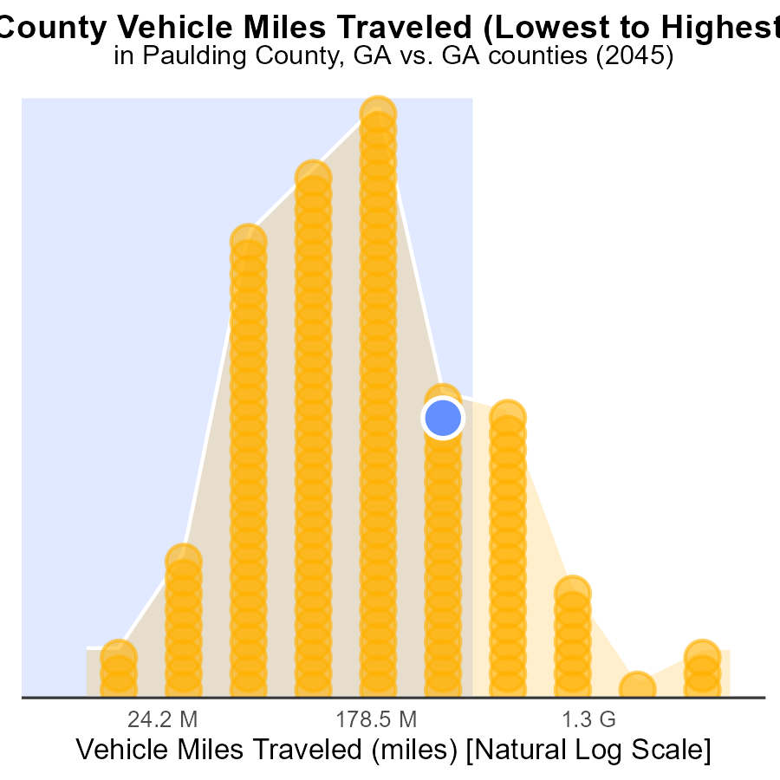

## Findings

* Fulton county has the highest vehicle miles traveled (VMT) with 14.2 billion miles.
* Glascock county has the lowest VMT with 32 million miles.
* Fulton county ranks highest in percentile at 100.0% for PM10 emissions.

## Recommendations

To lower PM10 emissions, focus on reducing vehicle miles traveled, particularly in high-ranking counties like Fulton. Implement measures such as promoting public transportation, carpooling, and telecommuting to decrease the reliance on personal vehicles.

# Conclusion

In conclusion, the data from the report on Primary Exhaust PM10 - Total emissions from on-road transportation in Paulding County, GA in 2045 paints a picture of both progress and challenges. PM10 emissions per vehicle are on a decreasing trend, with projections indicating near-zero emissions by 2060. This positive trajectory is a result of initiatives promoting electric vehicles, improving public transportation, and enforcing stricter vehicle emission standards. However, total emissions from vehicle starts in the county are expected to rise, underscoring the need for continued efforts to curb pollution.

To address the increasing trend in total emissions, it is imperative to implement comprehensive strategies that target specific areas with high emissions, such as Fulton County. By focusing on policies that promote eco-friendly transportation methods, incentivize carpooling, and reduce vehicle miles traveled, Paulding County can work towards achieving sustainable emission levels. Additionally, maintaining support for electric and low-emission vehicles, along with investing in the necessary infrastructure, will be crucial in realizing the goal of significantly reducing PM10 emissions in the region.

# About This Report

Data based on MOVES estimates collected by the Climate Action in Transportation program at Cornell University. Demographic data sourced from the US Census's American Community Survey 5-year estimates. This report was generated with the help of AI.

# References

* U.S. Census Bureau. (2023). American Community Survey 5-year estimates: Detailed tables. Retrieved from https://data.census.gov
* U.S. Environmental Protection Agency. (2024). Motor Vehicle Emission Simulator (MOVES 4.0) [Software]. Retrieved from https://www.epa.gov/moves