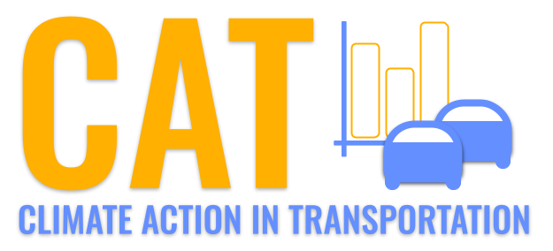 

**NOx Emissions in New Castle County, 2030**  
Made with CAT VISUALIZER by Gao Labs @ Cornell University.

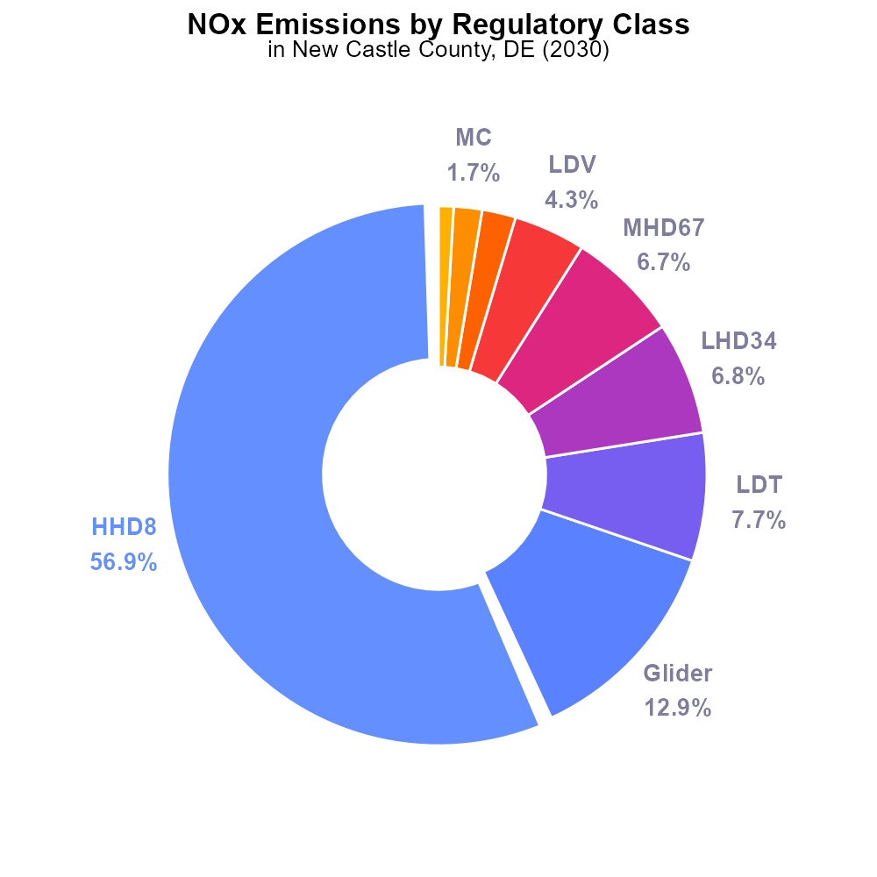

## Keywords

Oxides of Nitrogen; NOx emissions; on-road transportation; New Castle County, DE; 2030

## Highlights

* Study investigates NOx emissions from vehicles in New Castle County, DE.
* Transportation sector's impact on air quality in 2030 is analyzed.
* Strategies to mitigate NOx emissions are explored for the future.
* Findings aim to inform policies for cleaner air in the county.
* Importance of reducing NOx emissions for public health and environment.

# Introduction

In 2030, the study focuses on the Oxides of Nitrogen (NOx) emissions specifically from on-road transportation in New Castle County, DE. With the transportation sector being a significant contributor to air pollution, understanding the extent of NOx emissions becomes crucial for assessing the region's air quality. This report delves into the sources, impacts, and potential mitigation strategies associated with NOx emissions in the county.

The findings of this study aim to provide valuable insights to policymakers and stakeholders for developing effective strategies to reduce NOx emissions in the transportation sector, ultimately improving air quality and public health in New Castle County. The importance of addressing NOx emissions in line with environmental and health regulations is paramount, ensuring a sustainable and cleaner future for the region.

# Emissions by Regulatory Class

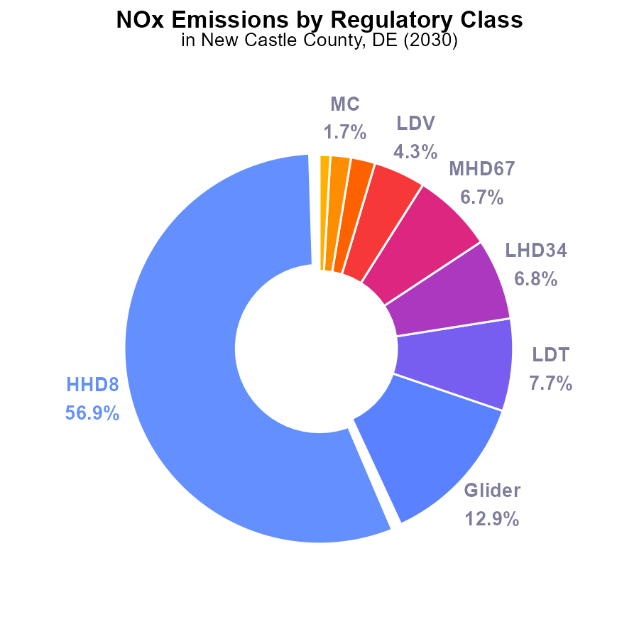

## Findings

* HHD8 vehicles contribute to 56.9% of NOx emissions in New Castle County, DE in 2030.
* Glider vehicles are responsible for 12.9% of the total NOx emissions.
* Collectively, LDT, LHD34, and MHD67 vehicles contribute to 21.2% of NOx emissions.

## Recommendations

To lower NOx emissions, focus on reducing HHD8 vehicles' emissions by implementing stricter emission standards. Additionally, consider transitioning away from glider vehicles and investing in cleaner transportation options such as LDV and urban buses.

# Time Driven by Regulatory Class

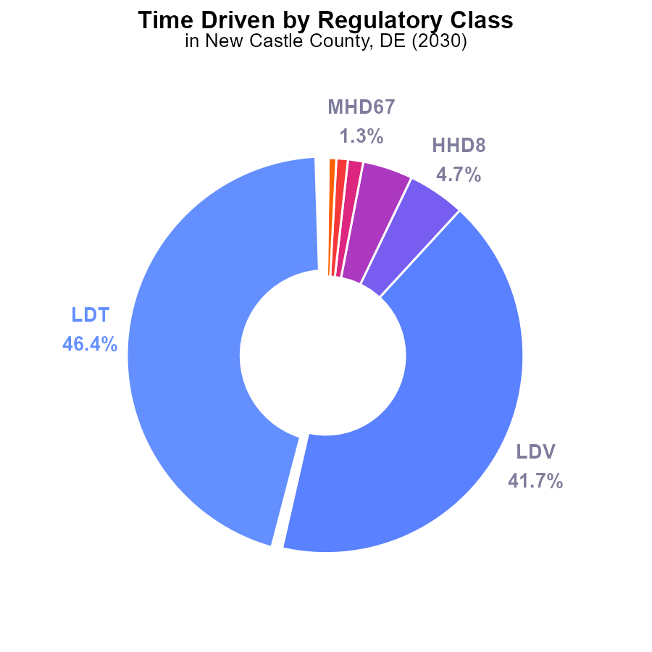

## Findings

* The top two contributors are LDT with 46.4% and LDV with 41.7% of NOx emissions.
* HHD8 and LHD34 are significant contributors, accounting for 9.4% in total.
* The remaining vehicle types each contribute less than 2% to NOx emissions.

## Recommendations

To lower NOx emissions, focus efforts on reducing LDT and LDV emissions by promoting electric vehicles, improving vehicle efficiency, and incentivizing public transportation.

# Emissions Rate (per capita) over Time for Passenger Vehicles

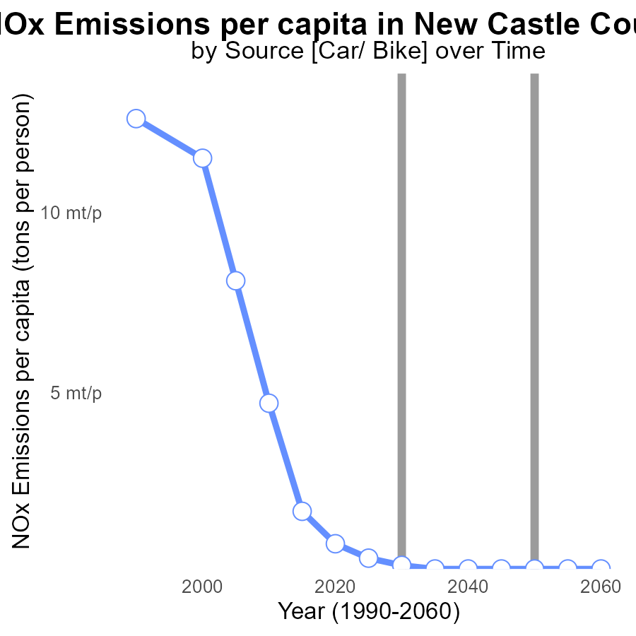

## Findings

* NOx emissions per capita in New Castle County decreased consistently from 2010 to 2035.
* The benchmark difference shows a continuous improvement in reducing NOx emissions per capita.
* By 2050, NOx emissions per capita are projected to reach 80.8 tons per person in New Castle County.

## Recommendations

To further lower NOx emissions in New Castle County, implement strict emissions control measures for industries and vehicles, promote the use of electric vehicles, invest in renewable energy sources, and encourage public transportation.

# Emissions over Time for Passenger Vehicles

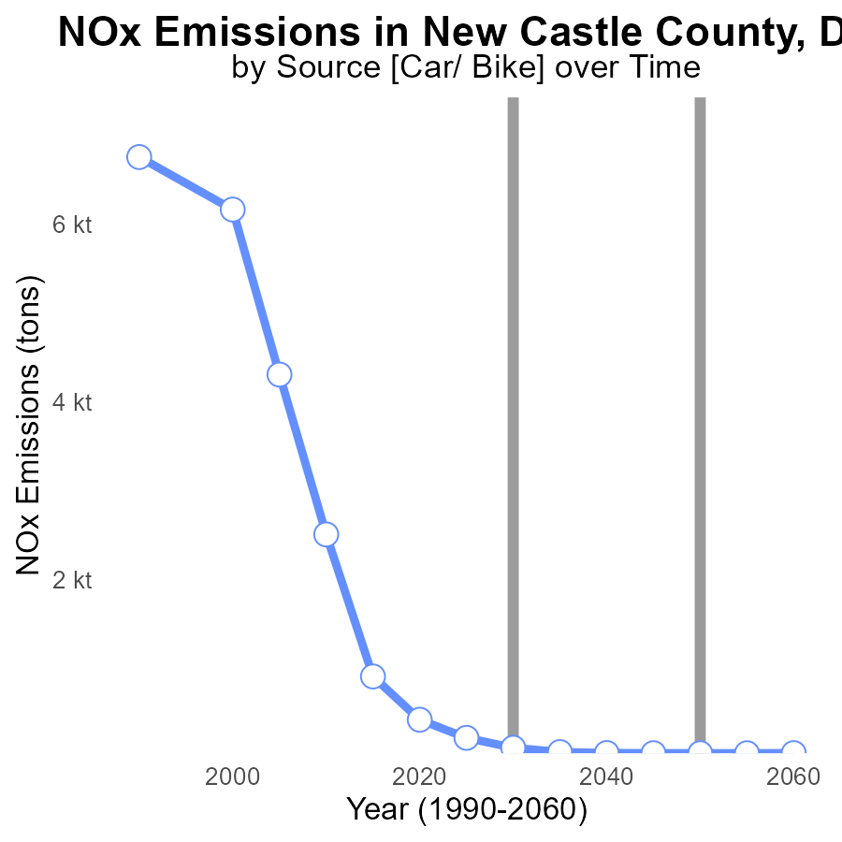

## Findings

* NOx emissions in New Castle County significantly decreased over the past 40 years.
* A notable drop of 96.3% in NOx emissions occurred from 2010 to 2050.
* Reductions in emissions have been consistent, with a decrease of 99.7% from 2010 to 2045.

## Recommendations

These significant reductions in NOx emissions reflect positive trends in environmental sustainability. To continue this progress, policymakers should focus on expanding the adoption of cleaner technologies, enforcing stricter emission regulations, and promoting public transportation and biking infrastructure. Additionally, investing in renewable energy sources and incentivizing energy efficiency programs can further contribute to lowering emission levels.

# Vehicles Mapped by Area

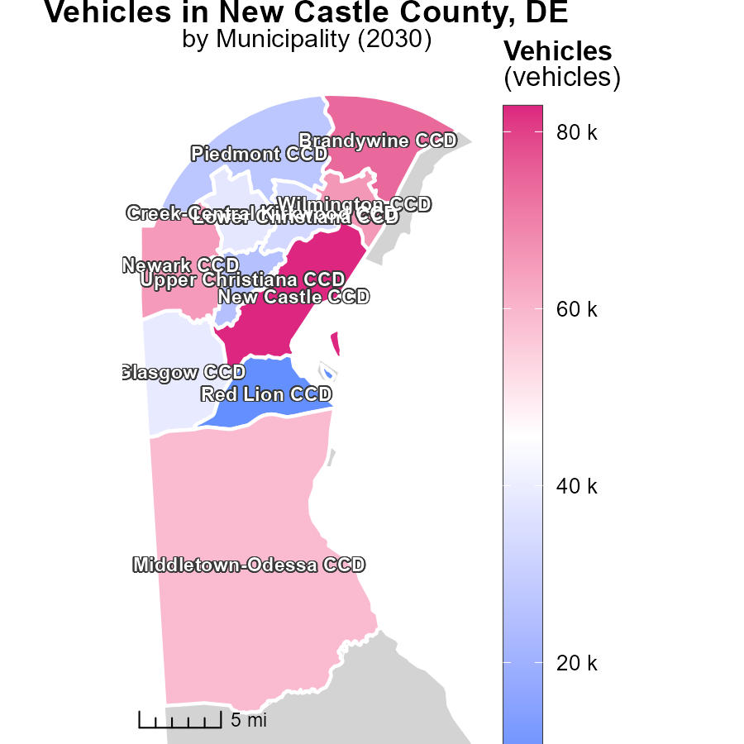

## Findings

* New Castle CCD, DE has the highest vehicle emissions at 82.9k
* Glasgow CCD, DE has a median vehicle emission at 39.1k
* Red Lion CCD, DE has the lowest vehicle emissions at 8.4k

## Recommendations

To lower vehicle emissions, focus on New Castle CCD, DE by promoting the use of public transportation and carpooling, incentivizing electric vehicle adoption, and improving infrastructure to support cycling and walking.

# Vehicles in My Region

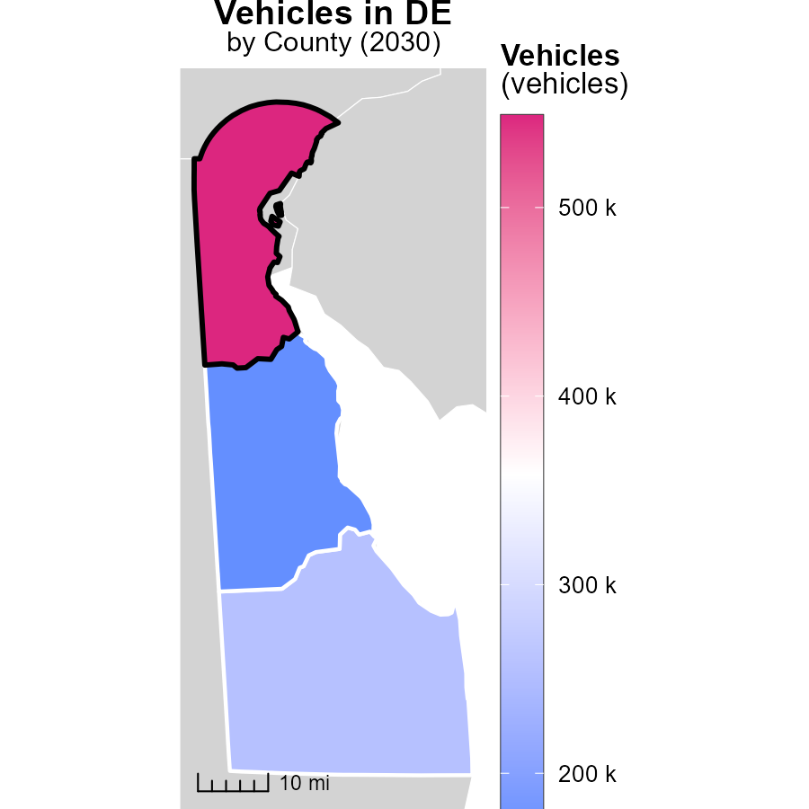

## Findings

* New Castle County has the highest vehicle emissions with 548.7k tons.
* Sussex County has a median vehicle emissions of 257.3k tons.
* Kent County has the lowest vehicle emissions at 168.7k tons.

## Recommendations

To lower emissions, encourage the use of public transportation, carpooling, and vehicles with higher fuel efficiency. Invest in infrastructure for electric vehicles.

# Emissions Rate (per vehicle) by Vehicle Type over Time

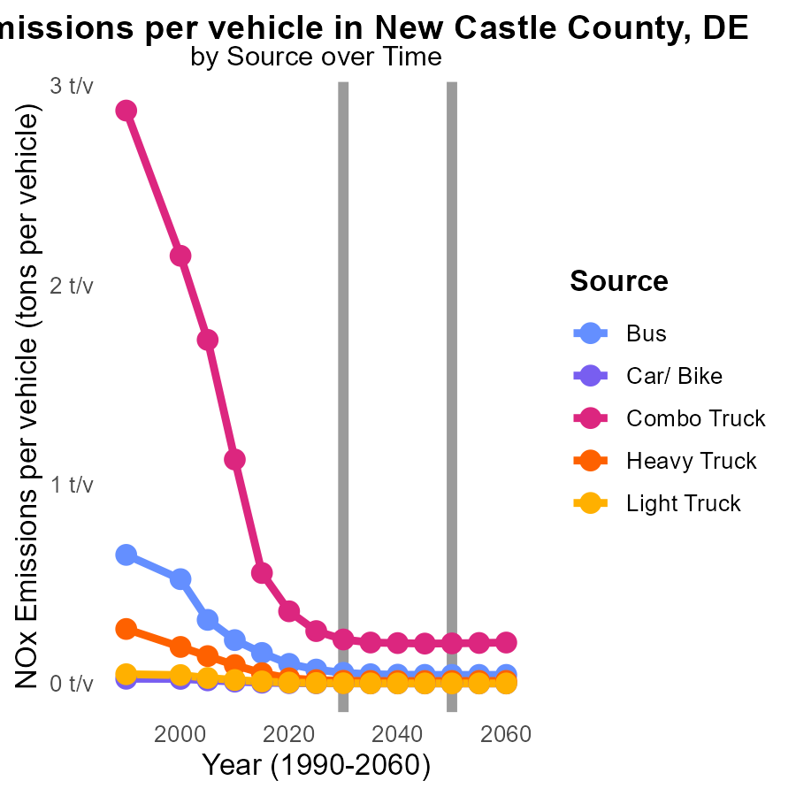

## Findings

* NOx emissions per vehicle are decreasing by an average of 0.04 tons across all vehicle types from 2020 to 2040.
* The heaviest reduction is seen in Combo Trucks, where emissions drop by 0.081 tons per vehicle between 2020 and 2040.
* While Light Trucks show the smallest total emissions, they still exhibit a decline of 0.0047 tons per vehicle from 2020 to 2040.

## Recommendations

To further reduce NOx emissions, policies should prioritize incentivizing the adoption of cleaner technologies across vehicle types. Initiatives like stricter emissions standards, promoting electric vehicles, and enhancing public transportation can accelerate the decrease in emissions per vehicle.

# Vehicle Miles Traveled by Vehicle Type over Time

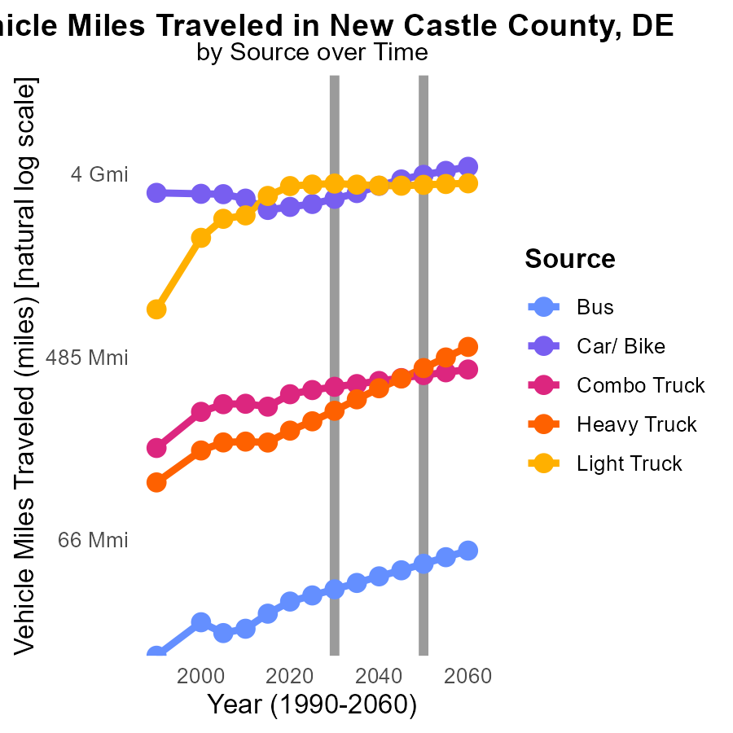

## Findings

* Bus NOx emissions are expected to decrease by 60.9% from 2020 to 2040.
* Car/Bike NOx emissions will decrease by 61.7% by 2040 compared to 2020 levels.
* Heavy Truck NOx emissions are projected to decrease by 59.6% from 2020 to 2040.

## Recommendations

To reduce NOx emissions further, policymakers could incentivize the use of electric vehicles, improve public transportation infrastructure to reduce reliance on buses, and implement stricter emission standards for trucks. These measures can help achieve significant emission reductions in line with the observed trends.

# Areas Ranked by Hotelling (Engines Off)

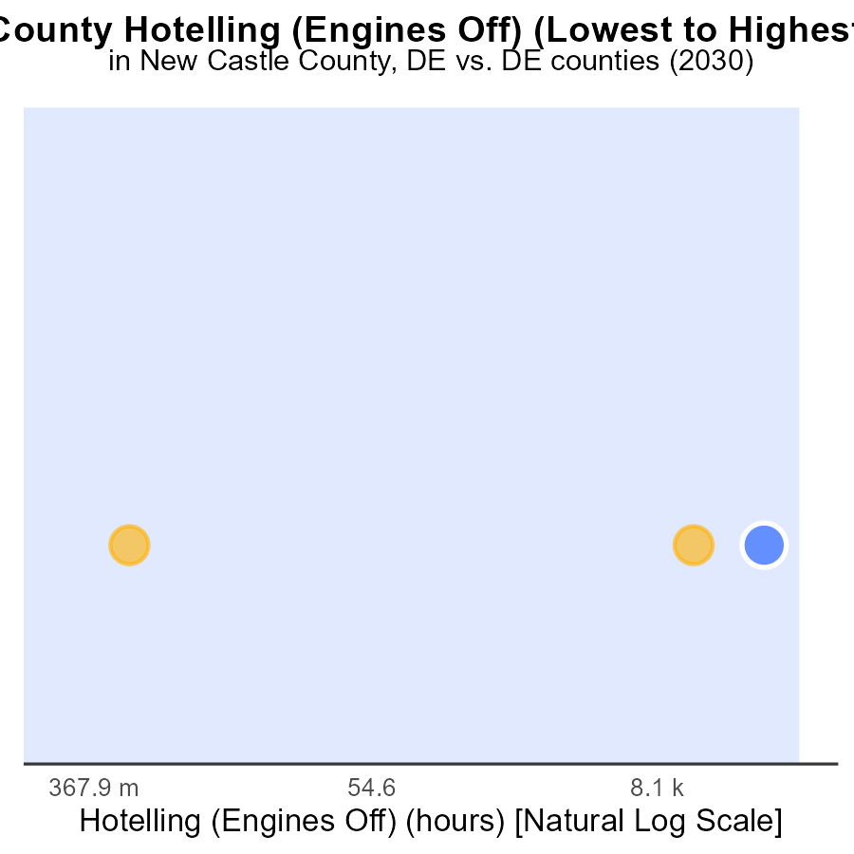

## Findings

* New Castle has the highest NOx emissions with 274.4 k hours, ranking 3rd and at 100.0% percentile.
* Sussex shows no emissions from Hotelling, ranking 1st at 33.3% percentile.
* Kent follows with 39.9 k hours of NOx emissions, ranking 2nd at 66.7% percentile.

## Recommendations

To lower emissions, focus on New Castle by implementing stricter emission control measures for engines during Hotelling. Encourage the use of cleaner technologies to reduce NOx levels in Kent. Continue monitoring Sussex to maintain its zero-emission status.

# Areas Ranked by Vehicle Starts

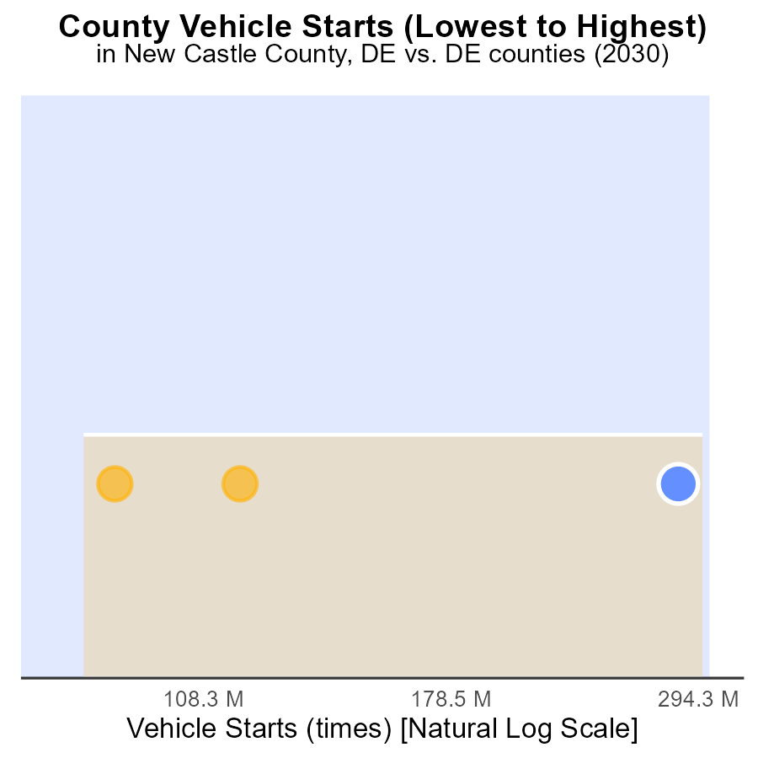

## Findings

* New Castle has the highest number of vehicle starts with 817.7 million, ranking 3rd across all counties.
* Kent has the least number of vehicle starts with 231.0 million, placing it in the 33.3rd percentile.
* Sussex falls in between, with 310.9 million vehicle starts, ranking 2nd and at the 66.7th percentile.

## Recommendations

To reduce NOx emissions from vehicles, New Castle should focus on implementing stricter vehicle emission standards, promoting public transportation, and investing in electric vehicle infrastructure. Kent can work on improving carpooling initiatives and encouraging telecommuting to lessen vehicle starts. Sussex should consider implementing vehicle maintenance programs and incentivizing the use of hybrid vehicles to reduce overall emissions.

# Conclusion

In conclusion, the data on Oxides of Nitrogen (NOx) emissions from on-road transportation in New Castle County, DE in 2030 shows a significant reliance on High Heavy Duty 8 (HHD8) vehicles, which contribute to over half of the NOx emissions. Efforts to reduce emissions should focus on stricter emission standards for HHD8 vehicles, transitioning away from glider vehicles, and promoting cleaner transportation options like Light Duty Trucks (LDT) and Light Duty Vehicles (LDV). The significant reduction in NOx emissions per capita over the years reflects positive progress in environmental sustainability. To continue this trend, policymakers should prioritize expanding the adoption of cleaner technologies, enforcing strict emission regulations, promoting public transportation, investing in renewable energy sources, and incentivizing energy efficiency programs to further lower emission levels.

Furthermore, analyzing NOx emissions per vehicle type reveals a decreasing trend from 2020 to 2040, with notable reductions in emissions across various vehicle categories. To achieve further reductions, initiatives such as incentivizing cleaner technologies, promoting electric vehicles, enhancing public transportation infrastructure, and implementing stricter emission standards for trucks and buses can accelerate the decrease in emissions per vehicle. By focusing on these strategies, New Castle County and other regions can work towards achieving significant reductions in NOx emissions, contributing to a cleaner and more sustainable environment.

# About This Report

Data based on MOVES estimates collected by the Climate Action in Transportation program at Cornell University. Demographic data sourced from the US Census's American Community Survey 5-year estimates. This report was generated with the help of AI.

# References

* U.S. Census Bureau. (2023). American Community Survey 5-year estimates: Detailed tables. Retrieved from https://data.census.gov
* U.S. Environmental Protection Agency. (2024). Motor Vehicle Emission Simulator (MOVES 4.0) [Software]. Retrieved from https://www.epa.gov/moves